Supplementary materials: Testing and validating the ECOSSE-model for estimating soil respiration from eight European permanent grassland sites

Fig. S1: Average daily air temperature (ºC; black line) and precipitation (mm; blue line) at the experimental sites during the measurements of net ecosystem respiration

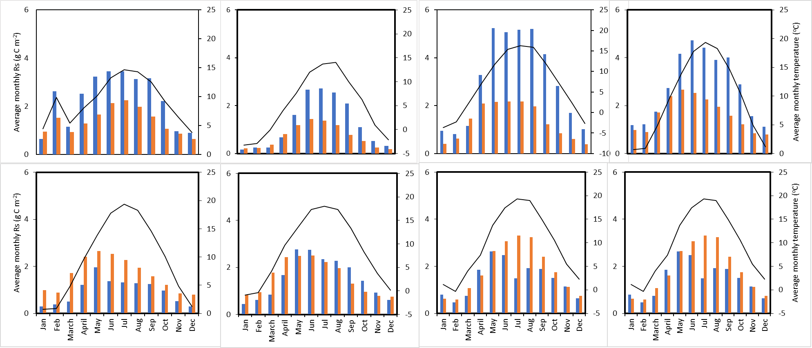
Easter Bush
Alp Weissenstein
Neustift
Chamau
Matra
Grünschwaige
Bovora
Amperlo
Fig. S2: Relationships between estimated (blue bar) and simulated (orange bar) monthly cumulative soil respiration (Rs) and average monthly air temperature (black line) at the investigated sites.

