Supplementary data
The fall armyworm, Spodoptera frugiperda (Lepidoptera: Noctuidae), influences Nilaparvata lugens population growth directly, by preying on its eggs, and indirectly, by inducing defenses in rice
Chen Qiu ¹, Jiamei Zeng ¹, Yingying Tang ¹, Qing Gao ¹, Wenhan Xiao ¹, and Yonggen Lou ^{1, 2}*
¹ State Key Laboratory of Rice Biology & Ministry of Agriculture Key Lab of Agricultural Entomology, Key Laboratory of Biology of Crop Pathogens and Insects of Zhejiang Province, Institute of Insect Sciences, Zhejiang University, Hangzhou 310058, China; cqiu2019@163.com (C.Q.); 262353332@qq.com (J.Z.); tyy034899@zju.edu.cn (Y.T.); 11916008@zju.edu.cn (Q.G.); 2223171532@qq.com (W.X.)
² Hainan Institute, Zhejiang University, Sanya 572025, China
* Correspondence: yglou@zju.edu.cn; Tel.: 0086-571-88982622
Figure S1. Effects of rice plants that were infested by FAW larvae on the feeding, fecundity and developmental duration of BPH.
Figure S2. Pre-infestation of FAW larvae on rice plants does not influence the hatching rate and developmental duration of BPH eggs.
Figure S3. Pre-infestation of gravid BPH females on rice plants does not influence the growth of FAW larvae.
Figure S4. Effect of FAW larvae infestation on the attractiveness of BPH-infested plants to the parasitoid Anagrus nilaparvatae.
Figure S5. The experimental setup for BPH infestation (a), FAW infestation (b) and BPH honeydew excretion (c).
Table S1. Student’s t-test analysis with data from figures in supporting information.
Table S2. Student’s t-test analysis with data from Figure 1.
Table S3. Analysis of variance with data from Figure 1.
Table S4. Student’s t-test analysis with data from Figure 2.
Table S5. Student’s t-test analysis with data from Figure 3.
Table S6. Student’s t-test analysis with data from Figure 4.
Table S7. Mean levels (+SE, n=5~6) of other phenolamides in rice plants that had been infested with 10 gravid BPH females for 24 h, after which the BPHs had been removed; levels measured 1, 3, 5 and 7 d after plants had been individually infested with either three 2nd-instar FAW larvae (BPH+FAW) or no FAW larvae (BPH).

Table S8. Mean levels (+SE, n=5~6) of other flavonoids in rice plants that had been infested with 10 gravid BPH females for 24 h, after which the BPHs had been removed; levels measured 1, 3, 5 and 7 d after plants had been individually infested with either three 2nd-instar FAW larvae (BPH+FAW) or no FAW larvae (BPH).
Table S9. Student’s t-test analysis with data from Table S7.
Table S10. Student’s t-test analysis with data from Table S8.

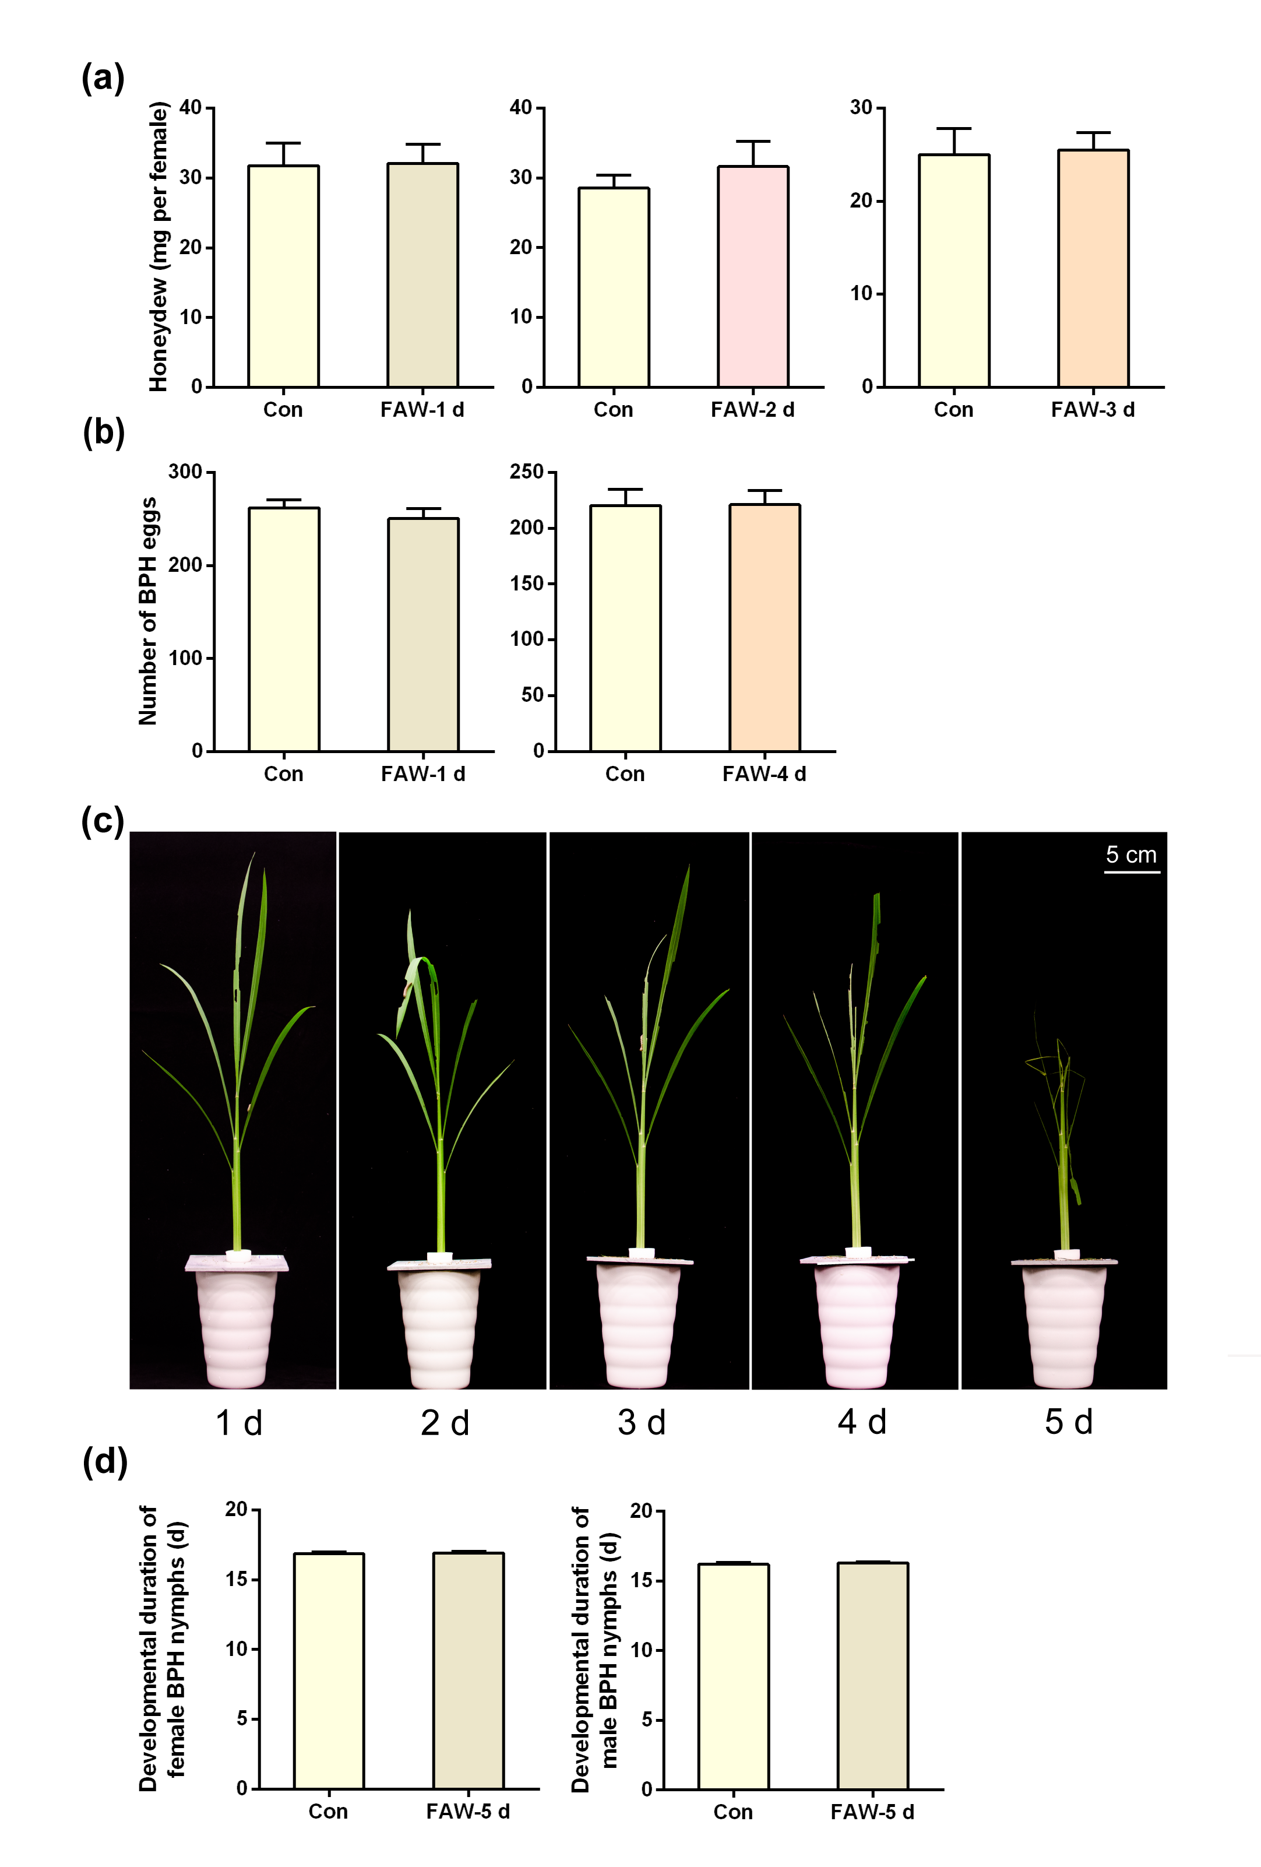
Figure S1. Effects of rice plants that were infested by FAW larvae on the feeding, fecundity and developmental duration of BPH.
(a) Mean mass of honeydew (+SE, n=21-25) excreted by a newly emerged BPH female adult feeding for 24 h on non-infested plants (Con) or plants that had been infested by one 3rd-instar FAW larva for 1, 2 or 3 d (FAW-1d, FAW-2d or FAW-3d); (b) Mean number of eggs (+SE, n=21-26) laid by a newly emerged female adult after feeding for 10 d on non-infested plants (Con) or plants that had been infested by one 3rd-instar FAW larva for 1 d or 4 d (FAW-1d or FAW-4d); (c) Phenotypes of rice plants that had been infested by one 3rd-instar FAW larva for 1-5 d; (d) Mean developmental duration (+SE, n=8~9) of BPH female or male nymphs on non-infested plants (Con) or plants that had been infested by one 3rd-instar FAW for 5 d (FAW-5d).

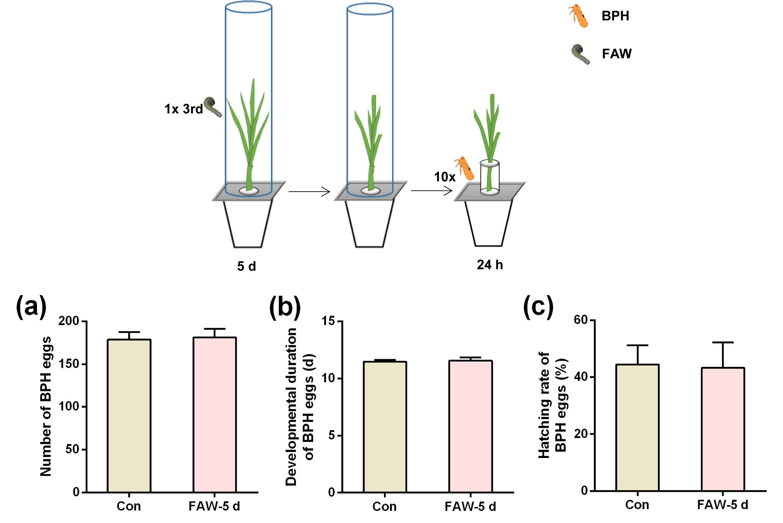

Figure S2. Pre-infestation of FAW larvae on rice plants does not influence the hatching rate and developmental duration of BPH eggs. Upper inset, schematic representation of the experimental design.
(a) Mean number of eggs (+SE, n=9~10) laid by 10 gravid BPH females for 24 h on non-infested plants (Con) or plants that had been pre-infested by one 3rd-instar FAW larva for 5 d (FAW-5d); (b) Mean developmental duration (+SE, n=10) of BPH eggs on non-infested plants (Con) or plants that had been pre-infested by one 3rd-instar FAW larva for 5 d (FAW-5d); (c) Mean hatching rate of BPH eggs (+SE, n=10) on non-infested plants (Con) or plants that had been pre-infested by one 3rd-instar FAW larva for 5 d (FAW-5d).

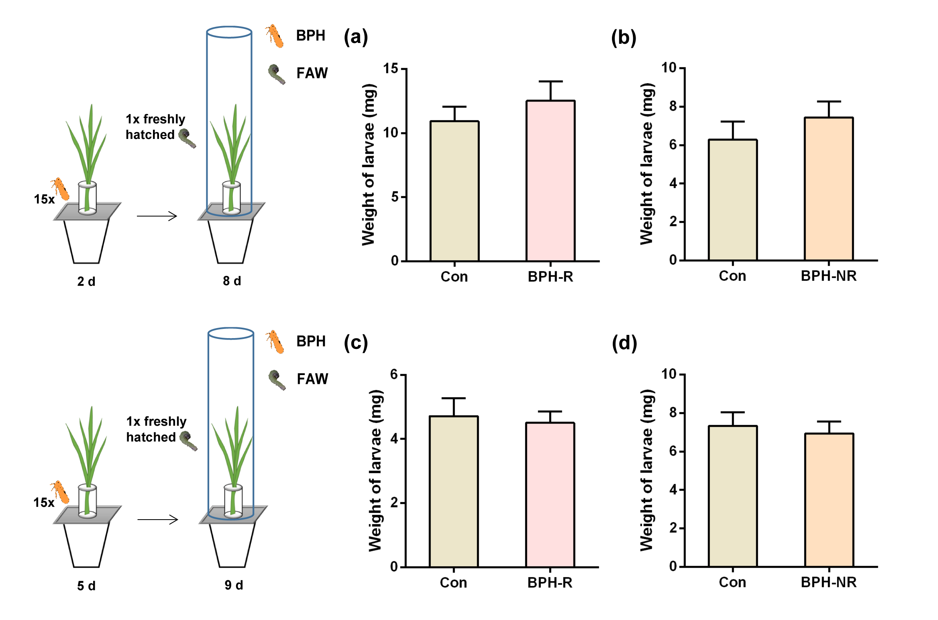

Figure S3. Pre-infestation of gravid BPH females on rice plants does not influence the growth of FAW larvae. Insets, schematic representations of the experimental design.
(a, b) Mean mass of individual FAW newly hatched larvae (+SE) 8 d after they fed on non-infested plants (Con) or plants that had been pre-infested by 15 gravid BPH females for 2 d, after which the BPHs had been removed (BPH-R) (a, n=12-14) or not removed (BPH-NR) (b, n=12-13); (c, d) Mean mass of individual FAW newly hatched larvae (+SE, n=21-28) 9 d after they fed on non-infested plants (Con) or plants that had been pre-infested by 15 gravid BPH females for 5 d, after which the BPHs had been removed (BPH-R) (c, n=21-28) or not removed (BPH-NR)(d, n=12-22).

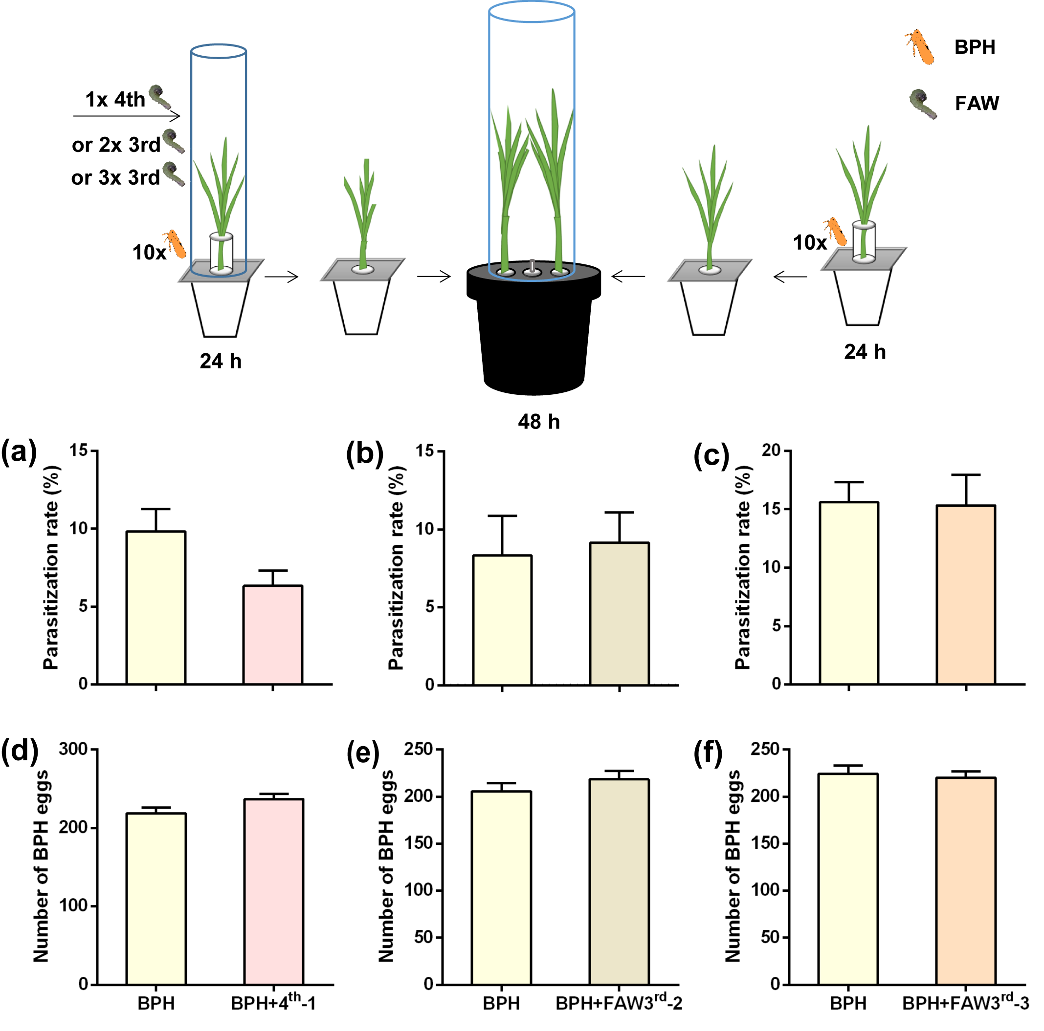

Figure S4. Effect of FAW larvae infestation on the attractiveness of BPH-infested plants to the parasitoid Anagrus nilaparvatae.
(a-c) Mean parasitism rate of BPH eggs (+SE ; a & b, n=15; c, n=19) by A. nilaparvatae on plants that had been infested with 10 gravid BPH females for 24 h and plants that had been co-infested with 10 gravid BPH females and one 4th-instar FAW larva (FAW4th-1) (a), two 3rd-instar FAW larvae (FAW3rd-2) (b) or three 3rd-instar FAW larvae (FAW3rd-3) (c) for 24 h. (d-f) Mean number of BPH eggs (+SE; d & e, n=15; f, n=19) laid by gravid BPH females on plants that had been infested with 10 gravid BPH females for 24 h and plants that had been co-infested with 10 gravid BPH females and one 4th-instar FAW larva (FAW4th-1) (d), two 3rd-instar FAW larvae (FAW3rd-2) (e) or three 3rd-instar FAW larvae (FAW3rd-3) (f) for 24 h. Upper inset, schematic representation of the experimental design.

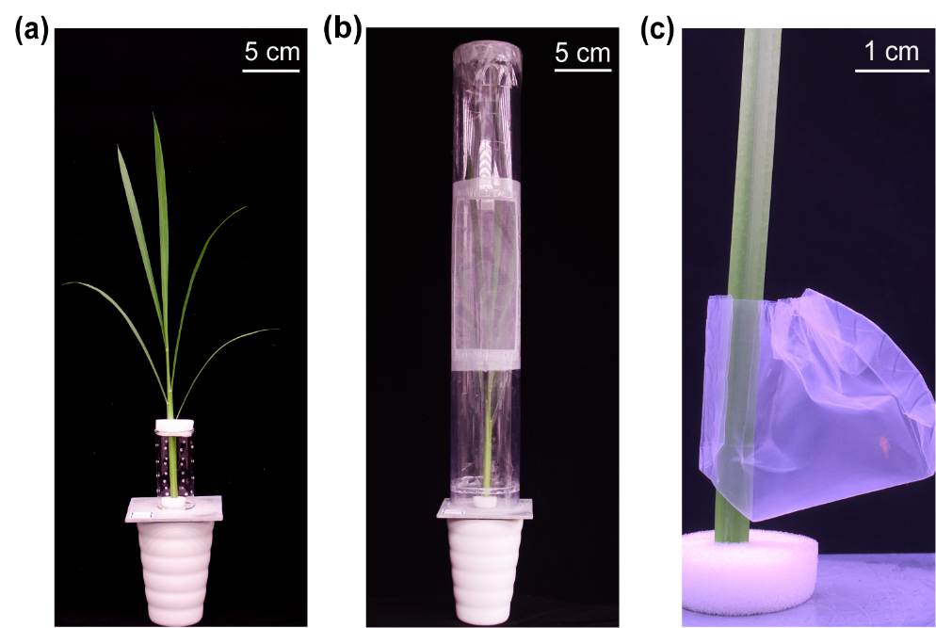
Figure S5. The experimental setup for BPH infestation (a), FAW infestation (b) and BPH honeydew excretion (c).

Table S1. Student’s t-test analysis with data from figures in supporting information
Figure | Parameter |  | t | df | P value
Figure S1a | Honeydew | 1 d | 0.07461 | 48 | 0.9408
 |  | 2 d | 0.0700 | 44 | 0.4876
 |  | 3 d | 0.1413 | 46 | 0.8883
Figure S1b | Number of BPH eggs | 1 d | 0.8082 | 47 | 0.4230
 |  | 4 d | 0.04185 | 40 | 0.9668
Figure S1c | Developmental duration of BPH nymphs | female | 0.1469 | 15 | 0.8852
 |  | male | 0.6521 | 15 | 0.5242
Figure S2a | Number of BPH eggs |  | 0.1676 | 17 | 0.8689
Figure S2b | Developmental duration of BPH eggs |  | 0.2633 | 17 | 0.7954
Figure S2c | Hatching rate of BPH eggs |  | 0.1045 | 17 | 0.9180
Figure S3a | Weight of larvae |  | 0.8468 | 24 | 0.4054
Figure S3b | Weight of larvae |  | 0.8963 | 23 | 0.3794
Figure S3c | Weight of larvae |  | 0.3705 | 32 | 0.7134
Figure S3d | Weight of larvae |  | 0.3355 | 47 | 0.7387
Figure S4a | Parasitization rate |  | 1.975 | 28 | 0.0582
Figure S4b | Parasitization rate |  | 0.2616 | 28 | 0.7955
Figure S4c | Parasitization rate |  | 0.08505 | 36 | 0.9327
Figure S4d | Number of BPH eggs |  | 1.829 | 28 | 0.0781
Figure S4e | Number of BPH eggs |  | 1.015 | 28 | 0.3188
Figure S4f | Number of BPH eggs |  | 0.4030 | 36 | 0.6893

Table S2. Student’s t-test analysis with data from Figure 1
Figure | Parameter | t | df | P value
Figure 1a | Developmental duration of BPH eggs | 0.5253 | 17 | 0.6061
Figure 1b | Hatching rate of BPH eggs | 1.180 | 17 | 0.2544
Figure 1c | Number of BPH eggs | 1.025 | 17 | 0.3196

Table S3. Analysis of variance with data from Figure 1
Figure | Parameter | F | df | P value
Figure 1d | Developmental duration of BPH eggs | 5.814 | 2, 26 | 0.0082
Figure 1e | Hatching rate of BPH eggs | 0.8744 | 2, 26 | 0.4290
Figure 1f | Number of BPH eggs | 0.07442 | 2, 26 | 0.9285

Table S4. Student’s t-test analysis with data from Figure 2
Figure | Parameter |  | t | df | P value
Figure 2a | Weight of larvae |  | 3.8756 | 51 | 0.0003
Figure 2b | Inceased percentage of mass of individual larvae | 1 d | 2.372 | 42 | 0.0224
 |  | 3 d | 12.02 | 39 | <0.0001
Figure 2c | Number of BPH eggs |  | 6.330 | 58 | <0.0001
Figure 2d | Inceased percentage of mass of individual larvae | 2 d | 2.523 | 56 | 0.0145
 |  | 3 d | 2.991 | 56 | 0.0041

Table S5. Student’s t-test analysis with data from Figure 3
Compounds |  | t | df | P value
JA | 1 d | 1.061 | 7 | 0.3241
 | 3 d | 1.564 | 8 | 0.1563
 | 5 d | 0.5392 | 8 | 0.6044
 | 7 d | 1.074 | 8 | 0.3143
JA-ILe | 1 d | 0.5772 | 7 | 0.5819
 | 3 d | 3.085 | 8 | 0.0150
 | 5 d | 0.2407 | 8 | 0.8158
 | 7 d | 1.114 | 8 | 0.2976
SA | 1 d | 1.707 | 7 | 0.1315
 | 3 d | 1.045 | 8 | 0.3264
 | 5 d | 0.6932 | 8 | 0.5078
 | 7 d | 1.766 | 8 | 0.1155
ABA | 1 d | 0.5090 | 7 | 0.6264
 | 3 d | 2.982 | 8 | 0.0175
 | 5 d | 1.483 | 8 | 0.1765
 | 7 d | 0.9744 | 8 | 0.3584
H₂O₂ | 1 d | 0.2947 | 8 | 0.7757
 | 3 d | 1.322 | 8 | 0.2227
 | 5 d | 0.5505 | 8 | 0.5970
 | 7 d | 0.1938 | 8 | 0.8512

Table S6. Student’s t-test analysis with data from Figure 4
Compounds |  | t | df | P value
N-feruloylputrescine | 1 d | 2.591 | 9 | 0.0291
 | 3 d | 0.3461 | 9 | 0.7372
 | 5 d | 1.186 | 10 | 0.2630
 | 7 d | 1.001 | 10 | 0.3405
luteolin | 1 d | 2.313 | 9 | 0.0460
 | 3 d | 1.897 | 9 | 0.0904
 | 5 d | 0.3899 | 10 | 0.7048
 | 7 d | 5.308 | 10 | 0.0003
asrtagalin | 1 d | 2.594 | 9 | 0.0290
 | 3 d | 1.108 | 9 | 0.2968
 | 5 d | 0.6745 | 10 | 0.5153
 | 7 d | 3.905 | 10 | 0.0029
luteolin 7-O-glucoside | 1 d | 2.542 | 9 | 0.0316
 | 3 d | 1.010 | 9 | 0.3388
 | 5 d | 0.9921 | 10 | 0.3445
 | 7 d | 3.057 | 10 | 0.0121
schaftoside+isoschaftoside | 1 d | 5.301 | 9 | 0.0005
 | 3 d | 0.5253 | 9 | 0.6120
 | 5 d | 1.410 | 10 | 0.1888
 | 7 d | 1.178 | 10 | 0.2662

Table S7. Mean levels (+SE, n=5~6) of other phenolamides in rice plants that had been infested with 10 gravid BPH females for 24 h, after which the BPHs had been removed; levels measured 1, 3, 5 and 7 d after plants had been individually infested with either three 2nd-instar FAW larvae (BPH+FAW) or no FAW larvae (BPH)
 |  | 1d |  | 3d |  | 5d |  | 7d
No. | Compounds (ng/g) | BPH | BPH+FAW | BPH | BPH+FAW | BPH | BPH+FAW | BPH | BPH+FAW
1 | Cinnamyl putrescine | 2.406 ± 0.9023 | 1.622 ± 0.2873 | 0.9260 ± 0.07708 | 1.271 ± 0.1926 | 0.8753 ± 0.1167 | 0.8257 ± 0.07191 | 0.6377 ± 0.09556 | 0.8122 ± 0.08717
2 | P-coumaryl putrescine | 715.6 ± 104.6 | 526.1 ± 18.55 | 316.7 ± 28.30 | 352.5 ± 64.07 | 234.7 ± 29.56 | 200.1 ± 14.90 | 104.5 ± 22.80 | 266.5 ± 90.19
3 | P-coumarylguanbutylamine | 35.46 ± 1.952 | 44.26 ± 6.132 | 28.92 ± 2.740 | 32.01 ± 5.260 | 26.65 ± 3.247 | 20.08 ± 0.8487 | 20.08 ± 0.8586 | 34.68 ± 8.088
4 | Myrosinyl putrescine | 27.29 ± 7.684 | 25.39 ± 4.266 | 47.07 ± 9.982 | 47.61 ± 4.332 | 45.21 ± 5.863 | 63.23 ± 16.86 | 98.07 ± 20.36 | 72.58 ± 22.51
5 | Feruloylagmatine | 7.171 ± 0.7346 | 7.335 ± 0.8474 | 6.407 ± 0.4706 | 6.888 ± 0.5885 | 7.095 ± 1.052 | 4.994 ± 0.2212 | 5.460 ± 0.5562 | 6.923 ± 0.9817
6 | Feruloyltyramine | 8.287 ± 2.844 | 4.096 ± 0.8196 | 0.4436 ± 0.08006 | 0.5355 ± 0.03418 | 0.4029 ± 0.06166 | 0.4038 ± 0.1244 | 0.1585 ± 0.03638 | 1.123 ± 0.7530
7 | Dicoumarimide | 0.03126 ± 0.001673 | 0.03137 ± 0.001139 | 0.03248 ± 0.003125 | 0.03362 ± 0.002284 | 0.02971 ± 0.001168 | 0.03026 ± 0.0009077 | 0.02853 ± 0.0005904 | 0.02803 ± 0.0001852
8 | Diferulimide | 114.0 ± 40.80 | 127.0 ± 36.08 | 230.4 ± 50.42 | 302.7 ± 49.89 | 146.1 ± 38.88 | 389.8 ± 219.7 | 185.6 ± 53.04 | 285.6 ± 43.27

Table S8. Mean levels (+SE, n=5~6) of other flavonoids in rice plants that had been infested with 10 gravid BPH females for 24 h, after which the BPHs had been removed; levels measured 1, 3, 5 and 7 d after plants had been individually infested with either three 2nd-instar FAW larvae (BPH+FAW) or no FAW larvae (BPH).
 |  | 1d |  | 3d |  | 5d |  | 7d
No. | Compounds (ng/g) | BPH | BPH+FAW | BPH | BPH+FAW | BPH | BPH+FAW | BPH | BPH+FAW
1 | Cosmosiin | 15.71 ± 2.254 | 15.05 ± 1.585 | 10.46 ± 1.194 | 9.915 ± 0.8753 | 8.926 ± 0.4674 | 8.041 ± 0.6055 | 7.116 ± 0.3972 | 6.198 ± 0.6545
2 | Isovitexin | 5.710 ± 0.6574 | 6.567 ± 0.6014 | 5.392 ± 0.4986 | 5.041 ± 0.3118 | 4.294 ± 0.3003 | 4.320 ± 0.2999 | 3.334 ± 0.1617 | 3.283 ± 0.1782
3 | Prunin | 7.458 ± 0.9341 | 5.225 ± 0.5657 | 4.458 ± 0.2446 | 4.143 ± 0.5099 | 3.459 ± 0.1914 | 2.992 ± 0.3674 | 2.387 ± 0.2308 | 2.312 ± 0.2199
4 | Isoquercitrin | 1.820 ± 0.3011 | 2.150 ± 0.2230 | 1.943 ± 0.1811 | 1.700 ± 0.1575 | 1.679 ± 0.08957 | 1.583 ± 0.1616 | 1.322 ± 0.06077 | 1.153 ± 0.08415
5 | Neoschaftoside | 0.2504 ± 0.03500 | 0.2828 ± 0.04805 | 0.1408 ± 0.01852 | 0.1172 ± 0.01470 | 0.1266 ± 0.01462 | 0.1165 ± 0.007548 | 0.08307 ± 0.005845 | 0.07611 ± 0.01867
6 | Carlinoside | 4.848 ± 0.6683 | 4.286 ± 0.6634 | 2.465 ± 0.1562 | 1.628 ± 0.3891 | 1.519 ± 0.3141 | 1.823 ± 0.1101 | 3.149 ± 0.8618 | 3.211 ± 1.211
7 | Rutin | 16.35 ± 2.410 | 17.88 ± 1.178 | 14.90 ± 0.9853 | 13.27 ± 0.9147 | 12.02 ± 0.6208 | 11.38 ± 1.459 | 10.09 ± 0.6204 | 10.18 ± 1.345

Table S9. Student’s t-test analysis with data from Table S7
Compounds |  | t | df | P value
Cinnamyl putrescine | 1 d | 0.7726 | 9 | 0.4596
 | 3 d | 1.539 | 9 | 0.1581
 | 5 d | 0.3691 | 10 | 0.7250
 | 7 d | 1.349 | 10 | 0.2070
P-coumaryl putrescine | 1 d | 1.962 | 9 | 0.0814
 | 3 d | 0.4754 | 9 | 0.6458
 | 5 d | 1.047 | 10 | 0.3200
 | 7 d | 2.2037 | 10 | 0.0521
P-coumarylguanbutylamine | 1 d | 1.0700 | 9 | 0.3125
 | 3 d | 0.4887 | 9 | 0.6367
 | 5 d | 1.959 | 10 | 0.0785
 | 7 d | 1.794 | 10 | 0.1030
Myrosinyl putrescine | 1 d | 0.2265 | 9 | 0.8259
 | 3 d | 0.05301 | 9 | 0.9589
 | 5 d | 0.8586 | 10 | 0.4107
 | 7 d | 0.8401 | 10 | 0.4205
Feruloylagmatine | 1 d | 0.1432 | 9 | 0.8893
 | 3 d | 0.6193 | 9 | 0.5511
 | 5 d | 1.953 | 10 | 0.0794
 | 7 d | 1.296 | 10 | 0.2239
Feruloyltyramine | 1 d | 1.539 | 9 | 0.1581
 | 3 d | 1.127 | 9 | 0.2890
 | 5 d | 0.006389 | 10 | 0.9950
 | 7 d | 2.1202 | 10 | 0.0600
Dicoumarimide | 1 d | 0.06016 | 9 | 0.9533
 | 3 d | 0.3024 | 9 | 0.7692
 | 5 d | 0.3683 | 10 | 0.7203
 | 7 d | 0.8197 | 10 | 0.4315
Diferulimide | 1 d | 0.2396 | 9 | 0.8160
 | 3 d | 1.011 | 9 | 0.3383
 | 5 d | 1.0387 | 10 | 0.3234
 | 7 d | 1.460 | 10 | 0.1749

Table S10. Student’s t-test analysis with data from Table S8
Compounds |  | t | df | P value
Cosmosiin | 1 d | 0.2471 | 9 | 0.8103
 | 3 d | 0.3767 | 9 | 0.7151
 | 5 d | 1.157 | 10 | 0.2740
 | 7 d | 1.199 | 10 | 0.2582
Isovitexin | 1 d | 0.9266 | 9 | 0.3611
 | 3 d | 0.6184 | 9 | 0.5516
 | 5 d | 0.06132 | 10 | 0.9523
 | 7 d | 0.2119 | 10 | 0.8364
Prunin | 1 d | 2.127 | 9 | 0.0623
 | 3 d | 0.5207 | 9 | 0.6152
 | 5 d | 1.127 | 10 | 0.2861
 | 7 d | 0.2355 | 10 | 0.8186
Isoquercitrin | 1 d | 0.8988 | 9 | 0.3922
 | 3 d | 1.017 | 9 | 0.3359
 | 5 d | 0.5225 | 10 | 0.6127
 | 7 d | 1.622 | 10 | 0.1358
Neoschaftoside | 1 d | 0.5248 | 9 | 0.6124
 | 3 d | 1.013 | 9 | 0.3373
 | 5 d | 0.6186 | 10 | 0.5500
 | 7 d | 0.3556 | 10 | 0.7295
Carlinoside | 1 d | 0.5922 | 9 | 0.5683
 | 3 d | 1.848 | 9 | 0.0977
 | 5 d | 0.8439 | 9 | 0.4206
 | 7 d | 0.05197 | 10 | 0.9596
Rutin | 1 d | 0.6028 | 9 | 0.5615
 | 3 d | 1.210 | 9 | 0.2571
 | 5 d | 0.4059 | 10 | 0.6974
 | 7 d | 0.05743 | 10 | 0.9553

