**Supporting information**

Fe3C Decorated Folic Acid-Derived Graphene-Like Carbon as Polysulfide Catalyst for High-Performance Lithium-Sulfur Battery

Zenghui Lin†, Junan Feng†, Wendong Liu, Lu Yin, Wanyang Chen, Chuan Shi, Jianjun Song*

College of Physics, Qingdao University, Qingdao 266071, Shandong, China.

*Correspondence: jianjun.song@qdu.edu.cn

† These authors contributed equally to this work.

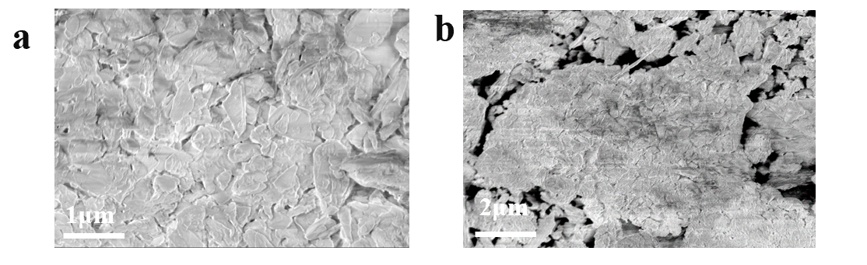

**Figure S1.** SEM images of folic acid

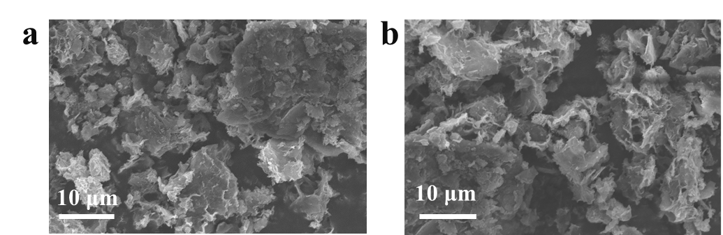

**Figure S2.** SEM images of N-CS

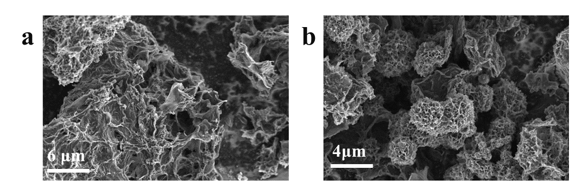

**Figure S3.** SEM images of Fe3C@N-CS

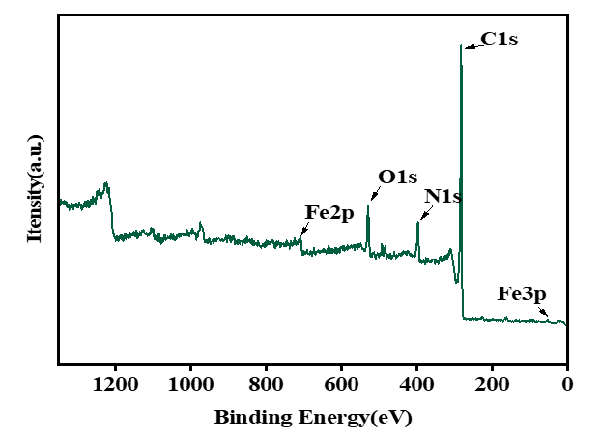

**Figure S4.** XPS spectrum of Fe3C@N-CS



**Figure S5.** Long cycle performance of Li-S battery with Fe3C@N-CS modified separator at 1 C

**Figure S6.** Galvanostatic charge/discharge profiles of Li-S battery with Fe3C@N-CS modified separator at 1 C.

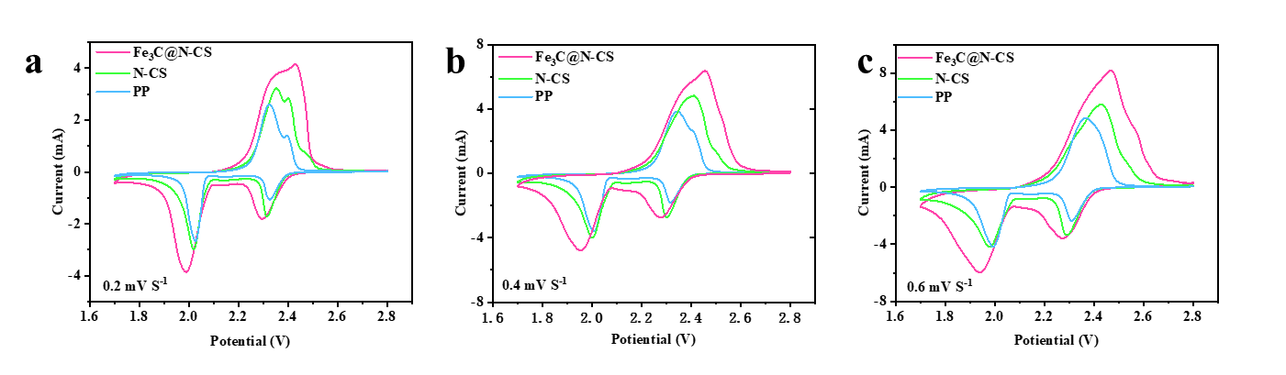

**Figure S7.** CV curves of Li-S battery with Fe3C@N-CS, N-CS, and PP separators at 0.2 mV s-1 (a), 0.4 mV s-1 (b), and 0.6 mV s-1 (c)