Supplementary Material

Chemical Identification of Secondary Metabolites from Rhizospheric Actinomycetes Using LC-MS Analysis: In Silico Antifungal Evaluation and Growth-Promoting Effects
Hazem S. Elshafie ¹, Laura De Martino ², Carmen Formisano ³, Lucia Caputo ², Vincenzo De Feo ², Ippolito Camele ^{1,*}
¹ School of Agricultural, Forestry, Food and Environmental Sciences, University of Basilicata,
85100 Potenza, Italy; hazem.elshafie@unibas.it (H.S.E.)
² Department of Pharmacy, University of Salerno, Via Giovanni Paolo II 132, 84084 Fisciano, Salerno, Italy; ldemartino@unisa.it (L.D.M.); lcaputo@unisa.it (L.C.); defeo@unisa.it (V.D.F.)
³ Department of Pharmacy, School of Medicine and Surgery, University of Naples Federico II, Via Montesano 49, 80131 Naples, Italy; carmen.formisano2@unina.it (C.F.)

* Correspondence: ippolito.camele@unibas.it (I.C.); Tel.: +39-0971-205544; Fax: +39-0971-205503

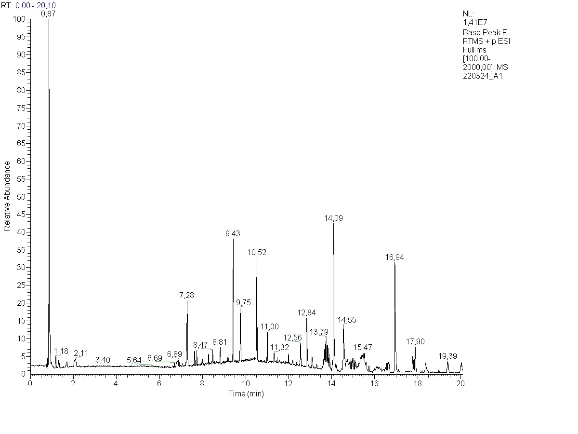
Figure S1. LC-MS chromatogram of the metabolites extract from Streptomyces spp. (Act11).

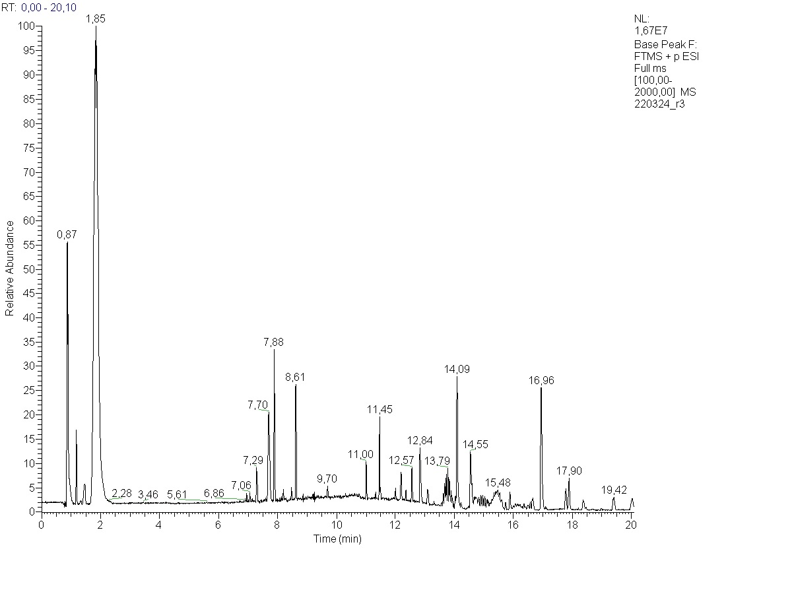
Figure S2. LC-MS chromatogram of the metabolites extract from S. atratus (Act2).

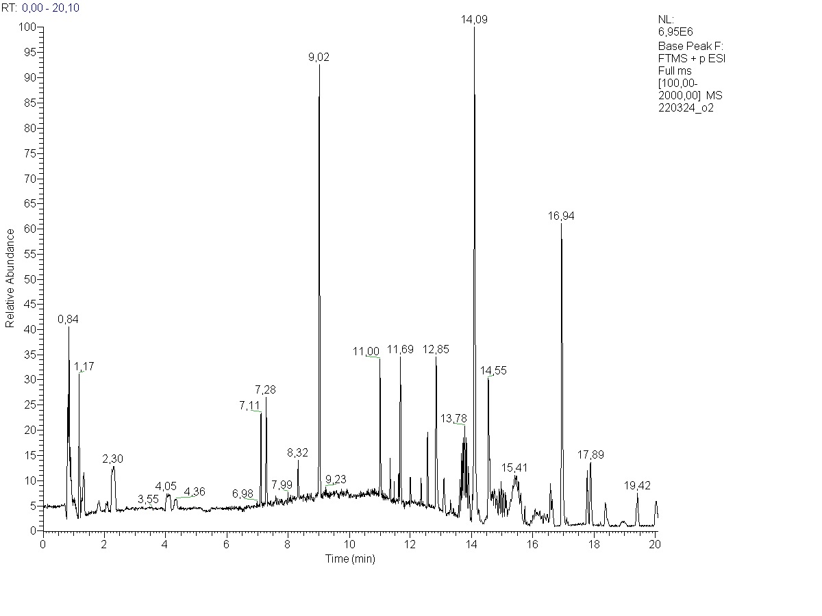
Figure S3. LC-MS chromatogram of the metabolites extract from A. humicola (Act3).

