Distribution and Nest Occupancy Patterns of Oecophylla smaragdina (Hymenoptera: Formicidae) Colonies in Oil Palm Plantations

Moïse Piere Exélis, Rosli Ramli, Azarae Hj Idris, Rabha Wael Ibrahim, Gemma Clemente-Orta

Supplementary Materials
Table 1. Occupied-unoccupied oil palm plantations by Asian weaver ant colonies in Malaysia.
Plantations | Zones* | Coordinates | Size (ha) | Observation dates
Felda Alor Setar | NP, Perlis-Kedah | Combined data | 16,884.18 | 2019
Felda Bukit Merah | NP, NW Perlis | 6°33’36”N 100°21’05”E | 100 | December 2015
Felda Bukit Kayu Hitam | NP, Kedah | 6°31’49”N 100°24’21”E | 123 | March 2014
Ladang Sungai Seraya | Kedah | 6°23’39”N 100°42’06”E | 255 | March 2014
Sime Darby Kuala Kurau | NP, Perak | 4°59’08”N 100°26’57”E | 2035 | May 2014
Ladang Kg Kalai | EP, Kelantan | 5°47’29”N 101°45’08”E | 1008 | July 2014
Felda Pantai Timur | EP, Terengganu | Combined data | 35,058.37 | 2011-2012
Felda Kuala Berang | EP, Terengganu | 5°04’13”N 103°05’32”E | 3234 | September 2014
Felda Belara Jerangau | EP, Terengganu | 5°04’13”N 103°05’32”E | 1250 | November 2014
TDM Berhad | EP, Terengganu | 4°52’58”N 103°14’01”E | 3050 | February 2015
Felda Sungai Besar | EP, Pahang | 3°18’28”N 103°21’57”E | 2067 | April 2015
FGV Bera Selatan 3 | EP, Pahang | 2°54’10”N 102°41’23”E | 1125 | June 2019
*Felda Keratong | EP, Pahang | 3°08’23”N  101°44’55” | >50,000 (absence) | April-May 2022
MPOB Teluk Intan | NP, Perak | 3°49’03”N 100°58’52”E | 600 | 2010-2014  2015  2020-2021
Felcra Teluk Intan | NP, Perak |  | 1025 | 2010-2014
SPP Teluk Intan | NP, Perak |  | 2035 | 2010-2014
UPP Sabak Bernam | CP to N, Selangor |  | >3000 | 2010-2014
Ladang Sungai Buloh | CP, Selangor | 3°09’40”N 101°27’40”E | 1027 | 2012  2018-2021
Ladang Kapar | CP, Selangor |  | 600 | 2014
Risda Alor Gajah | SP, Malacca | 2°21’59”N 102°13’30”E | 700 | 2015
Kebung Baru Kupuk | SP, Pontian Johor | 1°19’21”N 103°26’57”E | - | 2015
Kebung Tanjung Piai | SP, Johor | 1°16’30”N 103°30’41”E | 400 | 2015
Tanjung Sepang | SP, Johor | 1°22’35”N 104°16’49”E | 1000 | 2015
Desaru | SP, Johor | 1°27’03”N 104°17’15”E | 540 | 2015
Sawit Siang | SP, Johor | 1°39’45”N 104°13’00”E | >500 | 2015
Mados Sedili | SP, Johor | 1°43’46”N 104°09’15”E | 1000 | 2016
Pasir Logok | SP, Johor | (2°02’02”N 104°02’50”E | 1000 | 2016
Felda Tenggaroh Timur 2 | SP, Johor | 2°08’05”N 104°00’15”E | 1267 | 2016
Mersing | SP, Johor | 2°21’01”N 103°54’20”E | 2005 | 2014
Felda Gunung Besout | NP, Perak | 3°50’30” 101°18’08”E | >50,000 | 2019-2022
Felda Palong 16 | CP, Negeri Sembilan | 2°53’58”N 102°37’20”E | 1300 | 2021
Risda Palong | CP, Negeri Sembilan | 2°53’04”N 102°34’09”E | >1000 | 2021
Felda Pasir Besar Gemas | CP to SP, Negeri Sembilan | 2°39’02”N 102°34’12”E | >3000 | 2021
Felda Bukit Rokan Gemencheh | CP, Negeri Sembilan | 2°35’11”N 102°24’03”E | >2000 | 2021
Felcra Berhad Bukit Jelai | CP, Negeri Sembilan | 2°37’51”N 102°31’41”E | >1000 | 2021
Felda Sungai Kelamah | CP, Negeri Sembilan | 2°34’45”N 102°30’17”E | >1000 | 2021
MPOB, Lahad Datu | MB, Sabah | 5°01'48"N 118°25'02"E | 1000  (high abundance ) | June-July 2012  2013  December 2019
IOI Corporation Lahad Datu | MB, Sabah | 5°02’32”N 118°19’14”E | >30000 (High abundance) | 2012  2013
MPOB, Saratok | MB, Sarawak | 1°44'44"N 111°19’00"E | 1000 (High abundance) | July-August 2012
MARDI Saratok | MB, Sarawak | 1°55’11”N 111°13’41”E | 1000 | 2012
Marmahal | MB, Sabah | 6°34’04”N 117°30’29”E | >5000 | Personal communication
IJM Sabang | MB, Sabah | 6°22’12”N 117°29’32”E | >5000 | Personal communication
Felda Sahabat Tambisan | MB, Sabah | 5°27’32”N 119°08’30”E | 12,721.42 | Personal communication
FGV Indera Bakti | MB, Sabah | 5°25’39”N 119°04’53”E | >10,000 | Personal communication
Kampung Dundulit | MB, Sabah | 6°59’28”N 117°09’41”E | >10,000 | Personal communication
Ladang Boustead Sandakan | MB, Sabah | 5°54’18”N 117°50’51”E | >20,000 | Personal communication
THP Bukit Belian Estate | MB, Sabah | 5°42’01”N 117°50’20”E | > | Personal communication
Sime Darby Tawau | MB, Sabah | 4°20’03”N 117°49’35”E | >30,000 | Personal communication
Top Victory plantations Sdn.Bhd | MB, Kudat Sabah | 6°49’12”N 117°50’51”E | >20,000 | Personal communication
Felda Trolak | Perak –Selangor | Combined data | 37,219.19 | 2019-2020
Felda Raja Alias | CP, Negeri Sembilan | Combined data | 76,590.56 | 2022
Felda Kuantan | EP, Pahang | Combined data | 69,750.95 | 2020-2021
Felda Jengka | EP, Pahang | Combined data | 69,684.65 | 2019
Felda Mengapa | EP, Pahang |  | 63,577.04 | 2019
Felda Johor Bahru | SP, Johor | Combined data | 79.023.74 | 2019
Felda Segamat | SP, Melacca-Johor | Combined data | 50,884.14 | 2019
Felda Gua Musang | EP, Kelantan | Combined data | 17,092.15 | 2019
Felcra Kuala Pilah | SP, Negeri Sembilan | Combined data | >15,000 | 2022
Pekan Bandar Di Raja | EP, Pahang | Combined data  3°30’5”N 103°22’9”E | Urban & plantations | 10/01-21/02/2023
Ladang Lampung Metro Barat | Lampung Indonesia | 2°56’11”N 101°40’43”E | Isolated patches | 23/08-10/10/2023
Astra Agro Lestari | Kalimantan Centre, Indonesia | 2°23'10.2"S 111°47'57.7"E | 5, 352 | 1/10-3/10/2023
*O. smaragdina colonies were absent from the large plantations. Colonies occupied alternative host plants beside the plantations described in supplemental table 5.

Table 2. Occupancy study in selected oil palm fields.

*Plantations | Zone | Coordinates | Size (ha) | Observation periods
MPOB Teluk Intan | NP. Perak | 3°49’03”N 100°58’52”E | 600 | 2010-2015  2020-2021
UM plantations Sdn.Bhd Sg Ara | SP. Johor | 2°01'40'' N 103°5155” E | 400 | 2012-2015  2019
Felcra Berhad Sg Ara | SP. Johor | 2°01’47”N 103°51’43”E | 1000 | 2012-2015  2019
Boustead Ladang Teluk Sengat | SP. Ayer Tawar Johor | 1°34’09”N 104°02’15”E | 1000 | 2012-2015  2019
Ladang Sungai Buloh | CP. Selangor | 3°09’40”N 101°27’40”E | ±450 | 2018-2020
MPOB Lahad Datu | MB. Sabah | 5°01'48"N 118°25'02"E | 1000 | 2012-2014  2019
MPOB Saratok | MB. Sarawak | 1°44'44"N 111°19’00"E | 1000 | 2012
Felda Gunung Besout | NP. Perak | 3°50’30” 101°18’08”E | 1064.53 | 2020-2022
*O. smaragdina colonies were highly abundant with a dense nesting presence except for Felda Gunung Besout Perak.

Table 3. Colony growth development stage status.
Some definitions for (i) incipient, (ii) immature, (iii) pre-matured, (iv) matured Oecophylla smaragdina colonies:
An incipient is an embryonic colony identified as occupying only 1 palm within 1 to 3 months. The term immature is an innovative description to distinguish among the four determined growth of development stage of the Asian weaver ant. Pre-matured refers to the colonies newly reproductive emergence since the first release corresponding to a not yet acquired population dynamic stability. The matured colony is above 3 years of age with a notified stable population dynamic suitable for manipulation i.e. nest capture and translocation to unoccupied plantation blocks in the case of a sudden defoliator’s infestation outbreak.
Colony status | Range Age (month) | Occupied palm | Nest range number | References
Incipient | 1-3 | 1 | 1 | Hölldobler & Wilson, 1990
Immature | 4-16 | 3-5 | ≥ 2-15 | NA*
Pre-matured | 18-24 | 6-10 | ≥ 15-30 | Peng et al., 1998a; Peng et al., 2013
Matured | 36 | 8-21 | 38-149 | Offenberg et al., 2013; Exélis, 2015
*NA: not available
Table 4. Colonies nests distribution patterns in relation to growth maturity status.

Colonies Matured¹ Pre-matured Immature-Incipient
Type
Colonies | *Nest/Palm  distribution | Age | Total Nests | Occu-  Palms | Nest/Palm  distribution | Age | Total Nests | Occu-  Palms | Nest/Palm  distribution | Age | Total Nests | Occu-  Palms
1* | 1/3/5/7/13 | 39 | 53 | 12 | 1/3/5 | 11 | 14 | 4 | 1 | 3 | 3 | 1
2** | 3/5/7/11/15 | 63 | 101 | 15 | 2/3/5/7 | 24 | 30 | 6 | 1/3/3 | 6 | 7 | 3
3 | 1/3/5/7 | 39 | 50 | 12 | 1/3/5 | 11 | 15 | 5 | 1 | 1 | 1 | 1
4 | 1/3/5/7 | 34 | 44 | 12 | 1/3/5 | 12 | 17 | 5 | 1/2 | 4 | 3 | 2
5 | 1/3/5/7 | 38 | 50 | 12 | 1/3/5 | 13 | 17 | 5 | 1 | 1 | 1 | 1
6 | 1/3/5/7 | 36 | 48 | 12 | 3/5 | 9 | 11 | 3 | 1 | 1 | 1 | 1
7 | 1/3/5/7 | 41 | 50 | 12 | 3/5 | 8 | 11 | 3 | 2 | 3 | 2 | 1
8 | 1/3/5/7/9/11 | 49 | 77 | 15 | 1/3/5 | 17 | 23 | 7 | 1/2 | 4 | 3 | 2
9 | 1/3/5/7/9/13 | 47 | 69 | 15 | 1/3/5 | 14 | 19 | 6 | 2/2 | 6 | 4 | 2
Total | - | 386 | 542 | 117 | - |  | 157 | 44 | - | - | 25 | 14
Mean | 1/3/5/7 dominant | 43 | 60.2 | 13 | 1/3/5  dominant |  | 15.4 | 4.88 | 1 dominant |  | 2.77 | 1.55
*Colony nest distribution in Lahad Datu, Sabah. **Colony from Saratok, Sarawak. 1/3/5/7 represents an example of nest distribution in various palms within the same matured colony. ¹First emergence of sexual forms by an average18- 24 months range. All dataset residuals’ distribution followed a normal distribution by the Shapiro-Wilk test. ¹All ages are expressed in months.

Table 5. Oecophylla colonies host plants association in oil palm plantations.
These below fruiting trees and plants were identified as being among the favorite hosts for the Asian weaver ant colonies. The surveys conducted from January 2018 up to the end of 2022, demonstrated a satisfactory population stability with a high average nest abundance per occupied tree-plant.
Family | Colloquial/local names | Scientific botanical names | Number of trees examined | Average nests per tree
Rutacea¹ | Pomelo/Limau Bali | Citrus maxima | 10 | 3-5
- | Shaddock/Sarawak Pomelo | Citrus grandis | 10 | 3-5
- | Mandarin orange/Limau langkat | Citrus reticulata | 5 | 3-5
- | Lemon/Limau kerat lintang | Citrus medica limonum | 14 | 3-5
- | Key lime/Limau nipis | Citrus aurantiifolia | 30 | 5-9
- | Calamansi-Philippines lime/Limau  Kasturi | Citrofortunella microcarpa | 100 (orchards – isolated trees) – short trees ± 2.5 m | 1-3 (bigger size nests)
Rubiaceae | Akar Berdara Laut | Oxyceros longiflorus (Lam.) | Few | 1
Anacardiaceae | Mango/ Mangga | Mangifera indica | 106 | 5-10
Malvaceae | Cacao/Pokok Koko | Theobroma cacao | BC treatment | Way & Khoo, 1991
Arecaceae | Coconut palm/Kelapa | Cocos nucifera | 45 | 3-7
Clusiaceae | Purple mangosteen/Manggis | Garcinia mangostana | 9 | 3
Meliaceae | Langsat/ Duku | lancium domesticum | 20 | 3
Myrtaceae | Watery rose apple/Jambu air | Syzygium aqueum | 35 | 7-11
Myrtaceae | Java apple/Jambu merah | Syzygium samarangense | 15 | 7-11
Sapindaceae | Hairy lychee/Rambutan | Nephelium lappaceum | 50 | 7-9
Meliaceae | Langsat/Duku manis | Lansium parasiticum | 10 | 3-5
Melastomataceae | Common Sendudok | Melastoma malabathricum L. | Few | 1
Malvaceae | Mallow/Durian | Durio zibethinus | 35 | 5-7
Lauraceae | Ceylon cinnamon/Kayu manis | Cinnamomum iners | 20 | 5-9
Sapotaceae | Bullet wood-Spanish cherry/Bunga tanjung | Mimusops elengi | 20 (tall trees) | 5-9
Euphorbiaceae | Pokok Getah | Hevea braziliensis | Plantation > 100 | 3
²Unidentified plant  species |  | short plants ≤ 2.5 m high | 51 | 1-3 nests monodomous/polydomous
- Acanthaceae³  - Piperaceae  - Melastomataceae  - Melastomataceae | - Chinese violet/Rumput Israel  - Wild pepper/Daun kaduk  - Common Sendudok  - Senduduk | Short plants of various species ≤ 1.5 m high  - Asystasia gangetica  - Piper sarmentosum  - Melastoma malabathricum 'Alba'  - Melastoma malabathricum L. | >100 | Only 1 nest  Monodomous nesting
*All nests were constituted with only young leaves with old leaves nests being abandoned (N=300). ¹Fruits trees ≥ 3 m. ²Short occupied plants (average height ≤ 2.5 m) inside oil palm at close distance of few meters at Felda Gunung Besout Perak. ³These diverse host small size plants species (average height ≤ 1 m) are located at oil palm blocks outskirt within close distance (average 100 m) or inside the plantations.

Table 6. Descriptive analysis of barrack and brood nests of O. smaragdina.
Variable | All nests (26 nests) |  |  | Barrack nest (8 nests) |  |  |  | Brood nest (18 nests)
 | Min | Max | Mean¹ | Min | Max | Mean¹ |  | Min | Max | Mean¹
Number of leaflets | 4 | 29 | 11 ± 6 | 11 | 29 | 16 ± 7ª |  | 5 | 21 | 10 ± 5^{b}
Nest length | 28.0 | 64.0 | 45.9 ± 10.4 | 30.0 | 63.0 | 41.8 ± 12.9ª |  | 30.0 | 60.0 | 46.9 ± 9.6ª
Nest width | 6.0 | 32.0 | 14.6 ± 6.1 | 9.0 | 23.0 | 15.6 ± 6.0ª |  | 7.0 | 30.0 | 14.4 ± 6.2ª
Nest height | 3.0 | 23.0 | 10.8 ± 4.3 | 7.0 | 13.0 | 9.2 ± 2.5ª |  | 2.0 | 23.0 | 11.1 ± 4.5ª
Nest volume | 827.4 | 16621.5 | 4300.7± 3753.2 | 989.6 | 7289.9 | 3661.6 ± 2535.6ª |  | 829.4 | 16618.5 | 4452.8 ± 3998.5ª
Height from the ground | 4.0 | 10.0 | 7.2 ± 2.0 | 4.0 | 4.0 | 4.0 ± 0.0^{b} |  | 6.0 | 10.0 | 8.0 ± 1.3ª
Total workers | 11 | 64761 | 6333 ± 12419 | 11 | 1390 | 708 ± 544ª |  | 43 | 64761 | 7672 ± 13499ª
Number of major workers | 11 | 60873 | 5490 ± 11731 | 11 | 1390 | 706 ± 543ª |  | 43 | 60873 | 6629 ± 12814ª
Number of minor workers | 0 | 3888 | 842 ± 864 | 0 | 6 | 2 ± 3^{b} |  | 0 | 3888 | 1043 ± 846ª
Number of winged queens | 0 | 139 | 18 ± 36 | 0 | 0 | 0 ± 0^{b} |  | 0 | 139 | 22 ± 39ª
Number of worker pupae | 0 | 3650 | 630 ± 876 | 0 | 0 | 0 ± 0^{b} |  | 0 | 3650 | 780 ± 914ª
Number of larvae | 0 | 6509 | 979 ± 1557 | 0 | 0 | 0 ± 0^{b} |  | 0 | 6509 | 1212 ± 1652ª
Egg volume | 0 | 21.2 | 1.4 ± 4.3 | 0 | 0 | 0 ± 0ª |  | 0 | 21.2 | 1.7 ± 4.8ª
Note: ¹Variable with the different superscript alphabet had significantly different mean value at p < 0.05.

Table 7. Normality test of Shapiro-Wilk after dataset transformations and Kaiser-Meyer-Olkin (KMO) value

Variables | KMO value (Average: 0.6039) | p-value of Shapiro-Wilk^{1,2}
 |  | No transformation | Standardize (n-1) | Standardise (n) | Centre | Standard deviation⁻¹ (n-1) | Standard deviation⁻¹ (n) | Pareto | Log
Number of leaflets | 0.6828 | < 0.0001 | < 0.0001 | < 0.0001 | < 0.0001 | < 0.0001 | < 0.0001 | < 0.0001 | 0.0221
Nest length | 0.4375 | 0.0017 | 0.0017 | 0.0017 | 0.0017 | 0.0017 | 0.0017 | 0.0017 | 0.0002
Nest width | 0.4565 | < 0.0001 | < 0.0001 | < 0.0001 | < 0.0001 | < 0.0001 | < 0.0001 | < 0.0001 | 0.0329
Nest height | 0.4697 | 0.0218 | 0.0218 | 0.0218 | 0.0218 | 0.0218 | 0.0218 | 0.0218 | 0.0001
Nest volume | 0.4884 | < 0.0001 | < 0.0001 | < 0.0001 | < 0.0001 | < 0.0001 | < 0.0001 | < 0.0001 | 0.0061
Height from the ground | 0.6369 | 0.0003 | 0.0003 | 0.0003 | 0.0003 | 0.0003 | 0.0003 | 0.0003 | < 0.0001
Total workers | 0.6441 | < 0.0001 | < 0.0001 | < 0.0001 | < 0.0001 | < 0.0001 | < 0.0001 | < 0.0001 | < 0.0001
Number of major workers | 0.6270 | < 0.0001 | < 0.0001 | < 0.0001 | < 0.0001 | < 0.0001 | < 0.0001 | < 0.0001 | 0.0002
Number of minor workers | 0.8642 | < 0.0001 | < 0.0001 | < 0.0001 | < 0.0001 | < 0.0001 | < 0.0001 | < 0.0001 | < 0.0001
Number of winged queens | 0.3988 | < 0.0001 | < 0.0001 | < 0.0001 | < 0.0001 | < 0.0001 | < 0.0001 | < 0.0001 | 0.0044
Number of worker pupae | 0.7263 | < 0.0001 | < 0.0001 | < 0.0001 | < 0.0001 | < 0.0001 | < 0.0001 | < 0.0001 | 0.0024
Number of larvae | 0.7445 | < 0.0001 | < 0.0001 | < 0.0001 | < 0.0001 | < 0.0001 | < 0.0001 | < 0.0001 | 0.0030
Egg volume | 0.5534 | < 0.0001 | < 0.0001 | < 0.0001 | < 0.0001 | < 0.0001 | < 0.0001 | < 0.0001 | 0.0416
Note: ¹Null hypothesis (H₀) = The dataset variables followed a normal distribution and alternative hypothesis (H_{a}) = The dataset variables did not follow a normal distribution.
²Bold p-value indicated p-value < 0.05, thus this study accepted the H_{a}, indicated that the dataset variables did not follow a normal distribution.

Table 8. Correlation matrix for Pearson moment.
Variables | Correlation matrix^{1,2}
 | Total nests per colony |  | Total occupied palm |  | Average colony age³
Total number of nests/colony | 1 |  | 0.831 |  | 0.991
Total number of occupied palms | 0.831 |  | 1 |  | 0.845
Average colony age | 0.991 |  | 0.845 |  | 1
Note: ¹|0.000| < R < |0.300| = weak correlation, |0.300| < R < |0.700| = moderate correlation, and |0.700| < R < |1.000| = strong correlation. ²Values in bold indicated a significant correlation between two variables at α = 0.05. Since the p-value < α, H₀ is rejected. ³Newly unstable matured colony average of 24 months to reach maturity stability by 36 months (3 years). Covariance = 76.5 & 11.05 for nests and occupied palms respectively.
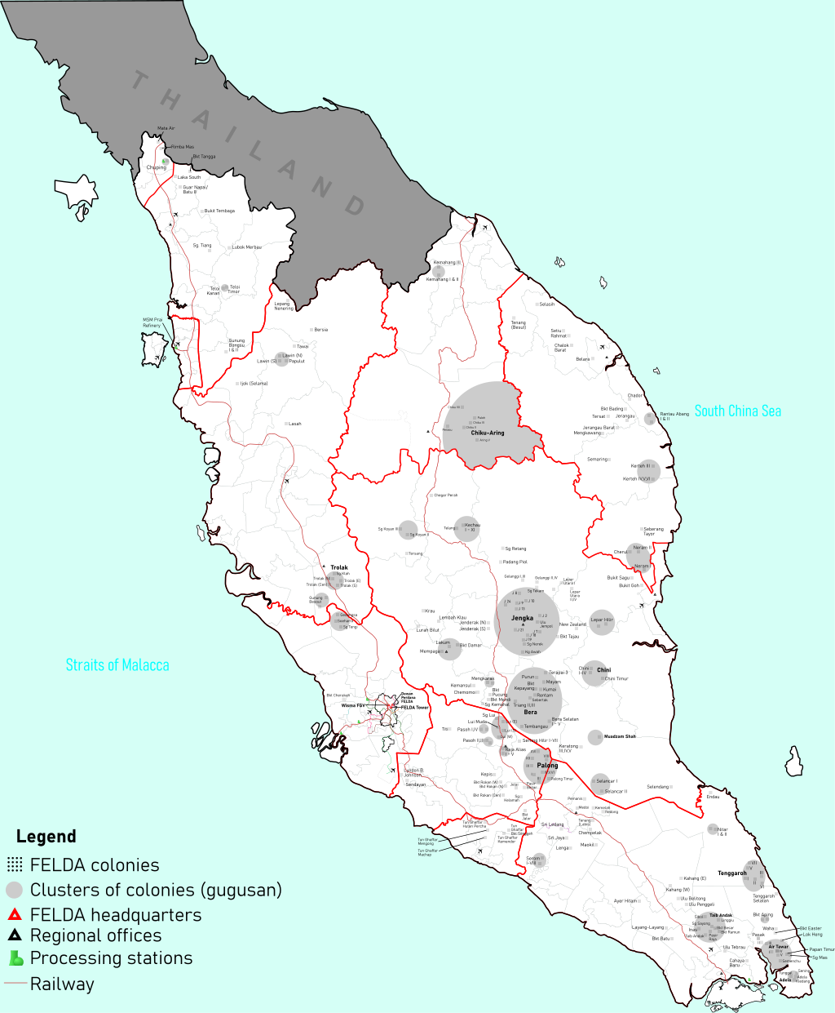
Figure 1 a. Felda map in Peninsular Malaysia. By Derkommander0916 - Karya sendiri, CC BY-SA 4.0. https://commons.wikimedia.org/w/index.php?curid=102743261
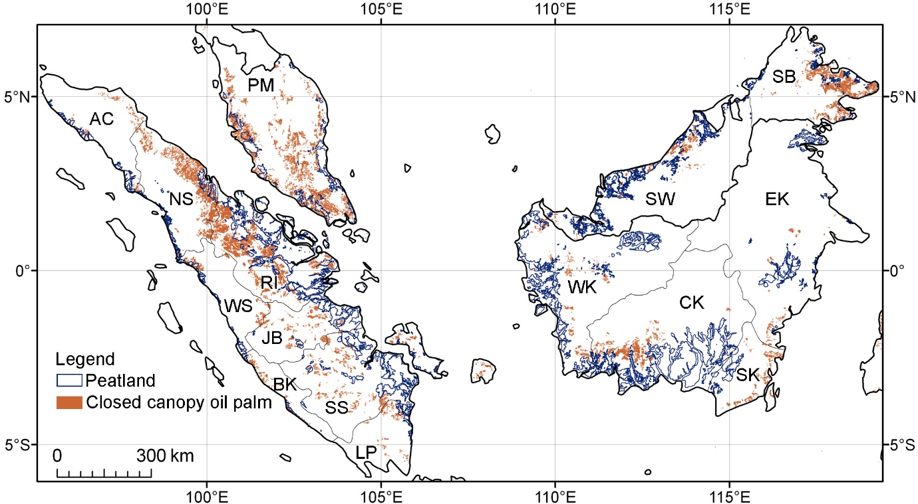
Figure 1 b. Oil palm plantations closed canopy and tropical peat lands distribution.
The distribution covers the lowlands of Peninsular Malaysia (PM), Borneo (SB: Sabah; SW: Sarawak) and Sumatra. Source: Butler, 2011. https://photos.mongabay.com/11/0307Koh_PNAS_Figure1.jpg. https://news.mongabay.com/2011/03/first-large-scale-map-of-oil-palm-plantations-reveals-big-environmental-toll/.

Figure 2: Boxplot of (a) barrack nest and (b) brood nests.

Figure 3. Discriminant analysis centroids graph.

Figure 4 A-C. O. smaragdina nests, palm trees distribution in function of the age in months

