Supplementary Information for:

**Side-Stream Enhanced Biological Phosphorus Removal (S2EBPR) Enables Effective** **Phosphorus Removal in a Pilot-scale Shortcut** **Nitrogen Removal System**

Dongqi Wanga,b,c,1, Il Hanb,1, Kester McCulloughb,d, Stephanie Klausd, Jangho Leeb, Varun Srinivasana,e, Mengbo Huangc, Zijian Leo Wangf, Guangyu Lia,b, Yuan Yanb, Kailong Lic, Lu Qinc, Charles B. Bottd, Jim McQuarrieg, Beverley M. Stinsonh, Christine deBarbadilloi, Paul Dombrowskij, James Barnardk, April Z. Gua,b,*[1]

a Department of Civil and Environmental Engineering, Northeastern University, 360 Huntington Avenue, Boston, MA, 02115, United States

b School of Civil and Environmental Engineering, Cornell University, 220 Hollister Hall, Ithaca, NY, 14853, United States

c Department of Municipal and Environmental Engineering, Xi'an University of Technology, Xi'an, Shaanxi, 710048, China

d Hampton Roads Sanitation District, 1434 Air Rail Avenue, Virginia Beach, VA, 23454, United States

e Brown and Caldwell, One Tech Drive, Andover, MA 01810, United States

f Department of Biological and Environmental Engineering, College of Agriculture and Life Sciences, Cornell University, Riley-Robb Hall, 106, 111 Wing Dr, Ithaca, NY, 14850, United States

g Denver Metro Wastewater Reclamation District, 6450 York St, Denver, CO 80229, United States

h AECOM, 3275 Lakeshore Rd Suite 201, Kelowna, BC V1W 3S9, Canada

i District of Columbia Water and Sewer Authority, 5000 Overlook Ave., SW, Washington, DC 20032, USA

j Woodard & Curran, Inc., 1699 King Street, Enfield, CT 06082, United States

k Black & Veatch, 8400 Ward Parkway, Kansas City, MO, 64114, United States

**Contents**

**1. Methods**

*1.1 Single-cell Raman micro-spectroscopy-based analyses*

**2. Tables**

**Table S1** Phases and operational conditions of the P(D)N-S2EBPR system at the Chesapeake-Elizabeth Sewage Treatment Plant (Virginia Beach, VA, USA).

**Table S2** Sampling plan in the full-scale pilot testing of the P(D)N-S2EBPR system at the Chesapeake-Elizabeth Sewage Treatment Plant (Virginia Beach, USA).

**Table S3** Summary of pollutant removal performance in the full-scale pilot testing of the P(D)N-S2EBPR system at the Chesapeake-Elizabeth Sewage Treatment Plant (Virginia Beach, USA). Data are expressed as mean±standard deviation. Values in parentheses indicate the range of data (min.–max.).

**3. Figures**

**Figure S1** Biological N removal performance during the pilot testing: (A) effluent NO2–-N and NO2–-N accumulation ratio (NAR); and (B) influent TIN and effluent NO3–-N, NO2–-N and NH4+-N. TIN: total inorganic nitrogen (sum of NO3–-N, NO2–-N and NH4+-N).

**Figure S2** The external carbon inputs during the pilot testing: (A) sCOD concentration in influent and fermentate; (B) sCOD load in influent and fermentate, and total sCOD load; (C) fermentate VFA/PO43–-P and total sCOD/PO43–-P mass ratios; (D) VFA composition (determined by HPLC) and total VFA concentration (determined by HACH kit, named as VFAH) in fermentate; (E) Effluent PO43–-P concentration vs the relative mass ratio of fermentate VFA to PO43–-P added to the P(D)N-S2EBPR system.

**Figure S3** Fate of sCOD in (A) Phase 1, (B) Phase 2, and (C) Phase 3. Value with a minus sign represents the sCOD consumption. Value in brackets represents the percentage of sCOD in each unit compared to the total input. AN: anaerobic reactor; AE: intermittently aerated continuous stirred-tank reactors; RAS: return activated sludge; S2EBPR: side-stream biological P remover; WAS: sCOD in the liquid phase of waste activated sludge. Units are in g/d.

**Figure S4** Fate of N species in (A) Phase 1, (B) Phase 2, and (C) Phase 3. Value with a plus or minus sign represents the N species production or removal, respectively. AN: anaerobic reactor; AE: intermittently aerated continuous stirred-tank reactors; MBBR: moving bed biofilm reactor; S2EBPR: side-stream biological P remover; RAS: return activated sludge; WAS: N species in the liquid phase of waste activated sludge. Units are in g/d.

**Figure S5** Metabolic activities of functionally relevant microorganisms related to P and N removal during the pilot testing: specific P release rate (Prel), specific P uptake rate (Pup), and P release to HAc uptake ratio (P/HAc).

**Figure S6** Profiles of sCOD, VFAs, PO43–-P, PHAs, TIN, NH4+-N, NO2–-N, and NO3–-N during the ex situ P release and uptake batch tests using different carbon sources and electron acceptors with the activated sludge collected at the end of Phase 3: (A, B) anaerobic-aerobic batch test fed with HAc; (C, D) anaerobic-aerobic batch test fed with fermentate; and (E, F) anaerobic-anoxic batch test fed with fermentate (NO3–-N was spiked at the beginning of the anoxic phase). VFA: total VFA concentration; HAc: acetate concentration; HPr: propionate concentration.

**Figure S7** Time series heatmap of the relative abundances of the known functionally relevant microorganisms at the genus level. Bars on the y-axis with different colors represent specific functions according to the MiDAS database. Values represent average relative abundance (%) for each sample.

**Figure S8** Relationship between P/HAc ratios and the ratios of PAO-to-GAO abundance determined by (A) 16S rRNA gene amplicon sequencing and (B) single-cell Raman micro-spectroscopy.

**1. Methods**

*1.1 Single-cell Raman micro-spectroscopy-based analyses*

*Sample pretreatment*: The sludge sample was washed three times with 0.9% (w/v) NaCl solution, diluted 20–100 times, homogenized by passing in and out of a 26 gauge needle and 1 mL syringe to obtain uniform distribution of cells, and then mounted on Raman grade calcium fluoride (CaF2) slide (Crystran Ltd., Poole, UK).

*Data acquisition*: Single-cell Raman spectra were acquired using a confocal Raman microscope (LabRam HR Evolution, HORIBA, Kyoto, Japan) configured with a 532 nm Nd:YAG laser and a 600 gr/mm grating. The instrument was daily calibrated with a silicon wafer at 520 cm−1 to ensure the measurement accuracy of the Raman shift. A 50×objective (Olympus LMPLFLN 50X, Tokyo, Japan) was used to observe the cells and collect the Raman spectra following the previously described protocol (Wang et al. 2021). At least 90 cells were measured for each sample, which is considered sufficient according to a kernel divergence-based sample size assessment method (Li et al. 2022). The acquisition time for each spectrum was 3×20 seconds per cell and the laser power was set to 25%. Spectra were collected with a scan from 400 cm−1 to 2000 cm−1.

*Data processing*: All Raman spectra were smoothed, background-corrected, and baselined using LabSpec 6.4 software. Quality control was conducted by excluding the spectra with unexpected signals (damaged) or low signal-to-noise ratio (SNR), or lack of major characteristic peak from bacterial components such as phenylalanine (~1002 cm−1) and amide I (~1657 cm−1). The relative abundances of total PAOs and total GAOs were quantified based on the different combinations of intracellular polymeric inclusions, including polyphosphate (polyP) (bands at 690−700 cm–1 for P−O−P stretching and 1148−1179 cm−1 for PO2− stretching), PHAs (bands at ~434 cm−1, ~839 cm−1, and ~1723 cm−1) and glycogen (bands at ~480 cm−1, ~852 cm−1, and ~938 cm−1). The relative contents of polyP, PHAs and glycogen in each cell were evaluated based on the intensity of the bands at 1168−1177 cm−1, ~1723 cm−1, and ~480 cm−1, respectively (normalized against the intensity of the amide I band).

**2. Tables**

Table S1. Phases and operational conditions of the P(D)N-S2EBPR system at the Chesapeake-Elizabeth Sewage Treatment Plant (Virginia Beach, VA, USA).

|  |  |  |  |
| --- | --- | --- | --- |
| Parameter | Phase 1  (June 13, 2019–August 19, 2019) | Phase 2  (August 20, 2019–December 23, 2019) | Phase 3  (December 24, 2019–March 26, 2020) |
| Total sCOD loada (g/d) | 468.1 | 568.7 | 929.0 |
| Influent sCOD load (g/d) | 300.6 | 355.0 | 450.6 |
| Fermentate sCOD load (g/d) | 167.5 | 213.7 | 478.4 |
| Fermentate VFA load (g COD/d) | 100.0 | 144.9 | 273.5 |
| Total sCOD/PO43--P ratiob | 45.6±4.7 | 43.5±7.4 | 75.4±14.4 |
| Total sCOD/TN ratiob | 4.4±0.6 | 4.7±0.7 | 8.8±1.5 |
| Influent sCOD/PO43--P ratioc | 39.6±6.0 | 41.7±7.5 | 52.5±8.7 |
| Side-stream COD/PO43--P ratiod | 42.0±11.3 | 38.9±11.6 | 154.7±47.6 |
| Side-stream VFA/PO43--P ratiod | 14.5±3.9 | 12.2±6.0 | 49.3±17.7 |
| Mainstream HRTn (h) | 5.0 | 5.0 | 5.0 |
| Mainstream anaerobic HRTa (h) | 0.2 | 0.2 | 0.2 |
| Mainstream aerobic HRTa (h) | 2.0 | 2.2 | 1.9 |
| MBBR HRTa (h) | 2.6 | 2.5 | 2.5 |
| Side-stream HRTa (h) | 3.8 | 3.6 | 3.6 |
| Side-stream SRT (h) | 8.0 | 10.0 | 7.1 |
| Total SRT (d) | 8.7 | 6.8 | 9.7 |
| Influent flow rate (m3/d) | 3.19 | 3.19 | 3.19 |
| Effluent flow rate (m3/d) | 3.13 | 3.20 | 3.24 |
| Fermentate flow rate (m3/d) | 0.08 | 0.14 | 0.14 |
| WAS flow rate (m3/d) | 0.07 | 0.10 | 0.07 |
| RAS rate(% of influent) | 128 | 136 | 138 |
| RAS diversion to S2EBPR (%) | 25 | 24 | 23 |
| RAS concentration (g TSS/L) | 7.1±1.2 | 6.1±0.9 | 8.7±2.9 |
| RAS concentration (g VSS/L) | 6.0±1.0 | 5.0±0.8 | 7.6±2.2 |
| MLSS (g/L) | 4.1±1.4 | 3.4±0.6 | 5.3±1.6 |

HRTn: nominal hydraulic retention time, calculated based on influent flow; HRTa: actual hydraulic retention time, calculated based on actual flow rate in the reactor; MBBR: moving bed biofilm reactor; SRT: sludge retention time; WAS: waste activated sludge; RAS: return activated sludge; S2EBPR: side-stream anaerobic reactor; TSS: total suspended solids; VSS: volatile suspended solids; MLSS: mixed liquor suspended solids.

a: combined total sCOD load from both influent and fermentate;

b: the relative mass ratio based on the total load from both influent and fermentate;

c: the relative mass ratio based on the load from influent;

d: the relative mass ratio based on the load from fermentate and RAS to S2EBPR.

Table S2. Sampling plan in the full-scale pilot testing of the P(D)N-S2EBPR system at the Chesapeake-Elizabeth Sewage Treatment Plant (Virginia Beach, USA).

|  |  |  |
| --- | --- | --- |
| Parameter/Test | Frequency/Sampling Date | Sampling site |
| Flow rate | Daily | INF, WAS, RAS, RAS split, AWF, SAR, CS |
| pH | 5/week | INF, WAS, RAS, RAS split, AWF, SAR, CS, MBBR |
| COD | 5/week | INF, EFF, AWF, SAR, AN, CS |
| sCOD | 5/week | INF, EFF, AWF  SAR, AN, CS |
| Alkalinity | Daily | INF, EFF, CS |
| TSS | 5/week | INF, EFF, CS, WAS, RAS, SAR |
| VSS | 5/week | INF, EFF, CS, WAS, RAS |
| SVI | 5/week | CS-4 |
| TP | 1/week | INF, EFF, CS-4, |
| PO43–-P | 5/week | INF, EFF, SAR, AWF, RAS, AN, CS, MBBR |
| TKN | 1/week | INF, EFF, CS-4 |
| NH4+-N | 5/week | INF, AWF, SAR, AN, CS, EFF, MBBR |
| NO3–-N, NO2–-N | 5/week | SAR, AN, EFF, CS, MBBR |
| ORP | 3/week | SAR |
| VFAs | 5/week | AWF, SAR |
| P removal activity | a | CS-4 |
| N removal activity | b | CS-4 |
| Raman analysis | c | CS-4 |
| DNA sequencing | d | CS-4 |

INF: influent; WAS: waste activated sludge; RAS: return activated sludge; AWF: A-stage WAS fermentate; SAR: side-stream anerobic reactor; CS: continuous stirred-tank reactor; CS-4: the 4th continuous stirred-tank reactor; MBBR: moving bed biofilm reactor; EFF: effluent; AN: anaerobic reactor; TSS: total suspended solids; VSS: volatile suspended solids; SVI: sludge volume index; TP: total phosphorus; TKN: total Kjeldahl nitrogen; ORP: oxidation-reduction potential; VFAs: volatile fatty acids.

a: June 27, July 10, July 19, July 30, August 7, August 14, August 28, August 7, September 17, October 17, November 4, November 19, December 9, 2019 and January 22, and February 22, 2020;

b: June 17, June 24, July 1, July 8, July 22, July 30, July 1, October 17, October 29, November 12, November 26, December 19, 2019 and January 7, January 15, January 29, February 5, and March 18, 2020;

c: June 4, October 4, 2019 and March 4, 2020;

d: July 3, August 2, August 30, September 13, October 4, October 19, October 25, November 8, November 11, November 15, November 22, November 29, December 6, December 13, December 20, 2019 and January 3, January 10, January 17, January 24, January 31, February 5, February 7, February 19, February 28, and March 20, 2020.

Table S3. Summary of pollutant removal performance in the full-scale pilot testing of the P(D)N-S2EBPR system at the Chesapeake-Elizabeth Sewage Treatment Plant (Virginia Beach, USA). Data are expressed as mean±standard deviation. Values in parentheses indicate the range of data (min.–max.).

|  |  |  |  |  |  |  |  |  |  |  |
| --- | --- | --- | --- | --- | --- | --- | --- | --- | --- | --- |
| Phase | Parameter | sCOD  (mg/L) | sCOD  removal (%) | PO43–-P  (mg/L) | PO43–-P  removal (%) | NO3–-N  (mg/L) | NO2–-N  (mg/L) | NH4+-N  (mg/L) | TIN  (mg/L) | TIN  removal (%) |
| 1 | Influent | 97±15  (75–146) |  | 2.5±0.3  (1.7–3.6) |  |  |  |  | 30.9±1.9  (25.4–35.4) |  |
| Fermentate | 2185±561  (870–3108) |  | 31.6±5.7  (22.4-46.9) |  |  |  | 97.4±22.7  (43.6–156.6) |  |  |
| Effluent | 32±4  (27–47) | 66.7±5.4  (49.1–78.0) | 2.3±1.0  (0.2–5.4) | 4.9±37.6  (-98.5–94.5) | 6.6±1.5  (0.2–5.4) | 0.1±0.1  (0.0–0.3) | 8.0±3.8  (4.2–31.5) | 14.6±3.4  (9.5–31.7) | 53.6±8.1  (35.4–71.1) |
| MBBR effluent |  |  | 2.7±2.1  (0.2–12.6) | -6.4±66.9  (-301.5–92.7) | 5.9±1.5  (0.5–8.6) | 0.2±0.1  (0.0–0.6) | 6.8±2.4  (2.7–16.7) | 12.8±2.8  (7.6–19.1) | 58.7±9.3  (39.7–76.2) |
| 2 | Influent | 112±17  (69–156) |  | 2.8±0.5  (2.0–6.1) |  |  |  | 32.4±2.6  (27.6–47.2) | 32.4±2.6  (27.6–47.2) |  |
| Fermentate | 1534±450  (681–2822) |  | 30.9±6.2  (13.5–47.7) |  |  |  | 105.2±26.4  (56.6–160.8) |  |  |
| Effluent | 35±5  (22–50) | 68.2±6.3  (44.4–79.5) | 2.1±1.3  (0.2–6.6) | 24.3±48.1  (-119.8–92.5) | 5.7±3.1  (0.4–17.3) | 2.1±1.6  (0.3–6.6) | 5.5±2.0  (0.2–13.7) | 2.9±13.1  (7.1–22.4) | 58.9±8.8  (31.6–74.6) |
| MBBR effluent |  |  | 2.0±1.2  (0.2–7.3) | 27.1±45.1  (-145.0–91.6) | 3.1±1.7  (0.0–9.9) | 0.7±0.8  (0.1–6.0) | 3.0±3.1  (0.1–20.4) | 6.6±3.7  (2.0–24.6) | 79.4±10.6  (30.2–92.8) |
| 3 | Influent | 142±30  (97–208) |  | 2.8±0.5  (1.7–4.3) |  |  |  | 29.0±3.0  (22.7–35.8) | 29.0±3.0  (22.7–35.8) |  |
| Fermentate | 3488±1775  (747–8922) |  | 23.8±16.1  (5.4–93.6) |  |  |  | 73.9±44.2  (30.1–191.4) |  |  |
| Effluent | 34±6  (25–49) | 74.9±7.2  (57.2–85.2) | 0.3±0.2  (0.1–1.8) | 87.4±9.2  (37.6–96.3) | 1.1±0.9  (0.3–3.4) | 2.8±1.4  (0.7–6.4) | 4.0±2.8  (0.4–12.4) | 7.8±3.9  (1.5–18.1) | 73.8±12.2  (42.6–94.7) |
| MBBR effluent |  |  | 0.3±0.2  (0.1–1.3) | 87.4±9.2  (45.1–96.9) | 1.1±0.9  (0.3–3.7) | 0.6±0.7  (0.1–5.8) | 2.4±2.0  (0.0–9.4) | 4.1±2.5  (0.1–12.8) | 86.0±8.2  (58.2–99.7) |

MBBR: anammox moving bed biofilm reactor; TIN: total inorganic nitrogen (sum of NO3–-N, NO2–-N and NH4+-N).

**3. Figures**

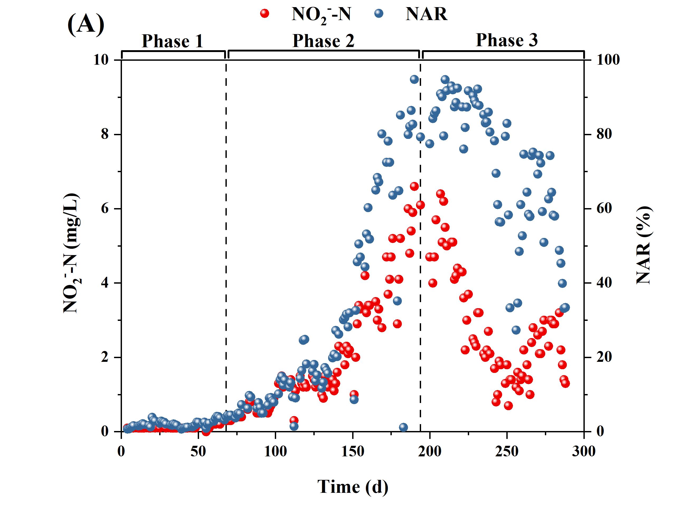

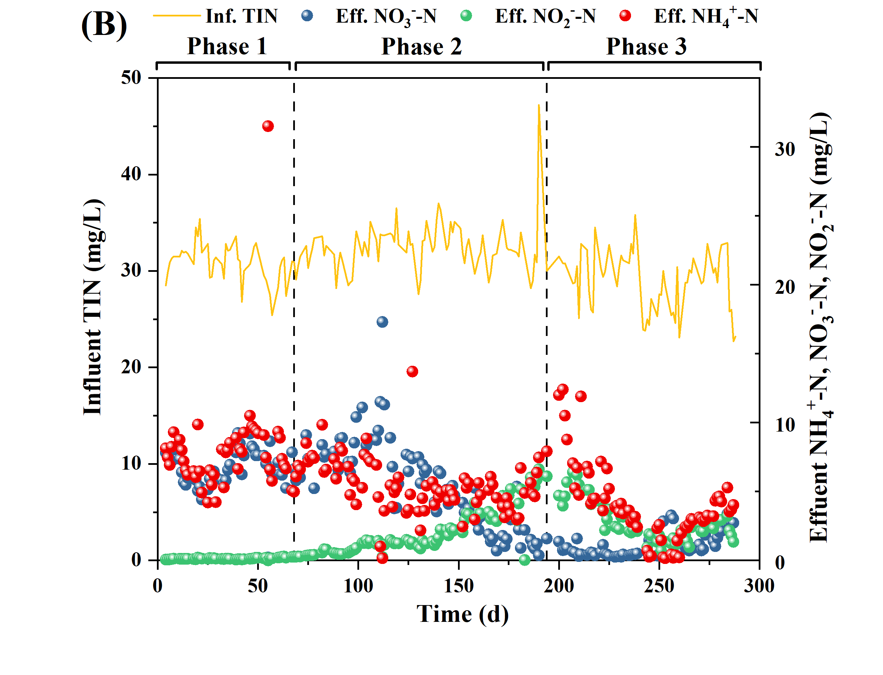

Figure S1. Biological N removal performance during the pilot testing: (A) effluent NO2–-N and NO2–-N accumulation ratio (NAR); and (B) influent TIN and effluent NO3–-N, NO2–-N and NH4+-N. TIN: total inorganic nitrogen (sum of NO3–-N, NO2–-N and NH4+-N).



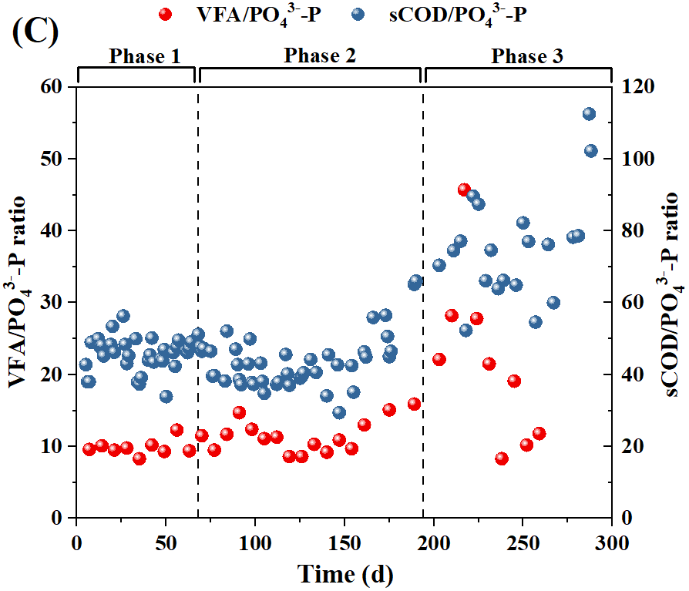





Figure S2. The external carbon inputs during the pilot testing: (A) sCOD concentration in influent and fermentate; (B) sCOD load in influent and fermentate, and total sCOD load; (C) fermentate VFA/PO43–-P and total sCOD/PO43–-P mass ratios; (D) VFA composition (determined by HPLC) and total VFA concentration (determined by HACH kit, named as VFAH) in fermentate; (E) Effluent PO43–-P concentration vs the relative mass ratio of fermentate VFA to PO43–-P added to the P(D)N-S2EBPR system.

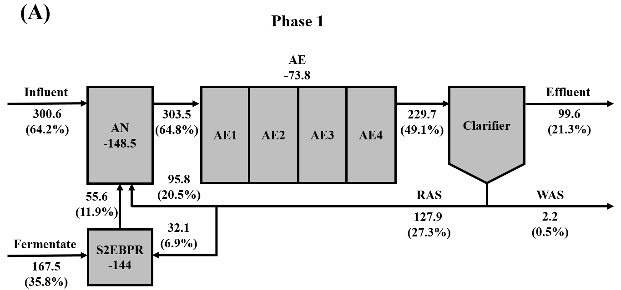

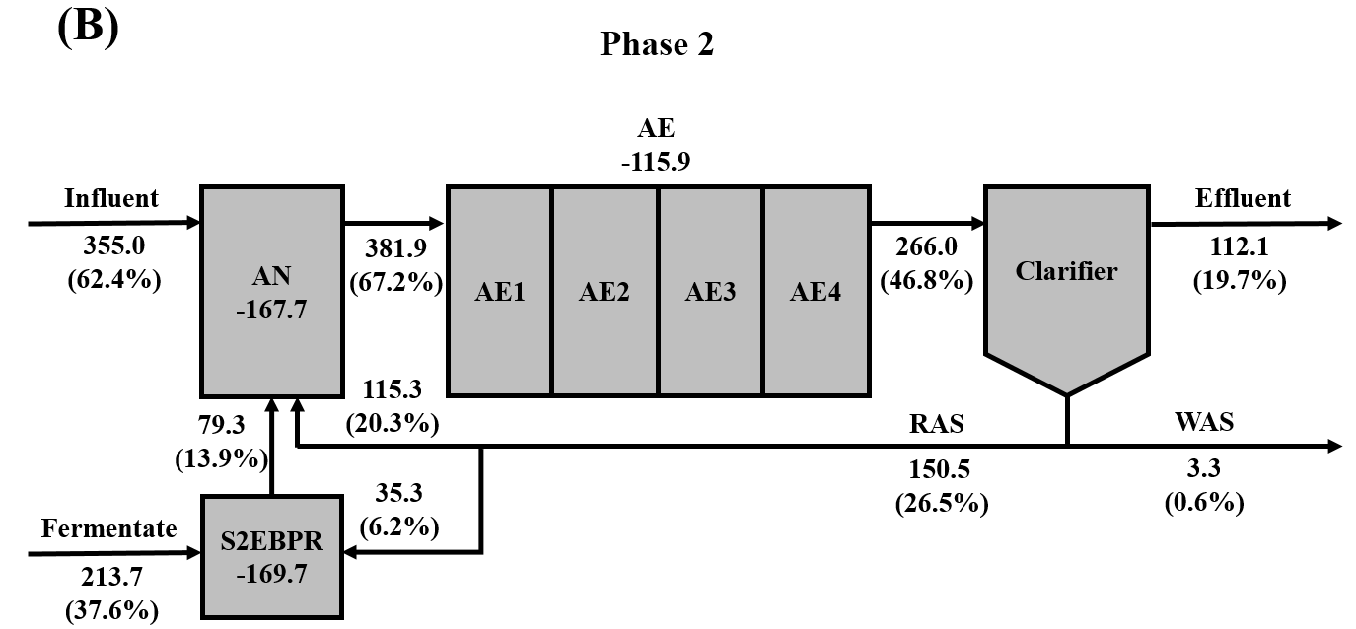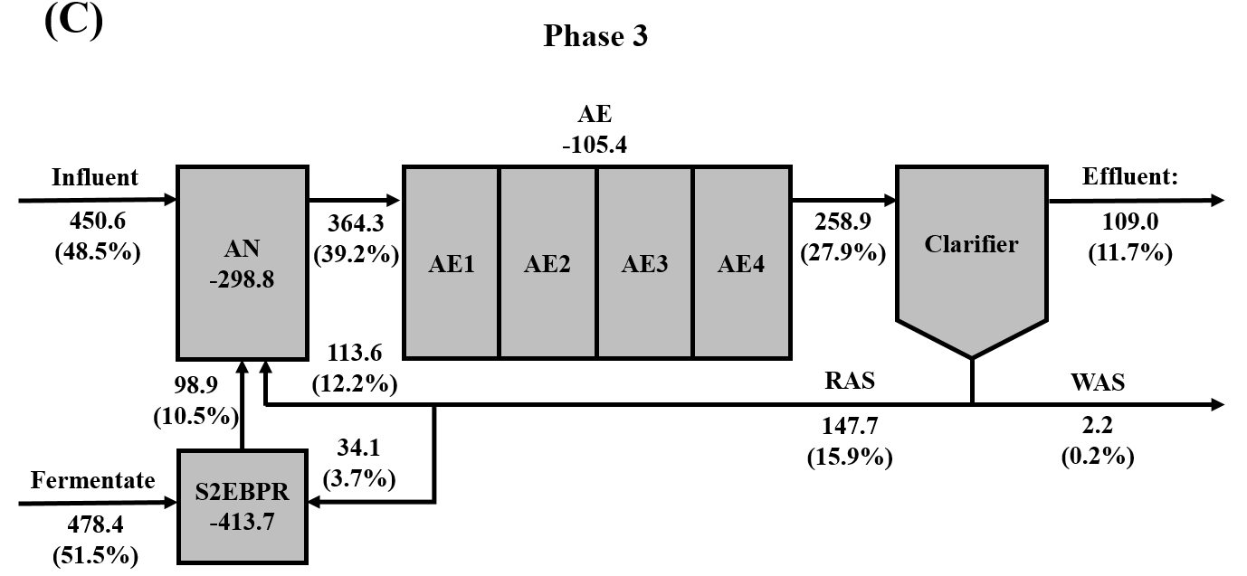

Figure S3. Fate of sCOD in (A) Phase 1, (B) Phase 2, and (C) Phase 3. Value with a minus sign represents the sCOD consumption. Value in brackets represents the percentage of sCOD in each unit compared to the total input. AN: anaerobic reactor; AE: intermittently aerated continuous stirred-tank reactors; RAS: return activated sludge; S2EBPR: side-stream biological P remover; WAS: sCOD in the liquid phase of waste activated sludge. Units are in g/d.

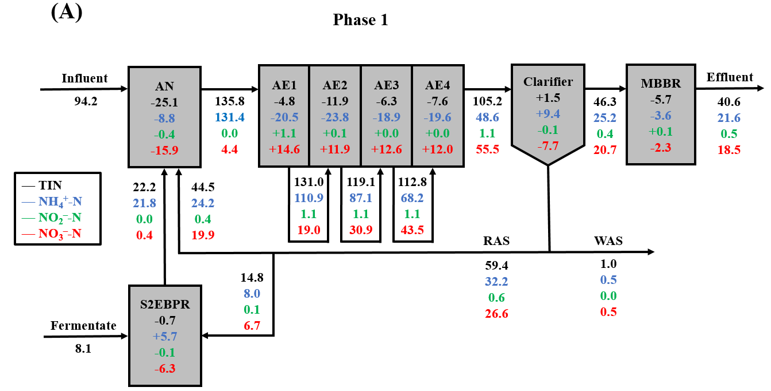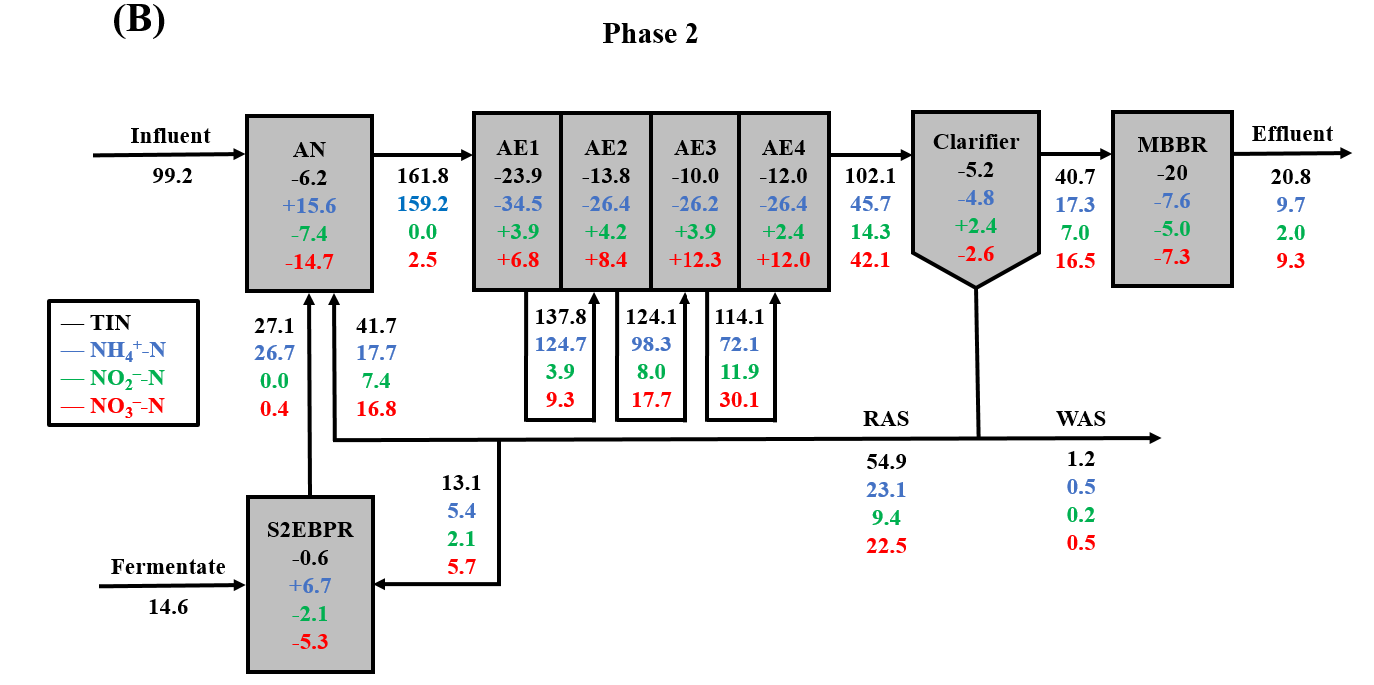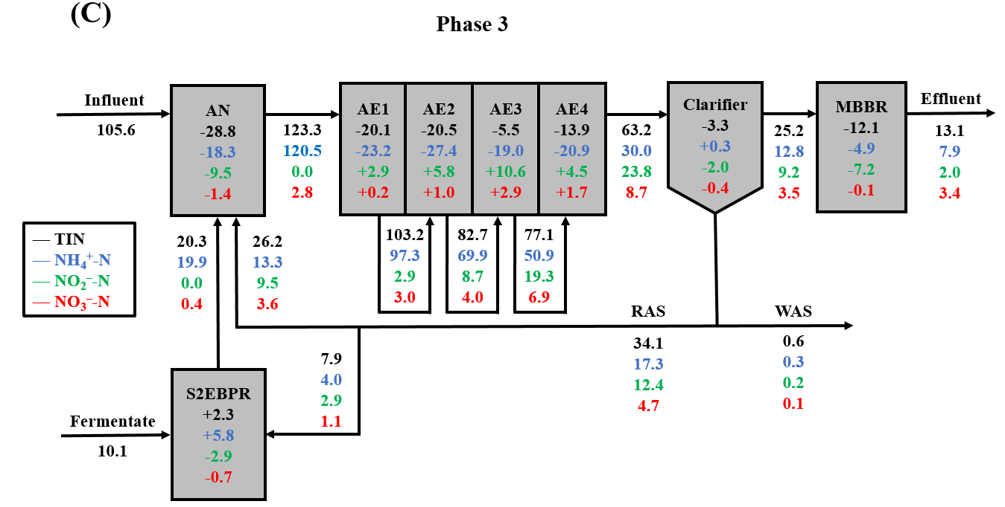

Figure S4. Fate of N species in (A) Phase 1, (B) Phase 2, and (C) Phase 3. Value with a plus or minus sign represents the N species production or removal, respectively. AN: anaerobic reactor; AE: intermittently aerated continuous stirred-tank reactors; MBBR: moving bed biofilm reactor; S2EBPR: side-stream biological P remover; RAS: return activated sludge; WAS: N species in the liquid phase of waste activated sludge. Units are in g/d.



Figure S5. Metabolic activities of functionally relevant microorganisms related to P and N removal during the pilot testing: specific P release rate (Prel), specific P uptake rate (Pup), and P release to HAc uptake ratio (P/HAc).



Figure S6. Profiles of sCOD, VFAs, PO43–-P, PHAs, TIN, NH4+-N, NO2–-N, and NO3–-N during the ex situ P release and uptake batch tests using different carbon sources and electron acceptors with the activated sludge collected at the end of Phase 3: (A, B) anaerobic-aerobic batch test fed with HAc; (C, D) anaerobic-aerobic batch test fed with fermentate; and (E, F) anaerobic-anoxic batch test fed with fermentate (NO3–-N was spiked at the beginning of the anoxic phase). VFA: total VFA concentration; HAc: acetate concentration; HPr: propionate concentration.

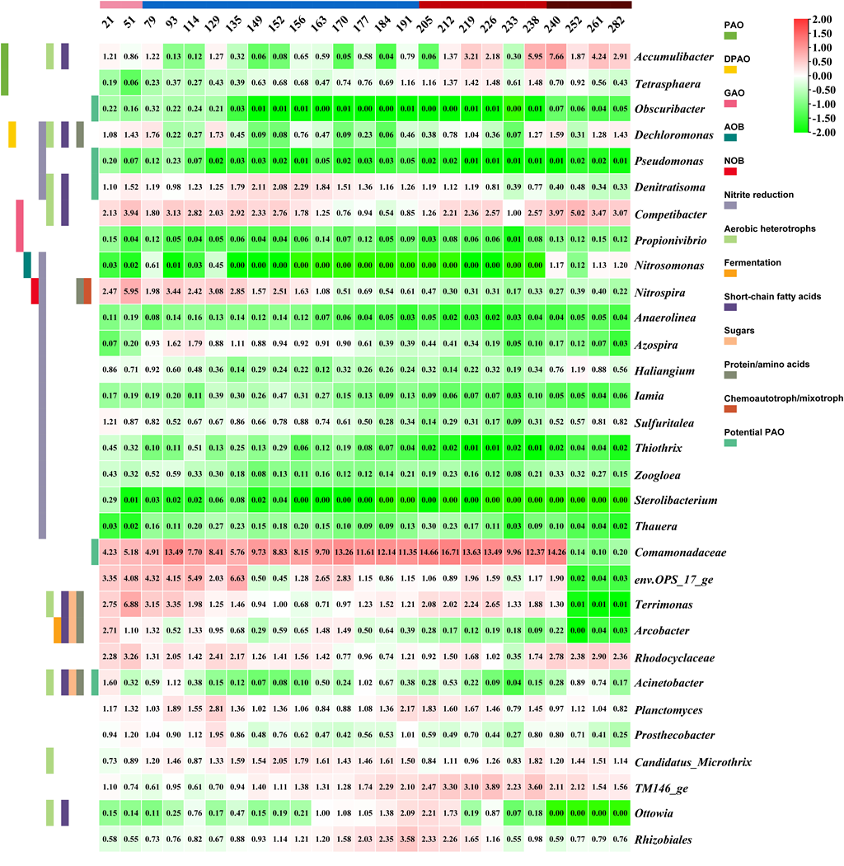

Figure S7. Time series heatmap of the relative abundances of the known functionally relevant microorganisms at the genus level. Bars on the y-axis with different colors represent specific functions according to the MiDAS database. Values represent average relative abundance (%) for each sample.





Figure S8. Relationship between P/HAc ratios and the ratios of PAO-to-GAO abundance determined by (A) 16S rRNA gene amplicon sequencing and (B) single-cell Raman micro-spectroscopy.

**Supplementary References**

Li, G., Wu, C., Wang, D., Srinivasan, V., Kaeli, D.R., Dy, J.G. and Gu, A.Z. (2022) Machine Learning-Based Determination of Sampling Depth for Complex Environmental Systems: Case Study with Single-Cell Raman Spectroscopy Data in EBPR Systems. Environmental science & technology 56(18), 13473-13484.

Wang, D., Li, Y., Cope, H.A., Li, X., He, P., Liu, C., Li, G., Rahman, S.M., Tooker, N.B., Bott, C.B., Onnis-Hayden, A., Singh, J., Elfick, A., Marques, R., Jessen, H.J., Oehmen, A. and Gu, A.Z. (2021) Intracellular polyphosphate length characterization in polyphosphate accumulating microorganisms (PAOs): Implications in PAO phenotypic diversity and enhanced biological phosphorus removal performance. Water research 206, 117726.

1. * Corresponding author.

   E-mail address: aprilgu@cornell.edu (A.Z. Gu)

   1 These authors contributed equally to this study.