Run  Supplementary  Table S1 Optimization of a combination of nutrients and light by RSM-CCD matrix for the analysis of chlorophyll a and b | Factor A:N (mg/L) | Factor B: P+K (mg/L) | Factor C: S (mg/L) | Factor D : LI (µmolm-2s-1) | Factor E : PP (h) | Chlorophyll a productivity |  | Chlorophyll b productivity
 |  |  |  |  |  | Actual Value | Predicted Value | Actual Value | Predicted Value
1 | 2500 | 250 | 70 | 137.5 | 12 | 9.76 | 11.19 | 6.11 | 3.71
2 | 2500 | 0 | 70 | 137.5 | 24 | 11.12 | 11.65 | 3.17 | 5.93
3 | 2500 | 500 | 70 | 137.5 | 24 | 12.47 | 13.35 | 7.16 | 5.26
4 | 2500 | 0 | 140 | 137.5 | 12 | 11.16 | 10.63 | 6.4 | 4.11
5 | 5000 | 250 | 70 | 137.5 | 0 | 3.01 | 3.82 | 2.78 | 3.44
6 | 5000 | 250 | 70 | 75 | 12 | 9 | 9.85 | 10.19 | 4.75
7 | 2500 | 250 | 140 | 75 | 12 | 9.55 | 11 | 4.34 | 3.21
8 | 5000 | 0 | 70 | 137.5 | 12 | 10.52 | 10.55 | 9.07 | 5.65
9 | 2500 | 250 | 0 | 200 | 12 | 13.97 | 13.23 | 6.9 | 4.22
10 | 2500 | 250 | 0 | 137.5 | 24 | 12.45 | 12.59 | 6.95 | 5.54
11 | 2500 | 250 | 140 | 137.5 | 24 | 12.96 | 11.44 | 3.99 | 5.65
12 | 0 | 250 | 70 | 137.5 | 24 | 12.6 | 11.92 | 1.47 | 3.99
13 | 2500 | 500 | 70 | 137.5 | 0 | 4.4 | 4.44 | 0.2385 | 1.5
14 | 0 | 0 | 70 | 137.5 | 12 | 10.3 | 12.26 | 1.48 | 2.45
15 | 2500 | 500 | 0 | 137.5 | 12 | 12.44 | 12.45 | 1.57 | 3.32
16 | 0 | 250 | 0 | 137.5 | 12 | 12.41 | 12.32 | 1.85 | 2.05
17 | 0 | 250 | 140 | 137.5 | 12 | 9.34 | 10.42 | 1.68 | 2.17
18 | 2500 | 0 | 70 | 75 | 12 | 13.6 | 12.86 | 1.49 | 3.49
19 | 2500 | 250 | 70 | 200 | 0 | 3.7 | 3.9 | 2.17 | 2.4
20 | 2500 | 250 | 70 | 200 | 24 | 12.35 | 12.83 | 6.89 | 6.16
21 | 2500 | 500 | 70 | 75 | 12 | 7.2 | 9.1 | 2.37 | 2.81
22 | 2500 | 250 | 70 | 75 | 24 | 11.74 | 10.7 | 5.59 | 5.03
23 | 2500 | 250 | 0 | 75 | 12 | 10.58 | 9.99 | 1.14 | 3.09
24 | 0 | 500 | 70 | 137.5 | 12 | 11.47 | 11.44 | 0.3587 | 1.78
25 | 5000 | 250 | 70 | 137.5 | 24 | 10.88 | 12.07 | 5.82 | 7.2
26 | 0 | 250 | 70 | 137.5 | 0 | 4.74 | 3.68 | 1.2 | 0.2308
27 | 2500 | 500 | 70 | 200 | 12 | 14.66 | 15.33 | 6.46 | 3.94
28 | 2500 | 250 | 70 | 137.5 | 12 | 12.59 | 11.19 | 3.59 | 3.71
29 | 2500 | 0 | 0 | 137.5 | 12 | 11.21 | 12.22 | 2.75 | 3.99
30 | 5000 | 500 | 70 | 137.5 | 12 | 15.41 | 13.45 | 5.98 | 4.98
31 | 2500 | 0 | 70 | 137.5 | 0 | 4.39 | 4.08 | 1.68 | 2.17
32 | 2500 | 250 | 70 | 137.5 | 12 | 11.23 | 11.19 | 4 | 3.71
33 | 2500 | 500 | 140 | 137.5 | 12 | 13.99 | 12.47 | 0.5249 | 3.43
34 | 2500 | 250 | 70 | 75 | 0 | 4.47 | 3.15 | 0.6074 | 1.27
35 | 2500 | 250 | 140 | 137.5 | 0 | 3.58 | 3.57 | 1.76 | 1.89
36 | 2500 | 250 | 0 | 137.5 | 0 | 2.32 | 3.98 | 0.5298 | 1.78
37 | 5000 | 250 | 140 | 137.5 | 12 | 11.92 | 11.68 | 4.92 | 5.37
38 | 0 | 250 | 70 | 75 | 12 | 11.61 | 11.09 | 4.77 | 1.55
39 | 2500 | 0 | 70 | 200 | 12 | 11.47 | 9.51 | 3.97 | 4.61
40 | 0 | 250 | 70 | 200 | 12 | 11.81 | 11.15 | 7.22 | 2.67
41 | 5000 | 250 | 70 | 200 | 12 | 11.96 | 12.68 | 4.29 | 5.88
42 | 2500 | 250 | 140 | 200 | 12 | 9.34 | 10.64 | 1.63 | 4.33
43 | 5000 | 250 | 0 | 137.5 | 12 | 12.76 | 11.35 | 2.64 | 5.26

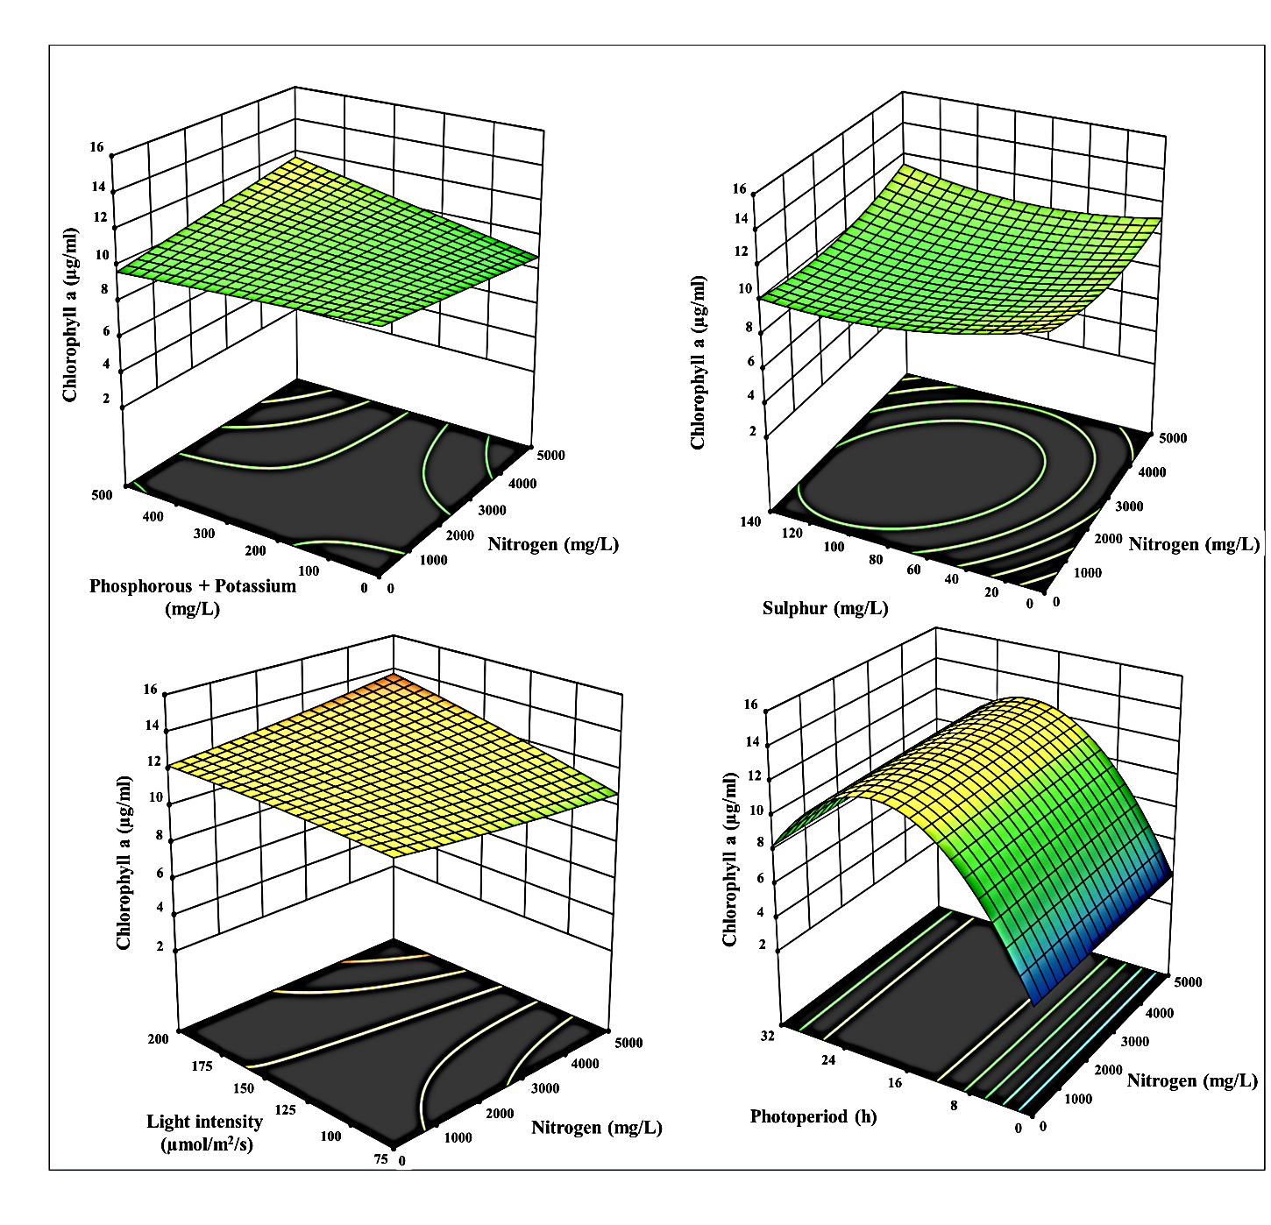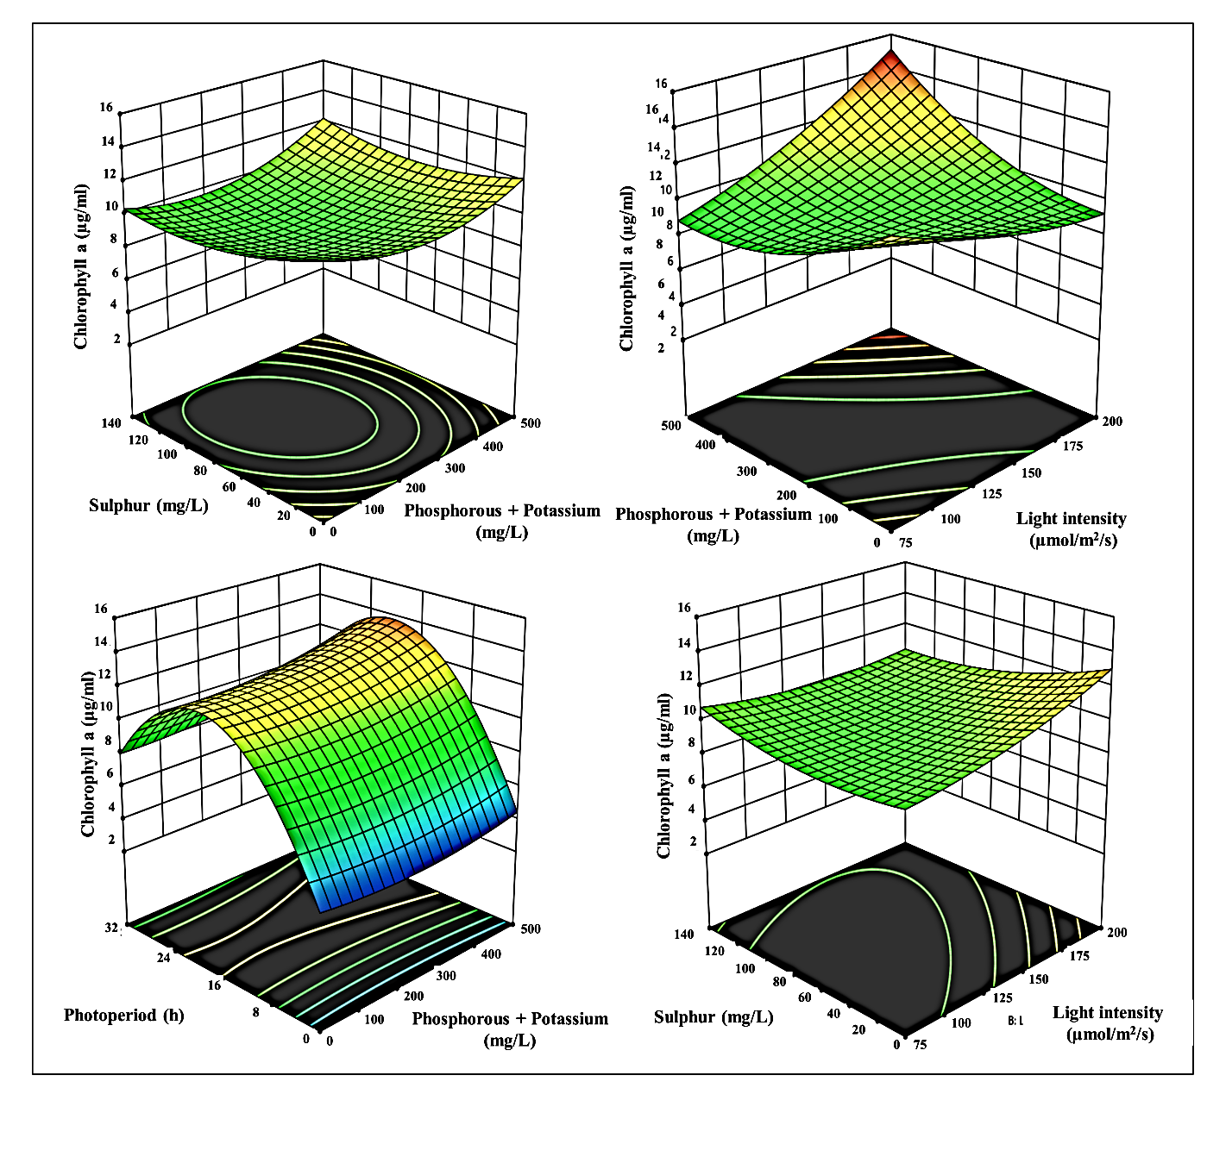
Fig S1 3-D surface and contour plots representing the interaction between the selected
parameters on Chlorophyll a yield (µg ml⁻¹), a) N with P+K, b) N with S, c) N with LI, d) N with PP, e) P+K with S, f) P+K with LI, g) P+K with PP, h) S with LI, i) S with PP, and j) LI with PP

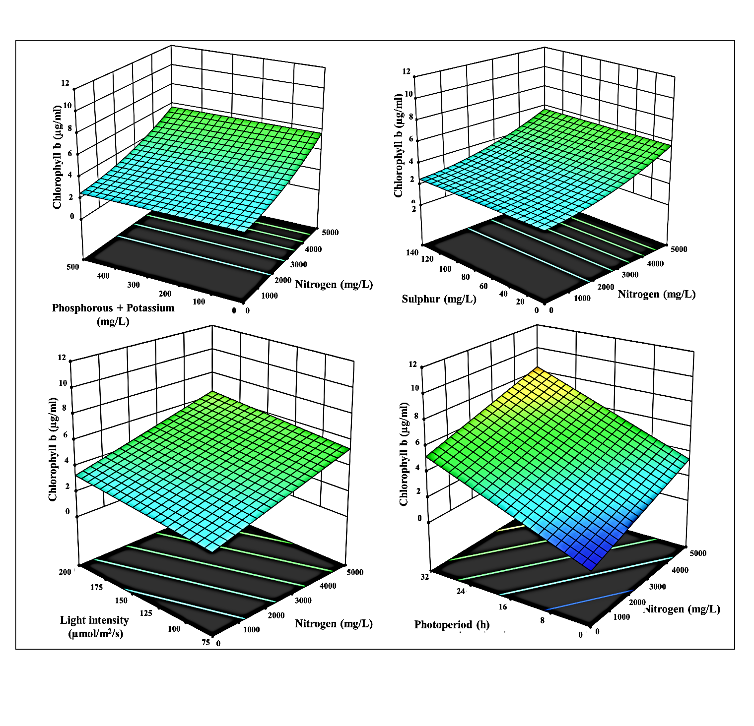

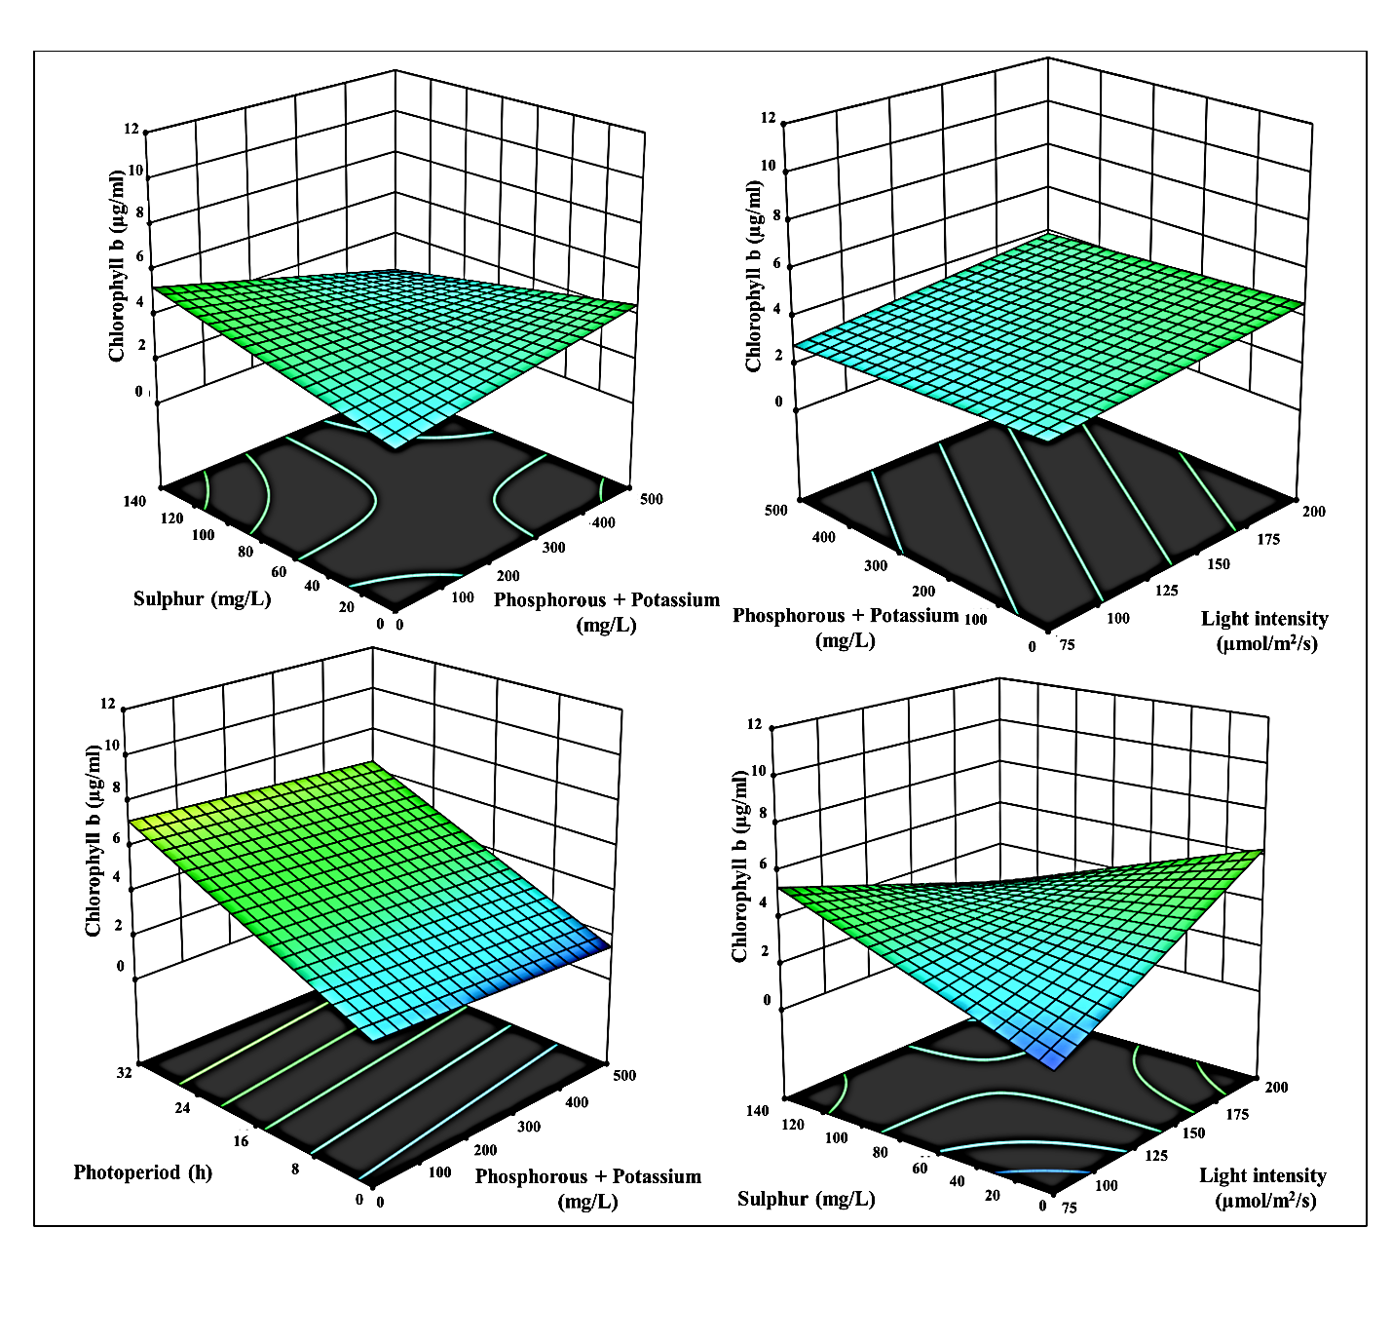
Fig S2 3-D surface and contour plots representing the interaction between the selected
parameters on Chlorophyll b yield (µg ml⁻¹), a) N with P+K, b) N with S, c) N with LI, d) N with PP, e) P+K with S, f) P+K with LI, g) P+K with PP, h) S with LI, i) S with PP, and j) LI with PP

