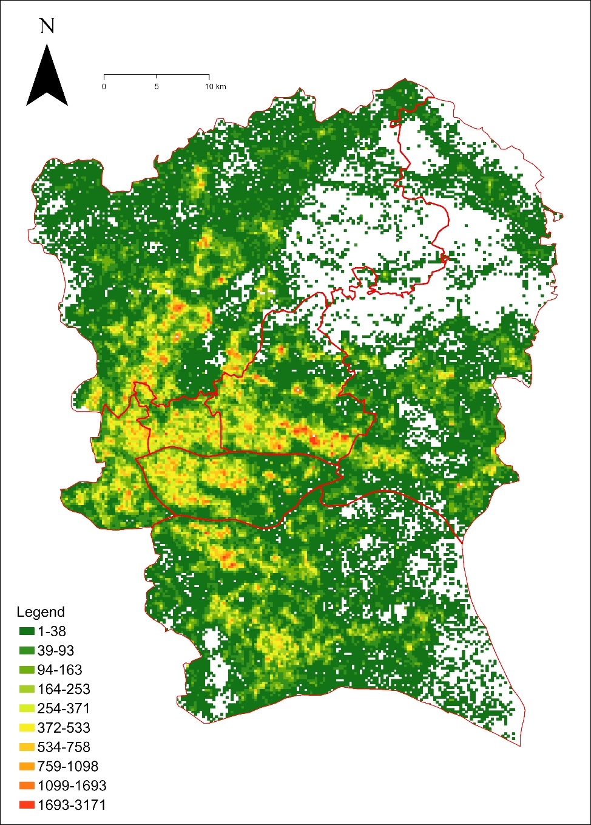 | 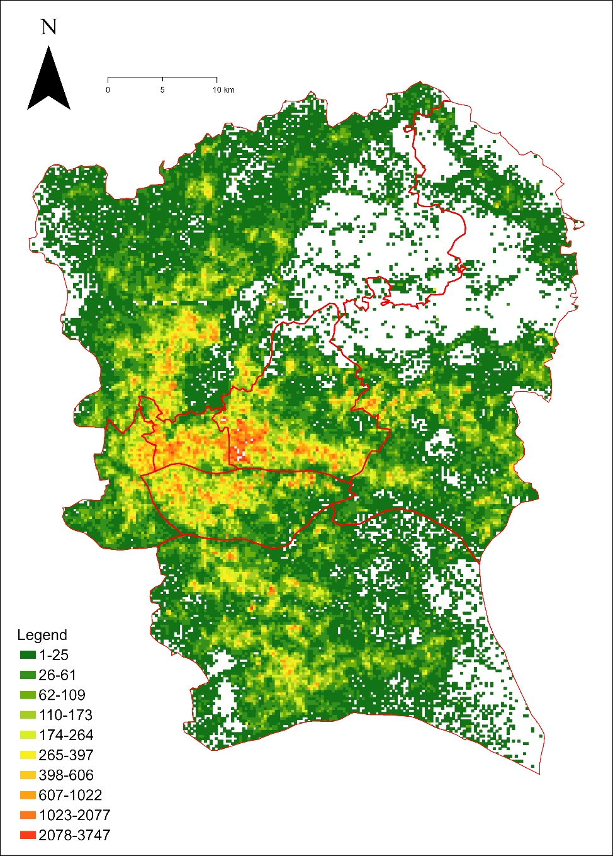
(a) | (b)
Figure S1. Results of the grid aggregated mobile phone data: (a) summary of the number of women living in the grid; (b) summary of the number of women working in the grid.
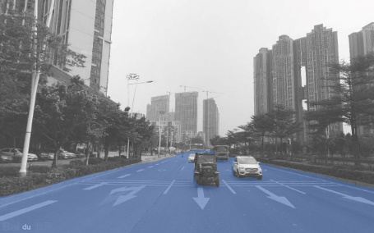Road | 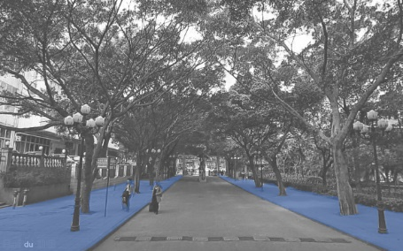Sidewalk | 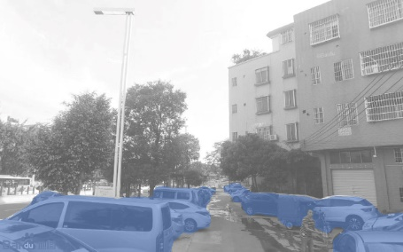Car | 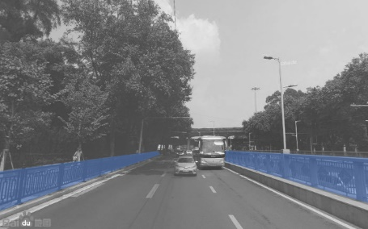Rail | 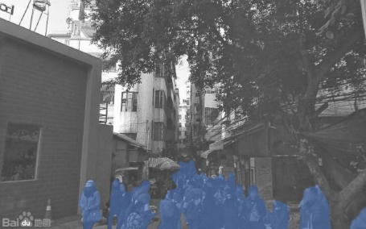Person
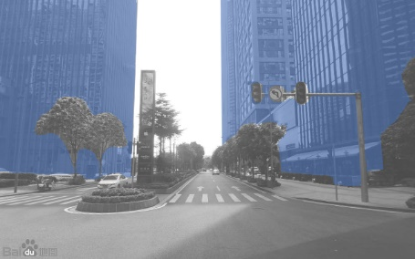Skyscraper | 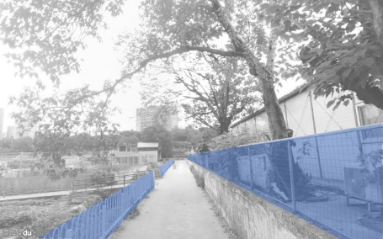Fence | 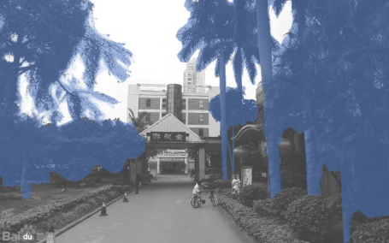Tree | 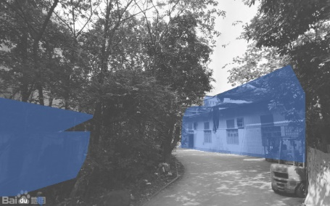House | 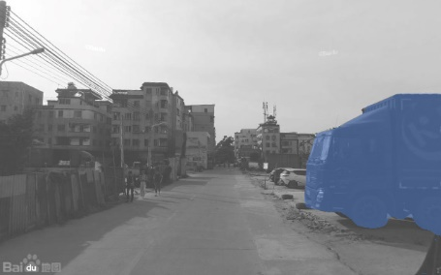Truck
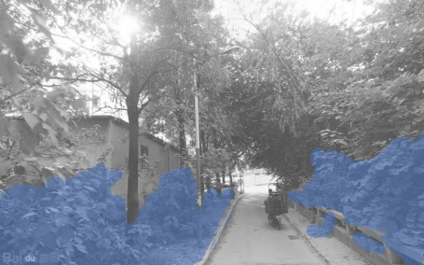Plant | 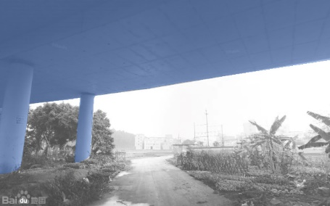Tunnel | 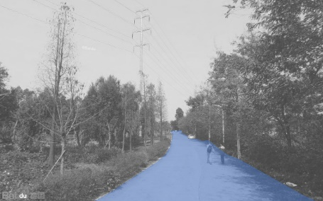Path | 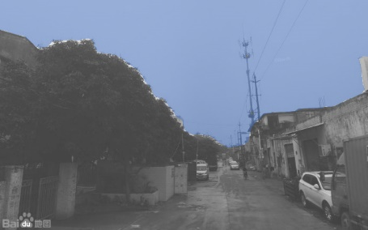Sky | 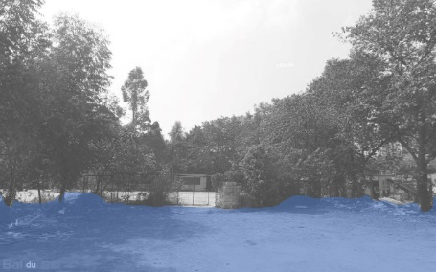Ground
Figure S2. Fifteen visual elements that affect perceived safety.

Table S1. Volunteer demographic information.
Group | Description
#1 | 20 women, 16 of whom are students and 4 of whom are staff; age range 19 - 48.
#2 | 10 women and 10 men, 8 of whom are women students and 2 of whom are women staff, the same applies to men; age range 18 - 50.
#3 | 10 men, 8 of whom are students and 2 of whom are staff; age range 20 - 53.
Table S2. Statistical description of features extracted by Semantic segmentation sorted by mean.
FID | Label | Number of images | Mean | Std.2 | Min | Max
1 | Sky | 165,734 | 26.03% | 16.37% | 0.00% | 77.26%
2 | Tree | 160,034 | 23.94% | 17.85% | 0.00% | 91.86%
3 | Building | 158,985 | 16.68% | 17.71% | 0.00% | 92.24%
4 | Road | 161,936 | 14.11% | 7.81% | 0.00% | 57.44%
5 | Unknown objects | 165,312 | 4.05% | 5.12% | 0.00% | 48.04%
6 | Car | 142,345 | 3.00% | 3.91% | 0.00% | 29.75%
7 | Sidewalk | 148,635 | 2.81% | 3.55% | 0.00% | 41.25%
8 | Wall | 108,003 | 1.53% | 3.52% | 0.00% | 39.52%
9 | Plant | 105,019 | 1.46% | 2.70% | 0.00% | 30.41%
10 | Grass | 89,403 | 1.12% | 2.30% | 0.00% | 30.24%
11 | Fence | 97,347 | 0.94% | 1.81% | 0.00% | 20.79%
12 | Ground | 69,970 | 0.62% | 1.85% | 0.00% | 42.64%
13 | Ceiling | 11,826 | 0.55% | 3.72% | 0.00% | 58.98%
14 | Bridge | 28,795 | 0.32% | 1.62% | 0.00% | 44.85%
15 | Truck | 34,996 | 0.28% | 1.30% | 0.00% | 32.77%
16 | Signboard | 80,321 | 0.27% | 0.72% | 0.00% | 21.29%
17 | Person | 69,339 | 0.23% | 0.68% | 0.00% | 22.81%
18 | Bus | 21,358 | 0.20% | 1.24% | 0.00% | 37.92%
19 | Rail | 32,861 | 0.17% | 0.69% | 0.00% | 17.40%
20 | Skyscraper | 6,121 | 0.15% | 1.27% | 0.00% | 49.15%
21 | Path | 18,222 | 0.15% | 0.92% | 0.00% | 26.92%
22 | Floor | 19,024 | 0.14% | 0.98% | 0.00% | 51.34%
23 | Van | 28,575 | 0.12% | 0.57% | 0.00% | 17.18%
24 | Mountain | 15,079 | 0.09% | 0.71% | 0.00% | 30.69%
25 | House | 10,859 | 0.07% | 0.76% | 0.00% | 59.45%
26 | Water | 10,596 | 0.07% | 0.61% | 0.00% | 24.05%
27 | Tower | 7,861 | 0.06% | 0.63% | 0.00% | 48.10%
28 | Window | 6,654 | 0.06% | 0.57% | 0.00% | 23.93%
29 | Pole | 34,110 | 0.05% | 0.19% | 0.00% | 3.00%
30 | Motorbike | 16,776 | 0.05% | 0.26% | 0.00% | 13.53%
31 | Bike | 14,673 | 0.04% | 0.28% | 0.00% | 17.57%
32 | Sunblind | 10,174 | 0.04% | 0.28% | 0.00% | 12.87%

Number of SVIs with at least one pixel label in the category.
The mean/std value was calculated based on all 166,015 images.

