Supplemental file: Table 1: NOS Scale
Studies | Selection | Comparability | Outcome | Overall Quality/ Overall risk of bias
Folkestead et al., 2020 | ++ | + | ++ | High
Tan et al., 2020 | ++ | + | ++ | Moderate
Liu et al. 2020 | +++ | ++ | +++ | Low
Kim et al, 2015 | +++ | ++ | +++ | Low
Ptasnuka et al, 2019 | +++ | ++ | ++ | Low
Pellat A et al, 2019 | ++ | ++ | ++ | Moderate
Yang et al., 2018 | +++ | ++ | +++ | Low
Fathi et al., 2020 | ++ | ++ | ++ | High
Cetinkaya et al.,2014 | ++ | + | +++ | Moderate
Zang et al., 2014 | +++ | ++ | +++ | Low
Fang et al., 2017 | +++ | ++ | +++ | Low
Foubert, 2018 | ++ | + | ++ | High
Sakin, 2018 | +++ | ++ | + | Moderate
Rosenblum et al., 2020 | +++ | ++ | +++ | Low

Figures: Funnel plots and forest plot after sensitivity analysis:
- Age and Survival.

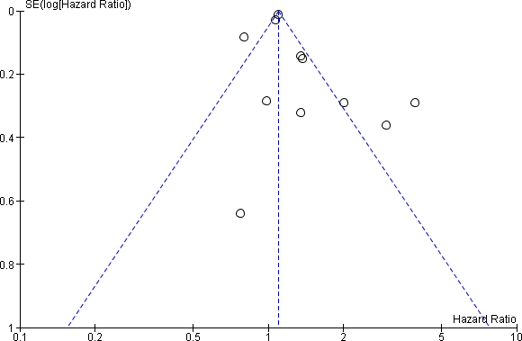
Funnel plot for outlying studies

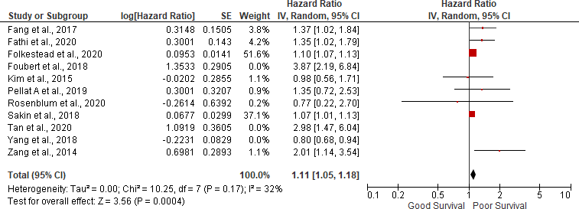
Forest plot of age and survival after sensitivity analysis:

Grade 3
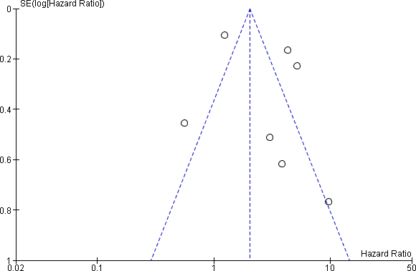
Funnel plot for outlying studies

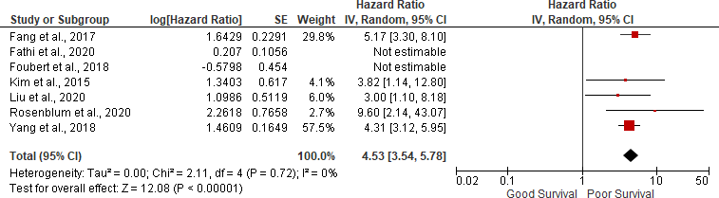
Forest plot of Grade and survival after sensitivity analysis

- Lymph node positivity
Funnel plot for outlying studies

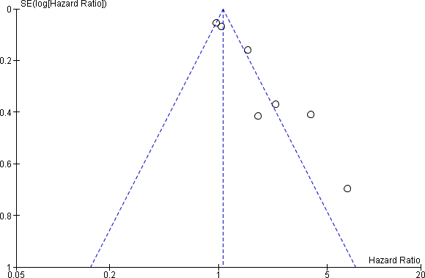

Forest plot of Lymph node positivity and survival after sensitivity analysis:

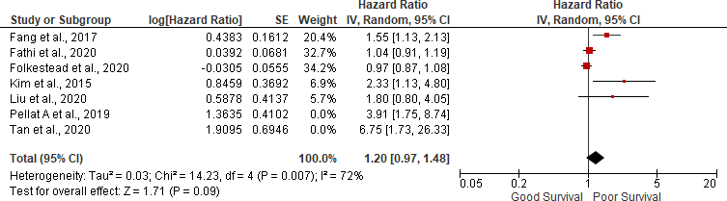

- Ki-67 more than 5%

Funnel plot for outlying studies

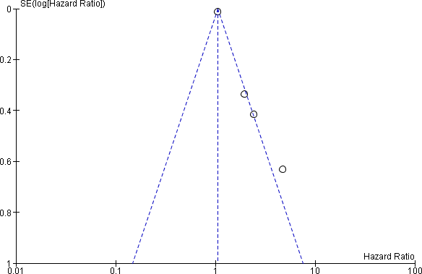

Forest plot of ki67 more than 5% and survival after sensitivity analysis:
