Supplementary Materials for

UNDERSTANDING THE GROUND VERTICAL DISPLACEMENT OF JOSHIMATH THROUGH INSAR DATA PROCESSING

Sai Deepak Pinakana¹ and Satyaprakash²*
Corresponding author: satya.prakash@sharda.ac.in

The PDF file includes:

Materials and Methods
Supplementary Text
Figs. S1 to S11
Tables S1
References

Materials & Methods
- HyP3
Because of various challenges in processing of SAR imagery for displacement value calculation, HyP3 - Hybrid Pluggable Processing Pipeline, a cloud-based system has been used in this study. With the processing requests being handles by automated systems, the processing speed is very quick. The user is needed to input basic information like the range of dates, area of interest and type of swath mode images. Once the user inputs the basic information, the processing starts on cloud and would be available for download for 14 days from the time of process completion. It is useful for timeseries analysis which plays an important role in monitoring the land deformation. Various techniques used for time series analysis of InSAR methods include Persistent Scatter (PS) and Short Baseline Subset Methods (SBAS) (13). While PS method uses only one master scene to form the interferograms, SBAS method uses different master scenes (13). In the study we have used the Vertex SBAS tool which is easy to use and visualize the images. The temporal baseline was set to 24 days. There is a limit of 1000 Jobs per month in the tool. Once the jobs are submitted, the results will be available as quickly as 40 minutes and will be available for download in the cloud storage for 14 days from the time of completion. An option is available for users who would like to process the timeseries analysis in MintPy and it helps in selecting the required files to be generated.
The generated product after setting up the SBAS in the HyP3 tool from the ASF website gives a zip file of different interferograms for the area and time of interest. Different files generated are detailed in Table 1.
- MintPy
MintPy is an open-source python package was used to perform time series analysis on Interferometric Synthetic Aperture Radar (InSAR) data. It reads and processes a stack of coregistered and unwrapped interferograms from various sources, including InSAR Scientific Computing Environment (ISCE), Advanced Rapid Imaging and Analysis (ARIA), Hybrid Pluggable Processing Pipeline (HyP3), Generic Mapping Tools Synthetic Aperture Radar (GMTSAR), Sentinel Application Platform (SNAP), and Repeat Orbit Interferometry Package format (ROI PAC), and produces 3D ground surface displacement measurements in the line-of-sight direction.
MintPy processing time depends on the area of interest. It takes approximately 45 minutes to process the area of a complete IW swath mode image. But as our study’s area of interest is limited to only the region of Joshimath, it took 5 minutes 20 seconds to read, process and produce an output file. The output file contains of various calculations including Average Phase Velocity, Average Spatial Coherence, Perpendicular Baseline History, Velocity, Time series of DEM error, Interferogram compilation represented in PNG and KMZ files.
After acquiring the output file, an extra command was used to extract the shapefile of displacement values for each point of area of interest. The command is as follows:
- save_qgis.py timeseries.h5 -g inputs/geometryRadar.h5 -o ts.shp
An additional Plugin for QGIS called as ps-time-series plugin (14) was installed. This plugin is used for Computation and visualization of time series of speed for Permanent Scatterers derived from satellite interferometry.
Supplementary Text
- Land Subsidence
Land subsidence is termed as gradual or rapid sinking of Earth’s surface which is caused by subsurface motion of earth materials (15). The primary causes of the process are subsurface fluid withdrawal (16), underground mining (17), hydro compaction (18), and natural consolidation (19). Many cities in the present-day world are undergoing this phenomenon. The list consists of but not limited to Venice (20), New Orleans (21), Houston (22), Mexico (23), Tokyo (24), Shanghai (25), Bangkok (26). With the land subsidence increasing in different cities all over the world, it generally has a pile of negative impacts. It causes both infrastructural damage and environmental damage (27). While the infrastructural damage like cracks on roads, tilting of houses can be observed by naked eye, the environmental damage leads to increased flooding during high tides, and increase in inland sea water intrusion. It is very important to monitor the subsidence rates in areas which go under subsurface fluid withdrawal, underground mining, hydro compaction, and natural consolidation, so that there would not be any adverse effects caused by it. Understanding the causes and effects of land subsidence is important for addressing the challenges it poses to sustainable land use and development.
The two different types of land subsidence measurement are majorly categorized into ground-based and remotely sensed methods (28). The ground-based methods consist of GPS - Global Positioning System monitoring stations, tripod LiDAR, and extensometry. The remotely sensed based methods consist of InSAR and LiDAR. Due to various physical challenges and objections in the field observations after a natural / artificial disaster, the remotely sensed methods have become more effective than ground-based methods for studies involving quick assessment and response. With an expeditious development in the field of technology during the previous decade, remote sensing has played an important role in disaster management by identifying the type of disaster, cause of disaster, intensity using the spectral and spatial changes of the region (29). The quality of spectral, spatial, and temporal resolution of the data is highly important in disaster assessment studies (30). Remote sensing methods are of two types, optical and radar. While the optical remote sensing is affected by light conditions and clouds, radar remote sensing overcomes these obstacles. Synthetic Aperture Radar (SAR) is a method of remote sensing which provides data of a place irrespective of clouds, rain, day, night, and fog because of its penetration ability (31).
InSAR is a remote sensing technique that uses SAR images to measure small changes in the surface of the Earth. It is widely used to map and monitor land subsidence, earthquakes, volcano deformation, and other geophysical processes (32). InSAR works by combining two or more radar images of the same area taken at different times to create an interferogram. The interference pattern created by the overlapping images can be used to calculate the phase difference between the two images, which is directly related to the surface displacement (33). One of the main advantages of InSAR is its ability to measure ground deformation over large areas with high spatial resolution and accuracy. InSAR can detect surface displacements as small as a few millimetres (33), making it ideal for monitoring slow-moving geophysical processes such as land subsidence. The applications of InSAR does not only include surface deformation but the method is also being used to monitor infrastructure, such as dams and bridges, to detect structural changes and potential safety hazards (34). InSAR technology has advanced significantly in recent years, with the launch of new satellites with higher resolution and more frequent revisit times, and the development of new processing techniques. This has led to an increased availability of InSAR data and an improved ability to detect and monitor small-scale surface deformation. InSAR has been used to study tectonic deformation in various regions, including the faults in Suban field, South Sumatra Basin, Indonesia (35) and the Northern Tibetan Plateau (36). It has also been used in monitoring volcanic deformation at several active volcanoes, such as Rabaul Caldera, Papua New Guinea (37) and Yellowstone Caldera (U.S.) (38). InSAR has also been used in the field of natural hazard monitoring. InSAR can be used to identify areas that are prone to landslides, floods, and earthquakes (39). InSAR data can be used to identify areas of ground deformation that may indicate an increased risk of landslides or floods. InSAR can also be used to track the movement of glaciers, which can be used to monitor the effects of climate change (40).
With SAR data providing all needed information on surface deformation, the processing of the data has always been a challenge. The process involving calculation of earth surface deformation using radar data requires in depth theoretical knowledge and processing softwares, which might be an obstacle in increasing the use of radar data for deformation monitoring (41). The most common type of issues (42) that the users of SAR imagery face are:
• Removal of distortions of some sort to make the products analysis ready
• Requirement of excessive computing resources and softwares
HyP3 which is a cloud-based system that is developed and maintained by the Alaska Satellite Facility (ASF) at the University of Alaska Fairbanks, gives access to on-demand higher-level SAR processed results (41). This method is a relatively new method and is a highly time saving method to get the results. The process gives interferograms and displacement maps for any area and date on demand. While HyP3 generates interferograms and displacement maps for any two SAR acquisitions, it is recommended not use single interferograms for deriving displacement values for the region (8). A SAR time series software such as The Miami INsar Time-series software in PYthon (MintPy) is recommended to use as a more robust method of determining surface displacement by analyzing a series of interferograms. MintPy is an open-source python package for InSAR time series analysis (6).
This study aims at evaluating the use of Hyp3 generated products in the MintPy software to process and analyze the interferograms to extract surface displacement values of Joshimath. The evaluation is performed for the area of Joshimath from January 2022 to January 2023 using Sentinel-1 SAR data. With the incidents of flash floods and cracks of house walls taking place in Joshimath, it is very important to analyze long term data to identify the cause and monitor the intensity of the situation. The main aim of using Hyp3 generated products and MintPy software for the analysis is to emphasize the use of these methods in generating the results quickly to take better decisions in the future. Quantum GIS (QGIS) 3.28.1 and Google Earth Pro were used to make maps, while Origin 2023 software was used to plot the graphs.
- Study Area and Dataset
  - Joshimath:
Joshimath is a town located in the Indian state of Uttarakhand, in the Chamoli district. It is situated at an altitude of 1861 meters above sea level and is surrounded by the majestic Himalayas. Geographically, Joshimath is located on the middle part of a hill, bordered by Karmanasa and Dhaknala to the west and east respectively, and surrounded by Dhauliganga and Alaknanda. The town serves as a base for many trekking routes in the surrounding Himalayas, such as the Nanda Devi Sanctuary and the Valley of Flowers National Park. The town receives moderate to heavy rainfall during the monsoon season and heavy snowfall during the winter.
The population of the area is 17,000 approximately. The maximum and minimum temperature levels in the area vary between 31 degrees Celsius to -2.9 degree Celsius. The normal annual rainfall rate is 1230.8 mm. The area receives maximum rainfall of the year in the month of August. It is pretty evident from the incidents like 2013 floods and 2021 flash floods that the area is highly vulnerable to natural disasters. Geologically the place is situated in the lesser Himalayas and lies in the tectonic fore deep (3)] and is situated in the seismic hazard zone of V which is the highest on the scale. The lithology of Joshimath includes Garnet mica gneiss, staurolite and kyanite gneisses, Garnet amphibolite (3). While majority of the southern part is covered by trees and rangelands, northern part of the area can be noticed to be of Ice or Snow which is due to presence of Himalayas.
  - Dataset:
Sentinel-1imagery was used in the study to estimate the land subsidence. It is constellation duo of satellite orbiting in a sun synchronous polar orbit. Sentinel – 1 satellite which provides SAR imagery to global users was launched by European Space Agency in the year 2014. It carries C-Band sensors with 4–8 GHz frequency and 7.5–3.8 cm wavelength. In this study, Sentinel-1 A satellite images from January 2022 to January 2023 were used. The IW – Interferometric Wide swath mode images of swath width 250 km were used to generate interferograms (5). 30 images of flight direction Ascending orbit with polarization VV+VH were used in the study.

Figure S1. Timeseries plot for different locations (Latitude and Longitude mentioned in every plot)

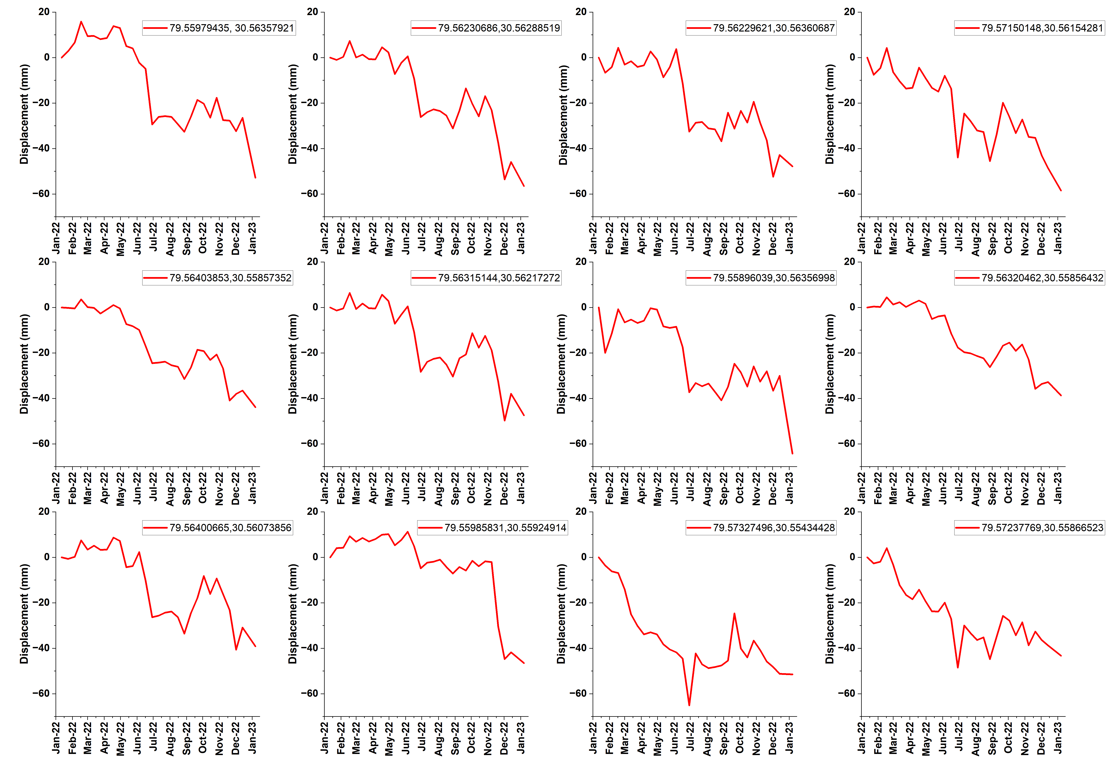

Figure S2. (Latitude and Longitude mentioned in every plot)

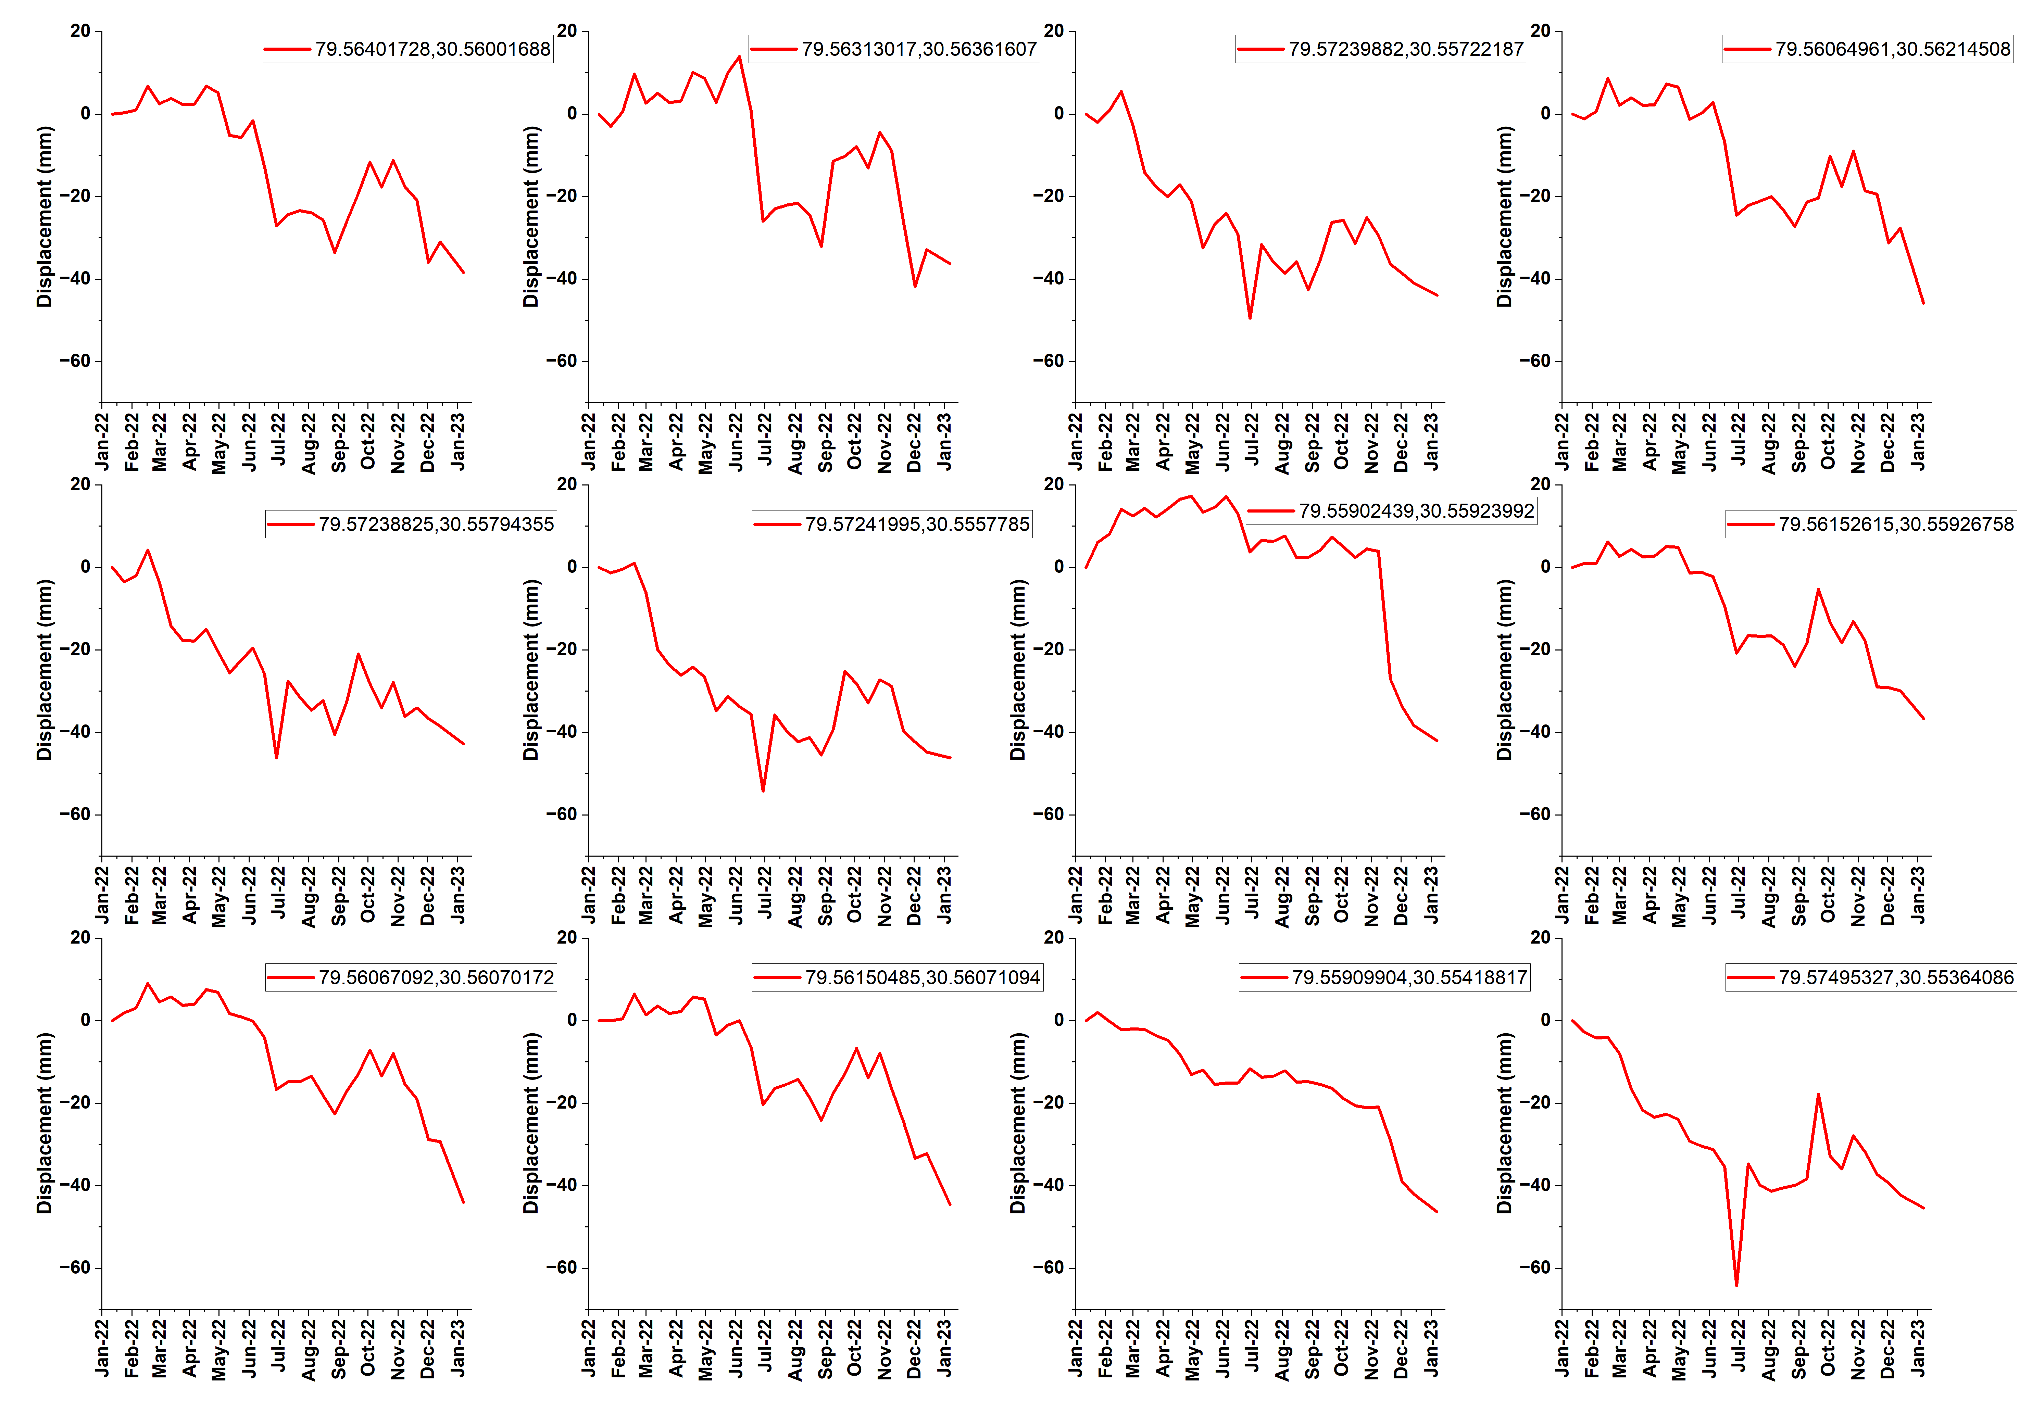

Figure S3. (Latitude and Longitude mentioned in every plot)

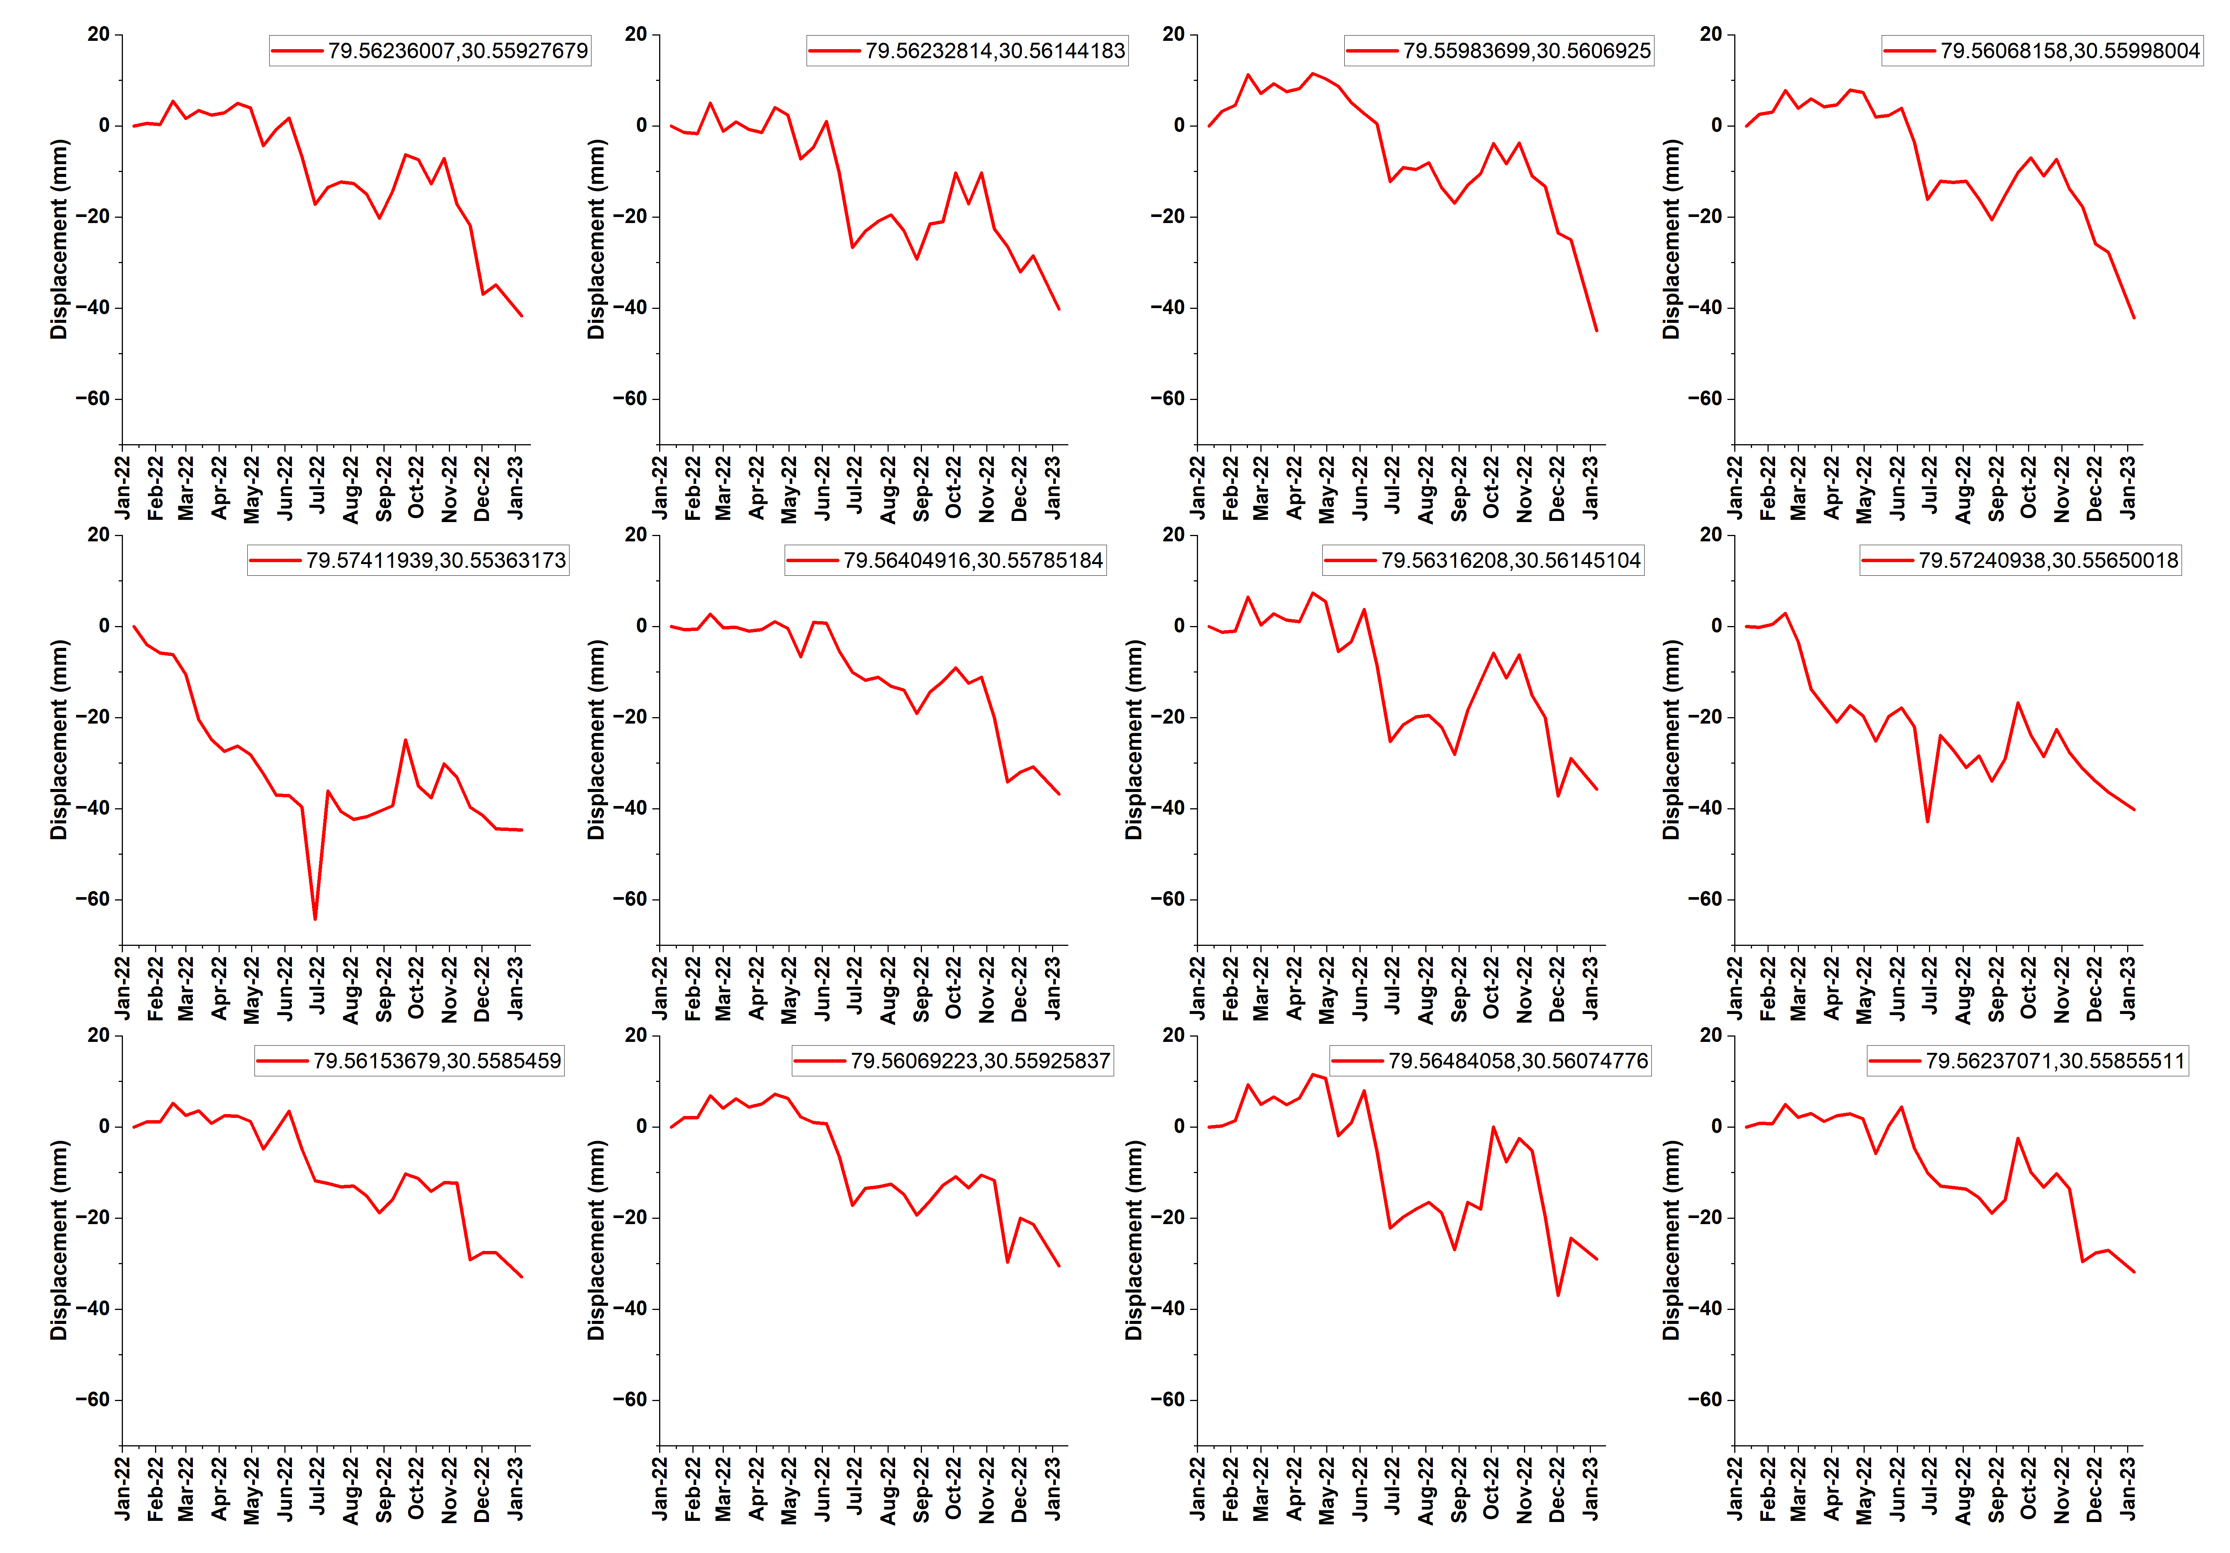

Figure S4. (Latitude and Longitude mentioned in every plot)
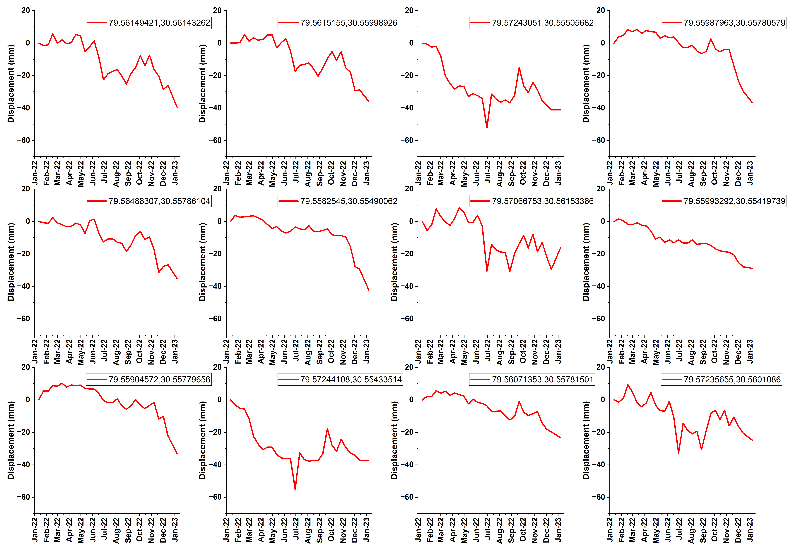

Figure S5. (Latitude and Longitude mentioned in every plot)
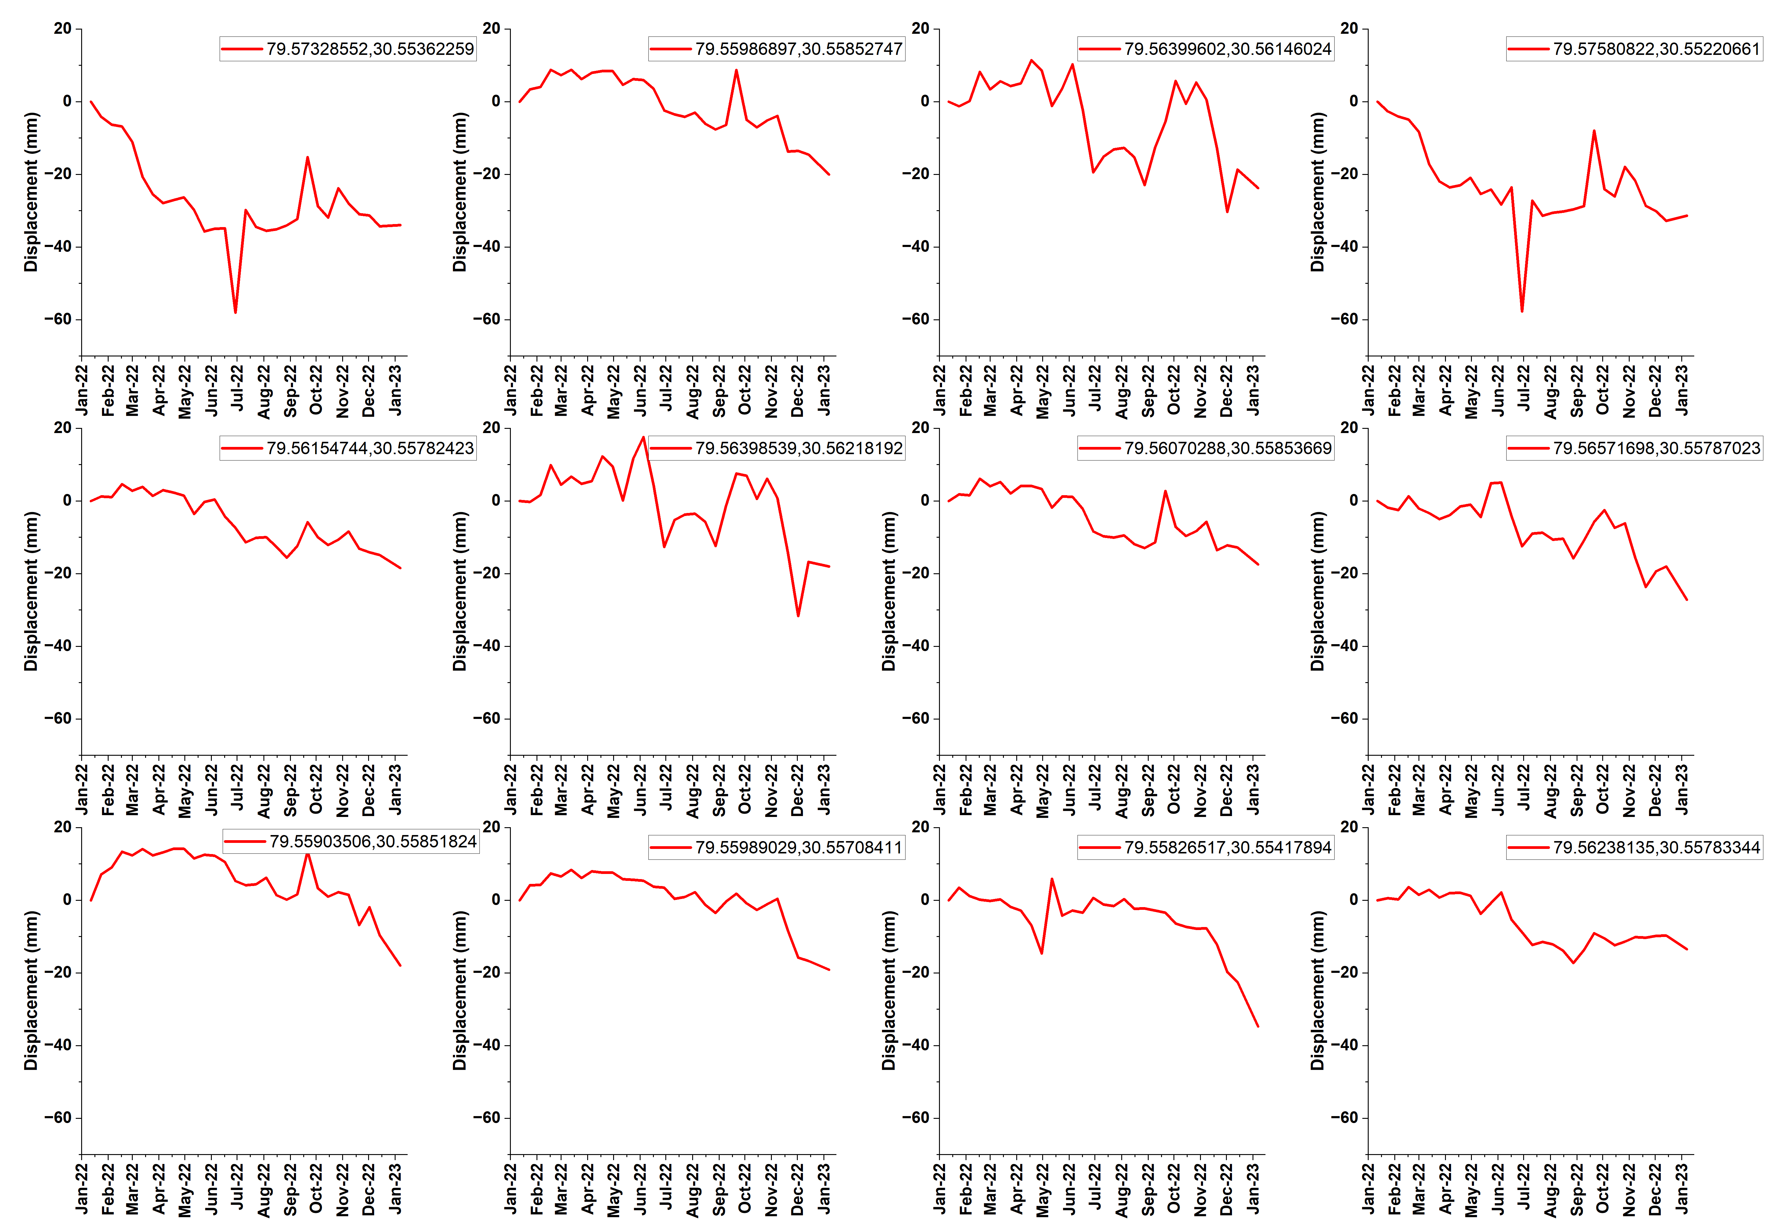

Figure S6. (Latitude and Longitude mentioned in every plot)
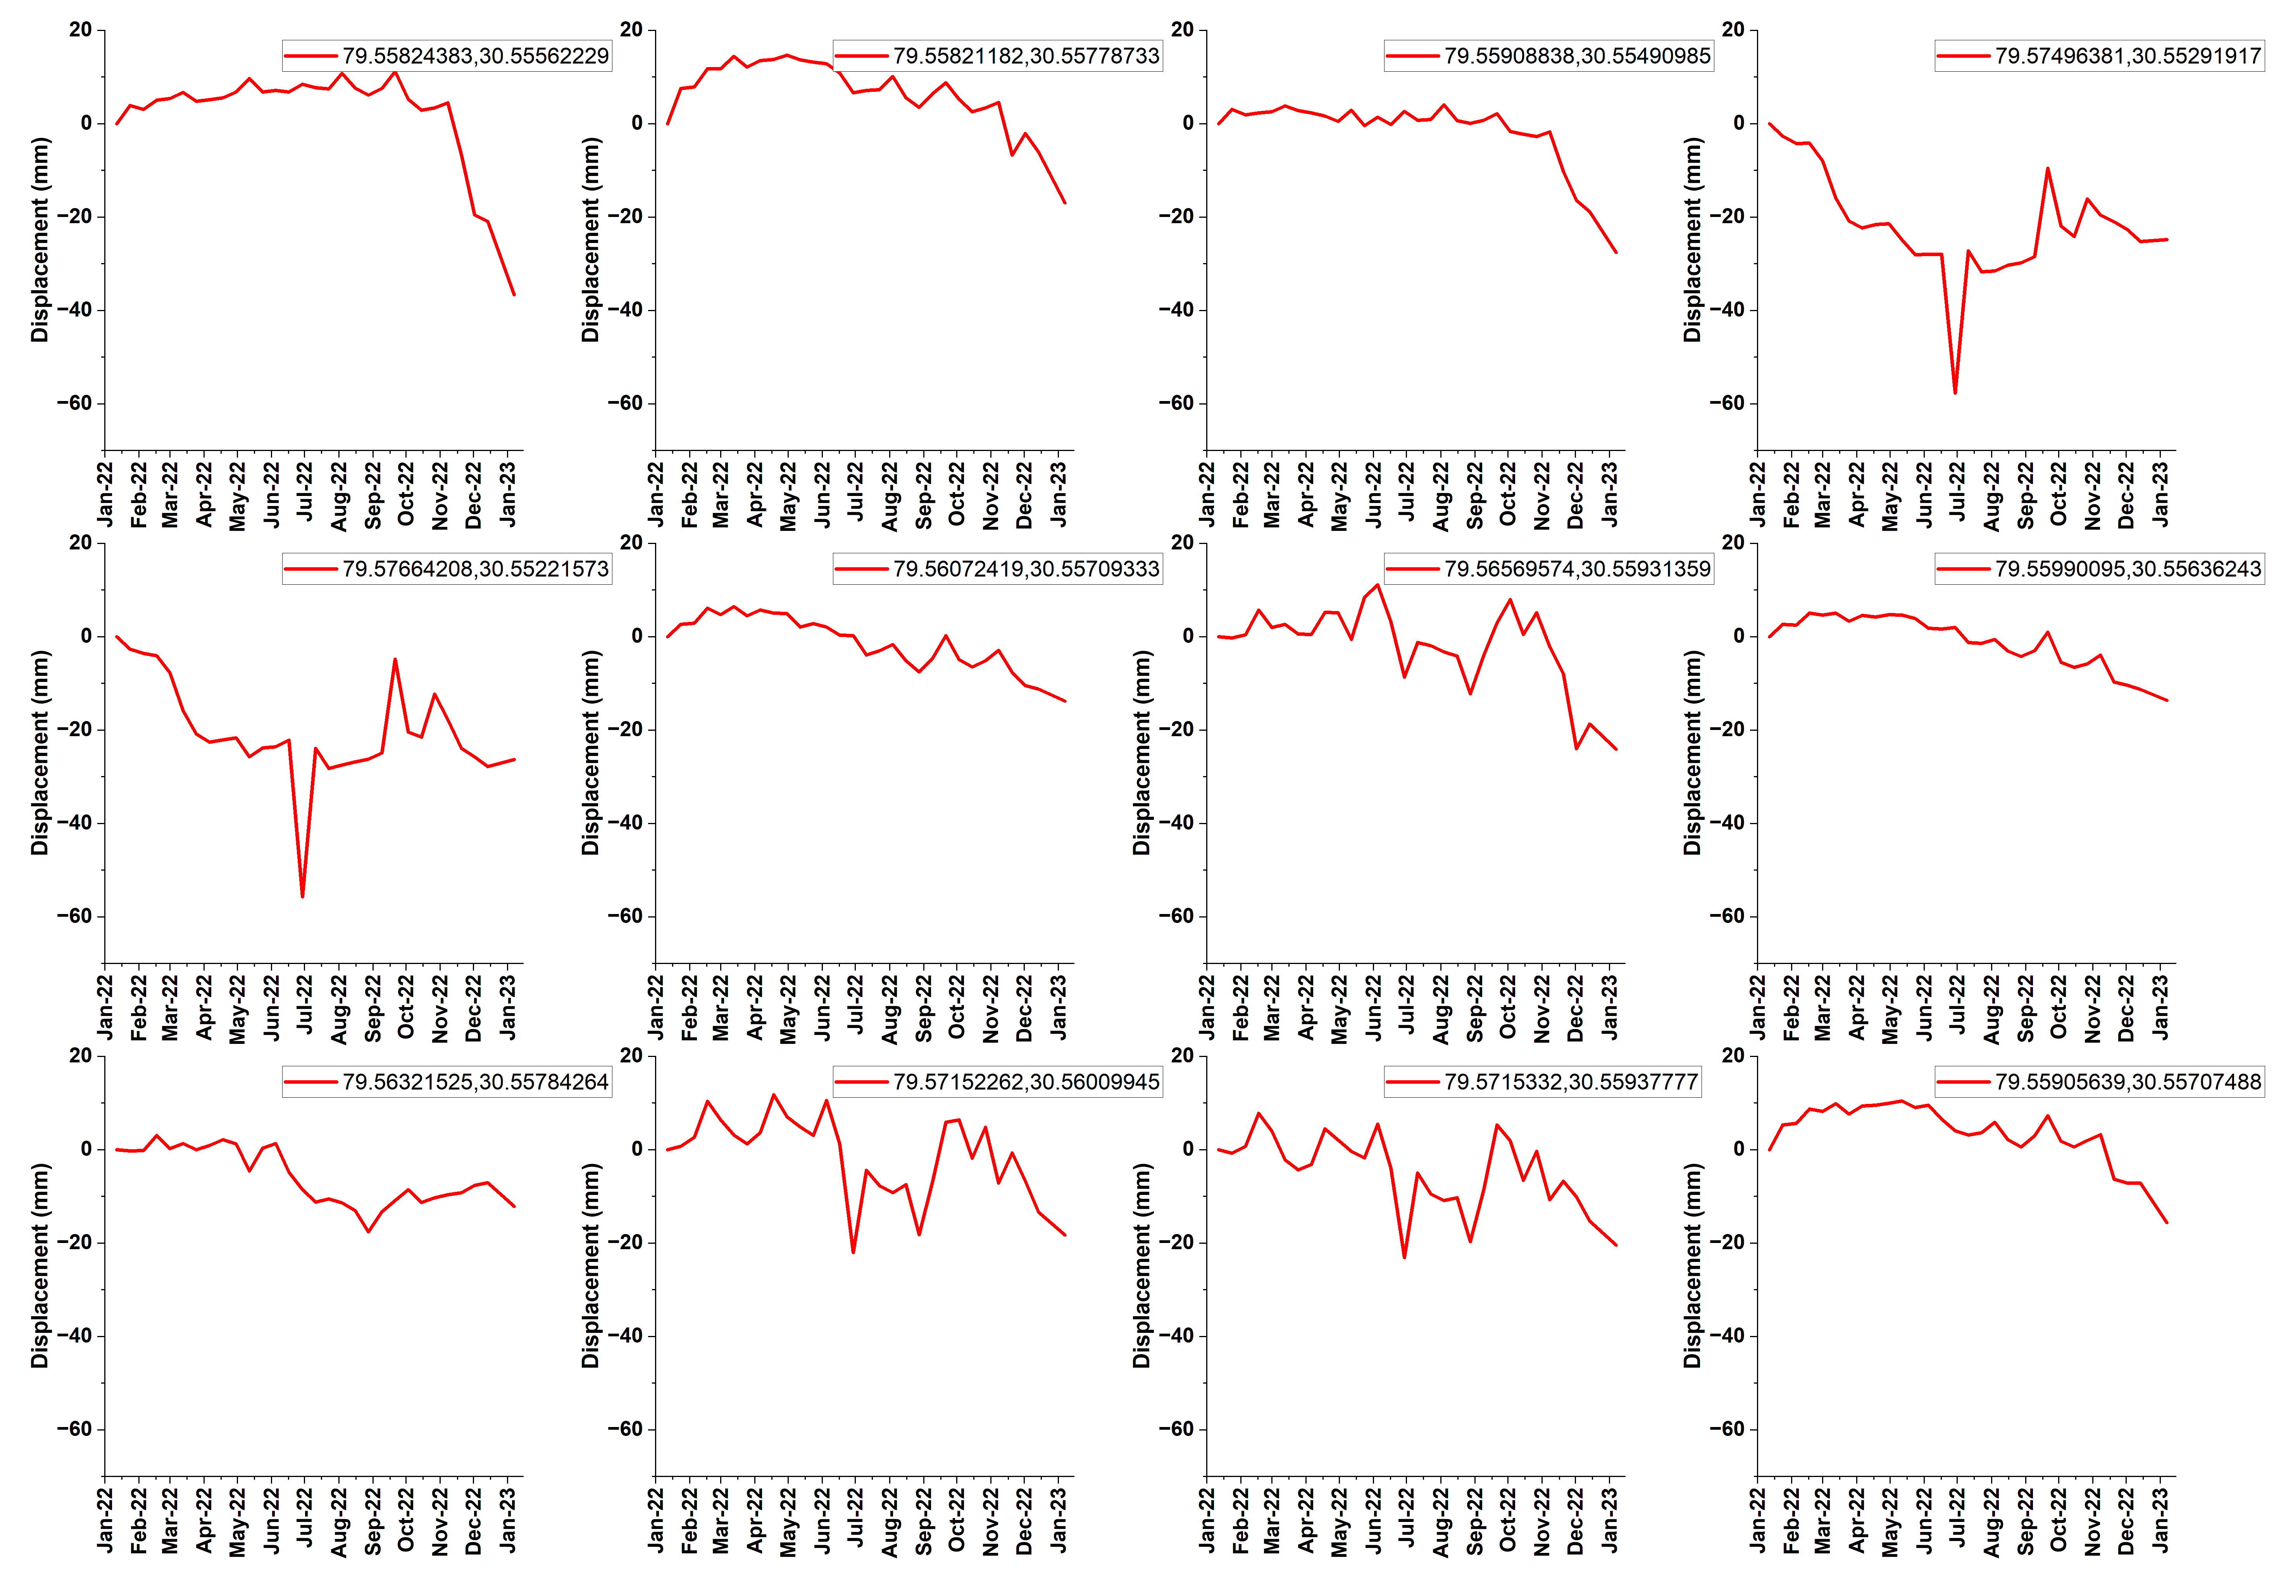

Figure S7. (Latitude and Longitude mentioned in every plot)
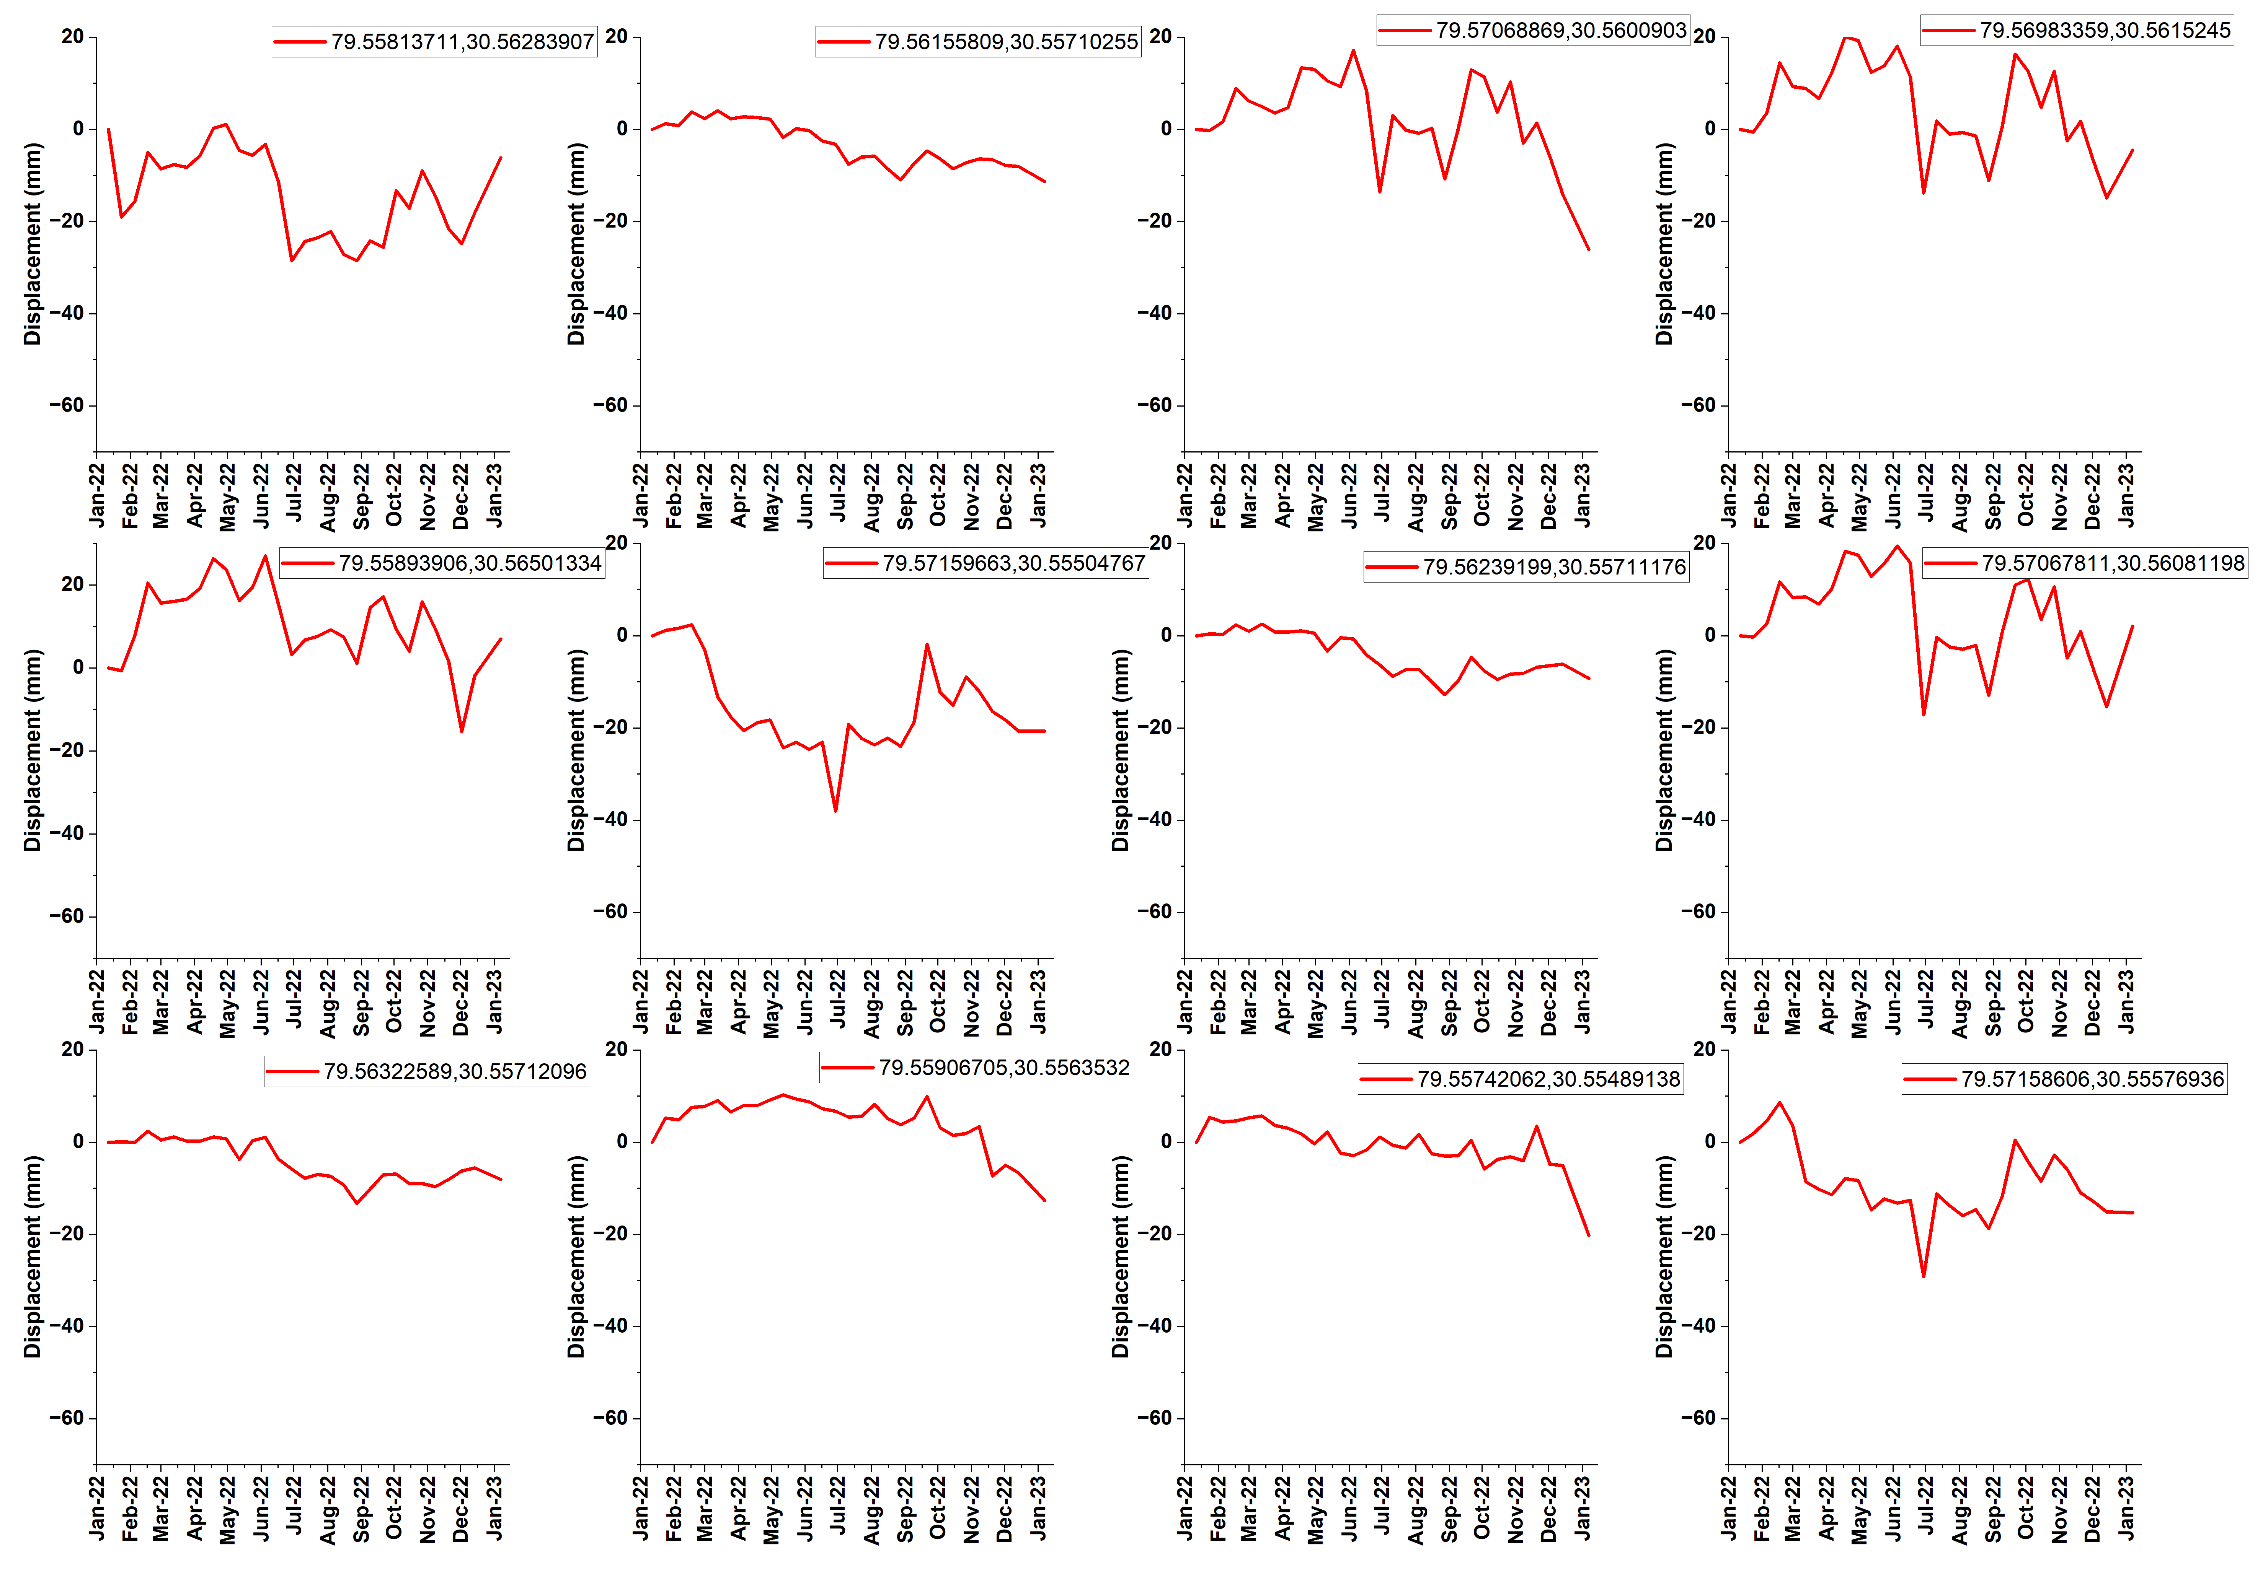

Figure S8. (Latitude and Longitude mentioned in every plot)
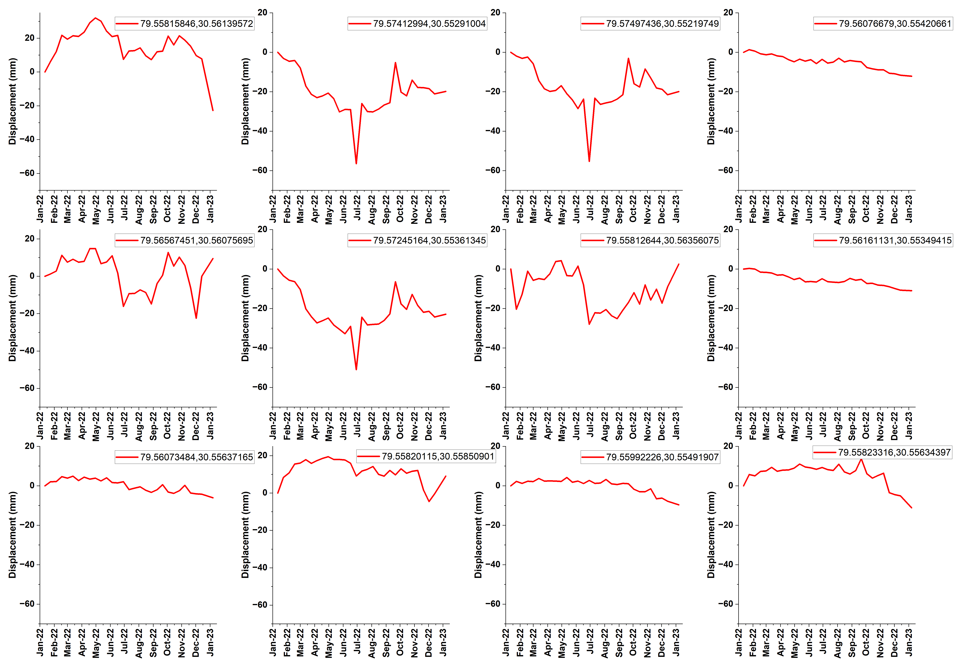

Figure S9. (Latitude and Longitude mentioned in every plot)
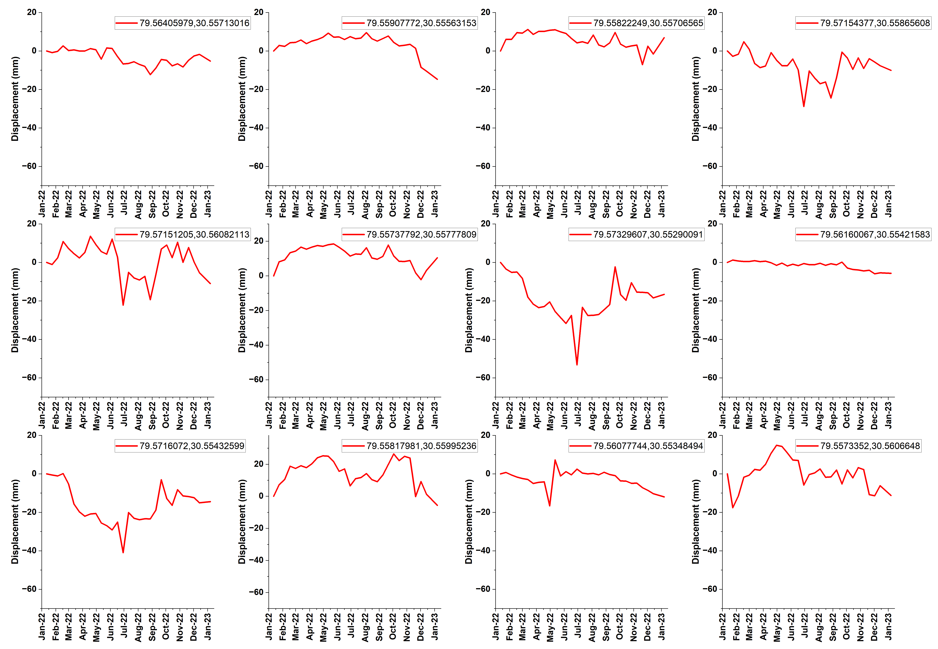

Figure S10. (Latitude and Longitude mentioned in every plot)
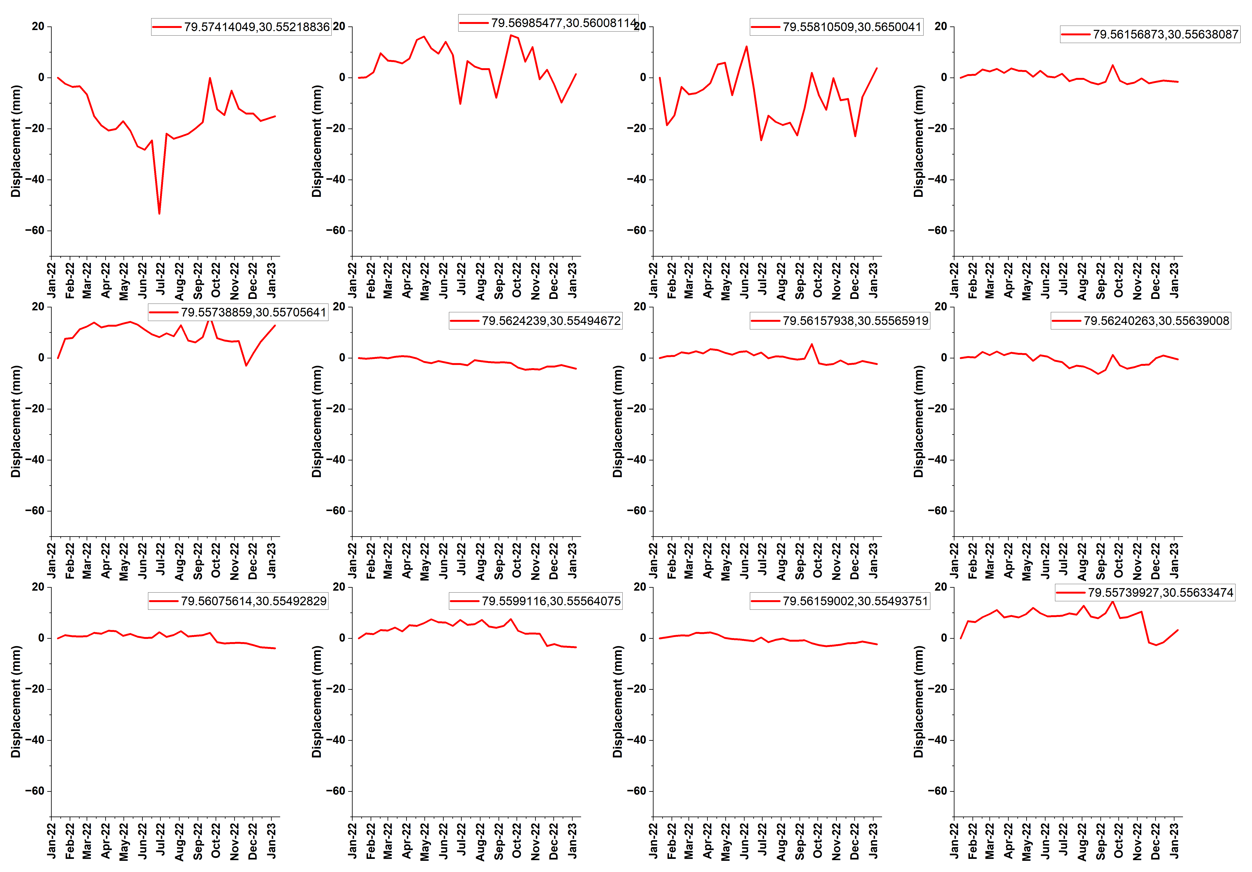

Figure S11. (Latitude and Longitude mentioned in every plot)
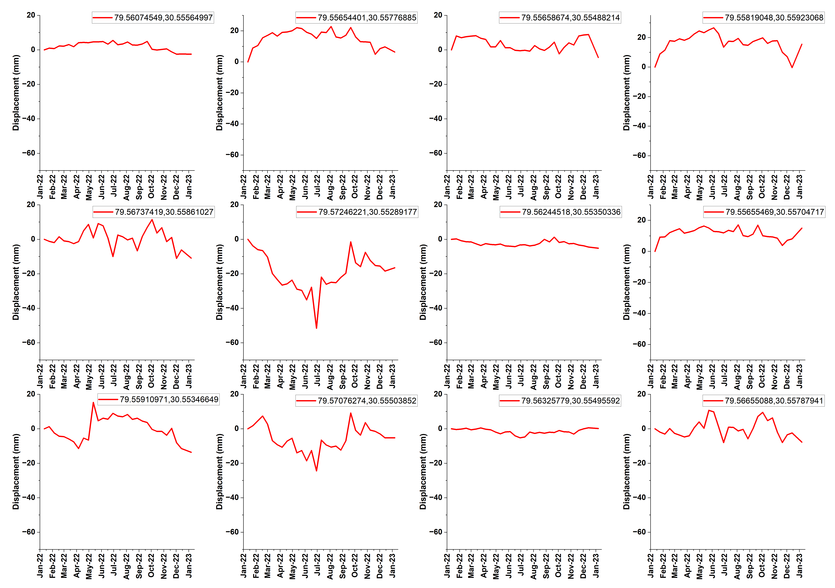

Table S1. Files generated through ASF HyP3
Name of the file | Format of the file | Mandatory/Optional
Wrapped Interferogram | PNG image, KMZ file, GeoTIFF | Optional
Unwrapped Interferogram | GeoTIFF, PNG image, KMZ file | Mandatory
Line-of-Sight Displacement Map | GeoTIFF | Optional
Vertical Displacement Map | GeoTIFF | Optional
Coherence Map | GeoTIFF | Mandatory
Amplitude Image | GeoTIFF | Mandatory
Parameter Documentation | Text File | Mandatory
Look Vector Maps | GeoTIFF | Optional
Incidence Angle Maps | GeoTIFF | Optional
DEM used to process the data | GeoTIFF | Optional
Water Mask | GeoTIFF | Mandatory

References
- Kannaujiya, S., Yadav, R. K., Champati ray, P. K., Sarkar, T., Sharma, G., Chauhan, P., Pal, S. K., Roy, P. N. S., Gautam, P. K., Taloor, A. K., & Yadav, A. (2022). Unraveling seismic hazard by estimating prolonged crustal strain buildup in Kumaun-Garhwal, Northwest Himalaya using GPS measurements. Journal of Asian Earth Sciences, 223, 104993. https://doi.org/10.1016/j.jseaes.2021.104993
- Kumar, P., Kumar, A., & Sinvhal, A. (2011). Assessment of seismic hazard in Uttarakhand Himalaya. Disaster Prevention and Management: An International Journal, 20(5), 531–542. https://doi.org/10.1108/09653561111178961
- CHAMOLI DISTRICT AT A GLANCE. (2006). http://cgwb.gov.in/District_Profile/Uttarakhand/Chamoli.pdf, Accessed on January 16, 2023.
- Karra, K., Kontgis, C., Statman-Weil, Z., Mazzariello, J. C., Mathis, M., & Brumby, S. P. (2021, July 1). Global land use / land cover with Sentinel 2 and deep learning. IEEE Xplore. https://doi.org/10.1109/IGARSS47720.2021.9553499.
- Vincent, P., Bourbigot, M., Johnsen, H., Piantanida, R., & Hajduch, G. (2020). Sentinel-1 ESA Unclassified For Official Use Sentinel-1 Product Specification. https://sentinel.esa.int/documents/247904/1877131/Sentinel-1-Product-Specification
- Yunjun, Z., Fattahi, H., & Amelung, F. (2019). Small baseline InSAR time series analysis: Unwrapping error correction and noise reduction. Computers & Geosciences, 133, 104331. https://doi.org/10.1016/j.cageo.2019.104331
- Hu, B., & Li, Z. (2021). Time-Series InSAR Technology for Ascending and Descending Orbital Images to Monitor Surface Deformation of the Metro Network in Chengdu. IEEE Journal of Selected Topics in Applied Earth Observations and Remote Sensing, 14, 12583–12597. https://doi.org/10.1109/jstars.2021.3130584
- Hogenson, K., Kristenson, H., Kennedy, J., Johnston, A., Rine, J., Logan, T., Zhu, J., Williams, F., Herrmann, J., Smale, J., & Meyer, F. (2020). Hybrid Pluggable Processing Pipeline (HyP3): A cloud-native infrastructure for generic processing of SAR data [Computer software]. https://doi.org/10.5281/zenodo.4646138
- Heim, A., and A. Gansser (1939), Central Himalayas—Geological observations of Swiss expedition, 1936, Mem. Soc. Helv. Sci. Nat., 73, 1–245.
- Auden, J. B. (1935), Traverses in the Himalaya, Rec. Geol. Surv. India, 69, 123 – 167
- Valdiya, K. S., Aspects of Tectonics—Focus on South Central Asia (Tata McGraw Hill Publ. Co., N. Delhi 1984) pp. 319.
- Mishra Commission, 1964, Report of the Commission set up by the Government of India vide letter No. 142/23-5/44/76 dated 08.04.1976.
- Shanker, P., Casu, F., Zebker, H. A., & Lanari, R. (2011). Comparison of Persistent Scatterers and Small Baseline Time-Series InSAR Results: A Case Study of the San Francisco Bay Area. IEEE Geoscience and Remote Sensing Letters, 8(4), 592–596. https://doi.org/10.1109/lgrs.2010.2095829
- Faunalia. (n.d.). faunalia / ps-speed · GitLab. GitLab. Retrieved January 15, 2023, from https://gitlab.com/faunalia/ps-speed/
- Galloway, Devin & Bawden, Gerald & Leake, Stanley & Honegger, DG. (2008). Land subsidence hazards. Landslide and land subsidence hazards to pipelines. US Geol Surv Open-File Rep. 1164.
- Budhu, M., & Adiyaman, I. B. (2009). Mechanics of land subsidence due to groundwater pumping. International Journal for Numerical and Analytical Methods in Geomechanics, 34(14), 1459–1478. https://doi.org/10.1002/nag.863
- Tripathi, N.; Singh, R.S. Underground Coal Mine Subsidence Impacts Forest Ecosystem. 2010. Available online: https://www.researchgate.net/publication/275207695 (accessed on 14, January 2023)
- Stumpf, A.J. (2013). Hydrocompaction Subsidence. In: Bobrowsky, P.T. (eds) Encyclopedia of Natural Hazards. Encyclopedia of Earth Sciences Series. Springer, Dordrecht. https://doi.org/10.1007/978-1-4020-4399-4_177
- Marfai, M.A., King, L. Monitoring land subsidence in Semarang, Indonesia. Environ Geol 53, 651–659 (2007). https://doi.org/10.1007/s00254-007-0680-3
- Tosi, L., Teatini, P. & Strozzi, T. Natural versus anthropogenic subsidence of Venice. Sci Rep 3, 2710 (2013). https://doi.org/10.1038/srep02710
- Dixon, Timothy & Amelung, Falk & Ferretti, Alessandro & Novali, Fabrizio & Rocca, Fabio & Dokka, Roy & Sella, G. & Kim, Sang-Wan & Wdowinski, Shimon & Whitman, Dean. (2006). Subsidence and flooding in New Orleans. Nature. 441. 587-588. 10.1038/441587a.
- Buckley, S. M. (2003). Land subsidence in Houston, Texas, measured by radar interferometry and constrained by extensometers. Journal of Geophysical Research, 108(B11). https://doi.org/10.1029/2002jb001848
- Poreh, D., Pirasteh, S. & Cabral-Cano, E. Assessing subsidence of Mexico City from InSAR and LandSat ETM+ with CGPS and SVM. Geoenviron Disasters 8, 7 (2021). https://doi.org/10.1186/s40677-021-00179-x
- NAKAJIMA, H., KANEKO, H., & TSUCHIDA, M. (2010). The management of land subsidence and groundwater conservation in Tokyo. Journal of Groundwater Hydrology, 52(1), 35–47. https://doi.org/10.5917/jagh.52.35
- Xu, Yeshuang & Shen, Shui-Long & Ren, Dong-Jie & Wu, Huai-Na. (2016). Analysis of Factors in Land Subsidence in Shanghai: A View Based on a Strategic Environmental Assessment. Sustainability. 8. 573. 10.3390/su8060573.
- Giao, P. & Nutalaya, P.. (2006). Land subsidence in Bangkok, Thailand. Engineering Geology. 82. 187-201. 10.1016/j.enggeo.2005.10.004.
- Abidin, H. Z., Andreas, H., Gumilar, I., & Brinkman, J. J. (2015). Study on the risk and impacts of land subsidence in Jakarta. Proceedings of the International Association of Hydrological Sciences, 372, 115–120. https://doi.org/10.5194/piahs-372-115-2015
- Measuring Subsidence. (n.d.). Harris Galveston Subsidence District. Retrieved June 21, 2022, from https://hgsubsidence.org/science-research/measuring-subsidence/
- Ye, P. Remote Sensing Approaches for Meteorological Disaster Monitoring: Recent Achievements and New Challenges. Int. J. Environ. Res. Public Health 2022, 19, 3701. https://doi.org/10.3390/ijerph19063701
- Shi, X., Zhang, L., Balz, T., & Liao, M. (2015). Landslide deformation monitoring using point-like target offset tracking with multi-mode high-resolution TerraSAR-X data. ISPRS Journal of Photogrammetry and Remote Sensing, 105, 128–140. https://doi.org/10.1016/j.isprsjprs.2015.03.017
- Monserrat, O., Crosetto, M., & Luzi, G. (2014). A review of ground-based SAR interferometry for deformation measurement. ISPRS Journal of Photogrammetry and Remote Sensing, 93, 40–48. https://doi.org/10.1016/j.isprsjprs.2014.04.001
- Li, S., Xu, W., & Li, Z. (2022). Review of the SBAS InSAR Time-series algorithms, applications, and challenges. Geodesy and Geodynamics, 13(2), 114–126. https://doi.org/10.1016/j.geog.2021.09.007
- Qiang, X. (2020). Accuracy detection of Satellite and InSAR Technology in the Deformation Monitoring in Civil Engineering. IOP Conference Series: Earth and Environmental Science, 580, 012066. https://doi.org/10.1088/1755-1315/580/1/012066
- Farneti E, Cavalagli N, Costantini M, et al. A method for structural monitoring of multispan bridges using satellite InSAR data with uncertainty quantification and its pre-collapse application to the Albiano-Magra Bridge in Italy. Structural Health Monitoring. 2023;22(1):353-371. doi:10.1177/14759217221083609
- Richard A. Schultz, Khalid A. Soofi, Peter H. Hennings, Xiaopeng Tong, and David T. Sandwell, (2014), "Using InSAR to detect active deformation associated with faults in Suban field, South Sumatra Basin, Indonesia," The Leading Edge 33: 882–884, 886–888. https://doi.org/10.1190/tle33080882.1
- Liu C, Ji L, Zhu L, Zhao C. InSAR-Constrained Interseismic Deformation and Potential Seismogenic Asperities on the Altyn Tagh Fault at 91.5–95°E, Northern Tibetan Plateau. Remote Sensing. 2018; 10(6):943. https://doi.org/10.3390/rs10060943
- Garthwaite, M. C., Miller, V. L., Saunders, S., Parks, M. M., Hu, G., & Parker, A. L. (2019). A Simplified Approach to Operational InSAR Monitoring of Volcano Deformation in Low- and Middle-Income Countries: Case Study of Rabaul Caldera, Papua New Guinea. Frontiers in Earth Science, 6. https://doi.org/10.3389/feart.2018.00240
- Barone A, Pepe A, Tizzani P, Fedi M, Castaldo R. New Advances of the Multiscale Approach for the Analyses of InSAR Ground Measurements: The Yellowstone Caldera Case-Study. Remote Sensing. 2022; 14(21):5328. https://doi.org/10.3390/rs14215328
- Solari, L.; Del Soldato, M.; Raspini, F.; Barra, A.; Bianchini, S.; Confuorto, P.; Casagli, N.; Crosetto, M. Review of Satellite Interferometry for Landslide Detection in Italy. Remote Sens. 2020, 12, 1351. https://doi.org/10.3390/rs12081351
- Rao, Y.S. (2011). Synthetic Aperture Radar (SAR) Interferometry for Glacier Movement Studies. In: Singh, V.P., Singh, P., Haritashya, U.K. (eds) Encyclopedia of Snow, Ice and Glaciers. Encyclopedia of Earth Sciences Series. Springer, Dordrecht. https://doi.org/10.1007/978-90-481-2642-2_618
- Agapiou, Athos & Lysandrou, Vasiliki. (2020). Detecting Displacements Within Archaeological Sites in Cyprus After a 5.6 Magnitude Scale Earthquake Event Through the Hybrid Pluggable Processing Pipeline (HyP3) Cloud-Based System and Sentinel-1 Interferometric Synthetic Aperture Radar (InSAR) Analysis. IEEE Journal of Selected Topics in Applied Earth Observations and Remote Sensing. 13. 10.1109/JSTARS.2020.3028272.
- Truckenbrodt, J., Freemantle, T., Williams, C., Jones, T., Small, D., Dubois, C., Thiel, C., Rossi, C., Syriou, A., & Giuliani, G. (2019). Towards Sentinel-1 SAR Analysis-Ready Data: A Best Practices Assessment on Preparing Backscatter Data for the Cube. Data, 4(3), 93. https://doi.org/10.3390/data4030093

