Supplementary materials

- Negative concentrations in Eulerian modelling analyte concentration field

Negative concentrations of analytes were observed at all ion cloud profiles along the entire ion cloud evolution from the ionisation chamber to the top ADMA electrode. It was also observed that refining the mesh reduces the negative concentrations. However, it was not straightforward how to quantify the negative concentrations.

The negatives appeared near the periphery of the ion cloud, see for example, a concentration profile in Fig. 1. They form a 3D negative concentration skin around the ion cloud. The minimal concentration as shown in Fig. 6 (the main text) is a single point in the skin that may or may not be an adequate representation of the effect of the negative concentration on the RP. On the contrary, the mesh size driven runtime has a clear correlation with the RP, Fig. 2. An increase in the runtime due to mesh refining increases the RP.

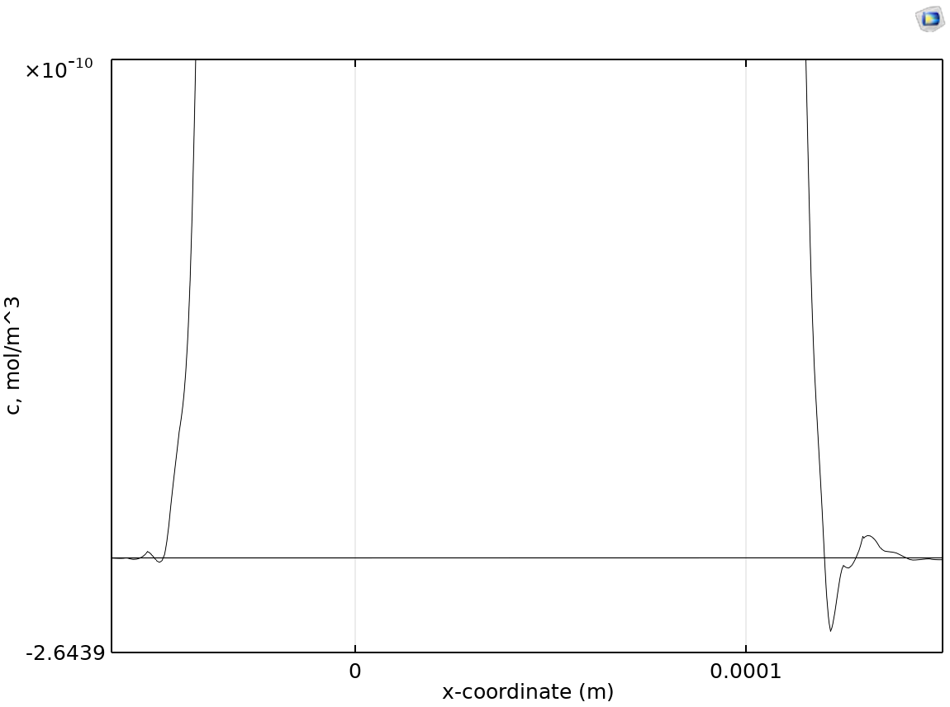
Figure 1. A fragment of the ion cloud concentration profile c(x) for the run shown in Fig. 6 (the main text) at z= - 0.96 mm. The black horizontal line shows c=0.

The runtime is practical because it indicates requirement for computer resources. Numerical problems often need a multi-domain mesh structure with variable density in the domains. The geometry of mesh is also important. It was observed that decreasing the mesh size reduces the minimal negative concentrations and increases the RP. Therefore, an investigation into this phenomenon confirmed this was an artefact that was widening the ion cloud thickness and therefore decreasing the RP.

Figure 2. A normalised RP calculated according to Eulerian approach vs. numerical modelling run time obtained for various Qsh and mesh structures. The RP max was calculated according to expression (1) from the main text.

The appearance of the negative concentration skin around ion clouds creates difficulties with using a Eulerian approach for evaluating the performance of ADMA models. Extrapolation of the RP vs. runtime gives a necessary estimate circa 1,000,000 s (~10 days) runtime to evaluate RP with 10% accuracy using ordinary computers. Alternatively, use of supercomputers may not be cost effective due to a lot of resources required to design the model and the mesh. In this way we are in a grey area perhaps beyond the science where mathematics cannot provide clear guidance. It seems that a more reliable and practical way is to employ a hybrid approach to evaluate RP from Lagrangian trajectories and the analytical consideration of ion cloud broadening in the ion separation section.

Velocity profile in the ADMA

The velocity magnitude is mainly contributed by velocity of the x-component along the separation air conduit. It is comfortably inside the prescribed upper limit for the COMSOL Multiphysics Navier-Stokes equation module (Mach number Ma<0.3). An important feature of the velocity profile is the flow uniformity in the separation zone -0.7 mm>z>0.75 mm, Fig. 3. It’s very different from the laminar flow velocity profile v_{z} ~z² (Poiseuille law).

A slight asymmetry in the velocity profile near the z=-1 mm and z=1 mm walls is caused by the influence of the ion sample inlet slit. This was confirmed in modelling runs without the slit where the ADMA velocity profile was symmetric.
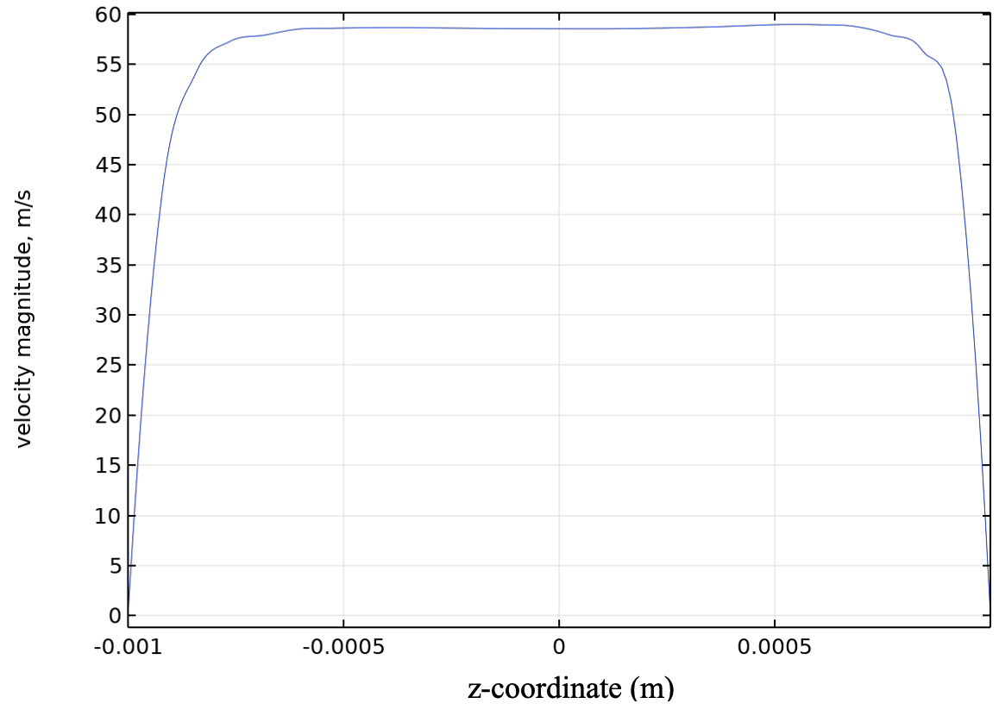
Figure 3. Velocity magnitude in the ADMA ion separation zone at {x=1 mm,y=0,z}. Y-axis is along the inlet ion sample length. Qsh=40 l/min, the ADMA cross-section is 2 mm x 3 mm.

