Supplementary Materials
for
One-Step low temperature synthesis of CeO₂ nanoparticles stabilized by carboxymethylcellulose
Vasily V. Spiridonov¹, Andrey V. Sybachin¹, Vladislava A. Pigareva¹, Mikhail I. Afanasov¹, Sharifjon A. Musoev², Alexander V. Knotko², Sergey B. Zezin¹
¹ Lomonosov Moscow State University, Department of Chemistry, Leninskie gory 1-3, 119991, Moscow, Russia;
² Lomonosov Moscow State University, Faculty of Materials Science, Leninskie gory 1-73, 119991 Moscow, Russia;
Cerium content determination
The determination of the cerium content in the composites was carried out using the UV spectroscopy method. The measurements were carried out on a Specord M40 device from Carl Zeiss (Jena, Germany) in the spectral range from 280 to 500 nm. Sample solutions were prepared to record UV spectra. A calibration graph was built according to the method given in [I D Nickson, I. D.; Boxall, C.; Jackson, A.; Whillock, G O H. A spectrophotometric study of cerium IV and chromium VI species in nuclear fuel reprocessing process streams, Materials Science and Engineering 2010, 9, 012011]. To construct this calibration graph, weighed amounts of cerium ammonium nitrate 0.5 mg, 1 mg, 1.5 mg and 2 mg were dissolved in 100 µl of concentrated H₂SO₄. Then 10 ml of an aqueous solution containing 0.1% wt. silver nitrate and 0.2 g ammonium persulfate was added to solutions. After that, the UV spectra of the obtained solutions were recorded in the wavelength range from 200 to 500 nm and the absorption intensity was measured at a wavelength of 310 nm, D_{λ=310 nm}. Absorption spectra of solutions containing cerium ions of various concentrations and a calibration are presented in Supplementary materials Figure S1.
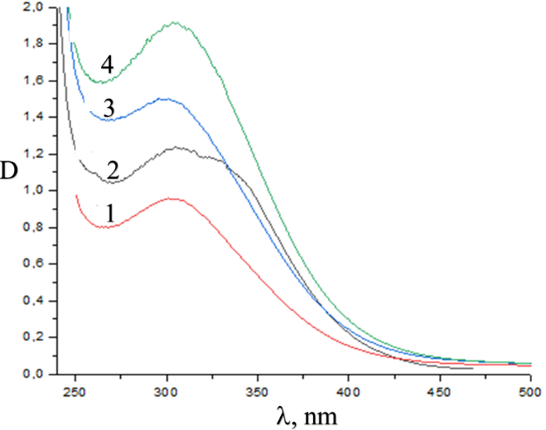
a | b

Figure S1. UV spectra of (NH₄)₂Ce(NO₃)₆ solutions (a) and the calibration curve for the determination of Ce⁴⁺ ions in solution an λ = 310 nm (b). Concentrations: 0.05 mg/ml (1); 0.1 mg/ml (2); 0.15 mg/ml (3); 0.2 mg/ml (4).

