Supplementary materials

Supplementary Table S1. Soil pH, soil organic carbon (SOC), soil total nitrogen (STN), litter organic carbon (LOC), litter total nitrogen (LTN), tea bag organic carbon (TOC) and tea bag total nitrogen (TTN) in green and red tea bags measured at the beginning of the trial (28 November). Each value represents the mean (± SD) from four measurements (n = 4).

Soil pH | SOC  (g kg^{‒1}) | STN  (g kg^{‒1}) | LOC  (g kg^{‒1}) | LTN  (g kg^{‒1}) | TOC_{green}  (g kg^{‒1}) | TTN_{green}  (g kg^{‒1}) | TOC_{red}  (g kg^{‒1}) | TTN_{red}  (g kg^{‒1})
7.40 ± 0.03 | 43.3 ± 0.21 | 1.45 ± 0.02 | 40.8 ± 2.39 | 5.27 ± 0.87 | 39.7 ± 1.01 | 2.76 ± 0.09 | 43.0 ± 1.17 | 0.71 ± 0.02

Supplementary Table S2. ANOVA statistics of soil and litter parameters. Soil organic carbon (SOC); soil total nitrogen (STN); litter organic carbon (LOC); litter total nitrogen (LTN); organic carbon in green tea bags (TOC_{green}); total nitrogen in green tea bags (TTN_{green}); organic carbon in red tea bags (TOC_{red}); total nitrogen in red tea bags (TTN_{red}); soil carbon to nitrogen ratio (Soil C/N); litter carbon to nitrogen ratio (Litter C/N); carbon to nitrogen ratio in green tea bags (Green tea C/N); carbon to nitrogen ratio in red tea bags (Red tea C/N); soil pH; stabilization factor of tea bags (S_{TBI}); decomposition constant of tea bags (k_{TBI}); percentage of litter decomposed (d_{litter}).

Parameter | F value - Treatment | P value - Treatment | F value -  Treatment × Species | P value -  Treatment × Species
SOC | 33.543 | 0.00009 | 5.263 | 0.02285
STN | 18.450 | 0.00104 | 26.351 | 0.00004
LOC | 26.590 | 0.00024 | 8.688 | 0.00465
LTN | 385.457 | 0.00000 | 0.416 | 0.66911
TOC_{green} | 23.331 | 0.00041 | 3.213 | 0.07627
TTN_{green} | 19.497 | 0.00084 | 70.360 | 0.00000
TOC_{red} | 0.997 | 0.33785 | 13.826 | 0.00077
TTN_{red} | 0.369 | 0.55501 | 113.303 | 0.00000
Soil C/N | 0.096 | 0.76155 | 20.270 | 0.00014
Litter C/N | 121.392 | 0.00000 | 4.212 | 0.04114
Green tea C/N | 6.932 | 0.02186 | 10.097 | 0.00268
Red tea C/N | 2.498 | 0.14001 | 86.193 | 0.00000
Soil pH | 511.078 | 0.00000 | 1.284 | 0.31243
S_{TBI} | 7.871 | 0.01588 | 0.211 | 0.81272
k_{TBI} | 7.302 | 0.01923 | 0.174 | 0.84266
d_{litter} | 17.714 | 0.00121 | 0.098 | 0.90741

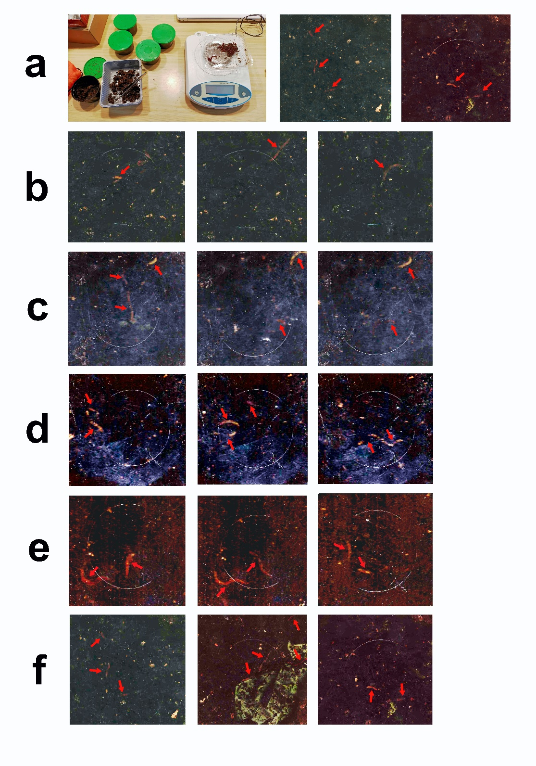
Supplementary Figure S1. (row a) Earthworm weighting at the beginning of the trial and images shot on 1 December; (row b) images shot on 3 January; (row c) images shot on 1 February; (row d) images shot on 28 February; (row e) images shot on 15 March; (row f) images shot on 30 March. Red arrows indicate earthworms.

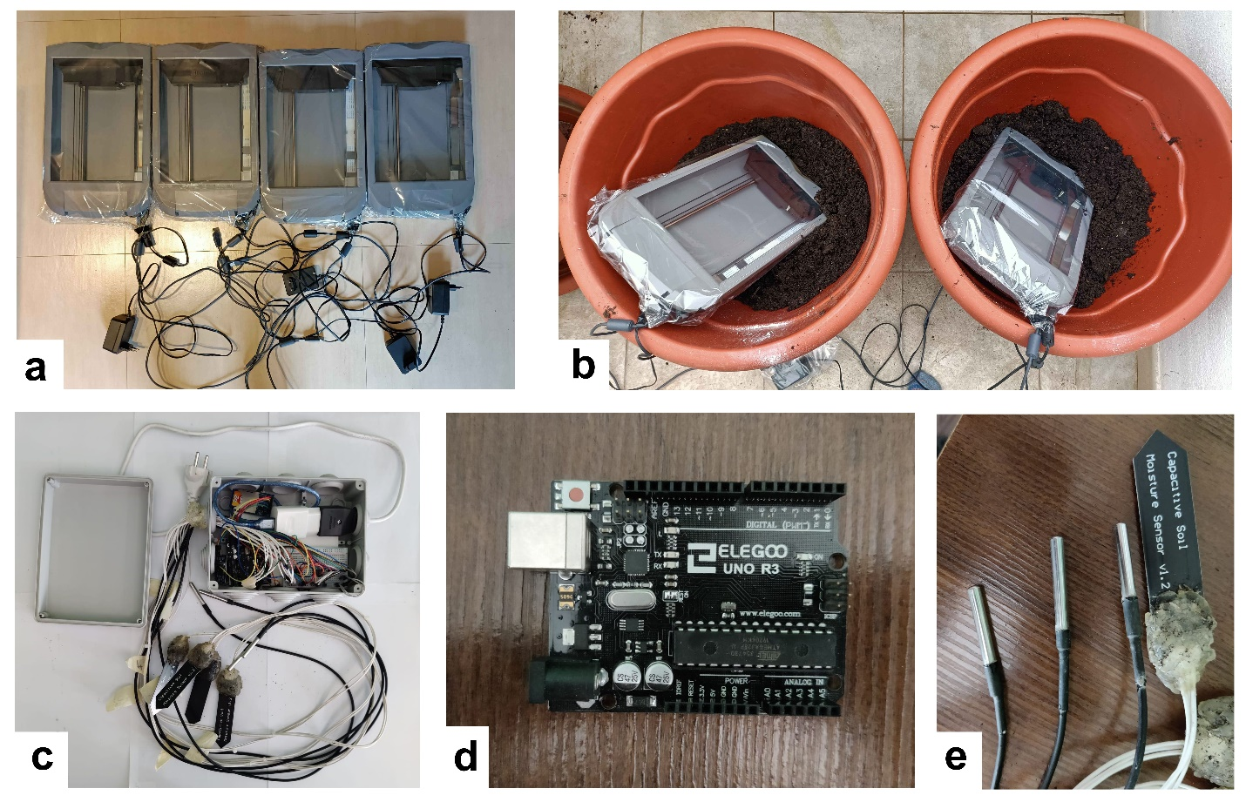

Supplementary Figure S2. (a) The four image scanners used and sealed; (b) two image scanners placed inside the pots; (c) the datalogger used for the measurement of soil temperature and soil water content; (d) board with integrated microcontroller; (e) temperature and capacitive sensors.

Supplementary Figure S3. Relative abundance (> 1%) of bacterial families in soils under different treatments, consisting of broccoli with earthworms (BR_{earth}), faba bean with earthworms (FB_{earth}), broccoli without earthworms (BR_{no-earth}), and faba bean without earthworms (FB_{no-earth}). Ward's clustering method, using Euclidean distance, was used to estimate the distance among all bacterial families in response to the soil treatments. The measures within each treatment are in triplicate.

Supplementary Figure S4. Relative abundance (> 1%) of bacterial genera in soils under different treatments, consisting of broccoli with earthworms (BR_{earth}), faba bean with earthworms (FB_{earth}), broccoli without earthworms (BR_{no-earth}), and faba bean without earthworms (FB_{no-earth}). Ward's clustering method, using Euclidean distance, was used to estimate the distance among all bacterial genera in response to the treatments. The measures within each treatment are in triplicate.

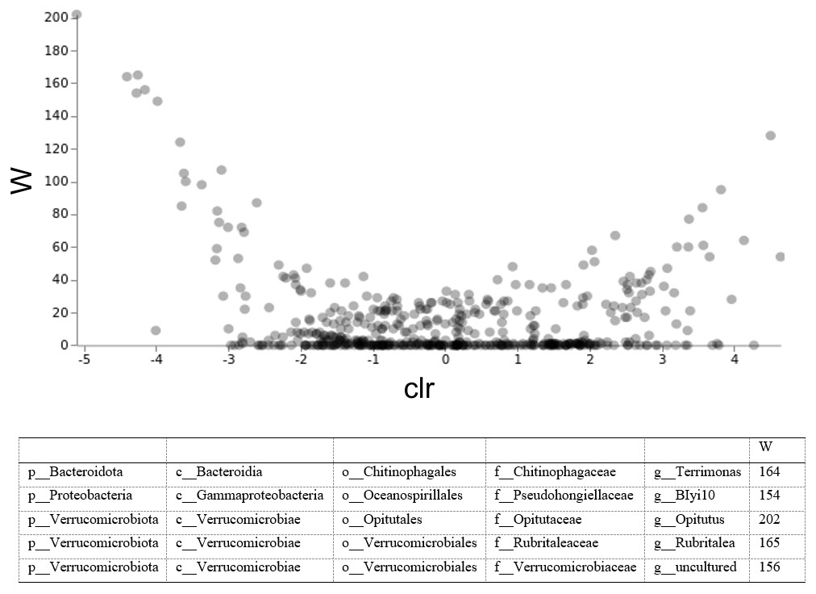

Supplementary Figure S5. ANCOM differential abundance volcano plot: BR_{earth} (broccoli with earthworms) vs BR_{no-earth} (broccoli without earthworms) The x-axis value represents the centered log ratio (clr) transformed F statistic (between groups). The y-axis value represents the empirical distribution of W (the number of times of the null-hypothesis was rejected. Taxa with rejected null-hypothesis are shown (p: phyla; c: class; o: order; f: family; g: genus). The measures within each treatment are in triplicate.

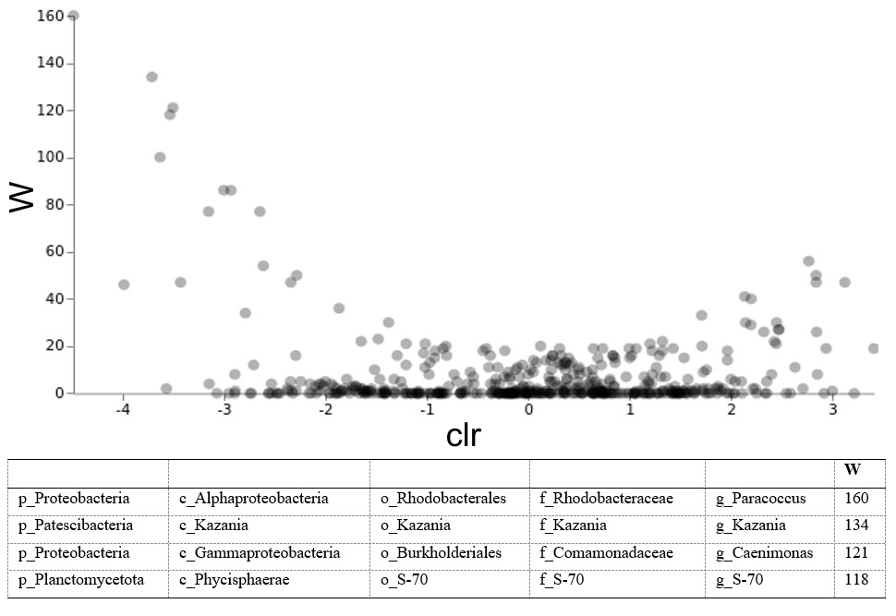

Supplementary Figure S6. ANCOM differential abundance volcano plot: FB_{earth} (faba bean with earthworms) vs FB_{no-earth} (faba bean without earthworms). The x-axis value represents the centered log ratio (clr) transformed F statistic (between groups). The y-axis value represents the empirical distribution of W (the number of times of the null-hypothesis was rejected. Taxa with rejected null-hypothesis are shown (p: phyla; c: class; o: order; f: family; g: genus). The measures within each treatment are in triplicate.

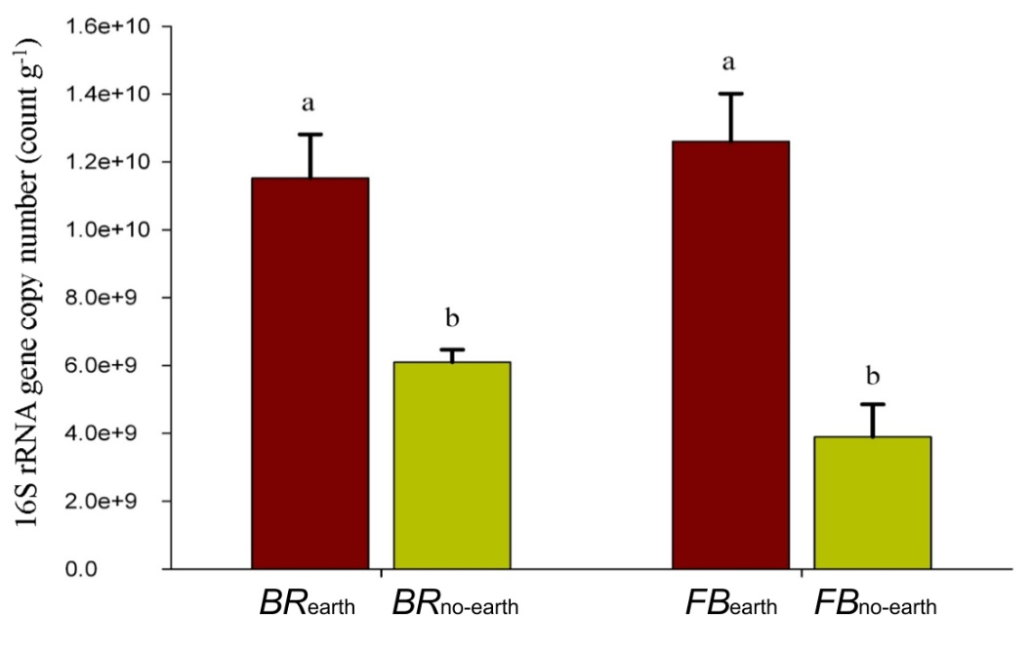
Supplementary Figure S7. 16S rRNA gene copies number in soils under different treatments, consisting of broccoli with earthworms (BR_{earth}), broccoli without earthworms (BR_{no-earth}), faba bean with earthworms (FB_{earth}), and faba bean without earthworms (FB_{no-earth}). Means with similar letters are not significantly different at 5% probability level (Tukey's HSD test). The measures within each treatment are in triplicate.

