Supplementary Materials:
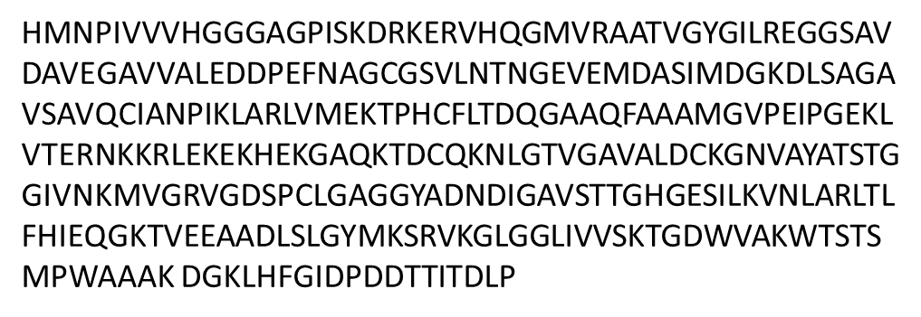
Figure S1. Amino acid sequence of Homo sapiens Asparaginase 4O0H extracted from the Protein Data Bank website.
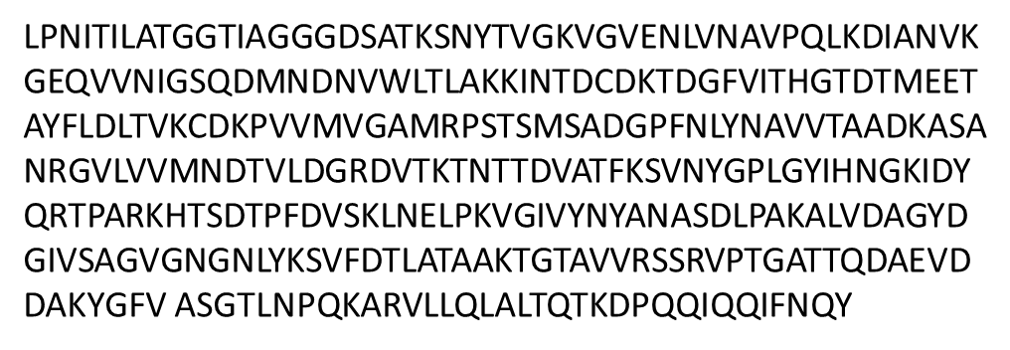
Figure S2. Amino acid sequence of Escherichia coli Asparaginase 3ECA extracted from the Protein Data Bank website.
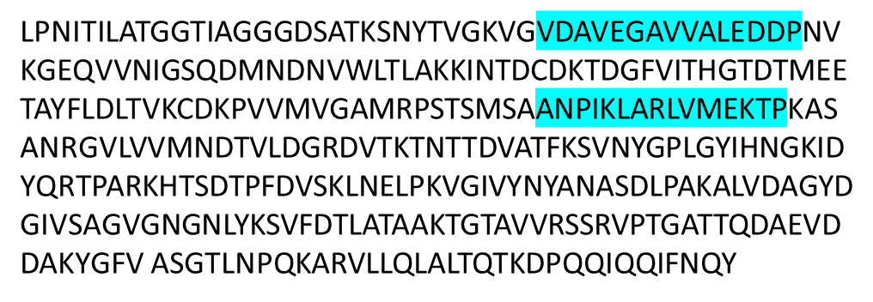
Figure S3. Amino acid sequence of Humanized Chimeric Asparaginase engineered with human asparaginase fragments. The residues corresponding to human asparginase that were inserted as substituents in the E.coli enzyme are highlighted in blue.

