Supplementary Materials

Stress-inducible SCAN transcription factors suppress stress response and are biomarkers for better prognoses in cancers

Takanori Eguchi ^{1,}*, Mona Sheta ^{1,2}, and Stuart K. Calderwood ³

¹ Department of Dental Pharmacology, Faculty of Medicine, Dentistry and Pharmaceutical Sciences, Okayama University, Okayama 700-8525, Japan; mona.anas@nci.cu.edu.eg (M.S.)
² Department of Cancer Biology, National Cancer Institute, Cairo University, Cairo 11796, Egypt.
³ Department of Radiation Oncology, Beth Israel Deaconess Medical Center, Harvard Medical School, Boston, MA 02115, USA; scalderw@bidmc.harvard.edu
* Correspondence: eguchi@okayama-u.ac.jp; Phone: +81 86 235 6661, Fax +81 86 235 6664

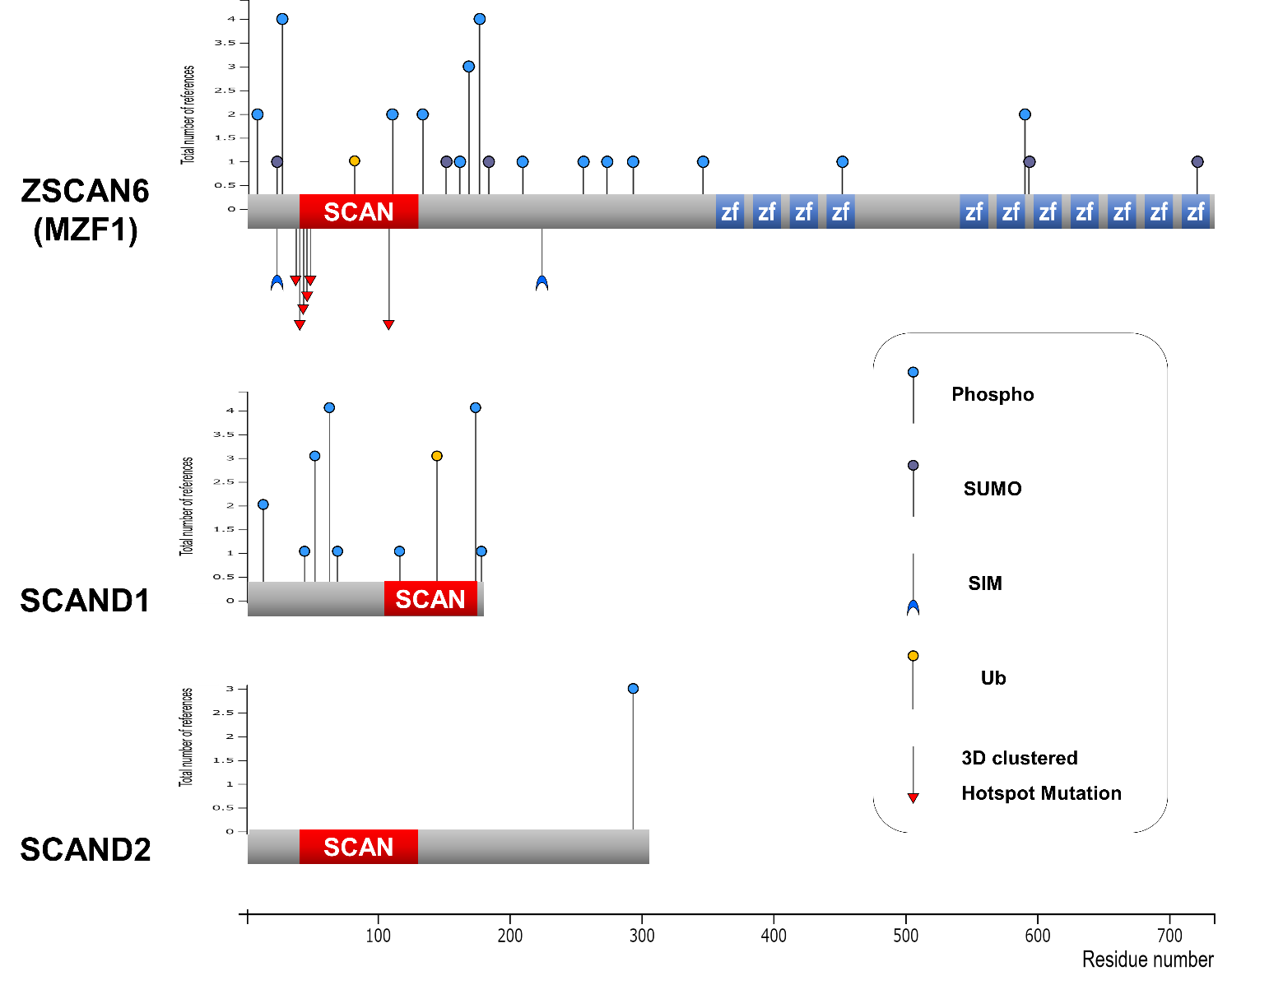
Figure S1. Protein structures of MZF1(ZSCAN6), SCAND1, and SCAND2. Post-translational modifications (PTM) and hotspot mutation were mapped. SCAN, SCAN domain. zf, zinc finger domain. Phospho, phosphorylation site. SUMO, sumoylation site. SIM, SUMO interaction motif. Ub, ubiquitination site. Some PTMs were shown in a ref. (Eguchi T et al., 2015, J Cell Biochem 116). This figure was shown as a supplemental item in ref. (Eguchi T et al., 2022, Cells 11).

Table S1. Co-expression correlation of SCAN-TF genes vs. HSPs in prostate adenocarcinoma specimens.
vs MZF1 |  |  |  | vs SCAND1 |  |  |  | vs SCAND2
Correlated Gene | Spearman's Correlation | p-Value | q-Value | Correlated Gene | Spearman's Correlation | p-Value | q-Value | Correlated Gene | Spearman's Correlation | p-Value | q-Value
HSPBP1 | 0.504 | 8.89E-33 | 2.82E-31 | HSPBP1 | 0.778 | 2.90E-100 | 1.81E-97 | HSPBP1 | 0.159 | 4.34E-04 | 1.54E-03
HSPA13 | -0.448 | 1.75E-25 | 3.29E-24 | HSPA13 | -0.572 | 7.79E-44 | 1.05E-42 | HSPA13 | -0.357 | 4.18E-16 | 9.13E-15
HSPA4 | -0.358 | 3.41E-16 | 2.70E-15 | HSPA4 | -0.303 | 7.97E-12 | 2.47E-11 | HSPA4 | -0.394 | 1.52E-19 | 4.80E-18
HSPBAP1 | 0.354 | 6.99E-16 | 5.37E-15 | HSPBAP1 | 0.347 | 2.94E-15 | 1.09E-14 | HSPBAP1 | 0.281 | 2.62E-10 | 2.80E-09
HSPB11 | 0.352 | 1.08E-15 | 8.16E-15 | HSPB11 | 0.516 | 1.36E-34 | 1.20E-33 | HSPB11 | 0.248 | 2.99E-08 | 2.35E-07
HSPA4L | -0.326 | 1.58E-13 | 9.53E-13 | HSPA4L | -0.411 | 2.66E-21 | 1.32E-20 | HSPA4L | -0.0341 | 0.452 | 0.571
HSP90AA1 | -0.321 | 3.63E-13 | 2.11E-12 | HSP90AA1 | -0.188 | 2.86E-05 | 5.87E-05 | HSP90AA1 | -0.32 | 4.34E-13 | 6.62E-12
HSPH1 | -0.3 | 1.42E-11 | 6.96E-11 | HSPH1 | -0.191 | 2.20E-05 | 4.55E-05 | HSPH1 | -0.312 | 1.67E-12 | 2.37E-11
HSPA7 | 0.298 | 1.69E-11 | 8.21E-11 | HSPA7 | 0.241 | 7.45E-08 | 1.84E-07 | HSPA7 | 0.277 | 4.54E-10 | 4.67E-09
HSPB9 | 0.278 | 4.05E-10 | 1.70E-09 | HSPB9 | 0.342 | 7.59E-15 | 2.76E-14 | HSPB9 | 0.269 | 1.64E-09 | 1.56E-08
HSP90B3P | -0.246 | 3.47E-08 | 1.20E-07 | HSP90B3P | -0.403 | 1.78E-20 | 8.51E-20 | HSP90B3P | -0.242 | 6.29E-08 | 4.72E-07
HSPE1 | 0.216 | 1.38E-06 | 3.98E-06 | HSPE1 | 0.392 | 2.07E-19 | 9.38E-19 | HSPE1 | -0.124 | 6.20E-03 | 0.0161
HSPB8 | -0.21 | 2.79E-06 | 7.77E-06 | HSPB8 | -0.0333 | 0.463 | 0.528 | HSPB8 | 0.0593 | 0.191 | 0.293
HSPB7 | -0.203 | 6.01E-06 | 1.61E-05 | HSPB7 | -0.0237 | 0.602 | 0.66 | HSPB7 | 0.0263 | 0.563 | 0.672
HSPA12A | -0.203 | 6.43E-06 | 1.72E-05 | HSPA12A | -0.149 | 9.59E-04 | 1.69E-03 | HSPA12A | 0.0673 | 0.138 | 0.225
HSP90AB4P | 0.184 | 4.27E-05 | 1.03E-04 | HSP90AB4P | 0.189 | 2.55E-05 | 5.25E-05 | HSP90AB4P | 0.149 | 9.91E-04 | 3.21E-03
HSPA1B | 0.176 | 9.23E-05 | 2.14E-04 | HSPA1B | 0.274 | 7.90E-10 | 2.19E-09 | HSPA1B | -0.0374 | 0.41 | 0.531
HSPA5 | -0.174 | 1.11E-04 | 2.54E-04 | HSPA5 | -0.212 | 2.41E-06 | 5.40E-06 | HSPA5 | -0.29 | 6.94E-11 | 8.09E-10
HSPA8 | -0.157 | 5.07E-04 | 1.06E-03 | HSPA8 | -0.352 | 1.07E-15 | 4.07E-15 | HSPA8 | -0.274 | 7.08E-10 | 7.10E-09
HSPG2 | -0.151 | 7.93E-04 | 1.62E-03 | HSPG2 | -0.282 | 2.42E-10 | 6.88E-10 | HSPG2 | -0.0246 | 0.587 | 0.693
HSP90AB2P | -0.15 | 8.69E-04 | 1.76E-03 | HSP90AB2P | -0.268 | 1.92E-09 | 5.20E-09 | HSP90AB2P | -0.202 | 6.80E-06 | 3.55E-05
HSPA6 | 0.145 | 1.36E-03 | 2.69E-03 | HSPA6 | 0.163 | 2.94E-04 | 5.49E-04 | HSPA6 | 0.0642 | 0.157 | 0.25
HSPA1A | 0.137 | 2.49E-03 | 4.72E-03 | HSPA1A | 0.279 | 3.51E-10 | 9.90E-10 | HSPA1A | -0.0836 | 0.0651 | 0.121
HSPB6 | -0.134 | 2.95E-03 | 5.54E-03 | HSPB6 | 0.102 | 0.0244 | 0.0364 | HSPB6 | 0.0603 | 0.183 | 0.283
HSPA14 | -0.117 | 9.41E-03 | 0.0163 | HSPA14 | -0.277 | 5.08E-10 | 1.42E-09 | HSPA14 | -0.0762 | 0.0928 | 0.163
HSP90B1 | -0.112 | 0.0132 | 0.0223 | HSP90B1 | -0.167 | 2.04E-04 | 3.87E-04 | HSPB1 | 0.034 | 0.454 | 0.572
HSPB3 | -0.112 | 0.0137 | 0.023 | HSPB3 | 0.0262 | 0.563 | 0.625 | HSPB3 | -0.0508 | 0.263 | 0.377
HSPA1L | 0.0931 | 0.0397 | 0.0615 | HSPA1L | 0.0935 | 0.039 | 0.0564 | HSPA1L | 0.156 | 5.28E-04 | 1.84E-03
HSP90AB1 | -0.0746 | 0.0996 | 0.142 | HSP90AB1 | -0.11 | 0.0155 | 0.0238 | HSP90AB1 | -0.276 | 5.67E-10 | 5.76E-09
HSPB2 | -0.0639 | 0.159 | 0.215 | HSPB2 | 0.177 | 8.44E-05 | 1.66E-04 | HSPB2 | 0.109 | 0.0159 | 0.0366
HSPB1 | 0.0573 | 0.207 | 0.271 | HSPB1 | 0.45 | 9.36E-26 | 5.66E-25 | HSP90B1 | -0.244 | 4.93E-08 | 3.74E-07
HSPA9 | -0.0491 | 0.279 | 0.351 | HSPA9 | -0.208 | 3.71E-06 | 8.17E-06 | HSPA9 | -0.246 | 3.54E-08 | 2.76E-07
HSPA2 | -0.042 | 0.354 | 0.431 | HSPA2 | 0.204 | 5.40E-06 | 1.18E-05 | HSPA2 | -0.0254 | 0.576 | 0.684
HSPD1 | -0.0358 | 0.43 | 0.508 | HSPD1 | -0.0162 | 0.721 | 0.767 | HSPD1 | -0.26 | 5.75E-09 | 5.05E-08
HSPB1P1 | 0.0191 | 0.675 | 0.736 | HSPB1P1 | 0.406 | 9.63E-21 | 4.65E-20 | HSPB1P1 | 0.0196 | 0.665 | 0.757
HSPA12B | 0.0161 | 0.723 | 0.778 | HSPA12B | 0.0806 | 0.0754 | 0.104 | HSPA12B | 0.135 | 2.77E-03 | 7.98E-03
Spearman’s correlation < -0.25 were shown in red. p-Values < 1E-10 were shown in yellow. q-Values < 1E-10 were shown in green.
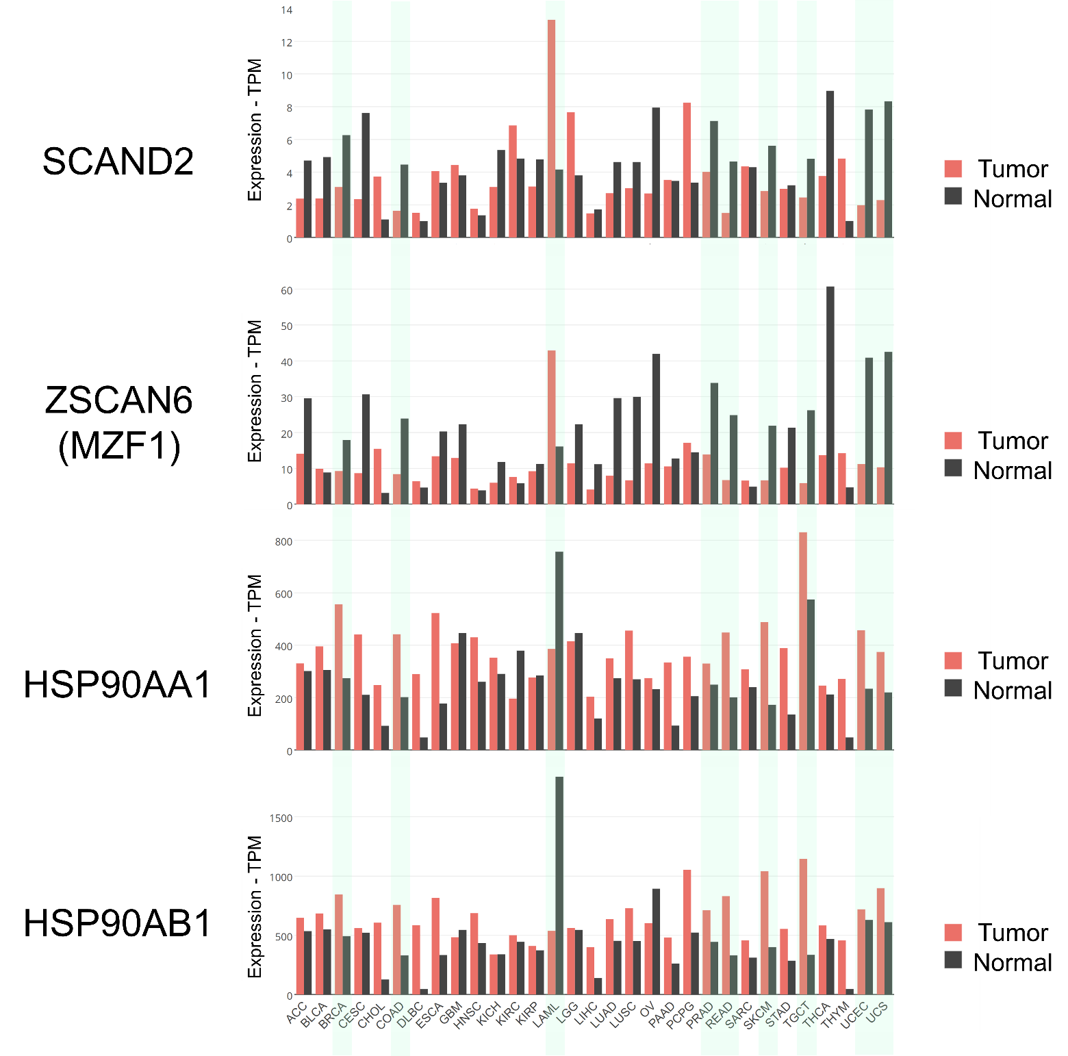
Figure S2. Gene expression profiling of SCAND2, ZSCAN6(MZF1), and HSP90 genes in various tumor types vs. paired normal tissues.

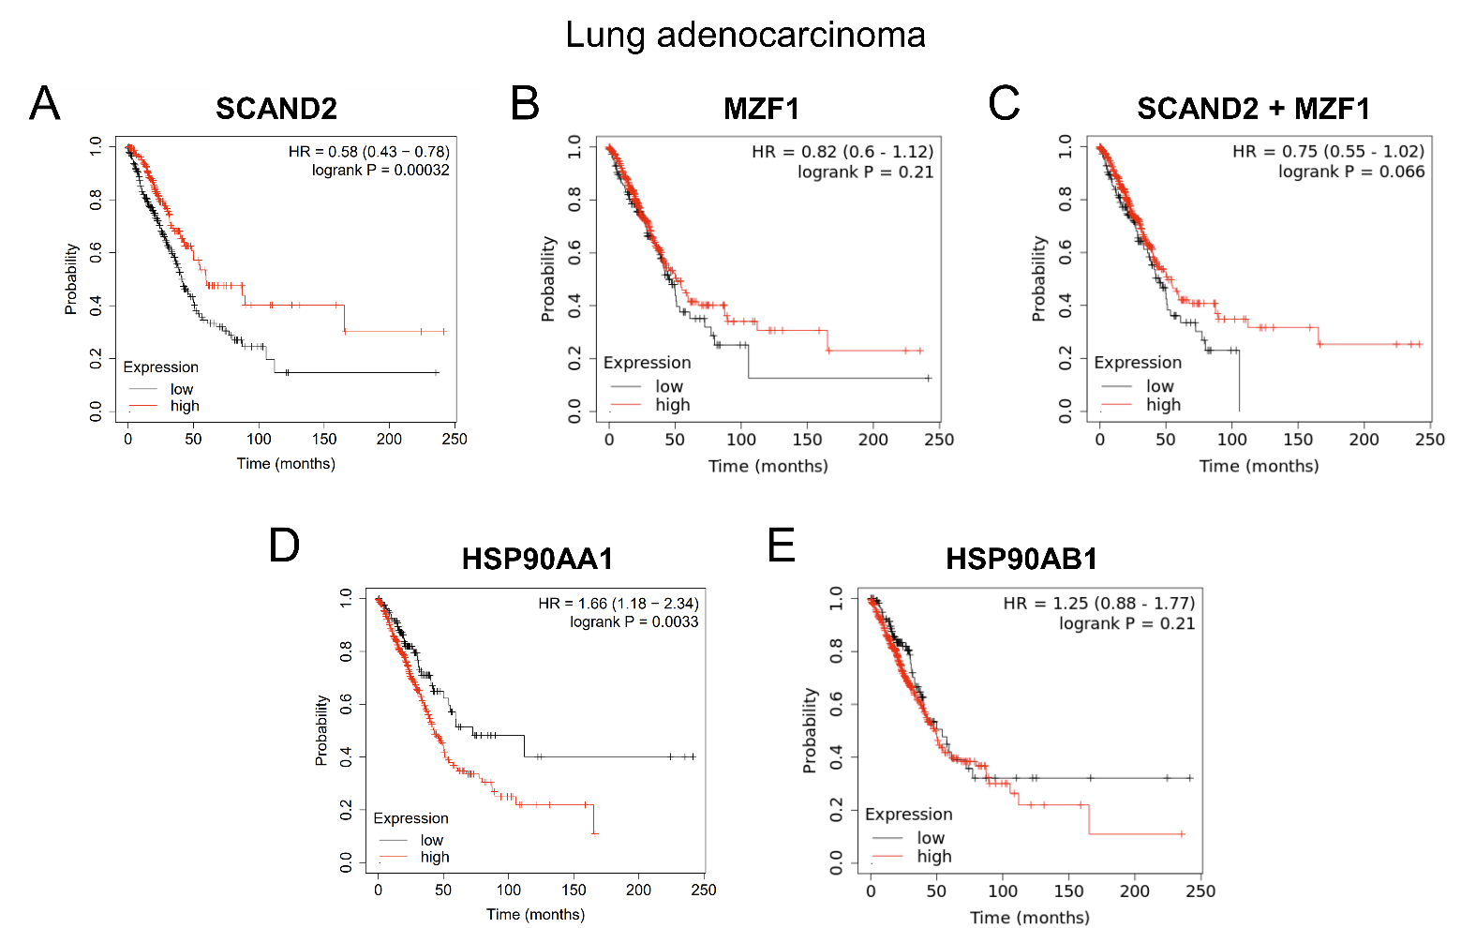
Figure S3. Kaplan-Meier analysis of SCAN-TFs and HSP90 expression in lung adenocarcinoma. SCAND2 and MZF1 expression are correlated with a better prognosis, whereas HSP90 expression is correlated with a poor prognosis of lung adenocarcinoma.

