Supplementary file PDA-CMCs-HEC hydrogels
Figure S1: Swelling factor as a function of HEC content
Figure S2: IR spectra of (a) chitosan (CS) and (b) carboxymethyl chitosan (RCOOH)
Figure S3: IR spectra of hydrogels prepared by crosslinking different ratios of HEC
Figure S4: IR spectra of (a) PDA and (b) PDA-ZnO NPs
Figure S5: X-ray diffractogram of CS, HEC and CMCs-HEC
Figure S6: X-ray diffractogram of citric acid
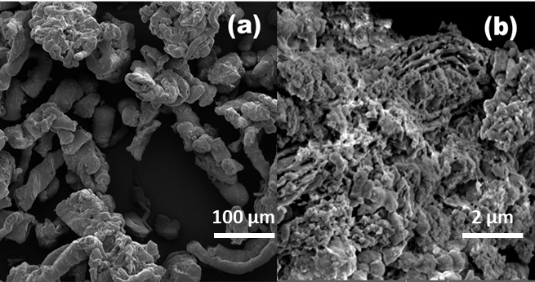
Figure S7: SEM Micrographs of (a) HEC and (b) CMCsNa
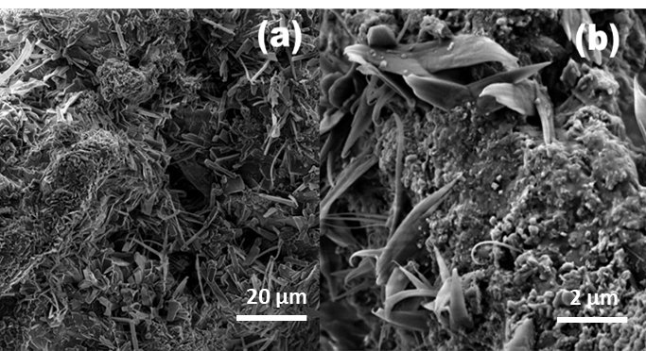
Figure S8: SEM Micrographs of PDA nanosheets on PDA-CMCs-ZnO-HEC
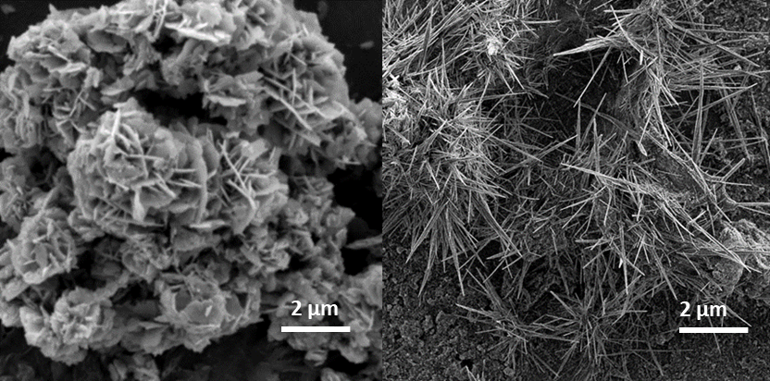
Figure S9: SEM micrographs of ZnO nanorods on PDA-ZnO-CMCs-HEC
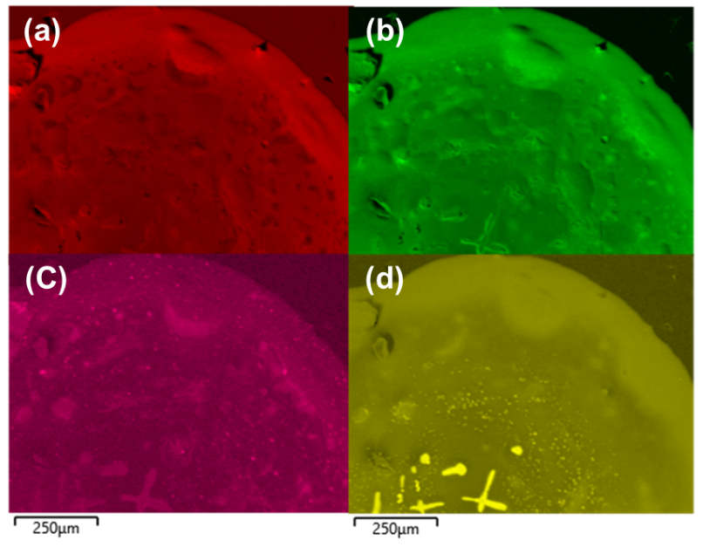
Figure S10: Elemental mapping showing (a) carbon (b) oxygen (c) zinc (d) chlorine

Figure S11 MIC of composite hydrogels without PDA-ZnO against E. coli.

Figure S12: MIC of composite hydrogels with PDA-ZnO against E. coli.

