Supplementary Information
MOCVD-grown Ga₂O₃ as a gate dielectric on AlGaN/GaN based heterojunction field effect transistor.
Samiul Hasan^{1*}, Mohi Uddin Jewel¹, Scott R. Crittenden², Dongkyu Lee³, Vitaliy Avrutin⁴, Ümit Özgür⁴, Hadis Morkoç⁴, and Iftikhar Ahmad¹*
¹Department of Electrical Engineering, University of South Carolina, Columbia, SC 29208, USA
²Department of Physics and Astronomy, University of South Carolina, Columbia, SC 29208, USA
³Department of Mechanical Engineering, University of South Carolina, Columbia, SC 29208, USA
⁴Department of Electrical and Computer Engineering, Virginia Commonwealth University, Richmond, VA 23284, USA
E-mail: shasan@email.sc.edu, ahmad@cec.sc.edu

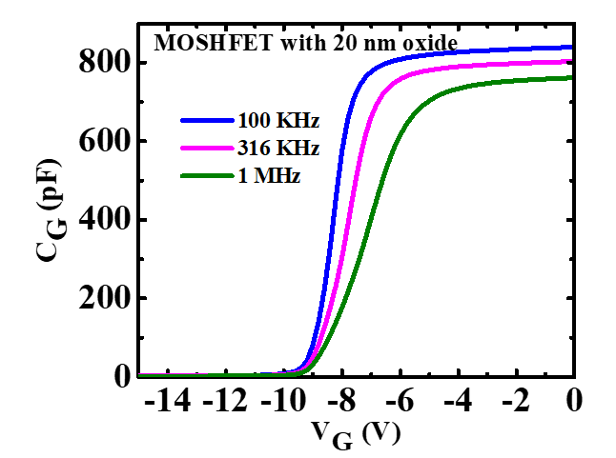
(a)

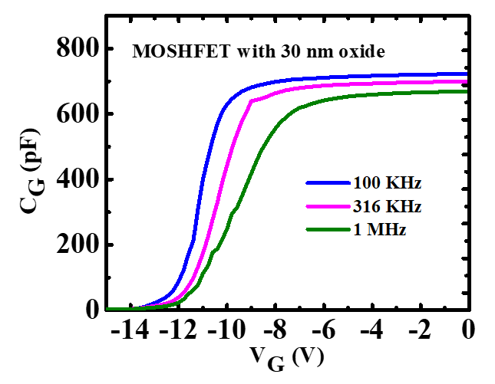
(b)
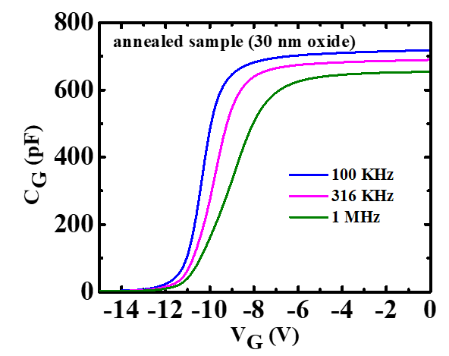
(c)

Figure S1. Frequency-dependent CV measurements of MOSHFET with (a) 20 nm thick gate oxide (b) 30 nm thick gate oxide, and (c) annealed 30 nm thick gate oxide.

