Supplement 1. The Preterm Birth Risk Assessment Scale-Korean Version [PBRAS-23-K]
We would like to evaluate the preterm labor risk by assessing what symptom(s) you experienced during your pregnancy, specifically from the 20th week of pregnancy to labor.
Please check V for the following questions that apply to you.
Questions | Never  (0) | Rarely  (1) | Sometimes  (2) | Often  (3)
1. I have anemia (hemoglobin level lower than 10 g/dL).
2. I feel depressed.
3. I don’t take the prescribed medication.
4. I cannot sleep well.
5. My belly feels tight and hard often.
6. I feel pelvic pressure.
7. I feel deep penetrating pain.
8. I have dull pain in my back and belly.
9. I have lots of stress (at home/work).
10. I feel very sensitive (at home/work).
11. It is hard to work on my feet (at home/work).
12. I have too heavy of a workload (at home/work).
13. I have intense muscle pain.
14. I’m worried about the baby being born too early.
15. I try to hang tight even for one more day for my baby.
16. I feel nervous to hear that I have a short cervix.
17. I feel sad to hear that I could have preterm labor.
18. I get stressed by hearing negative things from my doctor.
19. I feel stressed by being responsible for all of the housework.
20. I rest fewer than two hours a day.
21. I get annoyed at my husband from time to time.
22. I eat fewer than four times a day.
23. What I want from my husband is not to do anything but to just listen to me, but I am sad he doesn’t understand it.

.

Supplement 2. Internal Consistency of Each Factor
Factor | Number of items (item number) | Mean ± SD | Item mean ± variance | Cronbach’s α
1 | 5 (22, 23, 24, 25, 26) | 9.34±3.86 | 1.87 ±1.09 | .80
2 | 4 (13, 14, 15, 20) | 9.04±3.01 | 1.57± 0.85 | .83
3 | 3 (27, 29, 31) | 3.83±2.46 | 1.28±0.97 | .78
4 | 4 (7, 8, 10, 11) | 5.70±2.65 | 1.43±0.81 | .72
5 | 3 (1, 3, 21) | 1.91±1.92 | 0.64±0.73 | .61
6 | 2 (2, 6) | 3.56±1.34 | 1.78±0.70 | .44
7 | 2 (28, 30) | 3.38±1.52 | 1.69±1.03 | .20
Total | 23 | 33.98±10.43 | 1.48±0.90 | .85
SD: standard deviation

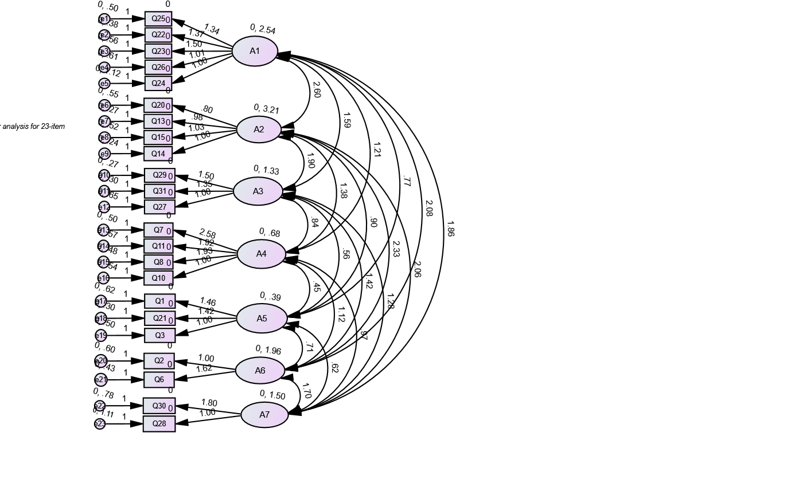
Supplement 3. Confirmatory factor analysis

