Supplementary Materials
Table S1. Descriptive data across willow sexes and streams on the Pumice Plain of Mount St. Helens. Values represent averages and standard errors. Connectivity is a relative measure based on current outputs from Circuitscape and is treated here as unitless [56]. Entries with a sample size of 1 do not have standard errors. NA values indicate lack of sampling at a particular site. Sample sizes (n) are listed on different levels of each parameter given that sample sizes varied across willow sex and stream identity. Overall taxa richness here describes dependent community richness for all individual willow samples. Taxa richness for subsequent analyses varied depending on subsets used for different parameter suites. Abbreviations: C:N molar ratio is %C divided by %N and standardized by the molecular weights of C and N, %CT is percent condensed tannins, and SLA is a standardized measure for specific leaf area.
Data Descriptor | Overall Taxa  Richness | Landscape  Parameter | Litter Chemistry Parameters |  |  |  | Leaf Area  Parameter
 |  | Connectivity  (n) | %C  (n)* | %N | C:N | %CT | SLA  (mm² mg⁻¹; n)
Across willow sexes
Female | 3.27 ± 0.08 | 0.30 ±  0.02 (191) | 46.80 ±  0.26 (16) | 1.26 ±  0.18 | 61.91 ±  8.89 | 13.29 ±  1.95 | 13.49 ±  0.87 (56)
Male | 3.08 ± 0.09 | 0.22 ±  0.02 (144) | 46.95 ±  0.25 (15) | 1.17 ±  0.21 | 71.69 ±  10.27 | 14.74 ±  2.38 | 12.91 ±  0.79 (53)
Across streams
Camp | 3.68 ± 0.23 | 0.16 ±  0.02 (19) | 47.25 (1) | 2.21 | 24.93 | 2.47 | NA
Clear | 3.42 ± 0.23 | 0.27 ±  0.02 (12) | NA | NA | NA | NA | NA
Forsyth | 4.00 ± 0.20 | 0.31 ±  <0.01 (39) | 46.47 ±  0.07 (4) | 2.20 ±  0.10 | 24.80 ±  1.17 | 5.28 ±  0.83 | NA
Geo-W | 2.84 ± 0.10 | 0.22 ±  0.01 (116) | 47.05 ±  0.25 (19) | 0.89 ±  0.13 | 78.81 ±  7.16 | 16.71 ±  1.46 | 13.04 ±  0.70 (70)
Goose | 3.20 ± 0.15 | 0.16 ±  <0.01 (35) | 46.69 ±  0.39 (6) | 1.31 ±  0.41 | 69.20 ±  19.41 | 14.44 ±  4.98 | 17.07 ±  0.54 (29)
Redrock | 2.82 ± 0.17 | 0.06 ±  <0.01 (44) | NA | NA | NA | NA | NA
Willow | 3.39 ± 0.13 | 0.54 ±  0.06 (70) | 45.87 (1) | 1.83 | 29.23 | 6.21 | 3.21 ±  0.15 (10)
*all sample sizes were consistent across chemical parameters

Table S2. Results of Akaike’s Information Criteria (AIC) model selection for our taxa richness generalized linear models (GLMs). We tested all relevant combinations of parameter interactions and included the five best models for each parameter set below, except for the leaf area set which only included two factors. One-parameter models were not included due to lower explanatory value. Bold text and ΔAIC = 0.000 indicate the best model. Abbreviations: k is the number of parameters including the error estimate, L is the log-likelihood measure, AIC is the ranking measure, and ΔAIC is the change in AIC fit from the best model.
Parameters | k | L | AIC | ΔAIC
Landscape Models (n = 335)
Connectivity and Stream | 3 | -498.826 | 1015.653 | 0.000
Connectivity, Willow Sex, Stream, and  Connectivity by Willow Sex | 5 | -498.110 | 1018.220 | 2.567
Connectivity, Willow Sex, and Stream | 4 | -499.503 | 1019.005 | 3.352
Willow Sex and Stream | 3 | -502.911 | 1023.823 | 8.170
Connectivity and Willow Sex | 3 | -520.831 | 1049.661 | 34.008
Litter Chemistry Models (n = 31)
%N, %CT, and Weevils | 4 | -40.386 | 90.771 | 0.000
%N and %CT | 3 | -41.789 | 91.578 | 0.807
%N, %CT, and Willow Sex | 4 | -41.869 | 93.737 | 2.966
%C, %N, and %CT | 4 | -42.671 | 95.343 | 4.572
%C and %N | 3 | -43.716 | 95.433 | 4.662
Leaf Area Models (n = 109)
Specific Leaf Area and Willow Sex | 3 | -162.167 | 332.333 | 0.000
Leaf Area, Willow Sex, and Leaf Area by Willow Sex | 4 | -171.006 | 352.013 | 19.680

Table S3. EM (estimated marginal) means analysis for the stream factor of our taxa richness vs. landscape generalized linear model (Table 1; df = 327). Grouping codes indicate overlaps (same letter is no difference) between levels of the stream factor. Letters were generated using Tukey’s HSD multiple comparisons. Abbreviations: SE is the standard error of the EM mean while lower and upper CLs are the confidence limits of the EM mean based on the SE.
Stream | EM Mean | SE | Lower CL | Upper CL | Group
Redrock | 2.672 | 0.169 | 2.339 | 3.005 | a
Geo-W | 2.799 | 0.010 | 2.603 | 2.996 | a
Goose | 3.119 | 0.182 | 2.760 | 3.478 | ab
Clear | 3.419 | 0.308 | 2.814 | 4.025 | abc
Willow | 3.582 | 0.146 | 3.295 | 3.870 | bc
Camp | 3.607 | 0.246 | 3.123 | 4.092 | bc
Forsyth | 4.030 | 0.171 | 3.694 | 4.366 | c

Table S4. Results of Akaike’s Information Criteria (AIC) model selection for our community dissimilarity permutational MANOVAs (PERMANOVAs). We tested all relevant combinations of parameter interactions and included the five best models for each parameter set below, except for the leaf area set which only included two factors. One-parameter models were not included due to lower explanatory value. Bold text and ΔAIC = 0.000 indicate the best model. Abbreviations: C:N molar ratio is %C divided by %N and standardized by the molecular weights of C and N, k is the number of parameters including the error estimate, L is the log-likelihood measure, AIC is the ranking measure, and ΔAIC is the change in AIC fit from the best model.
Parameters | k | L | AIC | ΔAIC
Landscape Models (n = 335)
Connectivity, Willow Sex, and Stream | 4 | -909.464 | 1046.270 | 0.000
Connectivity, Willow Sex, Stream, and  Connectivity by Willow Sex | 5 | -910.340 | 1047.394 | 1.124
Connectivity and Stream | 3 | -904.233 | 1049.501 | 3.231
Willow Sex and Stream | 3 | -903.726 | 1050.007 | 3.737
Connectivity and Willow Sex | 3 | -834.059 | 1119.675 | 73.231
Litter Chemistry Models (n = 31)
%N and %CT | 3 | -92.689 | 19.765 | 0.000
%N, %CT, and Weevils | 4 | -93.937 | 20.516 | 0.751
%C, %N, C:N, and %CT | 5 | -95.602 | 20.852 | 1.087
%C and %N | 3 | -91.344 | 21.110 | 1.345
%C, %N, and %CT | 4 | -93.004 | 21.449 | 1.684
Leaf Area Models (n = 109)
Specific Leaf Area and Willow Sex | 3 | -282.286 | 235.071 | 0.000
Leaf Area, Willow Sex, and Leaf Area by Willow Sex | 4 | -283.804 | 235.553 | 0.482

Table S5. Pairwise results from the stream factor of our landscape PERMANOVA test (Table 2). Contrasts indicate which stream levels were compared for each row. Bolded rows indicate significant effects at ⍺ = 0.05. A Bonferroni correction method adjusted p-values for pairwise comparisons (Martinez Arbizu 2020). Abbreviations: SS is sum of squares, R² is the correlation coefficient, F is a pseudo-F test statistic, and p is the null model probability parameter.
Contrast 1 | Contrast 2 | SS | F | R² | p-adjusted
Redrock | Geo-W | 0.314 | 8.887 | 0.053 | 0.021
Redrock | Willow | 0.712 | 23.931 | 0.176 | 0.021
Redrock | Camp | 0.384 | 14.431 | 0.191 | 0.021
Redrock | Clear | 0.233 | 9.968 | 0.156 | 0.021
Redrock | Forsyth | 0.405 | 14.891 | 0.155 | 0.021
Redrock | Goose | 0.482 | 15.744 | 0.170 | 0.021
Geo-W | Willow | 0.212 | 5.876 | 0.031 | 0.021
Geo-W | Camp | 0.157 | 4.225 | 0.031 | 0.032
Geo-W | Clear | 0.416 | 11.443 | 0.083 | 0.021
Geo-W | Forsyth | 0.117 | 3.254 | 0.021 | 0.147
Geo-W | Goose | 0.214 | 5.630 | 0.036 | 0.021
Willow | Camp | 0.083 | 2.694 | 0.030 | 0.147
Willow | Clear | 0.575 | 19.740 | 0.198 | 0.021
Willow | Forsyth | 0.060 | 1.950 | 0.018 | 0.194
Willow | Goose | 0.095 | 2.867 | 0.027 | 0.147
Camp | Clear | 0.317 | 14.737 | 0.337 | 0.021
Camp | Forsyth | 0.066 | 2.383 | 0.041 | 0.147
Camp | Goose | 0.053 | 1.615 | 0.030 | 0.194
Clear | Forsyth | 0.404 | 16.454 | 0.251 | 0.021
Clear | Goose | 0.369 | 12.266 | 0.214 | 0.021
Forsyth | Goose | 0.106 | 3.314 | 0.044 | 0.147

Table S6. Results of our SIMPER analysis for community member contributions to dissimilarity for the stream and willow sex factors of our landscape PERMANOVA test (Table 2). Contrasts indicate which stream levels were compared for each row. Stream contrasts only appeared if there was a pairwise difference found (Table S5). Values for community members (Weevil, Sawfly, Mite, Tent, Chrys, and Chew) are scaled contributions to dissimilarity within a stream contrast, divided by the maximum contribution for that contrast. Bolded values are ≥0.500 of the maximum contribution for each contrast. Relative contributions of endophytes, rust, aphids, and other caterpillars never exceeded 0.499 for any contrast and were thus not included here for simplicity. Stream contrasts are listed top-down from closest to farthest geographical distance. Abbreviations: Tent is tent caterpillars, Chrys is chrysomelid beetles, and Chew is any member of the chewing guild not explicitly included here.
Contrast 1 | Contrast 2 | Weevil | Sawfly | Mite | Tent | Chrys | Chew
Stream Comparisons
Redrock | Forsyth | 0.544 | 0.717 | 0.573 | *1.000 | 0.412 | 0.417
Geo-W | Camp | 0.717 | 0.747 | 0.274 | *1.000 | 0.072 | 0.586
Geo-W | Clear | 0.959 | 0.493 | 0.301 | 0.724 | *1.000 | 0.935
Geo-W | Goose | 0.714 | 0.532 | 0.482 | *1.000 | 0.077 | 0.894
Redrock | Willow | 0.585 | 0.663 | 0.491 | *1.000 | 0.000 | 0.473
Camp | Clear | 0.938 | 0.575 | 0.106 | 0.645 | *1.000 | 0.775
Forsyth | Clear | *1.000 | 0.502 | 0.454 | 0.570 | 0.707 | 0.744
Willow | Clear | *1.000 | 0.360 | 0.398 | 0.588 | 0.870 | 0.744
Redrock | Clear | 0.904 | 0.581 | 0.156 | 0.745 | *1.000 | 0.836
Clear | Goose | *1.000 | 0.261 | 0.272 | 0.647 | 0.957 | 0.679
Willow | Geo-W | 0.663 | 0.675 | 0.679 | *1.000 | 0.079 | 0.351
Redrock | Geo-W | *1.000 | *1.000 | 0.425 | 0.944 | 0.092 | 0.540
Redrock | Camp | 0.484 | 0.523 | 0.049 | *1.000 | 0.000 | 0.450
Redrock | Goose | 0.595 | 0.570 | 0.266 | *1.000 | 0.000 | 0.725
Willow Sex Comparison
Female | Male | 0.844 | 0.765 | 0.586 | *1.000 | 0.250 | 0.589
*1.000 is the maximum contribution to community dissimilarity between contrasts in any comparison

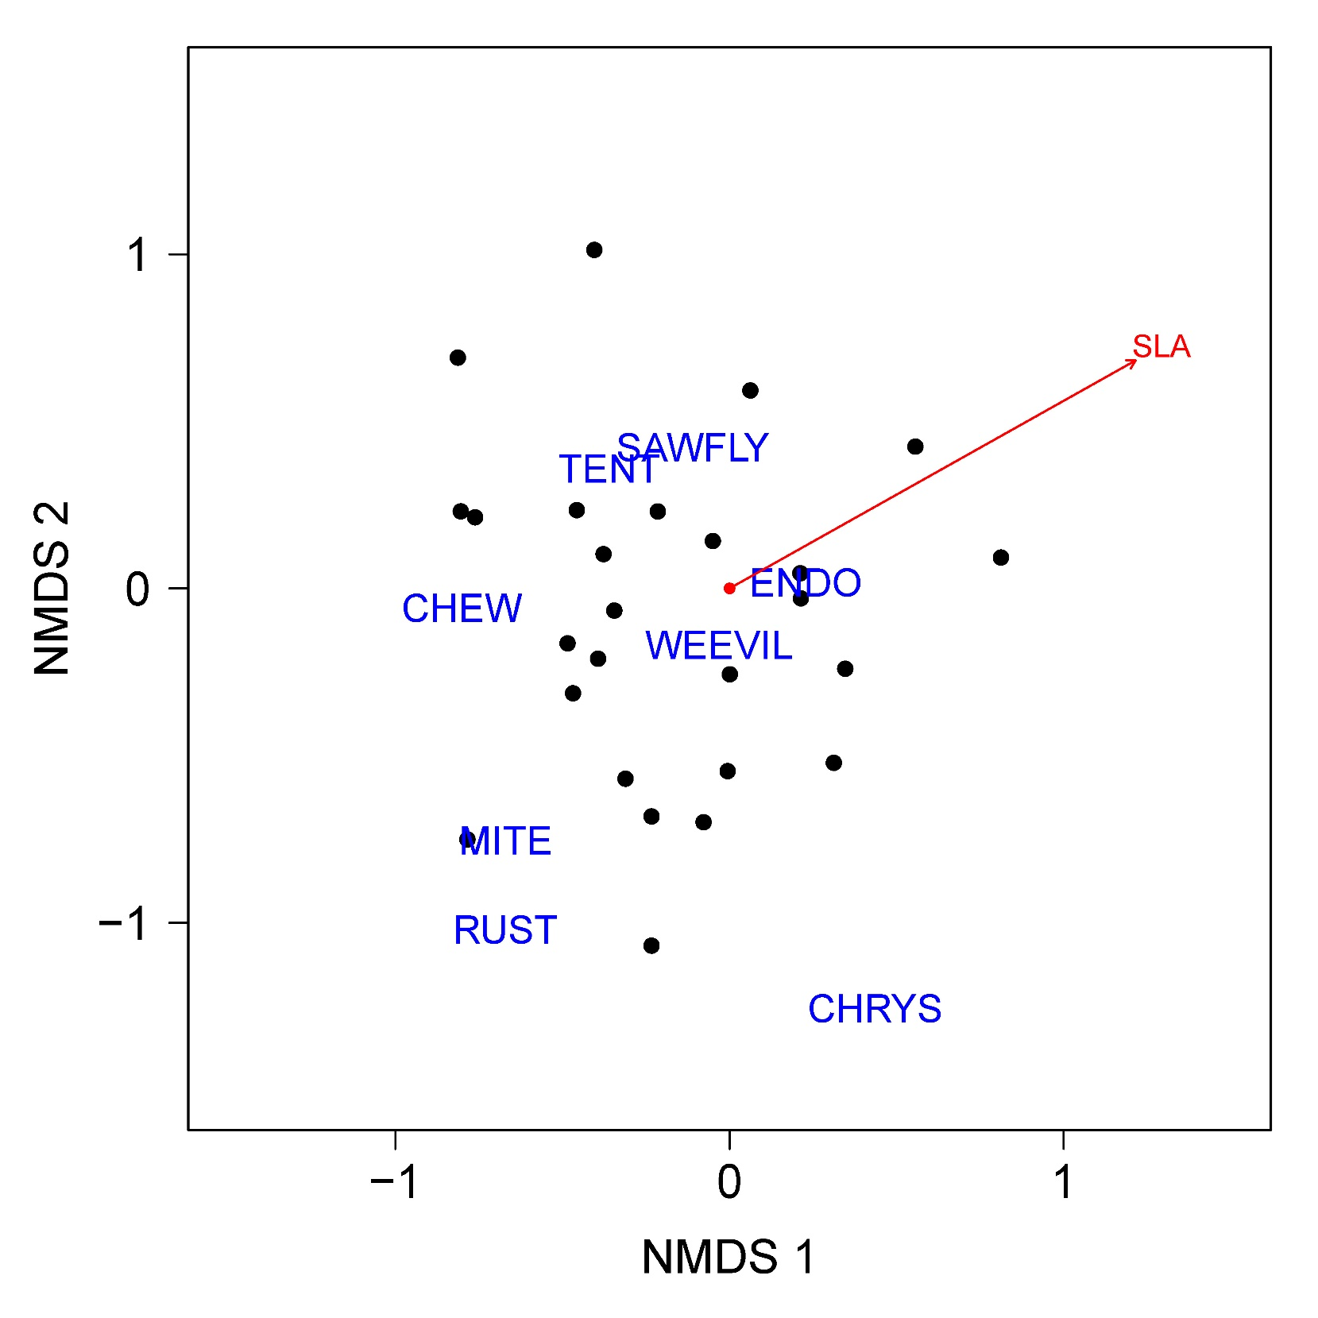
Figure S1. NMDS analysis (four-dimensional) examining dependent-community dissimilarity on tagged willow trees for our leaf area parameters. Blue words are centroids for the 8 observed community members related to leaf area. Relative length of the SLA (specific leaf area) vector indicates strength of effect on related community members. To find the best NMDS outputs, we sequentially increased the number of dimensions until stress was reduced to <0.1, based on 999 iterations and 200 random starts. Abbreviations: CHEW represents unidentified chewing guild arthropods, CHRYS represents chrysomelid beetles, ENDO represents endosymbiont organisms on willows, RUST represents fungi creating leaf rust on willow leaves, and TENT represents tent caterpillars.

References (from main text)
- Hall, K.R.; Anantharaman, R.; Landau, V.A.; Clark, M.; Dickson, B.G.; Jones, A.; Platt, J.; Edelman, A.; Shah, V.B. Circuitscape in Julia: Empowering dynamic approaches to connectivity assessment. Land 2021, 10, 301. https://doi.org/10.3390/land10030301

