Supplementary Information

Layer-by-Layer Deposited Multifunctional PDAC/rGO composite-based sensors
Ammar Al-Hamry ^{1,}*, Tianqi Lu ¹, Jing Bai ¹, Anurag Adiraju ¹, Tharun K. Ega ¹, Igor A. Pašti ² and Olfa Kanoun ^{1,}*
Citation: To be added by editorial staff during production.
Academic Editor: Firstname Lastname
Received: date
Accepted: date
Published: date
Publisher’s Note: MDPI stays neutral with regard to jurisdictional claims in published maps and institutional affiliations.
Copyright: © 2022 by the authors. Submitted for possible open access publication under the terms and conditions of the Creative Commons Attribution (CC BY) license (https://creativecommons.org/licenses/by/4.0/).
¹ Measurement and Sensor Technology, Department of Electrical Engineering and Information Technology, Chemnitz University of Technology, 09107 Chemnitz, Germany; Tianqi.Lu@etit.tu-chemnitz.de (T.L.); Baijingwhy@gmail.com (J.B.); Adiraju.Anurag@etit.tu-chemnitz.de (A.A.); e-mail@e-mail.com (T.K.E.)
² Faculty of Physical Chemistry, University of Belgrade, Studentski trg 12-16, 11158 Belgrade, Serbia; Igor@ffh.bg.ac.rs (I.A.P)
* Correspondence: Ammar.Al-Hamry@etit.tu-chemnitz.de (A.A.-H.); Olfa.Kanoun@etit.tu-chemnitz.de (O.K.)

Supplementary figures:

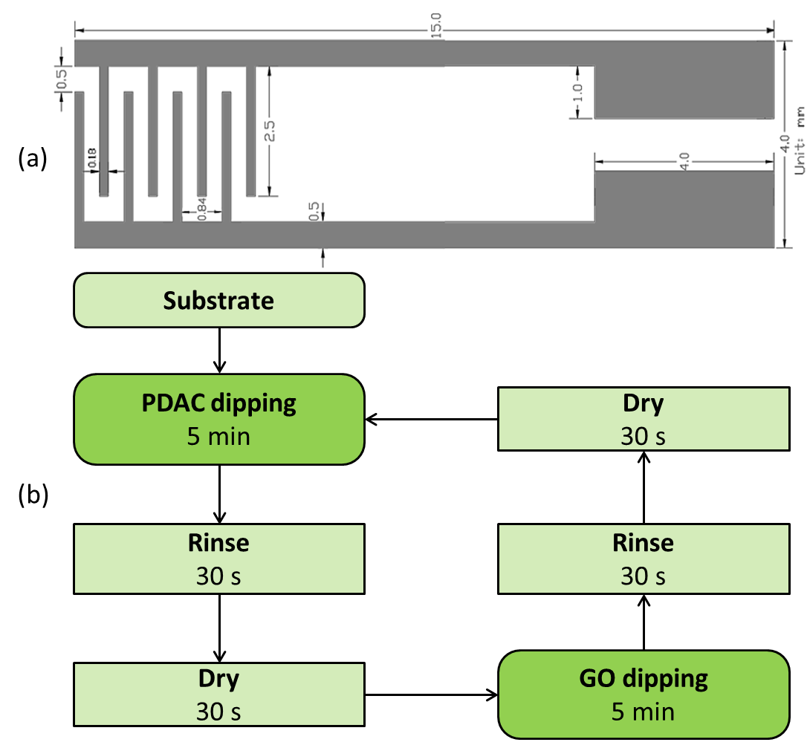

Figure S1. (a) Schematic representation of the screen printed Ag electrode used for the LbL deposition of PDAC/GO bi-layers; (b) Protocol for the LbL deposition of the PDAC/GO bi-layers.

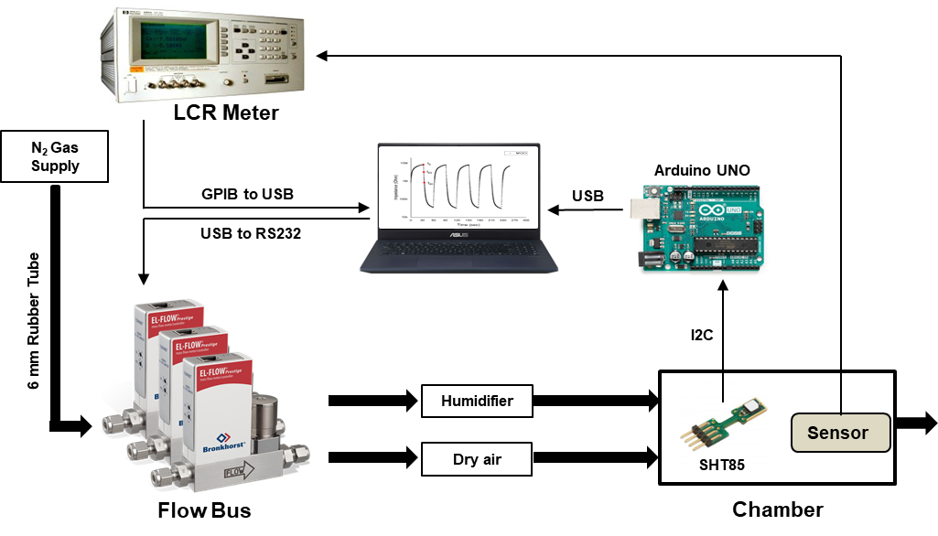
Figure S2. The block and connection diagram of the humidity measurement system.

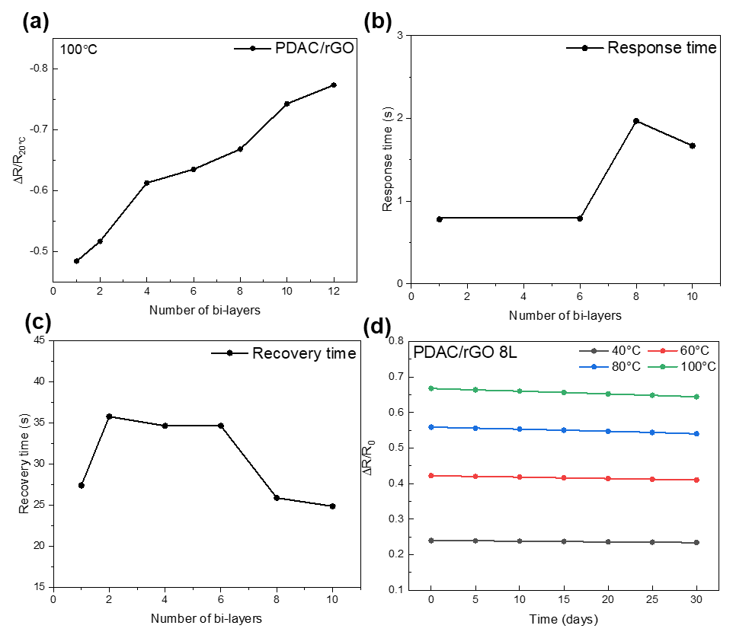
Figure S3. Temperature measurement (a) sensitivity curve as the function of the number of the PDAC/rGO layers; (b) response time as the function of the number of the PDAC/rGO layers; (c) recovery time as the function of the number of the PDAC/rGO layers; (d) Long-term stability curves for the temperature measurements using PDAC/rGO-8L sensor.

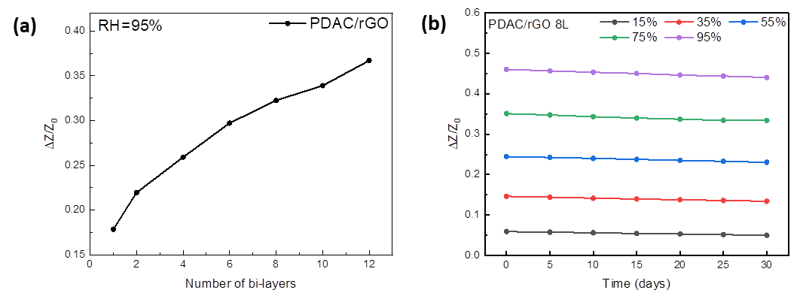
Figure S4. (a) Sensitivity of the response as response curve of different layers for the relative humidity measurements; (b) Long-term stability curves for the relative humidity measurements using PDAC/rGO-8L sensor.

Table S1. Information of the detected real samples.
Sample | Type | Storage temp. | Storage time
Wine | Rot Tempranillo 2015 Trocken, original liquid (Alcohol: 10.5%) | Room temperature | Newly opened
Coffee | Saturated brewed solution  (0.2020 g/ml) | Room temperature | Newly opened
Fresh Beef | Ground meat (10 g) | 8 °C | 2 days
Spoiled Beef | Ground meat (10 g) | 8 °C | 10 days
Fresh Pork | Ground meat (10 g) | 8 °C | 2 days
Spoiled Pork | Ground meat (10 g) | 8 °C | 10 days

