Simultaneous assessment of reactive species and radiosensitization of brain cancer cells using nanoparticle spectroscopy
Honour Djam¹, Harry Kramer², Caleb Thiegs¹, Anne Hubbard¹, Yohan Walter¹, Michael Merrick¹, Michael Mimlitz¹, Catherine Weeder², Haris Akhter², Megha Jacob², Gargee Khaparde², Ashley Abraham², Joe Bamesberger³, Andrew Ekpenyong*,¹.
1 Department of Physics, Creighton University, Omaha, USA
2 Department of Biology, Creighton University, Omaha, USA
3 HCB Pre-Health Science, Creighton University, Omaha, USA
* Correspondence
Andrew Ekpenyong, Creighton University, 2500 California Plaza, Omaha, NE 68178, USA
Email: andrewekpenyong@creighton.edu

Supporting Information

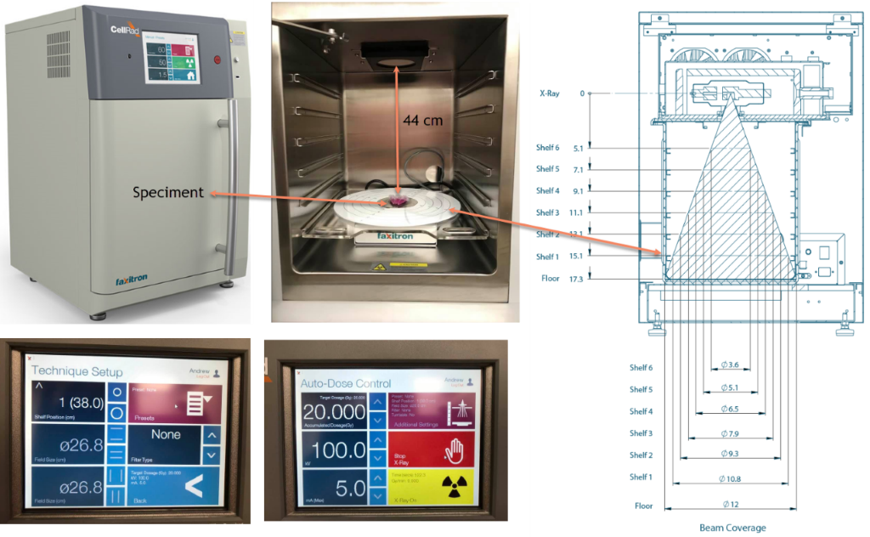
SI Figure 1: Faxitron CellRad. The self-shielded compact X-ray cell irradiator showing the beam divergence, field sizes for various shelf heights and the X-ray generator system. It delivers clinical doses to a cell culture. This cell irradiator has a dose rate up to 130 KVp and 5.0 mA, beam angle of 40º divergence, beam coverage of 9 cm - 27 cm diameter, source to sample distance of 13 cm - 38 cm, and a specimen turntable operated at 2RPM with integrated dosimeter.
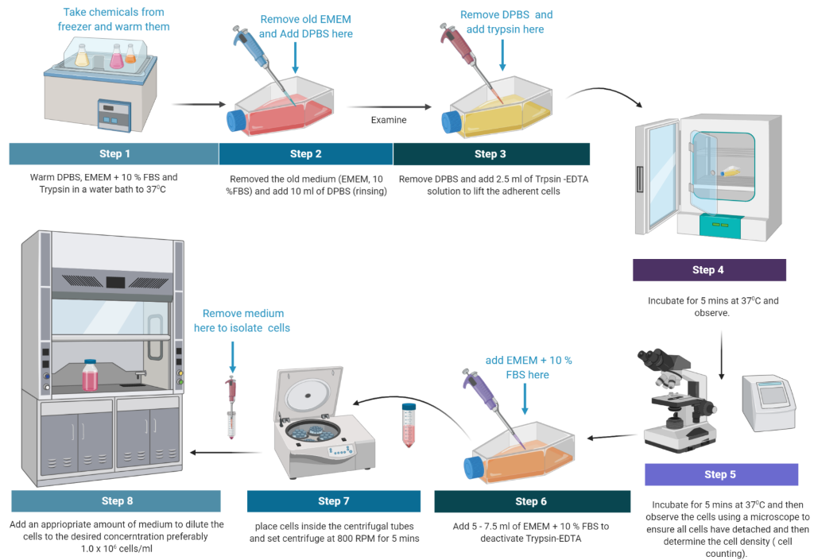

SI Figure 2 Cell Culture Preparation. Life-like sketches of cell culture equipment and annotated procedures used in the work.

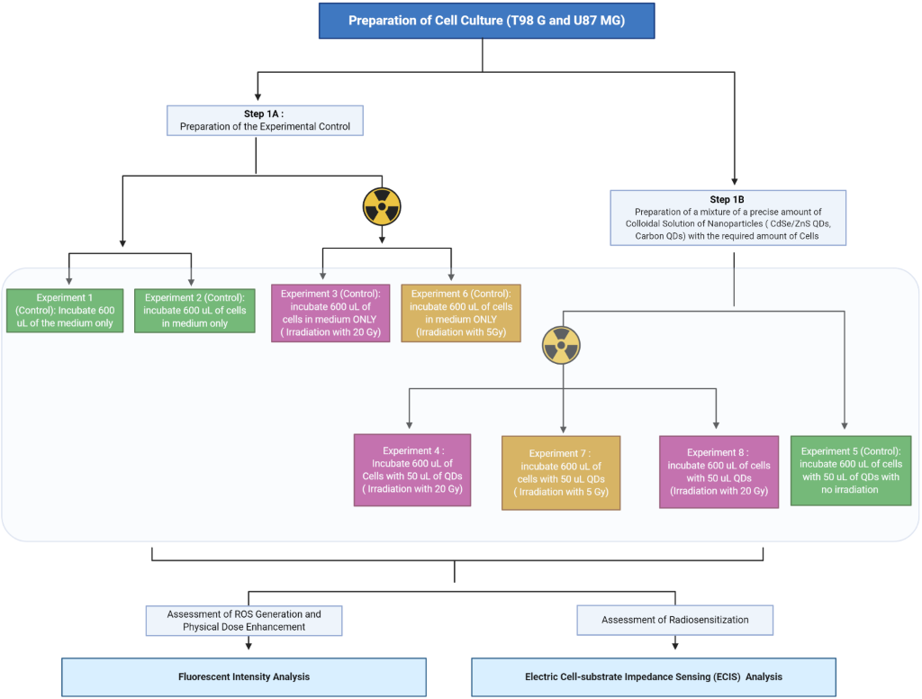
SI Figure 3: Full Experimental Workflow. All the steps from cell culture, incubation with QDs and CQDs, irradiation, nanoparticle spectroscopy and electric cell impedance sensing are laid out with quantitative annotations. In step 1A, NPs were incubated for 1 hour and all irradiation and spectroscopic measurements (step 1B) were completed within 30 minutes post-NP incubation.

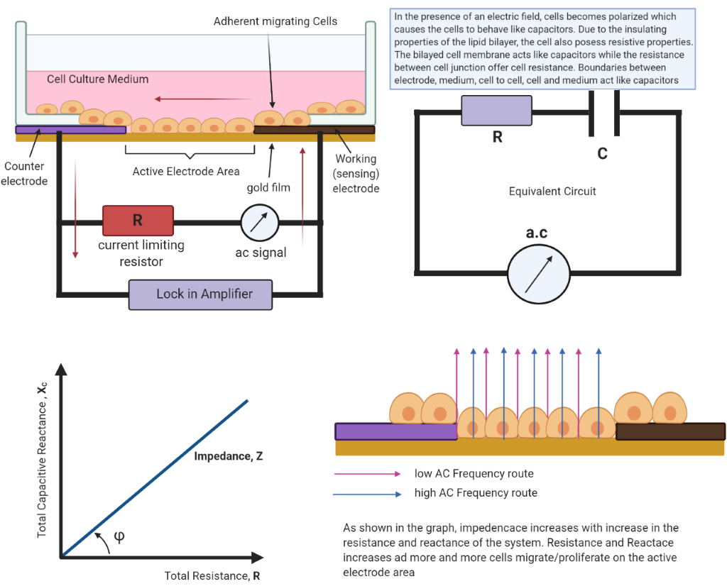
SI Figure 4: How ECIS Works. A simplified schematic illustration of coplanar two-electrode of one ECIS chamber viewed from the side (side view) showing the principle of measurement. The cell culture medium provides the electrical connection between the working smaller electrode and the larger counter electrode. An equivalent circuit (as annotated) shows how the capacitance and resistance all combine to form the impedance. As cell migrate and adhere to the active electrode area, the impedance increases due to the simultaneous increase in the resistance and reactance depending on the frequency of the ac circuit.

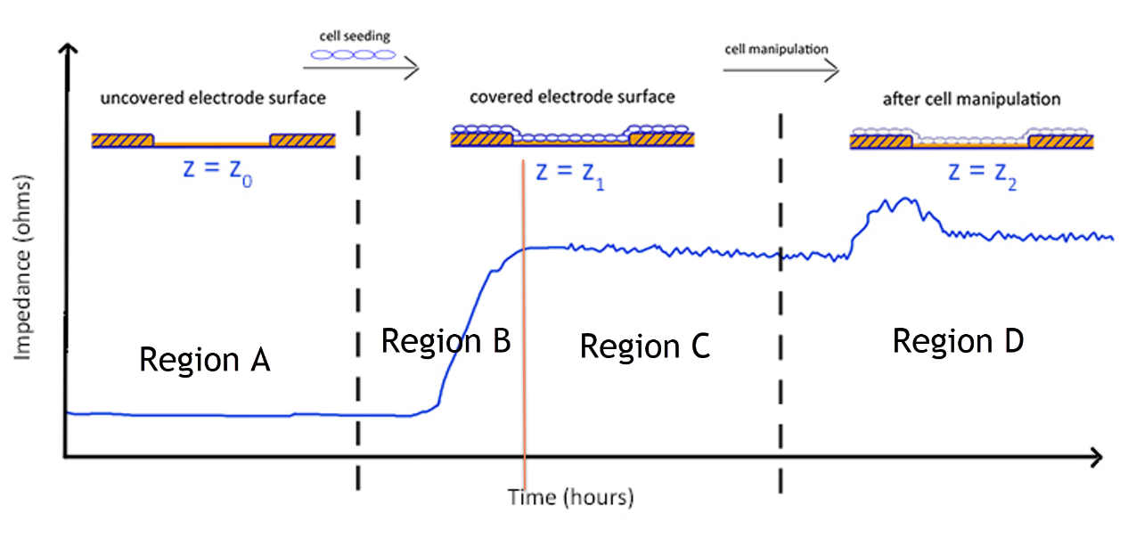
SI Figure 5: ECIS Results: illustration of impedance as a function of time. As more cells are added to the active electrode area, their presence causes an increase in impedance which plateaus once the cells have reached confluency. At this point, the cells can be perturbed, and the resulting changes in impedance due to changes in cell behavior are monitored.

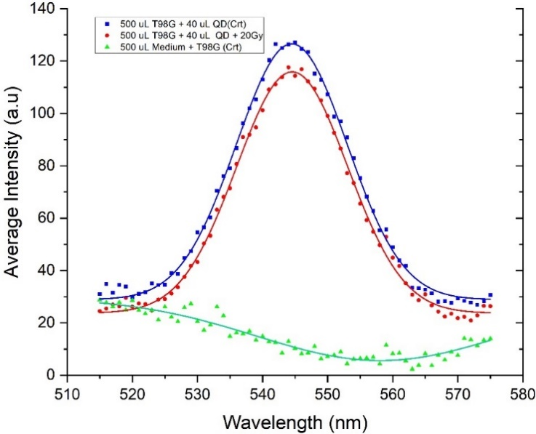 | 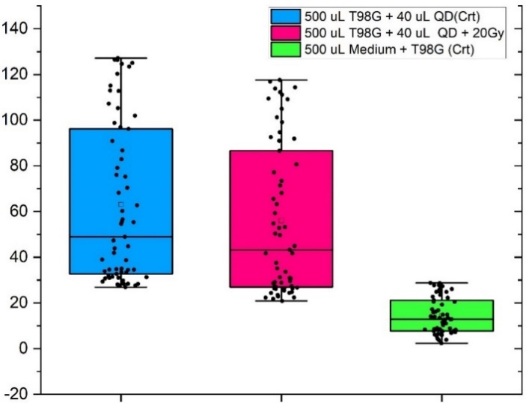
(a) | (b)

SI Figure 6: QD fluorescence spectra and statistical comparisons for T98G glioblastoma cells. (a). Average intensity plotted as a function of wavelength. T98G cells treated with 0.32 𝝁M core-shell PEGylated CdSe/ZnS QD before 20 Gy irradiation show reduced intensity. (b). Boxplot showing the range, peak, and mean intensities of all three conditions in A. ANOVA gives a statistically significant (***p<0.001) difference in intensities between 20 Gy irradiated (T98G+QD+20 Gy) and non-irradiated cells (T98G+QD).

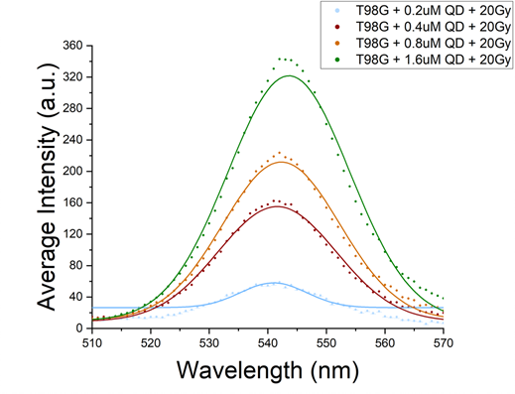 | 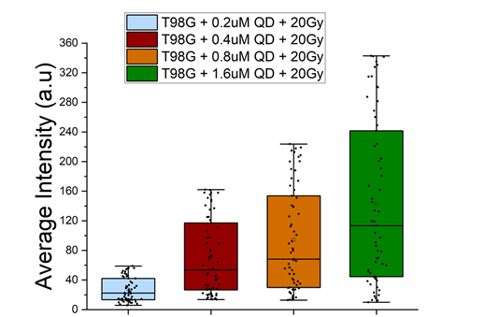
(a) | (b)

SI Figure 7 QD fluorescence spectra at various QD concentrations for T98G glioblastoma cells. (a). Average intensity plotted as a function of wavelength for T98G cells treated with 0.2 μM, 0.4 μM, 0.8 μM and 1.6 μM core-shell PEGylated CdSe/ZnS QD before 20 Gy, showing that higher concentrations of QDs at 20 Gy lead to increased fluorescence intensity. (b). Boxplot showing the range, peak, and mean intensities of all the conditions in (a).

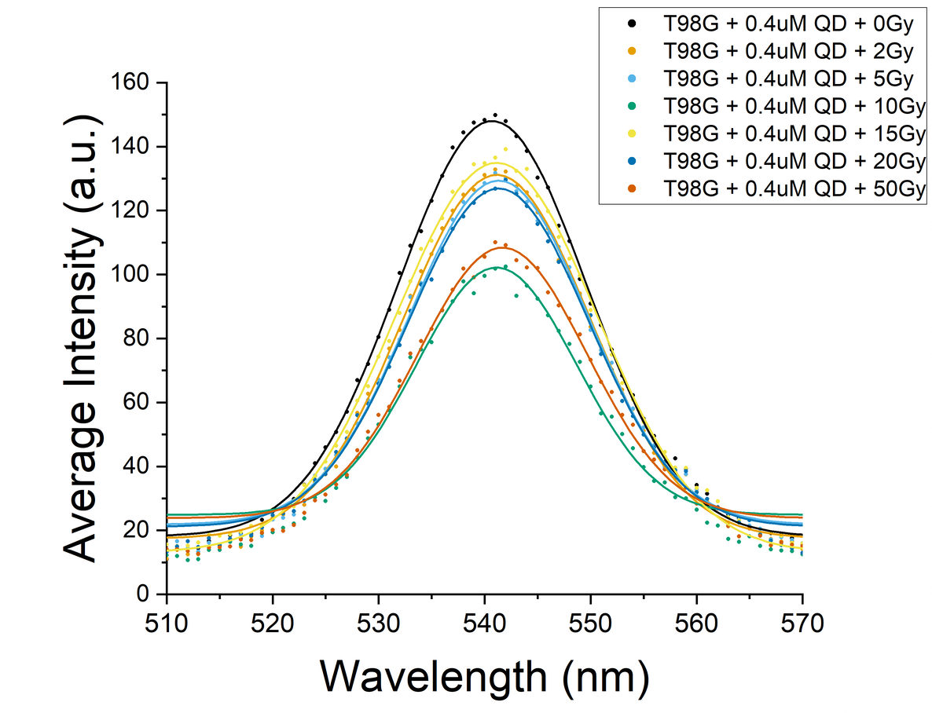 | 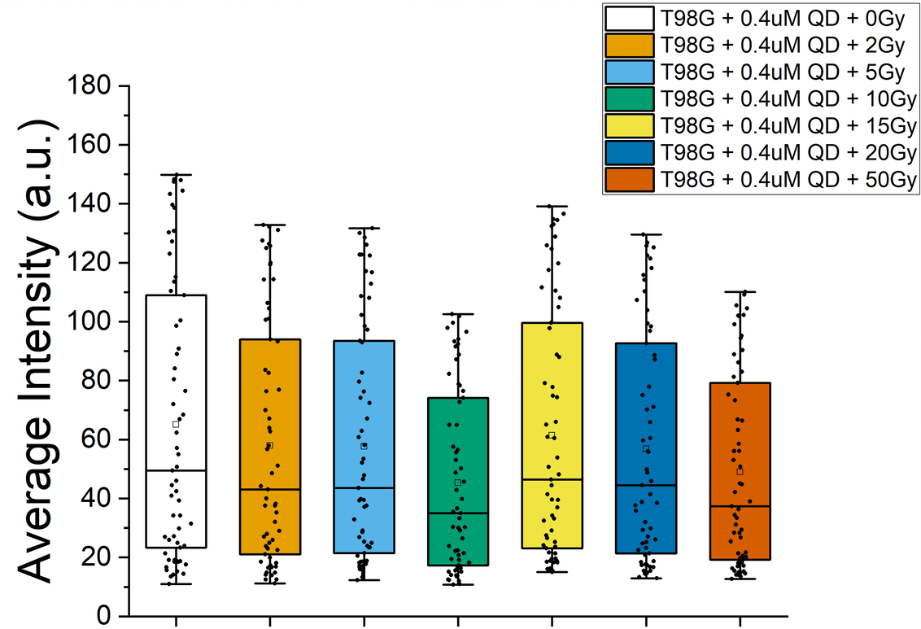
(a) | (b)

SI Figure 8. QD Spectra for T98G cells following irradiation at various doses. (a) Average intensity plotted as a function of wavelength for T98G cells treated with 0.4 μM core-shell PEGylated CdSe/ZnS QD before irradiation at 0, 2, 5, 10, 15, 20 and 50 Gy, showing optical quenching at every dose compared to non-irradiated condition. (b). Boxplot showing the range, peak, and mean intensities of all the conditions in (a).

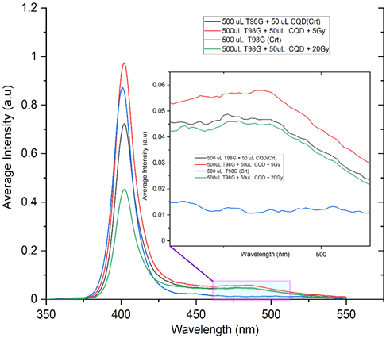 | 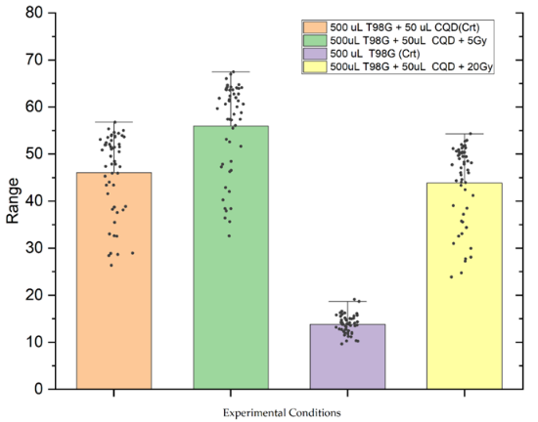
(a) | (b)

SI Figure 9 Carbon QD fluorescence spectra and statistical comparisons for T98G glioblastoma cells. (a). Fluorescence intensity spectra of T98G cell cultured with 0.2% carbon quantum dots (CQD) at 5 Gy and 20 Gy. There is a fluorescent enhancement of CQD spectra compared to the quenching in CdSe/ZnS QDs. (b). Statistical comparisons of the various experimental conditions of T98G cells with CQD. ANOVA showed statistically significant differences (p<0.01) between the 20 Gy and 5 Gy irradiated cells and unirradiated cells treated with CQD.

