SUPPORTING INFORMATION
An overlooked hepcidin-cadmium connection

Dawid Płonka ¹, Marta D. Wiśniewska ¹, Manuel D. Peris-Díaz ², Artur Krężel ², Arkadiusz M. Bonna ³ and Wojciech Bal ¹*
¹ Institute of Biochemistry and Biophysics, Polish Academy of Sciences, Pawińskiego 5a, 02-106 Warsaw, Poland; d.plonka@ibb.waw.pl (D.P.); m.wisniewska@ibb.waw.pl (M.D.W.)
² Department of Chemical Biology, Faculty of Biotechnology, University of Wrocław,
Joliot-Curie 14a, 50-383 Wrocław, Poland; manuel.perisdiaz@uwr.edu.pl (M.P.); artur.krezel@uwr.edu.pl (A.K.)
3
* Correspondence: wbal@ibb.waw.pl

Supporting figures

Scheme 1. Comparison of sequences of hepcidin-25 and α-domain of human metallothionein 2 (Cys residues set in bold).

MT2 KSCCSCCPVGCAKCAQGCICKGASDKCSCCA
hepcidin-25 DTHFPICIFCCGCCHRSKCGMCCKT

Figure S1. 100 μM 5R-hepcidin in 100mM HEPES pH 7.4, titrated with Cd(NO₃)₂ (top) and Zn(NO₃)₂ (bottom). Cd(II) and Zn(II) to peptide ratios are color coded on the plots.

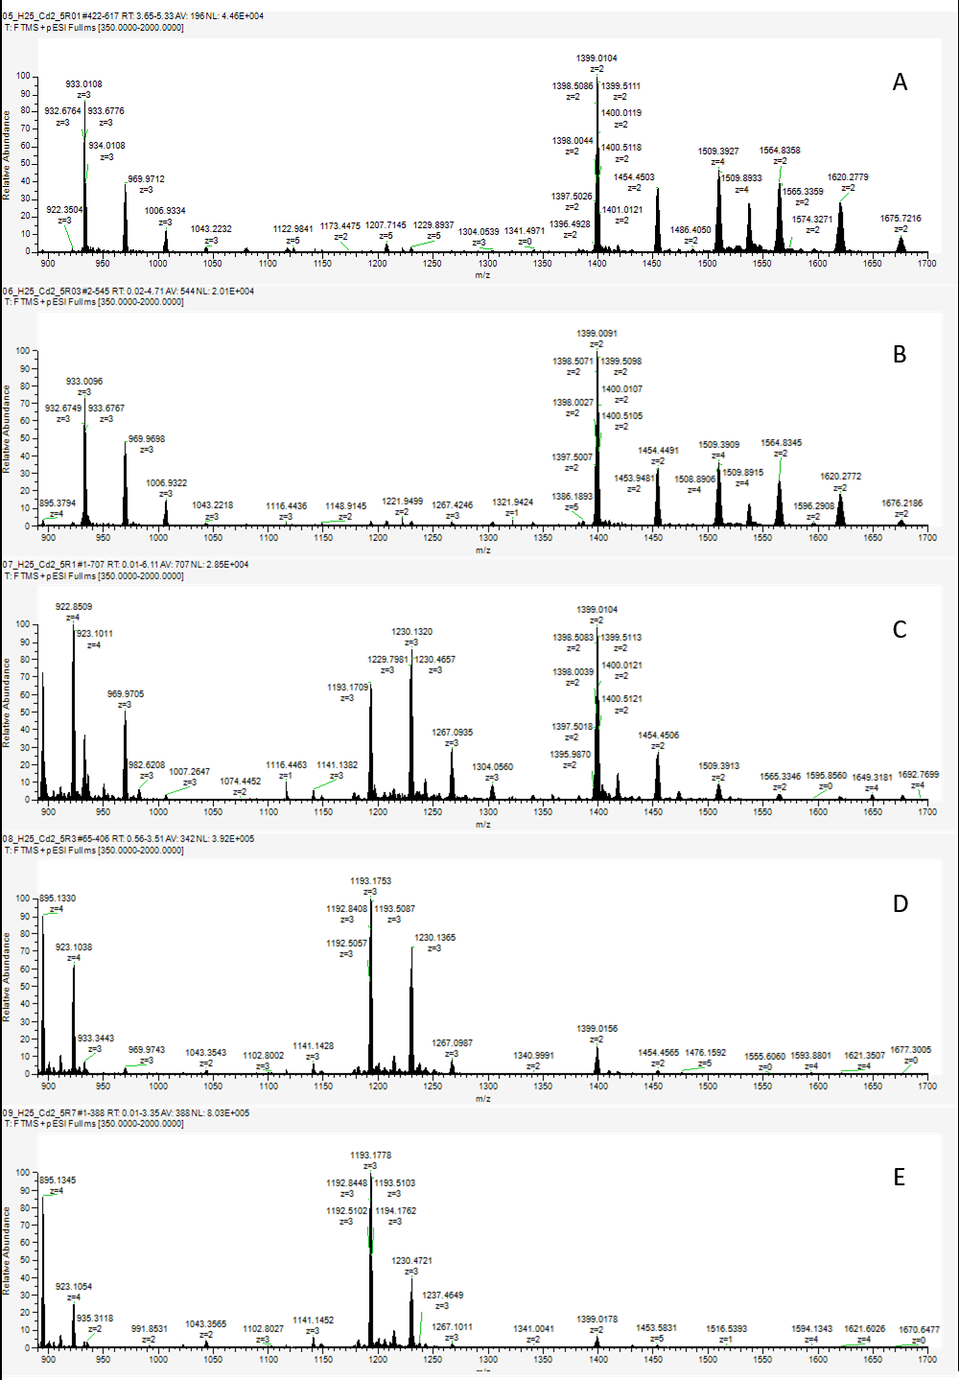
Figure S2. Native mass spectra of 10 μM Hepcidin-25 with 20 μM Cd(II) acetate with varying concentration of 5R-hepcidin: A) 1 μM, B) 3 μM, C) 10 μM, D) 30 μM, E) 70 μM in ammonium acetate pH 7.4.

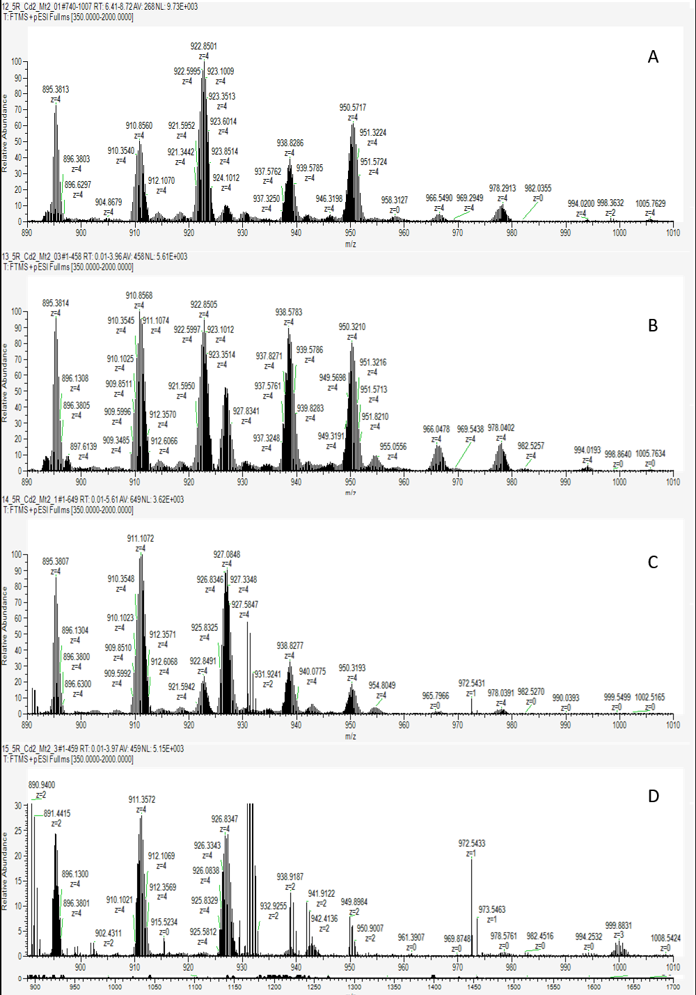
Figure S3. Native mass spectra of 10 μM 5R-hepcidin with 20 μM Cd(II) acetate with varying concentration of metallothionein MT2A: A) 1 μM, B) 3 μM, C) 10 μM, D) 30 μM in ammonium acetate pH 7.4 Due to high noise and differing intensities, for better clarity only fragment for 5R-hepcidin is shown, the fragment with peaks associated with MT2A is shown in Fig. S4.
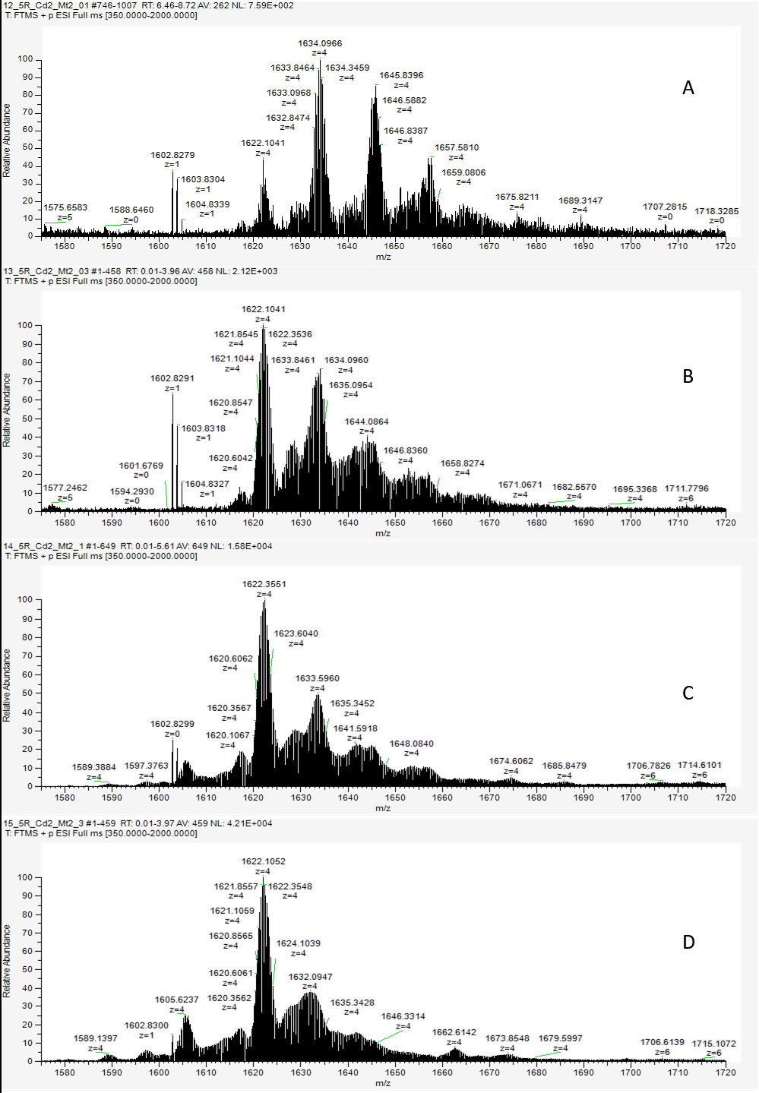
Figure S4. Native mass spectra of 10 μM 5R-hepcidin with 20 μM Cd(II) acetate with varying concentration of metallothionein MT2A: A) 1 μM, B) 3 μM, C) 10 μM, D) 30 μM in ammonium acetate pH 7.4 Due to high noise and differing intensities, for better clarity only peaks associated with MT2A is shown, the spectrum fragment with peaks associated with 5R-hepcidin is shown in Fig. S3.

