SUPPLEMENTARY (FIGURES AND TABLES)

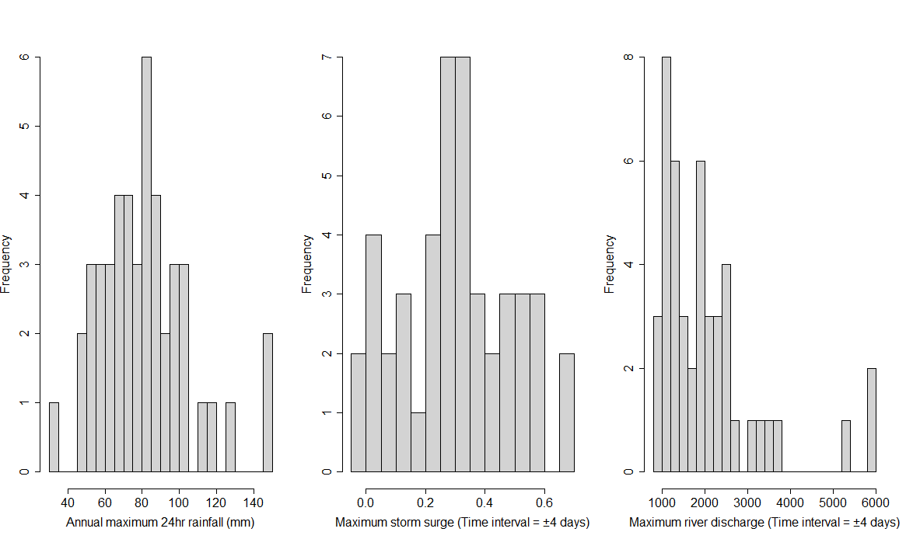
SF 1: Histogram plot of selected compound flood (CF) drivers
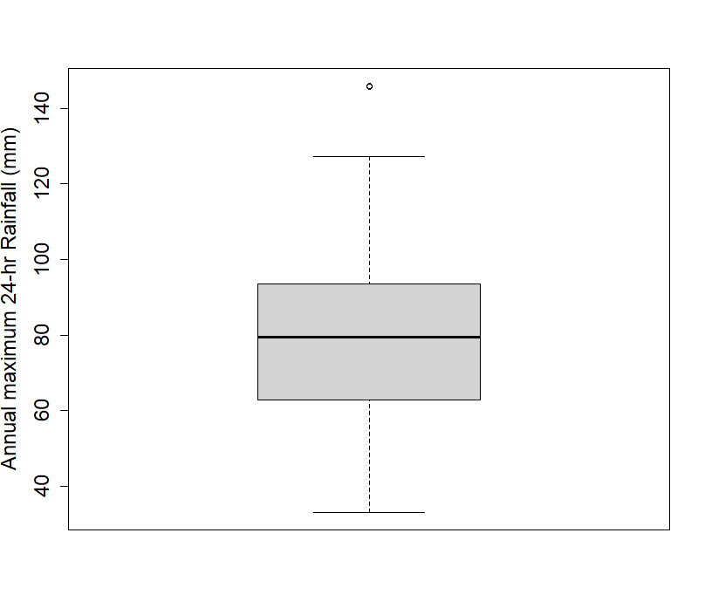(a)
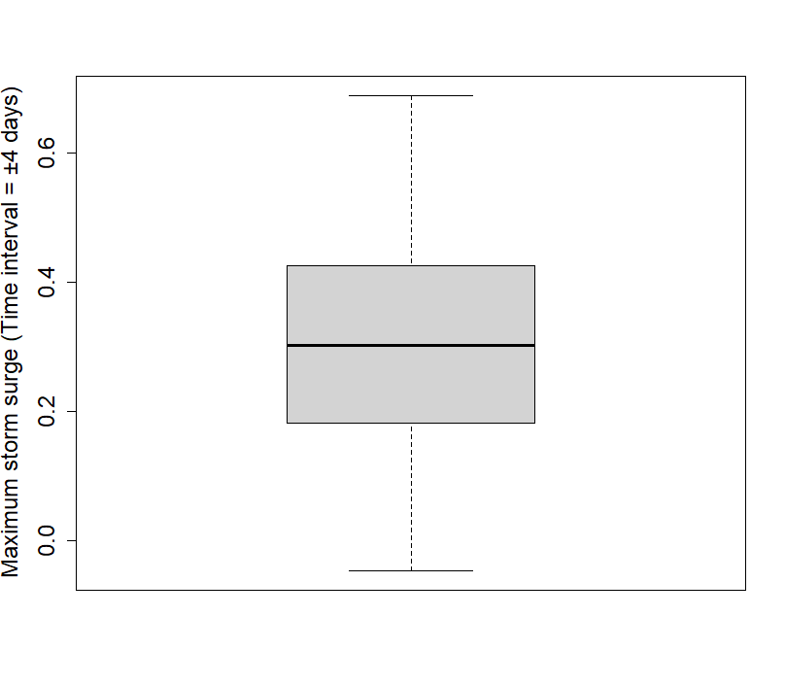(b)
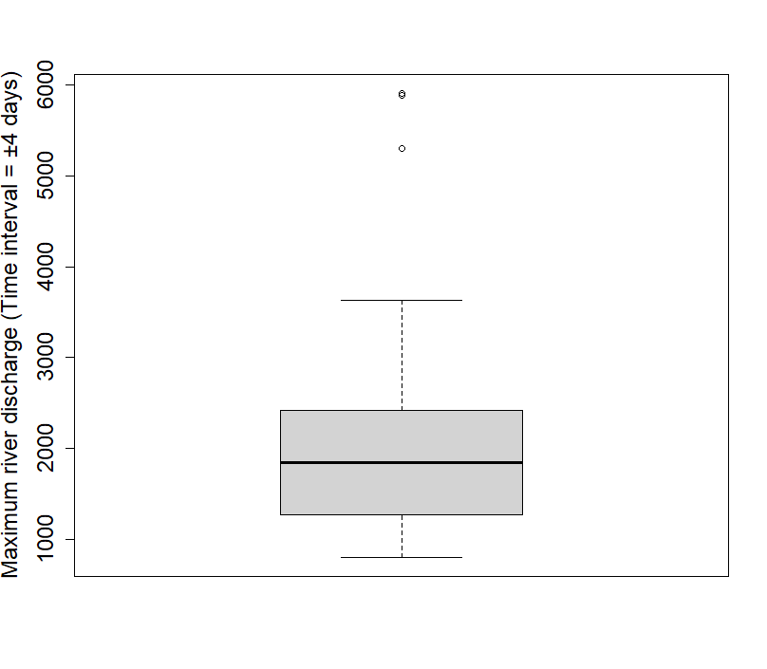(c)
SF 2: Box whisker plot of CF drivers (a) Annual maximum 24-hr Rainfall (mm) (b) Maximum Storm surge (Time interval = $± 4$ days) (m) (c) Maximum River discharge (Time interval = $± 4$ days) ($m^{3}\sec^{-1})$
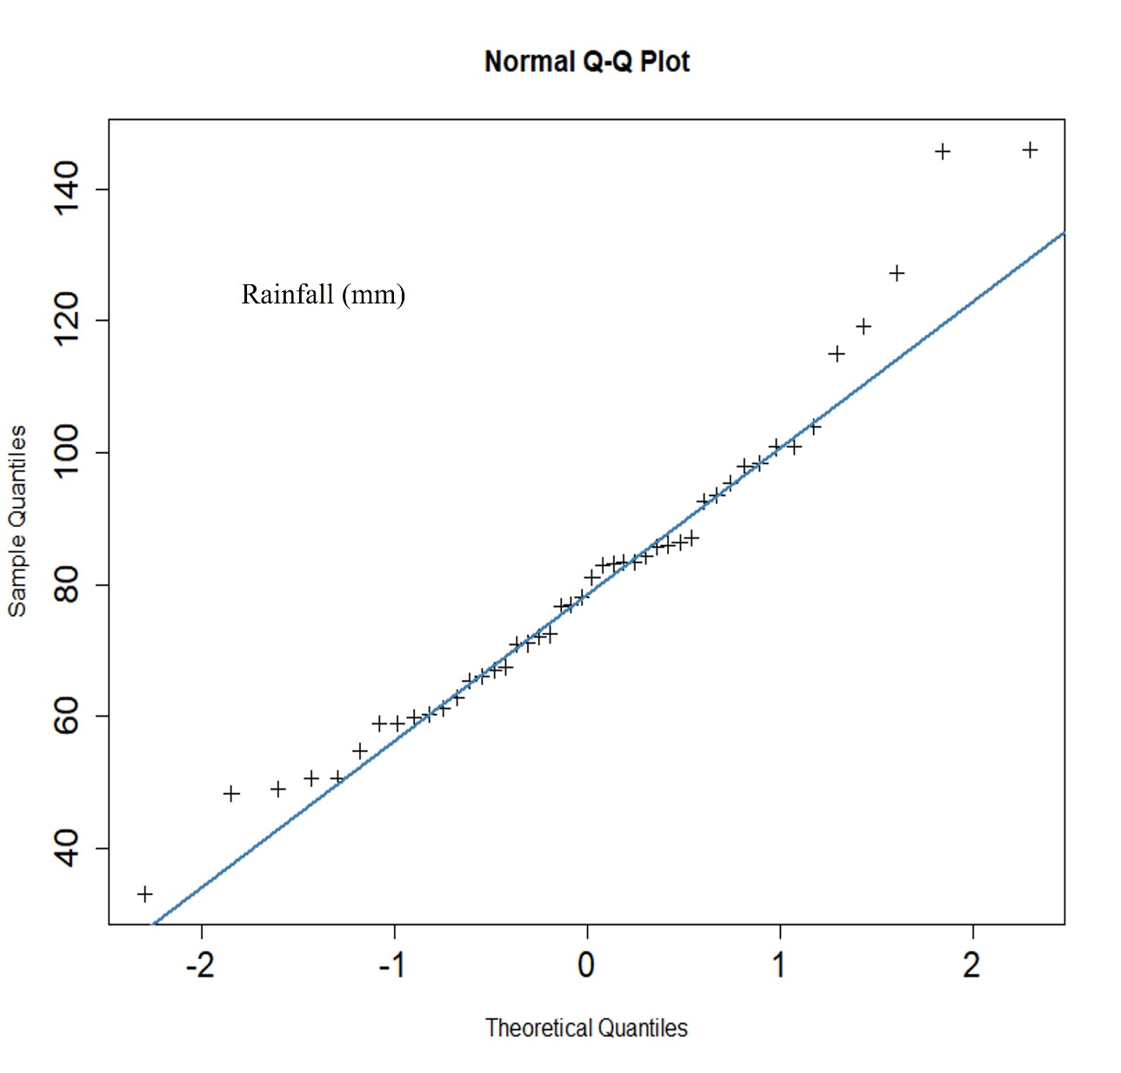(a)
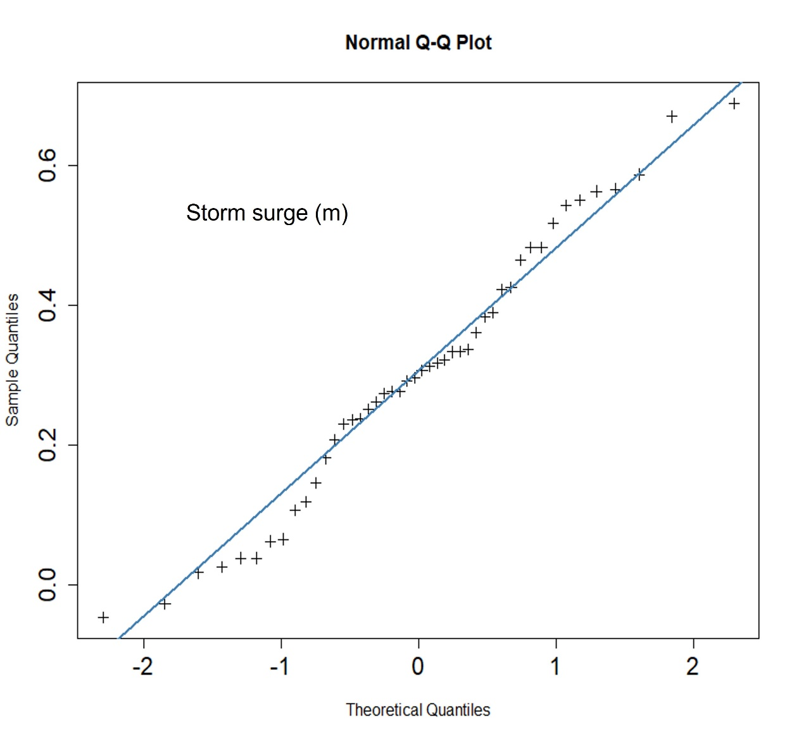(b)
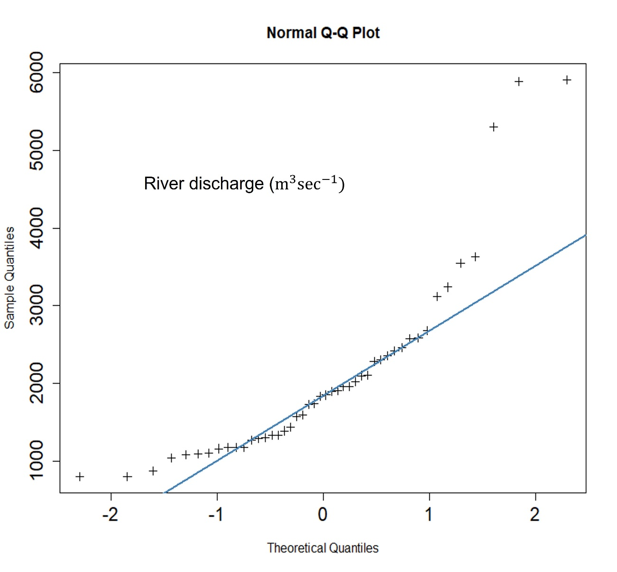(c)
SF 3: Normal Quantile-Quantile (Q-Q) plots for (a) Annual maximum 24-hr Rainfall (mm) (b) Maximum Storm surge (Time interval = ± 4 days) (m) (c) Maximum River discharge (Time interval = ± 4 days) ($m^{3}\sec^{-1}$)

ST 1: Basic summary statistics of the selected compound flooding (CF) drivers
Annual Maximum 24-hr Rainfall (mm) | Maximum Storm surge (Time interval = ±4days) (m) | Maximum River discharge (Time interval = ±4 days) ($m^{3}\sec^{-1}$)
Min. : 33.00 | Min. :-0.0470 | Min. : 800
1st Qu.: 63.42 | 1st Qu.: 0.1875 | 1st Qu.:1275
Median : 79.50 | Median : 0.3015 | Median :1840
Mean : 80.68 | Mean : 0.3025 | Mean :2074
3rd Qu.: 93.35 | 3rd Qu.: 0.4243 | 3rd Qu.:2405
Max. :146.00 | Max. : 0.6890 | Max. :5910
Var: 589.0201 | Var: 0.03544252 | Var: 1438211

ST 2: Test for homogeneity within individual time series of CF drivers
Flood variables | Pettitt (Estimated p-value) | SNHT test (Estimated p-value) | Buishand (Estimated p-value) | Overall conclusion
Annual Maximum 24-hr Rainfall (mm) | 1 > 0.05 (significance level) | 0.7764 > 0.05 (significance level) | 0.8316 > 0.05 (significance level) | Time series is homogenous
Storm Surge (Time interval = ±4days) (m)* | 0.02541 < 0.05 (significance level) | 0.02755 < 0.05 (significance level) | 0.09325 > 0.05 (significance level) | Time series is not homogenous
River Discharge (Time interval = ±4 days) ($m^{3}\sec^{-1})$ | 0.5625 > 0.05 (significance level) | 0.8773 > 0.05 (significance level) | 0.5616 > 0.05 (significance level) | Time series is homogenous
Note: The p-value has been computed using 20000 Monte Carlo simulations.
*Storm surge events (bold letter with an asterisk) exhibited non-homogenous behaviour, their estimated p-value for the Pettit and SNHT tests is less than p = 0.05

(a)
(b)

(c)
SF 4: Qualitative based visual inspection of nonparametric model’s performance fitted to (a) Annual maximum 24-hr Rainfall (mm) (b) Maximum Storm surge (Time interval = ± 4 days) (m) (c) Maximum River discharge (Time interval = ± 4 days) ${(m}^{3}\sec^{-1})$
(a)
(b)
(c)
SF 5: Comparing Probability-Probability (P-P) plots of the nonparametric models fitted to (a) Annual maximum 24-hr Rainfall (mm) (b) Maximum Storm surge (Time interval = ± 4 days) (m) (c) Maximum River discharge (Time interval = ± 4 days) ${(m}^{3}\sec^{-1})$
ST 3: Fitting 2-D parametric copulas in the second tree level (Tree 2) of vine structure constructed in parametric settings for (a) D-vine structure-1 (case-1) (b) D-vine structure-2 (case-2) (c) D-vine structure-3 (case-3)
(a) |  |  |  | Cramer von Mises functional statistics with parametric bootstrap procedure (N = 1000 (No. of bootstrap samples))
Copula family | Parameter estimates ($θ_{12|3})$ via MPL estimators | Standard Error estimates | MLL (Maximized Log-likelihood) | $$S_{n}$$ | p-value
Clayton | 0.4563 | 0.226 | 2.994 | 0.045034 | 0.1004
Gumbel | 1.326 | 0.137 | 3.885 | 0.0259 | 0.4241
Frank* | 2.925 | 0.886 | 4.651 | 0.018882 | 0.9096
Joe | 1.387 | 0.189 | 2.751
BB1 (Clayton-Gumbel) | $θ=theta=0.1784$; $δ=delta=1.2295$ | NA | 4.165 | 0.039161 | 0.3651
BB6 (Joe-Gumbel) | $θ=theta=1$; $δ=delta=1.326$ | NA | 3.885 | 0.041983 | 0.3312
BB7 (Joe-Clayton) | $θ=theta=1.2509$; $δ=delta=0.3332$ | NA | 3.956 | 0.047131 | 0.2882
BB8 (Joe-Frank) | $θ=theta=6$; $δ=delta=0.41$ | NA | 4.65 | 0.025064 | 0.6938
Survival clayton | 0.4985 | NA | 2.951 | 0.062309 | 0.1503
Survival Joe | 1.361 | NA | 2.082 | 0.080925 | 0.08242
Survival Gumbel | 1.301 | NA | 3.165 | 0.049017 | 0.2423
Survival BB1 | $θ=theta=0.2346$; $δ=delta=1.1872$ | NA | 3.523 | 0.041955 | 0.3242
Survival BB6 | $θ=theta=1$; $δ=delta=1.301$ | NA | 3.165 | 0.049017 | 0.2512
Survival BB7 | $θ=theta=1.1831$; $δ=delta=0.3829$ | NA | 3.226 | 0.050101 | 0.2313
Survival BB8 | $θ=theta=6$; $δ=delta=0.42$ | NA | 4.732 | 0.023331 | 0.7258
Note: Frank copula (bold letter with asterisk) fitted best in the dependence modelling of conditional flood pair (minimum value of S_{n} test statistics) in the second tree level (Tree 2) for D-vine structure-1 (case 1)

(b) |  |  |  | Cramer von Mises functional statistics with parametric bootstrap procedure (N = 1000 (No. of bootstrap samples))
Copula family | Parameter estimates ($θ_{13|2})$ via MPL estimators | Standard Error estimates | MLL (Maximized Log-likelihood) | $$S_{n}$$ | p-value
Rotated Joe 90 degrees | -1.033 | NA | 0.03724 | 0.019008 | 0.8646
Rotated Gumbel 90 degrees | -1.023 | NA | 0.03734 | 0.019269 | 0.8586
Frank | -0.3719 | 0.858 | 0.08094 | 0.021318 | 0.9206
Gaussian (or Normal) | -0.04792 | 0.149 | 0.05882 | 0.02055 | 0.9306
Rotated BB1 90 degrees | Theta = par = -3.438e-08 Delta = par2 = -1.023 | NA | 0.03732 | 0.019269 | 0.8576
Rotated BB6 90 degrees | Theta = par = -1.02, par2 = delta = -1.01 | NA | -6.883e-15 | 0.019159 | 0.8606
Rotated BB7 90 degrees | Theta = par = -1.033; delta = par2 = -6.135e-08 | NA | 0.03724 | 0.019008 | 0.8506
Rotated BB8 90 degrees | Theta = par = -1.2042 Delta = par2 = -0.8715 | NA | 0.2371 | 0.022101 | 0.7797
Rotated BB1 270 degrees | Theta = par = -0.08613  Delta = par2 = -1.00000 | NA | 0.2099 | 0.020603 | 0.8397
Rotated BB6 270 degrees* | Theta = par = -1  Delta = par2 = -1 | NA | -2.442e-15 | 0.018538 | 0.8696
Rotated BB7 270 degrees | Theta = par = -1.0000  Delta = par2 = -0.0861 | NA | 0.2099 | 0.020602 | 0.8117
Rotated BB8 270 degrees | Theta = par =-6  Delta = par2 = -0.07 | NA | 5.218e-15 | 0.020593 | 0.8167
Note: Rotated BB6 270 degrees copula (bold letter with an asterisk) fitted best in the joint modelling of conditional flood pair (minimum value of S_{n} test statistics) in second tree level (Tree-2) of the D-vine structure-2 (case-2)

(c) |  |  |  | Cramer von Mises functional statistics with parametric bootstrap procedure (N = 1000 (No. of bootstrap samples))
Copula family | Parameter estimates ($θ_{23|1})$ via MPL estimators | Standard Error estimates | MLL (Maximized Log-likelihood) | $$S_{n}$$ | p-value
Clayton | 0.6626 | 0.263 | 4.831 | 0.054285 | 0.05844
Gumbel | 1.301 | 0.119 | 3.387 | 0.027878 | 0.2892
Frank* | 2.972 | 0.946 | 5.483 | 0.019514 | 0.8776
Joe | 1.324 | 0.147 | 1.882 | 0.052833 | 0.04046
BB1 (Clayton-Gumbel) | $θ=theta=0.5498$; $δ=delta=1.0660$ | NA | 4.901 | 0.053774 | 0.1863
BB6 (Joe-Gumbel) | $θ=theta=1$; $δ=delta=1.301$ | NA | 3.387 | 0.060648 | 0.1643
BB7 (Joe-Clayton) | $θ=theta=1.0000$; $δ=delta=0.6626$ | NA | 4.831 | 0.063413 | 0.1214
BB8 (Joe-Frank) | $θ=theta=6$; $δ=delta=0.4$1 | NA | 5.483 | 0.033341 | 0.492
Survival clayton | 0.4335 | NA | 2.747 | 0.08952 | 0.05544
Survival Joe | 1.531 | NA | 4.078 | 0.073942 | 0.09241
Survival Gumbel | 1.374 | NA | 4.879 | 0.048689 | 0.2343
Survival BB1 | $θ=theta=2.813e-08$ ; $δ=delta=1.374$ | NA | 4.879 | 0.048689 | 0.2363
Survival BB6 | $θ=theta=1$; $δ=delta=1.374$ | NA | 4.879 | 0.048689 | 0.2363
Survival BB7 | $θ=theta=1.4184$; $δ=delta=0.2054$ | NA | 4.415 | 0.057852 | 0.1863
Survival BB8 | $θ=theta=5.77$; $δ=delta=0.44$ | NA | 5.557 | 0.032239 | 0.499
Note: Frank copula (bold letter with an asterisk) fitted best in the joint modelling of conditional flood pair (minimum value of S_{n} test statistics) in second tree level (Tree-2) of the D-vine structure-3 (case-3)

ST 4: Fitting 2-D parametric copulas in the second tree level (Tree 2) of vine structure constructed in semiparametric settings (parametric copula with nonparametric marginal pdfs) for (a) D-vine structure-1 (case-1) (b) D-vine structure-2 (case-2) (c) D-vine structure-3 (case-3)
(a) |  |  |  | Cramer von Mises functional statistics with parametric bootstrap procedure (N = 1000 (No. of bootstrap samples))
Copula family | Parameter estimates ($θ_{12|3})$ via MPL estimators | Standard Error estimates | MLL (Maximized Log-likelihood) | $$S_{n}$$ | p-value
Clayton | 0.4604 | 0.239 | 3.03 | 0.036116 | 0.1983
Gumbel | 1.341 | 0.166 | 4.417 | 0.019725 | 0.7637
Frank* | 2.898 | 0.889 | 4.743 | 0.015242 | 0.9865
Joe | 1.425 | 0.239 | 3.375 | 0.039103 | 0.1404
BB1 (Clayton-Gumbel) | $θ=theta=0.1479$; $δ=delta=1.2585$ | NA | 4.595 | 0.029008 | 0.5659
BB6 (Joe-Gumbel) | $θ=theta=1$; $δ=delta=1.341$ | NA | 4.417 | 0.031311 | 0.538
BB7 (Joe-Clayton) | $θ=theta=1.2868$; $δ=delta=0.3207$ | NA | 4.415 | 0.035376 | 0.4481
BB8 (Joe-Frank) | $θ=theta=6$; $δ=delta=0.41$ | NA | 4.743 | 0.019621 | 0.8317
Survival clayton | 0.5437 | NA | 3.515 | 0.047034 | 0.2443
Survival Joe | 1.351 | NA | 2.049 | 0.070968 | 0.1164
Survival Gumbel | 1.301 | NA | 3.255 | 0.039981 | 0.4011
Survival BB1 | $θ=theta=0.3195$; $δ=delta=1.1509$ | NA | 3.904 | 0.032153 | 0.504
Survival BB6 | $θ=theta=1$; $δ=delta=1.301$ | NA | 3.255 | 0.039981 | 0.3711
Survival BB7 | $θ=theta=1.1397$; $δ=delta=0.4565$ | NA | 3.681 | 0.038429 | 0.3721
Survival BB8 | $θ=theta=6$; $δ=delta=0.41$ | NA | 4.773 | 0.019717 | 0.8367
Note: Frank copula (bold letter with an asterisk) exhibited minimum value Cramer-Von Mises functional 𝑆_{n} statistics with p-value is greater than 0.05, thus recognized as the most parsimonious bivariate copula in defining bivariate joint dependence structure in Tree 2 for D-vine structure (case-1)

(b) |  |  |  | Cramer von Mises functional statistics with parametric bootstrap procedure (N = 1000 (No. of bootstrap samples))
Copula family | Parameter estimates ($θ_{13|2})$ via MPL estimators | Standard Error estimates | MLL (Maximized Log-likelihood) | $$S_{n}$$ | p-value
Rotated Joe 90 degrees | -1.03 | NA | 0.03642 | 0.018955 | 0.8736
Rotated Gumbel 90 degrees | -1.019 | NA | 0.03016 | 0.019115 | 0.8746
Frank | -0.2357 | 0.859 | 0.03313 | 0.021389 | 0.9066
Gaussian (or Normal) | -0.0437 | 0.15 | 0.04946 | 0.022396 | 0.8696
Rotated BB1 90 degrees | Theta = par = -5.383e-08 Delta = par2 = -1.019e+00 | NA | 0.03016 | 0.019115 | 0.8546
Rotated BB6 90 degrees | Theta = par = -1.03, par2 = delta = -1 | NA | -4.441e-15 | 0.018955 | 0.8606
Rotated BB7 90 degrees | Theta = par = -1.030e+00; delta = par2 = -4.136e-09 | NA | 0.03641 | 0.018955 | 0.8516
Rotated BB8 90 degrees | Theta = par = -1.1328 Delta = par2 = -0.8967 | NA | 0.1476 | 0.021387 | 0.7817
Rotated BB1 270 degrees | Theta = par = --0.081  Delta = par2 = -1.00000 | NA | 0.195 | 0.021287 | 0.7847
Rotated BB6 270 degrees* | Theta = par = -1  Delta = par2 = -1 | NA | -6.661e-16 | 0.017848 | 0.8866
Rotated BB7 270 degrees | Theta = par = -1.0000  Delta = par2 = -0.08104 | NA | 0.195 | 0.021289 | 0.7977
Rotated BB8 270 degrees | Theta = par =-6  Delta = par2 = -0.04 | NA | 8.993e-15 | 0.01939 | 0.8467
Note: Rotated BB6 270 degrees (or r270BB6 Copula) (bold letter with asterisk) exhibited minimum value Cramer-Von Mises functional $S_{n}$ statistics with p-value is greater than 0.05, thus recognized as the most parsimonious bivariate copula in defining bivariate joint dependence structure in Tree 2 for D-vine structure-2 (case 2).

(c) |  |  |  | Cramer von Mises functional statistics with parametric bootstrap procedure (N = 1000 (No. of bootstrap samples))
Copula family | Parameter estimates ($θ_{23|1})$ via MPL estimators | Standard Error estimates | MLL (Maximized Log-likelihood) | $$S_{n}$$ | p-value
Clayton | 0.6005 | 0.258 | 4.211 | 0.04817 | 0.07842
Gumbel | 1.264 | 0.135 | 2.824 | 0.028095 | 0.3262
Frank* | 2.754 | 0.985 | 4.903 | 0.020058 | 0.8616
Joe | 1.278 | 0.174 | 1.475 | 0.052335 | 0.03646
BB1 (Clayton-Gumbel) | $θ=theta=0.5261$; $δ=delta=1.0435$ | NA | 4.244 | 0.053884 | 0.2003
BB6 (Joe-Gumbel) | $θ=theta=1$; $δ=delta=1.264$ | NA | 2.824 | 0.059203 | 0.2023
BB7 (Joe-Clayton) | $θ=theta=1.0000$; $δ=delta=0.6006$ | NA | 4.211 | 0.060295 | 0.1643
BB8 (Joe-Frank) | $θ=theta=6$; $δ=delta=0.39$ | NA | 4.902 | 0.031829 | 0.498
Survival clayton | 0.3986 | NA | 2.628 | 0.080974 | 0.07642
Survival Joe | 1.462 | NA | 3.455 | 0.072261 | 0.09141
Survival Gumbel | 1.336 | NA | 4.312 | 0.047635 | 0.2692
Survival BB1 | $θ=theta=0.03614$ ; $δ=delta=1.31411$ | NA | 4.323 | 0.04636 | 0.2712
Survival BB6 | $θ=theta=1$; $δ=delta=1.336$ | NA | 4.312 | 0.047635 | 0.2702
Survival BB7 | $θ=theta=1.3412$; $δ=delta=0.2268$ | NA | 3.978 | 0.053815 | 0.2273
Survival BB8 | $θ=theta=6$; $δ=delta=0.4$ | NA | 4.918 | 0.032336 | 0.483
Note: Frank copula (bold letter with asterisk) exhibited minimum value Cramer-Von Mises functional $S_{n}$ statistics with p-value is greater than 0.05, thus recognized as the most parsimonious bivariate copula in defining bivariate joint dependence structure in Tree 2 for D-vine structure-2 (case 2).

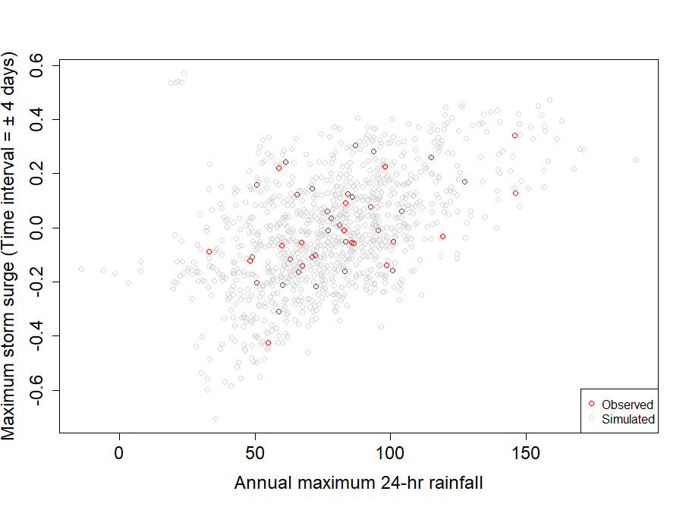(a)
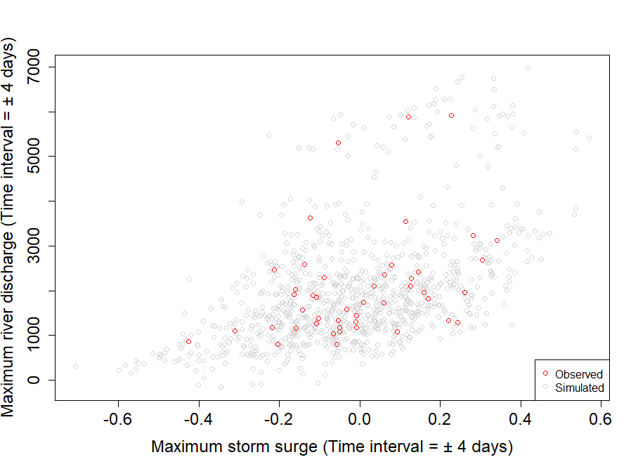 (b)
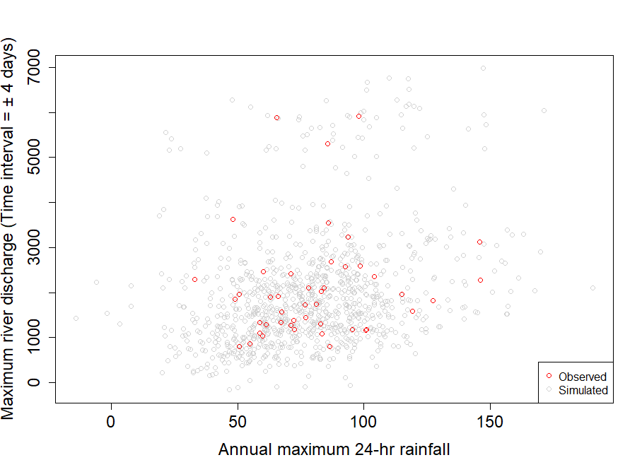(c)
SF 6: Overlapped 2-D scatterplot between simulated flood events (of sample size, N=1000, using D-vine structure in the nonparametric setting) and historical flood events for (a) rainfall and storm surge (b) storm surge and river discharge (c) rainfall and river discharge pair
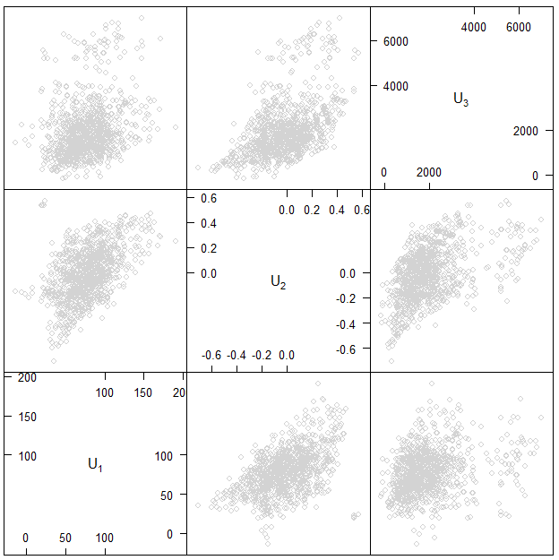
SF 7: 3-D scatterplot of flood samples generated from best-fitted D-vine structure in the nonparametric settings

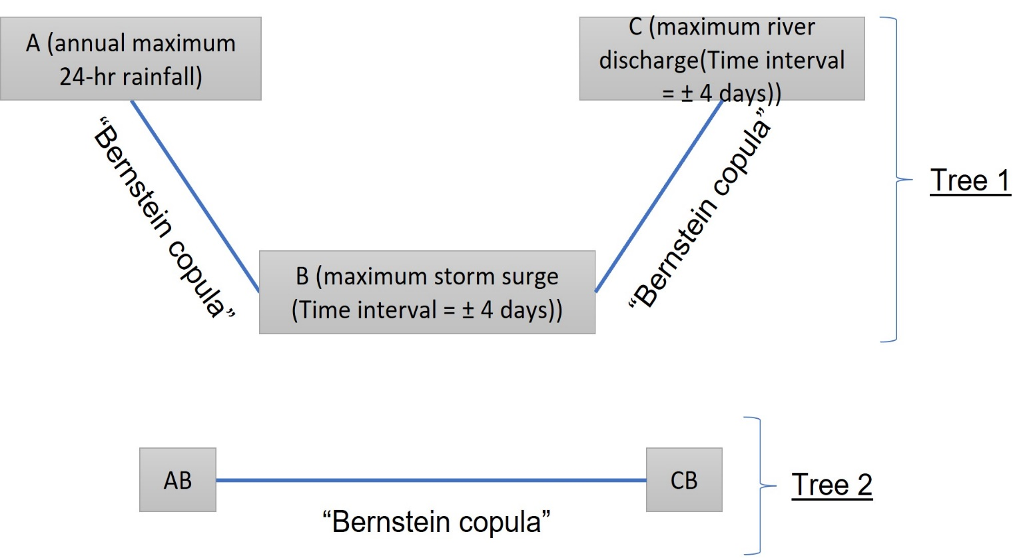
SF 8: Vine tree plot of the fitted D-vine structure (case-2) in the nonparametric distribution setting

