Supplementary Table 1 Characteristics of subjects¹ and endometrial biopsies in the study
_______________________________________________________________________________
Serial no. Subject ID Age Cycle day Histology Diagnosis Final selection
______________________________________________________________________________
Group 1 (Control, No endometriosis)
1 4 24 24 MSE NAD Yes
2 10 27 24 MSE NAD Yes
3 14 30 20 MSE NAD Yes
4 20 31 30 AE AEB, LM No
5 22 34 20 MSE NAD Yes
6 23 36 20 MSE NAD Yes
7 26 37 20 AE LM No
8 28 29 26 DyRM EP No
9 30 37 22 MSE NAD Yes
10 37 33 22 MSE EP No
11 39 32 25 MSE NAD Yes
12 45 24 20 MSE NAD Yes
13 48 28 23 MSE NAD Yes
14 59 29 26 LSE NAD No
15 64 27 20 AE LM No
16 EM1 36 26 MSE NAD Yes
17 EM63 33 24 MSE NAD Yes
_______________________________________________________________________________
Group 2 (Ovarian endometriosis, stage IV)
1 72 36 18 MSE NAD Yes
2 75 32 20 MSE NAD Yes
3 78 28 20 MSE NAD Yes
4 86 31 20 MSE NAD Yes
5 011 30 24 MSE NAD Yes
6 0111 36 24 MSE NAD Yes
7 112 32 26 DyRM AM No
8 113 35 22 MSE NAD Yes
9 114 31 20 MSE NAD Yes
10 115 26 20 DyRM AM No
11 119 22 20 ESE EP, LM No
12 120 33 24 MSE NAD Yes
13 126 33 22 AE AM No
14 128 28 18 MSE NAD Yes
15 129 32 18 DyRM AEB No
16 130 24 20 DyRM LM No
17 131 26 18 AE AM No
18 134 32 26 MSE NAD Yes
19 135 35 22 MSE NAD Yes
20 137 28 25 MSE NAD Yes
________________________________________________________________________________
¹all subjects were recruited from Infertility clinic and had been suffering from primary infertility. AE, atrophic endometrium; AEB, abnormal endometrial bleeding; AM, adenomyosis; DyRM, dysregulated maturation; EP, endometrial polyp; ESE, early secretory phase endometrium; LM, leiomyoma; LSE, late secretory phase endometrium; MSE, mid-secretory phase endometrium; NAD, no abnormality detected.

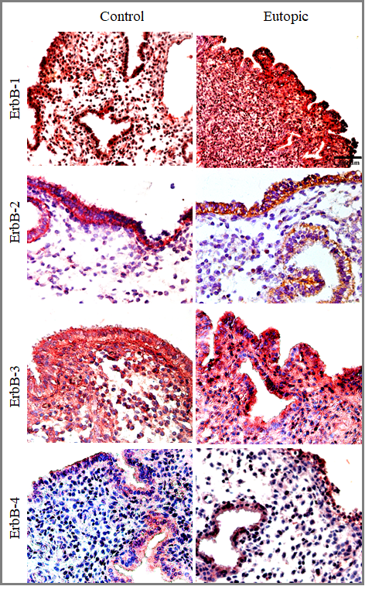
Supplementary Figure 1: Composite plate of representative photomicrographs at low magnification for ErbBs1-4 immunostaining in MSE obtained from both groups. Bar: 100 μm.

