Supplementary files.
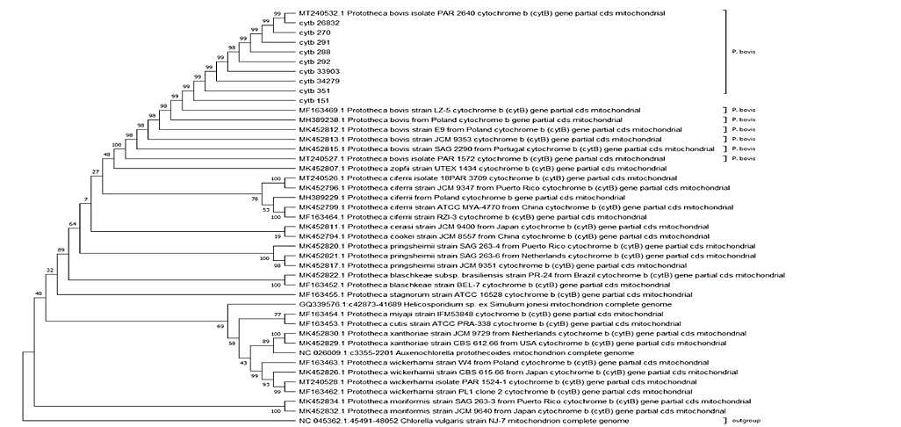

Supplementary figure 1. Phylogenetic tree of the Prototheca genus built with the MEGA bioinformatics program using the Maximum likelihood algorithm along with the Tamura-Nei model with G+I distribution and bootstrap of 500. Tree results clustered the cytB sequences from this study within the Prototheca bovis clade. Bootstrap values of each branch within the Prototheca bovis clade consist of values of 98–99.
Accession number | Species | Country
NC_045362.1 | Chlorella vulgaris strain NJ-7 | China
NC_026009.1 | Auxenochlorella protothecoides | China
MT240532.1 | Prototheca bovis isolate PAR 2640 | Italia
MT240528.1 | Prototheca wickerhamii isolate PAR 1524-1 | Italia
MT240527.1 | Prototheca bovis isolate PAR 1572 | Italia
MT240526.1 | Prototheca ciferrii isolate 18PAR 3709 | Italia
MK452834.1 | Prototheca moriformis strain SAG 263-3 | Puerto Rico
MK452832.1 | Prototheca moriformis strain JCM 9640 | Japan
MK452830.1 | Prototheca xanthoriae strain JCM 9729 | Netherlands
MK452826.1 | Prototheca wickerhamii strain CBS 615.66 | Japan
MK452822.1 | Prototheca blaschkeae subsp. brasiliensis strain PR-24 | Brazil
MK452821.1 | Prototheca pringsheimii strain SAG 263-6 | Netherlands
MK452820.1 | Prototheca pringsheimii strain SAG 263-4 | Puerto Rico
MK452817.1 | Prototheca pringsheimii strain JCM 9351 | Poland
MK452815.1 | Prototheca bovis strain SAG 2290 | Portugal
MK452813.1 | Prototheca bovis strain JCM 9353 | Poland
MK452812.1 | Prototheca bovis strain E9 | Poland
MK452811.1 | Prototheca cerasi strain JCM 9400 | Japan
MK452807.1 | Prototheca zopfii strain UTEX 1434 | Poland
MK452799.1 | Prototheca ciferrii strain ATCC MYA-4770 | China
MK452796.1 | Prototheca ciferrii strain JCM 9347 | Puerto Rico
MK452794.1 | Prototheca cookei strain JCM 8557 | China
MH389238.1 | Prototheca bovis | Poland
MH389229.1 | Prototheca ciferrii | Poland
MF163469.1 | Prototheca bovis strain LZ-5 | Poland
MF163464.1 | Prototheca ciferrii strain RZI-3 | Poland
MF163463.1 | Prototheca wickerhamii strain W4 | Poland
MF163462.1 | Prototheca wickerhamii strain PL1 clone 2 | Poland
MF163455.1 | Prototheca stagnorum strain ATCC 16528 | Poland
MF163454.1 | Prototheca miyajii strain IFM53848 | Poland
MF163453.1 | Prototheca cutis strain ATCC PRA-338 | Poland
MF163452.1 | Prototheca blaschkeae strain BEL-7 | Poland
GQ339576.1 | Helicosporidium sp. ex Simulium jonesi | Canada

Supplementary Table 1. Sequences retrieved from the GenBank used to develop the phylogenetic tree of the present study. Table shows the accession number of the sequence together with the species and country of origin.

