Altered microRNA transcriptome in cultured human airway cells upon infection with SARS-CoV-2
Idrissa Diallo¹, Rajesh Abraham Jacob², Elodie Vion¹, Robert A. Kozak³, Karen Mossman² and Patrick Provost^{1,*}
¹ CHU de Québec-Université Laval Research Center/CHUL Pavilion, Department of Microbiology, Infectious Diseases and Immunology, Faculty of Medicine, Université Laval, Quebec City, QC, G1V 0A6, Canada.
² McMaster Immunology Research Centre, M.G. DeGroote Institute for Infectious Disease Research, Department of Medicine, McMaster University, Hamilton, ON L8S 4K1, Canada.
³ Division of Microbiology, Department of Laboratory Medicine & Molecular Diagnostics, Sunnybrook Health Sciences Centre, Toronto, ON M4N 3M5, Canada.
The first two authors contributed equally to this work.
* Co-corresponding author: Dr. Patrick Provost
Phone: 1 418 525 4444 (ext. 48842)
E-mail: patrick.provost@crchudequebec.ulaval.ca

SUPPLEMENTARY FIGURES

In order of appearance in the manuscript

Table S1: The read counts at the data processing stages. The total number of reads (cleaned after 3’ adapter trimming and passed Solexa CHASTITY quality filter) at different sequencing data processing stages were averaged (n=3 biological replicates) and listed for each sample. Adapter-trimmed reads were expressed in counts and as percentage relative to all clean reads (8-30nt). Reads aligned to known human pre-miRNAs were expressed in counts and as percentage relative to the adapter-trimmed reads.
 | Clean Reads | Adapter-trimmed Reads >= 16nt  (% in clean reads) | Reads aligned to known pre-miRNA in miRBase21  (% in adapter-trimmed reads>16nt)
Mock 24 | 6469770 | 2632761 (41%) | 721864 (27%)
SARS-CoV-2 24h | 6026937 | 4701736 (78%) | 1849304 (39%)
Mock 72h | 6908146 | 4522348 (65%) | 2434309 (54%)
SARS-CoV-2 72h | 7004440 | 4842784 (69 %) | 1924870 (40%)

Figure S1. Adapter-trimmed reads length distribution in Calu-3 cells infected or not with SARS-CoV-2 virus. The total adaptor-trimmed read count for each length (16-30 nt) was measured for Mock and SARS-CoV-2 infected cells at 24 h and 72 h post-infection. n=3 biological replicates for each condition.

Table S2. List of primers used in this study. FW, forward; RV, reverse.
Genes | Sequences (5’-3’) | Accessions
FW_ACE2 | GGGATCAGAGATCGGAAGAAGAAA | NM_001371415.1
RV_ACE2 | AGGAGGTCTGAACATCATCAGTG
FW_TMPRSS2 | AGGTGAAAGCGGGTGTGAGG | NM_001135099.1
RV_TMPRSS2 | ATAGCTGGTGGTGACCCTGAG
FW_ADAM17 | CTGGACACGTGGTTGGTGAG | NM_003183.6
RV_ADAM17 | ATGAACAAGCTCTTCAGGTGGT
FW_CXCL10 | CCACGTGTTGAGATCATTGCT | NM_001565.4
RV_CXCL10 | TGCATCGATTTTGCTCCCCT
FW_IL-6 | CCCACCGGGAACGAAAGA | NM_000600.5
RV_IL-6 | TGGACCGAAGGCGCTTGT
FW_DYRK1A | AAAAATCAGCGAAAGCCAGGAT | NM_001396.5
RV_DYRK1A | TGCTGAAGTCTCTCCTCCTGTA
FW_AKT | ATGGACAGGGAGAGCAAACG | NM_005163.2
RV_AKT | CTGGCCACAGCCTCTGATG
FW_IFNB1 | GCGACACTGTTCGTGTTGTC | NM_002176.4
RV_IFNB1 | GCCTCCCATTCAATTGCCAC
FW_WNT | AAAATCCGGGGATCCTGCAC | NM_005430.4
RV_WNT | GTTTCTCGACAGCCTCGGTT
FW_NOTCH | GACATGCCACGTGGTGGA | NM_017617.5
RV_NOTCH | GGCACGATTTCCCTGACCA
FW_AngioT | GGGTACTACAGCAGAAGGGTATG | NM_001384479.1
RV_AngioT | GGGGATGTCTTGGCCTGAAT
FW_Renin | GGAACAGAACTCACCCTCCG | NM_000537.4
RV_Renin | GTGATTCCACCCACGGTGAT
FW_ACE | TCTGGCAGAACTTCACGGAC | NM_000789.4
RV_ACE | TTAGCAGGGCGTTGTACTGC
FW_SOCS4 | TGGGCACATGATGGCAGATAC | NM_199421.2
RV_SOCS4 | CCGTCTTTTCTGTCGGCACT
FW_Furin | TGGACCCCAAAATCAGCGAA | NM_002569.4
RV_Furin | GTGAGAGCGGTGAACCAAGA
FW_N-SARS | TGGACCCCAAAATCAGCGAA | NC_045512.2
RV_N-SARS | GTGAGAGCGAACCAAGA

Figure S2. SARS-CoV-2 potentially regulates several predicted host mRNA targets involved in fundamental cellular processes. mRNA levels of SOCS4, AKT, NOTCH, WNT genes were monitored by RT-qPCR (relative expression) following SARS-CoV-2 infection in Calu-3 cells. qPCR data were normalized with a reference gene (Actin beta, ACTB), reported to control (uninfected=mock), and expressed with a relative quantitation method (ddCT). Statistical analysis. All data presented were calculated from three biological replicates (n = 3) measurements ± SD. The ordinary one-way analysis of variance (ANOVA) and Šídák's multiple comparisons test were used for statistical analysis. Statistically significant differences (fold change vs. control) are indicated by stars (*), * p < 0.05; ** p < 0.01; *** p < 0.001, **** p < 0.0001.

Figure S3. Proportion of differentially expressed miRNAs in Calu-3 cells infected or not with SARS-CoV-2 virus. Differentially expressed miRNAs (upregulated, downregulated, or unchanged) are extracted from the scatter plot of Figure 6 and in reference to total number of miRNAs at 24h and 72h.

Figure S4. miR-1290 does not seem to regulate ACE2. Calu3 cells were co-transfected with homo sapiens (hsa) human miR-1290 mimic (0, 25, 50, and 100 nM) and a psiCHECK2 reporter construct (50 ng; see Supplementary File SX), in which the Rluc reporter gene was coupled with wild-type (WT) or mutated (MUT) human ACE2 3′ Untranslated Region (UTR). An unrelated, negative miRNA control (Mock) was used for normalization, in addition to the internal normalizer Fluc. “0 nM” corresponds to the transfection reagent-only control. Statistical analysis: Data were calculated from three biological replicates and expressed as means ± SD. The two-way analysis of variance (ANOVA) and Šídák's multiple comparisons test were used, and statistically significant differences (fold change WT vs. MUT) are indicated as follows: * p < 0.05; ** p < 0.01; *** p < 0.001; **** p < 0.0001; ns, nonsignificant.

Figure S5. Combination of miR-1246 and miR-1290 did not result in a additive repressive effect on ACE2 levels. Calu3 cells were co-transfected with a mix of two homo sapiens (hsa) human miR-1246 and miR-1290 mimic (0, 25, 50, and 100 nM) and a psiCHECK2 reporter construct (50 ng; see Supplementary File SX), in which the Rluc reporter gene was coupled with wild-type (WT) or mutated (MUT) human ACE2 3′ Untranslated Region (UTR). An unrelated, negative miRNA control (Mock) was used for normalization, in addition to the internal normalizer Fluc. “0 nM” corresponds to the transfection reagent-only control. Statistical analysis: Data were calculated from three biological replicates and expressed as means ± SD. The two-way analysis of variance (ANOVA) and Šídák's multiple comparisons test were used, and statistically significant differences (fold change WT vs. MUT) are indicated as follows: * p < 0.05; ** p < 0.01; *** p < 0.001; **** p < 0.0001; ns, nonsignificant.

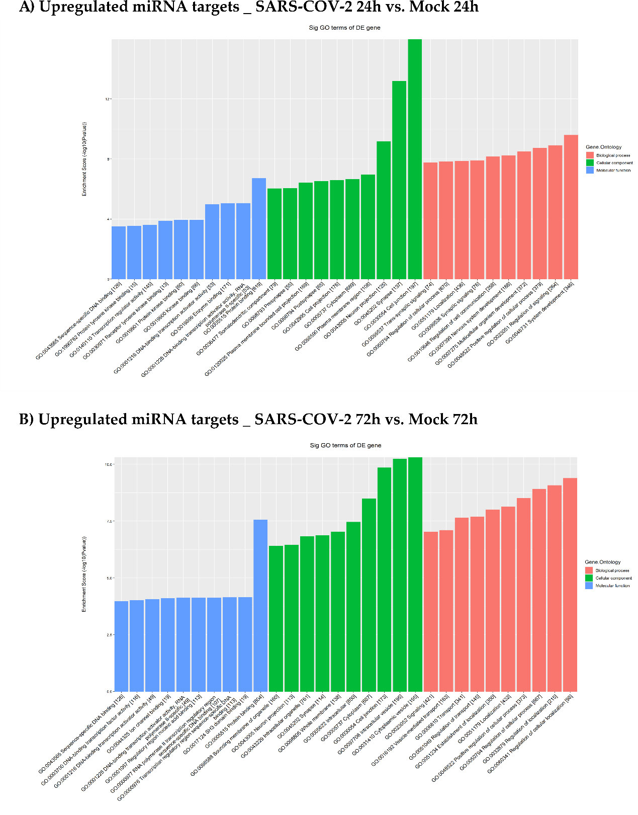
Figure S6. Enrichment score values of the top ten enrichment terms following SARS-CoV-2 infection vs. Mock. Filtered targets of upregulated miRNAs at A) 24 h and B) 72h post-infection were subjected to GO functional analysis (Biological Process, Molecular Function, Cellular Component).

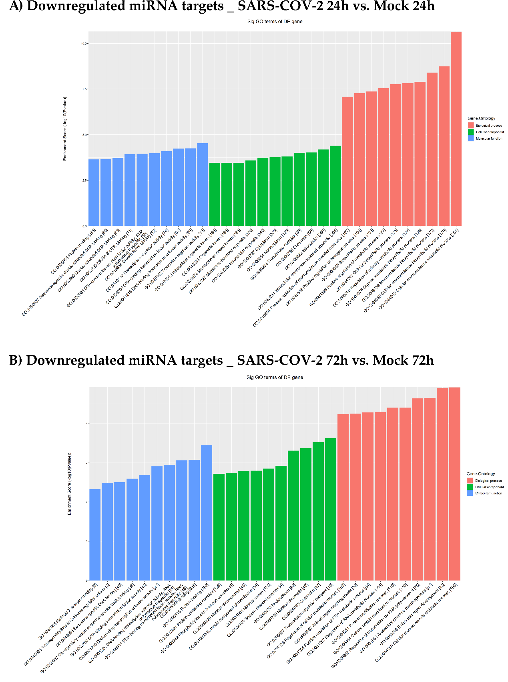
Figure S7. Enrichment score values of the top ten enrichment terms following SARS-CoV-2 infection vs. Mock. Filtered targets of downregulated miRNAs at A) 24 h and B) 72h post-infection were subjected to GO functional analysis (Biological Process, Molecular Function, Cellular Component).

