Low dose rate radiation induced secretion of TGF-β3 together with an activator in small extracellular vesicles modifies low dose hyper-radiosensitivity through ALK1 binding

1. Supplementary figures
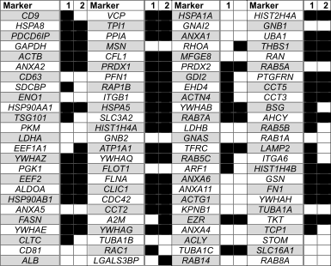
Figure S1. List of the 100 proteins most frequently detected in extracellular exosomes ^{[1]}, and their detection in two separate experiments (each with n=3 biological replicates) of exosomes from both LDR irradiated and unirradiated T-47D cells: ■ – detected, □ - not detected.
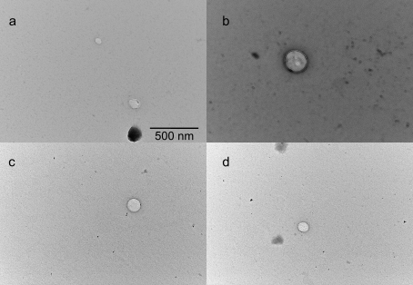
Figure S2. Transmission electron microscope (TEM) images of extracellular vesicles isolated from LDR primed (a,b) and unirradiated (d,e) T-47D cells. The shape and size of the isolated particles are consistent with that of extracellular exosomes.

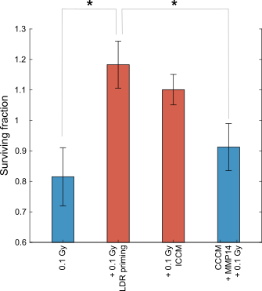
Figure S3. Survival of T-47D cells after pretreatment with control cell conditioned medium (CCCM) and recombinant matrix metalloproteinase 14 (MMP14). Pre-treatment with MMP14 did not lead to a change in radioresistance after 0.1 Gy consistent with removal of HRS, and the surviving fraction was lower than that of LDR primed cells and those pretreated with ICCM. Surviving fraction is given as error-weighted average of three separate experiments, each with four biological replicates. Error bars: SEM. Statistical analysis: student’s t-test. *p<0.05. Note that the surviving fractions were calculated relative to the plating efficiency of control cells, which were also exposed to the pretreatments.

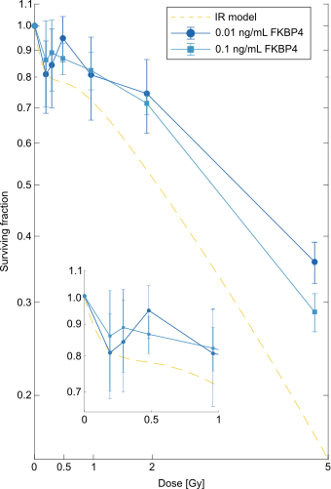
Figure S4. Survival of T-47D cells after pretreatment with Peptidyl-prolyl cis-trans isomerase FKBP4 (FKBP4). Addition of 0.01 ng/mL (●) or 0.1 ng/mL (■) recombinant FKBP4 to the medium of T-47D cells 48 hours before challenge γ-irradiation did not remove HRS from the cells. IR model= induced repair model-fit for untreated T-47D cells. Error bars represent SEM of three separate experiments, each with five biological replicates. Note that the surviving fractions were calculated relative to the plating efficiency of control cells, which were also exposed to the pretreatments.

[1] Keerthikumar, S.; Chisanga, D.; Ariyaratne, D.; Al Saffar, H.; Anand, S.; Zhao, K.; Samuel, M.; Pathan, M.; Jois, M.; Chilamkurti, N.; et al. ExoCarta: A Web-Based Comendium of Exosomal Cargo. J Mol Biol, 2017, 428 (4), 688–692. https://doi.org/10.1016/j.jmb.2015.09.019.

