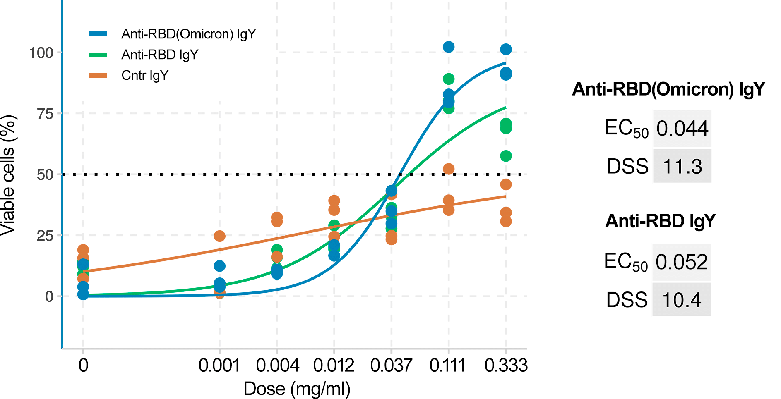
Figure S1. IgY antibodies raised against receptor-binding domains (RBD) of spike glycoproteins of Wuhan and Omicron variants neutralize SARS-CoV-2/Omicron virus in vitro. Neutralization capacity of anti-RBD(Omicron), anti-RBD(Wuhan) or control non-immune IgY was measured by monitoring viability of Vero-E6 cells after 48 h of infection with mCherry-expressing SARS-CoV-2 strain. Mean ± SD; n = 3.

