Supplementary Materials

Mariel Barjau-Aguilar et al _ Nitrogen and phosphorous mass balances show tropical eutrophic reservoirs behave as variable but persistent sinks of both elements: a case study using a long-term series to assess the effect of water level fluctuations

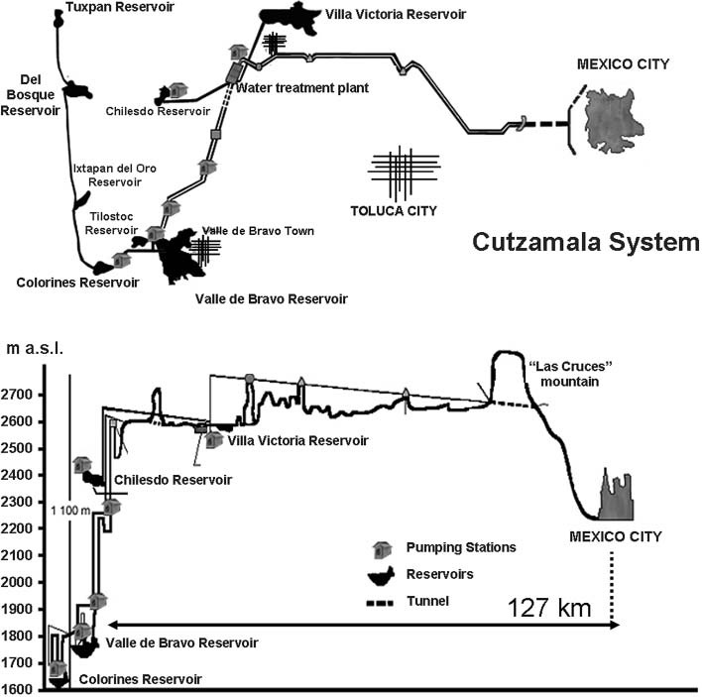
Figure S1.-The Cutzamala System. Outline and distribution of the reservoirs (top). Altitude profile (bottom). After Ramírez-Zierold et al. (2010).

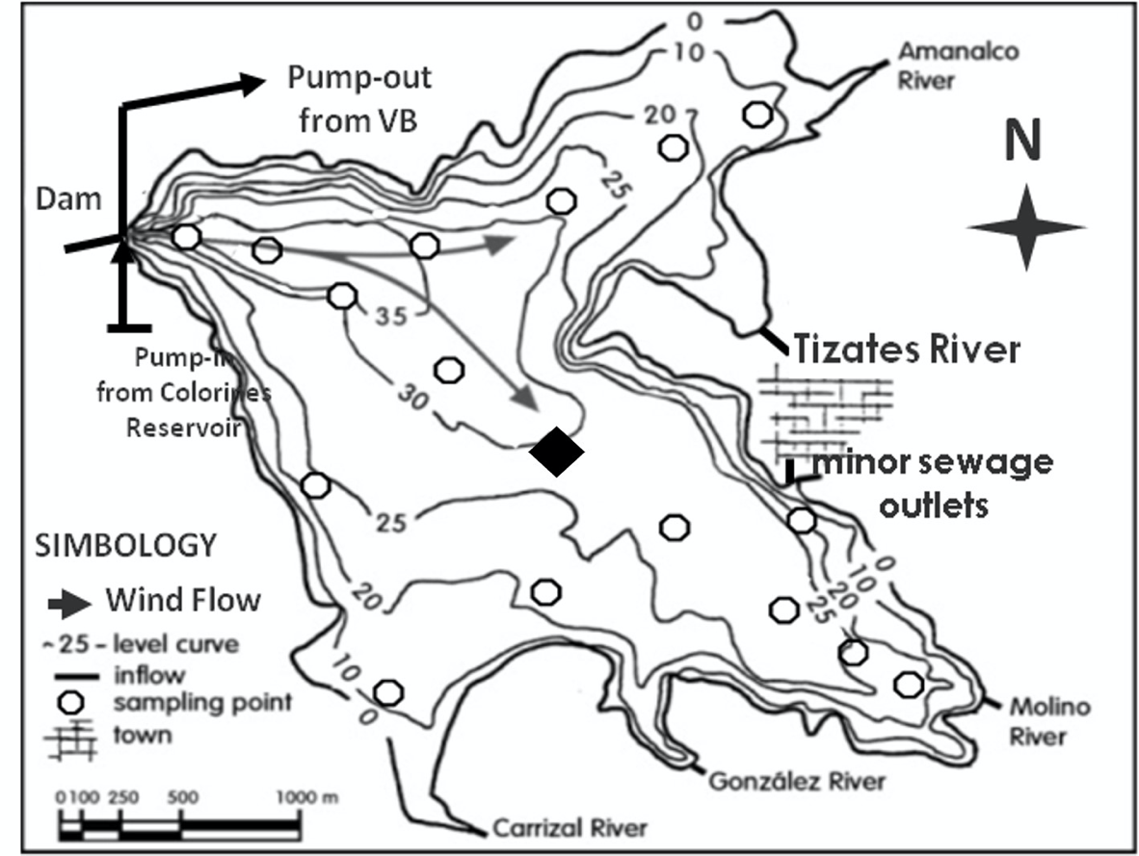
Figure S2. Bathymetric map of Valle de Bravo (VB) reservoir showing the main inputs (rivers and sewages), and water withdrawal route. Circles indicate all eventually sampled spots, and the black diamond the central station sampled throughout the log-term sampling here reported. Depth contours in m below the maximum level of the lake. Daily wind pathways over both arms are also indicated by the arrows. After Merino-Ibarra et al. (2021).

Table S1. Water Budget of Valle de Bravo. Mean, maximum and minimum daily water level and mean annual water budget components of Valle de Bravo during: the low water level fluctuations-1 (L-WLF-1) years (2002-2005), the high-water level fluctuations (H-WLF) years (2006-2013) −for better visualization shaded in purple−, the, water level fluctuations-2 (L-WLF-2) years (2014-2018), the overall mean (2003-2018) and the overall percentage of each inflow and outflow regarding the overall total inflows.

 |  | L-LWF-1 |  | H-LWF | L-LWF-2 | Overall
 |  | (2003-2005) |  | (2006-2013) | (2014-2018) | (2003-2018)
Reservoir
Water level ( m a.s.l) |  |  | 1827.0 | 1824.0 | 1827.8 | 1825.7
Min |  |  | 1826.4 | 1821.4 | 1826.5 | 1821.4
Max |  |  | 1827.5 | 1827.0 | 1828.6 | 1828.6
Surface area (10⁶m²) |  |  | 16.8 | 15.5 | 17.7 | 16.4
Volume (10⁶m³) |  |  | 342.2 | 290.2 | 353.0 | 319.6
ΔV/Δt (10⁶m³y⁻¹) |  |  | -23.1 | 7.2 | 8.8 | 2.0
Water Flows (10⁶m³y⁻¹) |  |  |  |  |  |  | % Input
Inflows |  |  | 221.6 | 199.5 | 231.1 | 213.5 | 100%
Precipitation |  |  | 16.2 | 17.3 | 19.7 | 17.8 | 8%
Pump-back |  |  | 8.5 | 20.3 | 16.6 | 16.9 | 8%
Rivers and sewages |  |  | 196.9 | 162.0 | 194.8 | 178.8 | 84%
- Rivers |  |  | 189.4 | 153.9 | 185.9 | 170.5 | 80%
- Amanalco River |  |  | 87.8 | 86.7 | 106.0 | 92.9 | 80%
- Molino River |  |  | 72.1 | 41.8 | 36.3 | 45.8 | 44%
- Gonzales River |  |  | 14.5 | 12.8 | 17.2 | 14.5 | 21%
- Carrizal River |  |  | 11.8 | 7.5 | 20.0 | 12.2 | 7%
- Santa Monica River |  |  | 3.2 | 5.0 | 6.4 | 5.1 | 2%
- Sewages |  |  | 7.5 | 8.1 | 8.9 | 8.2 | 4%
- Tizates |  |  | 5.3 | 4.2 | 5.7 | 4.9 | 2%
- Embarcadero I |  |  | 1.1 | 2.7 | 2.4 | 2.3 | 1%
- Embarcadero II |  |  | 1.1 | 1.2 | 0.8 | 1.1 | 0%
Outflows |  |  | -243.0 | -191.9 | -221.1 | -210.6 | -99%
Evaporation |  |  | -30.4 | -28.4 | -28.5 | -28.8 | -13%
Water Withdrawal |  |  | -212.6 | -163.5 | -192.6 | -181.8 | -85%
Inflows-Outflows |  |  | -21.4 | 7.6 | 10.0 | 2.9 | 1%

