Supplementary Material for

Suspended water droplet confined laser shock processing at elevated temperatures
Jian Liu ª, Xiaohan Zhang ª, Yali He ª, Zhe Zhao ª, Min Xia ^{b},Yaowu Hu ^{a*}
ª The Institute of Technological Sciences, Wuhan University, Wuhan, 430072, China
^{b} Department of Engineering, Lancaster University, Lancaster, LA1 4YW, United Kingdom

*Corresponding author: Yaowu Hu
E-mail: yaowuhu@whu.edu.cn

This file includes:
Supplementary Figures 1-8
Supplementary Tables 1-3
Supplementary Notes

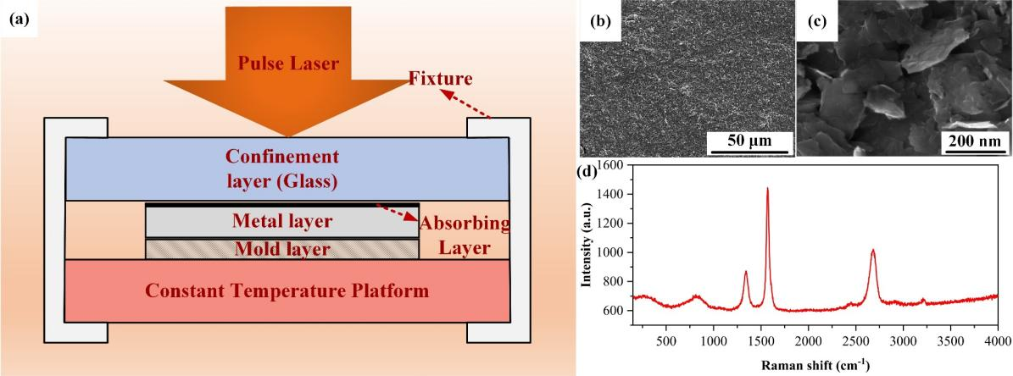
Fig. S1 The typical laser shock forming process: (a) Schematic view of laser shock forming, (b) and (c) SEM images of graphite, (d) Raman spectrum of graphite.

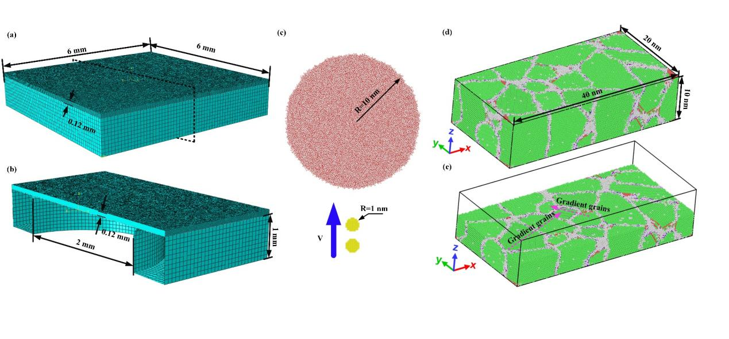
Fig. S2 The simulation models: (a) Global FE model, (b) Cross-section of the FE model, (c) Global MD model for droplet confinement process, (d) Global MD model for uniaxial tension of gradient grains, (e) Cross-section of the MD model in (d).

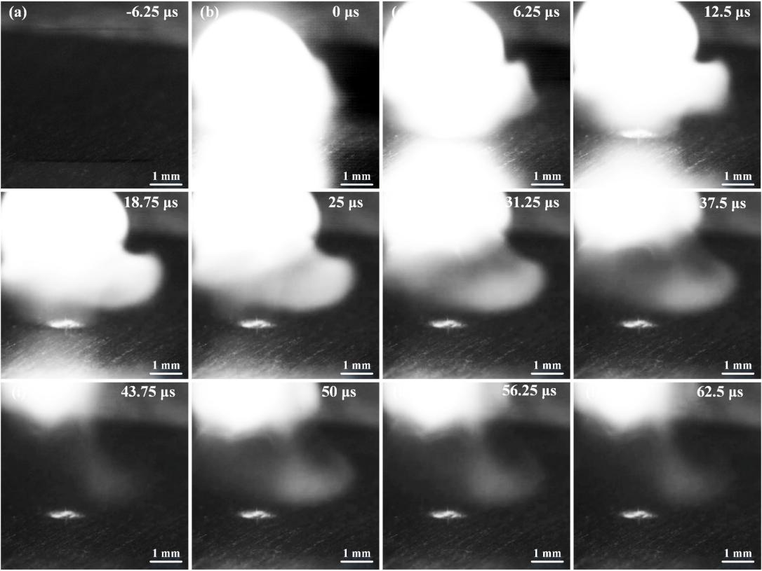
Fig. S3 Series of time-resolved images of laser induced plasma process at 300 ℃: (a) -6.25 μs, (b) 0 μs, (c) 6.25 μs, (d) 12.5 μs, (e) 18.75 μs, (f) 25 μs, (g) 31.25 μs, (h) 37.5 μs.

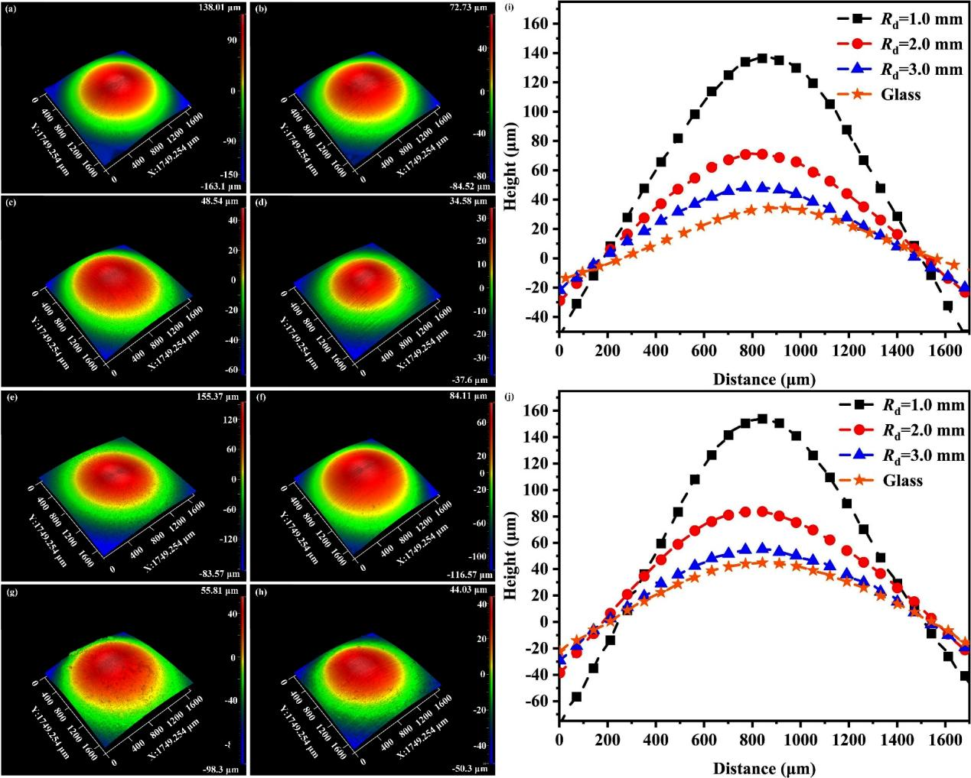
Fig. S4 3D and 2D morphologies of Cu sheets processed by LSF with different temperatures and confinement strategies: (a) R_{d}=1 mm, 350 ℃, (b) R_{d}=2 mm, 350 ℃, (c) R_{d}=3 mm, 350 ℃, (d) Glass confinement, 350 ℃, (e) R_{d}=1 mm, 400 ℃, (f) R_{d}=2 mm, 400 ℃, (g) R_{d}=3 mm, 400 ℃, (h) Glass confinement, 400 ℃, (i) 2D profiles of deformed Cu sheets at 350 ℃, (j) 2D profiles of deformed Cu sheets at 400 ℃

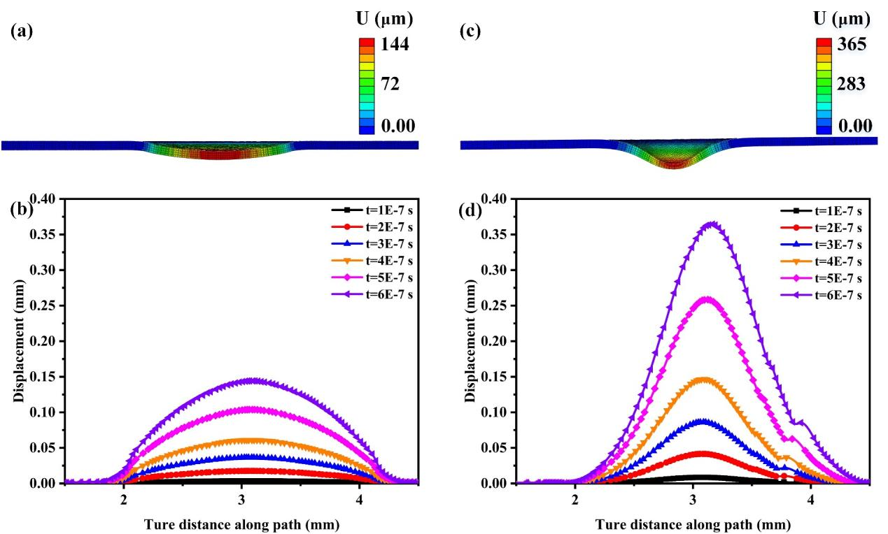
Fig. S5 FE simulation results of LSF with different confinement methods at 300 ℃: (a) Strain distribution of Cu sheet shocked with glass confinement, (b) Dynamic 2D profiles of deformed Cu sheets shocked with glass confinement, (c) Strain distribution of Cu sheet shocked with WDC, (d) Dynamic 2D profiles of the deformed Cu shocked with WDC.

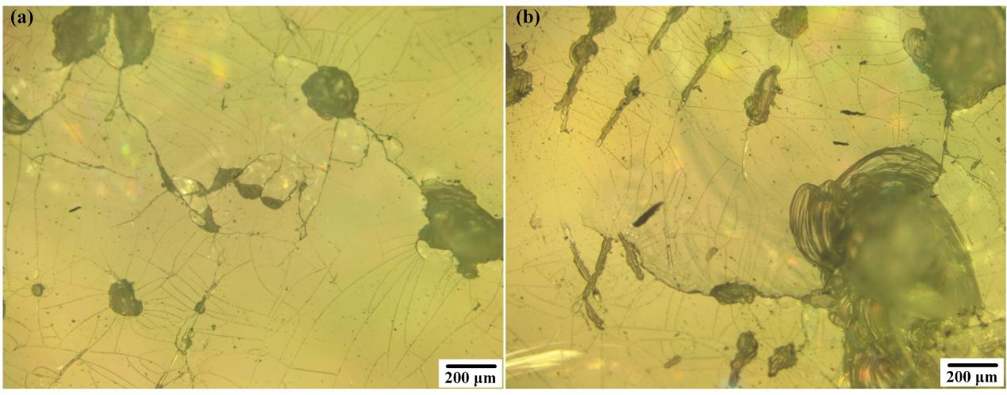
Fig. S6 Fragmentation image of glass confinement layer during continuous laser shock process at high temperature: (a) 300 ℃, (b) 350 ℃.

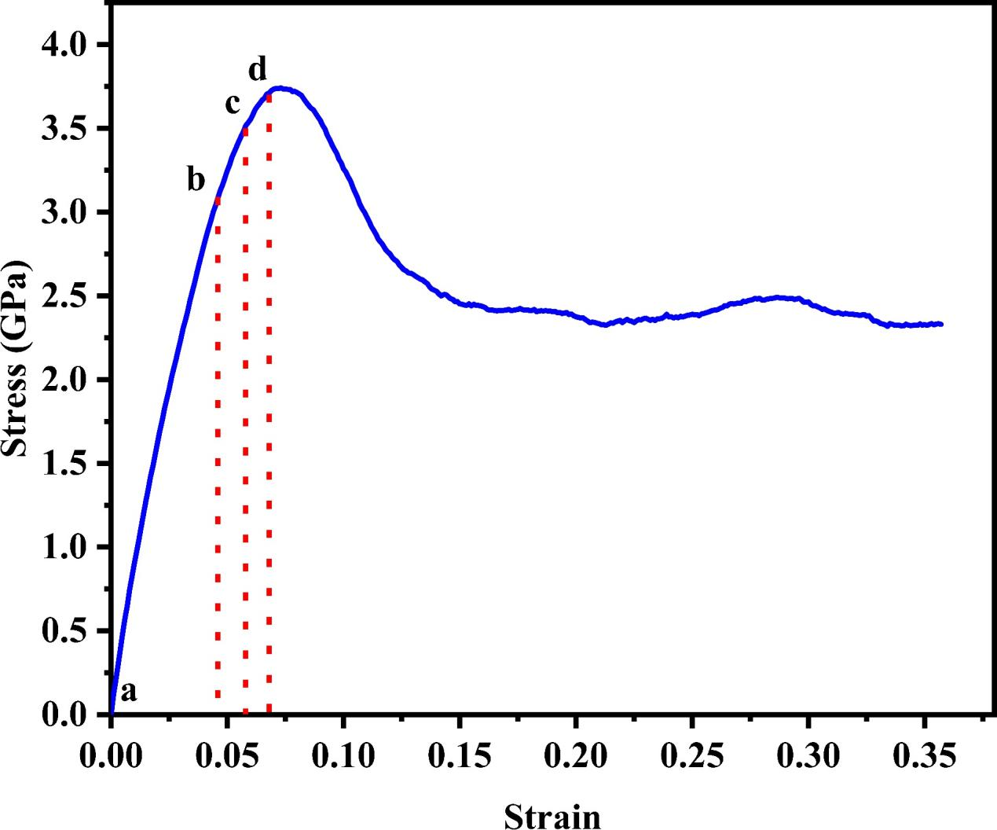
Fig. S7 The tensile curve of Cu obtained from MD simulation,

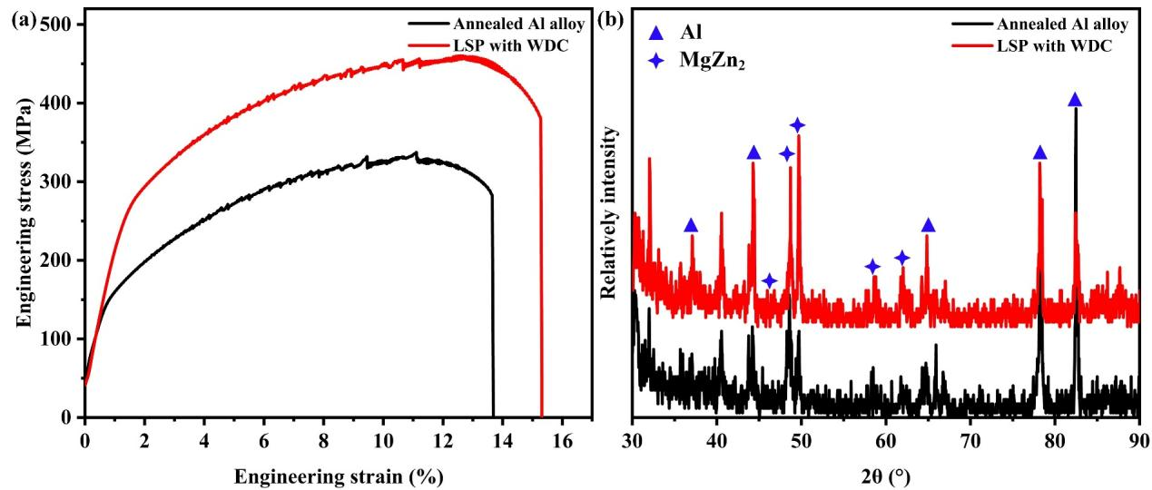
Fig. S8 Engineering stress-strain curves and XRD results of 7075 Al alloy: (a) Engineering stress-strain curves of annealed and LSPed 7075 Al alloy at 300 ℃, (b) XRD results of annealed and LSPed 7075 Al alloy at 300 ℃.

Table S1 Parameters of the J-C model used in this study
A | B | C | n | m
90 | 292 | 0.025 | 0.025 | 0.31

Table S2 Parameters used in vapor layer thickness calculation
Temperature (℃) | 𝜅  (W/m·K) | ∆𝑇  (℃) | 𝜂  (Pa·s) | 𝜌  (Kg/m³) | $${\text{ρ}}_{\text{v}}$$  (Kg/m³) | L  (J/Kg) | γ  (N/m) | a  (m)
300 | 4.3×10⁻³ | 200 | 8.58×10⁻⁵ | 712 | 0.52 | 1.4×10⁻⁶ | 1.47×10⁻² | 4.6×10⁻²
350 | 4.9×10⁻³ | 250 | 6.57×10⁻⁵ | 569.13 | 0.49 | 8.7×10⁻⁶ | 3.7×10⁻³ | 2.8×10⁻³
400 | 5.5×10⁻³ | 300 | 4.32×10⁻⁵ | 406.50 | 0.46 | 4.2×10⁻⁶ | 1.2×10⁻³ | 1.02×10⁻⁴

Table S3 Theoretical calculation results of laser energy density
Temperature (℃) | I_{1mm}  (GW/cm²) | I_{1.5mm}  (GW/cm²) | I_{2mm}  (GW/cm²) | I_{2.5mm}  (GW/cm²) | I_{3mm}  (GW/cm²)
300 | 42.23 | 17.62 | 10.86 | 9.12 | 8.13
350 | 43.85 | 17.78 | 10.94 | 9.19 | 8.14
400 | 44.70 | 18.12 | 11.05 | 9.21 | 8.16

Supplementary Notes

1. Experiment settings
As a comparison, the classical laser shock process using glass as confinement layer was designed (Fig. S1). Where the graphite coating was used as the absorption layer, Al foil was set as the sacrifice layer, and the K9 glass was selected as the confinement layer, respectively. The SEM images in Fig. S1(b) and (c) show that graphite flakes sizes between 50 and 300 nm, and the Raman test (Fig.S1(d)) demonstrate well crystallinity of graphite.

2. Simulation models
Fig. S2 shows the FE and MD models. The dimension of the Cu sheet in FE simulation was set to 6 mm × 6 mm × 0.12 mm (Fig. S2(a)). The mold was built as a square shell with a through hole, and was set up as an analytical rigid body. The radius of the through hole is 2 mm (Fig. S2(b)). The mesh sizes of the Cu sheet and the mold were set to 0.030 mm and 0.1 mm, respectively. The MD model for the droplet confinement process is shown in Fig. S2(c). The plasma was approximately replaced by Cu nanoparticles with a radius of 1 nm. The rigid SPC/E model of water was used, and a droplet with a radius of 10 nm was established. Additionally, a MD model containing 677353 atoms is shown in Fig. S2(d). And gradient grains can be observed in the middle region of the model Fig. S2(e).

3. Laser shock forming
Fig. S4 shows the results of laser shock forming results based on different confinement strategies at 350 ℃ and 400 ℃. Compared with glass confinement (Fig. S4(d) and (h)), the laser shock process based on droplet confinement exhibits significant forming efficiency at high temperatures, as evidenced by the increased deformation height (Fig. S4(i) and (j)). Additionally, the focusing enhancement effect of the droplet can be demonstrated by the concentrated deformation in the center of the forming region (Fig. S4(a) and (e)). Also, the size-dependent of the focusing enhancement effect can be confirmed by the weakening behavior of the concentrated deformation presented in Fig. S4(b) and (c) or Fig. S4(f) and (g).
It can be seen from Fig. S5(a) and (c) that the strain distribution characteristics in the FE simulation are in good agreement with the experimental results. The Cu sheets processed by laser shock forming with glass confinement exhibit smooth deformation, while increased strain and concentrated deformation behavior can be observed when droplet confinement is adopted. The dynamic strain curves (Fig. S5(b) and (d)) indicate that the center region of the Cu sheet presents a higher real-time strain rate due to the focusing enhancement effect of the droplet.

4. Laser shock peening
We attempted to compare the mechanical properties of annealed Cu after laser shock peening under different confinement strategies and high temperatures. Unfortunately, due to the frequent fragmentation of glass in the plasma confinement process at high temperatures (Fig. S6), we have not been able to successfully prepare the strengthened samples with glass as the confinement medium at high temperatures. However, benefiting from the high shock pressure induced by the focus enhancement effect of the droplet, it can be reasonably predicted that the droplet-based laser shock strategy has a better strengthening effect.
Fig. S7 shows the stress-strain curve obtained from the MD simulation. Among them, the meanings of the letters marked in the figure are as follows: a is the position before loading, and b, c and d correspond to the stress levels of stacking fault activation in the grains of G1, G2 and G3, respectively.

