Legends for supplementary figures
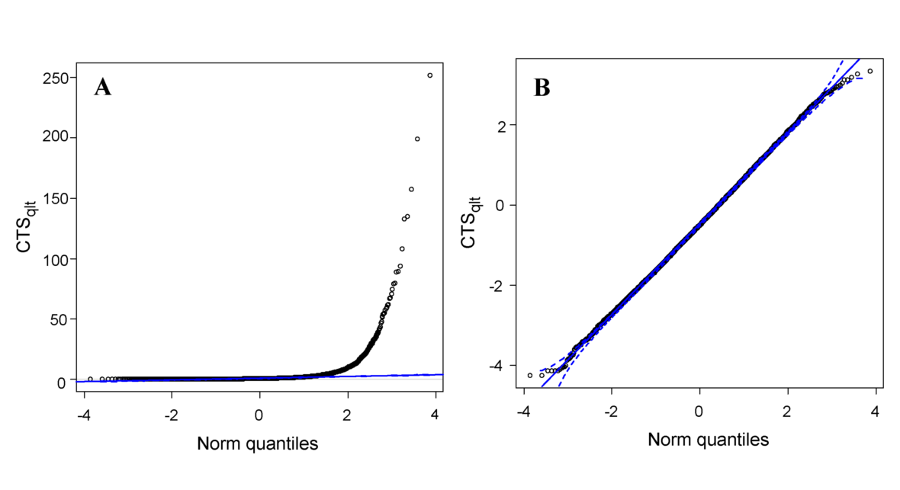Figure S1.
Note: The Q-Q plots for the CTS_{qlt} index before (A) and after (B) the Box-Cox transformation. The λ value is –0.2.
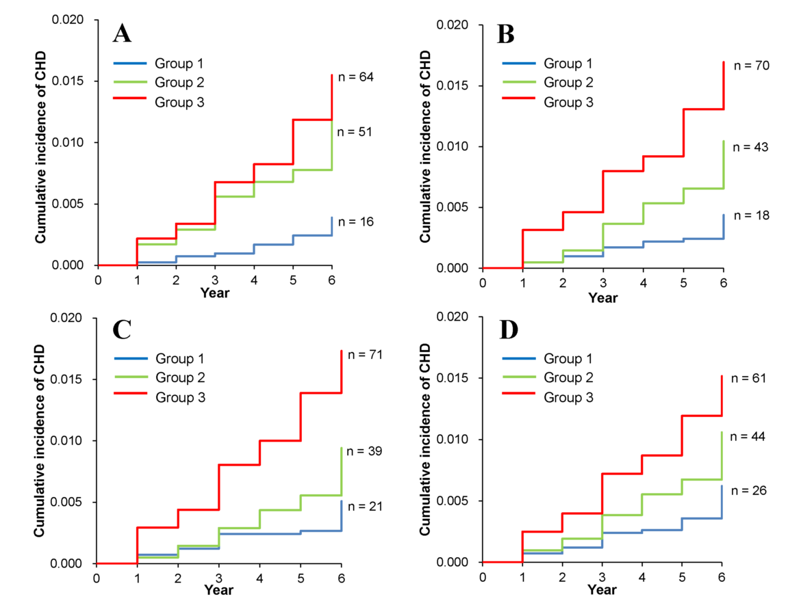
Figure 2
Note: Kaplan-Meier curves of cumulative CHD incidence in the groups of CTS_{qlt} (A), TG/HDL-c (B), CTS_{qnt} (C), and nonHDL-c (D). The study population is divided by 33.3 and 66.6 percentiles of each index. Groups 1, 2, and 3 are shown as blue, green, and red lines, respectively. .
Table S1. Categories of blood pressure and blood glucose levels.
 |  | Category
Factors |  | L | M | H
Blood pressure^{*1} | Systolic (mmHg) | – 139 | 140 – 159 | 160 –
 | Diastolic (mmHg) | – 89 | 90 – 99 | 100 –
Blood sugar (BS) ^{*2} | Fasting BS (mg/dL) ^{*3} | – 109 | 110 – 125 | 126 –
 | HbA1c (%) | – 6.0 | 6.1 – 6.4 | 6.5 –
*1, Higher category of systolic or diastolic blood pressure in each subject is chosen for regression analyses.
*2, Higher category of fasting blood glucose or HbA1c level is chosen in each subject for regression analyses.
*3, Fasting for more than 10 hours.

