Supporting Information

Polymer-coated daikon-based sunlight absorbers for highly efficient interface solar steam generation
Ming Li ^{a, b, #}, Zhenning Zhang ^{a, b, #}, Fan Yang ^{a, b}, Bo Wu ^{a, b}, Jie Yi ^{a, b}, Zhihui Yang ^{a, b}, Yuming Wu ^{a, b}, Weiming Wang ^{a, b}, Shuai Peng ^{a, b}, Jun Xiong ^{a, b,} *, Xue Min ^{a, b,} *
¹College of Chemistry and Chemical Engineering, Wuhan Textile University, Wuhan, China
²Hubei Key Laboratory of Biomass Fibers and Eco-dyeing & Finishing, Wuhan Textile University, Wuhan, China
#These authors contributed equally to this work and should be considered co-first authors
*Corresponding authors:
E-mail addresses: jxiong@wtu.edu.cn (Jun Xiong); xmin@wtu.edu.cn (Xue Min).

Characterization
SEM was characterized through JEOL InTouchScope (JSM-IT500) SEM. XRD patterns were carried out on a Rigaku Ultima IV diffractometer with a Cu Kα radiation source. XPS analysis was detected on a Kratos Axis Ultra with a Delay Line Detector photoelectron spectrometer utilizing an aluminum monochromatic X-ray source. FT-IR spectra were recorded by a Thermos Nicolet FT-IR spectrophotometer (model 6700). UV-Vis-NIR spectra were measured by Solid Spec-3700 Shimadzu. SCAs were performed on a contact angle meter (OAC20, DaraPhysics) through the static sessile drop method. The concentrations of Na⁺, Mg²⁺, K⁺, Ca²⁺, Fe³⁺ and Cu²⁺ were detected by inductively coupled plasma-mass spectroscopy (ICP-MS) using Agilent 7700. UV-vis absorption spectra were carried out on TU-1950 Persee. The simulated solar intensity was calibrated by PL-MW2000 optical density meter from Perfectlight.

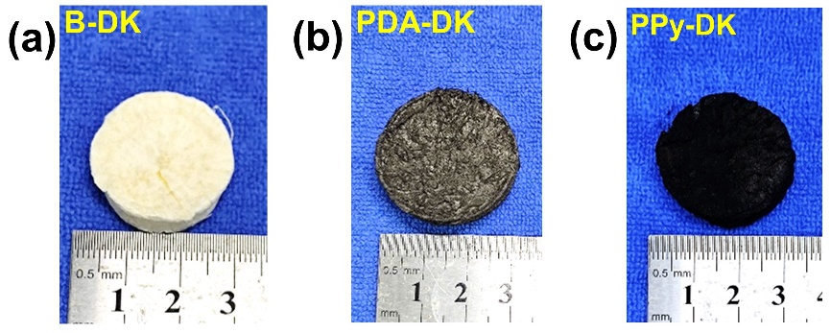
Figure S1. Photograph and diameter of (a) B-DK; (b) PDA-DK; (c) PPy-DK.

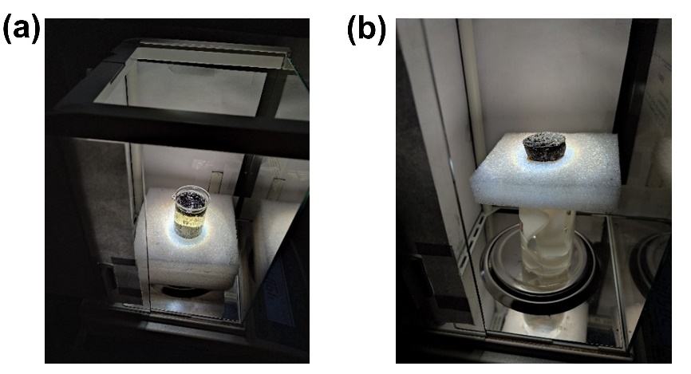
Figure S2. (a) The diagram of PPy-DK was direct put on the bulk water for solar steam generation; (b) the diagram of polyethylene foam (PEF) as insulating layer in PPy-DK system for solar steam generation.

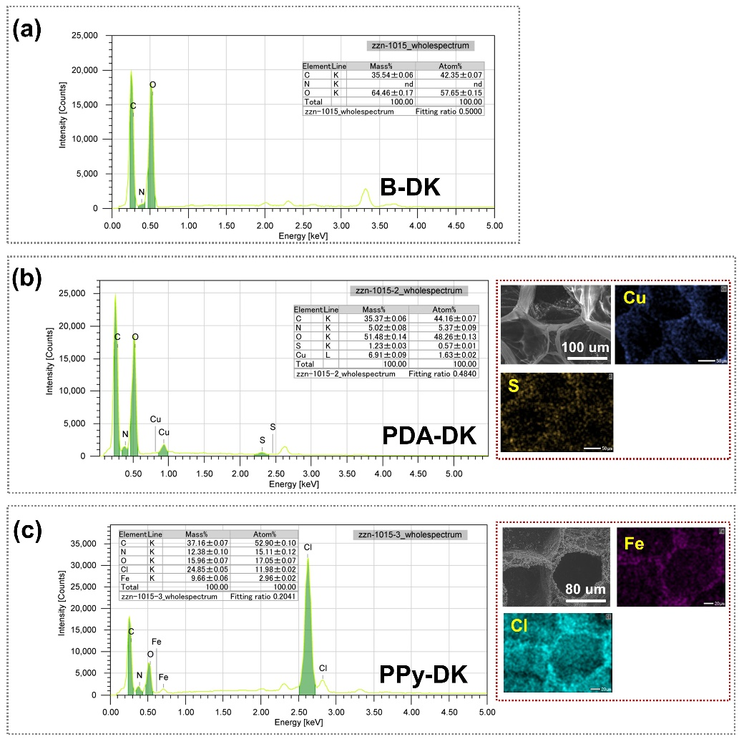
Figure S3. (a) The energy dispersive X-ray (EDX) spectroscopy B-DK; (b) the EDX spectroscopy and element mapping of PDA-DK; (c) the EDX spectroscopy and element mapping of PPy-DK.

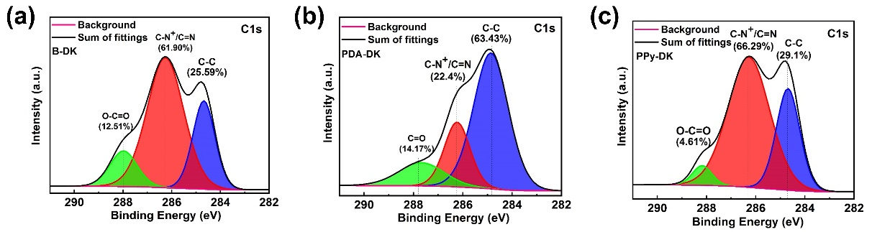
Figure S4. The high-resolution C 1s spectra of (a) B-DK; (b) PDA-DK; (c) PPy-DK.

Calculation equation of UV–Vis–NIR of B-DK, PDA-DK and PPy-DK
The solar absorption ability of B-DK, PDA-DK and PPy-DK is calculated through the following equation [S1,S2]:
A = [ʃ(1– R)·S·dλ] / [S·dλ]
A stands for the solar absorption, R represents the reflectance. S is solar spectral irradiance (W m^{–2} nm^{–1}). λ denotes the wavelength (nm).
Table S1. Proportion of light absorption in different spectral regions (300 – 2500 nm)
Sample | Total  absorption | UV  (300 – 400 nm) | Visible  (401 – 760 nm) | Infrared  (761 – 2500 nm)
Solar spectrum | 100.00% | 3.62% | 51.44% | 44.94%
B-DK | 33.13% | 2.00% | 16.83% | 14.30%
PDA-DK | 85.63% | 3.45% | 48.16% | 34.02%
PPy-DK | 98.11% | 3.58% | 50.90% | 43.63%

Calculation equation of photothermal conversion efficiency (η)
The solar energy conversion efficiency (η) is calculated through the following equations [S3,S4]:
η = m(H_{LV} + Q)/I; H_{LV} = 1.91846 × 10⁶[T₁/(T₁－33.91)]²; Q = c(T₁－T₀)
Where m is the net water evaporation rate (kg m^{–2} h^{–1}). H_{LV} is the liquid-vapor phase change enthalpy. Q is the sensible heat (J kg^{–1}). I stands for the power density of solar illumination. T₁ is the temperature of evaporation (K), T₀ is the initial temperature of the water, c is the specific heat capacity of bulk water (4.2 J g^{–1} K^{–1}).

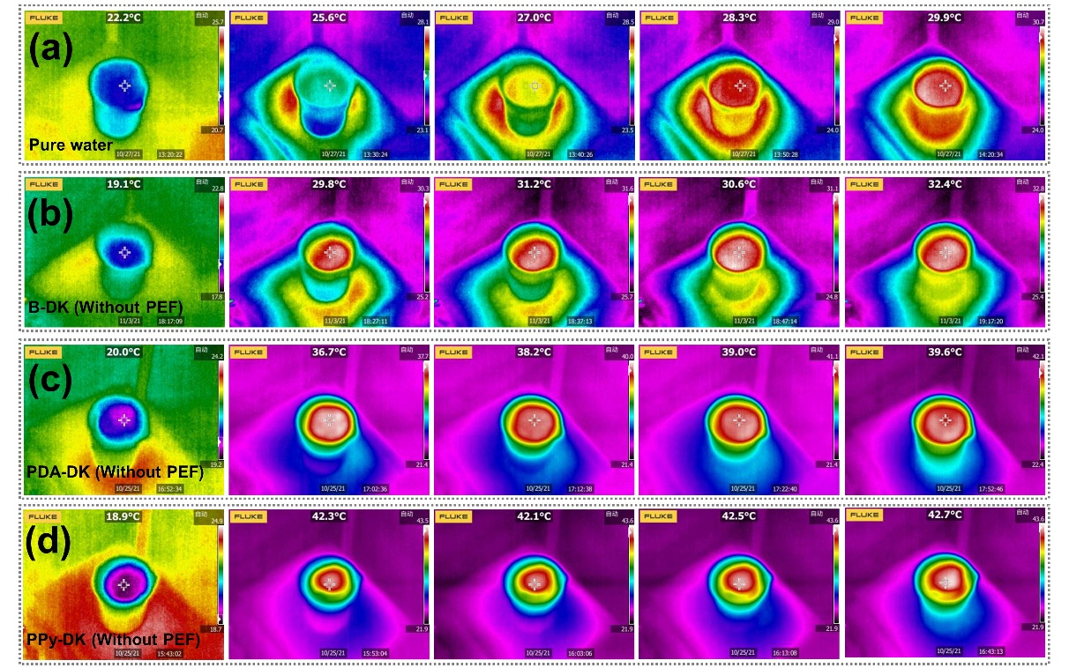
Figure S5. (a) IR images of pure water; (b) IR images of B-DK (without PEF); (c) IR images of PDA-DK (without PEF); (d) IR images of PPy-DK (without PEF) at 0, 10, 20, 30 and 60 mins, respectively.

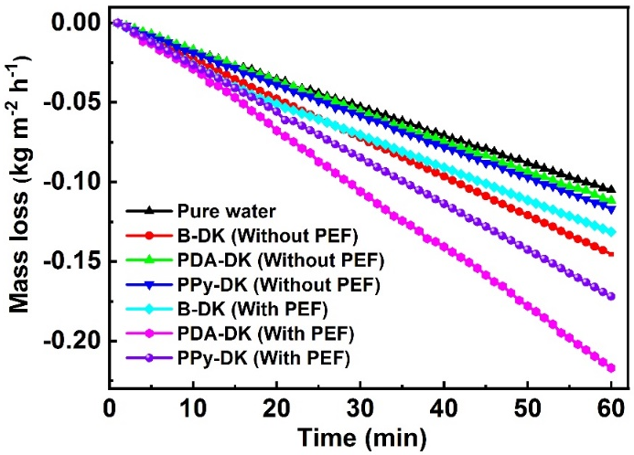
Figure S6. The dark field evaporation rates of pure water, B-DK (Without PEF), PDA-DK (Without PEF), PPy-DK (Without PEF), B-DK (With PEF), PDA-DK (With PEF) and PPy-DK (With PEF), respectively.

Table S2. Comparison of solar steam generation performance of PDA-DK with some previously reported PDA coated photothermal materials under 1-sun illumination
Entry | Photothermal material | Evaporation rate  (kg m⁻² h⁻¹) | Reference in S.I.
1 | PDA-based bacterial nanocellulose | 1.00 | [S5]
2 | PDA-based cellulose aerogel | 1.36 | [S6]
3 | Ag-PDA@Wood | 1.58 | [S7]
4 | PDA-carbon black-based PP non-woven fabric | 1.68 | [S8]
5 | PDA-RGO-PTFE film | 1.45 | [S9]
6 | Ag-PDA@Wooden flower | 2.08 | [S10]
7 | PDA-DK | 1.50 | This Work

Table S3. Comparison of solar steam generation performance of PPy-DK with some previously reported PPy coated photothermal materials under 1-sun illumination
Entry | Photothermal material | Evaporation rate  (kg m⁻² h⁻¹) | Reference in S.I.
1 | PPy-Wood | 1.33 | [S11]
2 | PPy-Sponge | 1.45 | [S12]
3 | PPy-based melamine foam | 1.57 | [S13]
4 | PPy-based sugarcane | 1.59 | [S14]
5 | PPy-based polyvinyl alcohol | 1.68 | [S15]
6 | PPy-paper | 1.38 | [S16]
7 | PPy-based natural latex | 1.76 | [S17]
8 | PPy-based sunflower discs | 1.74 | [S18]
9 | PPy-DK | 1.60 | This Work

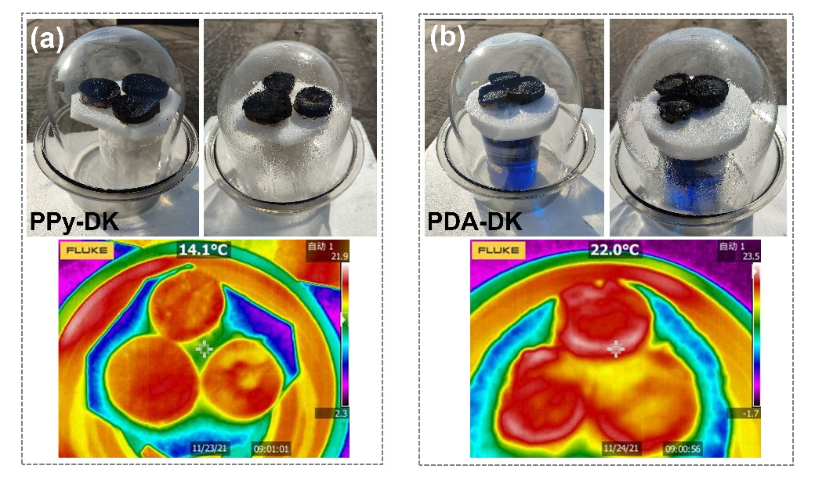
Figure S7. (a) Outdoor experiment of PPy-DK for desalination; (b) Outdoor experiments of PDA-DK for purification dyeing wastewater (methyl blue solution 20 mg L^{–1}).

References
[S1] M. Ye, J. Jia, Z. Wu, C. Qian, R. Chen, P.G. O'Brien, W. Sun, Y. Dong, G.A. Ozin, Synthesis of black TiOx nanoparticles by Mg reduction of TiO2 nanocrystals and their application for solar water evaporation, Adv. Energy Mater. 7 (2017) 1601811-1601817, https://doi.org/10.1002/aenm.201601811.
[S2] T. Lin, C. Yang, Z. Wang, H. Yin, X. Lü, F. Huang, J. Lin, X. Xie, M. Jiang, Effective nonmetal incorporation in black titania with enhanced solar energy utilization, Energy Enviro. Sci. 7 (2014) 967-972, https://doi.org/10.1039/c3ee42708k.
[S3] X. Li, R. Lin, G. Ni, N. Xu, X. Hu, B. Zhu, G. Lv, J. Li, S. Zhu, J. Zhu, Three-dimensional artificial transpiration for efficient solar waste-water treatment, Nat. Sci. Rev. 5 (2018) 70-77, https://doi.org/10.1093/nsr/nwx051.
[S4] X. Li, J. Li, J. Lu, N. Xu, C. Chen, X. Min, B. Zhu, H. Li, L. Zhou, S. Zhu, T. Zhang, J. Zhu, Enhancement of Interfacial solar vapor generation by environmental energy, Joule 2 (2018) 1331-1338, https://doi.org/10.1016/j.joule.2018.04.004.
[S5] X. Wu, S. Cao, D. Ghim, Q. Jiang, S. Singamaneni, Y.S. Jun, A thermally engineered polydopamine and bacterial nanocellulose bilayer membrane for photothermal membrane distillation with bactericidal capability, Nano Energy 79 (2021) 105353-105363, https://doi.org/10.1016/j.nanoen.2020.105353.
[S6] Y. Zou, J. Zhao, J. Zhu, X. Guo, P. Chen, G. Duan, X. Liu, Y. Li, A mussel-inspired polydopamine-filled cellulose aerogel for solar-enabled water remediation, ACS Appl. Mater. Interfaces 13 (2021) 7617-7624, https://doi.org/10.1021/acsami.0c22584.
[S7] J. Yang, Y. Chen, X. Jia, Y. Li, S. Wang, H. Song, Wood-based solar interface evaporation device with self-desalting and high antibacterial activity for efficient solar steam generation, ACS Appl. Mater. Interfaces 12 (2020) 47029-47037, https://doi.org/10.1021/acsami.0c14068.
[S8] S. Sun, B. Sun, Y. Wang, M. Fordjour Antwi-Afari, H.Y. Mi, Z. Guo, C. Liu, C. Shen, Carbon black and polydopamine modified non-woven fabric enabling efficient solar steam generation towards seawater desalination and wastewater purification, Sep. Purif. Technol. 278 (2021) 119621-119631, https://doi.org/10.1016/j.seppur.2021.119621.
[S9] B. Bai, X. Yang, R. Tian, X. Wang, H. Wang, A high efficiency solar steam generation system with using residual heat to enhance steam escape, Desalination 491 (2020) 114382-114391, https://doi.org/10.1016/j.desal.2020.114382.
[S10] S. Chen, Z. Sun, W. Xiang, C. Shen, Z. Wang, X. Jia, J. Sun, C.J. Liu, Plasmonic wooden flower for highly efficient solar vapor generation, Nano Energy 76 (2020) 104998-105007, https://doi.org/10.1016/j.nanoen.2020.104998.
[S11] W. Huang, G. Hu, C. Tian, X. Wang, J. Tu, Y. Cao, K. Zhang, Nature-inspired salt resistant polypyrrole–wood for highly efficient solar steam generation, Sustain. Energy Fuels 3 (2019) 3000-3008, https://doi.org/10.1039/c9se00163h.
[S12] Y. Fan, W. Bai, P. Mu, Y. Su, Z. Zhu, H. Sun, W. Liang, A. Li, Conductively monolithic polypyrrole 3-D porous architecture with micron-sized channels as superior salt-resistant solar steam generators, Sol. Energy Mater. Sol. Cells 206 (2020) 110347-110355, https://doi.org/10.1016/j.solmat.2019.110347.
[S13] C. Li, D. Jiang, B. Huo, M. Ding, C. Huang, D. Jia, H. Li, C.Y. Liu, J. Liu, Scalable and robust bilayer polymer foams for highly efficient and stable solar desalination, Nano Energy 60 (2019) 841-849, https://doi.org/10.1016/j.nanoen.2019.03.087.
[S14] C. Xiao, L. Chen, P. Mu, J. Jia, H. Sun, Z. Zhu, W. Liang, A. Li, Sugarcane-Based Photothermal Materials for Efficient Solar Steam Generation, ChemistrySelect 4 (2019) 7891-7895, https://doi.org/10.1002/slct.201901889.
[S15] B. Wen, X. Zhang, Y. Yan, Y. Huang, S. Lin, Y. Zhu, Z. Wang, B. Zhou, S. Yang, J. Liu, Tailoring polypyrrole-based Janus aerogel for efficient and stable solar steam generation, Desalination 516 (2021) 115228-115237, https://doi.org/10.1016/j.desal.2021.115228.
[S16] X. Wang, Q. Liu, S. Wu, B. Xu, H. Xu, Multilayer polypyrrole nanosheets with self-organized surface structures for flexible and efficient solar-thermal energy conversion, Adv. Mater. 31 (2019) e1807716-e1807714, https://doi.org/10.1002/adma.201807716.
[S17] Y. Xu, J. Wang, F. Yu, Z. Guo, H. Cheng, J. Yin, L. Yan, X. Wang, Flexible and efficient solar thermal generators based on polypyrrole coated natural latex foam for multimedia purification, ACS Sustainable Chem. Eng. 8 (2020) 12053-12062, https://doi.org/10.1021/acssuschemeng.0c03164.
[S18] Y. Chen, G. Zhao, L. Ren, H. Yang, X. Xiao, W. Xu, Blackbody-inspired array structural polypyrrole-sunflower disc with extremely high light absorption for efficient photothermal evaporation, ACS Appl. Mater. Interfaces 12 (2020) 46653-46660, https://doi.org/10.1021/acsami.0c11549.

