Coated Blade Spray-Mass Spectrometry as a New Approach for the Rapid Characterization of Brain Tumors
Joanna Bogusiewicz^{1#}, Magdalena Gaca-Tabaszewska^{1#}, Dominik Olszówka¹, Karol Jaroch¹, Jacek Furtak³, Marek Harat^{2,3}, Janusz Pawliszyn⁴ and Barbara Bojko^{1*}
¹ Department of Pharmacodynamics and Molecular Pharmacology, Faculty of Pharmacy, Collegium Medicum in Bydgoszcz, Nicolaus Copernicus University in Torun, 85-089 Bydgoszcz, Poland,
j.bogusiewicz@cm.umk.pl (J.B.); magda.gaca5@gmail.com (M.G.T.); dominikolszowka95@gmail.com (D.O.); karol.jaroch@cm.umk.pl (K.J.); bbojko@cm.umk.pl (B.B)
² Department of Neurosurgery, 10th Military Research Hospital and Polyclinic, 85-681 Bydgoszcz, Poland; jacek.furtak2019@gmail.com (J.F.); harat@10wsk.mil.pl (M.H.)
³ Department of Neurosurgery and Neurology, Faculty of Health Sciences, Collegium Medicum in Bydgoszcz, Nicolaus Copernicus University in Torun, 85-168 Bydgoszcz, Poland
⁴ Department of Chemistry, University of Waterloo, Waterloo, ON M1B 6G3, Canada; janusz@uwaterloo.ca (J.P.)
* Correspondence: Correspondence: bbojko@cm.umk.pl; Tel.: +48-525-853-564
# these authors contributed equally

SUPPLEMENTARY MATERIALS
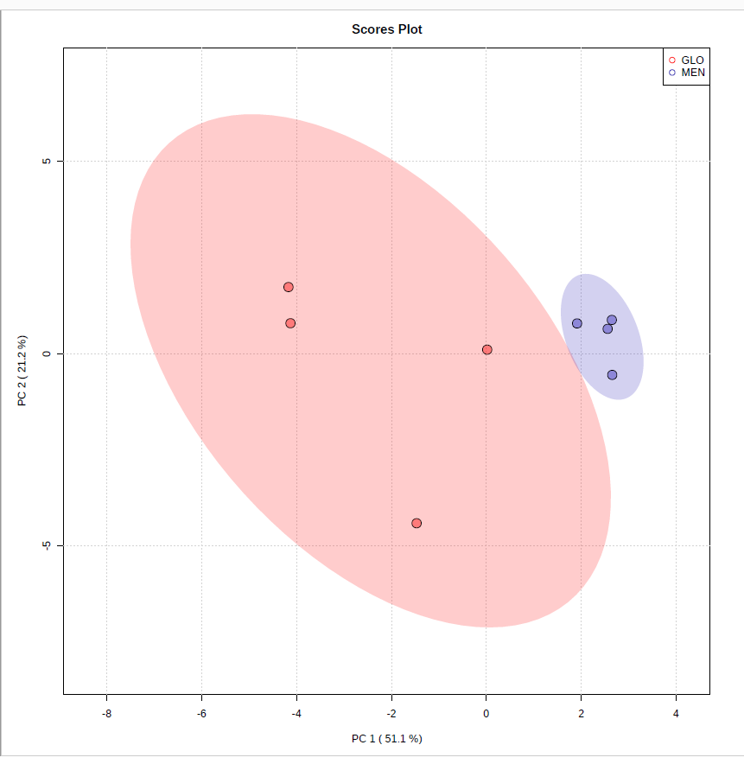
Figure S1. Principal component analysis of meningiomas and gliomas based on tentative lipid with VIP-score above 1.0

(A) | (B)
Figure S2. Standard addition curve of carnitine; (A) raw data; (B)- data normalized on internal standard (IS) area. Bars represent the standard deviation of peak areas and carnitine: IS peak area ratios.

Figure S3. Calibration curve for carnitine(trimethyl-d9) in brain tumor homogenate. Bars represent the standard deviation of peak areas

(A) | (B)
Figure S4. Standard addition curve of phenylalanine; (A) raw data; (B)- data normalized on internal standard (IS) area. Bars represent the standard deviation of peak areas and phenylalanine: IS peak area ratios.

Figure S5. Plots presenting optimization of desorption solvent for untargeted lipidomic analysis. Four analytical standards were used to optimize the desorption solvent: PG (17:0-20:4), PC (C16-18:1), LPE (17:1), Sphingosine (d17:1). Acetonitrile:methanol (1:1), acetonitrile: methanol (1:3), isopropanol: methanol (1:1) and isopropanol: methanol (1:3) solutions all contained 10 mM ammonium acetate and 1 mM acetic acid was tested as a desorption solution. The red arrows indicate desorption solvent selected to further experiments. It should be noted that both IPA: MeOH,1:3,v/v with 10 mM ammonium acetate and 1 mM acetic acid and IPA: MeOH,1:1,v/v with 10 mM ammonium acetate and 1 mM acetic acid were characterized by similar peak areas however relative standard deviation was higher for the second mixture (Table S3).
Plot for selection of optimal desorption solvent was constructed on the best peak areas obtained using given voltage. Exemplary plots showing selection of the voltage were given in the Figure S6.

Figure S6. Exemplary plots showing optimization of voltage for untargeted lipidomic analysis with use of IPA:MeOH,1:3,v/v with 10 mM ammonium acetate and 1 mM acetic acid. Four analytical standards were used to optimize the desorption solvent: PG (17:0-20:4), PC (C16-18:1), LPE (17:1), Sphingosine (d17:1). The red arrows indicate voltage selected to further experiments.

Figure S7. Plots presenting optimization of desorption solvent for targeted analysis. Four analytical standards were used to optimize the desorption solvent: Phenylalanine, Phenylalanine(d8), L-Carnitine inner salt, L-Carnitine(trimethyl-d9). Methanol:water (95:5) + 0,1% Formic acid, acetonitrile:methanol (1:1) + 0,1% formic acid, acetonitrile:methanol (1:1), acetonitrile:water (95:5) + 0,1% formic acid and acetonitrile:water (95:5) was tested as a desorption solution. The red arrows indicate desorption solvent selected to further experiments. Plot for selection of optimal desorption solvent was constructed on the best peak areas obtained using given voltage. Exemplary plots showing selection of the voltage were given in the Figure S8.

Figure S8. Exemplary plots showing optimization of voltage for targeted analysis with use of ACN:H₂O,95:5,v/v. Four analytical standards Phenylalanine, Phenylalanine(d8), L-Carnitine inner salt, L-Carnitine(trimethyl-d9) were used to optimize the desorption solvent: The red arrows indicate voltage selected to further experiments.

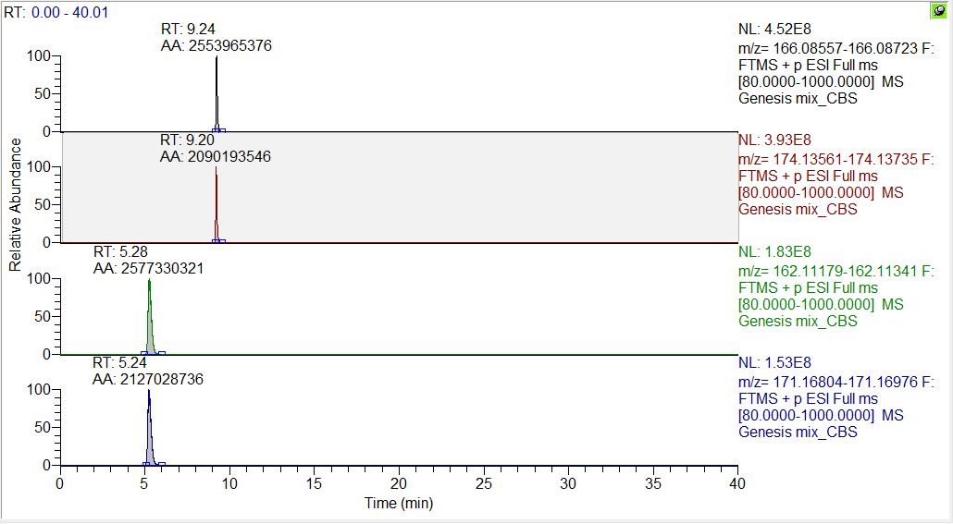
carnitine
carnitine(trimethyl-d9)
Figure S9. Comparison of the peak areas of the mixture of carnitine and its deuterated form in the concentration 10 ppm. The methodology of this analysis was presented in Bogusiewicz et al. (Bogusiewicz et al. 2020)* under metabolomics analysis on PFP column.
* Bogusiewicz, J.; Goryńska, P.Z.; Gaca, M.; Chmara, K.; Goryński, K.; Jaroch, K.; Paczkowski, D.; Furtak, J.; Harat, M.; Bojko, B. On-Site Sampling and Extraction of Brain Tumors for Metabolomics and Lipidomics Analysis. J. Vis. Exp. 2020, 2020, 159, doi:10.3791/61260.

Table S1. Standard addition curve details for carnitine
Sample [x] + carnitine | Raw data |  | Normalized data
Sample [x] + carnitine | area | RSD | ratio | RSD¹
x+50 ug/ml | 300725268 | 62% | 5.88 | 3%
x+30 ug/ml | 428917804 | 46% | 5.38 | 1%
x+10 ug/ml | 106366685 | 59% | 2.50 | 4%
X | 23917467 | 39% | 0.61 | 10%
¹ relative standard deviation

Table S2. Standard addition curve details for phenylalanine
sample [x] + phenylalanine | Raw data |  | Normalized data
sample [x] + phenylalanine | area | RSD | ratio: standard/Deuter | RSD¹
x+25 ug/ml | 21928862 | 60% | 4.14 | 13%
x+20 ug/ml | 49460652 | 93% | 3.12 | 11%
x+15 ug/ml | 14558740 | 55% | 2.54 | 6%
x+10 ug/ml | 19881108 | 41% | 1.75 | 5%
x+5 ug/ml | 7364715 | 44% | 1.00 | 11%
X | 3023055 | 43% | 0.24 | 13%
¹ relative standard deviation

Table S3. Peak areas and RSD for lipids used in the selection of desorption solvent for untargeted analysis.
sample [x] + phenylalanine | IPA:MeOH,1:3,v/v with 10 mM ammonium acetate and 1 mM acetic acid |  | IPA:MeOH,1:1,v/v with 10 mM ammonium acetate and 1 mM acetic acid
sample [x] + phenylalanine | Average area | RSD | Average area | RSD¹
PC C16-18:1 | 811259 | 23% | 766728 | 51%
LPE 17:1 | 939323 | 9% | 1000845 | 38%
PG 17:0-20:4 | 474606 | 28% | 493471 | 53%
Sphingosine (d17:1) | 2008763 | 23% | 7106255 | 110%
¹ relative standard deviation

