Table S1. Primers used for RT-qPCR analysis
Targets | Sequence (5’ to 3’)
TNF-α | Forward: CCT GTA GCC CAC GTC GTA GC  Reverse: TTG ACC TCA GCG CTG AGT TG
IL-4 | Forward: GAA TGT ACC AGG AGC CAT ATC  Reverse: CTC AGT ACT ACG AGT AAT CCA
IL-5 | Forward: TCA CCG AGC TCT GTT GAC AA  Reverse: CCA CAC TTC TCT TTT TGG CG
IL-13 | Forward: GAC CCA GAG GAT ATT GCA TG  Reverse: CCA GCA AAG TCT GAT GTG AG
GAPDH | Forward: CAT CTT CCA GGA GCG AGA CC  Reverse: AAG CCA TGC CAA TGT TGT CT
GAPDH = glyceraldehyde 3-phosphate dehydrogenase, IL = interleukin, TNF = tumor necrosis factor
Figure S1. Organ weights of the spleen and lymph node (LN)
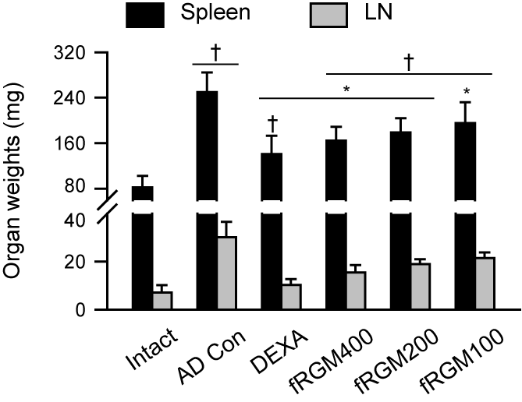
Values are represented as the means ± standard deviations. †: p < 0.05 vs. the Intact group; *: p < 0.05 vs. the AD Con.

