Assessing the wall-to-wall spatial and qualitative dynamics of the brazilian pasturelands, between 2010 and 2018, based on the analysis of the Landsat Data Archive

Supplementary material
For this study, a total of 18.205 images from the Landsat 5 and 8 satellites were analyzed, corresponding to 347 scenes necessary to cover the entire pasture area in the national territory (figure S1), as well as a 24-month window for the two periods analyzed (i.e. 2010 and 2018), in order to minimize interannual climatic variations and increase the chance of quality observations (i.e. without the interference of clouds and/or cloud shadows). All image processing and analysis were done using the programming languages Python, R and Javascript, the latter being used for the pre-processing steps performed on the Google Earth Engine platform (Gorelik et al,. 2017).

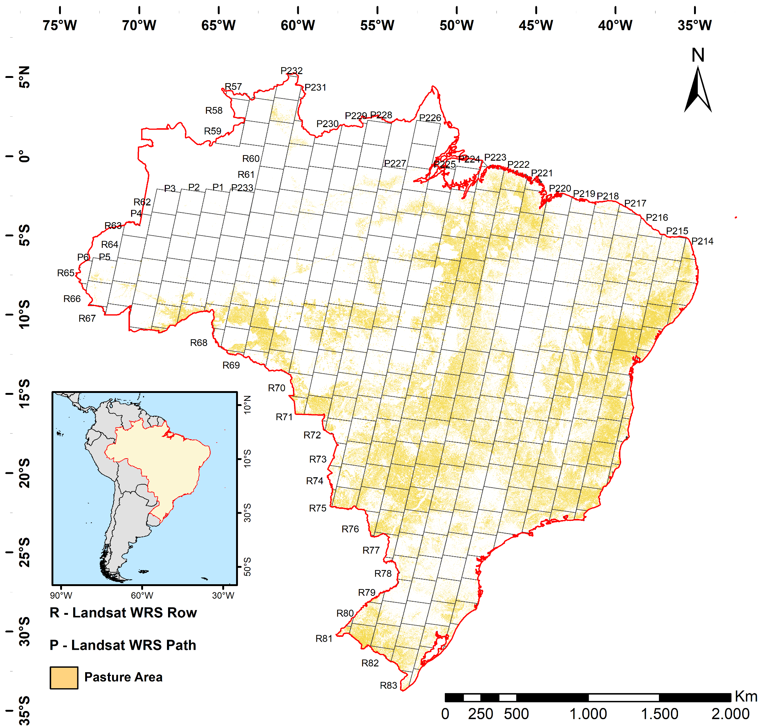
Figure S1 - Spatial distribution of pasture areas in Brazil (i.e. any occurrence of pasture in 2010 and/or 2018).

The elimination of observations contaminated with clouds and/or cloud shadows was done using the Landsat Band Quality Assessment (BQA). And in order to reduce the spectral differences between the TM and OLI sensor bands, which result in different NDVI values for the same target (figure S2), a translation equation was used, based on field spectroradiometric data obtained monthly for an entire hydrological cycle (from 05/2018 to 04/2019) using a Spectral Evolution spectroradiometer (figure S3).

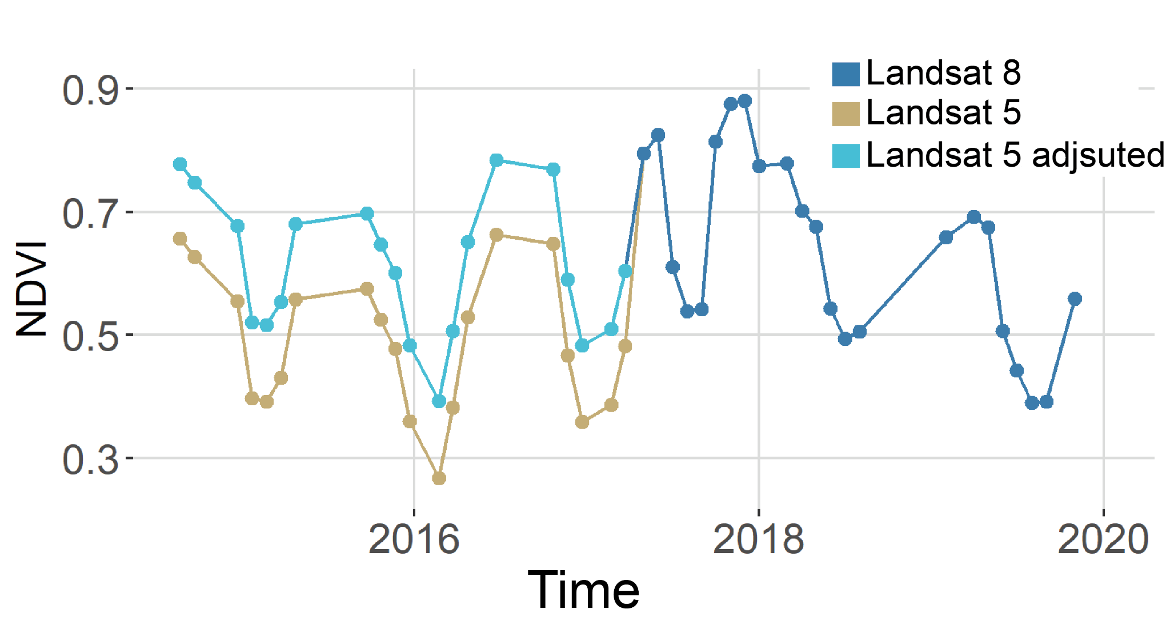
Figure S2 - Differences in NDVI time-series values based on Landsat 5 (TM) and Landsat 8 (OLI) data, with emphasis on the spectral correction applied to Landsat 5 data.

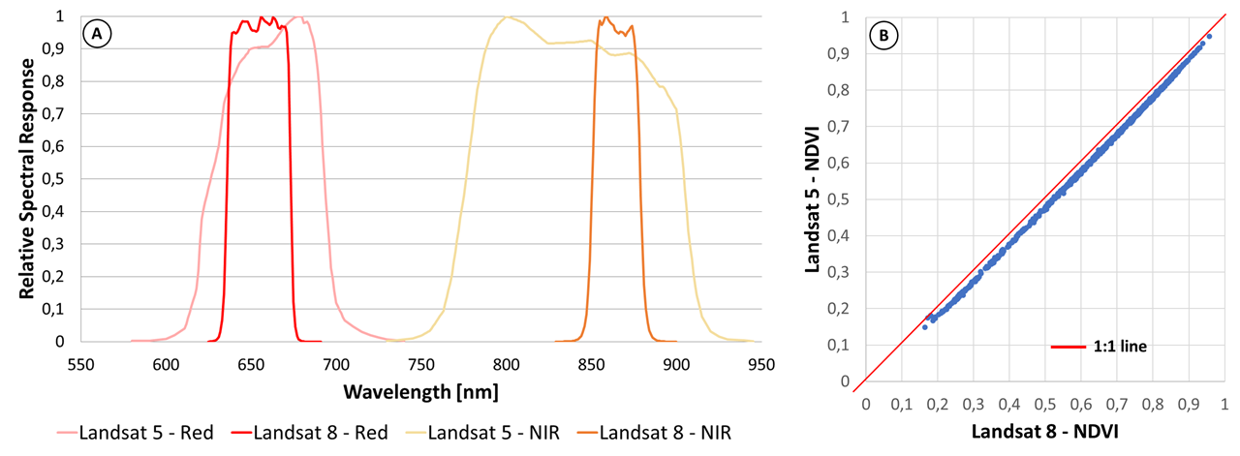
Figura S3 - Landsat 5 and 8 bands responsivity curves (a) and spectral regression between Landsat 8 and 5 NDVI values (b).
Due to the distinct availability of Landsat 5 and Landsat 8 images (figure S4), only the monthly observations (on a per-pixel basis) available for the two periods of analysis were considered, from which the median values for the two years were calculated (i.e. 2010 and 2018) (figures S5 and S6).

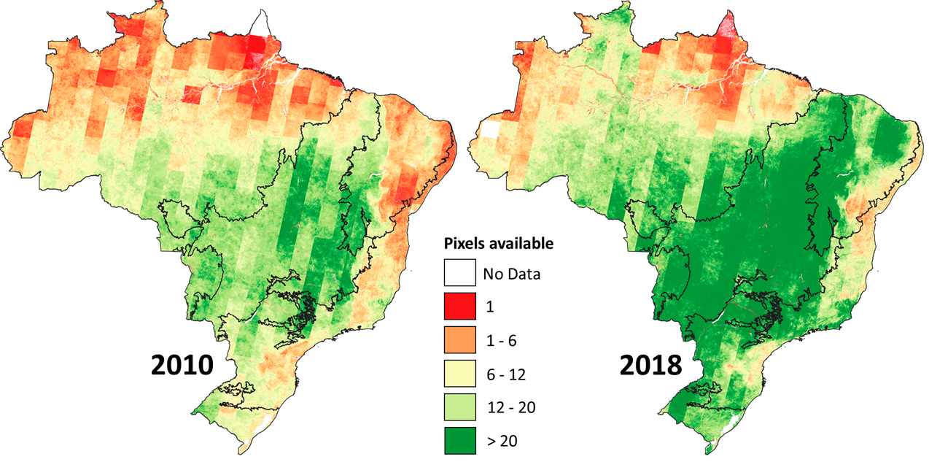
Figure S4 - Availability of quality observations (i.e. screened for clouds and/or cloud shadows) from the Landsat 5 (July 2009 to June 2011) and Landsat 8 (July 2017 to June 2019) Data Archives.

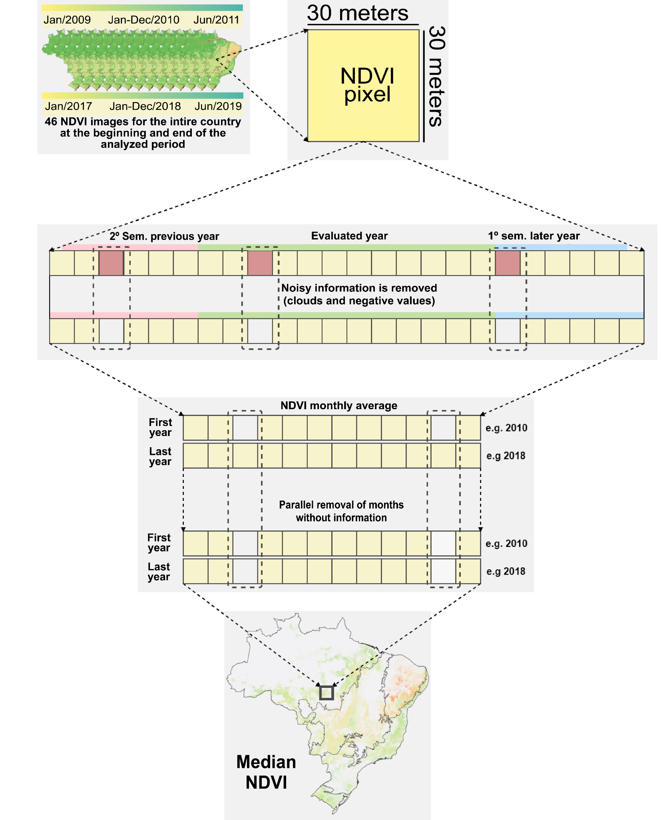
Figure S5 - Criteria used to calculate average NDVI images from Landsat 5 and 8 satellites (i.e 2010 and 2018), compatible and comparable to each other.

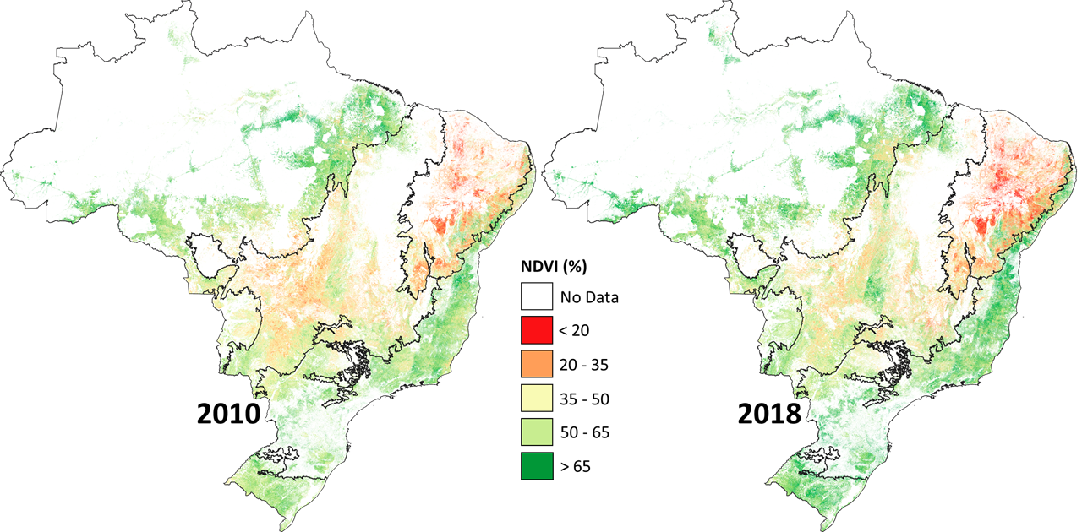
Figure S6 - Median NDVI images corresponding to pasture areas in 2010 and 2018.
The median NDVI values shown in Figure S6 were normalized according to the respective minimum and maximum values found for each biome (derived from the average of 1% of the lowest and highest values, respectively, in each unit of analysis) (Table S1 and Figure S7) .

Table S1 - Minimum and maximum median NDVI values for each unit of analysis (biome).
Biomes | Minimums | Maximums
Amazon | 0.32 | 0.86
Caatinga | 0.17 | 0.82
Cerrado | 0.25 | 0.77
Atlantic Forest | 0.30 | 0.84
Pampa | 0.42 | 0.80
Pantanal | 0.37 | 0.74

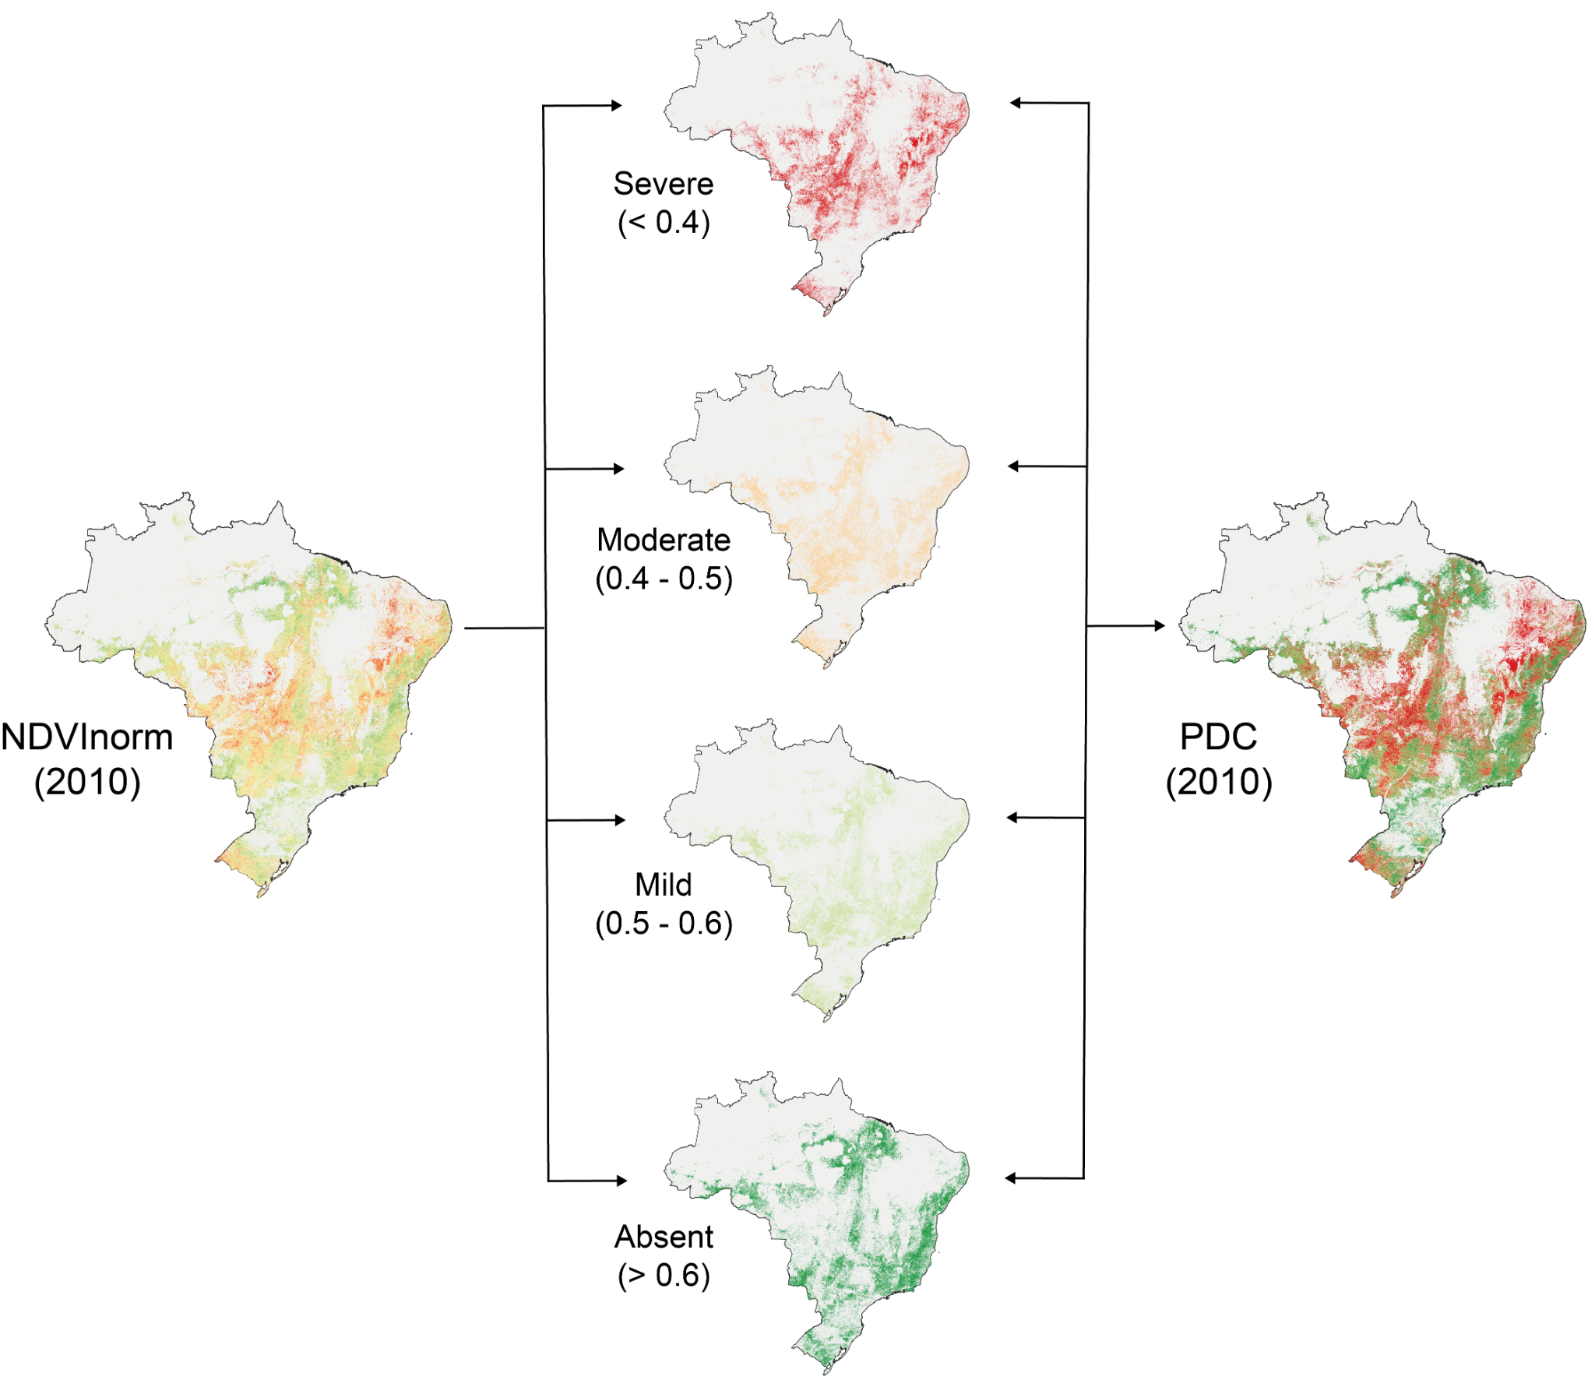
Figure S7 - Stratification of NDVInorm (normalized NDVI) into four degradation classes (PDC).

From the NDVInorm values, and considering the limits of properties with livestock activity in Brazil, the respective IDP values were generated (figure S8). Currently, Brazil has 5.5 million properties with CAR - Rural Environmental Registry, of which 2.7 million have at least 1 hectare of pasture and > 10% of the property is occupied with pasture.

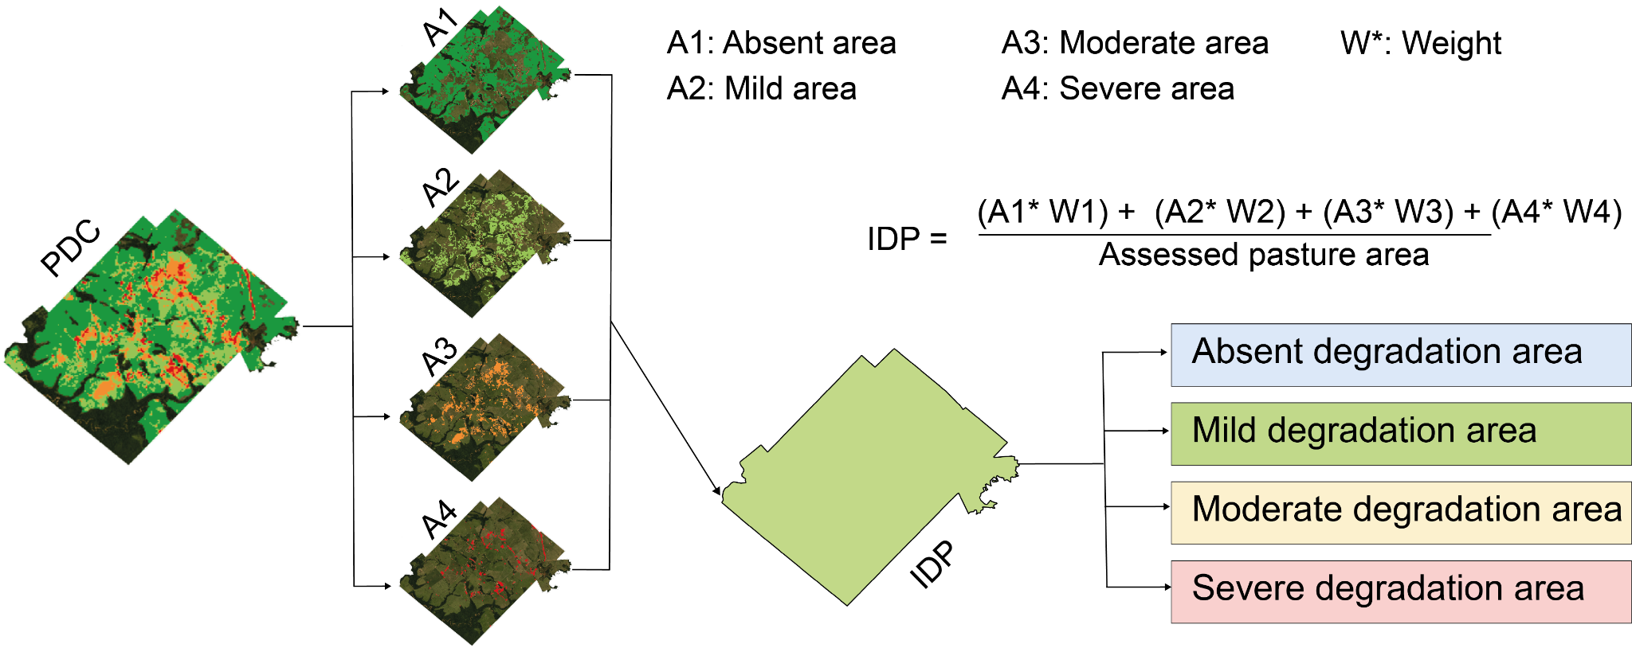
Figure S8 - Analysis approach for calculating the IDP - Pasture Degradation Index, for regions of interest - e.g. rural properties, municipalities and states. In the example, a rural property in the municipality of Pedra Preta - MT.

As for the accuracy analysis, this was based on data collected in the field, between 04/2019 and 01/2020 (figure S9).
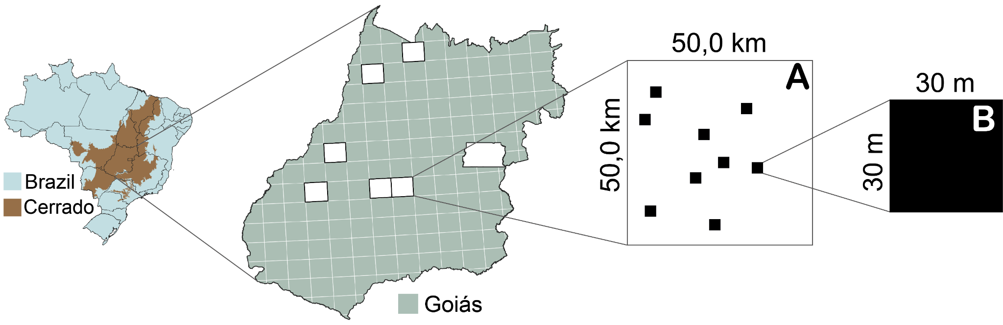
Figure S9 - Field samples for the accuracy analysis of the pasture quality mapping. Six 50 km x 50 km cells were sampled (A), and in each cell 9 Landsat pixels with 30 m resolution (B) were sampled.

All the codes used in this study are available via the following links, as described below:
- Javascripts to process the images used on the Google Earth Engine platform, applying spectral corrections, matching image availability, and calculating the NDVI median:
  - https://code.earthengine.google.com/0eb1027647b4333957b7964b8db5aa20
- Python script to normalize the median NDVI images considering the Brazilian biomes as units of analysis:
  - https://github.com/lapig-ufg/pasture-degrad/blob/main/Codes/2_py_ndvi_normalization.py
- Script in R for calculating the NDVI areas, normalized according to degradation classes:
  - https://github.com/lapig-ufg/pasture-degrad/blob/main/Codes/3_R_pasture_class_area.R

References
Gorelick, N., Hancher, M., Dixon, M., Ilyushchenko, S., Thau, D., Moore, R., 2017. Google Earth Engine: planetary-scale geospatial analysis for everyone. Remote Sens. Environ. 202, 18–27.

