Supplementary Materials
Table S1: Gene symbols and corresponding primers for TaqMan® assays.
gene symbol | gene name | amplicon length | TaqMan® Assay ID
Lama4 | laminin, alpha 4 | 81 | Mm01193660_m1
Lama5 | laminin, alpha 5 | 64 | Mm01222029_m1
Col1a1 | collagen, type I, alpha 1 | 89 | Mm00801666_g1
Col4a1 | collagen, type IV, alpha 1 | 74 | Mm01210125_m1
Fn1 | fibronectin 1 | 58 | Mm01256744_m1
Hprt | hypoxanthine guanine phosphoribosyl transferase | 131 | Mm03024075_m1

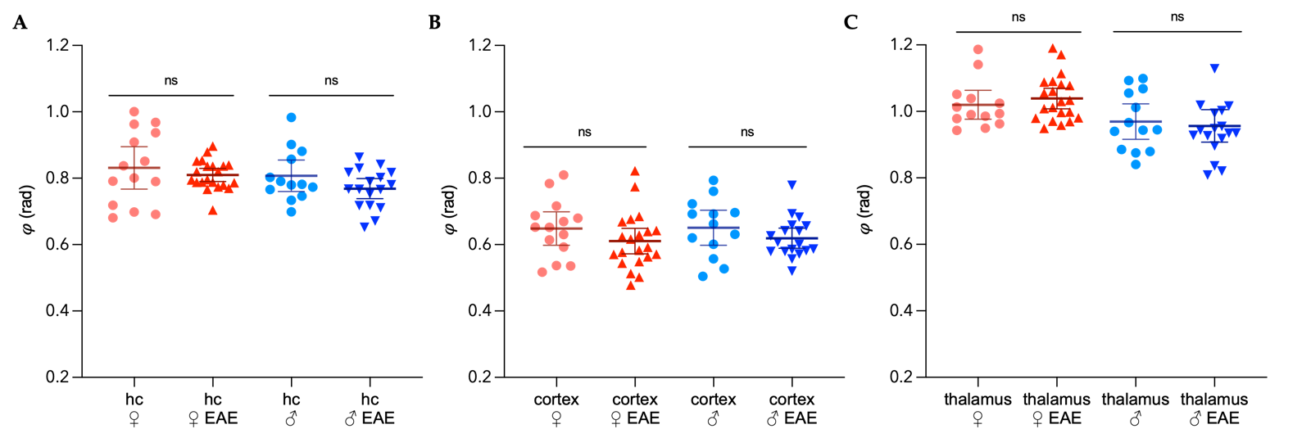
Figure S1. Regional distribution of sex-specific fluidity 𝜑 in the midbrain of the mouse in healthy and EAE. A) hippocampus (hc), B) cortex and C) thalamic area; light red = healthy female, dark red = EAE female, light blue = healthy male, dark blue = EAE male. Representation of individual data points with mean and 95%CI. n_{female naive} = 14, n_{male naive} = 13, n_{female EAE} = 21, n_{male EAE} = 18. Group comparison performed with unpaired t test with Welch correction.
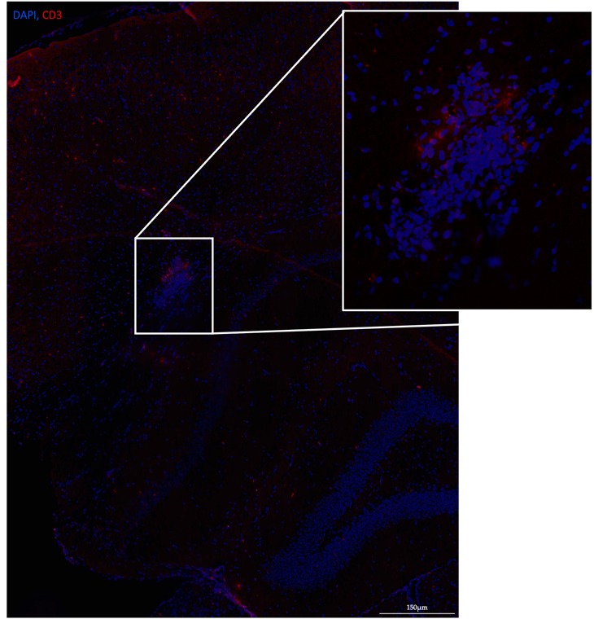
Figure S2. Singular cortical lesion in the midbrain in male EAE, adjacent to the hippocampus. CD3 (red) and DAPI (blue). Scale bar = 150µm.

