**Supplementary Materials**

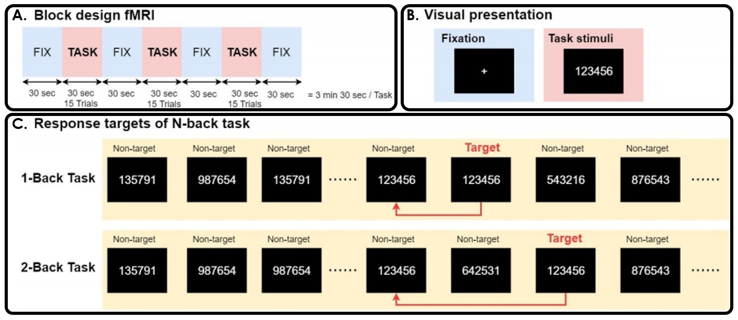

**Figure S1. N-back WM task diagram.**

(A) *N*-back task contains three epochs, (B) each composed of a 30-second task period and a 30-second fixing on a crosshair. The interstimulus interval between each trial during a task period was 2 s. In total, 45 trials were conducted, with each task consisting of 80% nontarget trials and 20% target trials. (C) In each run of the *N*-back tasks, participants were instructed to pay attention to a series of six-digit numerical stimuli and respond when the presented number matched the number presented *N* items before (*N* = 1 or 2).

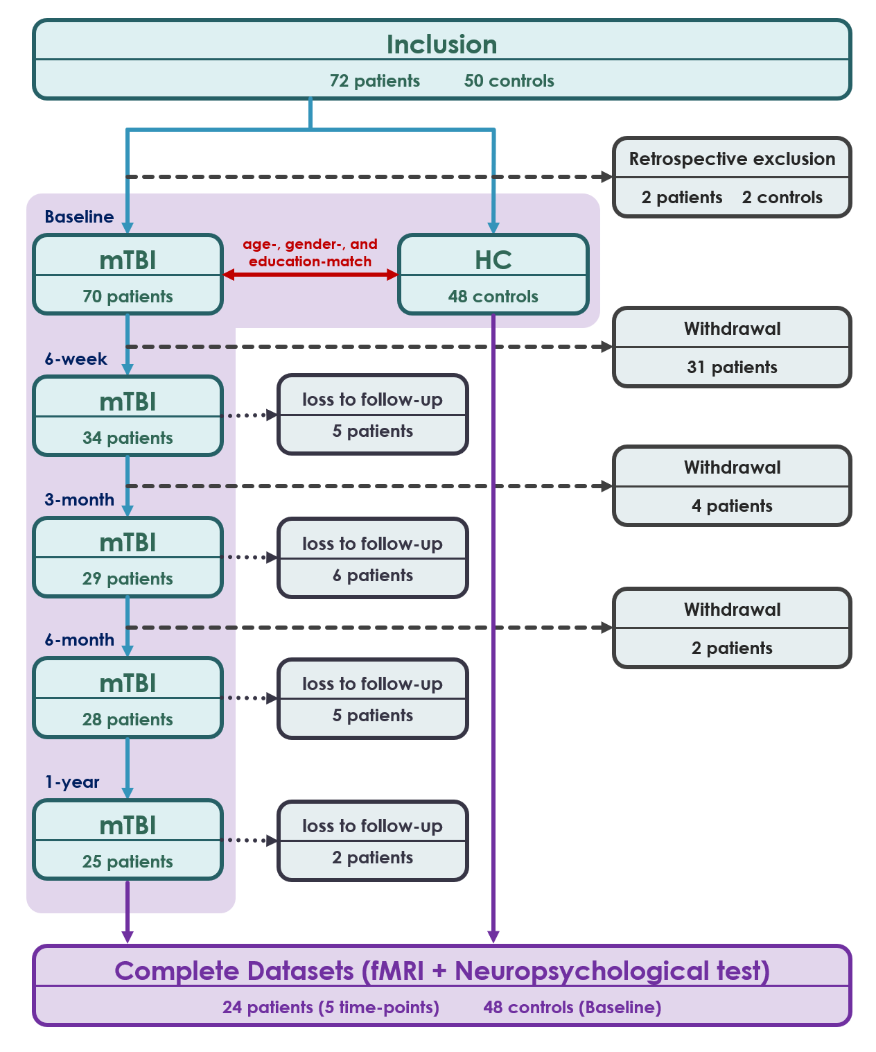

**Figure S2. Flow chart.**

Flow chart of participant inclusion and exclusion in this study.

**Table S1. WM 2-back task-induced activation and deactivation peak regions among all participants**



**Abbreviations:** AINS = anterior insula; PINS = posterior insula; Amyg. = amygdala; aPFC = anterior prefrontal cortex; CRB = cerebellum; dACC = dorsal anterior cingulate cortex; dlPFC = dorsolateral prefrontal cortex; FEF = frontal eye fields; Hippo. = hippocampus; IFC = inferior frontal cortex; IFG = inferior frontal gyrus; IPS = inferior parietal sulcus; ITG = inferior temporal gyrus; L = left; MCC = middle cingulate cortex; MTG = middle temporal gyrus; Orb. = orbitalis; PCC = posterior cingulate cortex; R = right; rmPFC = rostro-medial prefrontal cortex; Rolandicoper. = Rolandic operculum; SMA = supplementary motor area; SPL = superior parietal lobe; TPJ = temporal parietal junction; Tri. = triangularis; vmPFC = ventromedial prefrontal cortex; fMRI = functional magnetic resonance imaging; mTBI = mild traumatic brain injury; WM = working memory; MRI = magnetic resonance imaging; PCS = postconcussive symptoms; HC = healthy control; MMSE = Mini-Mental State Examination; WAIS-IV = Wechsler Adult Intelligence Scale, fourth edition; WMI = WM index; AMT = arithmetic ability; DS = digit span score; SPM = Statistical Parametric Mapping; ROI = region-of-interest; SVM = support vector machine; ROC-AUC = area under receiver operating characteristic curve; DMN = default mode network.

**Table S2. Demographics, clinical and cognitive characteristics, and WM task performance of the participants**

