Supplementary information
Near chromosome-level genome assembly and annotation of Rhodotorula babjevae strains reveals high intraspecific divergence

Giselle C. Martín-Hernández¹, Bettina Müller¹, Christian Brandt^{2,3}, Martin Hölzer^{2,4}, Adrian Viehweger^{2,5}, Volkmar Passoth^{1,*}

¹Department of Molecular Sciences, Swedish University of Agricultural Sciences, 75007 Uppsala, Sweden
²nanozoo GmbH, Leipzig, Germany
³Institute for Infectious Diseases and Infection Control, Jena University Hospital, Jena, Germany
⁴RNA Bioinformatics and High-Throughput Analysis, Friedrich Schiller University Jena, Jena, Germany
⁵Department of Medical Microbiology, University Hospital Leipzig, Germany
*Author for Correspondence: Volkmar Passoth, Department of Molecular Sciences, Swedish University of Agricultural Sciences, Uppsala, Sweden, +4618673380, Volkmar.Passoth@slu.se

Supplementary Table 1. Program versions used for the genome assembly and annotation pipeline
Supplementary Table 2. Characteristics from the contigs and scaffolds of Rhodotorula babjevae CBS 7808 genome assembly
Supplementary Table 3. Characteristics from the contigs and scaffolds of Rhodotorula babjevae DBVPG 8058 genome assembly
Supplementary Table 4. Distribution of exon counts in the transcriptome of two strains of Rhodotorula babjevae.
Supplementary Table 5. Examples of lipid and carotenoid metabolism related genes in Rhodotorula babjevae CBS 7808 genome assembly
Supplementary Table 6. Examples of lipid and carotenoid metabolism related genes in Rhodotorula babjevae DBVPG 8058 genome assembly
Supplementary Table 7. Contigs with assigned homology between Rhodotorula babjevae strains
Supplementary Table 8. Summary of features from strain-unique contigs in Rhodotorula babjevae
Supplementary Table 9. Genetic divergence between Rhodotorula babjevae strains and closely related Rhodotorula species
Supplementary Table 10. Alignment statistics of the duplicated genes from the genome of Rhodotorula babjevae CBS 7808 identified by OrthoVenn2
Supplementary Table 11. Alignment statistics of the duplicated genes from the genome of Rhodotorula babjevae DBVPG 8058 identified by OrthoVenn2
Supplementary Table 12. Alignment statistics of the duplicated genes from the genome of Rhodotorula babjevae CBS 7808 identified by BLASTp
Supplementary Table 13. Alignment statistics of the duplicated genes from the genome of Rhodotorula babjevae DBVPG 8058 identified by BLASTp

Supplementary Figure 1. Allele frequency values of single nucleotide polymorphisms (SNP) in Rhodotorula babjevae.
Supplementary Figure 2. Gene Ontology (GO) term summary related to the GO topic: molecular functions
Supplementary Figure 3. Gene Ontology (GO) term summaries belonging to the GO topic: biological processes
Supplementary Figure 4. Gene Ontology (GO) term summaries belonging to the GO topic: cellular components
Supplementary Figure 5. Examples of lipid metabolism pathways in Rhodotorula babjevae CBS 7808 reconstructed by KEGG Mapper
Supplementary Figure 6. Examples of lipid metabolism pathways in Rhodotorula babjevae DBVPG 8058 reconstructed by KEGG Mapper
Supplementary Figure 7. Quantitative assessment of the hybrid genome assemblies and annotation completeness using Benchmarking Universal Single-Copy Orthologs (BUSCO)
Supplementary Figure 8. LASTZ alignment of the mitochondrial genome sequences from Rhodotorula babjevae CBS 7808 and DBVPG 8058
Supplementary Figure 9. LASTZ alignment of contigs with assigned homology from Rhodotorula babjevae CBS 7808 and DBVPG 8058 representing putative chromosomes
Supplementary Table 1. Program versions used for the genome assembly and annotation pipeline
Program | Version
Bandage | 0.8.1
BBMap | 38.86
Biopython | 1.74
BioRuby | 2.0.1
BUSCO | 3.0.2
BWA | 0.7.17
chromoMap | 0.2
dammit | 1.2
fastp | 0.20.0
FastQC | 0.11.8
Filtlong | 0.2.0
Flye | 2.8
ggplot2 | 3.3.1
HISAT | 2.2.0
Medaka | 0.10.0
MetaEuk | 1.ea903e5
minimap2 | 2.17
MITOS | 2.0.3
MultiQC | 1.8
NanoPlot | 1.25.0
Pilon | 1.23
Racon | 1.4.7
RepeatMasker | 4.0.9
samtools | 1.10
simple-circularise | 1.0
SortMeRNA | 2.1b
sourmash | 2.0.1
StringTie | 2.1.1
Tapestry | 1.0.0

Supplementary Table 2. Characteristics from the contigs and scaffolds of Rhodotorula babjevae CBS 7808 genome assembly
Contig/scaffold | Length (bp) | GC content (%) | Read depth | No. of telomeric regions
ontig_10 | 1,067,634 | 67.97 | 39 | 0
contig_11 | 1,300,441 | 68.18 | 42 | 1
contig_12 | 511,897 | 68.45 | 33 | 0
contig_2 | 30,876 | 38.85 | 892 | 2
contig_25 | 627,118 | 68.03 | 47 | 0
contig_26 | 40,644 | 57.95 | 20 | 1
contig_27 | 320,063 | 67.64 | 31 | 1
contig_28 | 422,133 | 67.84 | 36 | 0
contig_3 | 1,574,520 | 68.39 | 49 | 1
contig_30 | 1,569,459 | 68.66 | 48 | 0
contig_31 | 979,228 | 68.28 | 40 | 1
contig_36 | 1,056,323 | 68.50 | 52 | 0
contig_37 | 362,52 | 68.05 | 34 | 0
contig_38 | 881,966 | 68.53 | 51 | 1
contig_39 | 564,129 | 68.13 | 41 | 1
contig_4 | 418,972 | 67.71 | 38 | 1
contig_45 | 762,86 | 68.32 | 37 | 1
contig_46 | 8,677 | 65.90 | 79 | 0
contig_5 | 2,415,752 | 68.54 | 46 | 1
contig_62 | 644,441 | 68.12 | 42 | 0
contig_65 | 630,535 | 68.27 | 52 | 1
contig_66 | 406,102 | 68.73 | 45 | 0
contig_7 | 1,460,653 | 68.35 | 46 | 1
contig_9 | 429,397 | 68.87 | 36 | 1
scaffold_40 | 948,604 | 68.04 | 50 | 0
scaffold_49 | 1,089,446 | 67.93 | 52 | 0
scaffold_6 | 1,337,997 | 68.23 | 46 | 1

Supplementary Table 3. Characteristics from the contigs and scaffolds of Rhodotorula babjevae DBVPG 8058 genome assembly
Contig/scaffold | Length (bp) | GC content (%) | Read depth | No. of telomeric regions
contig_1 | 565,532 | 67.52 | 44 | 1
contig_20 | 637,402 | 68.57 | 43 | 0
contig_33 | 529,001 | 68.19 | 42 | 2
contig_38 | 1,780,658 | 68.22 | 43 | 0
contig_40 | 1,004,683 | 68.30 | 43 | 1
contig_42 | 1,446,680 | 68.41 | 45 | 0
contig_44 | 357,974 | 68.15 | 44 | 0
contig_45 | 394,205 | 68.00 | 42 | 0
contig_46 | 670,828 | 68.68 | 42 | 1
contig_47 | 557,103 | 68.12 | 43 | 0
contig_48 | 931,129 | 68.59 | 43 | 1
contig_49 | 396,114 | 68.44 | 40 | 1
contig_51 | 924,743 | 68.52 | 45 | 1
contig_53 | 571,073 | 67.98 | 43 | 1
contig_54 | 766,724 | 68.39 | 40 | 0
contig_57 | 1,049,892 | 68.40 | 43 | 1
contig_65 | 41,334 | 67.14 | 59 | 1
contig_66 | 419,035 | 67.94 | 44 | 1
contig_68 | 408,627 | 68.12 | 39 | 0
contig_69 | 1,447,990 | 68.48 | 45 | 1
contig_70 | 789,767 | 68.03 | 43 | 0
contig_71 | 449,691 | 68.69 | 42 | 1
contig_72 | 5,97 | 48.69 | 306 | 2
contig_73 | 659,761 | 67.77 | 41 | 0
contig_74 | 614,034 | 68.46 | 41 | 0
contig_75 | 900,917 | 68.16 | 43 | 0
contig_77 | 446,828 | 68.09 | 43 | 1
contig_79 | 28,432 | 38.89 | 1160 | 1
contig_82 | 299,18 | 68.75 | 40 | 2
contig_83 | 6,381 | 59.36 | 101 | 0
contig_84 | 425,34 | 67.39 | 45 | 0
contig_85 | 573,802 | 68.36 | 41 | 1
contig_86 | 443,617 | 68.68 | 42 | 1
scaffold_52 | 977,625 | 68.29 | 43 | 1

Supplementary Table 4. Distribution of exon counts in the transcriptome of two strains of Rhodotorula babjevae.
Strain | CBS 7808 | DBVPG 8058
Exons per transcript | Number of transcripts
1 | 1201 | 1176
2 | 1400 | 1417
3 | 1367 | 1366
4 | 1108 | 1154
5 | 808 | 767
6 | 581 | 539
7 | 391 | 385
8 | 275 | 268
9 | 168 | 159
10 | 121 | 95
11 | 61 | 68
12 | 42 | 54
13 | 36 | 29
14 | 19 | 17
15 | 11 | 8
16 | 5 | 5
17 | 4 | 3
18 | 2 | 2
19 | 2 | 1
20 | 3 | 1
21 | 0 | 1
23 | 0 | 1
24 | 2 | 0
Total | 7607 | 7516

Supplementary Table 5. Examples of lipid and carotenoid metabolism related genes in Rhodotorula babjevae CBS 7808 genome assembly
Gene | Enzyme | EC | Pathway | Contig/scaffold | Gene ID
CDC19 | Pyruvate kinase 1 | 2.7.1.40 | Glycolysis | contig_10 | NANOZOOG247, NANOZOOG248
MAE1 | NADP-dependent malic enzyme | 1.1.1.40 | NADPH regeneration | contig_10 | NANOZOOG21
MAE2 | NAD-dependent malic enzyme 3 | 1.1.1.38 | Tricarboxylic acid cycle | contig_36 | NANOZOOG2566
ACL2 | ATP-citrate synthase subunit 2 | 2.3.3.8 | Lipid synthesis | contig_30 | NANOZOOG1597
ACL1 | ATP-citrate synthase subunit 1 | 2.3.3.8 | Lipid synthesis | contig_30 | NANOZOOG1598
ACC1 | Acetyl-CoA carboxylase | 6.4.1.2 | Fatty acid synthesis | scaffold_6 | NANOZOOG7298, NANOZOOG7299, NANOZOOG7300
FAS1 | β- subunit of fatty acid synthase complex | 2.3.1.86 | Fatty acid synthesis | scaffold_6 | NANOZOOG7332, NANOZOOG7509
FAS2 | 𝛼- subunit of fatty acid synthase complex | 2.3.1.86 | Fatty acid synthesis | scaffold_6 | NANOZOOG7507, NANOZOOG7508
OLE1 | Acyl-CoA desaturase | 1.14.19.1 | Unsaturated fatty acid synthesis | contig_30 | NANOZOOG1596
ACAD11 | Acyl-CoA dehydrogenase family member 11 | 1.3.99 | Fatty acid beta-oxidation | scaffold_6 | NANOZOOG7232
IBR3 | Probable acyl-CoA dehydrogenase IBR3 | 1.3.99 | Fatty acid beta-oxidation | scaffold_49 | NANOZOOG6894
ECI1 | Enoyl-CoA hydratase 1 | 4.2.1.17 | Fatty acid beta-oxidation | scaffold_49 | NANOZOOG6861
ECI1 | Enoyl-CoA hydratase 1 | 4.2.1.17 | Fatty acid beta-oxidation | contig_11 | NANOZOOG791
POT1 | Acetyl-CoA acyltransferase | 2.3.1.16 | Fatty acid beta-oxidation | contig_3 | NANOZOOG3582, NANOZOOG3634
POT1 | Acetyl-CoA acyltransferase | 2.3.1.16 | Fatty acid beta-oxidation | contig_65 | NANOZOOG5517
POT1 | Acetyl-CoA acyltransferase | 2.3.1.16 | Fatty acid beta-oxidation | contig_36 | NANOZOOG2634
LRO1 | Phospholipid:diacylglycerol acyltransferase | 2.3.1.158 | Glicerolipid synthesis | contig_5 | NANOZOOG4705
HMG1 | HMG-CoA reductase | 1.1.1.34 | Isoprenoid synthesis | contig_31 | NANOZOOG2214, NANOZOOG2215, NANOZOOG2216
HCS1 | HMG-CoA synthase | 2.3.3.10 | Isoprenoid synthesis | contig_62 | NANOZOOG5192
ERG8 | Phosphomevalonate kinase, peroxisomal | 2.7.4.2 | Isoprenoid synthesis | scaffold_6 | NANOZOOG7354
crtYB | Bifunctional lycopene cyclase/phytoene synthase | 5.5.1.19 & 2.5.1.32 | Carotenoid synthesis | scaffold_6 | NANOZOOG7200
crtI | Phytoene desaturase | 1.3.99.30 | Carotenoid synthesis | scaffold_6 | NANOZOOG7203
BTS1 | Geranylgeranyl pyrophosphate synthase | 2.5.1.- | Carotenoid synthesis | contig_5 | NANOZOOG4762

Supplementary Table 6. Examples of lipid and carotenoid metabolism related genes in Rhodotorula babjevae DBVPG 8058 genome assembly
Gene | Enzyme | EC | Pathway | Contig/scaffold | Gene ID
CDC19 | Pyruvate kinase 1 | 2.7.1.40 | Glycolysis | contig_54 | NANOZOOG3961, NANOZOOG3962
MAE1 | NADP-dependent malic enzyme | 1.1.1.40 | NADPH regeneration | contig_47 | NANOZOOG2569
MAE2 | NAD-dependent malic enzyme 2 | 1.1.1.38 | Tricarboxylic acid cycle | contig_57 | NANOZOOG4100
ACL1 | ATP-citrate synthase subunit 1 | 2.3.3.8 | Lipid synthesis | contig_20 | NANOZOOG209
ACC1 | Acetyl-CoA carboxylase | 6.4.1.2 | Fatty acid synthesis | contig_70 | NANOZOOG5315, NANOZOOG5316, NANOZOOG5317, NANOZOOG5318
FAS1 | β- subunit of fatty acid synthase complex | 2.3.1.86 | Fatty acid synthesis | contig_70 | NANOZOOG5349
FAS2 | 𝛼- subunit of fatty acid synthase complex | 2.3.1.86 | Fatty acid synthesis | contig_33 | NANOZOOG458, NANOZOOG459
OLE1 | Acyl-CoA desaturase | 1.14.19.1 | Unsaturated fatty acid synthesis | contig_20 | NANOZOOG210
ACAD10 | Acyl-CoA dehydrogenase family member 10 | 1.3.99 | Fatty acid beta-oxidation | contig_53 | NANOZOOG3588
ACAD11 | Acyl-CoA dehydrogenase family member 11 | 1.3.99 | Fatty acid beta-oxidation | contig_70 | NANOZOOG5252
IBR3 | Probable acyl-CoA dehydrogenase IBR3 | 1.3.99 | Fatty acid beta-oxidation | contig_40 | NANOZOOG1380
D6C81_05617 | Enoyl-CoA hydratase 1 | 4.2.1.17 | Fatty acid beta-oxidation | contig_40 | NANOZOOG1413
POT1 | Acetyl-CoA acyltransferase | 2.3.1.16 | Fatty acid beta-oxidation | contig_57 | NANOZOOG4029
POT1 | Acetyl-CoA acyltransferase | 2.3.1.16 | Fatty acid beta-oxidation | contig_74 | NANOZOOG5938
POT1 | Acetyl-CoA acyltransferase | 2.3.1.16 | Fatty acid beta-oxidation | contig_75 | NANOZOOG6026, NANOZOOG6080
HMG1 | HMG-CoA reductase | 1.1.1.34 | Isoprenoid synthesis | contig_82 | NANOZOOG6558, NANOZOOG6559, NANOZOOG6560
HCS1 | HMG-CoA synthase | 2.3.3.10 | Isoprenoid synthesis | contig_38 | NANOZOOG1015
crtYB | Bifunctional lycopene cyclase/phytoene synthase | 5.5.1.19 & 2.5.1.32 | Carotenoid synthesis | contig_70 | NANOZOOG5230
crtI | Phytoene desaturase | 1.3.99.30 | Carotenoid synthesis | contig_70 | NANOZOOG5227
BTS1 | Geranylgeranyl pyrophosphate synthase | 2.5.1.- | Carotenoid synthesis | contig_69 | NANOZOOG5016

Supplementary Table 7. Contigs with assigned homology between Rhodotorula babjevae strains
DBVPG8058_contigs
CBS7808_ | 1 | 20 | 33 | 38 | 40 | 42 | 44 | 45 | 46 | 47 | 48 | 49 | 51 | 53 | 54 | 57 | 65 | 66 | 68 | 69 | 70 | 71 | 72 | 73 | 74 | 75 | 77 | 79 | 82 | 83 | 84 | 85 | 86 | 52
contigs
2 |  |  |  |  |  |  |  |  |  |  |  |  |  |  |  |  |  |  |  |  |  |  |  |  |  |  |  | 97
3 |  |  |  |  |  |  |  |  | 85 |  |  |  |  |  |  |  |  |  |  |  |  |  |  |  |  | 84
4 |  |  |  |  |  |  |  | 82
5 |  |  |  |  |  |  |  |  |  |  |  |  |  |  |  |  |  |  |  | 84 |  |  |  |  |  |  |  |  |  |  |  |  |  | 84
7 |  |  |  |  |  |  |  |  |  |  | 84 |  |  | 86
9 |  |  |  |  |  |  |  |  |  |  |  |  |  |  |  |  |  |  |  |  |  |  |  |  |  |  |  |  |  |  |  |  | 87
10 |  |  |  |  |  |  |  |  |  | 82 |  |  |  |  | 85
11 |  |  |  |  |  | 84 | 86 |  |  |  |  |  |  |  |  |  |  |  |  |  |  |  |  |  |  |  |  |  |  |  | 85
12 |  |  |  |  |  |  |  |  |  |  |  |  |  |  |  |  |  |  | 84 |  |  | 86
25 |  |  |  |  |  |  |  |  |  |  |  |  |  |  |  |  |  |  |  |  |  |  |  |  |  |  |  |  |  |  |  | 85
26
27 |  |  |  | 85
28 |  |  |  |  |  |  |  |  |  |  |  |  |  |  |  |  |  | 84
30 |  | 84 |  |  |  | 84 | 86
31 |  |  |  |  |  |  |  |  |  |  |  |  |  |  |  |  |  |  |  |  |  |  |  | 84 |  |  |  |  | 85
36 |  |  |  |  |  |  |  |  |  |  |  |  |  |  |  | 83
37 |  |  |  |  |  |  |  |  |  |  |  |  |  |  |  |  |  |  | 84 |  |  | 86
38 |  |  |  | 85
39 | 85
45 |  |  |  |  |  |  |  |  |  |  |  |  |  |  | 85 |  |  |  |  |  |  |  |  |  |  |  | 86
46
62 |  |  |  | 85
65 |  |  |  |  |  |  |  |  |  |  |  |  |  |  |  |  |  |  |  |  |  |  |  |  | 83
66 |  |  |  |  |  |  |  |  |  |  |  | 85
6 |  |  | 82 |  |  |  |  |  |  |  |  |  |  |  |  |  |  |  |  |  | 83
40 |  |  |  |  |  |  |  |  |  |  |  |  | 84
49 |  |  |  |  | 83 |  |  |  |  |  |  |  |  |  |  |  | 91
The contigs corresponding to the mitochondrial genome are denoted in yellow and to putative extrachromosomal elements in green. Unique forward alignments are represented in blue and unique reverse alignments in orange.

Supplementary Table 8. Summary of features from strain-unique contigs in Rhodotorula babjevae
Contig name | R. babjevae strain number | Size (bp) | GC content (%) | Relative read depth* | Size of circular contig (bp)
contig_26 | CBS 7808 | 40,644 | 57.95 | 0,5 | 30,109
contig_46 | CBS 7808 | 8,677 | 65.9 | 1,8 | -
contig_83 | DBVPG 8058 | 6,381 | 59.36 | 2,4 | -
contig_72 | DBVPG 8058 | 5,97 | 48.69 | 7,2 | -

*Read depth of the contig divided by the average read depth of contigs with assigned homology between Rhodotorula babjevae strains

Supplementary Table 9. Genetic divergence between Rhodotorula babjevae strains and closely related Rhodotorula species
 | Rhodotorula babjevae CBS 7808
 | DNA-DNA homology |  |  | ANI | kr | Accesion number
Strain | Distance | DDH estimate | Difference in % G+C
R. babjevae DBVPG 8058 | 0.5787 | 44.20% | 0.00 | 84.48% | 0.088959 | this study
R. graminis WP1 | 0.6415 | 39.00% | 0.47 | 82.85% | 0.098387 | JTAO00000000.1
R. glutinis ZHK | 0.6240 | 40.40% | 0.43 | 83.43% | 0.095288 | JAAGPT000000000.1
R. toruloides CBS 14 | 0.9350 | 22.40% | 6.40 | 77.01% | 0.221540 | PRJEB40807
 | Rhodotorula babjevae DBVPG 8058
R. babjevae CBS 7808 | 0.5787 | 44.20% | 0.00 | 84.48 % | 0.088959 | this study
R. graminis WP1 | 0.6349 | 39.50% | 0.48 | 82.88% | 0.096059 | JTAO00000000.1
R. glutinis ZHK | 0.6233 | 40.40% | 0.43 | 83.26% | 0.095886 | JAAGPT000000000.1
R. toruloides CBS 14 | 0.9319 | 22.50% | 6.40 | 77.36% | 0.205772 | PRJEB40807
 | Rhodotorula toruloides CBS 14
R. toruloides NP11 | 0.0893 | 97.60% | 0.21 | 100% | 0.000445 | ALAU00000000.1
R. toruloides CGMCC 2.1609 | 0.3725 | 66.80% | 0.10 | 99.27% | 0.000337 | LKER00000000.1
R. toruloides VN1 | 0.6319 | 39.7% | 0.07 | 85.48% | 0.094063 | SJTE00000000.1
R. toruloides NBRC 0880 | 0.6456 | 38.60% | 0.00 | 85.15% | 0.101898 | LCTV00000000.2

ANI, Average Nucleotide Identity values using the web-based calculator available at Kostas Lab [17]; DDH, DNA–DNA homology estimated using the Genome-to-Genome Distance Calculator 2.1 with GBDP2_MUMMER program [18].

Supplementary Table 10. Alignment statistics of the duplicated genes from the genome of Rhodotorula babjevae CBS 7808 identified by OrthoVenn2
Contig/  scaffold | Query | Subject | Inflation | Query  start | Query  stop | Subject  start | Subject  stop | %  identity | %  coverage | Mismatches | Gaps | Gap Bases | Score | E-Value | Gene ID | Strand
contig_10 | 7 | 2 | 1,1 | 1 | 218 | 5 | 222 | 100 | 46 | 0 | 0 | 0 | 1135 | 7E-154 | NANOZOOG8 | -
 |  |  |  | 290 | 456 | 222 | 385 | 95 | 34 | 6 | 1 | 3 | 783 | 1E-100
contig_10 | 2 | 7 | 1,1 | 5 | 222 | 1 | 218 | 100 | 55 | 0 | 0 | 0 | 1135 | 6E-154 | NANOZOOG3 | +
 |  |  |  | 222 | 385 | 290 | 456 | 95 | 41 | 6 | 1 | 3 | 783 | 9E-101
contig_10 | 84 | 701 | 0,9 | 12 | 359 | 1 | 401 | 68 | 94 | 66 | 7 | 63 | 1338 | 0E+00 | NANOZOOG85 | -
contig_11 | 701 | 84 | 0,9 | 1 | 401 | 12 | 359 | 68 | 84 | 66 | 7 | 63 | 1338 | 0E+00 | NANOZOOG701 | -
contig_12 | 801 | 812 | 0,8 | 1 | 280 | 1 | 304 | 89 | 82 | 8 | 1 | 24 | 1379 | 0E+00 | NANOZOOG801 | +
contig_12 | 812 | 801 | 0,8 | 1 | 304 | 1 | 280 | 89 | 91 | 8 | 1 | 24 | 1379 | 0E+00 | NANOZOOG812 | -
contig_12 | 830 | 831 | 0,5 | 13 | 178 | 1 | 166 | 100 | 93 | 0 | 0 | 0 | 894 | 1E-125 | NANOZOOG830 | +
contig_12 | 831 | 830 | 0,5 | 1 | 166 | 13 | 178 | 100 | 97 | 0 | 0 | 0 | 894 | 1E-125 | NANOZOOG831 | -
contig_12 | 865 | 866 | 0,7 | 278 | 663 | 194 | 574 | 47 | 45 | 82 | 9 | 167 | 885 | 4E-111 | NANOZOOG865 | +
contig_12 | 866 | 865 | 0,7 | 194 | 574 | 278 | 663 | 47 | 52 | 82 | 9 | 167 | 891 | 5E-112 | NANOZOOG866 | +
 |  |  |  | 1 | 92 | 118 | 236 | 56 | 16 | 25 | 3 | 27 | 363 | 6E-37
contig_27 | 1195 | 1201 | 1,8 | 1144 | 1928 | 18 | 755 | 91 | 38 | 24 | 4 | 47 | 3062 | 0E+00 | NANOZOOG1195 | -
contig_27 | 1201 | 1195 | 1,8 | 18 | 755 | 1144 | 1928 | 91 | 90 | 24 | 4 | 47 | 3065 | 0E+00 | NANOZOOG1201 | +
contig_10 | 122 | 123 | 0,4 | 8 | 190 | 1 | 211 | 84 | 91 | 5 | 1 | 28 | 873 | 2E-121 | NANOZOOG123 | +
contig_10 | 123 | 122 | 0,4 | 1 | 211 | 8 | 190 | 87 | 87 | 0 | 1 | 28 | 905 | 3E-126 | NANOZOOG124 | -
contig_28 | 1319 | 1324 | 0,7 | 7 | 308 | 256 | 553 | 76 | 96 | 68 | 3 | 4 | 1123 | 2E-152 | NANOZOOG1319 | -
contig_28 | 1324 | 1319 | 0,7 | 1 | 245 | 62 | 309 | 83 | 44 | 38 | 2 | 3 | 960 | 1E-127 | NANOZOOG1324 | +
contig_30 | 1409 | 1960 | 1,8 | 1 | 789 | 26 | 830 | 90 | 58 | 68 | 2 | 16 | 3512 | 0E+00 | NANOZOOG1409 | -
contig_30 | 1960 | 1409 | 1,8 | 26 | 830 | 1 | 789 | 90 | 95 | 63 | 2 | 16 | 3419 | 0E+00 | NANOZOOG1956 | +
contig_30 | 1409 | 2182 | 1,8 | 1 | 1354 | 3 | 1301 | 87 | 96 | 112 | 5 | 59 | 5497 | 0E+00 | NANOZOOG1409 | -
contig_31 | 2182 | 1409 | 1,8 | 3 | 1301 | 1 | 1354 | 87 | 99 | 111 | 5 | 59 | 5492 | 0E+00 | NANOZOOG2177 | +
contig_30 | 1409 | 5744 | 1,8 | 1 | 1354 | 3 | 1301 | 87 | 96 | 112 | 5 | 59 | 5497 | 0E+00 | NANOZOOG1409 | -
contig_66 | 5744 | 1409 | 1,8 | 3 | 1340 | 1 | 1354 | 90 | 100 | 112 | 4 | 20 | 5706 | 0E+00 | NANOZOOG5732 | +
contig_30 | 1428 | 1430 | 1,0 | 1 | 294 | 1 | 290 | 99 | 58 | 0 | 1 | 4 | 1501 | 0E+00 | NANOZOOG1428 | -
contig_30 | 1430 | 1428 | 1,0 | 154 | 290 | 1 | 137 | 100 | 47 | 0 | 0 | 0 | 701 | 5E-92 | NANOZOOG1429 | +
contig_30 | 1500 | 1501 | 0,7 | 15 | 276 | 30 | 296 | 76 | 94 | 55 | 4 | 9 | 1038 | 9E-144 | NANOZOOG1499 | -
contig_30 | 1501 | 1500 | 0,7 | 1 | 301 | 1 | 301 | 100 | 100 | 0 | 0 | 0 | 1566 | 0E+00 | NANOZOOG1500 | -
contig_30 | 1515 | 1516 | 0,6 | 1 | 189 | 31 | 219 | 100 | 99 | 0 | 0 | 0 | 983 | 3E-138 | NANOZOOG1514 | +
contig_30 | 1516 | 1515 | 0,6 | 31 | 219 | 1 | 189 | 100 | 86 | 0 | 0 | 0 | 983 | 3E-138 | NANOZOOG1515 | -
contig_30 | 1587 | 1588 | 0,2 | 1 | 204 | 1 | 242 | 84 | 100 | 0 | 1 | 38 | 782 | 4E-103 | NANOZOOG1586 | -
contig_30 | 1588 | 1587 | 0,2 | 1 | 242 | 1 | 204 | 84 | 38 | 0 | 1 | 38 | 782 | 1E-102 | NANOZOOG1587 | +
contig_30 | 1749 | 1763 | 1,0 | 1 | 509 | 1 | 551 | 64 | 89 | 80 | 13 | 134 | 1713 | 0E+00 | NANOZOOG1746 | +
contig_30 | 1763 | 1749 | 1,0 | 1 | 551 | 1 | 509 | 64 | 84 | 80 | 13 | 134 | 1713 | 0E+00 | NANOZOOG1760 | -
contig_30 | 1886 | 5661 | 0,5 | 140 | 358 | 120 | 337 | 73 | 59 | 47 | 4 | 15 | 702 | 4E-91 | NANOZOOG1883 | -
 |  |  |  | 1 | 27 | 74 | 100 | 96 | 8 | 1 | 0 | 0 | 133 | 3E-09
contig_66 | 5661 | 1886 | 0,5 | 122 | 337 | 142 | 358 | 75 | 64 | 51 | 3 | 3 | 767 | 6E-101 | NANOZOOG5649 | -
 |  |  |  | 74 | 100 | 1 | 27 | 96 | 8 | 1 | 0 | 0 | 134 | 3E-09
contig_30 | 1917 | 1931 | 0,7 | 67 | 400 | 170 | 511 | 64 | 82 | 105 | 4 | 22 | 1137 | 1E-153 | NANOZOOG1914 | +
contig_30 | 1931 | 1917 | 0,7 | 142 | 511 | 47 | 400 | 60 | 68 | 119 | 6 | 30 | 1137 | 1E-153 | NANOZOOG1927 | +
contig_30 | 1960 | 2182 | 1,8 | 24 | 830 | 1 | 736 | 80 | 89 | 93 | 6 | 71 | 2959 | 0E+00 | NANOZOOG1956 | +
contig_31 | 2182 | 1960 | 1,8 | 1 | 736 | 24 | 830 | 80 | 56 | 89 | 6 | 71 | 3017 | 0E+00 | NANOZOOG2177 | +
contig_30 | 1960 | 5744 | 1,8 | 24 | 830 | 1 | 776 | 83 | 93 | 103 | 4 | 31 | 3158 | 0E+00 | NANOZOOG1956 | +
contig_66 | 5744 | 1960 | 1,8 | 24 | 830 | 1 | 776 | 83 | 93 | 103 | 4 | 31 | 3158 | 0E+00 | NANOZOOG5732 | +
contig_31 | 2140 | 2163 | 1,8 | 1 | 856 | 1 | 837 | 91 | 97 | 52 | 2 | 25 | 4077 | 0E+00 | NANOZOOG2135 | +
contig_31 | 2163 | 2140 | 1,8 | 1 | 837 | 1 | 856 | 91 | 100 | 52 | 2 | 25 | 4077 | 0E+00 | NANOZOOG2158 | +
contig_31 | 2182 | 5744 | 1,8 | 1 | 1301 | 1 | 1340 | 85 | 98 | 130 | 7 | 75 | 5228 | 0E+00 | NANOZOOG2177 | +
contig_66 | 5744 | 2182 | 1,8 | 1 | 1340 | 1 | 1301 | 85 | 96 | 129 | 7 | 75 | 5233 | 0E+00 | NANOZOOG5732 | +
contig_38 | 2814 | 2815 | 1,1 | 2 | 354 | 1 | 366 | 96 | 99 | 0 | 1 | 13 | 1752 | 0E+00 | NANOZOOG2808 | -
contig_38 | 2815 | 2814 | 1,1 | 1 | 366 | 2 | 354 | 96 | 96 | 0 | 1 | 13 | 1752 | 0E+00 | NANOZOOG2809 | +
contig_38 | 3048 | 3049 | 1,1 | 460 | 804 | 1 | 345 | 100 | 41 | 0 | 0 | 0 | 1848 | 0E+00 | NANOZOOG3042 | -
contig_38 | 3049 | 3048 | 1,1 | 1 | 345 | 460 | 804 | 100 | 100 | 0 | 0 | 0 | 1848 | 0E+00 | NANOZOOG3043 | +
contig_38 | 3071 | 3073 | 0,4 | 4 | 156 | 15 | 161 | 95 | 11 | 2 | 1 | 6 | 624 | 3E-74 | NANOZOOG3065 | -
contig_38 | 3073 | 3071 | 0,4 | 12 | 161 | 1 | 156 | 95 | 68 | 2 | 1 | 6 | 698 | 3E-85 | NANOZOOG3067 | +
contig_39 | 3191 | 3192 | 1,3 | 98 | 659 | 1 | 534 | 93 | 76 | 12 | 3 | 28 | 2647 | 0E+00 | NANOZOOG3184 | -
contig_39 | 3192 | 3191 | 1,3 | 1 | 534 | 98 | 659 | 93 | 100 | 12 | 3 | 28 | 2647 | 0E+00 | NANOZOOG3185 | +
contig_39 | 3207 | 3228 | 0,2 | 1 | 258 | 82 | 334 | 38 | 96 | 146 | 8 | 17 | 415 | 2E-49 | NANOZOOG3200 | +
contig_39 | 3228 | 3207 | 0,2 | 82 | 334 | 1 | 258 | 38 | 74 | 149 | 7 | 15 | 371 | 8E-43 | NANOZOOG3221 | +
contig_39 | 3262 | 3263 | 1,1 | 24 | 450 | 1 | 421 | 79 | 92 | 73 | 3 | 16 | 1672 | 0E+00 | NANOZOOG3255 | -
contig_39 | 3263 | 3262 | 1,1 | 1 | 421 | 24 | 450 | 79 | 99 | 73 | 3 | 16 | 1662 | 0E+00 | NANOZOOG3256 | -
contig_10 | 38 | 24 | 1,4 | 1 | 578 | 1 | 602 | 74 | 75 | 131 | 3 | 24 | 2256 | 0E+00 | NANOZOOG39 | +
contig_10 | 24 | 38 | 1,4 | 1 | 602 | 1 | 578 | 74 | 92 | 131 | 3 | 24 | 2222 | 0E+00 | NANOZOOG25 | -
contig_45 | 3996 | 4172 | 1,2 | 1 | 394 | 106 | 499 | 93 | 100 | 27 | 0 | 0 | 1889 | 0E+00 | NANOZOOG3989 | -
contig_46 | 4172 | 3996 | 1,2 | 106 | 499 | 1 | 394 | 93 | 41 | 27 | 0 | 0 | 1889 | 0E+00 | NANOZOOG4164 | +
contig_45 | 3997 | 4172 | 0,1 | 88 | 116 | 1 | 29 | 97 | 25 | 1 | 0 | 0 | 147 | 1E-12 | NANOZOOG3990 | -
contig_46 | 4172 | 3997 | 0,1 | 1 | 29 | 88 | 116 | 97 | 3 | 1 | 0 | 0 | 147 | 9E-12 | NANOZOOG4164 | +
contig_45 | 3999 | 4000 | 0,3 | 310 | 403 | 1 | 94 | 100 | 8 | 0 | 0 | 0 | 496 | 4E-59 | NANOZOOG3992 | +
contig_45 | 4000 | 3999 | 0,3 | 1 | 94 | 310 | 403 | 100 | 100 | 0 | 0 | 0 | 496 | 4E-60 | NANOZOOG3993 | -
contig_45 | 3999 | 645 | 0,4 | 590 | 1109 | 743 | 1251 | 36 | 45 | 318 | 10 | 15 | 784 | 3E-87 | NANOZOOG3992 | +
 |  |  |  | 147 | 536 | 218 | 607 | 31 | 34 | 254 | 11 | 26 | 383 | 1E-37
contig_11 | 645 | 3999 | 0,4 | 743 | 1251 | 590 | 1109 | 37 | 40 | 311 | 11 | 23 | 785 | 2E-87 | NANOZOOG645 | +
 |  |  |  | 218 | 607 | 147 | 536 | 30 | 30 | 255 | 10 | 26 | 380 | 3E-37
contig_45 | 4016 | 4020 | 1,1 | 1 | 381 | 1 | 429 | 84 | 98 | 21 | 3 | 48 | 1783 | 0E+00 | NANOZOOG4008 | +
contig_45 | 4020 | 4016 | 1,1 | 1 | 437 | 1 | 389 | 84 | 89 | 22 | 3 | 48 | 1815 | 0E+00 | NANOZOOG4012 | -
contig_45 | 4044 | 4049 | 1,5 | 1 | 562 | 1 | 540 | 96 | 96 | 1 | 1 | 22 | 2725 | 0E+00 | NANOZOOG4036 | +
contig_45 | 4049 | 4044 | 1,5 | 1 | 540 | 1 | 562 | 96 | 93 | 1 | 1 | 22 | 2725 | 0E+00 | NANOZOOG4041 | -
contig_5 | 4319 | 4337 | 0,9 | 85 | 390 | 23 | 320 | 94 | 76 | 9 | 1 | 8 | 1470 | 0E+00 | NANOZOOG4311 | -
contig_5 | 4337 | 4319 | 0,9 | 23 | 320 | 85 | 390 | 94 | 93 | 9 | 1 | 8 | 1470 | 0E+00 | NANOZOOG4329 | +
contig_5 | 4320 | 4333 | 1,8 | 1324 | 2016 | 1540 | 2279 | 89 | 33 | 3 | 3 | 83 | 3530 | 0E+00 | NANOZOOG4312 | -
 |  |  |  | 693 | 1206 | 865 | 1314 | 82 | 22 | 26 | 4 | 66 | 1994 | 0E+00
 |  |  |  | 1 | 296 | 123 | 418 | 100 | 15 | 1 | 0 | 0 | 1641 | 0E+00
 |  |  |  | 297 | 526 | 562 | 791 | 99 | 11 | 3 | 0 | 0 | 1172 | 1E-130
contig_5 | 4333 | 4320 | 1,8 | 1540 | 2279 | 1324 | 2016 | 89 | 30 | 3 | 3 | 83 | 3522 | 0E+00 | NANOZOOG4325 | +
 |  |  |  | 862 | 1319 | 690 | 1211 | 81 | 20 | 33 | 3 | 64 | 2004 | 0E+00
 |  |  |  | 123 | 418 | 1 | 296 | 100 | 13 | 1 | 0 | 0 | 1638 | 0E+00
 |  |  |  | 562 | 791 | 297 | 526 | 99 | 10 | 3 | 0 | 0 | 1169 | 2E-130
contig_5 | 4350 | 4351 | 0,5 | 1 | 161 | 1 | 161 | 100 | 74 | 0 | 0 | 0 | 832 | 2E-113 | NANOZOOG4342 | -
contig_5 | 4351 | 4350 | 0,5 | 1 | 161 | 1 | 161 | 100 | 55 | 0 | 0 | 0 | 833 | 1E-113 | NANOZOOG4343 | +
contig_5 | 4513 | 4514 | 0,3 | 52 | 162 | 1 | 111 | 100 | 59 | 0 | 0 | 0 | 556 | 9E-75 | NANOZOOG4503 | -
contig_5 | 4514 | 4513 | 0,3 | 1 | 111 | 52 | 162 | 100 | 100 | 0 | 0 | 0 | 556 | 5E-75 | NANOZOOG4504 | -
contig_5 | 4606 | 4608 | 1,6 | 56 | 519 | 67 | 530 | 99 | 89 | 6 | 0 | 0 | 2485 | 0E+00 | NANOZOOG4596 | +
contig_5 | 4608 | 4606 | 1,6 | 67 | 530 | 56 | 519 | 99 | 88 | 6 | 0 | 0 | 2485 | 0E+00 | NANOZOOG4597 | -
contig_5 | 4665 | 5915 | 0,5 | 1 | 364 | 21 | 377 | 50 | 95 | 164 | 10 | 23 | 815 | 2E-107 | NANOZOOG4654 | -
contig_7 | 5915 | 4665 | 0,5 | 21 | 377 | 1 | 364 | 50 | 93 | 162 | 11 | 23 | 832 | 7E-110 | NANOZOOG5903 | +
contig_5 | 4799 | 4806 | 0,6 | 5 | 359 | 1 | 357 | 69 | 93 | 72 | 7 | 46 | 1096 | 3E-150 | NANOZOOG4788 | +
contig_5 | 4806 | 4799 | 0,6 | 1 | 357 | 5 | 359 | 69 | 93 | 73 | 6 | 42 | 1110 | 2E-152 | NANOZOOG4795 | -
contig_5 | 4820 | 4821 | 1,8 | 1 | 577 | 93 | 669 | 100 | 65 | 1 | 0 | 0 | 3107 | 0E+00 | NANOZOOG4809 | -
 |  |  |  | 452 | 735 | 1 | 305 | 25 | 31 | 202 | 5 | 31 | 226 | 2E-19
contig_5 | 4821 | 4820 | 1,8 | 93 | 669 | 1 | 577 | 100 | 86 | 1 | 0 | 0 | 3107 | 0E+00 | NANOZOOG4810 | +
 |  |  |  | 1 | 305 | 452 | 735 | 25 | 42 | 202 | 5 | 31 | 226 | 2E-19
contig_5 | 4904 | 6916 | 0,5 | 1 | 300 | 15 | 318 | 57 | 94 | 114 | 7 | 22 | 841 | 6E-113 | NANOZOOG4893 | -
scaffold_49 | 6916 | 4904 | 0,5 | 15 | 318 | 1 | 300 | 57 | 88 | 114 | 7 | 22 | 841 | 6E-113 | NANOZOOG6904 | +
contig_5 | 4985 | 6431 | 1,8 | 4 | 550 | 127 | 633 | 66 | 49 | 140 | 4 | 50 | 1774 | 0E+00 | NANOZOOG4974 | -
 |  |  |  | 599 | 1033 | 722 | 1218 | 64 | 42 | 118 | 5 | 62 | 1600 | 0E+00
scaffold_40 | 6431 | 4985 | 1,8 | 127 | 633 | 4 | 550 | 66 | 33 | 140 | 4 | 50 | 1821 | 0E+00 | NANOZOOG6419 | -
 |  |  |  | 722 | 1218 | 599 | 1033 | 64 | 28 | 118 | 5 | 62 | 1601 | 0E+00
contig_62 | 5301 | 5315 | 0,2 | 2 | 209 | 7 | 165 | 41 | 60 | 73 | 4 | 49 | 363 | 1E-43 | NANOZOOG5290 | -
contig_62 | 5315 | 5301 | 0,2 | 7 | 165 | 2 | 209 | 41 | 96 | 73 | 4 | 49 | 362 | 1E-43 | NANOZOOG5304 | -
contig_62 | 5361 | 5364 | 1,0 | 1 | 359 | 30 | 375 | 87 | 92 | 1 | 6 | 47 | 1671 | 0E+00 | NANOZOOG5350 | -
contig_62 | 5364 | 5361 | 1,0 | 30 | 375 | 1 | 359 | 87 | 88 | 1 | 6 | 47 | 1671 | 0E+00 | NANOZOOG5353 | +
contig_65 | 5478 | 5479 | 0,6 | 232 | 536 | 1 | 305 | 100 | 57 | 0 | 0 | 0 | 1542 | 0E+00 | NANOZOOG5467 | +
contig_65 | 5479 | 5478 | 0,6 | 1 | 305 | 232 | 536 | 100 | 100 | 0 | 0 | 0 | 1542 | 0E+00 | NANOZOOG5468 | -
contig_65 | 5489 | 5490 | 1,8 | 50 | 611 | 1 | 552 | 98 | 66 | 1 | 1 | 10 | 2919 | 0E+00 | NANOZOOG5478 | -
contig_65 | 5490 | 5489 | 1,8 | 1 | 552 | 50 | 611 | 98 | 100 | 1 | 1 | 10 | 2919 | 0E+00 | NANOZOOG5479 | +
contig_7 | 5795 | 5796 | 1,8 | 100 | 917 | 1 | 818 | 100 | 60 | 0 | 0 | 0 | 4320 | 0E+00 | NANOZOOG5783 | +
contig_7 | 5796 | 5795 | 1,8 | 1 | 818 | 100 | 917 | 100 | 100 | 0 | 0 | 0 | 4320 | 0E+00 | NANOZOOG5784 | -
scaffold_40 | 6488 | 6489 | 1,8 | 532 | 1212 | 1 | 615 | 87 | 38 | 18 | 5 | 72 | 3034 | 0E+00 | NANOZOOG6476 | +
scaffold_40 | 6489 | 6488 | 1,8 | 1 | 615 | 532 | 1212 | 87 | 100 | 18 | 5 | 72 | 3034 | 0E+00 | NANOZOOG6477 | -
scaffold_40 | 6541 | 6542 | 0,8 | 5 | 260 | 1 | 256 | 100 | 98 | 1 | 0 | 0 | 1340 | 0E+00 | NANOZOOG6529 | +
scaffold_40 | 6542 | 6541 | 0,8 | 1 | 256 | 5 | 260 | 100 | 99 | 1 | 0 | 0 | 1340 | 0E+00 | NANOZOOG6530 | -
contig_11 | 662 | 663 | 0,3 | 2 | 137 | 1 | 178 | 75 | 99 | 2 | 1 | 42 | 621 | 6E-84 | NANOZOOG662 | -
contig_11 | 663 | 662 | 0,3 | 1 | 178 | 2 | 137 | 75 | 60 | 3 | 2 | 42 | 628 | 9E-85 | NANOZOOG663 | +
scaffold_40 | 6688 | 6689 | 0,5 | 117 | 340 | 1 | 224 | 100 | 64 | 0 | 0 | 0 | 1147 | 2E-160 | NANOZOOG6676 | +
scaffold_40 | 6689 | 6688 | 0,5 | 1 | 224 | 117 | 340 | 100 | 100 | 0 | 0 | 0 | 1147 | 1E-160 | NANOZOOG6677 | -
scaffold_49 | 6849 | 6850 | 0,4 | 237 | 413 | 3 | 179 | 100 | 39 | 0 | 0 | 0 | 887 | 6E-120 | NANOZOOG6837 | +
scaffold_49 | 6850 | 6849 | 0,4 | 3 | 179 | 237 | 413 | 100 | 99 | 0 | 0 | 0 | 887 | 2E-120 | NANOZOOG6838 | -
scaffold_49 | 6968 | 6969 | 1,0 | 1 | 302 | 1 | 302 | 100 | 91 | 1 | 0 | 0 | 1611 | 0E+00 | NANOZOOG6956 | +
scaffold_49 | 6969 | 6968 | 1,0 | 1 | 302 | 1 | 302 | 100 | 100 | 1 | 0 | 0 | 1611 | 0E+00 | NANOZOOG6957 | -
scaffold_6 | 7285 | 7300 | 0,3 | 52 | 162 | 1 | 111 | 100 | 69 | 0 | 0 | 0 | 554 | 7E-75 | NANOZOOG7271 | -
scaffold_6 | 7300 | 7285 | 0,3 | 1 | 111 | 52 | 162 | 100 | 100 | 0 | 0 | 0 | 554 | 4E-75 | NANOZOOG7286 | -
scaffold_6 | 7286 | 7301 | 0,3 | 31 | 144 | 1 | 114 | 100 | 73 | 0 | 0 | 0 | 590 | 3E-80 | NANOZOOG7272 | +
scaffold_6 | 7301 | 7286 | 0,3 | 1 | 114 | 31 | 144 | 100 | 90 | 0 | 0 | 0 | 590 | 2E-80 | NANOZOOG7287 | -
scaffold_6 | 7312 | 7313 | 1,8 | 461 | 1837 | 1 | 1371 | 100 | 74 | 0 | 2 | 6 | 7255 | 0E+00 | NANOZOOG7298 | -
scaffold_6 | 7313 | 7312 | 1,8 | 1 | 1371 | 461 | 1837 | 100 | 100 | 0 | 2 | 6 | 7255 | 0E+00 | NANOZOOG7299 | +

Supplementary Table 11. Alignment statistics of the duplicated genes from the genome of Rhodotorula babjevae DBVPG 8058 identified by OrthoVenn2
Contig/  scaffold | Query | Subject | inflation | Query start | Query  end | Subject  start | Subject  end | %  identity | %  coverage | Mismatches | Gaps | Gap Bases | Score | E-Value | Gene ID | Strand
contig_1 | 7 | 8 | 0,7 | 1 | 215 | 65 | 279 | 100 | 73 | 0 | 0 | 0 | 1152 | 3E-161 | NANOZOOG8 | -
contig_1 | 8 | 7 | 0,7 | 65 | 279 | 1 | 215 | 100 | 77 | 0 | 0 | 0 | 1152 | 3E-161 | NANOZOOG9 | +
contig_33 | 450 | 490 | 0,1 | 1 | 87 | 10 | 79 | 45 | 47 | 31 | 1 | 17 | 189 | 3E-19 | NANOZOOG450 | -
contig_33 | 490 | 450 | 0,1 | 10 | 79 | 1 | 87 | 45 | 47 | 31 | 1 | 17 | 185 | 9E-19 | NANOZOOG490 | -
contig_38 | 699 | 700 | 0,6 | 4 | 341 | 1 | 382 | 53 | 98 | 129 | 4 | 54 | 982 | 4E-133 | NANOZOOG699 | -
contig_38 | 700 | 699 | 0,6 | 1 | 382 | 4 | 341 | 53 | 87 | 129 | 4 | 54 | 982 | 5E-133 | NANOZOOG700 | -
contig_38 | 881 | 918 | 0,3 | 1 | 131 | 1 | 131 | 99 | 100 | 1 | 0 | 0 | 657 | 8E-91 | NANOZOOG881 | +
contig_38 | 918 | 881 | 0,3 | 1 | 131 | 1 | 131 | 99 | 96 | 1 | 0 | 0 | 657 | 8E-91 | NANOZOOG918 | +
contig_40 | 1190 | 1191 | 0,8 | 117 | 447 | 1 | 333 | 99 | 74 | 0 | 1 | 2 | 1702 | 0E+00 | NANOZOOG1189 | +
contig_40 | 1191 | 1190 | 0,8 | 1 | 333 | 117 | 447 | 99 | 99 | 0 | 1 | 2 | 1702 | 0E+00 | NANOZOOG1190 | -
contig_42 | 1575 | 1576 | 1,0 | 22 | 597 | 2 | 623 | 54 | 95 | 238 | 5 | 52 | 1710 | 0E+00 | NANOZOOG1573 | +
contig_42 | 1576 | 1575 | 1,0 | 13 | 623 | 33 | 597 | 54 | 90 | 232 | 5 | 52 | 1694 | 0E+00 | NANOZOOG1574 | +
contig_42 | 1638 | 1639 | 0,2 | 3 | 90 | 1 | 88 | 98 | 63 | 2 | 0 | 0 | 443 | 1E-58 | NANOZOOG1636 | +
contig_42 | 1639 | 1638 | 0,2 | 1 | 88 | 3 | 90 | 98 | 100 | 2 | 0 | 0 | 443 | 6E-59 | NANOZOOG1637 | -
contig_42 | 1914 | 1926 | 1,1 | 1 | 581 | 1 | 621 | 66 | 78 | 167 | 6 | 42 | 1547 | 0E+00 | NANOZOOG1911 | -
 |  |  |  | 632 | 733 | 768 | 869 | 81 | 14 | 19 | 0 | 0 | 420 | 4E-43
contig_42 | 1926 | 1914 | 1,1 | 1 | 621 | 1 | 581 | 66 | 66 | 171 | 5 | 42 | 1545 | 0E+00 | NANOZOOG1923 | +
 |  |  |  | 768 | 882 | 632 | 742 | 79 | 13 | 20 | 1 | 4 | 437 | 3E-45
contig_42 | 2011 | 2024 | 0,2 | 1 | 280 | 1 | 278 | 40 | 98 | 161 | 4 | 10 | 352 | 2E-40 | NANOZOOG2008 | +
contig_42 | 2024 | 2011 | 0,2 | 1 | 278 | 1 | 280 | 35 | 94 | 156 | 5 | 36 | 354 | 8E-41 | NANOZOOG2021 | -
contig_45 | 2239 | 4377 | 0,3 | 1 | 236 | 1 | 227 | 49 | 96 | 112 | 3 | 9 | 489 | 1E-60 | NANOZOOG2235 | +
contig_65 | 4377 | 2239 | 0,3 | 1 | 227 | 1 | 236 | 49 | 64 | 112 | 3 | 9 | 486 | 4E-60 | NANOZOOG4367 | +
contig_47 | 2581 | 2590 | 1,6 | 1 | 800 | 1 | 754 | 67 | 93 | 206 | 9 | 64 | 2524 | 0E+00 | NANOZOOG2573 | -
contig_47 | 2590 | 2581 | 1,6 | 1 | 541 | 1 | 541 | 79 | 71 | 110 | 2 | 2 | 2102 | 0E+00 | NANOZOOG2582 | -
 |  |  |  | 609 | 754 | 631 | 800 | 57 | 19 | 49 | 1 | 24 | 507 | 2E-54
contig_47 | 2601 | 2627 | 0,8 | 1 | 414 | 1 | 343 | 68 | 82 | 59 | 6 | 75 | 1356 | 0E+00 | NANOZOOG2593 | +
contig_47 | 2627 | 2601 | 0,8 | 1 | 343 | 1 | 414 | 68 | 99 | 60 | 6 | 75 | 1324 | 0E+00 | NANOZOOG2619 | +
contig_47 | 2722 | 2726 | 1,1 | 17 | 419 | 1 | 395 | 88 | 90 | 25 | 4 | 24 | 1764 | 0E+00 | NANOZOOG2714 | -
contig_47 | 2726 | 2722 | 1,1 | 1 | 395 | 17 | 419 | 87 | 98 | 30 | 4 | 24 | 1687 | 0E+00 | NANOZOOG2718 | +
contig_48 | 2976 | 2977 | 0,9 | 664 | 1001 | 1 | 338 | 100 | 29 | 0 | 0 | 0 | 1753 | 0E+00 | NANOZOOG2967 | -
contig_48 | 2977 | 2976 | 0,9 | 1 | 338 | 664 | 1001 | 100 | 100 | 0 | 0 | 0 | 1753 | 0E+00 | NANOZOOG2968 | +
contig_48 | 3002 | 3004 | 0,3 | 291 | 456 | 99 | 237 | 64 | 30 | 32 | 1 | 27 | 573 | 1E-71 | NANOZOOG2993 | +
contig_48 | 3004 | 3002 | 0,3 | 57 | 237 | 238 | 456 | 56 | 73 | 58 | 2 | 38 | 595 | 3E-75 | NANOZOOG2995 | +
contig_51 | 3445 | 3446 | 1,8 | 749 | 1312 | 91 | 654 | 100 | 33 | 1 | 0 | 0 | 2994 | 0E+00 | NANOZOOG3436 | -
 |  |  |  | 560 | 650 | 1 | 91 | 100 | 5 | 0 | 0 | 0 | 487 | 2E-51
contig_51 | 3446 | 3445 | 1,8 | 91 | 654 | 749 | 1312 | 100 | 86 | 1 | 0 | 0 | 2994 | 0E+00 | NANOZOOG3437 | +
 |  |  |  | 1 | 91 | 560 | 650 | 100 | 14 | 0 | 0 | 0 | 487 | 9E-52
contig_51 | 3500 | 4822 | 1,8 | 711 | 1428 | 683 | 1451 | 54 | 48 | 261 | 11 | 109 | 2049 | 0E+00 | NANOZOOG3491 | +
 |  |  |  | 31 | 470 | 24 | 403 | 57 | 26 | 125 | 7 | 68 | 1157 | 9E-135
 |  |  |  | 572 | 701 | 404 | 575 | 45 | 9 | 53 | 1 | 42 | 359 | 2E-34
contig_69 | 4822 | 3500 | 1,8 | 683 | 1239 | 711 | 1222 | 67 | 35 | 140 | 2 | 45 | 1964 | 0E+00 | NANOZOOG4811 | +
 |  |  |  | 24 | 403 | 31 | 470 | 57 | 26 | 125 | 7 | 68 | 1154 | 3E-134
 |  |  |  | 404 | 575 | 572 | 701 | 45 | 9 | 53 | 1 | 42 | 310 | 1E-28
contig_53 | 3517 | 7028 | 0,7 | 1 | 224 | 29 | 252 | 98 | 100 | 5 | 0 | 0 | 1118 | 1E-157 | NANOZOOG3508 | -
contig_86 | 7028 | 3517 | 0,7 | 29 | 252 | 1 | 224 | 98 | 89 | 5 | 0 | 0 | 1118 | 1E-157 | NANOZOOG6994 | -
contig_69 | 4979 | 4980 | 1,8 | 1 | 620 | 51 | 670 | 100 | 93 | 1 | 0 | 0 | 3319 | 0E+00 | NANOZOOG4967 | +
 |  |  |  | 505 | 669 | 6 | 175 | 28 | 24 | 114 | 3 | 9 | 175 | 2E-13
contig_69 | 4980 | 4979 | 1,8 | 51 | 670 | 1 | 620 | 100 | 93 | 1 | 0 | 0 | 3319 | 0E+00 | NANOZOOG4968 | -
 |  |  |  | 6 | 175 | 505 | 669 | 28 | 24 | 114 | 3 | 9 | 175 | 2E-13
contig_69 | 5060 | 5062 | 1,8 | 204 | 999 | 2 | 956 | 76 | 80 | 69 | 9 | 159 | 3159 | 0E+00 | NANOZOOG5048 | +
contig_69 | 5062 | 5060 | 1,8 | 2 | 956 | 204 | 999 | 76 | 83 | 69 | 9 | 159 | 3148 | 0E+00 | NANOZOOG5049 | -
contig_70 | 5308 | 5318 | 0,3 | 1 | 122 | 1 | 122 | 100 | 76 | 0 | 0 | 0 | 620 | 8E-85 | NANOZOOG5294 | -
contig_70 | 5318 | 5308 | 0,3 | 1 | 122 | 1 | 122 | 100 | 100 | 0 | 0 | 0 | 620 | 6E-85 | NANOZOOG5304 | +
contig_70 | 5308 | 6580 | 0,3 | 5 | 159 | 1 | 156 | 84 | 96 | 20 | 2 | 5 | 615 | 1E-83 | NANOZOOG5294 | -
contig_82 | 6580 | 5308 | 0,3 | 1 | 156 | 5 | 159 | 84 | 97 | 21 | 2 | 5 | 597 | 7E-81 | NANOZOOG6562 | +
contig_70 | 5329 | 5332 | 1,8 | 156 | 1230 | 1 | 1061 | 99 | 50 | 0 | 1 | 14 | 5626 | 0E+00 | NANOZOOG5315 | -
contig_70 | 5332 | 5329 | 1,8 | 1 | 1061 | 156 | 1230 | 99 | 100 | 0 | 1 | 14 | 5626 | 0E+00 | NANOZOOG5318 | +
contig_73 | 5763 | 5786 | 1,8 | 77 | 786 | 1 | 709 | 89 | 84 | 31 | 3 | 47 | 3375 | 0E+00 | NANOZOOG5747 | +
contig_73 | 5786 | 5763 | 1,8 | 1 | 709 | 77 | 786 | 89 | 97 | 31 | 3 | 47 | 3376 | 0E+00 | NANOZOOG5770 | +
contig_74 | 5904 | 5905 | 0,5 | 270 | 534 | 1 | 265 | 100 | 49 | 0 | 0 | 0 | 1317 | 0E+00 | NANOZOOG5888 | +
contig_74 | 5905 | 5904 | 0,5 | 1 | 265 | 270 | 534 | 100 | 100 | 0 | 0 | 0 | 1317 | 0E+00 | NANOZOOG5889 | -
contig_74 | 5915 | 5916 | 1,8 | 50 | 609 | 1 | 549 | 98 | 59 | 1 | 1 | 11 | 2905 | 0E+00 | NANOZOOG5899 | -
contig_74 | 5916 | 5915 | 1,8 | 1 | 549 | 50 | 609 | 98 | 100 | 1 | 1 | 11 | 2905 | 0E+00 | NANOZOOG5900 | +
contig_77 | 6501 | 6510 | 1,8 | 1 | 750 | 1 | 703 | 91 | 94 | 18 | 2 | 47 | 3469 | 0E+00 | NANOZOOG6483 | -
contig_77 | 6510 | 6501 | 1,8 | 1 | 703 | 1 | 750 | 91 | 100 | 18 | 2 | 47 | 3469 | 0E+00 | NANOZOOG6492 | +
contig_84 | 6685 | 6687 | 0,7 | 2 | 464 | 3 | 482 | 53 | 98 | 200 | 4 | 29 | 1155 | 1E-155 | NANOZOOG6667 | -
contig_84 | 6687 | 6685 | 0,7 | 3 | 482 | 2 | 464 | 53 | 94 | 194 | 5 | 37 | 1214 | 9E-165 | NANOZOOG6669 | -
scaffold_52 | 7488 | 7489 | 1,2 | 80 | 443 | 1 | 368 | 98,913 | 80,531 | 0 | 2 | 4 | 1911 | 0E+00 | NANOZOOG7454 | +
scaffold_52 | 7489 | 7488 | 1,2 | 1 | 368 | 80 | 443 | 98,913 | 98,913 | 0 | 2 | 4 | 1911 | 0E+00 | NANOZOOG7455 | -
scaffold_52 | 7497 | 7498 | 1,4 | 1 | 501 | 10 | 515 | 99,0119 | 100 | 0 | 1 | 5 | 2509 | 0E+00 | NANOZOOG7463 | -
scaffold_52 | 7498 | 7497 | 1,4 | 10 | 515 | 1 | 501 | 99,0119 | 97,2816 | 0 | 1 | 5 | 2509 | 0E+00 | NANOZOOG7464 | +

Supplementary Table 12. Alignment statistics of the duplicated genes from the genome of Rhodotorula babjevae CBS 7808 identified by BLASTp
Contig/  scaffold | Query | Subject | Query  start | Query  stop | Subject  start | Subject  stop | %  identity | %  coverage | Mismatches | Gaps | Gap Bases | Score | E-Value | Gene ID | Strad
contig_10 | 24 | 38 | 1 | 602 | 1 | 578 | 74 | 92 | 131 | 3 | 24 | 2222 | 0E+00 | NANOZOOG25 | -
contig_10 | 38 | 24 | 1 | 578 | 1 | 602 | 74 | 75 | 131 | 3 | 24 | 2256 | 0E+00 | NANOZOOG39 | +
contig_10 | 84 | 701 | 12 | 359 | 1 | 401 | 68 | 94 | 66 | 7 | 63 | 1338 | 0E+00 | NANOZOOG85 | -
contig_11 | 701 | 84 | 1 | 401 | 12 | 359 | 68 | 84 | 66 | 7 | 63 | 1338 | 0E+00 | NANOZOOG701 | -
contig_10 | 122 | 123 | 8 | 190 | 1 | 211 | 84 | 91 | 5 | 1 | 28 | 873 | 2E-121 | NANOZOOG123 | +
contig_10 | 123 | 122 | 1 | 211 | 8 | 190 | 87 | 87 | 0 | 1 | 28 | 905 | 3E-126 | NANOZOOG124 | -
contig_10 | 326 | 327 | 1 | 330 | 1 | 359 | 73 | 94 | 67 | 4 | 29 | 1258 | 3E-174 | NANOZOOG326 | -
contig_10 | 327 | 326 | 1 | 359 | 1 | 330 | 72 | 79 | 70 | 4 | 29 | 1260 | 2E-174 | NANOZOOG327 | -
contig_12 | 801 | 812 | 1 | 280 | 1 | 304 | 89 | 82 | 8 | 1 | 24 | 1379 | 0E+00 | NANOZOOG801 | +
contig_12 | 812 | 801 | 1 | 304 | 1 | 280 | 89 | 91 | 8 | 1 | 24 | 1379 | 0E+00 | NANOZOOG812 | -
contig_12 | 830 | 831 | 13 | 178 | 1 | 166 | 100 | 93 | 0 | 0 | 0 | 894 | 1E-125 | NANOZOOG830 | +
contig_12 | 831 | 830 | 1 | 166 | 13 | 178 | 100 | 97 | 0 | 0 | 0 | 894 | 1E-125 | NANOZOOG831 | -
contig_30 | 1409 | 5744 | 1 | 1354 | 3 | 1340 | 90 | 99 | 114 | 4 | 20 | 5728 | 0E+00 | NANOZOOG1409 | -
contig_66 | 5744 | 1409 | 3 | 1340 | 1 | 1354 | 90 | 100 | 112 | 4 | 20 | 5706 | 0E+00 | NANOZOOG5732 | +
contig_66 | 5744 | 2182 | 1 | 1340 | 1 | 1301 | 85 | 96 | 129 | 7 | 75 | 5233 | 0E+00 | NANOZOOG5732 | +
contig_31 | 2182 | 5744 | 1 | 1301 | 1 | 1340 | 85 | 98 | 130 | 7 | 75 | 5228 | 0E+00 | NANOZOOG2177 | +
contig_30 | 1409 | 2182 | 1 | 1354 | 3 | 1301 | 87 | 96 | 112 | 5 | 59 | 5497 | 0E+00 | NANOZOOG1409 | -
contig_31 | 2182 | 1409 | 3 | 1301 | 1 | 1354 | 87 | 99 | 111 | 5 | 59 | 5492 | 0E+00 | NANOZOOG2177 | +
contig_30 | 1471 | 1488 | 73 | 364 | 1 | 256 | 87 | 70 | 3 | 2 | 36 | 1222 | 5E-171 | NANOZOOG1470 | -
contig_30 | 1488 | 1471 | 1 | 256 | 73 | 364 | 87 | 100 | 3 | 2 | 36 | 1222 | 4E-171 | NANOZOOG1487 | +
contig_30 | 1500 | 1501 | 15 | 276 | 30 | 296 | 76 | 94 | 55 | 4 | 9 | 1038 | 9E-144 | NANOZOOG1499 | -
contig_30 | 1501 | 1500 | 30 | 296 | 15 | 276 | 76 | 86 | 55 | 4 | 9 | 1037 | 1E-143 | NANOZOOG1500 | -
contig_30 | 1515 | 1516 | 1 | 189 | 31 | 219 | 100 | 99 | 0 | 0 | 0 | 983 | 3E-138 | NANOZOOG1514 | +
contig_30 | 1516 | 1515 | 31 | 219 | 1 | 189 | 100 | 86 | 0 | 0 | 0 | 983 | 3E-138 | NANOZOOG1515 | -
contig_30 | 1851 | 1892 | 42 | 284 | 1 | 209 | 84 | 70 | 1 | 4 | 38 | 992 | 6E-138 | NANOZOOG1848 | -
contig_30 | 1892 | 1851 | 1 | 209 | 42 | 284 | 84 | 99 | 1 | 4 | 38 | 992 | 4E-138 | NANOZOOG1889 | -
contig_31 | 2140 | 2163 | 1 | 856 | 1 | 837 | 91 | 97 | 52 | 2 | 25 | 4077 | 0E+00 | NANOZOOG2135 | +
contig_31 | 2163 | 2140 | 1 | 837 | 1 | 856 | 91 | 100 | 52 | 2 | 25 | 4077 | 0E+00 | NANOZOOG2158 | +
contig_36 | 2615 | 2616 | 16 | 325 | 1 | 266 | 86 | 75 | 0 | 1 | 44 | 959 | 5E-131 | NANOZOOG2609 | +
contig_36 | 2616 | 2615 | 1 | 266 | 16 | 325 | 86 | 100 | 0 | 1 | 44 | 964 | 6E-132 | NANOZOOG2610 | -
contig_37 | 2717 | 2727 | 1 | 574 | 1 | 627 | 79 | 100 | 80 | 2 | 53 | 2379 | 0E+00 | NANOZOOG2711 | -
contig_37 | 2727 | 2717 | 1 | 627 | 1 | 574 | 79 | 92 | 77 | 2 | 53 | 2408 | 0E+00 | NANOZOOG2721 | +
contig_38 | 2814 | 2815 | 2 | 354 | 1 | 366 | 96 | 99 | 0 | 1 | 13 | 1752 | 0E+00 | NANOZOOG2808 | -
contig_38 | 2815 | 2814 | 1 | 366 | 2 | 354 | 96 | 96 | 0 | 1 | 13 | 1752 | 0E+00 | NANOZOOG2809 | +
contig_38 | 2854 | 2877 | 1 | 481 | 1 | 476 | 85 | 97 | 67 | 2 | 7 | 1475 | 0E+00 | NANOZOOG2848 | -
contig_38 | 2877 | 2854 | 1 | 469 | 1 | 474 | 85 | 78 | 66 | 2 | 7 | 1502 | 0E+00 | NANOZOOG2871 | +
contig_38 | 3041 | 3043 | 153 | 610 | 3 | 460 | 100 | 72 | 1 | 0 | 0 | 2369 | 0E+00 | NANOZOOG3035 | +
contig_38 | 3043 | 3041 | 3 | 460 | 153 | 610 | 100 | 100 | 1 | 0 | 0 | 2369 | 0E+00 | NANOZOOG3037 | -
contig_39 | 3191 | 3192 | 98 | 659 | 1 | 534 | 93 | 76 | 12 | 3 | 28 | 2647 | 0E+00 | NANOZOOG3184 | -
contig_39 | 3192 | 3191 | 1 | 534 | 98 | 659 | 93 | 100 | 12 | 3 | 28 | 2647 | 0E+00 | NANOZOOG3185 | +
contig_39 | 3262 | 3263 | 24 | 450 | 1 | 421 | 79 | 92 | 73 | 3 | 16 | 1672 | 0E+00 | NANOZOOG3255 | -
contig_39 | 3263 | 3262 | 1 | 421 | 24 | 450 | 79 | 99 | 73 | 3 | 16 | 1662 | 0E+00 | NANOZOOG3256 | -
contig_45 | 4016 | 4020 | 1 | 381 | 1 | 429 | 84 | 98 | 21 | 3 | 48 | 1783 | 0E+00 | NANOZOOG4008 | +
contig_45 | 4020 | 4016 | 1 | 437 | 1 | 389 | 84 | 89 | 22 | 3 | 48 | 1815 | 0E+00 | NANOZOOG4012 | -
contig_45 | 4044 | 4049 | 1 | 562 | 1 | 540 | 96 | 96 | 1 | 1 | 22 | 2725 | 0E+00 | NANOZOOG4036 | +
contig_45 | 4049 | 4044 | 1 | 540 | 1 | 562 | 96 | 93 | 1 | 1 | 22 | 2725 | 0E+00 | NANOZOOG4041 | -
contig_5 | 4319 | 4337 | 85 | 390 | 23 | 320 | 94 | 76 | 9 | 1 | 8 | 1470 | 0E+00 | NANOZOOG4311 | -
contig_5 | 4337 | 4319 | 23 | 320 | 85 | 390 | 94 | 93 | 9 | 1 | 8 | 1470 | 0E+00 | NANOZOOG4329 | +
contig_5 | 4341 | 4342 | 16 | 520 | 1 | 495 | 98 | 95 | 0 | 1 | 10 | 2477 | 0E+00 | NANOZOOG4333 | +
contig_5 | 4342 | 4341 | 1 | 495 | 16 | 520 | 98 | 100 | 0 | 1 | 10 | 2477 | 0E+00 | NANOZOOG4334 | -
contig_62 | 5361 | 5364 | 1 | 359 | 30 | 375 | 87 | 92 | 1 | 6 | 47 | 1671 | 0E+00 | NANOZOOG5350 | -
contig_62 | 5364 | 5361 | 30 | 375 | 1 | 359 | 87 | 88 | 1 | 6 | 47 | 1671 | 0E+00 | NANOZOOG5353 | +
contig_7 | 5765 | 5781 | 2 | 401 | 85 | 501 | 78 | 89 | 72 | 3 | 19 | 1543 | 0E+00 | NANOZOOG5753 | +
contig_7 | 5781 | 5765 | 84 | 501 | 1 | 401 | 78 | 80 | 72 | 3 | 19 | 1590 | 0E+00 | NANOZOOG5769 | -
contig_7 | 5929 | 5930 | 1 | 444 | 147 | 590 | 100 | 100 | 0 | 0 | 0 | 2286 | 0E+00 | NANOZOOG5917 | +
contig_7 | 5930 | 5929 | 147 | 590 | 1 | 444 | 100 | 75 | 0 | 0 | 0 | 2286 | 0E+00 | NANOZOOG5918 | -
scaffold_40 | 6541 | 6542 | 5 | 260 | 1 | 256 | 100 | 98 | 1 | 0 | 0 | 1340 | 0E+00 | NANOZOOG6529 | +
scaffold_40 | 6542 | 6541 | 1 | 256 | 5 | 260 | 100 | 99 | 1 | 0 | 0 | 1340 | 0E+00 | NANOZOOG6530 | -
scaffold_49 | 6968 | 6969 | 1 | 302 | 1 | 302 | 100 | 91 | 1 | 0 | 0 | 1611 | 0E+00 | NANOZOOG6956 | +
scaffold_49 | 6969 | 6968 | 1 | 302 | 1 | 302 | 100 | 100 | 1 | 0 | 0 | 1611 | 0E+00 | NANOZOOG6957 | -
scaffold_6 | 7144 | 7145 | 9 | 163 | 1 | 153 | 95 | 91 | 5 | 1 | 2 | 767 | 1E-106 | NANOZOOG7132 | +
scaffold_6 | 7145 | 7144 | 1 | 153 | 9 | 163 | 95 | 100 | 5 | 1 | 2 | 767 | 1E-106 | NANOZOOG7133 | +
scaffold_6 | 7266 | 7271 | 1 | 353 | 76 | 407 | 86 | 93 | 24 | 2 | 27 | 1381 | 0E+00 | NANOZOOG7252 | +
scaffold_6 | 7271 | 7266 | 76 | 407 | 1 | 353 | 86 | 81 | 24 | 2 | 27 | 1405 | 0E+00 | NANOZOOG7257 | -
scaffold_6 | 7312 | 7313 2 | 461 | 1837 | 1 | 1371 | 100 | 74 | 0 | 2 | 6 | 7255 | 0E+00 | NANOZOOG7298 | -
scaffold_6 | 7313 | 7312 | 1 | 257 | 196 | 452 | 100 | 97 | 0 | 0 | 0 | 1350 | 2E-174 | NANOZOOG7299 | +
contig_5 | 4606 | 4608 | 56 | 519 | 67 | 530 | 99 | 89 | 6 | 0 | 0 | 2485 | 0E+00 | NANOZOOG4596 | +
contig_5 | 4608 | 4606 | 67 | 530 | 56 | 519 | 99 | 88 | 6 | 0 | 0 | 2485 | 0E+00 | NANOZOOG4597 | -
contig_28 | 1276 | 1280 | 1 | 590 | 1 | 595 | 80 | 96 | 71 | 7 | 55 | 2390 | 0E+00 | NANOZOOG1276 | -
contig_28 | 1280 | 1276 | 1 | 595 | 1 | 590 | 80 | 95 | 71 | 8 | 51 | 2317 | 0E+00 | NANOZOOG1280 | +
scaffold_6 | 7498 | 7497 | 1 | 399 | 1 | 355 | 89 | 78 | 0 | 1 | 44 | 1870 | 0E+00 | NANOZOOG7483 | +
scaffold_6 | 7497 | 7498 | 1 | 355 | 1 | 399 | 89 | 100 | 0 | 1 | 44 | 1870 | 0E+00 | NANOZOOG7482 | -

Supplementary Table 13. Alignment statistics of the duplicated genes from the genome of Rhodotorula babjevae DBVPG 8058 identified by BLASTp
Contig/  scaffold | Query | Subject | Query  start | Query  stop | Subject  start | Subject  stop | %  identity | %  coverage | Mismatches | Gaps | Gap Bases | Score | E-Value | Gene ID | Sense
contig_1 | 7 | 8 | 1 | 215 | 65 | 279 | 100 | 73 | 0 | 0 | 0 | 1152 | 3E-161 | NANOZOOG8 | -
contig_1 | 8 | 7 | 65 | 279 | 1 | 215 | 100 | 77 | 0 | 0 | 0 | 1152 | 3E-161 | NANOZOOG9 | +
contig_40 | 1190 | 1191 | 117 | 447 | 1 | 333 | 99 | 74 | 0 | 1 | 2 | 1702 | 0E+00 | NANOZOOG1189 | +
contig_40 | 1191 | 1190 | 1 | 333 | 117 | 447 | 99 | 99 | 0 | 1 | 2 | 1702 | 0E+00 | NANOZOOG1190 | -
contig_42 | 1785 | 1823 | 21 | 253 | 1 | 254 | 86 | 84 | 6 | 2 | 29 | 901 | 2E-123 | NANOZOOG1782 | +
contig_42 | 1823 | 1785 | 1 | 254 | 21 | 253 | 86 | 85 | 6 | 2 | 29 | 966 | 2E-133 | NANOZOOG1820 | +
contig_45 | 2269 | 2270 | 1 | 341 | 74 | 414 | 98 | 80 | 8 | 0 | 0 | 1769 | 0E+00 | NANOZOOG2265 | +
contig_45 | 2270 | 2269 | 74 | 414 | 1 | 341 | 98 | 82 | 8 | 0 | 0 | 1769 | 0E+00 | NANOZOOG2266 | -
contig_47 | 2722 | 2726 | 17 | 419 | 1 | 395 | 88 | 90 | 25 | 4 | 24 | 1764 | 0E+00 | NANOZOOG2714 | -
contig_47 | 2726 | 2722 | 1 | 395 | 17 | 419 | 87 | 98 | 30 | 4 | 24 | 1687 | 0E+00 | NANOZOOG2718 | +
contig_48 | 2853 | 2854 | 137 | 580 | 1 | 444 | 100 | 77 | 0 | 0 | 0 | 2285 | 0E+00 | NANOZOOG2845 | +
contig_48 | 2854 | 2853 | 1 | 444 | 137 | 580 | 100 | 100 | 0 | 0 | 0 | 2285 | 0E+00 | NANOZOOG2846 | -
contig_51 | 3245 | 3246 | 1 | 187 | 36 | 222 | 100 | 94 | 0 | 0 | 0 | 932 | 3E-130 | NANOZOOG3236 | -
contig_51 | 3246 | 3245 | 36 | 222 | 1 | 187 | 100 | 84 | 0 | 0 | 0 | 932 | 4E-130 | NANOZOOG3237 | +
contig_51 | 3354 | 3355 | 98 | 459 | 1 | 359 | 99 | 76 | 1 | 2 | 3 | 1900 | 0E+00 | NANOZOOG3345 | +
contig_51 | 3355 | 3354 | 1 | 359 | 98 | 459 | 99 | 100 | 1 | 2 | 3 | 1900 | 0E+00 | NANOZOOG3346 | -
contig_51 | 3393 | 3394 | 1 | 233 | 37 | 269 | 100 | 93 | 1 | 0 | 0 | 1221 | 1E-172 | NANOZOOG3384 | +
contig_51 | 3394 | 3393 | 37 | 269 | 1 | 233 | 100 | 87 | 1 | 0 | 0 | 1221 | 1E-172 | NANOZOOG3385 | -
contig_53 | 3517 | 7028 | 1 | 224 | 29 | 252 | 98 | 100 | 5 | 0 | 0 | 1118 | 1E-157 | NANOZOOG3508 | -
contig_86 | 7028 | 3517 | 29 | 252 | 1 | 224 | 98 | 89 | 5 | 0 | 0 | 1118 | 1E-157 | NANOZOOG6994 | -
contig_53 | 3695 | 3696 | 1 | 173 | 37 | 209 | 100 | 97 | 0 | 0 | 0 | 910 | 2E-127 | NANOZOOG3686 | +
contig_53 | 3696 | 3695 | 37 | 209 | 1 | 173 | 100 | 83 | 0 | 0 | 0 | 910 | 2E-127 | NANOZOOG3687 | -
contig_54 | 3739 | 3743 | 1 | 439 | 1 | 364 | 75 | 82 | 34 | 4 | 75 | 1598 | 0E+00 | NANOZOOG3730 | +
contig_54 | 3743 | 3739 | 1 | 361 | 1 | 436 | 75 | 99 | 36 | 4 | 75 | 1486 | 0E+00 | NANOZOOG3734 | -
contig_69 | 4979 | 4980 | 1 | 620 | 51 | 670 | 100 | 93 | 1 | 0 | 0 | 3319 | 0E+00 | NANOZOOG4967 | +
contig_69 | 4980 | 4979 | 51 | 670 | 1 | 620 | 100 | 93 | 1 | 0 | 0 | 3319 | 0E+00 | NANOZOOG4968 | -
contig_69 | 5060 | 5062 | 204 | 999 | 2 | 956 | 76 | 80 | 69 | 9 | 159 | 3159 | 0E+00 | NANOZOOG5048 | +
contig_69 | 5062 | 5060 | 2 | 956 | 204 | 999 | 76 | 83 | 69 | 9 | 159 | 3148 | 0E+00 | NANOZOOG5049 | -
contig_70 | 5308 | 6580 | 5 | 159 | 1 | 156 | 84 | 96 | 20 | 2 | 5 | 615 | 1E-83 | NANOZOOG5294 | -
contig_82 | 6580 | 5308 | 1 | 156 | 5 | 159 | 84 | 97 | 21 | 2 | 5 | 597 | 7E-81 | NANOZOOG6562 | +
contig_71 | 5441 | 5451 | 1 | 475 | 1 | 475 | 87 | 83 | 62 | 0 | 0 | 2050 | 0E+00 | NANOZOOG5427 | -
contig_71 | 5451 | 5441 | 1 | 475 | 1 | 475 | 87 | 100 | 62 | 0 | 0 | 2113 | 0E+00 | NANOZOOG5437 | +
contig_73 | 5763 | 5786 | 77 | 786 | 1 | 709 | 89 | 84 | 31 | 3 | 47 | 3375 | 0E+00 | NANOZOOG5747 | +
contig_73 | 5786 | 5763 | 1 | 709 | 77 | 786 | 89 | 97 | 31 | 3 | 47 | 3376 | 0E+00 | NANOZOOG5770 | +
contig_75 | 6248 | 6249 | 7 | 379 | 1 | 363 | 97 | 93 | 0 | 1 | 10 | 1907 | 0E+00 | NANOZOOG6230 | -
contig_75 | 6249 | 6248 | 1 | 363 | 7 | 379 | 97 | 100 | 0 | 1 | 10 | 1907 | 0E+00 | NANOZOOG6231 | +
contig_77 | 6501 | 6510 | 1 | 750 | 1 | 703 | 91 | 94 | 18 | 2 | 47 | 3469 | 0E+00 | NANOZOOG6483 | -
contig_77 | 6510 | 6501 | 1 | 703 | 1 | 750 | 91 | 100 | 18 | 2 | 47 | 3469 | 0E+00 | NANOZOOG6492 | +
scaffold_52 | 7488 | 7489 | 80 | 443 | 1 | 368 | 99 | 81 | 0 | 2 | 4 | 1911 | 0E+00 | NANOZOOG7454 | +
scaffold_52 | 7489 | 7488 | 1 | 368 | 80 | 443 | 99 | 99 | 0 | 2 | 4 | 1911 | 0E+00 | NANOZOOG7455 | -
scaffold_52 | 7497 | 7498 | 1 | 501 | 10 | 515 | 99 | 100 | 0 | 1 | 5 | 2509 | 0E+00 | NANOZOOG7463 | -
scaffold_52 | 7498 | 7497 | 10 | 515 | 1 | 501 | 99 | 97 | 0 | 1 | 5 | 2509 | 0E+00 | NANOZOOG7464 | +

a)
b)
Supplementary Figure 1. Allele frequency values of single nucleotide polymorphisms (SNP) in Rhodotorula babjevae. (a) R. babjevae CBS 7808; (b) R. babjevae DBVPG 8058.

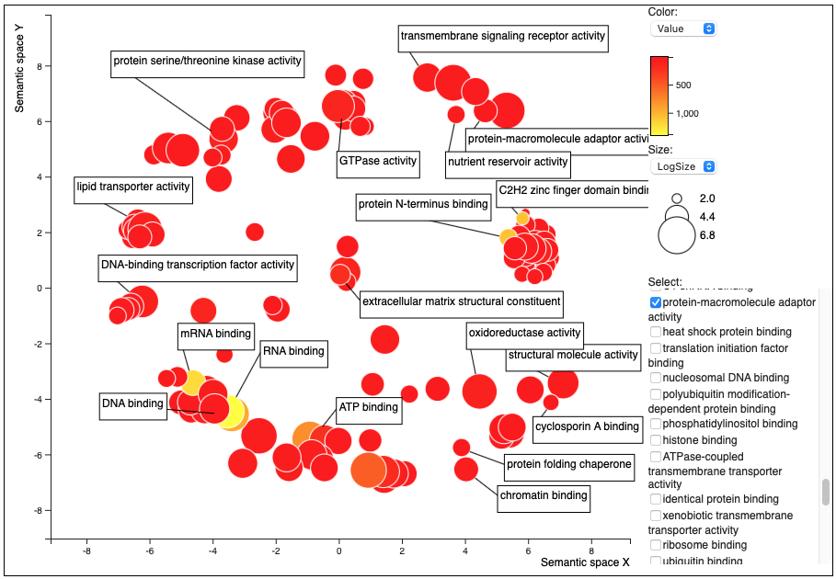
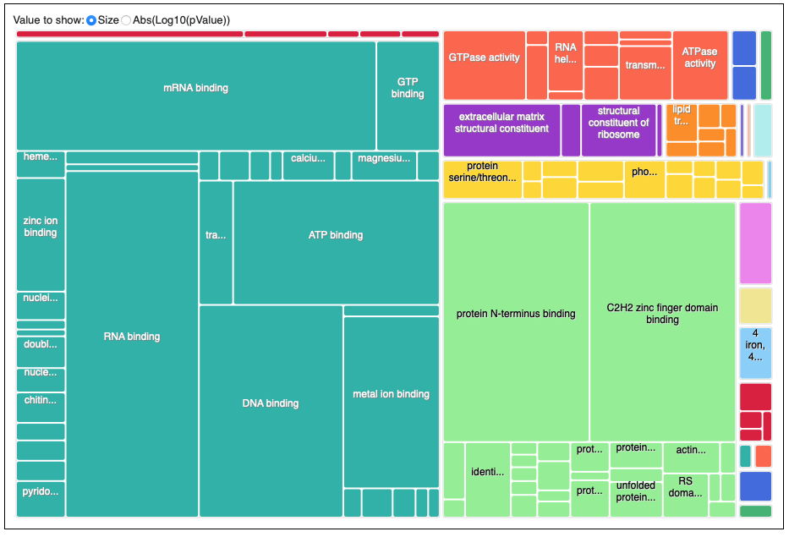
a)
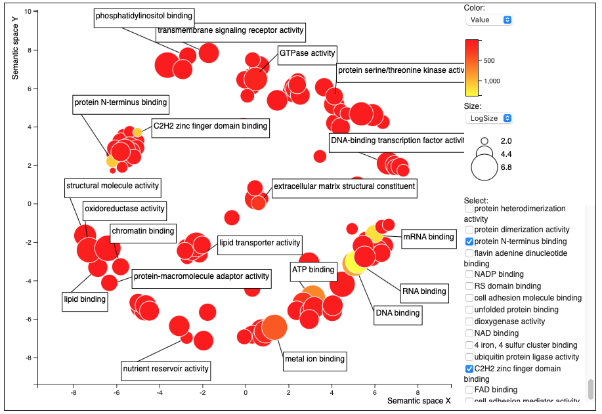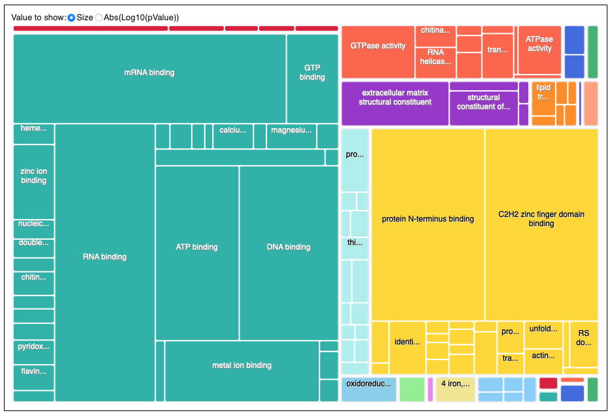
b)
Supplementary Figure 2. Gene Ontology (GO) term summary related to the GO topic: molecular functions. (a) Rhodotorula babjevae CBS 7808; (b) R. babjevae DBVPG 8058.

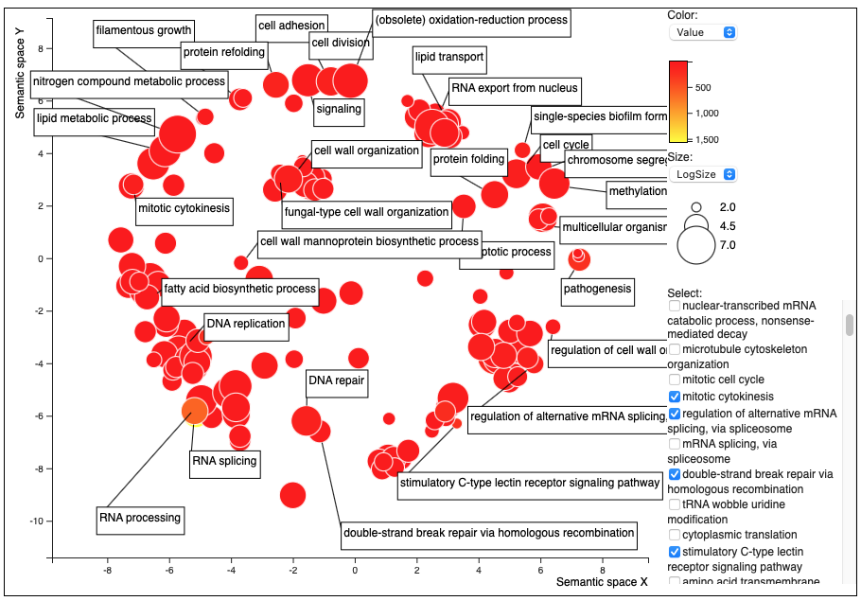
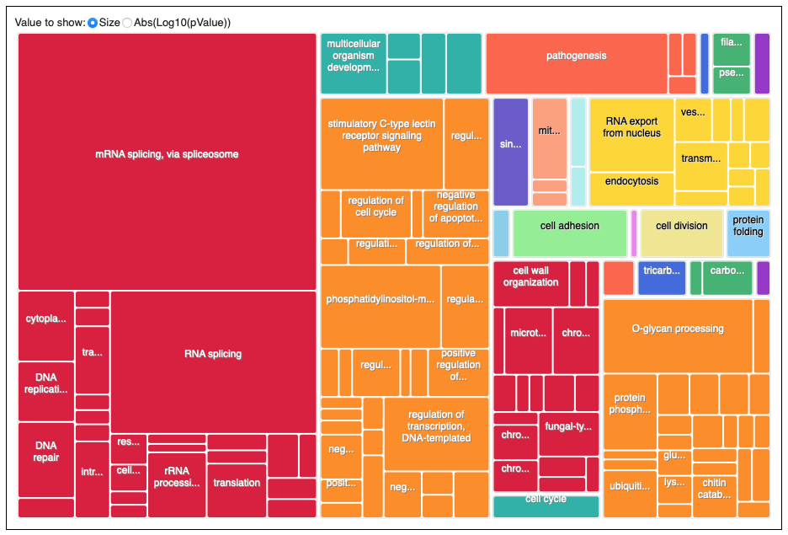
a)
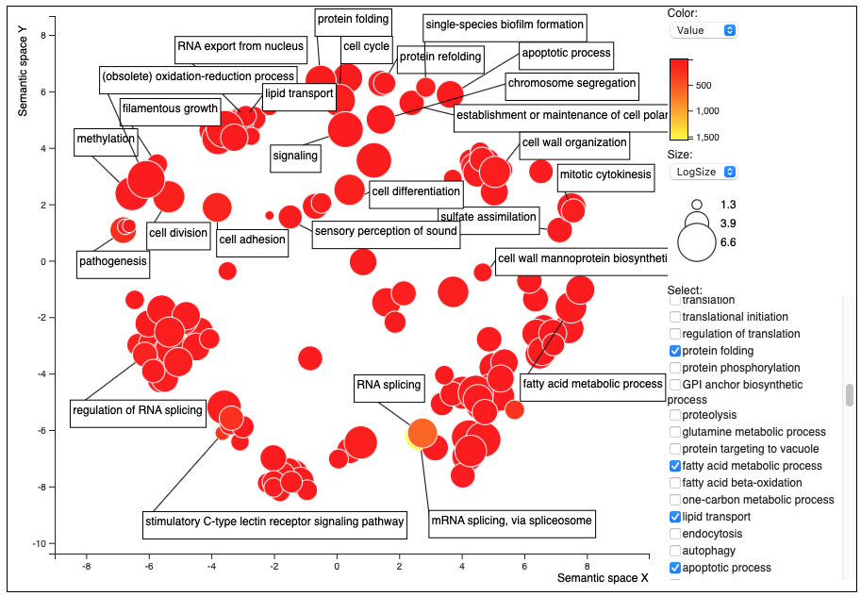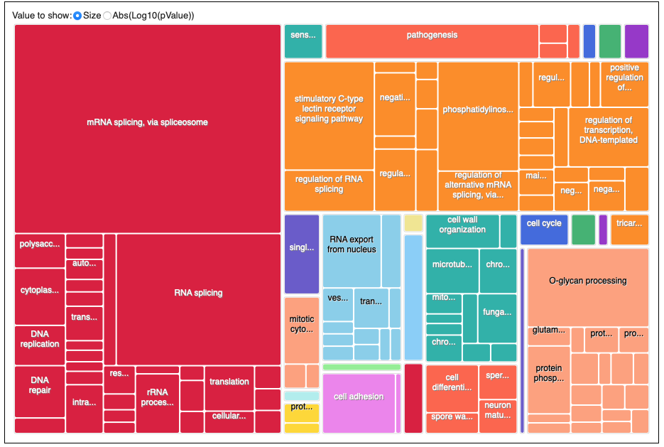
b)
Supplementary Figure 3. Gene Ontology (GO) term summaries belonging to the GO topic: biological processes. (a) Rhodotorula babjevae CBS 7808; (b) R. babjevae DBVPG 8058.

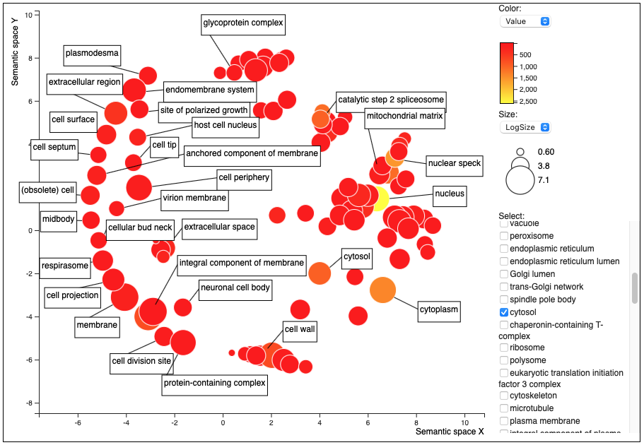

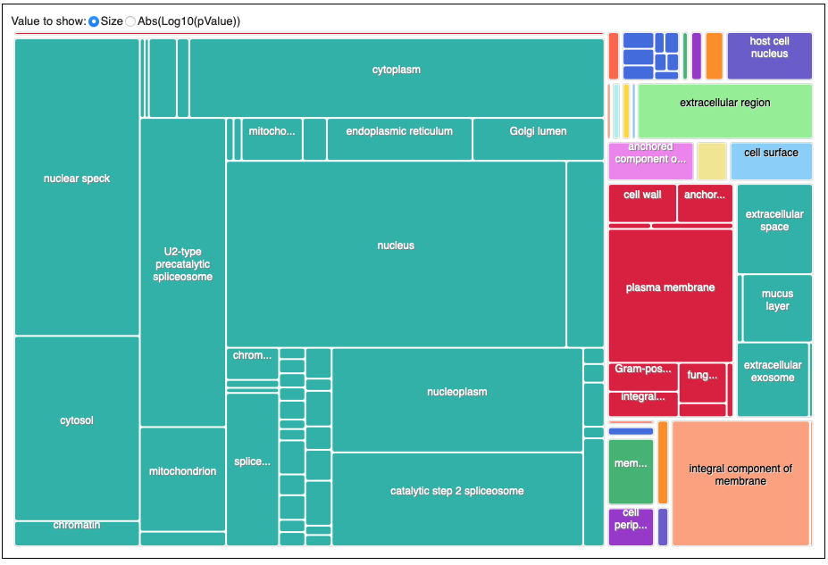
a)
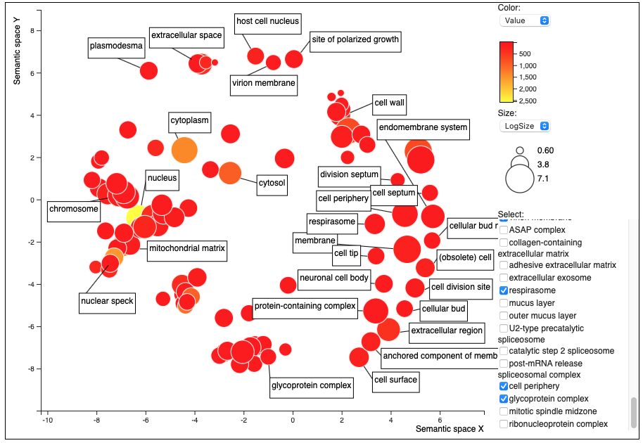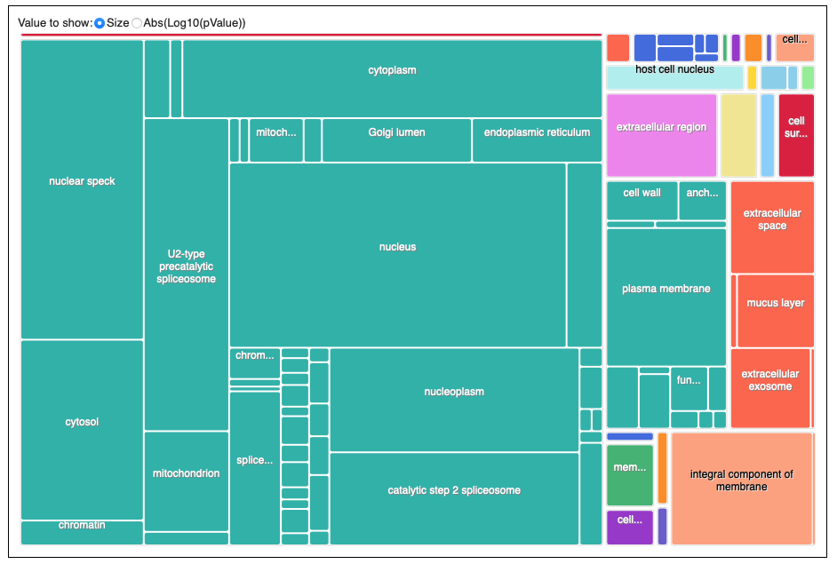
b)
Supplementary Figure 4. Gene Ontology (GO) term summaries belonging to the GO topic: cellular components. (a) Rhodotorula babjevae CBS 7808; (b) R. babjevae DBVPG 8058.
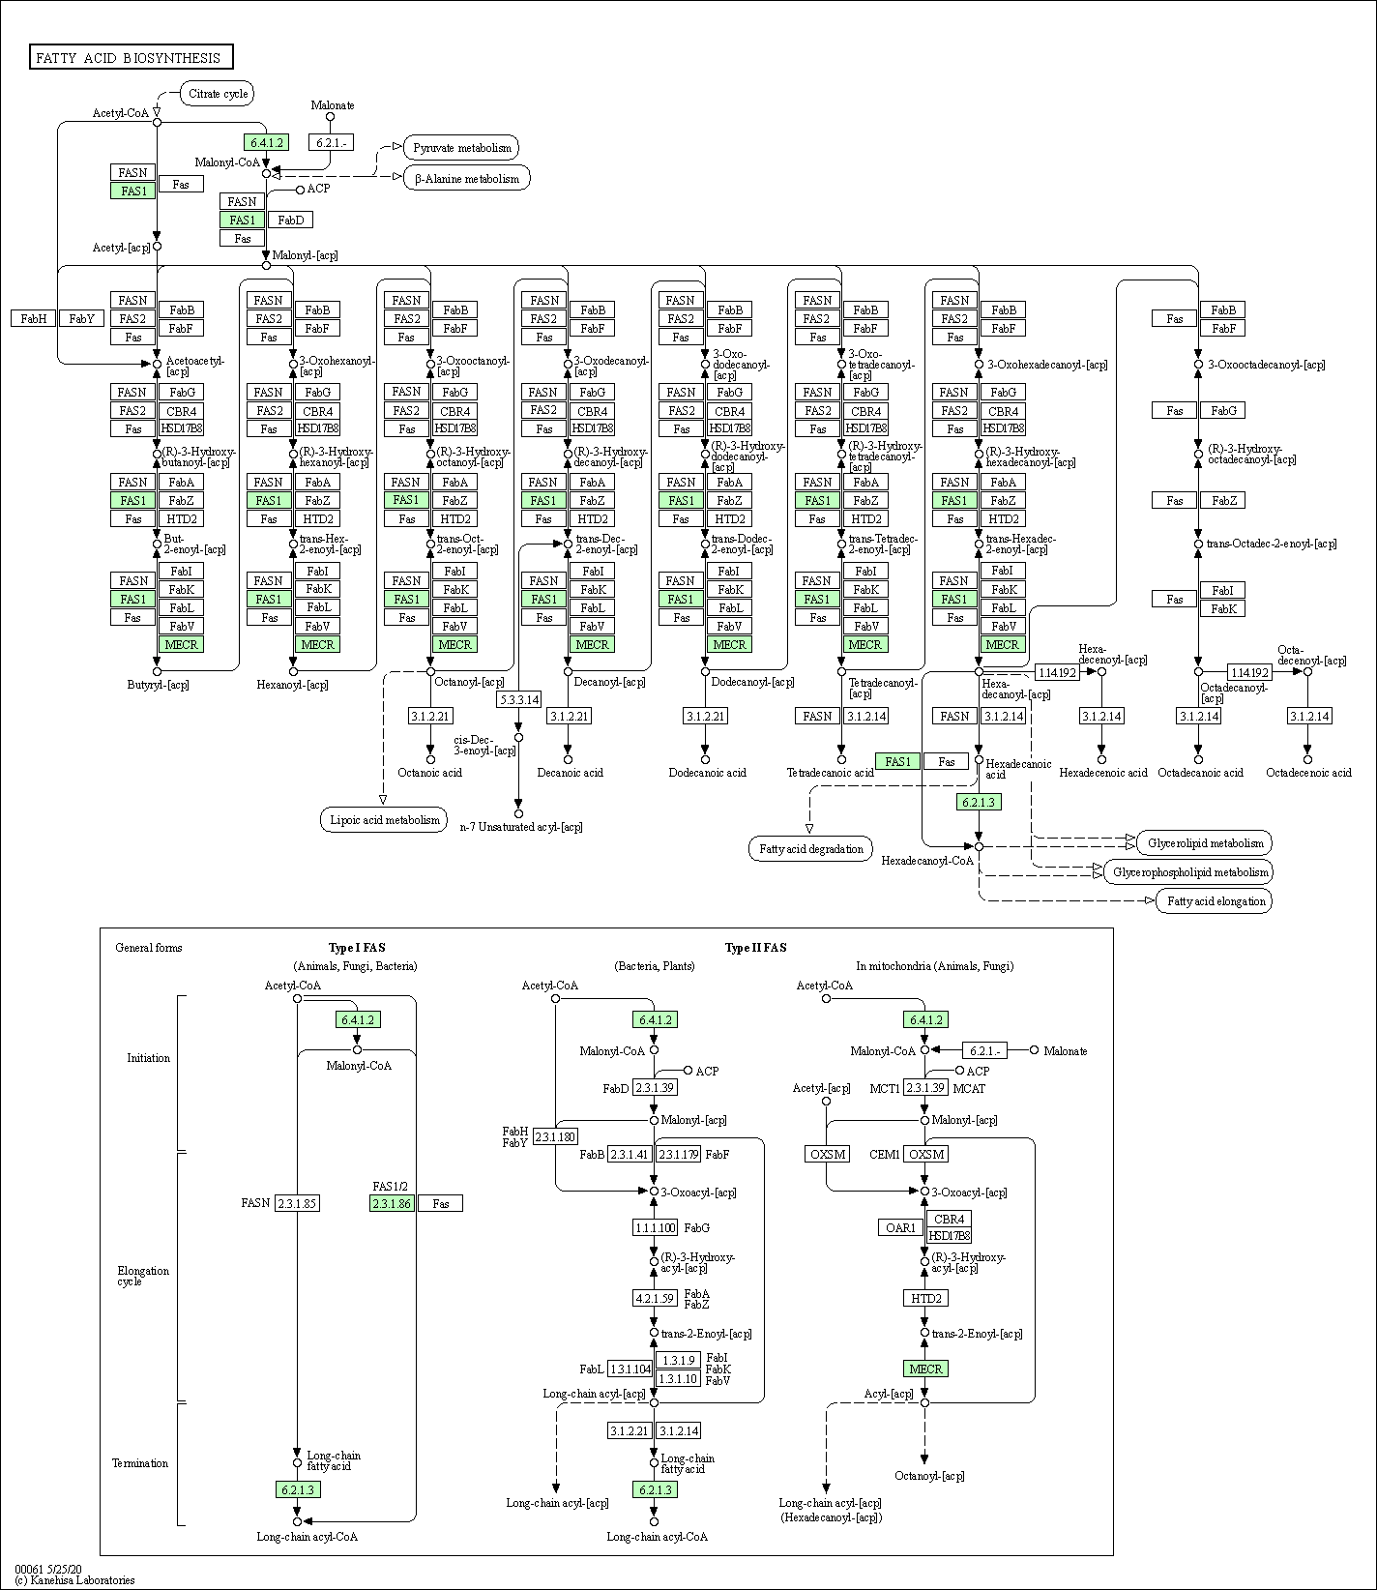
a)
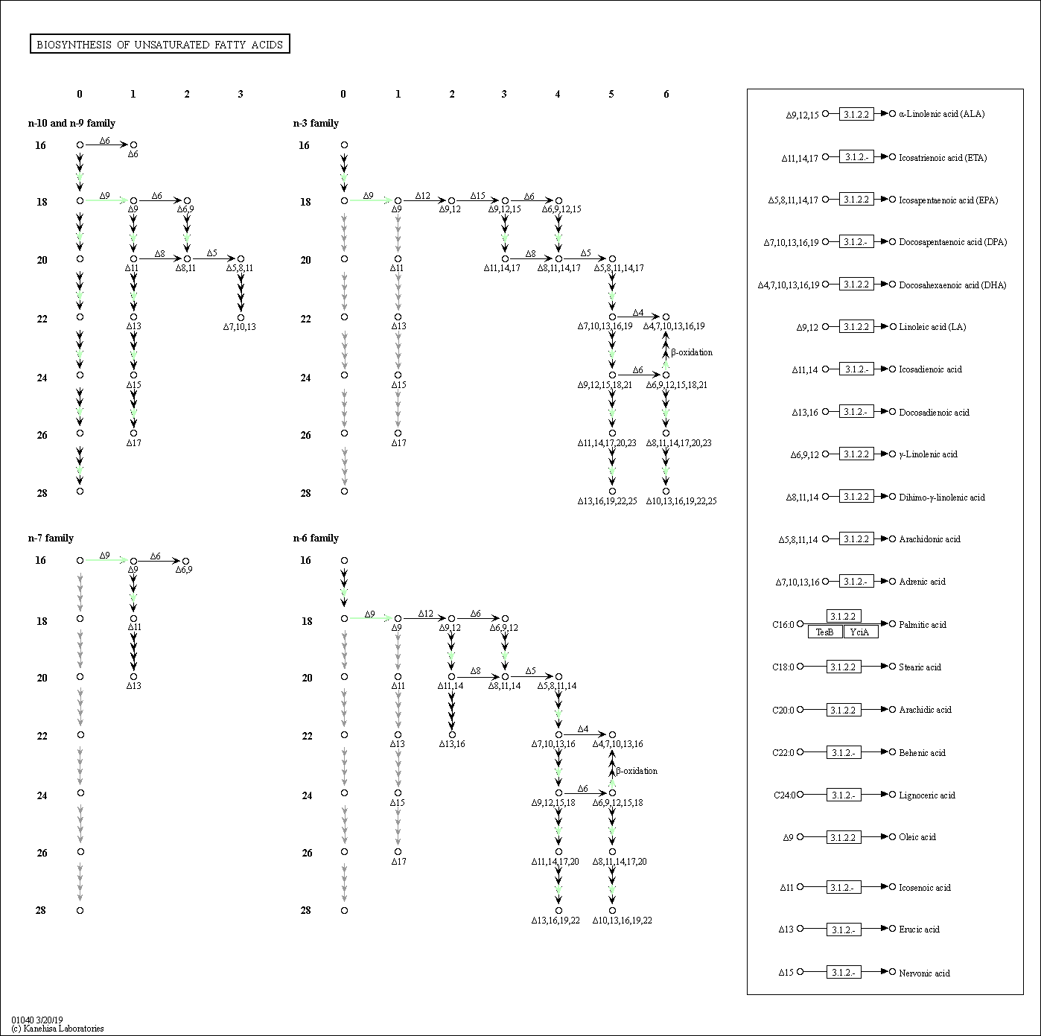
b)
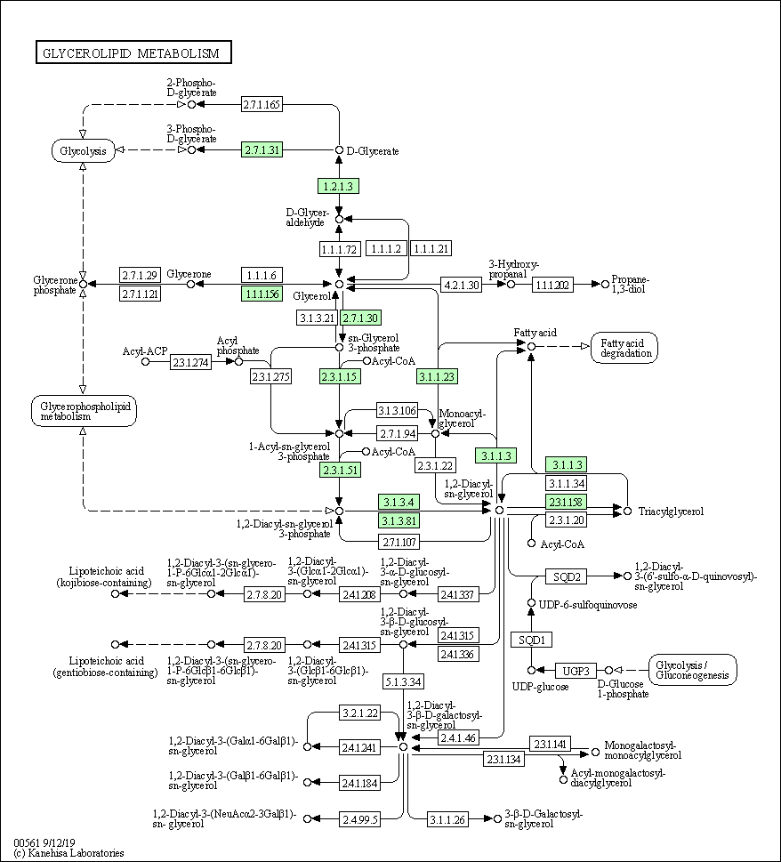
c)
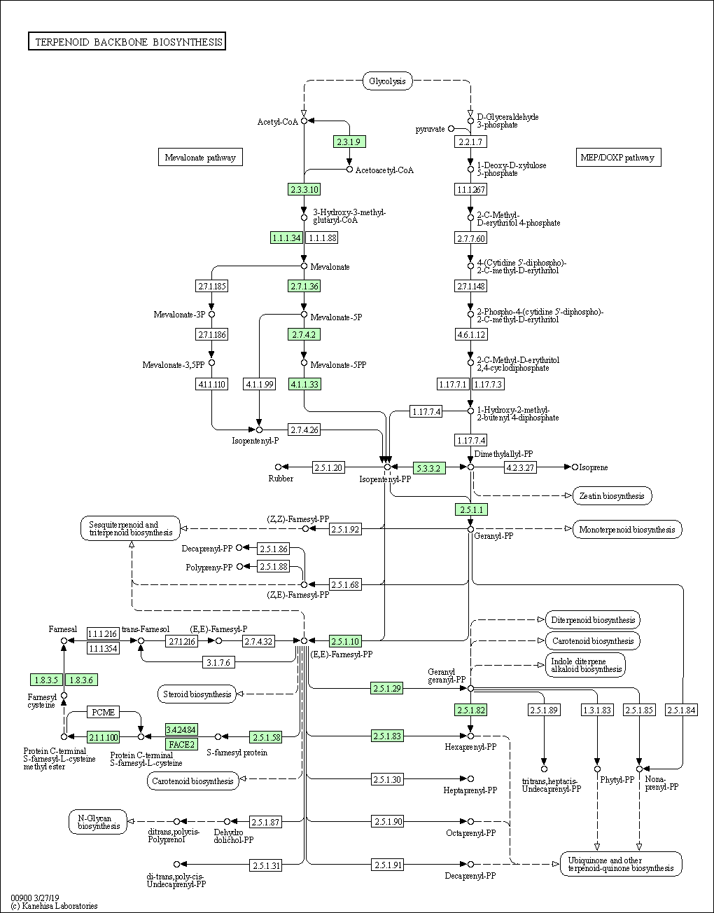
d)
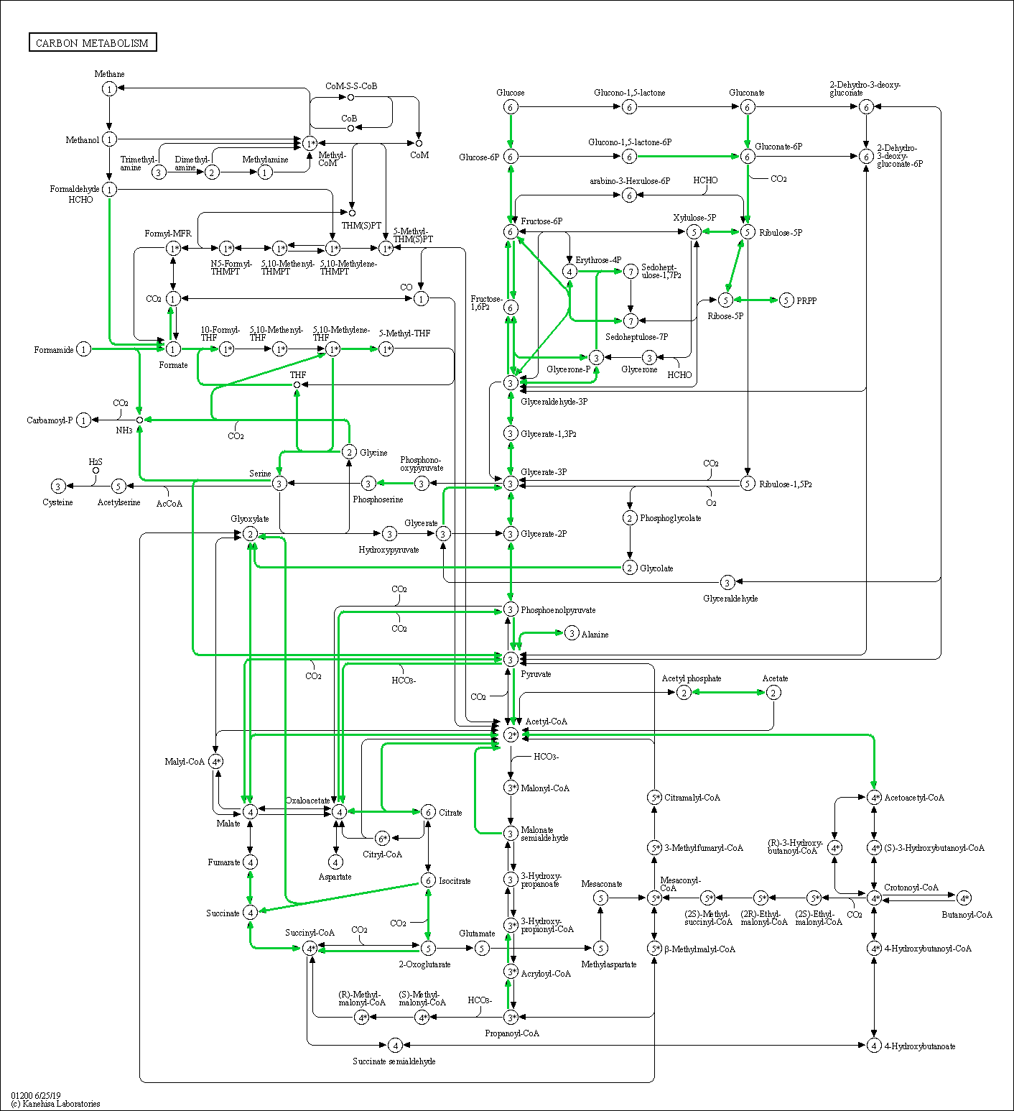
e)
Supplementary Figure 5. Examples of lipid metabolism pathways in Rhodotorula babjevae CBS 7808 reconstructed by KEGG Mapper. The annotated transcripts with affiliated KEGG Orthology (KO) identifiers involved in each metabolic pathway are colored in green. (a) Biosynthesis of fatty acids; (b) biosynthesis of unsaturated fatty acids; (c) glycerolipid methabolism; (d) terpenoid backbone biosynthesis; (e) Carbon metabolism.
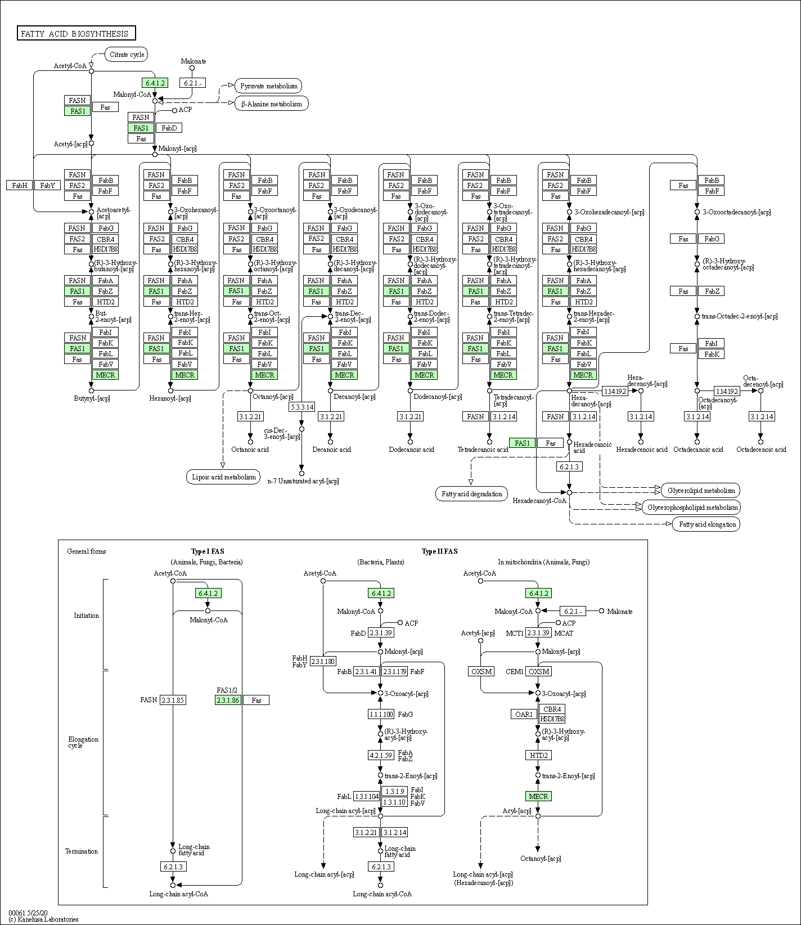
a)
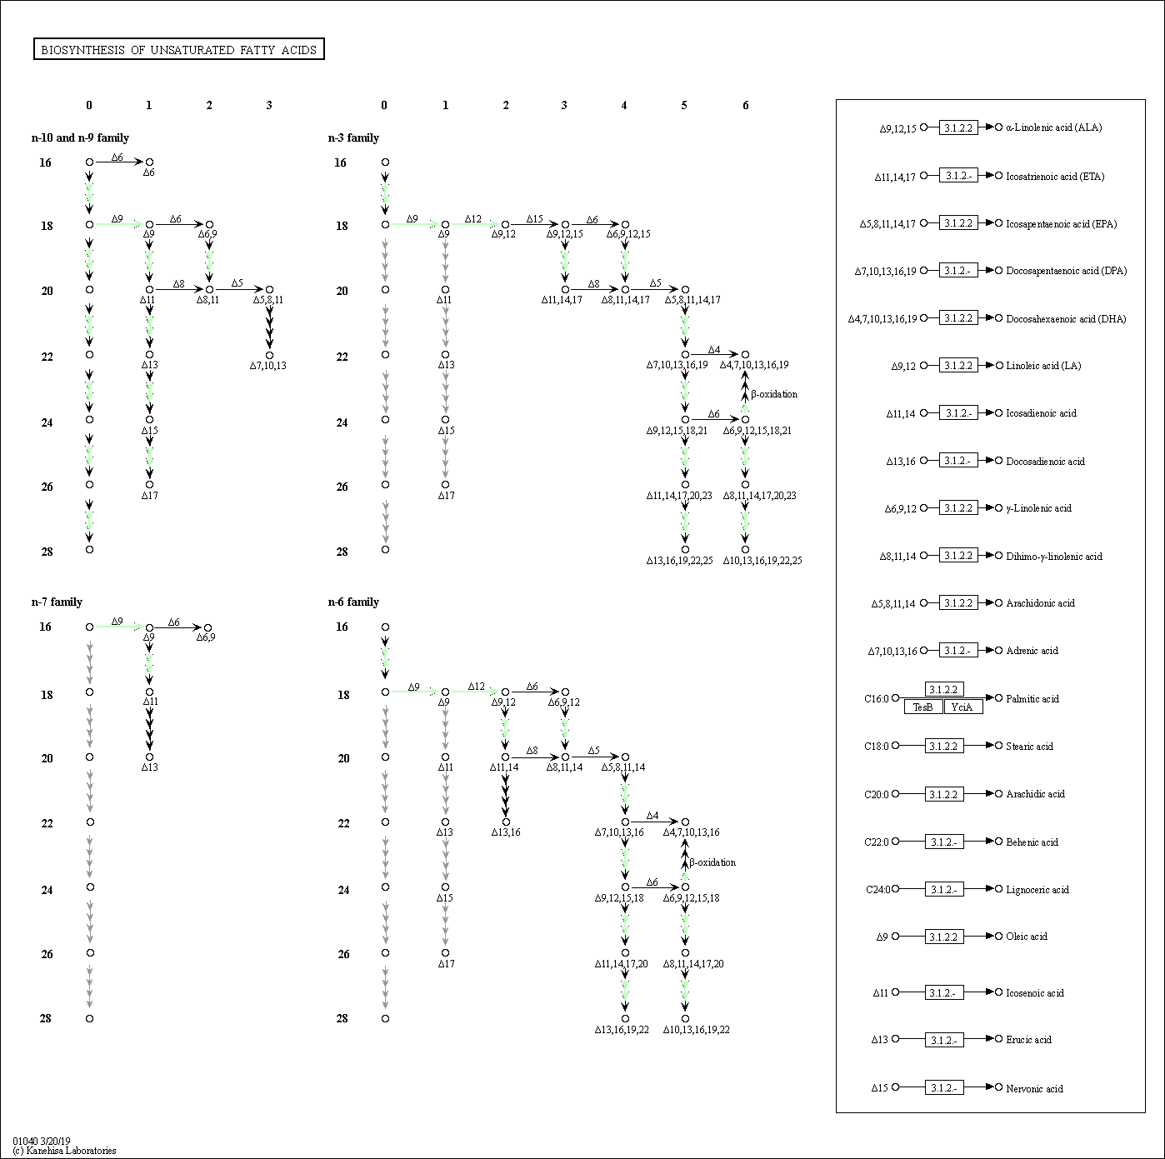
b)
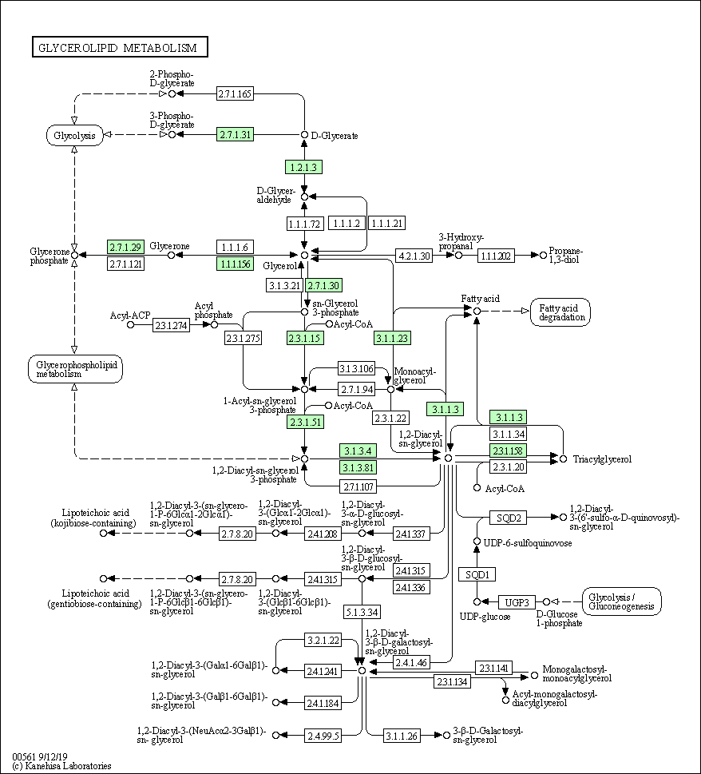
c)
d)
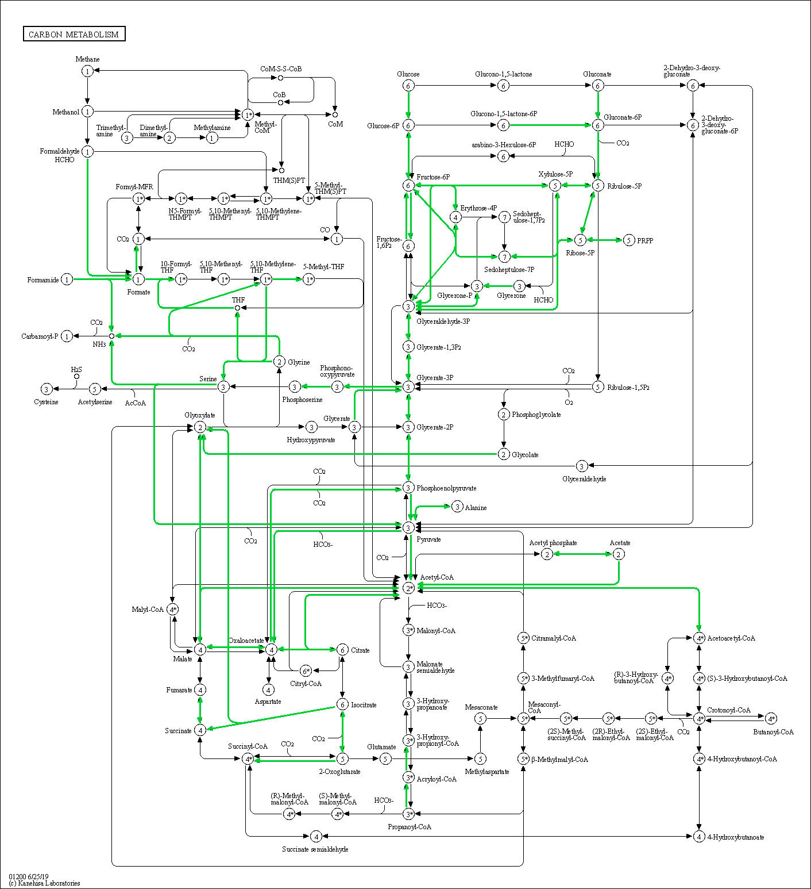
e)
Supplementary Figure 6. Examples of lipid metabolism pathways in Rhodotorula babjevae DBVPG 8058 reconstructed by KEGG Mapper. The annotated transcripts with affiliated KEGG Orthology (KO) identifiers involved in each metabolic pathway are colored in green. (a) Biosynthesis of fatty acids; (b) biosynthesis of unsaturated fatty acids; (c) glycerolipid methabolism; (d) terpenoid backbone biosynthesis; (e) Carbon metabolism.
a)
b)
Supplementary Figure 7. Quantitative assessment of the hybrid genome assemblies and annotation completeness using Benchmarking Universal Single-Copy Orthologs (BUSCO). (a) Rhodotorula babjevae CBS 7808; (b) R. babjevae DBVPG 8058.

Supplementary Figure 8. LASTZ alignment of the mitochondrial genome sequences from Rhodotorula babjevae CBS 7808 and DBVPG 8058. The alignment was performed with the sequences after circularization. The consensus sequence is represented as a black bar. The identity bar represents pairs as green for 100% mean pairwise identity, green-brown for at least 30% and under 100%, and red for below 30%. In the bar representation of each sequence, pairs with 100% mean pairwise identity are gray and the gaps are represented either as a horizontal line in the contig that lacks the sequence or as a black bar in the contig that contains the sequence. Unique forward alignments are represented in blue and unique reverse alignments in red within LASTZ alignment graph.

a)
b)
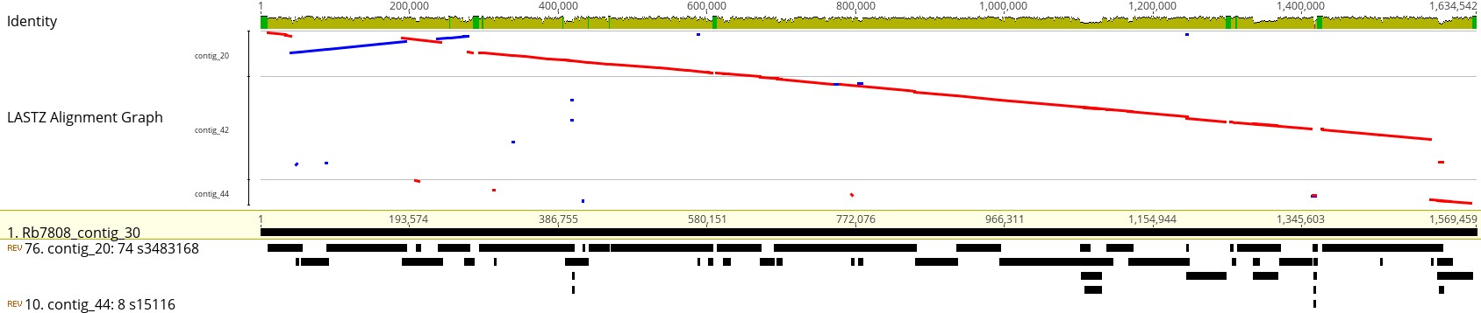
c)
d)
e)
f)
g)
h)
i)
j)
k)
l)
m)
n)
o)
p)
q)
r)
s)
t)
u)
Supplementary Figure 9. LASTZ alignment of contigs with assigned homology from Rhodotorula babjevae CBS 7808 and DBVPG 8058 representing putative chromosomes. R. babjevae putative chromosomes: (a) 1, (b) 2, (c) 3, (d) 4, (e) 5, (f) 6, (g) 7, (h) 8, (i) 9, (j) 10, (k) 11, (l) 12, (m) 13, (n) 14, (o) 15, (p) 16, (q) 17, (r) 18, (s) 19, (t) 20, (u) 21. The identity bar represents pairs as green for 100% mean pairwise identity, green-brown for at least 30% and under 100%, and red for below 30%. In the bar representation of each sequence, pairs with 100% mean pairwise identity are gray and the gaps are represented either as a horizontal line in the contig that lacks the sequence or as a black bar in the contig that contains the sequence. Unique forward alignments are represented in blue and unique reverse alignments in red within LASTZ alignment graph.

