Supplementary Files

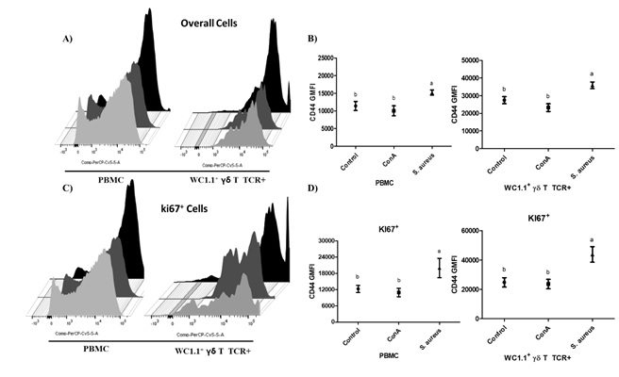
Supplemental Figure 1. Representative histogram from flow cytometry analysis of CD44 expression in peripheral blood mononuclear cells (PBMCs; A and C) and WC1.1⁺ γδ T cells (A and C) in unstimulated controls (light gray) and upon stimulation with concanavalin-A (Con-A; dark gray) and S. aureus (black). An increase in the CD44 geometric mean fluorescence intensity (GMFI) values upon stimulation with S. aureus in overall PBMCs and WC1.1⁺ γδ T cells (B) and in proliferative (Ki67⁺) PBMCs and WC1.1⁺ γδ T cells (D) was found. Different letters indicate P < 0.05. Con-A: concanavalin-A type III.

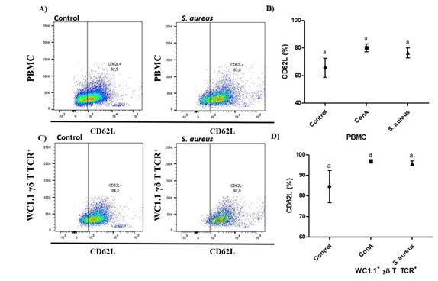
Supplemental Figure 2. Representative dot plots from flow cytometry analysis demonstrating the CD62L population in peripheral blood mononuclear cells (PBMCs; A) and WC1.1⁺ γδ T cells (C) in unstimulated controls and upon stimulation with S. aureus. An increase in the percentage of CD62L⁺ cells amongWC1.1⁺ γδ T cells (D) upon stimulation with S. aureus was observed, although no significant difference was observed in PBMCs (C). Different letters indicate P < 0.05. Con-A: concanavalin-A type III.
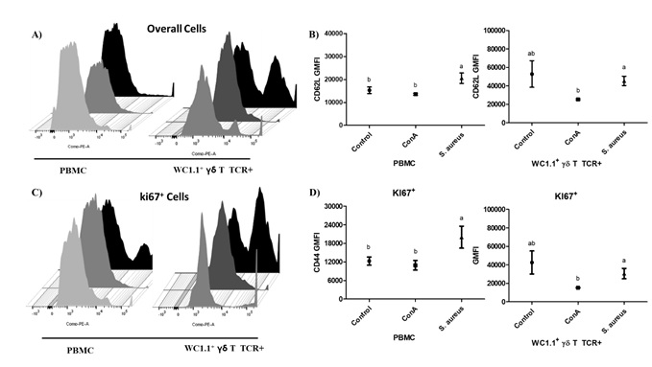
Supplemental Figure 3. Representative histogram of flow cytometry analysis of CD62L expression in peripheral blood mononuclear cells (PBMCs; A and C) and WC1.1⁺ γδ T cells (A and C) in unstimulated controls (light gray) and upon stimulation with concanavalin-A (Con-A; dark gray) and S. aureus (black). An increase in CD62L geometric mean fluorescence intensity (GMFI) values upon stimulation with S. aureus in overall PBMCs and proliferative (Ki67⁺) (B and D) cells was found, although WC1.1⁺ γδ T cells (B and D) upon stimulation with S. aureus did not express higher levels of CD62L than unstimulated controls. Different letters indicated P < 0.05.

