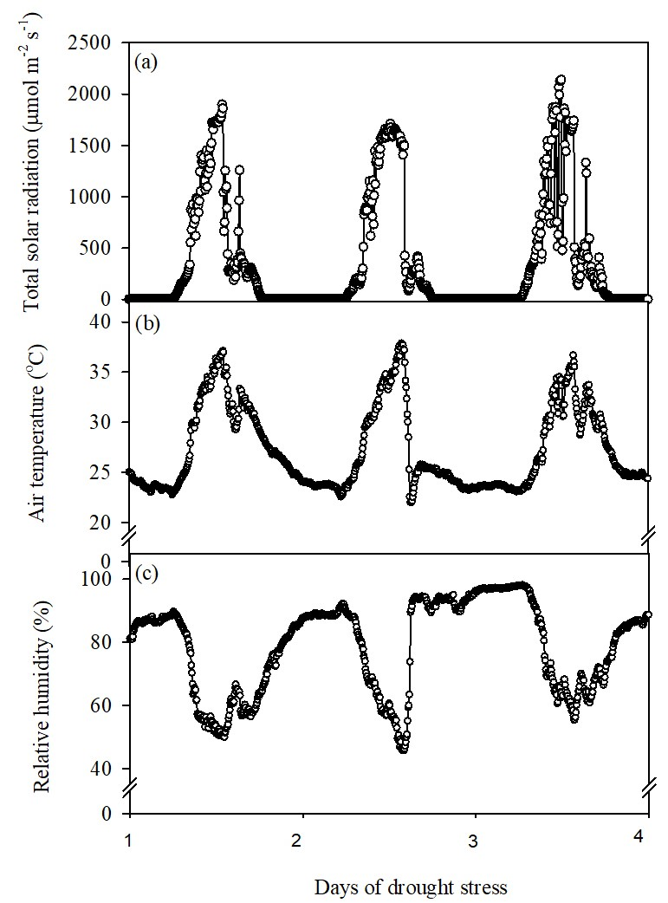

Supplementary figure 1: Weather conditions during root column experiment, showing the variation in (a) total solar radiation (μmol m⁻² s⁻¹), (b) air temperature (^{ο}C), and (c) relative humidity (%).
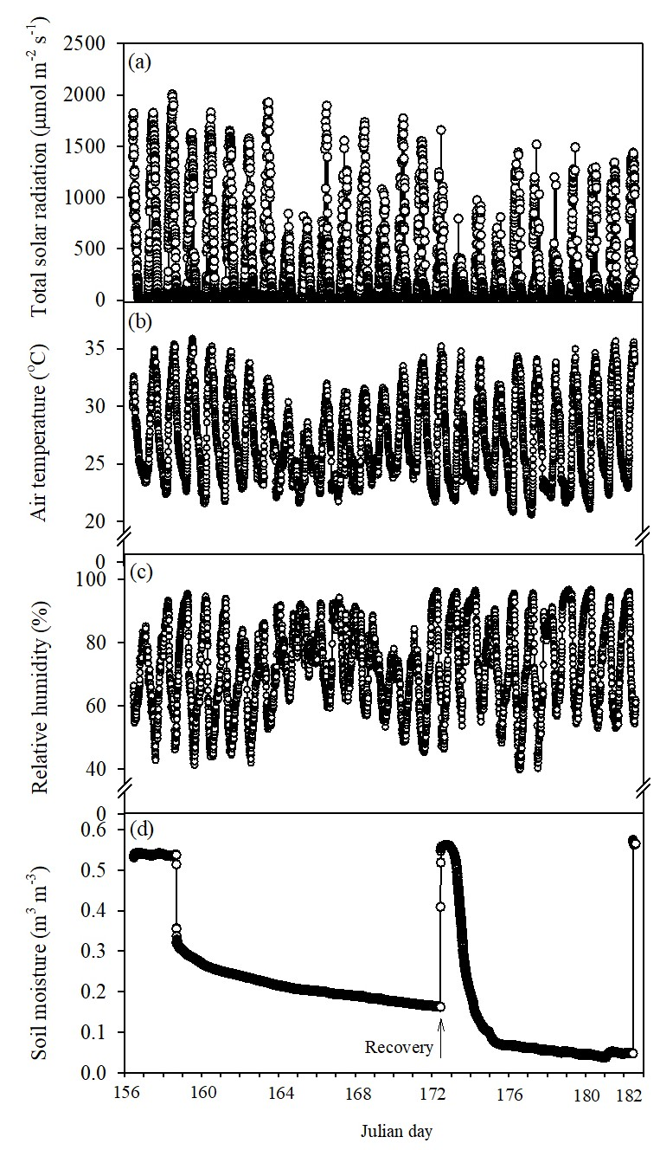
Supplementary figure 2: Weather conditions prevailed during the field experiment, indicating variation in (a) total solar radiation (μmol m⁻² s⁻¹), (b) air temperature (^{ο}C), (c) relative humidity (%), and (d) soil moisture (m³ m⁻³)

