Supplementary information

Assessing the economic viability of the plastic biorefinery and its contribution to a more circular plastic sector

Megan Roux and Cristiano Varrone

Table S1: Major cost inputs to the model
Component | Cost (USD/kg) | Reference
Raw materials
LCC enzyme | 25.0 | [1]
NaOH | 0.32 | [2]
H₂SO₄ | 0.07 | [2]
THF | 1.53 | [3]
O2 | 0.04 | [3]
Cellulose | 0.45 | [3]
Crude glycerol | 0.14 | [4]
C. butirycum culture | 213 | [5]
PDO pre-culture medium | 0.007 | [2]
PDO fermentation broth | 0.004 | [2]
Methanol | 0.24 | [2]
Water | 1.33 | [6]
Catalysts*
Pt/C | 194 | [3]
RuSn4/C | 539 | [3]
TBT | 150 | [7]
Utilities
Cooling water | 0.00005 | [2]
Chilled water | 0.0004 | [2]
Steam | 0.012 | [2]
High pressure steam | 0.02 | [2]
Electricity** | 0.1 | [2]
Revenues
Na₂SO₄ | 1.00 | [2]
Activated carbon | 1.20 | [3]
PEF | 2.70 | Assumed
PTT | 2.70 | Assumed
*Catalyst life span is assumed 6 months, with 10 % replacement at 20 % of the cost [3].
**In USD/kW-h

Table S2: Inputs to the DCCF analysis
Parameter | Value | Reference
Cost of PET pre-treatment (USD/kg PET) | 277 | [8]
Cost of labour (USD/h) | 34.5 | [9]
Construction period (years) | 3 | [10]
1st year expenditures (%) | 8.0 | [10]
2nd year expenditures (%) | 60 | [10]
3rd year expenditures (%) | 32 | [10]
Tax rate (%) | 22 | [11]
Depreciation (years)* | 5.0 | [12]
Working capital (% of fixed capital) | 15 | [12]
Start-up time (years) | 0.5 | [10]
Revenue during start-up (% of normal) | 50 | [10]
Operating costs during start-up (% of normal) | 75 | [10]
Discount rate (%) | 10 | [10]
*Straight-line depreciation over 5 years

Table S3: Summary of capital and operating costs, and revenues.
Fixed capital (USD) | 498 379 707
Working capital (USD) | 74 810 956
Total capital investment (USD) | 573 550 663
Revenues (USD/year) | 391 411 846
Operating costs (USD/year) | 367 323 069

Table S4: DCCF of Scenario 1 in USD
 | 2022 | 2023 | 2024 | 2025 | 2026 | 2027 | 2028 | 2029 | 2030 | 2031 | 2032 | 2033 | 2034 | 2035
Revenue |  |  |  | 195,705,923 | 391,411,846 | 391,411,846 | 391,411,846 | 391,411,846 | 391,411,846 | 391,411,846 | 391,411,846 | 391,411,846 | 391,411,846 | 391,411,846
Operating Costs |  |  |  | 275,492,302 | 367,323,069 | 367,323,069 | 367,323,069 | 367,323,069 | 367,323,069 | 367,323,069 | 367,323,069 | 367,323,069 | 367,323,069 | 367,323,069
Gross Profit |  |  |  | -79,786,379 | 24,088,777 | 24,088,777 | 24,088,777 | 24,088,777 | 24,088,777 | 24,088,777 | 24,088,777 | 24,088,777 | 24,088,777 | 24,088,777
Depreciation |  |  |  | 99,747,941 | 99,747,941 | 99,747,941 | 99,747,941 | 99,747,941
Net Profit |  |  |  | -140,036,770 | -59,014,149 | -59,014,149 | -59,014,149 | -59,014,149 | 18,789,246 | 18,789,246 | 18,789,246 | 18,789,246 | 18,789,246 | 18,789,246
Cash Flow | -39,899,177 | -299,243,824 | -234,407,662 | -40,288,829 | 40,733,793 | 40,733,793 | 40,733,793 | 40,733,793 | 18,789,246 | 18,789,246 | 18,789,246 | 18,789,246 | 18,789,246 | 18,789,246
CCF | -39,899,177 | -339,143,001 | -573,550,663 | -80,188,005 | -298,409,208 | -257,675,415 | -216,941,622 | -176,207,830 | -157,418,584 | -138,629,338 | -119,840,093 | -101,050,847 | -82,261,601 | -63,472,356
DCF | -36,271,979 | -247,308,946 | -176,113,946 | -27,517,812 | 25,292,481 | 22,993,164 | 20,902,876 | 19,002,615 | 7,968,474 | 7,244,068 | 6,585,516 | 5,986,833 | 5,442,575 | 4,947,796
DCCF | -36,271,979 | -283,580,924 | -459,694,871 | -487,212,683 | -258,288,444 | -235,295,280 | -214,392,403 | -195,389,788 | -187,421,314 | -180,177,246 | -173,591,730 | -167,604,898 | -162,162,323 | -157,214,527

Table S5(a): Stream table showing most important process streams relating to Fig.2 in the main report. Flows are in kg/h.
 | 1 | 2 | 3 | 4 | 5 | 6 | 7 | 8 | 9 | 10 | 11 | 12 | 13
PET | 6437.83 | 649.56
LCC | 12.86 | 12.86
NaOH | 1576.34
H2SO4 |  |  |  | 23506.30 |  |  |  | 577.34 | 48.30
Water | 25082.45 |  | 25082.45 |  | 43889.76 |  | 4.38 | 1109.00 | 26.38
EG |  |  | 2654.25 |  | 2654.25 | 11.61 | 2609.40
Na2TP |  |  | 4710.37 |  | 0.01 | 0.01
PTA |  |  |  |  | 5550.30
Na2SO4 |  |  |  |  | 3859.02 | 3859.02
Cellulose |  |  |  |  |  |  |  | 16654.05
THF |  |  |  |  |  |  |  | 242.32 | 242.32
CaOH |  |  |  |  |  |  |  | 399.70
HMF |  |  |  |  |  |  |  |  |  | 5462.53
CaSO4 |  |  |  |  |  |  |  |  | 928.74
Humins |  |  |  |  |  |  |  |  |  | 10064.04
Oxygen |  |  |  |  |  |  |  |  |  |  | 1664.53
AC |  |  |  |  |  |  |  |  |  |  |  | 6061.48
FDCA |  |  |  |  |  |  |  |  |  |  |  |  | 6328.71
GVL |  |  |  |  |  |  |  |  |  |  |  |  | 1.13

LCC= leaf compost cutinase, Na₂TP=sodium terephthalate, THF=tetrahydrofuran, AC=activated carbon, GVL=gamma-valerolactone

Table S5(b): Stream table showing most important process streams relating to Fig.2 in the main report. Flows are in kg/h.
 | 14 | 15 | 16 | 17 | 18 | 19 | 20 | 21 | 22 | 23 | 24 | 25 | 26
Water |  | 9.93 |  |  |  | 978.03 | 3007 | 3311.64 | 33.27
PTA |  |  |  |  |  |  |  |  |  |  | 902.87 | 40.63 | 40.63
DMFD |  | 47.33 | 6148.94
Methanol | 527 | 6.31 |  |  |  |  |  |  |  | 383.00 | 5.56
PEF |  |  |  | 7420.96 | 5550.30
C. butirycum cells |  |  |  |  |  | 5.51 | 2772.40 | 2772.40
Fermentation media |  |  |  |  |  | 2037.90
Glycerol |  |  |  |  |  | 6601.70
FFA |  |  |  |  |  | 81.50 | 81.50 | 81.50
KCl |  |  |  |  |  | 489.02 | 489.02 |  | 9.75
PDO |  |  |  |  |  |  | 3630.94 | 21.17 | 3609.77
DMT |  |  |  |  |  |  |  |  |  |  | 36.4 | 5347.97
PTT |  |  |  |  |  |  |  |  |  |  |  |  | 6667.27

FFA=free fatty acids

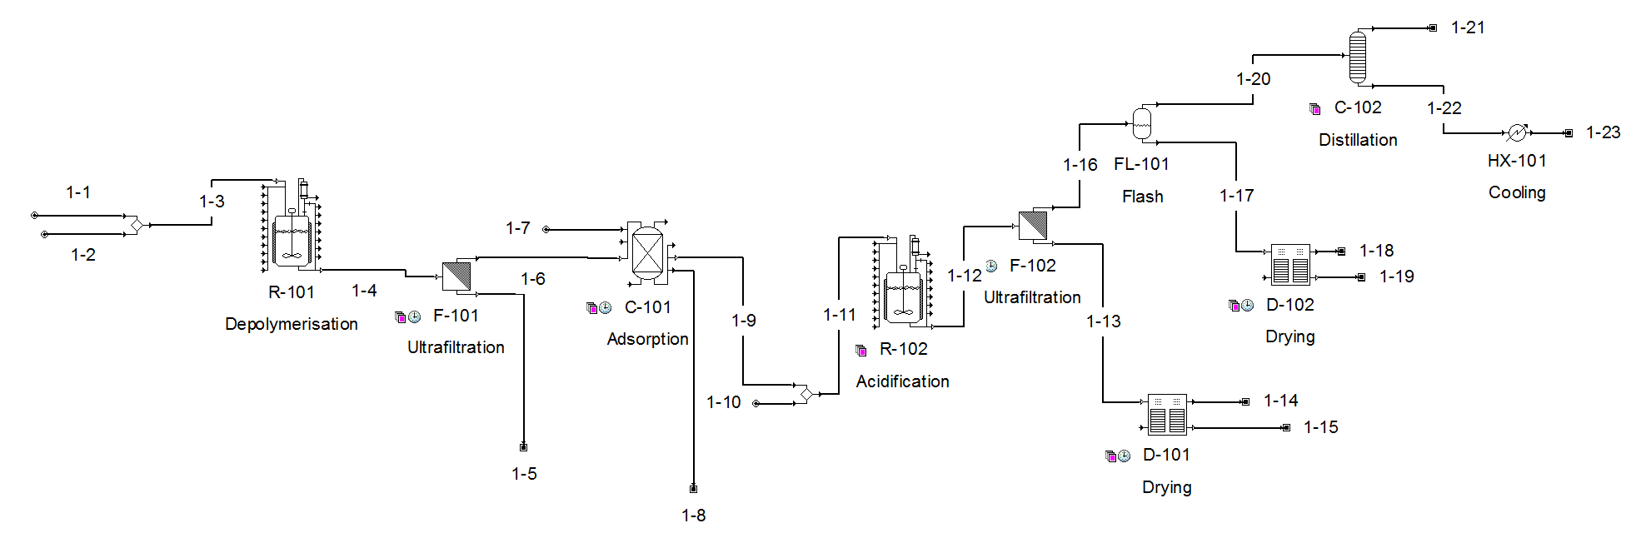

Figure S1(a): Process flow diagram of Area 1 (PET depolymerisation). Stream 1-1: PET, stream 1-15: PTA, stream 1-19: Na₂SO₄, stream 1-23: EG.
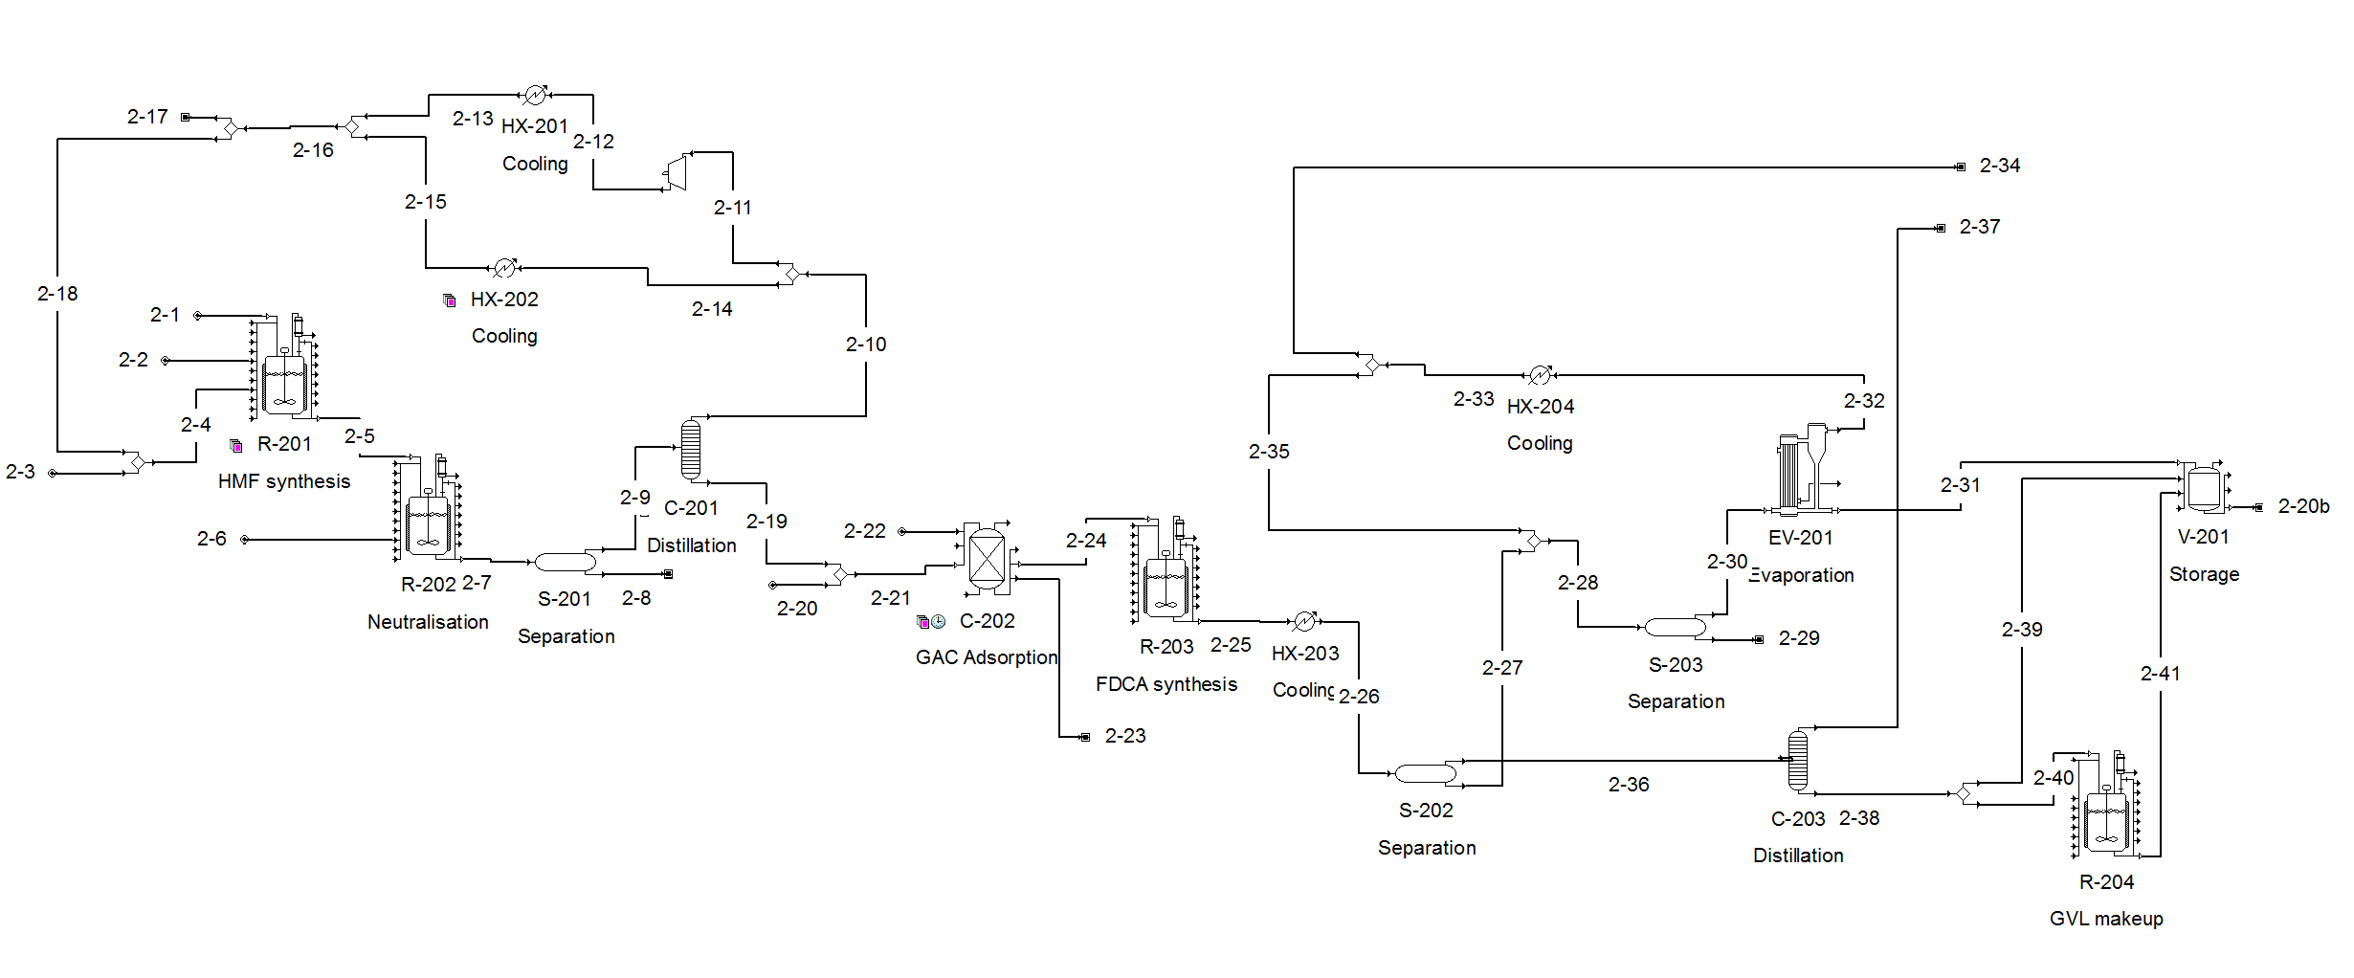
Figure S1(b): Process flow diagram of Area 2 (FDCA production). Stream 2-1: cellulose, stream 2-29: FDCA, stream 2-20b: GVL recycle to stream 20 (not implemented due to limit in number of unit operations, but modelled in stream 2-20)

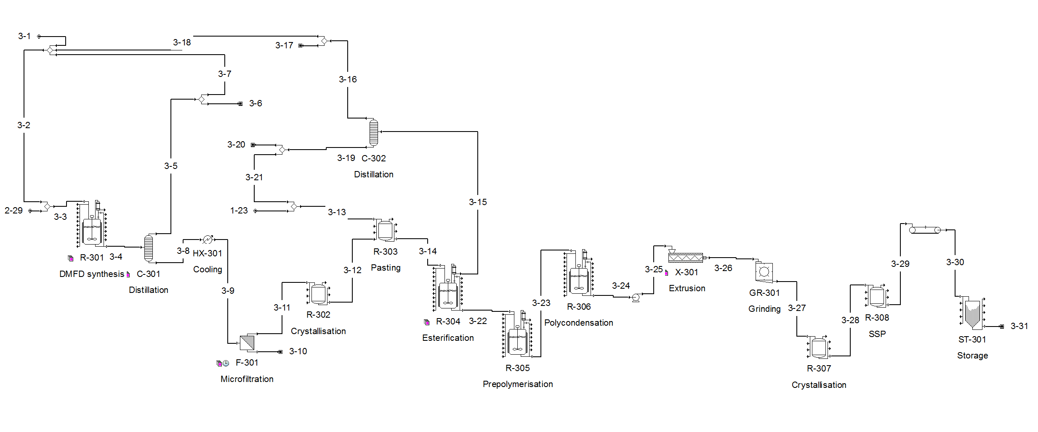

Figure S1(c): Process flow diagram of Area 3 (PEF synthesis). Stream 2-29: FDCA, stream 3-1: methanol make-up, stream 1-23: EG, stream 3-31: PEF.

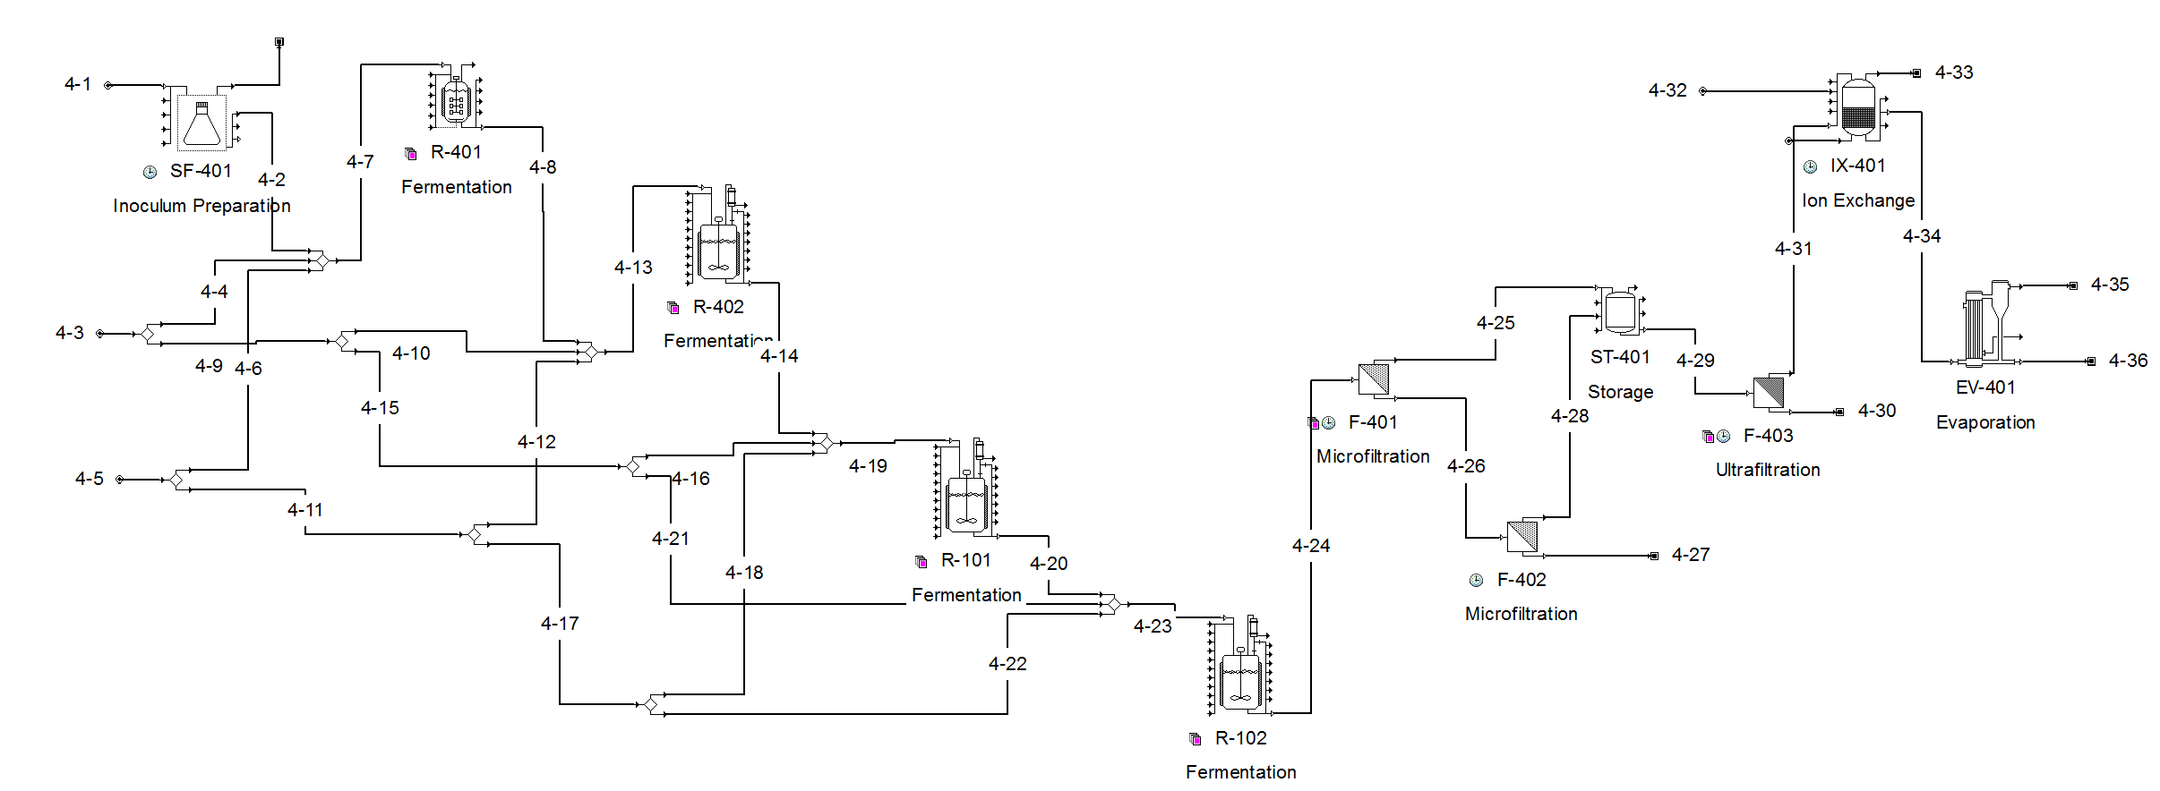

Figure S1(d): Process flow diagram of Area 4 (PDO production). Stream 4-1: starter culture, stream 4-3: fermentation media, stream 4-5: crude glycerol, stream 4-36: PDO.

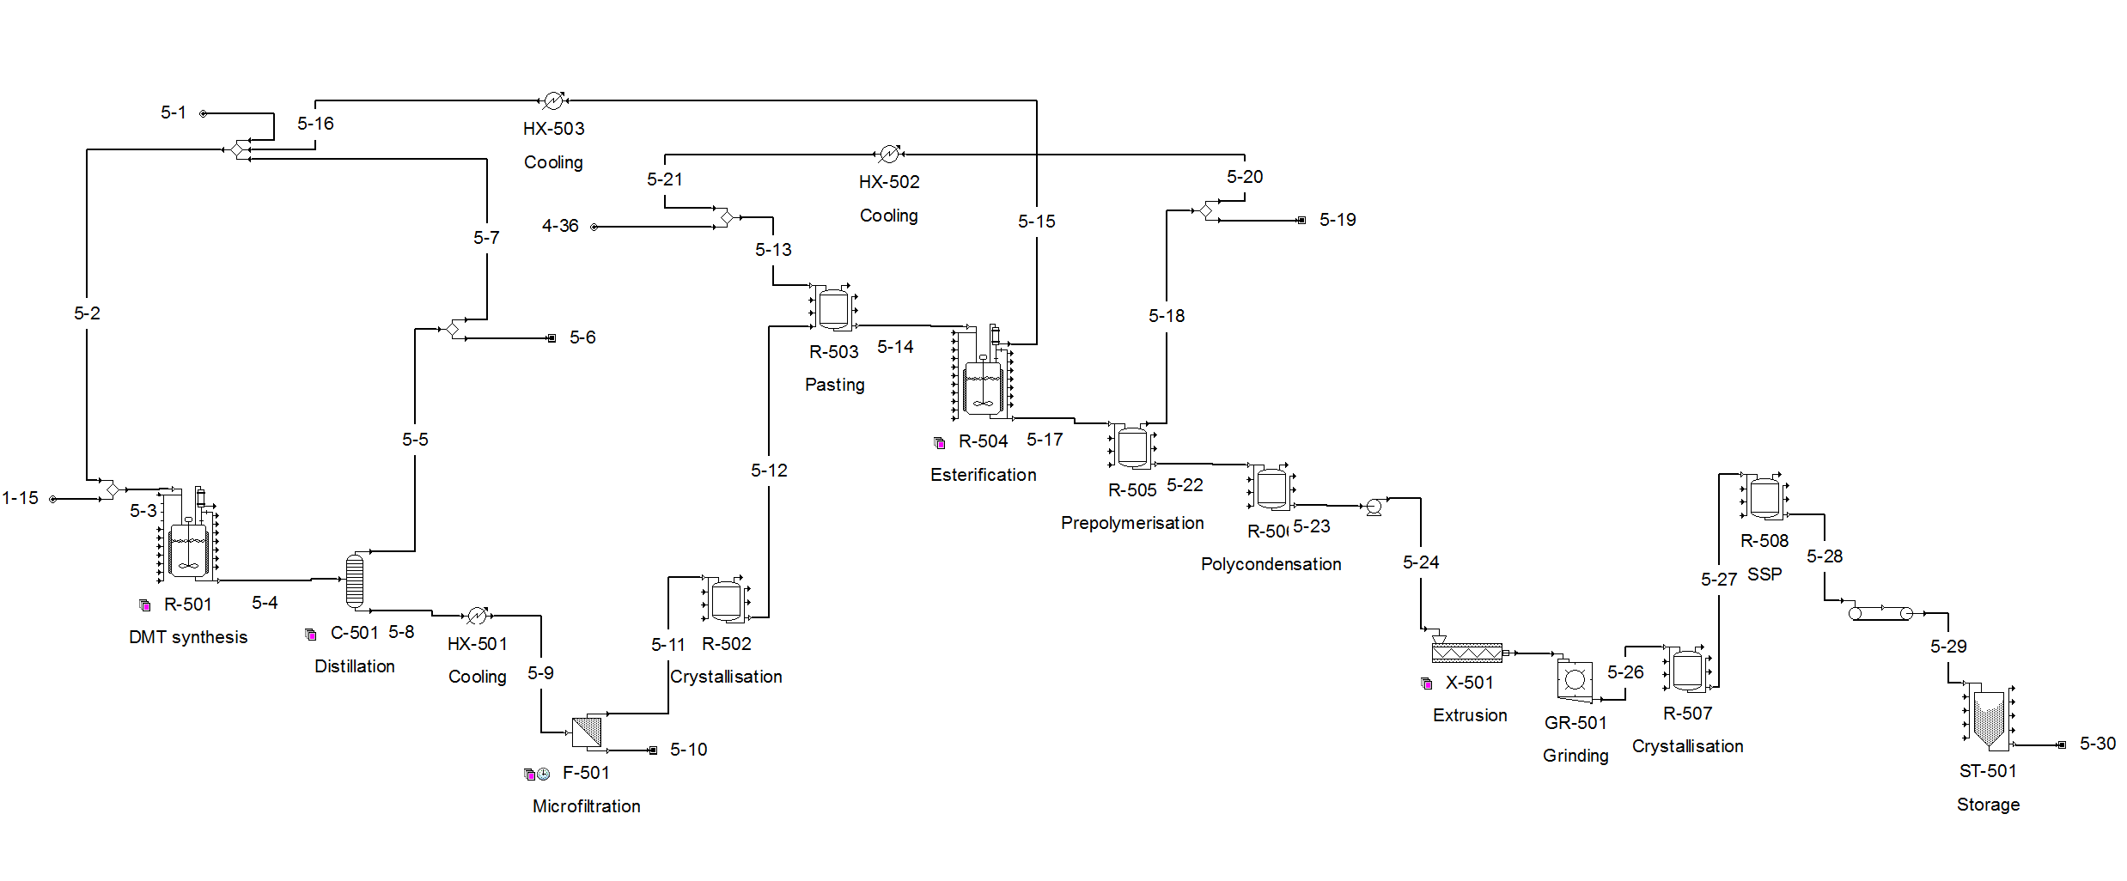

Figure S1(e): Process flow diagram of Area 5 (PTT synthesis). Stream 1-15: PTA, stream 5-1: methanol make-up, stream 4-36: PDO, stream 5-30: PTT.

References:

- Tournier, V.; Topham, C. M.; Gilles, A.; David, B.; Folgoas, C.; Moya-Leclair, E.; Kamionka, E.; Desrousseaux, M. -L.; Texier, H.; Gavalda, S.; Cot, M.; Guémard, E.; Dalibey, M.; Nomme, J.; Cioci, G.; Barbe, S.; Chateau, M.; André, I.; Duquesne, S.; Marty, A. An engineered PET depolymerase to break down and recycle plastic bottles. Nature 2020, 580, pp. 216-219. doi:10.1038/s41586-020-2149-4.
- Intelligen, Inc. SuperPro Designer Database, 2021.
- Kim, H.; Choi, J.; Park, J.; Won, W. Production of a sustainable and renewable biomass-derived monomer: conceptual process design and techno-economic analysis. Green Chem. 2020, 22, pp. 7070-7079. doi:10.1039/d0gc02258f.
- Nomanbhay, S.; Hussein, R.; Ong, M. Y. Sustainability of biodiesel production in Malaysia by production of bio-oil from crude glycerol using microwave pyrolysis: a review. Green Chemistry Letters and Reviews 2018, 11(2), pp. 135-157. doi: 10.1080/17518253.2018.1444795.
- Public Health England, 2021. Bacteria Collection: Clostridium butyricum. [Online]. Available at: https://www.phe- culturecollections.org.uk/products/bacteria/detail.jsp?refId=NCTC+7423&collectio n=nctc#medDoc. [Accessed 17 April 2021].
- European Environment Agency, 2012. Agricultural, industrial and household water prices in late 1990s. [Online]. Available at: https://www.eea.europa.eu/data-and- maps/figures/agricultural-industrial-and-household-water-prices-in-late-1990s. [Accessed 15 August 2021].
- Sigma-Aldrich, 2021. Titanium(IV) butoxide. [Online]. Available at: https://www.sigmaaldrich.com/catalog/product/aldrich/244112?lang=en&region= DK. [Accessed 17 August 2021].
- Singh, A.; Rorrer, N. A.; Nicholson, S. R.; Erickson, E.; DesVeaux, J. S.; Avelino, A. F. T.; Lamers, P.; Bhatt, A.; Zhang, Y.; Avery, G.; Tao, L.; Pickford, A. R.; Carpenter, A. C.; McGeehan, J. E.; Beckham, G. T. Techno-economic, life-cycle, and socioeconomic impact analysis of enzymatic recycling of poly(ethylene terephthalate). Joule 2021, 5, pp.1-25. doi:10.1016/j.joule.2021.06.015.
- SalaryExplorer, 2021. Chemical Plant Operator Average Salary in Denmark 2021. [Online]. Available at: http://www.salaryexplorer.com/salary- survey.php?loc=58&loctype=1&job=12174&jobtype=3. [Accessed 15 August 2021].
- Davis, R.; Tao, L.; Tan, E. C. D.; Biddy, M. J.; Beckham, G. T.; Scarlata C.; Jacobsen, J.; Cafferty, K.; Ross, J.; Lukas, J.; Knorr, D.; Schoen, P. Process Design and Economics for the Conversion of Lignocellulosic Biomass to Hydrocarbons: Dilute-Acid and Enzymatic Deconstruction of Biomass to Sugars and Biological Conversion of Sugars to Hydrocarbons. National Renewable Energy Laboratory (NREL) Report, 2013, NREL/TP-5100-60223.
- Copenhagen Capacity, 2021. Taxation in Denmark. [Online]. Available at: https://www.copcap.com/set-up-a-business/taxation. [Accessed 20 August 2021].
- Seider, W. D.; Seader, J. D.; Lewin, D. R.; Widago, S. Product and Process Design Principles: Synthesis, Analysis, and Evaluation, 3rd ed.; John Wiley & Sons, Inc., United States of America, 2009; pp. 534-627.

