A NARX model to Predict Cabin Air Temperature to ameliorate HVAC Functionality
Srikanth Kolachalama, Hafiz Malik
Electrical and Computer Engineering, University of Michigan, Dearborn 48128, USA
Corresponding author: skola@umich.edu; Co-author: hafiz@umich.edu

Supplementary Material - Tables and Figures

Table 1: Modelling and Training the Deep learning model (2020 Cadillac CT5)

NARX—Deep Learning Model
Properties |  | Dataset—Training and Testing
Property | Value | ACCSSP (MPH) | Summer - Set 1 | Winter - Set 2
Training function | Levenberg-Marquardt backpropagation | 35 | 1-1578 | 1-671
Input/Feedback delays | 1:2 | 45 | 1-1913 | 1-1088
Hidden layer size | 10 | 55 | 1-5097 | 1-2066
Network | Open | 65 | 1-5563 | 1-4536
Performance | MSE | 75 | 1-2242 | 1-3014

- Prediction of CATOP - Test Cases
- Data Set 1 (Summer: EAT > 65 °F)

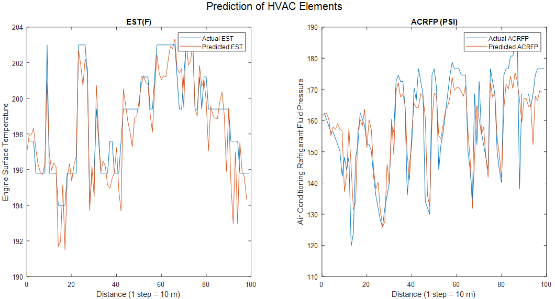
Fig. 1: ACCSSP = 35 MPH, CAT = 66 °F, EAT = 81.5 °F

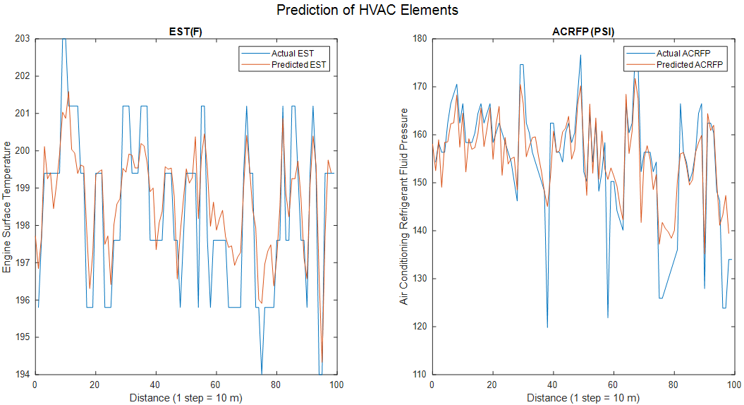
Fig. 2: ACCSSP = 45 MPH, CAT = 67 °F, EAT = 76.6 °F

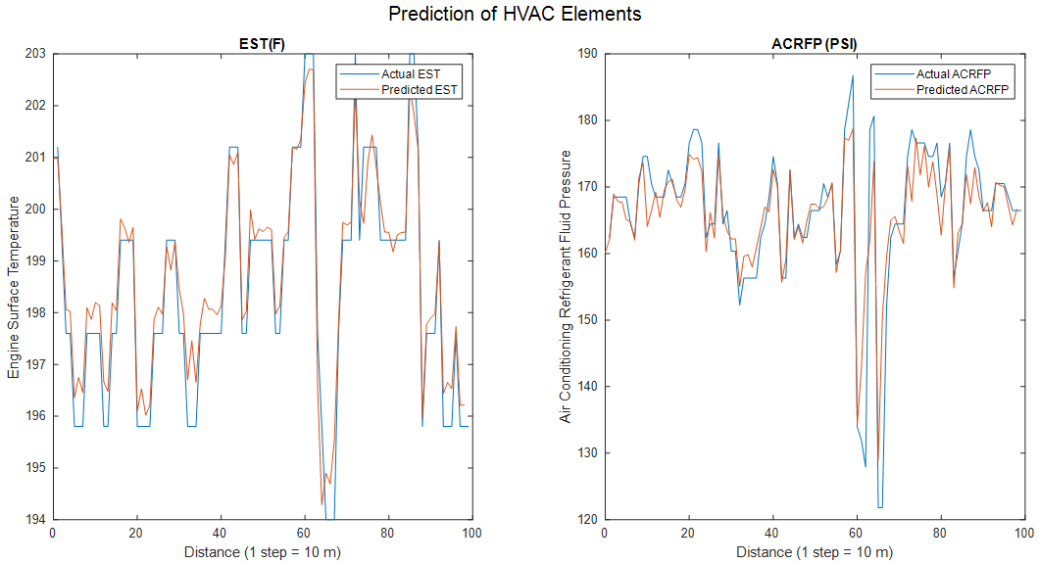
Fig. 3: ACCSSP = 55 MPH, CAT = 65 °F, EAT = 73.4 °F

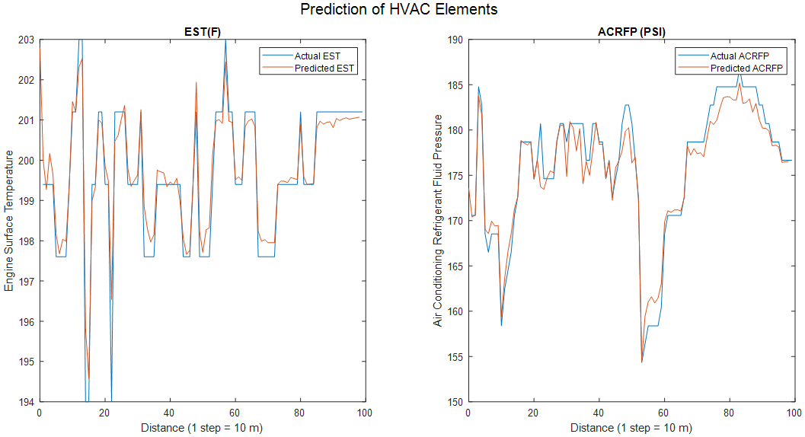
Fig. 4: ACCSSP = 65 MPH, CAT = 70 °F, EAT = 80.6 °F

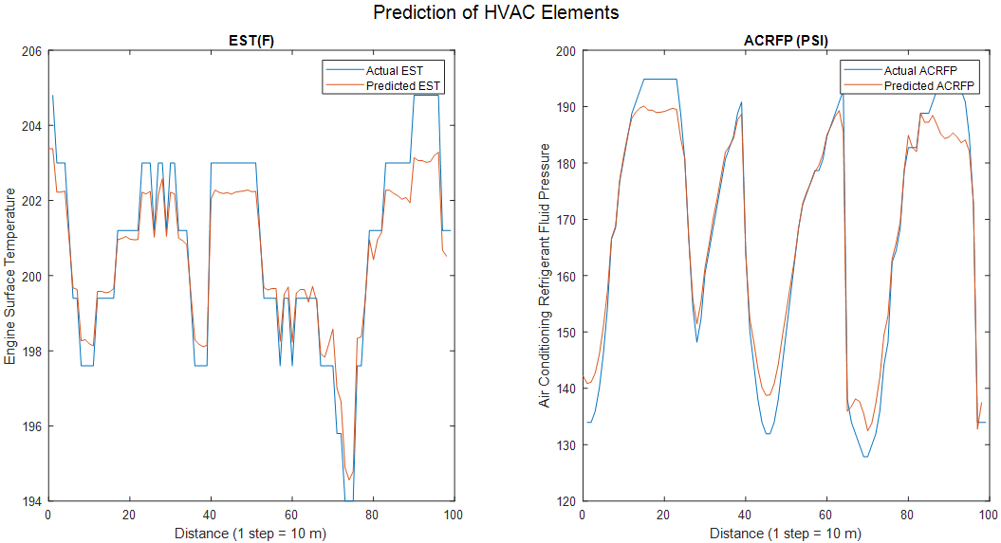
Fig. 5: ACCSSP = 75 MPH, CAT = 68 °F, EAT = 79.7 °F

- Data Set 2 (Winter: EAT < 45 °F)

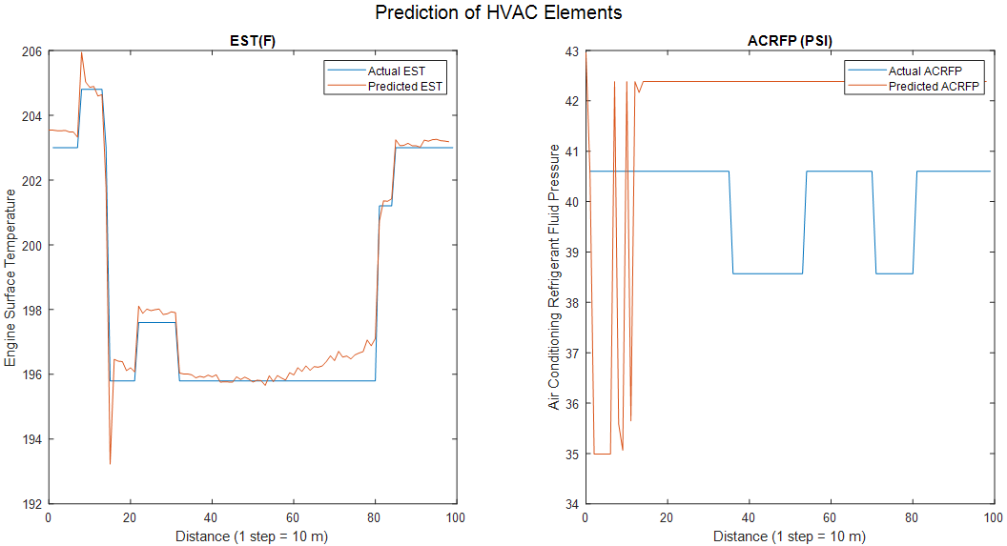
Fig. 6: ACCSSP = 35 MPH, CAT = 76 °F, EAT = 34.7 °F

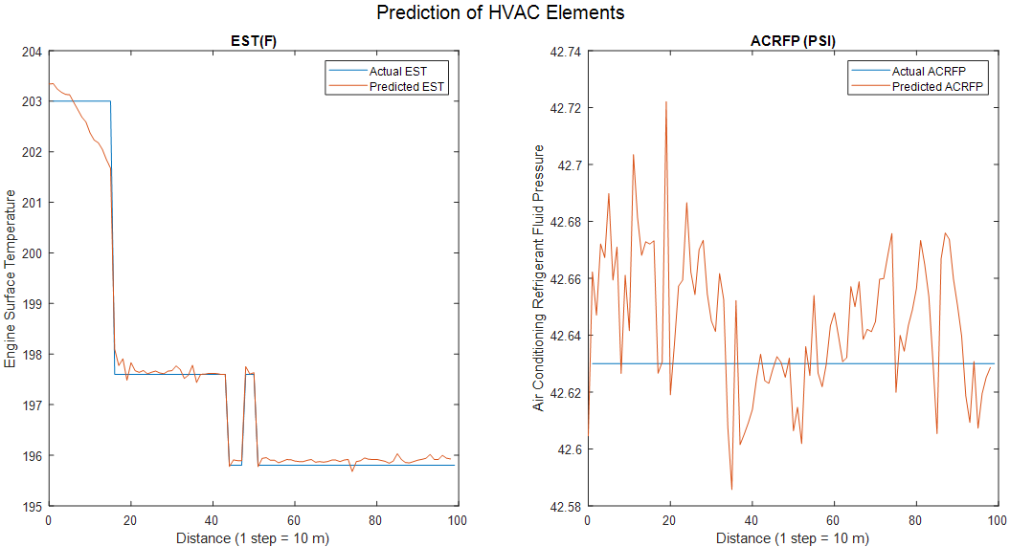
Fig. 7: ACCSSP = 45 MPH, CAT = 71 °F, EAT = 38.14 °F

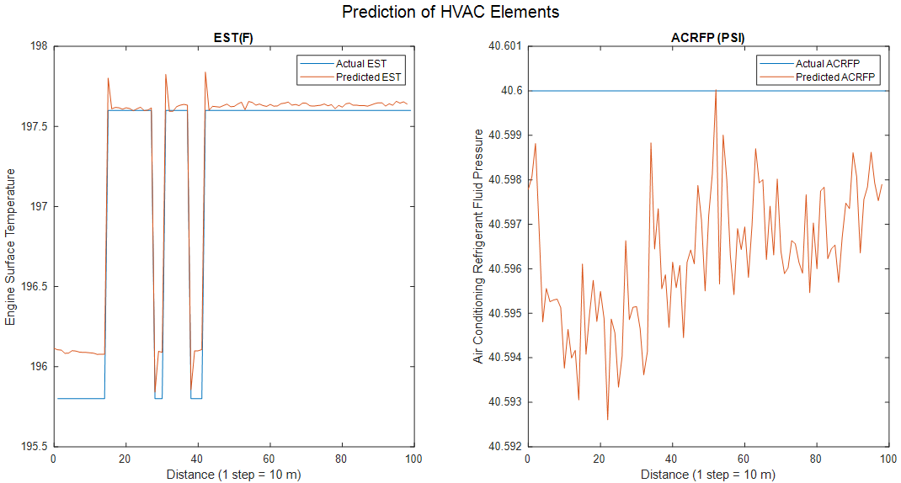
Fig. 8: ACCSSP = 55 MPH, CAT = 73 °F, EAT = 38.3 °F

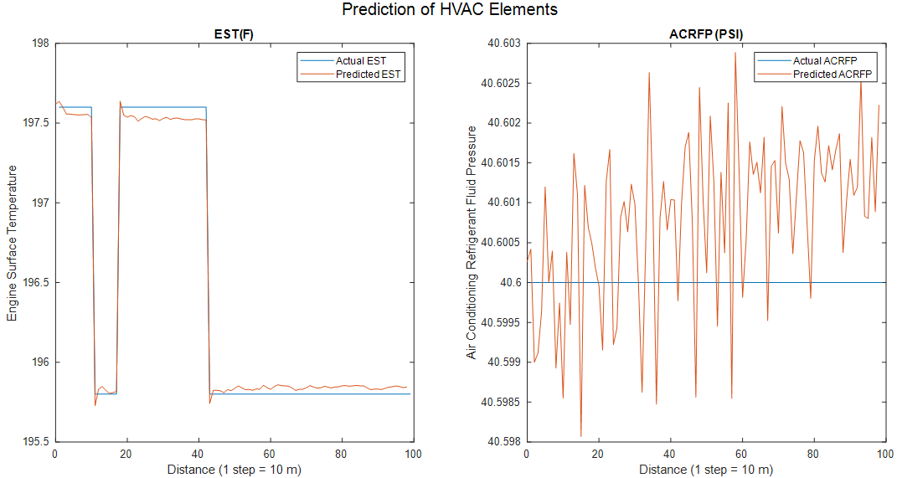
Fig. 9: ACCSSP = 65 MPH, CAT = 74 °F, EAT = 40.1 °F

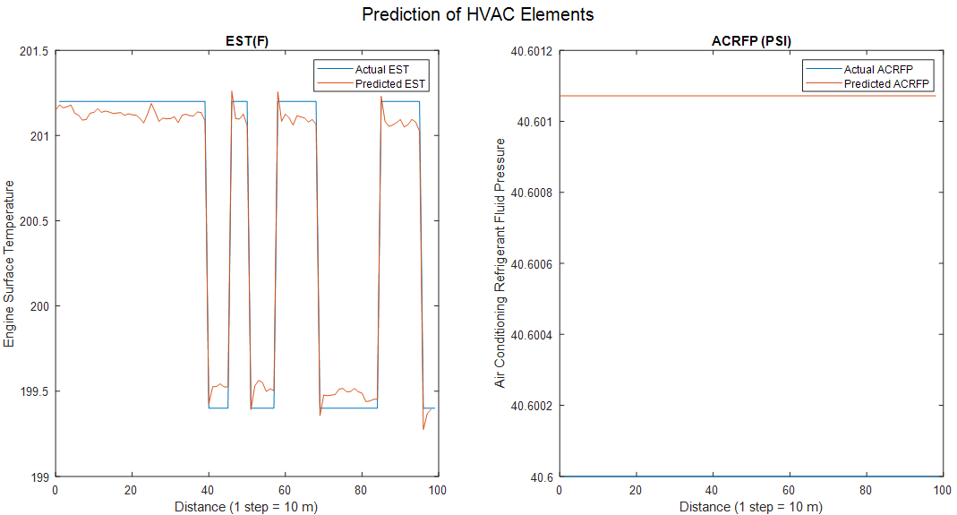
Fig. 10: ACCSSP = 75 MPH, CAT = 72 °F, EAT = 36.9 °F
- Prediction of CAT Profile - Test Cases
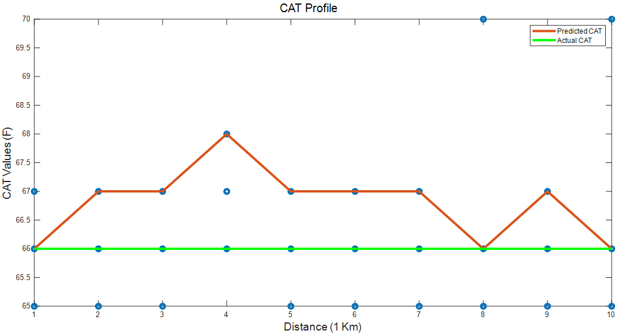
Fig. 11: ACCSSP = 35 MPH; EAT = 78.56 °F; CAT = 66 °F

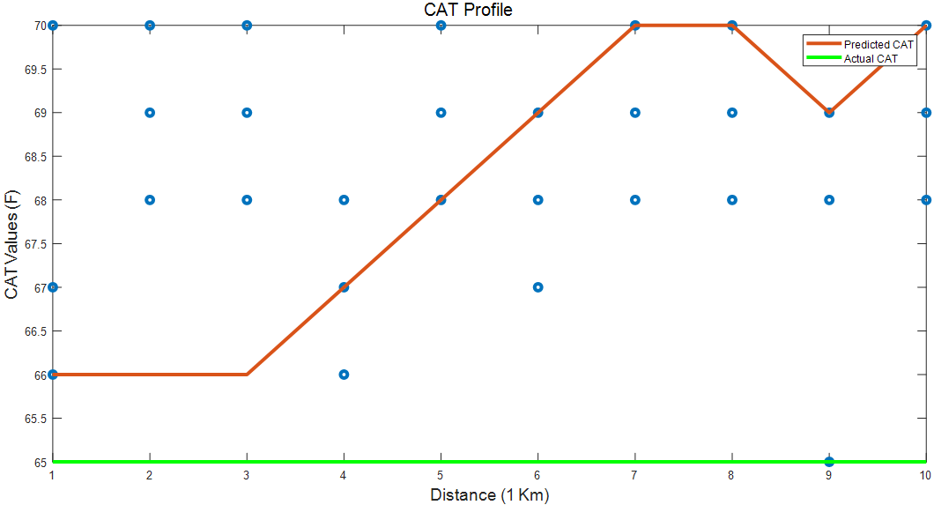
Fig. 12: ACCSSP = 45 MPH; EAT = 71.38 °F; CAT = 65 °F

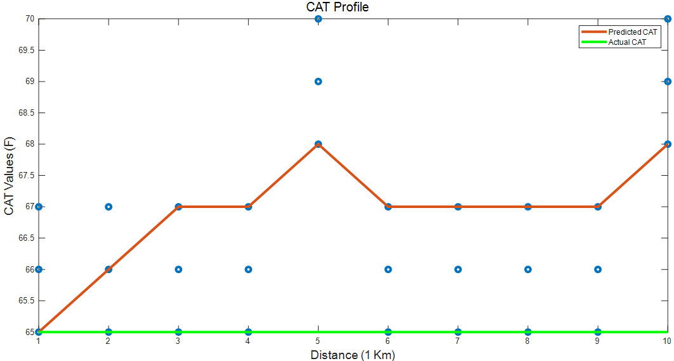
Fig. 14: ACCSSP = 55 MPH; EAT = 70.99 °F; CAT = 65 °F

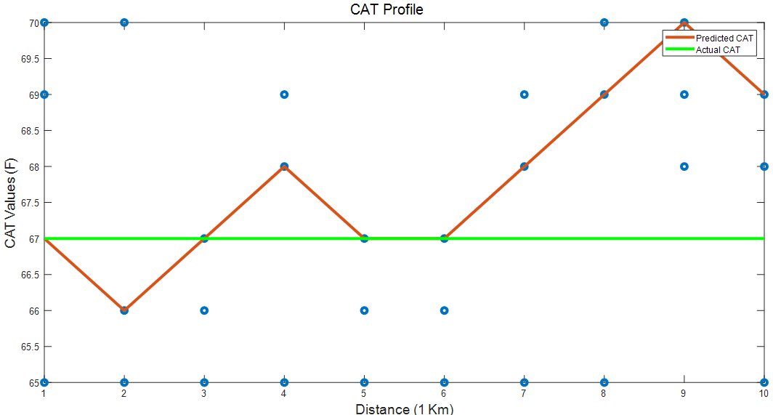
Fig. 15: ACCSSP = 65 MPH; EAT = 81.09 °F; CAT = 67 °F

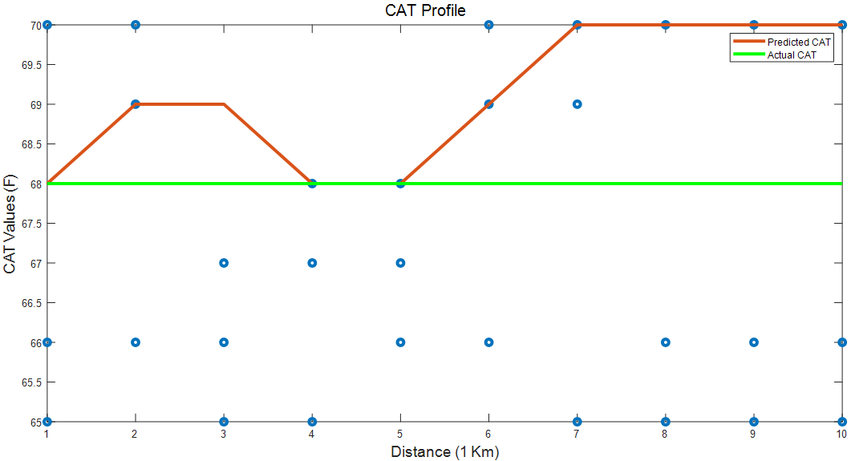
Fig. 16: ACCSSP = 75 MPH; EAT = 84.39 °F; CAT = 68 °F

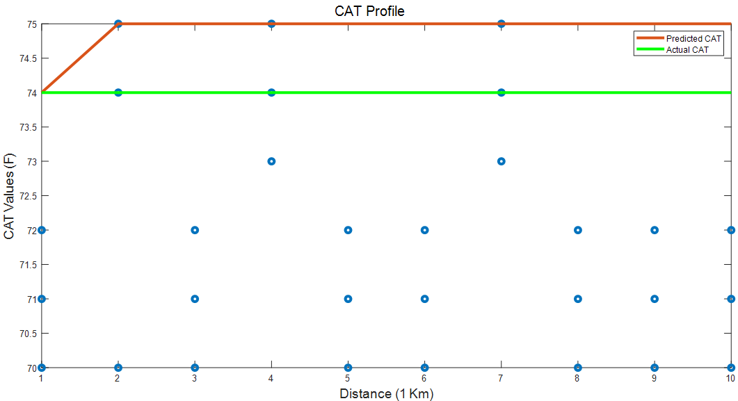
Fig. 17: ACCSSP = 35 MPH; EAT = 36.80 °F; CAT = 74 °F

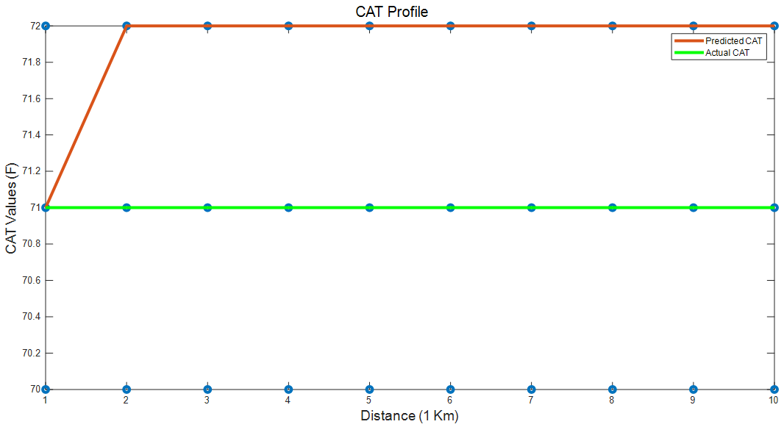
Fig. 18: ACCSSP = 45 MPH; EAT = 33.8 °F; CAT = 71 °F

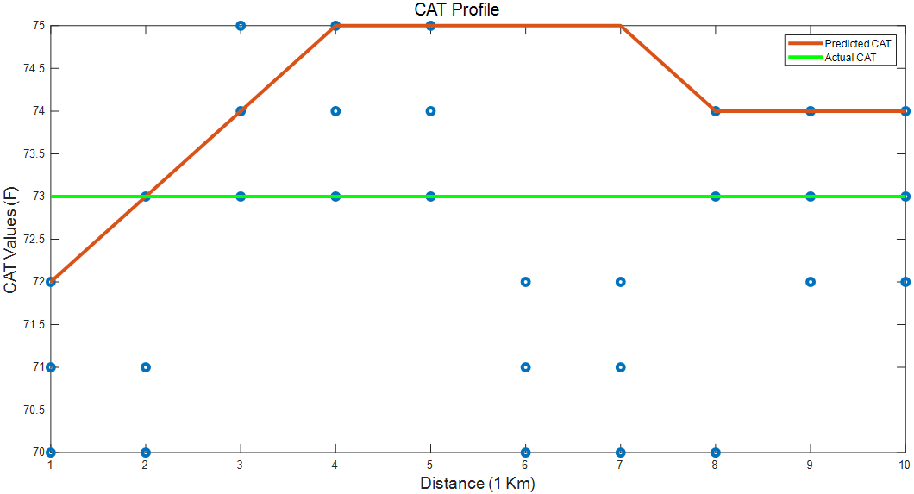
Fig. 19: ACCSSP = 55 MPH; EAT = 33.8 °F; CAT = 73 °F

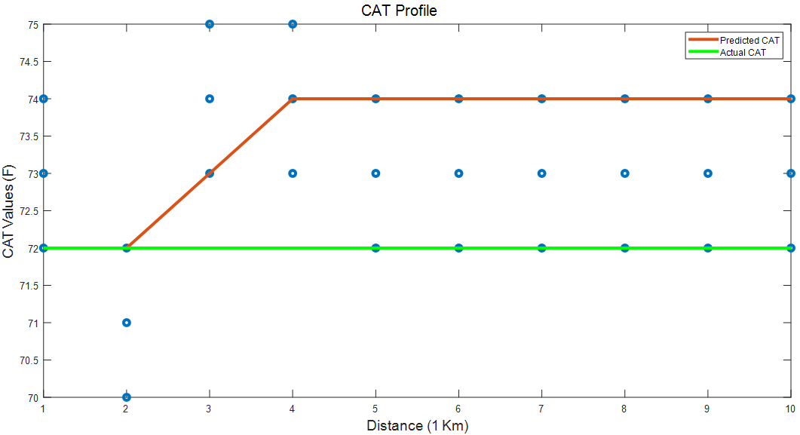
Fig. 20: ACCSSP = 65 MPH; EAT = 37.4 °F; CAT = 72 °F
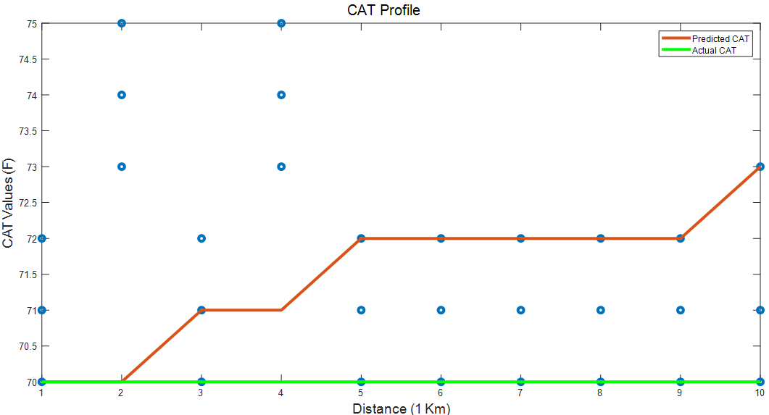
Fig. 21: ACCSSP = 75 MPH; EAT = 37.4 °F; CAT = 70 °F

