Supplementary Information for
Assessment of the Contribution of a Thermodynamic and Mechanical Destabilization of Myosin–Binding Protein C Domain C2 to the Pathomechanism of Hypertrophic Cardiomyopathy–causing Double Mutation MYBPC3^{Δ25bp/D389V}
Frederic V. Schwäbe ¹, Emanuel K. Peter¹, Manuel H. Taft¹ and Dietmar J. Manstein^{1,2,}*
¹ Institute for Biophysical Chemistry, Hannover Medical School, Fritz Hartmann Centre for Medical Research Carl Neuberg Str. 1, D-30625 Hannover, Germany
² Division for Structural Biochemistry, Hannover Medical School, Carl Neuberg Str. 1, D-30625 Hannover, Germany
* Correspondence: manstein.dietmar@mh-hannover.de

Supplementary Methods

CORE-MD II: Correlation Guided Enhanced Molecular Dynamics (MD)-Sampling.

The CORE-MD II technique is an enhanced MD-simulation method that relies in part on partitioning of the entire pathway into short trajectories that we refer to as instances. The CORE-MD II sampling within each instance is accelerated by adaptive path-dependent Metadynamics simulations. The second part of the enhanced sampling MD approach involves kinetic Monte Carlo (kMC) sampling between the different configurations that are accessed during each instance. The combination of the partition of the total simulation into short non-equilibrium simulations and the kMC-sampling facilitates the sampling of rare events of protein-dynamics on long time-scales without definitions of a priori reaction pathways and additional parameters.

For the derivation of the CORE-MD II method a global probability
P(x_{i}(t)) is defined, that can be sub-divided over N time-slices or subtrajectories k with length
τ_{k}, which are described by local probability densities ρ_{k}(x_{i}(t)) :

$$P\left(x_{i}\left(t\right)\right)=\lim_{N→∞}{\prod_{k}^{N}{ρ_{k}}}\left(x_{i}\left(t\right)\right)$$

where x_{i}(t) stands for the coordinate of an atom with the index i.
In the CORE-MD II formalism, we then consider the averaging process of a trajectory dependent quantity X(t),
the partition into small trajectories allows for a faster formation of time-averages than
the determination of the expectation value of the complete trajectory, which is
linked to the time-scale problem of MD-simulations. Therefore, the
expectation value of the complete trajectory can be approximated as :

$$\left\langle X\left(t\right)\right\rangle =X\left(t\right)P\left(x_{i}\left(t\right)\right)≈X\left(t\right)\prod_{k}^{K}{ρ_{k}}\left(x_{i}\left(t\right)\right)$$

which states that the partition of the complete trajectory into a
finite number of K sub-trajectories is approximately sufficient for the
sampling of the expectation value $\left\langle X\left(t\right)\right\rangle$.
We define the number of configurations K by a minimal set of the
number of atoms N_{a} in the system, which guarantees a fast forward propagation.
Within each instance k, the local pathway is described by
the reduced action $L_{i_{k}}\left(t\right)$ :
$$L_{i_{k}}\left(t\right)=\sum_{t<τ_{k}}{p_{i}}\left(t\right)Δx_{i}\left(t\right)$$

where $Δx_{i}\left(t\right)=x_{i}\left(t\right)-\left\langle x_{i}\left(t\right)\right\rangle$, p_{i}(t) is the momentum and t stands for the time.
The local path $L_{i_{k}}\left(t\right)$ is used to define the local autocorrelation
function $C_{i_{k}}\left(t\right)$ :

$C_{i_{k}}\left(t\right)=\frac{1}{τ_{k}}\sum_{t≤τ_{k}}{\frac{\left(L_{i_{k}}\left(t\right)-\left\langle L_{i_{k}}\left(t\right)\right\rangle \right)\left(L_{i_{k}}\left(t'\right)-\left\langle L_{i_{k}}\left(t\right)\right\rangle \right)}{\left|L_{i_{k}}\left(t\right)-\left\langle L_{i_{k}}\left(t\right)\right\rangle \right|\left|L_{i_{k}}\left(t'\right)-\left\langle L_{i_{k}}\left(t\right)\right\rangle \right|}}$

where $L_{i_{k}}\left(t'\right)$ is determined with a frequency equal to 1 ps⁻¹.
and $\left\langle ...\right\rangle$ denotes the time-average.
The CORE-MD II technique samples the system along a correlation dependent probability between
states with an index k using a kinetic Monte Carlo (kMC) algorithm.
We limit the number of kMC configurations by a minimal set of the number of atoms N_{a} in the system, which guarantees a fast forward propagation within a small window of three possible selections in each kMC-step.
With a frequency of τ_{k}, we perform a kMC-step and express a rate r_{k} for each instance k.
We then calculate the cumulative rates and apply the kinetic Monte Carlo algorithm,
for the selection of a configuration k with which a configuration is used for the subsequent trajectory instance.
The kMC sampling guides the trajectory between equilibrium configurations of the system, where
each instance k resembles a state that resides close to the equilibrium state.
We continue with the description of the second component of the CORE-MD II [1] algorithm that applies
the local biases. (1) At each initialization of a new trajectory-fragment, the velocities are selected from
a random distribution. (2) In order to accelerate the sampling within each instance, we apply a
history dependent bias potential that is related to Metadynamics [2], while the history dependency is limited by the time-scale of each instance. We add the Gaussians to the history dependent potential
using the Well-tempered Metadynamics technique through a normalization of the added Gaussians by the
factor. The corresponding bias is added throughout the simulation.
Finally, we accelerate the sampling within each instance and apply the statistical
bias as described in our recent work on the CORE-MD algorithm. We implemented the correlation dependent bias by a factorization with the variable $λ_{i_{k}}\left(t\right)$ with which we scale the
gradient of all atoms in the system. This statistical bias enhances the decay of the correlation
function and accelerates the access of new states by the system.

References
1. Harper, A.R.; Goel, A.; Grace, C.; Thomson, K.L.; Petersen, S.E.; Xu, X.; Waring, A.; Ormondroyd, E.; Kramer, C.M.; Ho, C.Y.; et al. Common Genetic Variants and Modifiable Risk Factors Underpin Hypertrophic Cardiomyopathy Susceptibility and Expressivity. Nat Genet 2021, 53, 135–142, doi:10.1038/s41588-020-00764-0.
2. Laio, A.; Parrinello, M. Escaping Free-Energy Minima. PNAS 2002, 99, 12562–12566, doi:10.1073/pnas.202427399.

Supplementary Figures
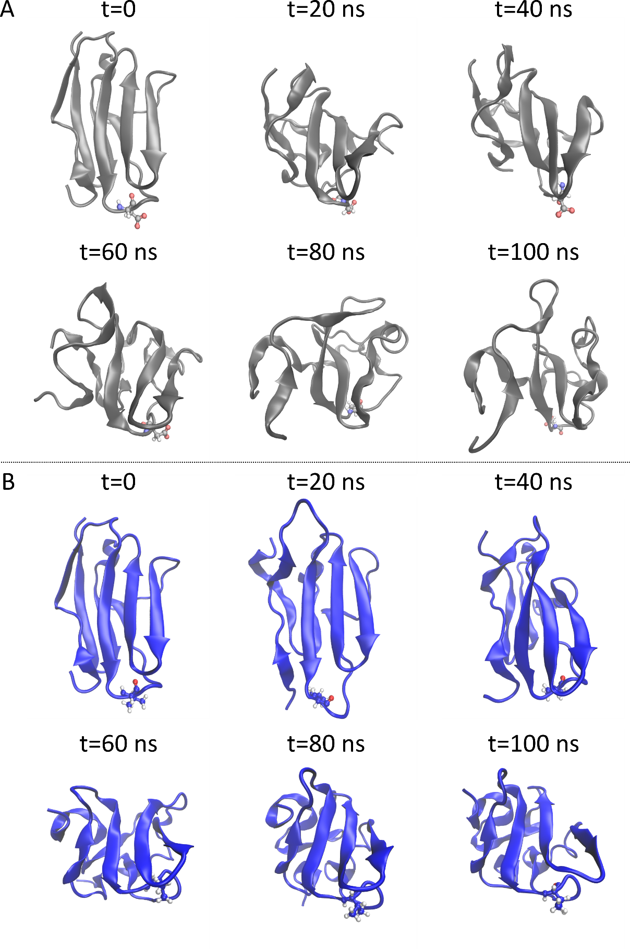
Figure S1. Sample conformers obtained from a 100 ns CORE-MD II simulation of MyBPC C2 wt (A) and D389V (B) domain. Wt structures are shown in grey and D389V in blue. Asp389 and Val389 are shown as CPK representations. Structures of time points from 0-100 ns are shown in increments of 20 ns.
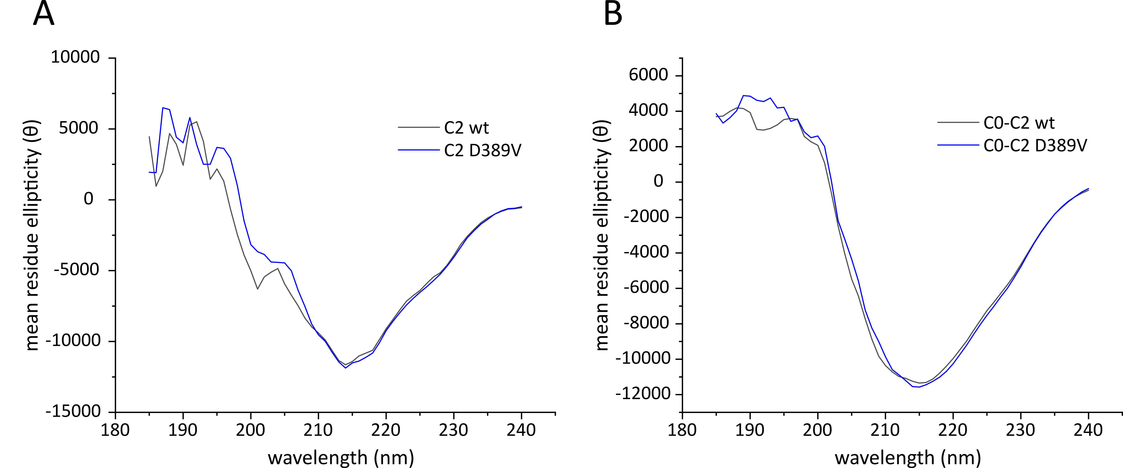
Figure S2. Circular Dichroism spectra of MyBPC C2 and C0-C2 domains. Data were processed using DichroWeb server. Mean residue ellipticity is plotted against the wavelength for (A) C2 wt and D389V and (B) C0-C2 wt and D389V.
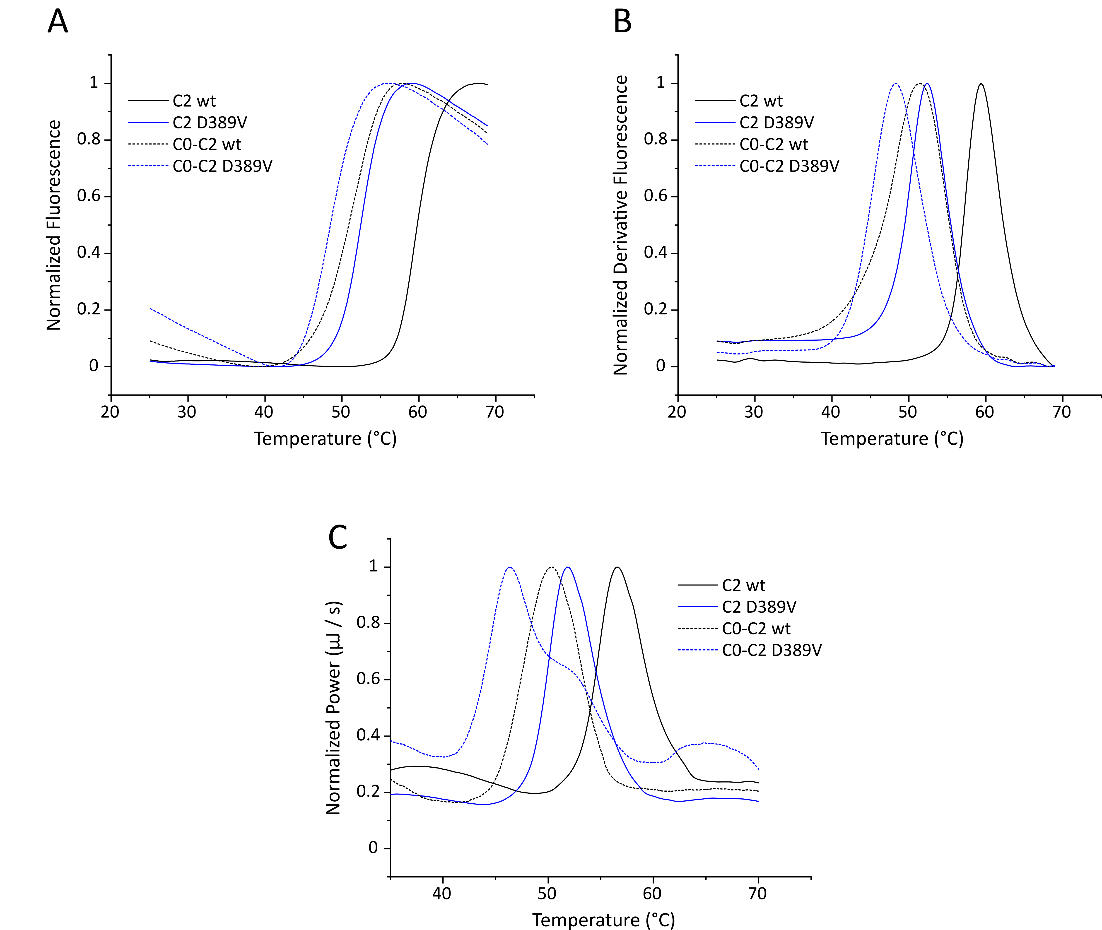
Figure S3. Analysis of thermal stability of N-terminal MyBPC constructs. C2 is shown as solid lines, C0-C2 as dashed lines; wt protein is displayed as black and D389V as blue. Representative (A) normalized and (B) normalized derivative fluorescence traces resulting from a thermal shift assay (TSA). Protein melting temperature (T_{m}) was determined as the temperature value at the maximum of the first derivative. (C) Representative normalized power traces of a differential scanning calorimetry experiment (DSC). T_{m} corresponds to the maximum of each trace.
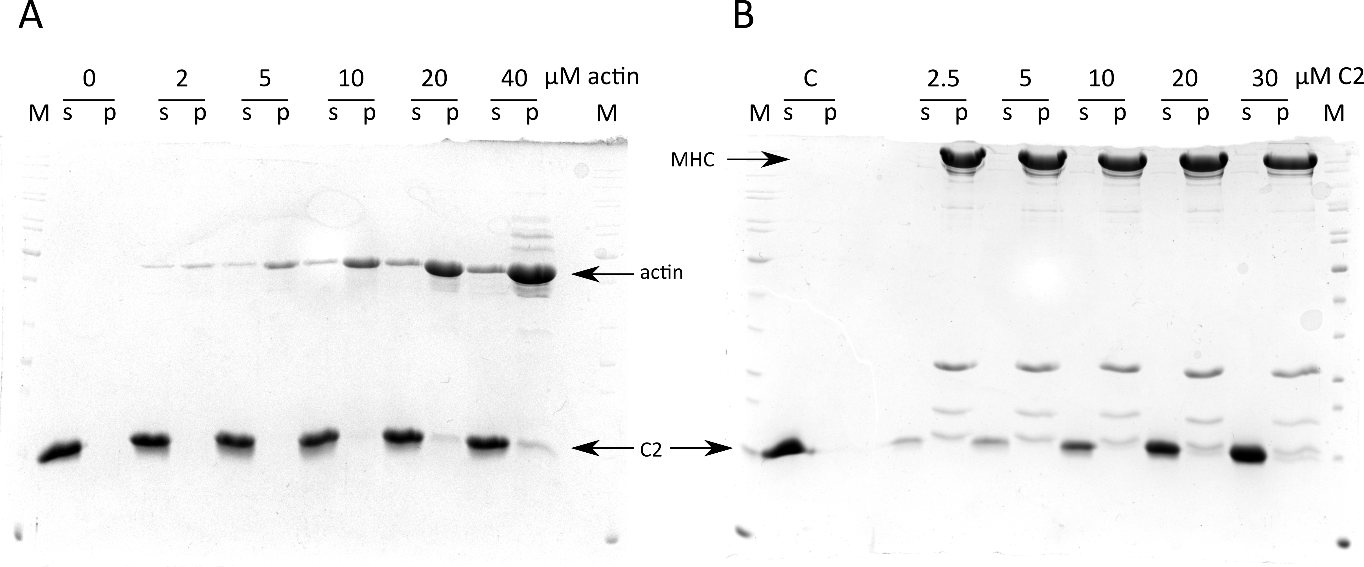
Figure S4. Co-sedimentation assay of MyBPC C2 with F-actin and β-cardiac myosin. (A) Representative SDS gel of a high-speed co-sedimentation assay with 0 – 40 µM actin and 30 µM MyBPC C2. M: PageRuler Unstained Protein Ladder, 0 – 40: total concentration of actin in µM, s: supernatant, p: pellet. Densitometric analysis yielded <2% MyBPC C2 in the pellet fraction with the highest actin concentration (B) Representative SDS gel of a high-speed co-sedimentation assay with 2.5 µM β-cardiac myosin and 2.5-30 µM MyBPC C2. Densitometric analysis yielded <2% MyBPC C2 in the pellet fraction with the highest C2 concentration. M: PageRuler Unstained Protein Ladder, 0-30: total concentration of C2 in µM, s: supernatant, p: pellet, MHC: myosin heavy chain, s: supernatant, p: pellet, C: 30 µM C2 without myosin.
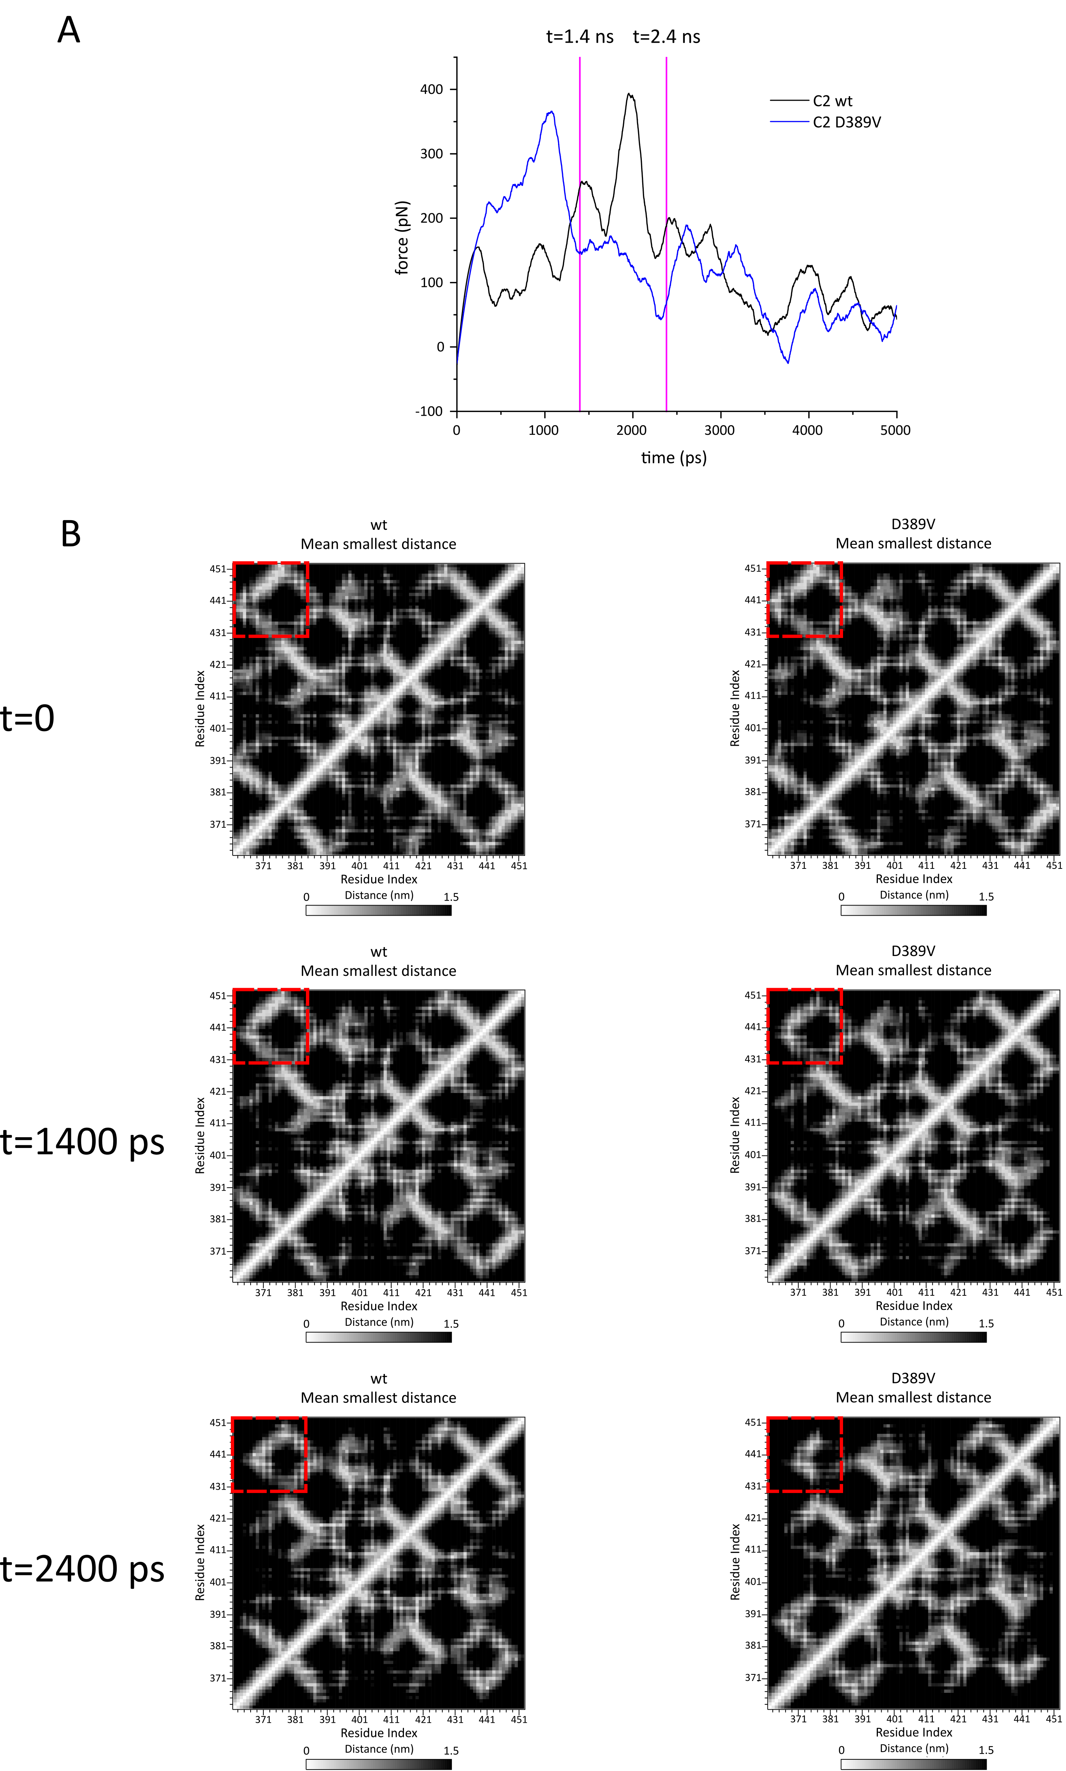
Figure S5. Constant Velocity Steered Molecular Dynamics (cvSMD) simulation of MyBPC C2 domain unfolding. The SMD atom was pulled at a velocity of 0.01 Å/ps and the spring constant was set to 7 kcal/mol/Å. (A) Sample traces for an unfolding simulation of each wt and D389V MyBPC C2 domain. The force acting on the SMD atom is plotted against the time of the simulation. Data were smoothened using Savitzky-Golay filter to compensate for the noise created by the spring acting on the fixed atom. (B) Mean smallest distance maps of time points 0, 1400 and 2400 ps in the unfolding experiments displayed in (A). The time-averaged minimum distance of each residue to every other residue is plotted in heat maps with white indicating the smallest and black the largest distance ranging from 0–1.5 nm. This map reveals differences in the global conformational space of C2 wt and D389V. Dashed boxes indicate an N-to-C-terminal β-sheet contact of C2 wt that is destabilized in C2 D389V.

