SUPPORTING INFORMATION

Distinguishing Between Isobaric Ions Using Microdroplet Hydrogen-Deuterium Exchange Mass Spectrometry
Xiaowei Song^{1,2}, Jia Li², Mohammad Mofidfar¹, Richard N. Zare^{1*}
- Department of Chemistry, Stanford University, Stanford, CA, USA. 94305
- Department of Chemistry, Fudan University, Shanghai, China. 200438

Correspondence
Richard N. Zare: rnz@stanford.edu

Table of Contents
Figure/Table | Legend | Pages
Figure S1 | CID-MS/MS spectra of codeine, and hydrocodone. | S2
Figure S2 | CID-MS/MS spectra of 6-acetyl morphine, and naloxona. | S3
Figure S3 | CID-MS/MS spectra of morphine, and norcodeine. | S4
Table S1 | List of isobaric ions that were frequently detected in saliva or serum and successfully distinguished by HDX-CPSI-MS. | S5
Table S2 | List of isobaric ions that were frequently detected in biological fluids and successfully distinguished by HDX-CPSI-MS. | S6

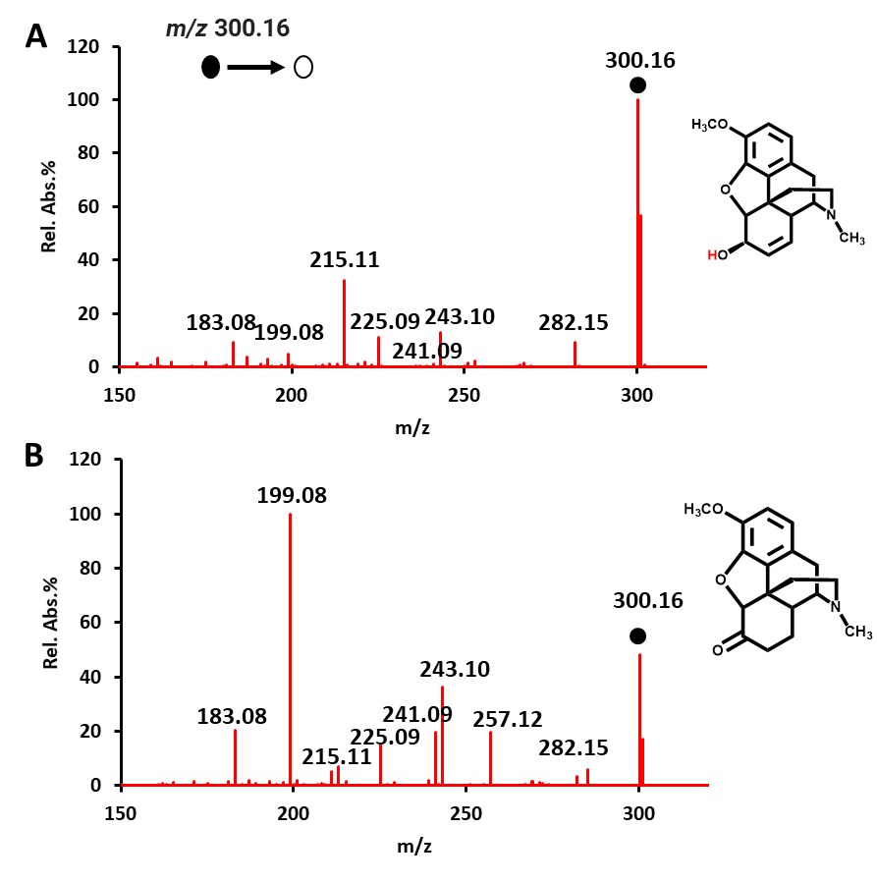
Figure S1. CID-MS/MS spectra of (A) codeine and (B) hydrocodone. The black dot indicates the precursor ion.

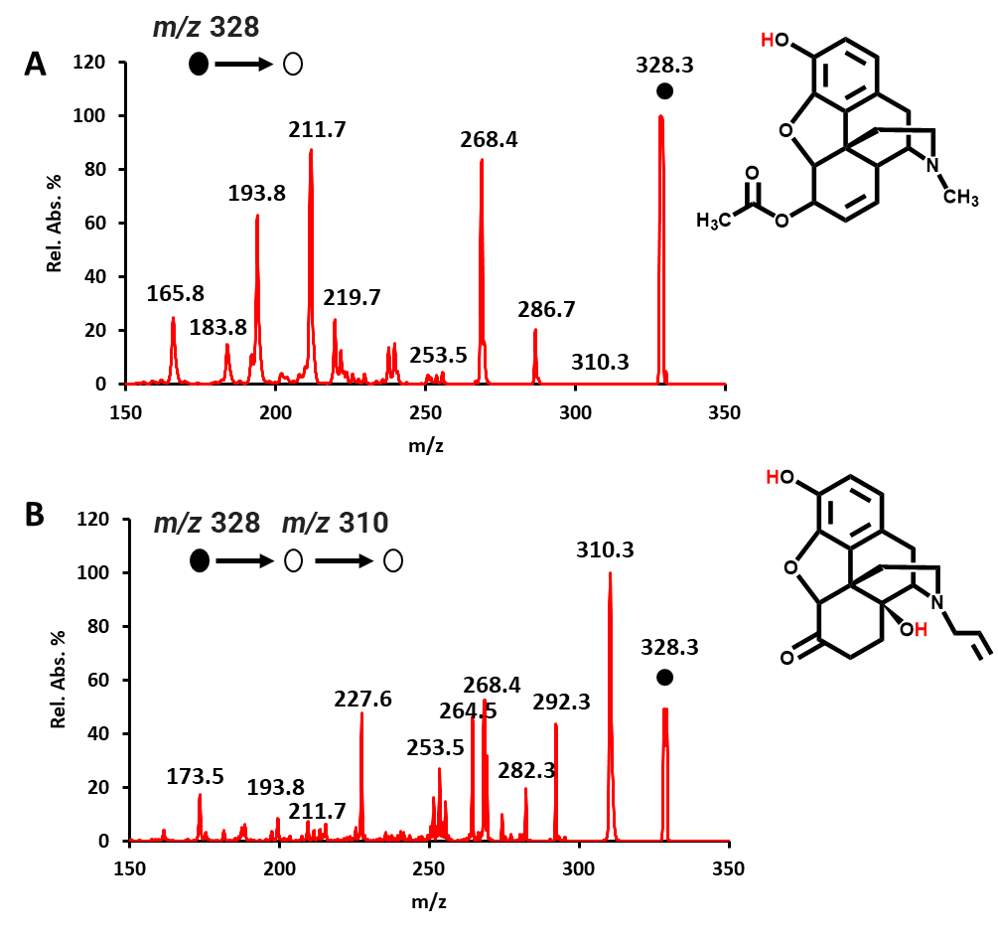
Figure S2. CID-MS/MS spectra of (A) 6-acetyl morphine and (B) naloxone. The black dot indicates the precursor ion.

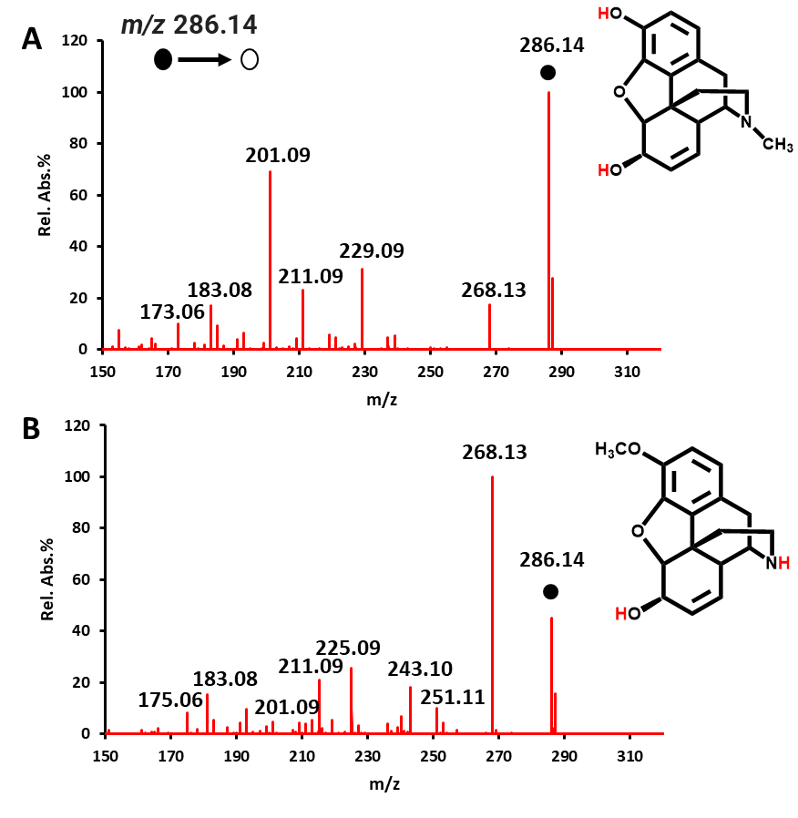
Figure S3. CID-MS/MS spectra of (A) morphine and (B) norcodeine. The black dot indicates the precursor ion.

Table S1. Isobaric ions that were frequently detected in saliva or serum and successfully distinguished by HDX-CPSI-MS.
No | Exact m/z | Adduct Ions | Formulae | Metabolites | Number of Exchangeable  proton sites | Base  peaks
1 | 118.0862 | [M+H]⁺ | C₅H₁₁NO₂ | Betaine | 1 | D₀
 |  |  |  | 5-Aminopentanoic acid | 3 | D₁
 |  |  |  | Valine | 3 | D₀
2 | 141.0789 | [M+K]⁺ | C₅H₁₄N₂ | Cadaverine | 4 | D₂
 |  |  |  | N-methyl putrescine | 3 | D₂
3 | 146.0459 | [M-H]⁻ | C₅H₉NO₄ | Glutamate | 3 | D2
 |  |  |  | O-acetyl serine | 2 | D₀
 |  |  |  | N-acetyl serine | 2 | D₁
4 | 280.0904 | [M+Na]⁺ | C₁₀H₁₅N₃O₅ | 5-Methylcytidine | 5 | D₂
 |  |  |  | 3-methylcytidine | 4 | D₂
 | 280.0920 | [M+H]⁺ | C₈H₂₀NO₆P | glycerophosphocholine | 3 | D₂
5 | 112.0369 | [M+Na]⁺ | C₃H₇NO₂ | Alanine | 3 | D₁
 |  |  |  | Sarcosine | 2 | D₁
6 | 126.0520 | [M+Na]⁺ | C₄H₉NO₂ | aminobutyric acid | 3 | D₁
 |  |  |  | N, N-dimethylglycine | 1 | D₀
7 | 137.0706 | [M+H]⁺ | C₇H₈N₂O | 2-aminobenzamide | 4 | D₁
 |  |  |  | N-methylnicotinamide | 1 | D₀

Table S2. The relative intensities in HDX patterns acquired from samples of glucose (G) and inositol (I) at different molar ratios.
m/z | G:I Simulated HDX Patterns |  |  | G:I Observed HDX Patterns
 | 1:1 | 3:1 | 1:3 | 1:1 | 3:1 | 1:3
203.05 | 46 | 55 | 33 | 41 | 55 | 38
204.06 | 73 | 82 | 57 | 72 | 78 | 63
205.07 | 100 | 100 | 91 | 100 | 100 | 95
206.08 | 95 | 83 | 100 | 87 | 91 | 100
207.09 | 64 | 49 | 74 | 52 | 51 | 79
208.10 | 28 | 19 | 35 | 17 | 18 | 40
209.11 | 4 | 2 | 6 | 5 | 6 | 7

