Supplementary material
The pseudo-symmetric N-benzyl hydroxyethylamine core in a new series of heteroarylcarboxyamide HIV-1 Pr inhibitors: synthesis, molecular modeling and biological evaluation.
ª

Table of content

Copies of ¹H and ¹³C NMR spectra of compounds 5c and 6c S2-S3
Copies of ¹H and ¹³C NMR spectra of compounds 7a-c, 8a-c, 9a-c S4-S12
Inhibition assays S13
Supplementary figures S1-S3 S14-S16

Recombinant HIV-Pr Inhibition Assay.
Solution A:
10 μL of a substrate stock solution in DMSO (10 mg/mL, 10.6 mM) were diluted in 1.99 mL 100 mM MES buffer, pH 5.5, containing 400 mMNaCl,1 mM EDTA,1 mM DTT, and 1 mg/mL BSA, to a final concentration of 53 mM.
Solution B:10 μL of a protease stock solution(0.4 mg/mL)in 10 mM
sodium phosphate buffer, pH = 6.5, containing 1mM EDTA, 10% glycerol, 0.05% mercaptoethanol, 50mM NaCl, were diluted 100 times with the MES dilution buffer, pH 5.5,
to a final concentration of 0.004 mg/mL.
Assay:
114 μL of solution A, 11 μL of solution B and 75 μL of the MES dilution buffer were pre-incubated in a cuvette, at 25 °C. After 1 min, 2 μL of the inhibitor in DMSO or MES were added and the fluorence was recorded at 325 nm excitation and 420 nm emission. Final concentrations in the assay were 1.2 nM protease, 30 μM substrate and 0.5 nM –5 mM inhibitor. IC50 were obtained by measuring the relative residual enzyme activity (ratio of the increase of fluorescence velocities before and after the addition of inhibitor) and by fitting the residual activity vs. inhibitor concentration semilog plots to a tetraparametric logistic function (Sigma plot 2001, SPSS Inc.). The experiments were run in triplicate.

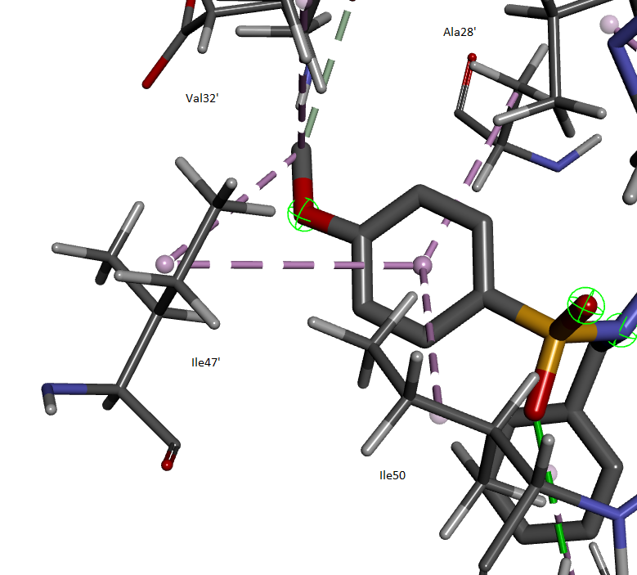
Supplementary figure S1: interactions of the 4-methoxyphenyl group at P2’ in the model structure of the complex of compound 9b with the protease.

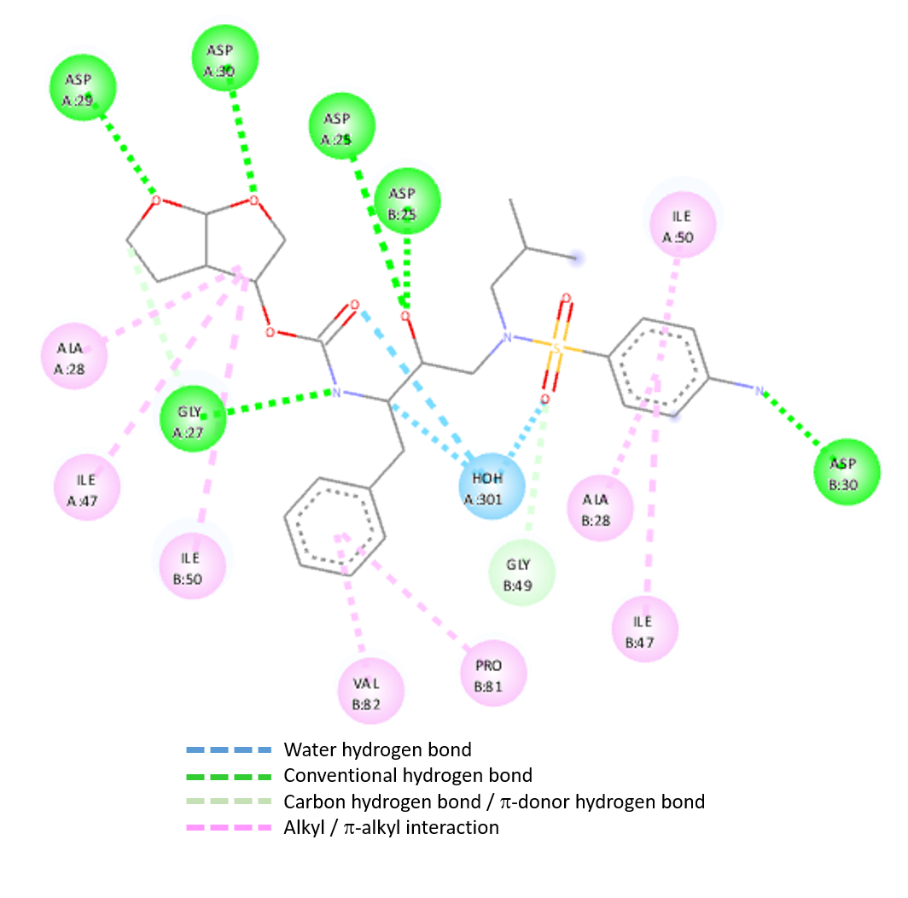

Supplementary figure S2: map of the interactions of Darunavir with the protease.

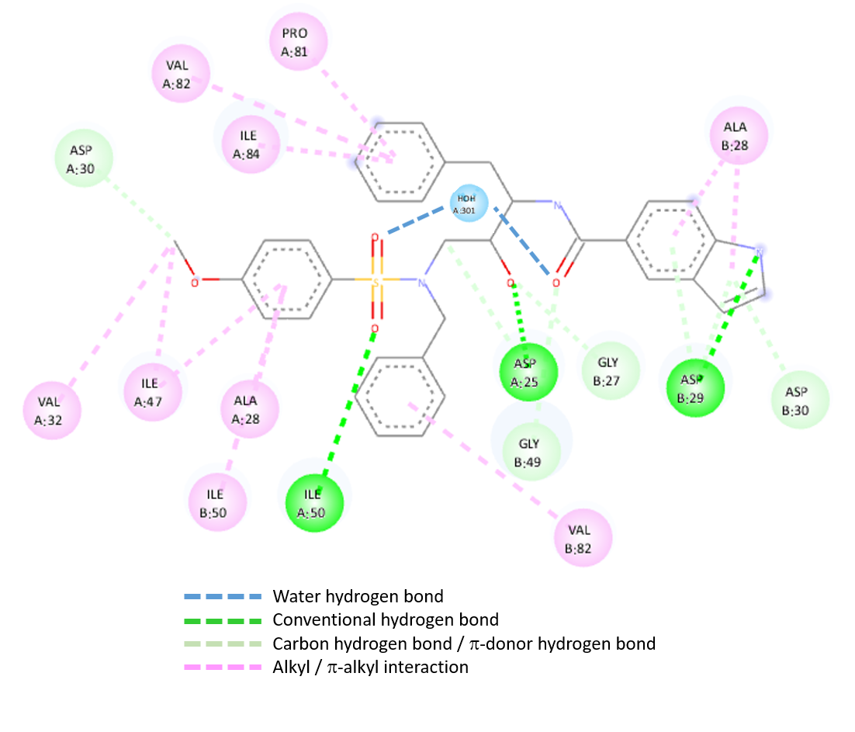
Supplementary figure S3: map of the interactions of compound 9b with the protease.

