Supporting Information
Computational Insights into the Binding Mechanism of OxyS sRNA with Chaperone Protein Hfq
Mengxin Li^{1#}, Yalong Cong^{1#}, Yifei Qi^{1,2} and John Z.H., Zhang^{1,2,3,4*}
¹Shanghai Engineering Research Center of Molecular Therapeutics and New Drug Development, Shanghai Key Laboratory of Green Chemistry & Chemical Process, School of Chemistry and Molecular Engineering, East China Normal University at Shanghai, 200062, China
²Shenzhen Institute of Synthetic Biology, Shenzhen Institutes of Advanced Technology, Chinese Academy of Sciences, Shenzhen, People’s Republic of China
³NYU-ECNU Center for Computational Chemistry at NYU Shanghai, Shanghai 200062, China
⁴Department of Chemistry, New York University, NY, NY10003, USA
Correspondence to: John.zhang@nyu.edu

#Contributed equally to this work.

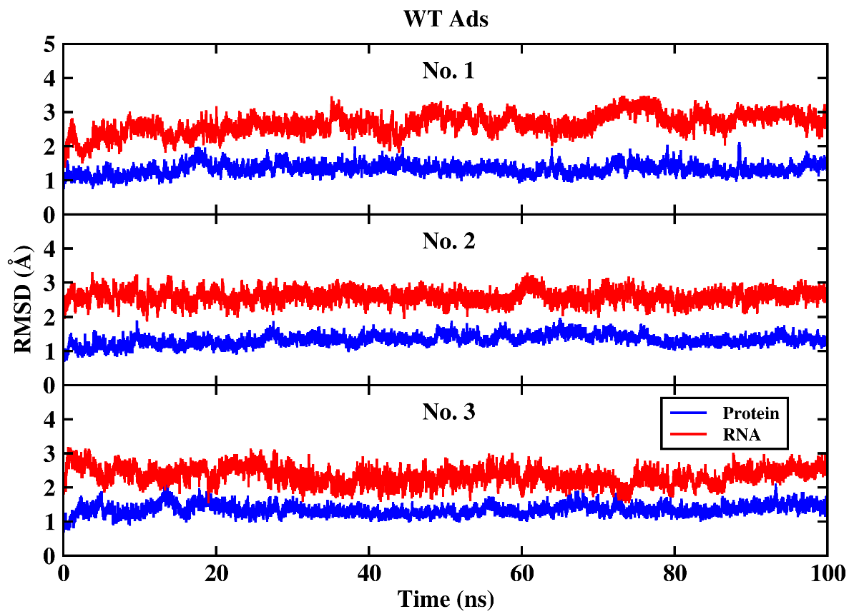
Figure S1 RMSD of Ads system for protein and RNA under three simulations.
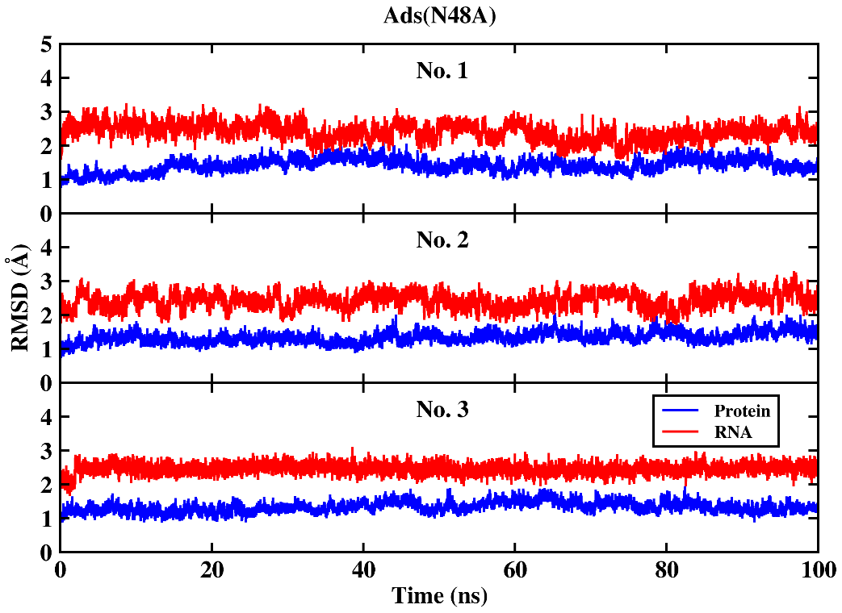
Figure S2 RMSD of Ads (N48A) system for protein and RNA under three simulations.
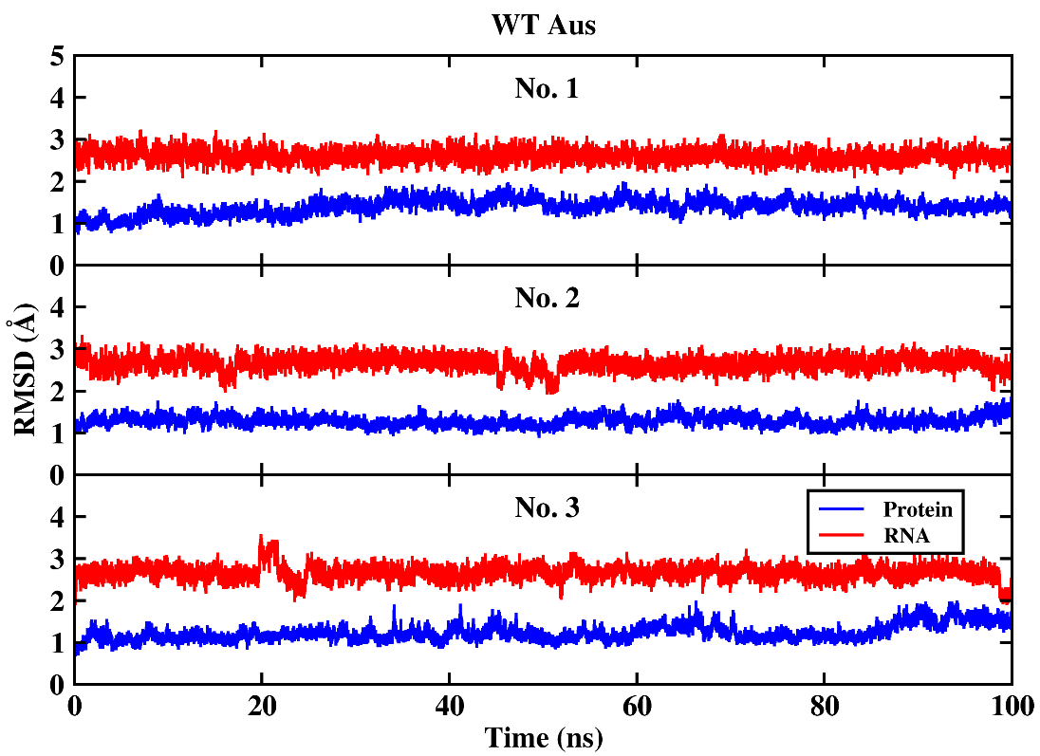
Figure S3 RMSD of Aus system for protein and RNA under three simulations.
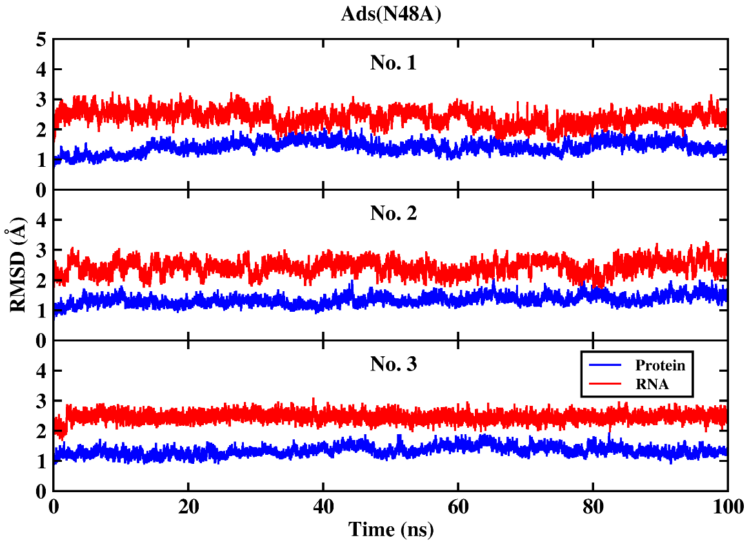
Figure S4 RMSD of Aus (N48A) system for protein and RNA under three simulations.
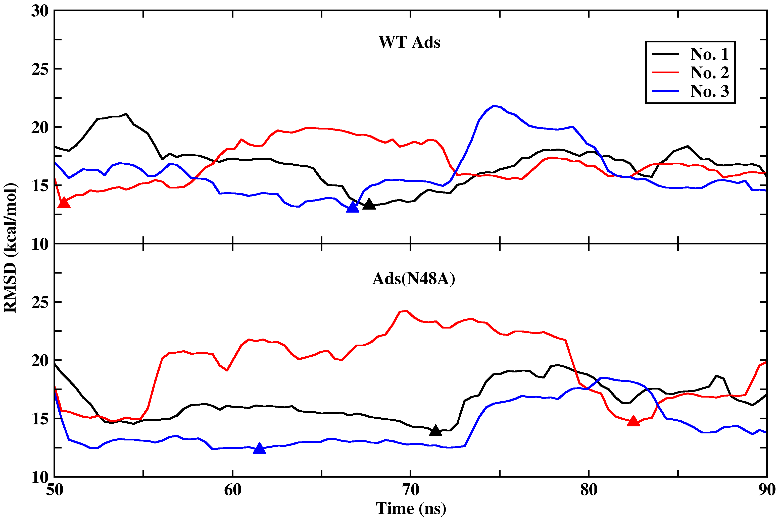
Figure S5 The RMSD of gas phase interaction energy of any continuous 10 ns snapshots during the last 50 ns for Ads systems. The abscissa represents the start time of continuous 10 ns samples. The samples of continuous 10 ns with the smallest RMSD are marked triangle.
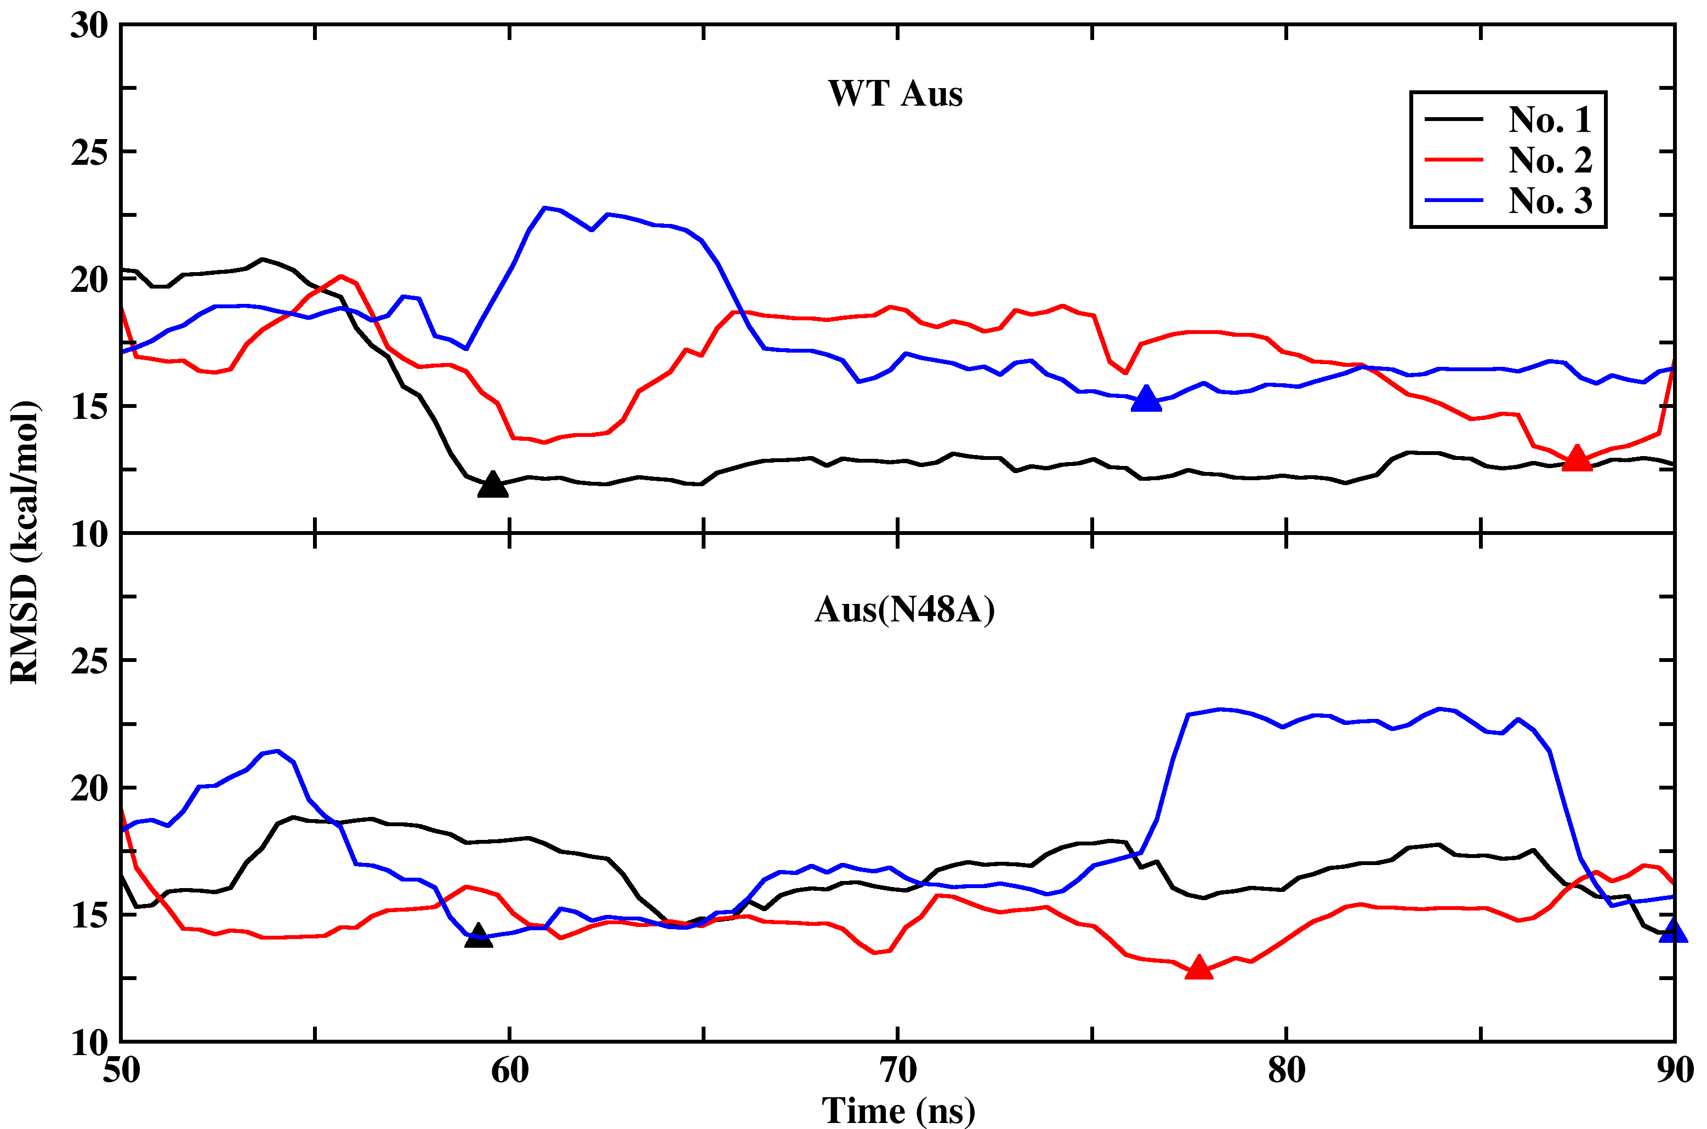
Figure S6 The RMSD of gas phase interaction energy of any continuous 10 ns snapshots during the last 50 ns simulation for Aus systems. The abscissa represents the start time of continuous 10 ns samples. The samples of continuous 10 ns with the smallest RMSD are marked triangle.
Figure S7 Time-averaged interaction entropy of continuous 10 ns with lowest energy fluctuation of for Ads systems under three simulations.
Figure S8 Time-averaged interaction entropy of continuous 10 ns with lowest energy fluctuation of for Aus systems under three simulations.

