Supplementary table S1:

S.N. | Primers | Direction | Sequence | Amplicon Length
1 | Krupple homolog (Kr-h1)-long | Forward | TTGCATCAGGTTGCCCACTA | 668
 |  | Reverse | CACCGTTTTCTTGGAGGGAGA
2 | Kr-h1–T7 nested | Forward | TAATACGACTCACTATAGGGAGAAAAACTCATTCAGACTCATCGGT | 440
 |  | Reverse | TAATACGACTCACTATAGGGAGATACTCCCTCTGTCTTTCTTCTTCG
3 | pGEMT–T7 nested | Forward | TAATACGACTCACTATAGGGAGAAAGATACCAGGCGTTTCCCC | 433
 |  | Reverse | TAATACGACTCACTATAGGGAGAGCCGGATCAAGAGCTACCAA
4 | Kr-h1 RT-PCR | Forward | TGAAGGTACATACCCGCACG | 109
 |  | Reverse | TAGTGGGCAACCTGATGCAA
5 | Elongation factor (Ef-1α)-RT-PCR | Forward | CGTTTACCGCTTCAGGACGT | 91
 |  | Reverse | GCATGCCTGGTTTCAGAATA

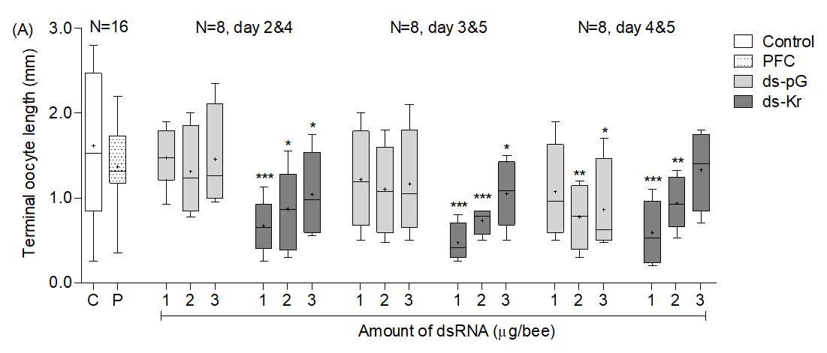
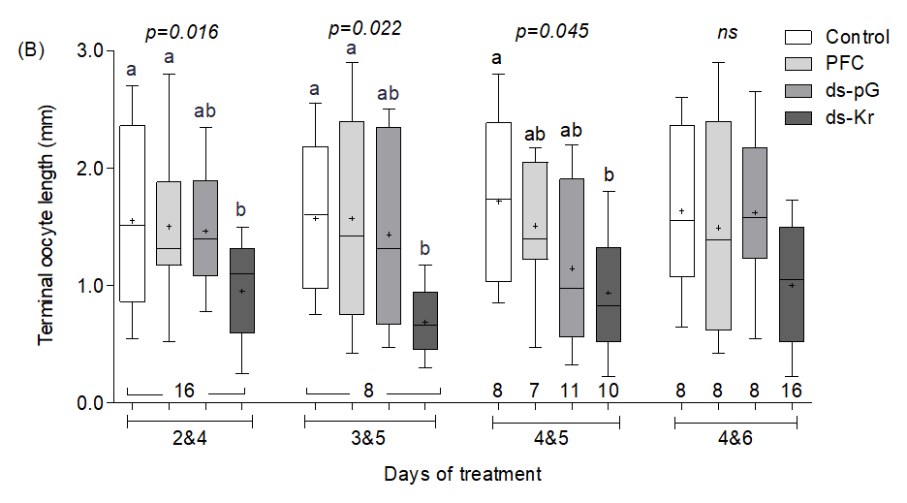
Supplementary Figure S2. The influence of the days of dsRNA injection on ovarian activity. (A) A summary of experiments in which we tested different amounts of dsRNA (1-3µg, as shown on the X axis). We loaded plasmid (ds-pG) or Bombus terrestris Kr-h1 dsRNA onto 0.1pmol PFCnp. Ovarian activity was assessed on day 7 of the experiment. We compared each treatment group with the control group (C) using Unpaired t test with Welch's correction for multiple comparisons. * - α<0.05, ** - α<0.001, *** - α<0.0001. (B) A summary of experiments in which we injected 1 µg control or Kr-h1 dsRNA loaded to 0.1µg/µl PFCnp. Sample sizes is shown below each box plot. Treatments marked with different small letters are statistically different in a Kruskal-Wallis H Test, followed by Dunn’s post-hoc analysis comparing each combination of injection days. For additional details, see Supplementary Figure S1.

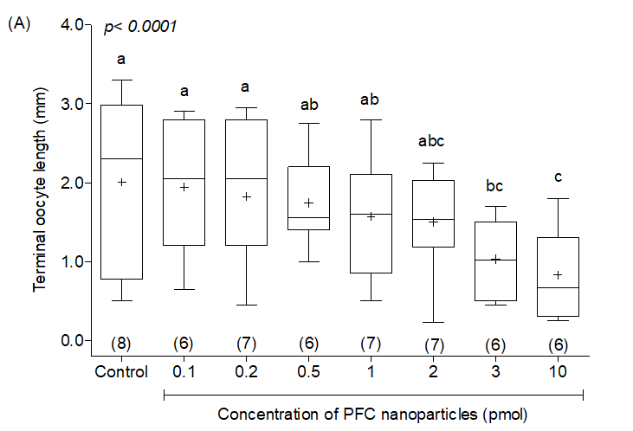
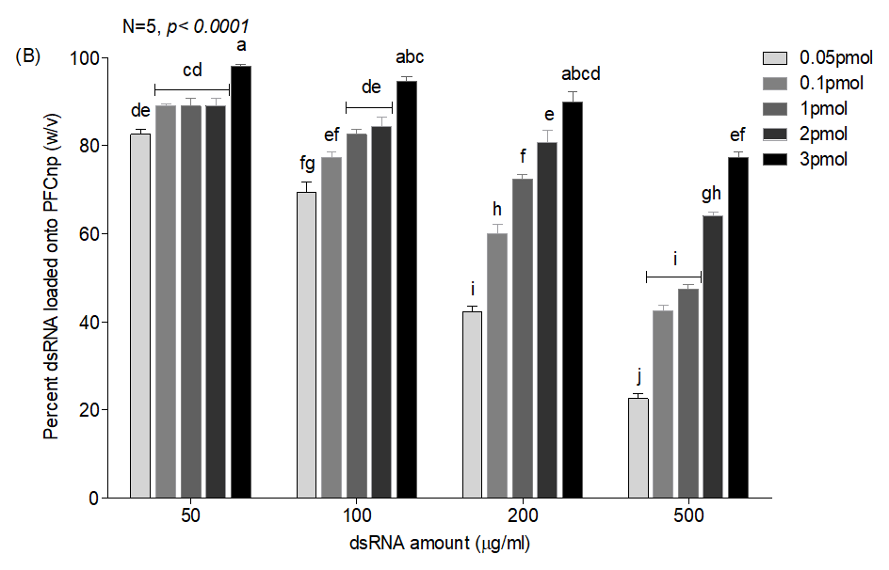
Supplementary Figure S1: The influence of PFCnp concentration on ovarian activity and on dsRNA binding efficiency. (A) Ovarian activity and survival. The x-axis shows increasing concentration of PFCnp (not loaded with RNA) injected to bees. The number of bees surviving, out of a total of 8 injected bees, is shown in parentheses. Treatments with different letters are statistically different in a Kruskal-Wallis test followed by pairwise Dunn posthoc test. The box plots show ovarian activity at the age of 7 days. Each box plot shows the median (—), mean (+), and the box frame spans over the first to the third quartile. The whiskers depict the 5th/95th percentile; outliers are depicted with black dots. (B) dsRNA loading efficiency. The darkness of the bar corresponds to the amount of PFCnp onto which the dsRNA was loaded. The bars and whiskers depict mean ± SE, N=5. Further details as in Figure 1. Bars marked with different small letters are significantly different in Two-way ANOVA and Bonferroni posthoc tests using log 10 transformed data.

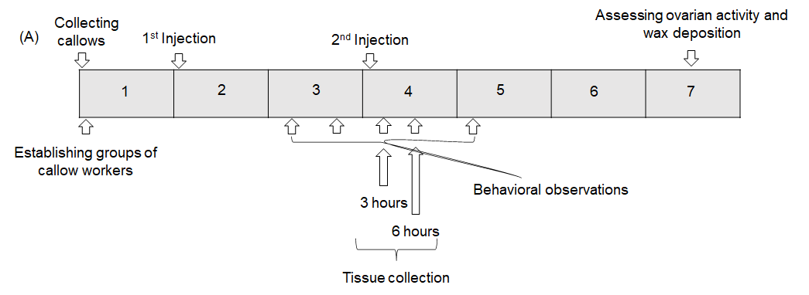
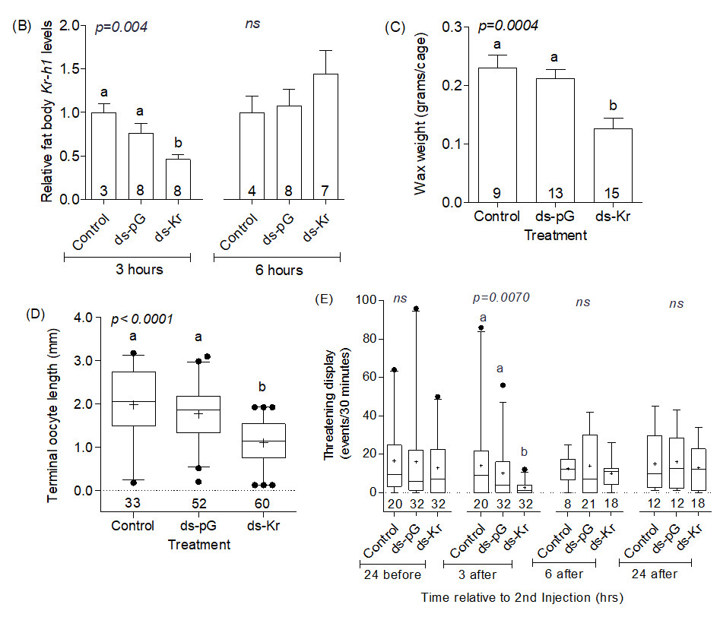
Supplementary figure S3: The influence of naked Kr-h1 dsRNA injection on JH-regulated physiology and behavior. (A) general outline of the experiment. (B) Fat body Kr-h1 mRNA levels. (C) Wax weight at the end of experiment. (D) Ovarian activity at 7 days of age. The vertical bars in panels B-D depict mean ± SE. (E) The amounts of threatening displays performed before and after the 2nd dsRNA injections. The details of the box plots in panel E are as described in Supplementary Figure S1. Treatments marked with different small letters are statistically different in either one-way ANOVA followed by Tukey post-hoc analysis for parametric data (B & C), or Kruskal Wallis H tests followed by Dunn’s post-hoc analysis for non-parametric data (D & E). Numbers below the bars depict the sample size for each group; the sample size in C is the number of cages from which wax amount was measured.

Supplementary table S2: Summary of the three-way ANOVA analysis of the figure 2 B & C.

 | Variations | F | DF | P value
Ovarian maturation | Treatment | 6.689 | 3 | <0.001
 | Trial | 0.856 | 1 | 0.356
 | DMF vs. JH | 10.266 | 1 | 0.002
 | Treatment x Trial | 0.814 | 3 | 0.488
 | Treatment x DMF vs JH | 0.099 | 3 | 0.960
 | Trial x DMF vs JH | 2.257 | 1 | 0.135
 | Treatment x Trial x DMF vs JH | 0.343 | 3 | p = 0.794
Wax secretion | Treatment | 16.646 | 3 | <0.001
 | Trial | 2.692 | 1 | 0.111
 | DMF vs. JH | 2.040 | 1 | 0.164
 | Treatment x Trial | 1.289 | 3 | 0.296
 | Treatment x DMF vs JH | 0.282 | 3 | 0.838
 | Trial x DMF vs JH | 0.003 | 1 | 0.953
 | Treatment x Trial x DMF vs JH | 0.737 | 3 | p = 0.538

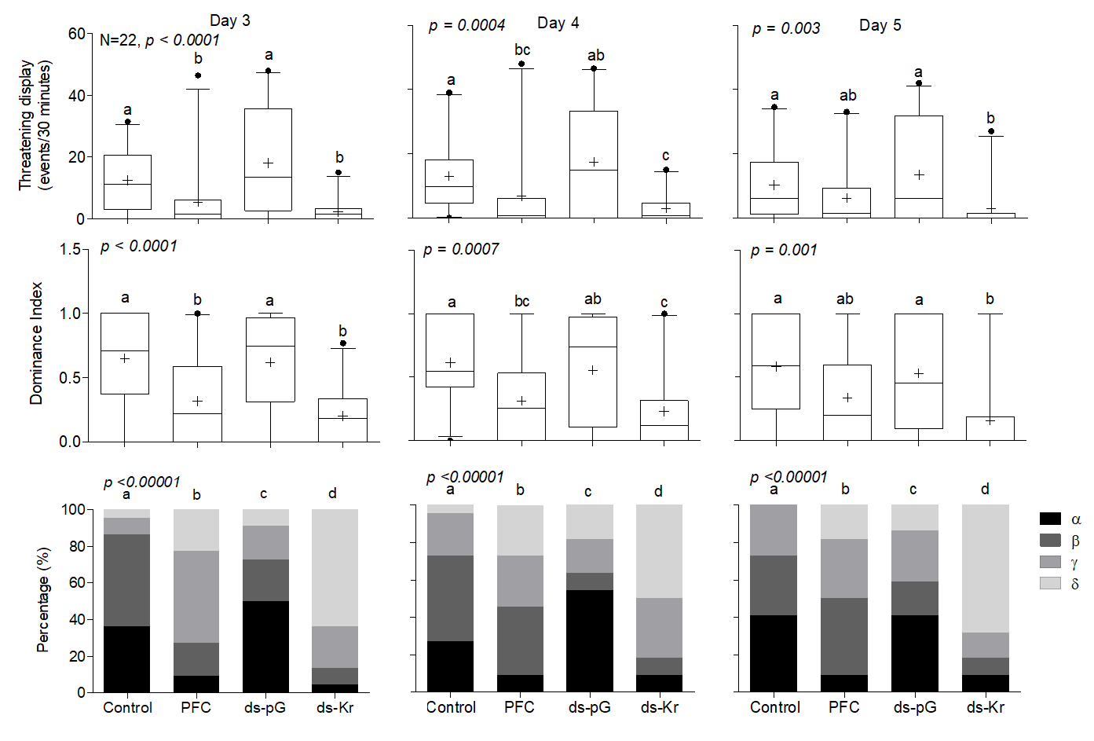
Supplementary Figure S4: The influence dsRNA mediated Kr-h1 knock-down on dominance and agonistic behavior – separate analyses for each observation day. Top row: Threatening displays. Middle row: Dominance index. Lower row: Dominance rank. The right, central, and left columns summarize the observations on Day 3, 4, and 5, respectively. Other details as in Fig. 3.

