Supplementary Materials
Designing an efficient self-assembled plasmonic nanostructures from spherical shaped nanoparticles
Vasanthan Devaraj ^{1,Ϯ}, Jong-Min Lee ^{1,2,Ϯ} , Ye-ji Kim ³ , Hyuk Jeong ¹ and Jin-Woo Oh ^{1,3,4,*}
¹Bio-IT Fusion Technology Research Institute, Pusan National University, Busan, 46241, Republic of Korea; devarajvasanthan@gmail.com
²School of Nanoconvergence Technology, Hallym University, Chuncheon, 24252, Republic of Korea; jongminlee1984@gmail.com
³Department of Nano Fusion Technology and BK21 Plus Nano Convergence Division, Pusan National University, Busan, 46241, Republic of Korea; kkyeaj0608@gmail.com
⁴Department of Nanoenergy Engineering, Pusan National University, Busan, 46241, Republic of Korea
*Correspondence: ojw@pusan.ac.kr
^{Ϯ}V.D. and J.-M.L contributed equally.

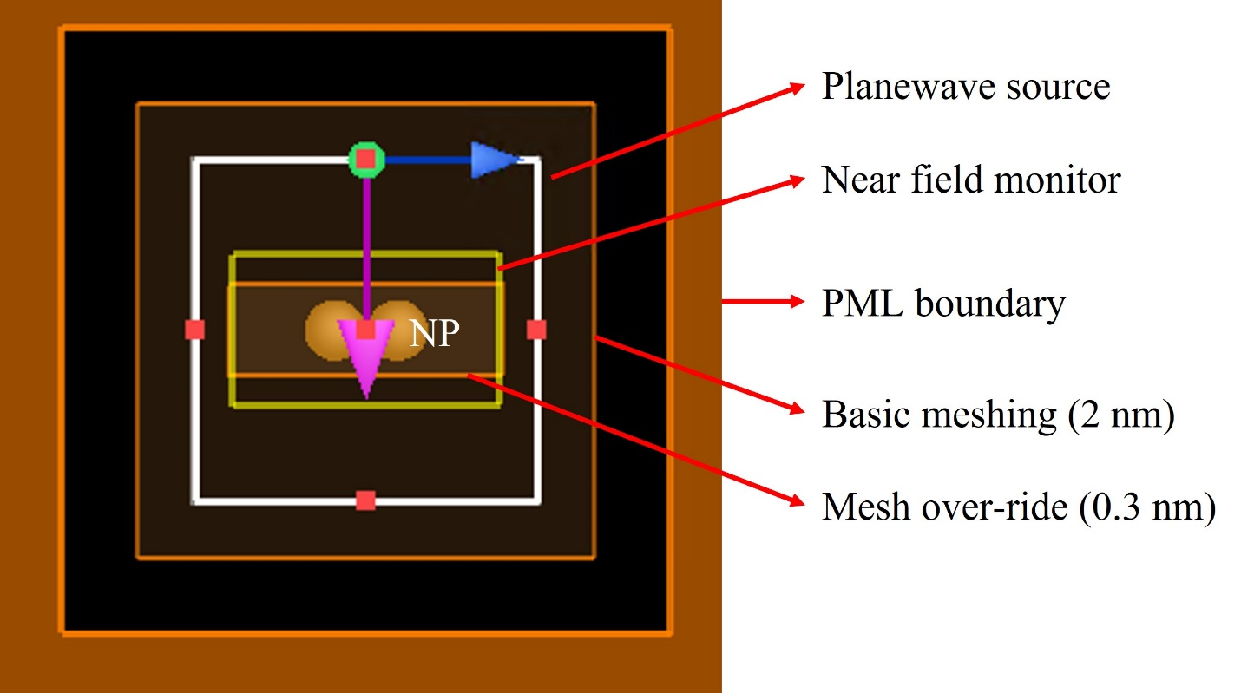
Figure S1. Modelling information which is used throughout our simulations.
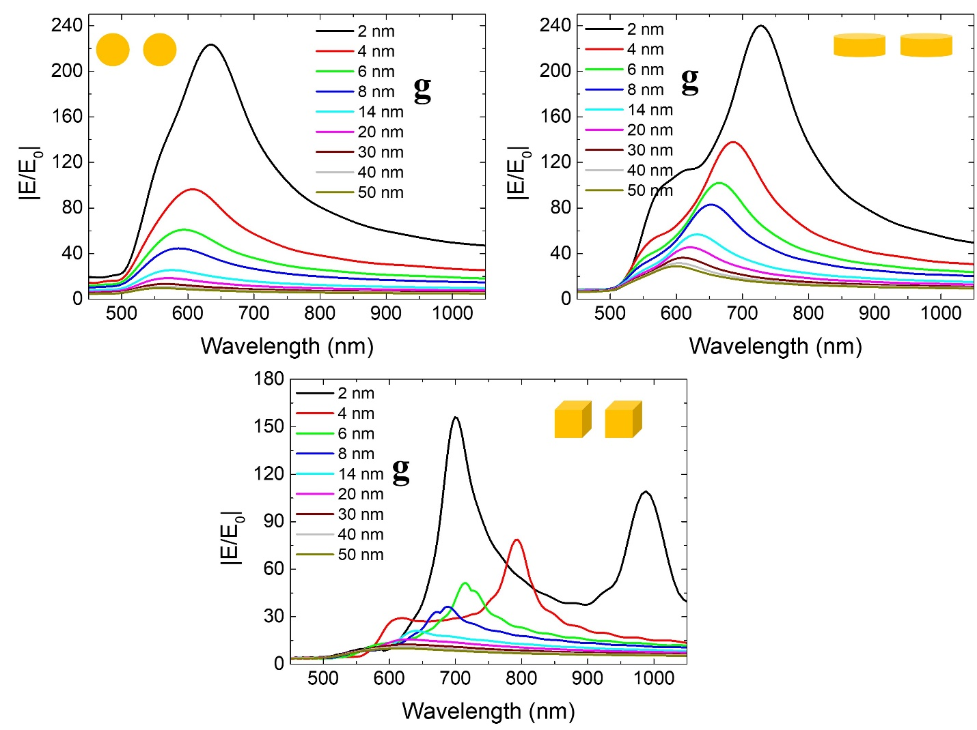
Figure S2. Simulated broadband near field spectra |E/E₀| for dimer nanostructures with NP shapes of a sphere (a), disk (b), and cube (c) as a function of gap size.

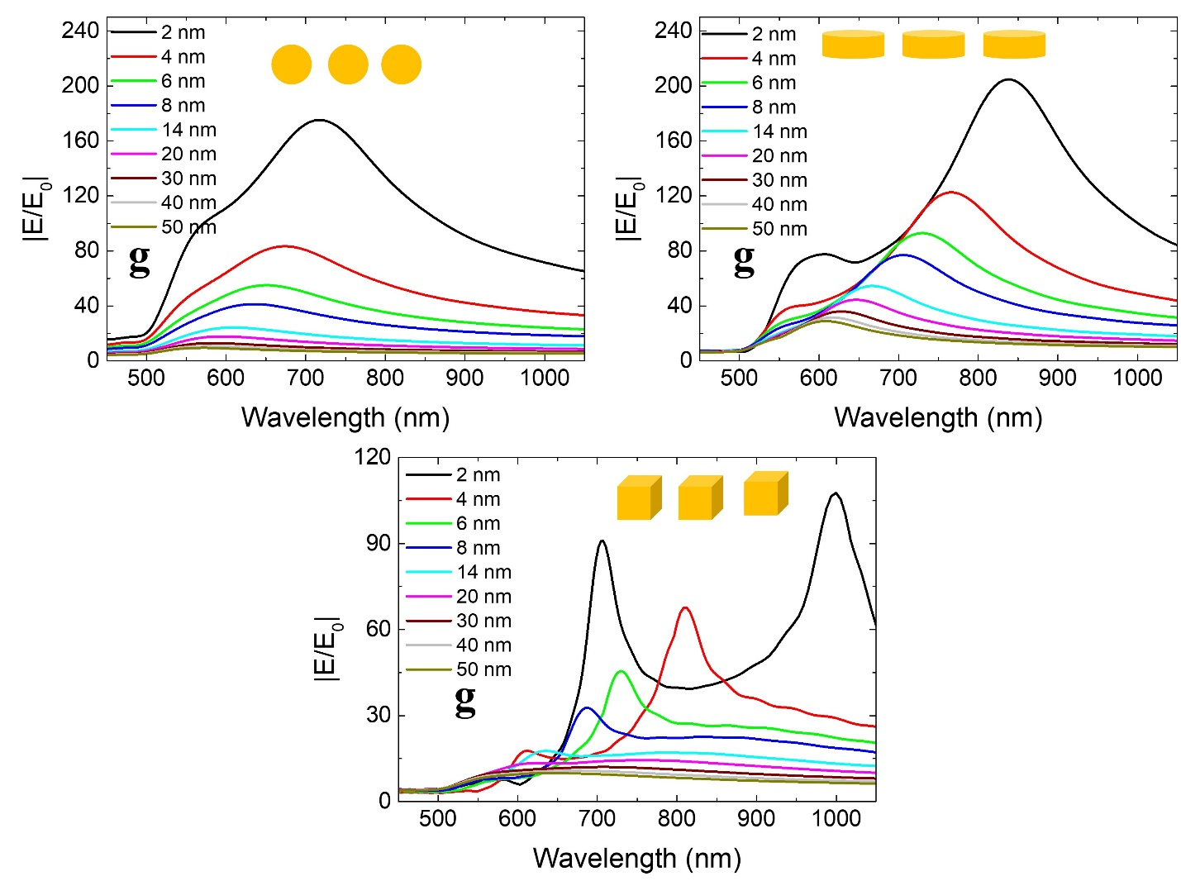
Figure S3. Simulated broadband near field spectra |E/E₀| for trimer nanostructures with NP shapes of a sphere (a), disk (b), and cube (c) as a function of gap size.

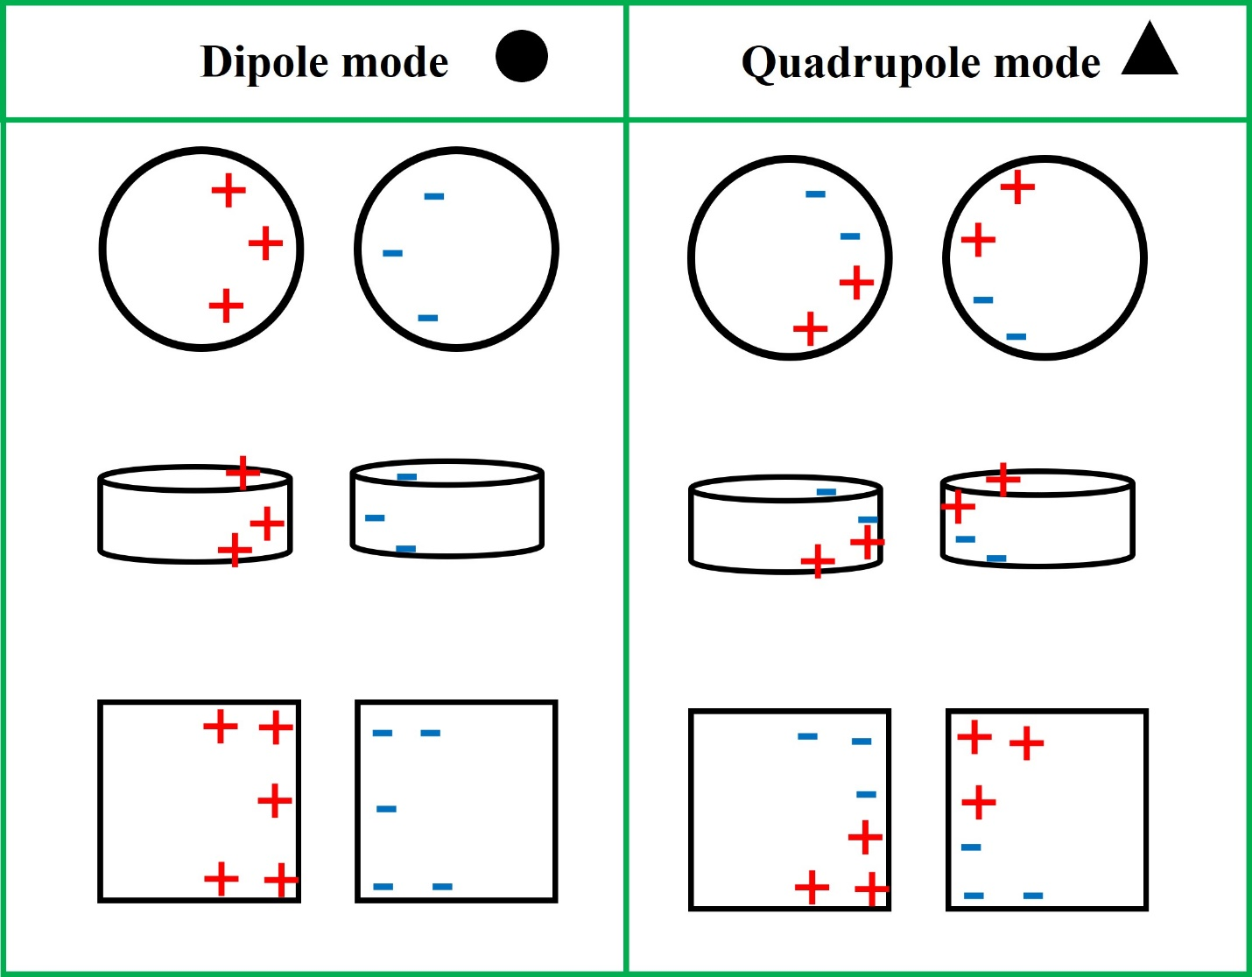
Figure S4. Schematic description of surface charge distributions reveals dipolar or quadrupolar modes in a plasmonic cavity region.

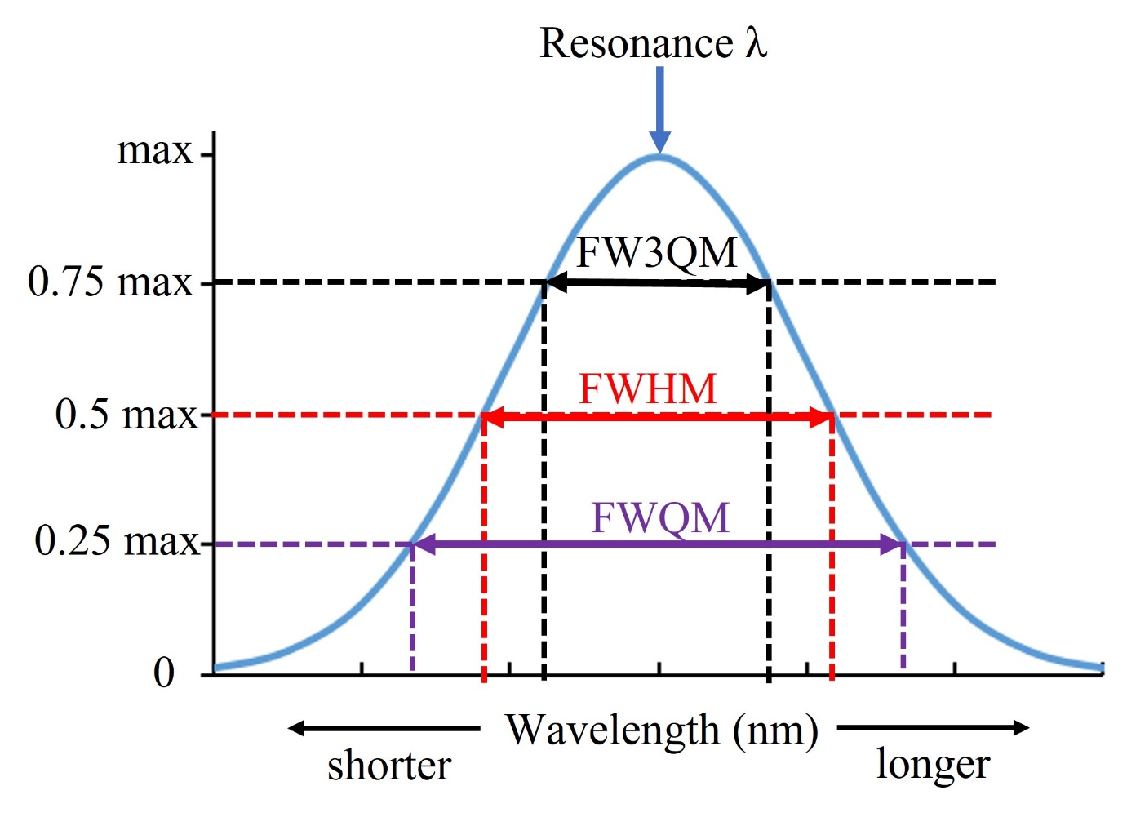
Figure S5. Data covering the FW3QM region in evaluating the broadband spectral performance of plasmonic nanostructures.

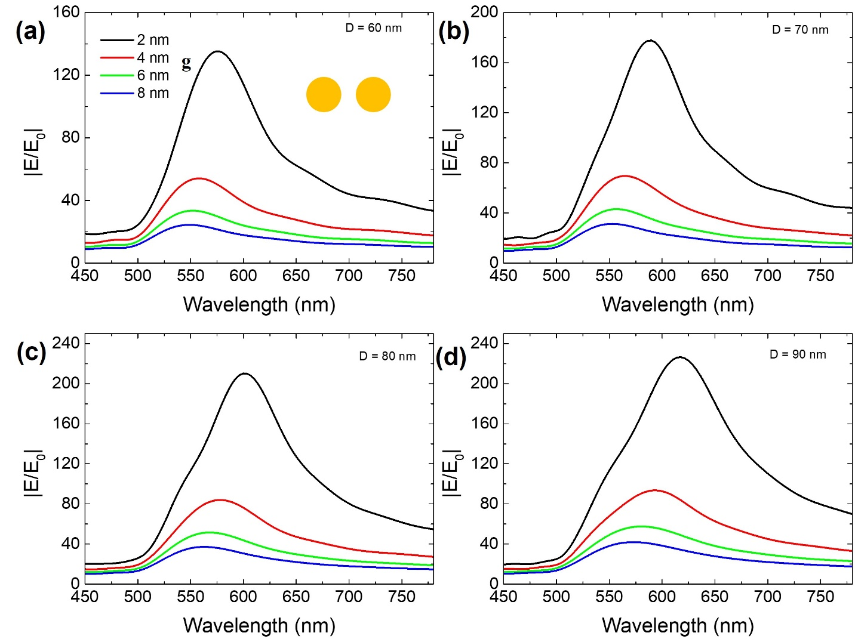

Figure S6. Simulated broadband gap-size dependent near field spectra |E/E₀| for sphere-based dimer nanostructures with different NP diameter: 60 nm (a), 70 nm (d), 80 nm (c) and 90 nm (d).

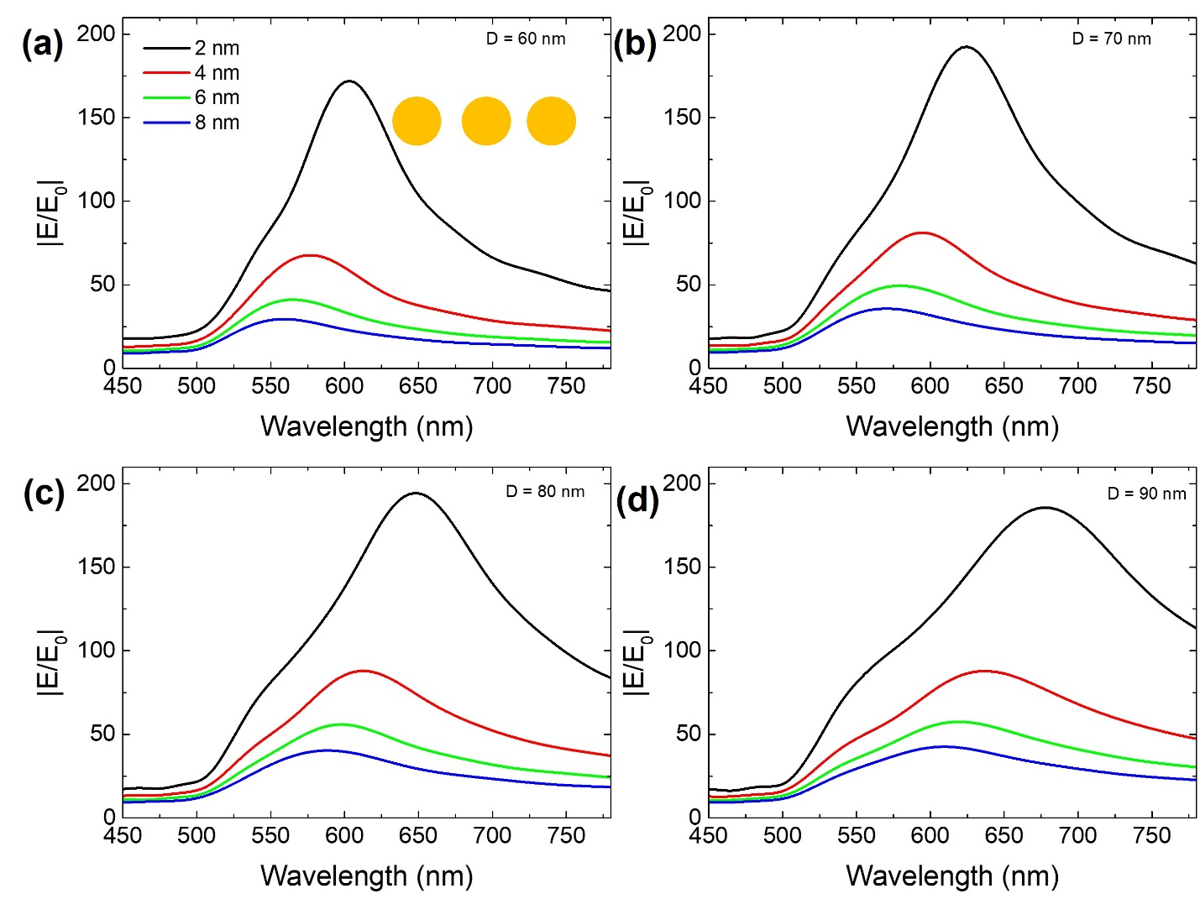

Figure S7. Simulated broadband gap-size dependent near field spectra |E/E₀| for sphere-based trimer nanostructures with different NP diameter: 60 nm (a), 70 nm (d), 80 nm (c) and 90 nm (d).

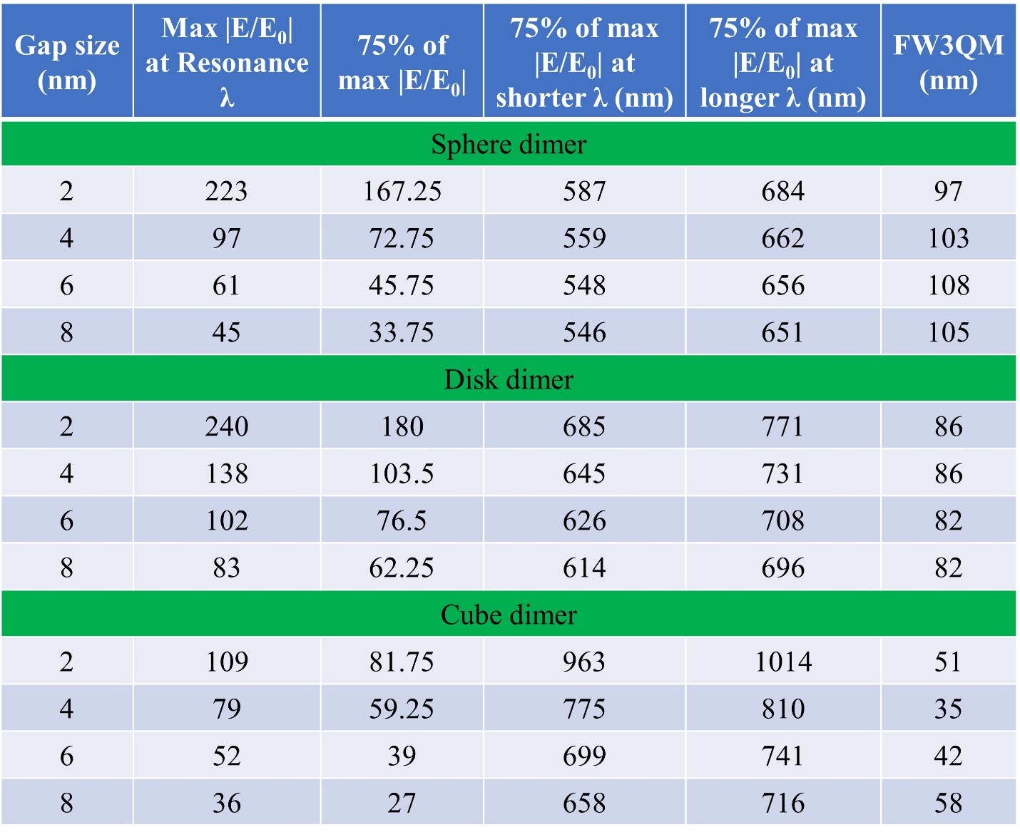
Table 1. FW3QM calculation information for dimer nanostructures for different gap sizes.

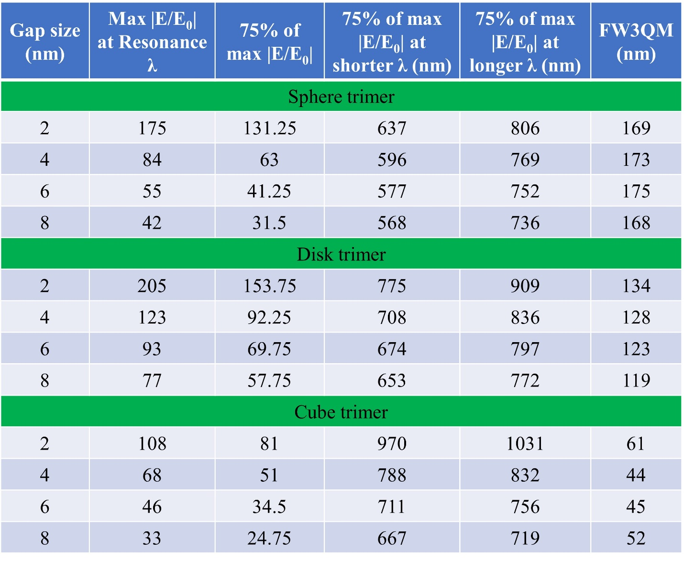
Table 2. FW3QM calculation information for trimer nanostructures for different gap sizes.

