Attempts to access a series of pyrazoles lead to new hydrazones with antifungal potential against Candida species including azole-resistant strains

Georgiana NEGRU,ª Laure KAMUS,^{b} Elena BÎCU,^{a,}* Sergiu SHOVA,^{c} Boualem SENDID,^{b} Faustine DUBAR,^{b,}* and Alina GHINET. ^{a,d,e}*

^{a.} ‘Alexandru Ioan Cuza’ University of Iasi, Faculty of Chemistry, Bd. Carol I, nr. 11, 700506 Iasi, Romania.
^{b} Univ. Lille, CHU Lille, UGSF UMR CNRS 8576, Inserm U1285, Glycobiology in Fungal and Clinical Applications, Unité de Glycobiologie Structurale et Fonctionnelle.
^{c} ‘Petru Poni’ Institute of Macromolecular Chemistry, Iasi, Romania.
^{d} Junia, Health and Environment, Laboratory of Sustainable Chemistry and Health, F-59000 Lille, France.
^{e} Univ. Lille, Inserm, CHU Lille, Institut Pasteur Lille, U1167 - RID-AGE - Facteurs de risque et déterminants moléculaires des maladies liées au vieillissement, F-59000 Lille, France.
* Corresponding authors.
---Supplementary information---

Materials and methods for synthesis and characterizations
Starting materials are commercially available and were used without further purification (suppliers: Carlo Erba Reagents S.A.S., Thermo Fisher Scientific Inc., Tokyo Chemical Industry Co. Ltd. and Sigma-Aldrich Co.). Melting points were measured on an MPA 100 OptiMelt® apparatus and are uncorrected. Nuclear magnetic resonance (NMR) spectra were acquired at 400 MHz for ¹H NMR, and at 100 MHz for ¹³C NMR on a Varian 400-MR spectrometer with tetramethylsilane (TMS) as internal standard, at room temperature (RT) or at 500 MHz for ¹H NMR, and at 125 MHz for ¹³C NMR on a Bruker Avance III 500 MHz spectrometer with tetramethylsilane (TMS) as internal standard, at room temperature (RT). Chemical shifts (δ) are expressed in ppm relative to TMS. Splitting patterns are designed: s, singlet; d, doublet; dd, doublet of doublets; t, triplet; q, quadruplet; quint, quintuplet; m, multiplet; sym m, symmetric multiplet; br s, broaden singlet; br t, broaden triplet. Coupling constants (J) are reported in Hertz (Hz). Thin layer chromatography (TLC) was realized on Macherey Nagel silica gel plates with fluorescent indicator and were visualized under a UV-lamp at 254 nm and 365 nm. Elemental analyses (C, H, N) of new compounds were determined on a Thermo Electron apparatus by “Pôle Chimie Moléculaire-Welience”, Faculté des Sciences Mirande, Dijon, France.

General procedure for the synthesis of benzylidenemalononitriles (3a-c)
A mixture of aldehyde (2a-c, 1 equiv), malononitrile (1 equiv) and few drops of piperidine in ethanol, was stirred at reflux for 6-8 h. After cooling the reaction medium to room temperature, the obtained precipitate was filtered, washed with ethanol, and then recrystallized from ethanol to afford the pure expected product (3a-c).
2-(3,4,5-Trimethoxybenzylidene)malononitrile (3a)
Yellow solid; mp (EtOH) 149-151 °C; 90% yield; R_{f} (EtOAc:Cyclohexane 1:1)=0.84; ¹H NMR (CDCl₃, 500 MHz) δ ppm 3.90 (s, 6H, 2OCH₃), 3.97 (s, 3H, OCH₃), 7.18 (s, 2H, 2ArH), 7.65 (s, 1H, =CH). Compound 3a presented the same physico-chemical properties as previously reported.¹
2-(4-Bromobenzylidene)malononitrile (3b)
White solid; mp (EtOH) 162-164 °C; 87% yield; R_{f} (EtOAc:Cyclohexane 1:1)=0.93. ¹H NMR (DMSO-d₆, 500 MHz) δ ppm 7.81-7.86 (m, 4H, 4ArH), 8.51 (s, 1H, =CH). Compound 3b presented the same physico-chemical properties as previously reported.²

2-(4-Nitrobenzylidene)malononitrile (3c)

Brown solid; mp (EtOH) 160-162 °C; 79% yield; R_{f} (EtOAc:Cyclohexane 1:1)=0.83. ¹H NMR (CDCl₃, 400 MHz) δ ppm 7.88 (s, 1H, =CH), 8.08 (d, J = 8.8 Hz, 2H, 2ArH), 8.39 (d, J = 8.8 Hz, 2H, 2ArH). Compound 3c presented the same physico-chemical properties as previously reported.³
General procedure for the preparation of hydrazone derivatives (1a-o)
A solution of benzylidenemalononitrile (3a-c, 1 equiv) and hydrazine (4a-n, 1 equiv) in ethanol was stirred at reflux for 4-8 h. After cooling the reaction medium to room temperature, the product precipitated was collected by filtration, washed with ethanol and purified by recrystallization from ethanol to obtain pure target hydrazone.
1-(2-(Trifluoromethyl)phenyl)-2-(3,4,5-trimethoxybenzylidene)hydrazine (1a)
White solid; mp (EtOH) 147-148 °C; 79% yield; R_{f} (EtOAc:Cyclohexane 1:1)=0.64. ¹H NMR (CDCl₃, 500 MHz) δ ppm 3.89 (s, 3H, OCH₃), 3.92 (s, 6H, 2OCH₃), 6.89-6.92 (m, 3H, 3ArH), 7.47-7.50 (m, 2H, 2ArH), 7.73 (s, 1H, =CH), 7.78 (d, J = 9.0 Hz, 1H, ArH), 8.01 (s, 1H, NH). ¹³C NMR (CDCl₃, 125 MHz) δ ppm 56.3 (2OCH₃), 61.1 (OCH₃), 103.7 (2CH), 112.3 (q, J = 60.0, 30.0 Hz, C), 114.8 (CH), 119.1 (CH), 125.0 (q, J = 541.2, 270.0 Hz, C), 126.3 (q, J = 11.2, 6.2 Hz, CH), 130.4 (C), 133.3 (CH), 140.1 (=CH), 142.2 (C), 142.3 (C), 153.6 (2C). Elemental analysis calcd (%) for C₁₇H₁₇F₃N₂O₃: C 57.63, H 4.84, N 7.91; found: C 57.92, H 4.89, N 7.33.
1-(2-Methoxyphenyl)-2-(3,4,5-trimethoxybenzylidene)hydrazine (1b)
Yellow solid; mp (EtOH) 179-180 °C; 71% yield; R_{f} (EtOAc:Cyclohexane 1:1) = 0.66. ¹H NMR (CDCl₃, 500 MHz) δ ppm 3.88 (s, 3H, OCH₃), 3.89 (s, 3H, OCH₃), 3.92 (s, 6H, 2OCH₃), 6.83-6.86 (m, 2H, 2ArH), 6.91 (s, 2H, 2ArH), 6.98 (td, J = 7.0, 2.0 Hz, 1H, ArH), 7.52 (dd, J = 7.5, 2.0 Hz, 1H, ArH), 7.70 (s, 1H, =CH), 8.07 (s, 1H, NH). ¹³C NMR (CDCl₃, 125 MHz) δ ppm 55.7 (OCH₃), 56.3 (2OCH₃), 61.1 (OCH₃), 103.3 (2CH), 110.2 (CH), 112.5 (CH), 119.4 (CH), 121.7 (CH), 131.2 (C), 134.3 (C), 138.1 (=CH), 138.7 (C), 145.3 (C), 153.6 (2C). Elemental analysis calcd (%) for C₁₇H₂₀N₂O₄: C 64.54, H 6.37, N 8.86; found: C 64.87, H 6.52, N 9.02.

1-(2-Bromophenyl)-2-(3,4,5-trimethoxybenzylidene)hydrazine (1c)
Pink solid; mp (EtOH) 155-157 °C; 83% yield; R_{f} (EtOAc:Cyclohexane 1:1)=0.65. ¹H NMR (CDCl₃, 500 MHz) δ ppm 3.89 (s, 3H, OCH₃), 3.92 (s, 6H, 2OCH₃), 6.74 (td, J = 8.0, 1.5 Hz, 1H, ArH), 6.91 (s, 2H, 2ArH), 7.28 (td, J = 8.0, 1.5 Hz, 1H, ArH), 7.44 (dd, J = 8, 1.5 Hz, 1H, ArH), 7.58 (dd, J = 8.0, 1.5 Hz, 1H, ArH), 7.76 (s, 1H, =CH), 8.05 (s, 1H, NH). ¹³C NMR (CDCl₃, 125 MHz) δ ppm 56.3 (2OCH₃), 61.1 (OCH₃), 103.5 (2CH), 106.9 (C), 114.5 (CH), 120.7 (CH), 128.7 (CH), 130.6 (C), 132.4 (CH), 139.0 (C), 139.6 (=CH), 141.5 (C), 153.6 (2C). Elemental analysis calcd (%) for C₁₆H₁₇BrN₂O₃: C 52.62, H 4.69, N 7.67; found: C 52.76, H 4.90, N 7.95.
1-(2-Chlorophenyl)-2-(3,4,5-trimethoxybenzylidene)hydrazine (1d)
Pink solid; mp (EtOH) 164-166 °C; 71% yield; R_{f} (EtOAc:Cyclohexane 1:1)=0.66. ¹H NMR (CDCl₃, 500 MHz) δ ppm 3.86 (s, 3H, OCH₃), 3.92 (s, 6H, 2OCH₃), 6.80 (td, J = 8.0, 1.5 Hz, 1H, ArH), 6.90 (s, 2H, 2ArH), 7.23-7.29 (m, 2H, 2ArH), 7.60 (dd, J = 8.0, 1.5 Hz, 1H, ArH), 7.73 (s, 1H, =CH), 8.05 (s, 1H, NH). ¹³C NMR (CDCl₃, 125 MHz) δ ppm 56.2 (2OCH₃), 61.1 (OCH₃), 103.5 (2CH), 114.2 (CH), 117.0 (C), 120.1 (CH), 128.0 (CH), 129.2 (CH), 130.6 (C), 139.0 (C), 139.6 (=CH), 140.6 (C), 153.6 (2C). Elemental analysis calcd (%) for C₁₆H₁₇ClN₂O₃: C 59.91, H 5.34, N 8.73; found: C 60.22, H 5.66, N 8.98.
1-(2,4-Dichlorophenyl)-2-(3,4,5-trimethoxybenzylidene)hydrazine (1e)
White solid; mp (EtOH) 185-187 °C; 79% yield; R_{f} (EtOAc:Cyclohexane 1:1)=0.66. ¹H NMR (CDCl₃, 500 MHz) δ ppm 3.88 (s, 3H, OCH₃), 3.90 (s, 6H, 2OCH₃), 6.87 (s, 2H, 2ArH), 7.18 (dd, J = 8.5, 2.0 Hz, 1H, ArH), 7.25 (d, J = 2.0 Hz, 1H, ArH), 7.50 (d, J = 8.5 Hz, 1H, ArH), 7.69 (s, 1H, =CH), 7.96 (s, 1H, NH). ¹³C NMR (CDCl₃, 125 MHz) δ ppm 56.2 (2OCH₃), 61.0 (OCH₃), 103.5 (2CH), 114.9 (CH), 117.1 (C), 124.0 (C), 128.1 (CH), 128.7 (CH), 130.3 (C), 139.1 (C), 139.4 (C), 140.2 (=CH), 153.5 (2C). Elemental analysis calcd (%) for C₁₆H₁₆Cl₂N₂O₃: C 54.10, H 4.54, N 7.89; found: C 54.29, H 4.79, N 8.01.
1-(2,4-Difluorophenyl)-2-(3,4,5-trimethoxybenzylidene)hydrazine (1f)
Yellow solid; mp (EtOH) 185-188 °C; 65% yield; R_{f} (EtOAc:Cyclohexane 1:1) = 0.53. ¹H NMR (DMSO-d₆, 500 MHz) δ ppm 3.69 (s, 3H, OCH₃), 3.84 (s, 6H, 2OCH₃), 6.95 (s, 2H, 2ArH), 6.99 (td, J = 9.0, 2.0 Hz, 1H, ArH), 7.18 (td, J = 9.0, 2.0 Hz, 1H, ArH), 7.53 (td, J = 9.0, 2.0 Hz, 1H, ArH), 8.03 (s, 1H, =CH), 10.18 (s, 1H, NH). ¹³C NMR (DMSO-d₆, 125 MHz) δ ppm 55.9 (2OCH₃), 60.1 (OCH₃), 103.1 (2CH), 103.8 (CH), 111.4 (dd, J = 21.2, 2.5 Hz, CH), 114.2 (q, J = 8.7, 5.0 Hz, CH), 130.5 (q, J = 10.0, 2.5 Hz, C), 131.1 (C), 138.0 (C), 139.4 (=CH), 148.4 (dd, J = 240.0, 11.2 Hz, C), 153.2 (2C), 154.7 (dd, J = 235.0, 10.0 Hz, C). Elemental analysis calcd (%) for C₁₆H₁₆F₂N₂O₃: C 59.62, H 5.00, N 8.69; found: C 59.90, H 5.23, N 8.88.
1-(o-Tolyl)-2-(3,4,5-trimethoxybenzylidene)hydrazine (1g)
Yellow solid; mp (EtOH) 200-202 °C; 88% yield; R_{f} (EtOAc:Cyclohexane 1:1)=0.63. ¹H NMR (DMSO-d₆, 500 MHz) δ ppm 2.19 (s, 3H, CH₃), 3.75 (s, 3H, OCH₃), 3.84 (s, 6H, 2OCH₃), 6.66 (t, J = 7.5 Hz, 1H, ArH), 6.84 (s, 2H, 2ArH), 6.97 (d, J = 7.5 Hz, 1H, ArH), 7.07 (t, J = 7.5 Hz, 1H, ArH), 7.41 (d, J = 7.5 Hz, 1H, ArH), 7.90 (s, 1H, =CH), 8.85 (br s, 1H, NH). ¹³C NMR (DMSO-d₆, 125 MHz) δ ppm 17.1 (CH₃), 55.5 (2OCH₃), 60.1 (OCH₃), 102.4 (2CH), 112.0 (CH), 118.6 (CH), 120.3 (C), 126.4 (CH), 129.8 (CH), 131.2 (C), 137.5 (C), 137.6 (=CH), 142.7 (C), 152.8 (2C). Elemental analysis calcd (%) for C₁₇H₂₀N₂O₃: C 67.98, H 6.71, N 9.33; found: C 68.19, H 6.93, N 9.55.

1-(4-Chlorophenyl)-2-(3,4,5-trimethoxybenzylidene)hydrazine (1h)
Yellow solid; mp (EtOH) 156-158 °C; 79% yield; R_{f} (EtOAc:Cyclohexane 1:1) = 0.66. ¹H NMR (CDCl₃, 500 MHz) δ ppm 3.88 (s, 3H, OCH₃), 3.89 (s, 6H, 2OCH₃), 6.85 (s, 2H, 2ArH), 7.01 (d, J = 9.0 Hz, 2H, 2ArH), 7.20 (d, J = 9.0 Hz, 2H, 2ArH), 7.51 (s, 1H, =CH), 7.73 (br s, 1H, NH). ¹³C NMR (CDCl₃, 125 MHz) δ ppm 56.2 (2OCH₃), 61.0 (OCH₃), 103.3 (2CH), 113.9 (2CH), 124.5 (C), 129.2 (2CH), 130.9 (C), 137.9 (=CH), 138.7 (C), 143.4 (C), 153.5 (2C). Elemental analysis calcd (%) for C₁₆H₁₇ClN₂O₃: C 59.91, H 5.34, N 8.73; found: C 60.26, H 5.59, N 9.01.
1-(2-Fluorophenyl)-2-(3,4,5-trimethoxybenzylidene)hydrazine (1i)
Pink solid; mp (EtOH) 145-147 °C; 75% yield; R_{f} (EtOAc:Cyclohexane 1:1)=0.61. ¹H NMR (CDCl₃, 500 MHz) δ ppm 3.88 (s, 3H, OCH₃), 3.91 (s, 6H, 2OCH₃), 6.77-6.81 (m, 1H, ArH), 6.89 (s, 2H, 2ArH), 7.01-7.05 (m, 1H, ArH), 7.11 (t, J = 8.0 Hz, 1H, ArH), 7.59 (t, J = 8.0 Hz, 1H, ArH), 7.66 (s, 1H, =CH), 7.79 (d, J = 2.5 Hz, 1H, NH). ¹³C NMR (CDCl₃, 125 MHz) δ ppm 56.2 (2OCH₃), 61.0 (OCH₃), 103.4 (2CH), 114.5 (d, J = 2.5 Hz, CH), 114.9 (d, J = 17.5 Hz, CH), 119.5 (d, J = 7.5 Hz, CH), 124.9 (d, J = 3.7 Hz, CH), 130.7 (C), 133.1 (d, J = 8.7 Hz, C), 138.9 (C), 139.3 (=CH), 149.7 (d, J = 237.5 Hz, C), 153.6 (2C). Elemental analysis calcd (%) for C₁₆H₁₇FN₂O₃: C 63.15, H 5.63, N 9.21; found: C 63.40, H 5.89, N 9.39.
1-(Pentafluorophenyl)-2-(3,4,5-trimethoxybenzylidene)hydrazine (1j)
Orange solid with the same physico-chemical properties as previously described;⁴ mp (EtOH) 220-223 °C; 77% yield; R_{f} (EtOAc:Cyclohexane 1:1)=0.45. ¹H NMR (DMSO-d₆, 500 MHz) δ ppm 3.68 (s, 3H, OCH₃), 3.80 (s, 6H, 3OCH₃), 6.90 (s, 2H, 2ArH), 8.01 (s, 1H, =CH), 10.28 (s, 1H, NH). ¹³C NMR (DMSO-d₆, 125 MHz) δ ppm 55.8 (2OCH₃), 60.1 (OCH₃), 103.2 (2CH), 121.3 (C), 130.4 (C), 132.8 (C), 134.7 (C), 136.5 (C), 136.8 (C), 138.3 (C), 138.8 (C), 141.8 (=CH), 153.2 (2C). Elemental analysis calcd (%) for C₁₆H₁₃F₅N₂O₃: C 51.07, H 3.48, N 7.44; found: C 51.25, H 3.61, N 7.69.
1-(4-Bromophenyl)-2-(3,4,5-trimethoxybenzylidene)hydrazine (1k)
White solid; mp (EtOH) 152-155 °C; 73% yield; R_{f} (EtOAc:Cyclohexane 1:1)=0.92. ¹H NMR (CDCl₃, 500 MHz) δ ppm 3.88 (s, 3H, OCH₃), 3.91 (s, 6H, 2OCH₃), 6.87 (s, 2H, 2ArH), 6.97 (d, J = 8.0 Hz, 2H, 2ArH), 7.35 (d, J = 8.0 Hz, 2H, 2ArH), 7.56 (s, 1H, =CH), 7.67 (s, 1H, NH). ¹³C NMR (CDCl₃, 125 MHz) δ ppm 56.2 (2OCH₃), 61.0 (OCH₃), 103.2 (2CH), 111.8 (C), 114.3 (2CH), 130.7 (C), 132.1 (2CH), 137.9 (=CH), 138.7 (C), 143.7 (C), 153.5 (2C). Elemental analysis calcd (%) for C₁₆H₁₇BrN₂O₃: C 52.62, H 4.69, N 7.67; found: C 52.81, H 4.95, N 7.88.
1-(p-Tolyl)-2-(3,4,5-trimethoxybenzylidene)hydrazine (1l)
Yellow solid; mp (EtOH) 172-174 °C; 55% yield; R_{f} (EtOAc:Cyclohexane 1:1)=0.82. ¹H NMR (CDCl₃, 500 MHz) δ ppm 2.38 (s, 3H, CH₃), 3.87 (s, 9H, 3OCH₃), 5.53 (s, 1H, NH), 6.66 (s, 2H, 2ArH), 7.20 (d, J = 8.0 Hz, 2H, 2ArH), 7.48 (d, J = 8.0 Hz, 2H, 2ArH). ¹³C NMR (CDCl₃, 125 MHz) δ ppm 21.5 (CH₃), 56.2 (2OCH₃), 60.9 (OCH₃), 85.7 (=CH), 106.1 (2CH), 122.4 (2CH), 129.7 (2CH), 133.1 (C), 137.4 (C), 141.4 (C), 150.3 (C), 153.1 (2C). Elemental analysis calcd (%) for C₁₇H₂₀N₂O₃: C 67.98, H 6.71, N 9.33; found: C 68.07, H 6.85, N 9.50.
1-(2-Methoxyphenyl)-2-(4-nitrobenzylidene)hydrazine (1m)
Dark red solid; mp (EtOH) 165-167 °C; 68% yield; R_{f} (EtOAc:Cyclohexane 1:1)=0.49. ¹H NMR (DMSO-d₆, 500 MHz) δ ppm 3.86 (s, 3H, OCH₃), 6.83 (t, J = 7.5 Hz, 1H, ArH), 6.92 (t, J = 7.5 Hz, 1H, ArH), 6.97 (d, J = 8.0 Hz, 1H, ArH), 7.46 (dd, J = 8.0, 1.5 Hz, 1H, ArH), 7.82 (dd, J = 9.0, 2.0 Hz, 2H, 2ArH), 8.21 (dd, J = 9.0, 2.0 Hz, 3H, 2ArH+ =CH), 10.3 (s, 1H, NH). ¹³C NMR (DMSO-d₆, 125 MHz) δ ppm 55.6 (OCH₃), 111.1 (CH), 112.3 (CH), 120.0 (CH), 121.3 (CH), 124.1 (2CH), 126.0 (2CH), 133.6 (C), 135.2 (=CH), 142.7 (C), 145.6 (C), 146.0 (C). Elemental analysis calcd (%) for C₁₄H₁₃N₃O₃: C 61.99, H 4.83, N 15.49; found: C 62.23, H 4.97, N 15.72.
1-(4-Bromobenzylidene)-2-phenylhydrazine (1n)
White solid with the same physico-chemical properties as previously described;⁵ mp (EtOH) 121-123 °C; 61% yield; R_{f} (EtOAc:Cyclohexane 1:1)=0.62. ¹H NMR (CDCl₃, 500 MHz) δ ppm 6.88-6.91 (m, 1H, ArH), 7.11 (dd, J= 9.0, 1.0 Hz, 2H, 2ArH), 7.27-7.30 (m, 2H, 2ArH), 7.48-7.53 (m, 5H, 4ArH+NH), 7.61 (s, 1H, =CH). ¹³C NMR (CDCl₃, 125 MHz) δ ppm 112.9 (2CH), 120.5 (CH), 122.3 (C), 127.7 (2CH), 129.5 (2CH), 131.9 (2CH), 134.4 (C), 135.9 (=CH), 144.5 (C). Elemental analysis calcd (%) for C₁₃H₁₁BrN₂: C 56.75, H 4.03, N 10.18; found: C 56.93, H 4.34, N 10.33.
1-(4-Bromobenzylidene)-2-(3,4-dimethylphenyl)hydrazine (1o)
White solid; mp (EtOH) 141-143 °C; 69% yield; R_{f} (EtOAc:Cyclohexane 1:1)=0.59. ¹H NMR (CDCl₃, 500 MHz) δ ppm 2.20 (s, 3H, CH₃), 2.26 (s, 3H, CH₃), 6.84 (d, J= 7.5 Hz, 1H, ArH), 6.93 (s, 1H, ArH), 7.03 (d, J= 8.5 Hz, 1H, ArH), 7.46-7.54 (m, 4H, 4ArH), 7.58 (br s, 2H, NH+ =CH). ¹³C NMR (CDCl₃, 125 MHz) δ ppm 19.1 (CH₃), 20.2 (CH₃), 110.4 (CH), 114.4 (CH), 122.1 (C), 127.6 (2CH), 128.6 (C), 130.5 (CH), 131.9 (2CH), 134.6 (C), 135.3 (=CH), 137.7 (C), 142.6 (C). Elemental analysis calcd (%) for C₁₅H₁₅BrN₂: C 59.42, H 4.99, N 9.24; found: C 59.65, H 5.07, N 9.50.

X-ray crystallography
X-ray diffraction measurements for 1e and 1i were carried out with a Rigaku Oxford-Diffraction XCALIBUR E CCD diffractometer equipped with graphite-monochromated MoKα radiation. The unit cell determination and data integration were carried out using the CrysAlis package of Oxford Diffraction.⁶ The structures were solved by Intrinsic Phasing using Olex2⁷ software with the SHELXT⁸ structure solution program and refined by full-matrix least-squares on F² with SHELXL-2015⁹ using an anisotropic model for non-hydrogen atoms. All H atoms attached to carbon were introduced in idealized positions (d_{CH} = 0.96 Å) using the riding model with their isotropic displacement parameters fixed at 120% of their riding atom. The positions of H atoms for NH groups were determined from Fourier synthesis maps and verified through the hydrogen bonds parameters. Table 1 provides a summary of the crystallographic data together with refinement details for compounds. The geometric parameters are summarized in Table S1. The supplementary crystallographic data can be obtained free of charge via www.ccdc.cam.ac.uk/conts/retrieving.html (or from the Cambridge Crystallographic Data Centre, 12 Union Road, Cambridge CB2 1EZ, UK; fax: (+44) 1223–336-033; or deposit@ccdc.ca.ac.uk).
Table 1. Crystal data and details of data collection
Parameter | 1e | 1i
empirical formula | C₁₆H₁₆Cl₂N₂O₃ | C₁₆H₁₇FN₂O₃
Fw | 355.21 | 304.31
space group | P2₁/c | P2₁/c
a [Å] | 15.4951(11) | 14.3054(9)
b [Å] | 7.8815(5) | 7.8734(4)
c [Å] | 15.5152(12) | 15.509(2)
α [°] | 90 | 90
β [°] | 117.006(9) | 117.591(6)
γ [°] | 90 | 90
V [Å³] | 1688.2(2) | 1548.1(2)
Z | 4 | 4
_{calcd} [g·cm⁻³] | 1.398 | 1.306
Crystal size [mm] | 0.25 × 0.20 × 0.10 | 0.30 × 0.20 × 0.10
T [K] | 293 | 293
μ [mm⁻¹] | 0.400 | 0.099
2Θ range [°] | 5.258 to 50.054 | 3.212 to 50.054
Reflections collected | 7201 | 8594
Independent reflections | 2989[R_{int}=0.0321] | 2699[R_{int}=0.0257]
Data/restraints/parameters | 2989/0/211 | 2699/0/202
R₁^{[a]} | 0.0470 | 0.0499
wR₂^{[b]} | 0.1121 | 0.1245
GOF^{[c]} | 1.020 | 1.020
Largest diff. peak/hole / e Å⁻³ | 0.25/-0.30 | 0.20/-0.18
CCDC No. | 2097685 | 2097687
ª R₁ = Σ||F_{o}| |F_{c}||/Σ|F_{o}|. ^{b}wR₂ = {Σ[w(F_{o}² F_{c}²)²]/Σ[w(F_{o}²)²]} ^{1/2}. ^{c}GOF = {Σ[w(F_{o}² F_{c}²)²]/(n p)}^{1/2}, where n is the number of reflections and p is the total number of parameters refined.

Table S1. Bond distances (Å) and angles(°).
Compound 1e.
O1-C9 | 1.418(3)
O2-C4 | 1.377(3)
O2-C8 | 1.429(3)
O3-C3 | 1.368(3)
O3-C7 | 1.427(3)
N1-N2 | 1.370(3)
N1-C10 | 1.274(3)
N2-C11 | 1.387(3)
C1-C2 | 1.392(3)
C1-C6 | 1.396(3)
C1-C10 | 1.458(3)
C2-C3 | 1.379(3)
C3-C4 | 1.395(3)
C4-C5 | 1.385(3)
C5-C6 | 1.383(3)
C11-C12 | 1.390(3)
C11-C16 | 1.388(3)
C12-C13 | 1.384(3)
C13-C14 | 1.370(4)
C14-C15 | 1.369(4)
C15-C16 | 1.382(3)

O3-C3-C2 | 124.9(2)
O3-C3-C4 | 114.7(2)
C2-C3-C4 | 120.4(2)
O2-C4-C3 | 120.8(2)
O2-C4-C5 | 119.4(2)
C5-C4-C3 | 119.6(2)
O1-C5-C4 | 114.6(2)
O1-C5-C6 | 124.9(2)
C6-C5-C4 | 120.5(2)
C5-C6-C1 | 119.7(2)
N1-C10-C1 | 122.4(2)
N2-C11-C12 | 120.3(2)
N2-C11-C16 | 122.0(2)
C16-C11-C12 | 117.7(2)
C11-C12-Cl1 | 119.5(2)
C13-C12-Cl1 | 118.8(2)
C13-C12-C11 | 121.7(3)
C14-C13-C12 | 119.0(3)
C13-C14-Cl2 | 119.3(3)
C15-C14-Cl2 | 120.0(3)
C15-C14-C13 | 120.7(3)
C14-C15-C16 | 120.1(3)
C15-C16-C11 | 120.7(3)

Compound 1i.
F1-C12 | 1.359(3)
O1-C5 | 1.369(2)
O1-C9 | 1.426(3)
O2-C4 | 1.378(2)
O2-C8 | 1.425(3)
O3-C3 | 1.363(2)
O3-C7 | 1.424(3)
N1-N2 | 1.366(2)
N1-C10 | 1.276(2)
N2-C11 | 1.381(3)
C1-C2 | 1.392(3)
C1-C6 | 1.391(3)
C1-C10 | 1.459(3)
C2-C3 | 1.379(3)
C3-C4 | 1.398(3)
C4-C5 | 1.389(3)
C5-C6 | 1.381(3)
C11-C12 | 1.377(3)
C11-C16 | 1.385(3)
C12-C13 | 1.373(4)
C13-C14 | 1.362(5)
C14-C15 | 1.372(5)
C15-C16 | 1.383(4)

C6-C1-C10 | 117.98(18)
C3-C2-C1 | 120.29(19)
O3-C3-C2 | 125.13(19)
O3-C3-C4 | 115.09(18)
C2-C3-C4 | 119.77(18)
O2-C4-C3 | 120.31(18)
O2-C4-C5 | 119.73(19)
C5-C4-C3 | 119.71(19)
O1-C5-C4 | 114.65(19)
O1-C5-C6 | 124.94(19)
C6-C5-C4 | 120.41(19)
C5-C6-C1 | 119.81(19)
N1-C10-C1 | 122.41(19)
N2-C11-C16 | 123.4(2)
C12-C11-N2 | 119.4(2)
C12-C11-C16 | 117.2(2)
F1-C12-C11 | 117.5(2)
F1-C12-C13 | 119.4(3)
C13-C12-C11 | 123.1(3)
C14-C13-C12 | 118.4(3)
C13-C14-C15 | 120.6(3)
C14-C15-C16 | 120.3(3)
C15-C16-C11 | 120.3(3)

The crystal is built-up from two-dimensional wave-like layers formed through the packing of supramolecular chains developing parallel to 110 plane. A partial diagram of the crystal packing viewed along a axis is shown in Figure 1S.

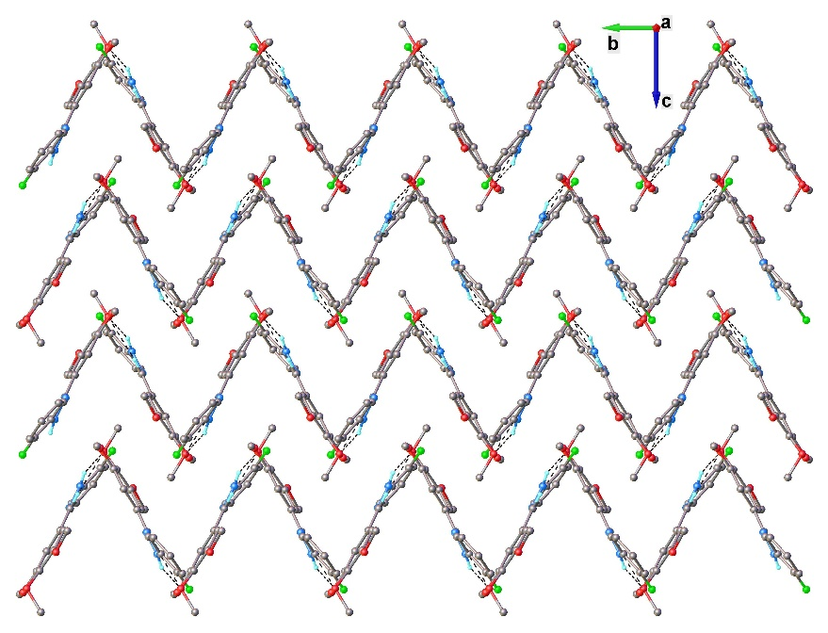
Figure 1S. View of the crystal packing for 1i along a axis.

MIC₉₉ determination assays. MIC₉₉ determination against Candida spp. were determined according to the standard culture microdilution method form Clinical and Laboratory Standard Institute (CLSI). Inocula from Candida spp. strains were obtained from fungal cultures in Sabouraud dextrose agar (SDA) at 37°C for 24h. The initial concentration of Candida spp. strains were 1-5x10⁶ CFU/mL. The inocula were adjusted in order to obtain an optical density of 0.5 in the McFarland scale using sterile mQ water. Cells were suspended in RPMI 1640 medium to obtain a final concentration of 5x10³ CFU/mL. The evaluation of the antifungal activity of hydrazones derivatives was performed against Candida albicans, Candida dubliniensis, Candida glabrata, Candida parasilosis and Candida tropicalis cultured in 96-well microplates at different concentrations (0.06 μg/mL to 32 μg/mL) at 37°C for 24h. Growth and sterility controls were also used. In the other hand, a positive control was also realized with fluconazole (0.5 μg/mL and 0.06 μg/mL). Fungal growth was determined in colorimetric assays (AlamarblueTM). Minimum IC (MIC₉₉) was defined as the lowest concentration of hydrazine derivative that produces a reduction of 99% of the yeast growth compared to controls (in the absence of compound).

Cell viability assay. Human HEK293 (Human Embryonic Kidney 293 cells) were grown in triple flask to 95% confluence and resuspended for dispensing at 1.25x10⁵ cells/mL of DMEM, 10% FBS/Pen/Strep/L-glutamine. HEK293 cells were plated in 96-well microplates (5000 cells per well in 40 μL media (DMEM/10%FBS/Pen/Strep/L-glutamine) before incubation in standard conditions (5% CO₂; 95% humidity, 37 °C) for 24 hours.
Subsequently cells were overlaid with RPMI medium containing different concentrations of drugs (0.06 μg/mL to 32 μg/mL) and cell viability was determined using MTT reagent as per manufacturer’s recommendations.

National Cancer Institute (NCI) - One Dose Mean Graph for hydrazones 1c, 1d, 1i, 1k and 1l
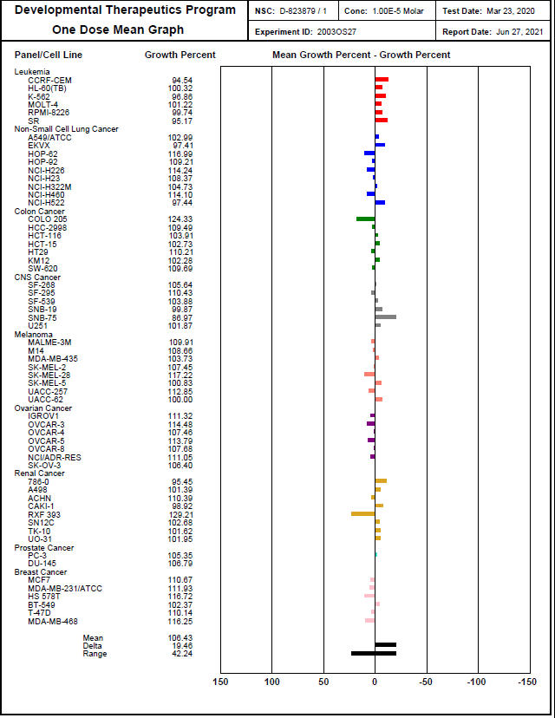
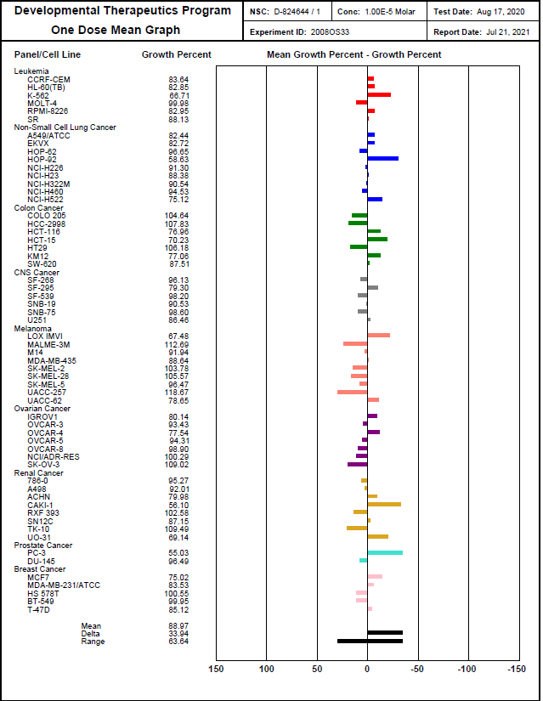
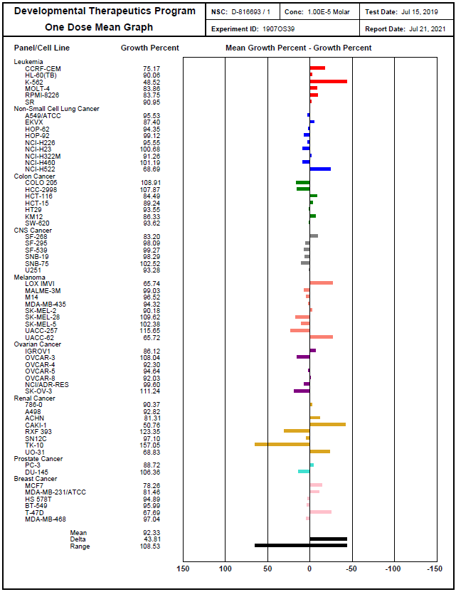
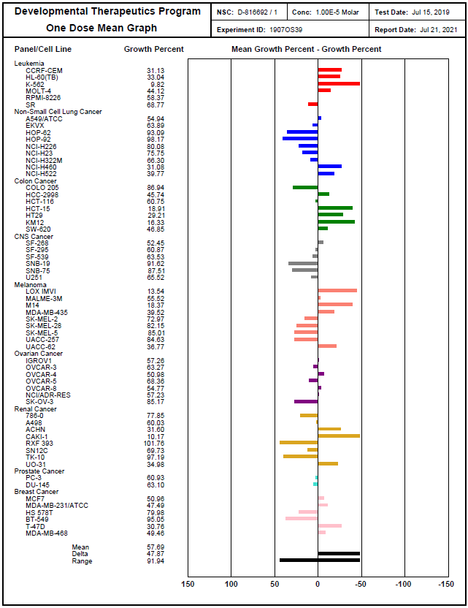
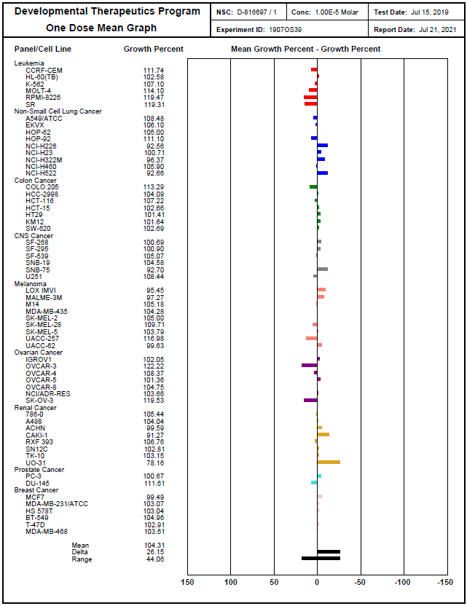
References
[1] Attar, S. R.; Shinde, B.; Kamble, S. B. Res. Chem. Intermed. 2020, 46, 4723.
[2] Wang, Z.; Yuan, X.; Cheng, Q.; Zhang, T.; Luo, J. New J. Chem. 2018, 42, 11610.
[3] (a) Yadav, C. L.; Gunjan Rajput, A.; Kumar, K.; Drew, M. G. B.; and Singh, N. Inorg. Chem. 2020, 59, 11417; (b) C. Li, D. Zhong, X. Huang, G. Shen, Q. Li, J. Du, Q. Li, S. Wang, J. Li, J. Dou, New J. Chem. 2019, 43, 5813.
[4] Khan, M.; Ahad, G.; Manaf, A.; Naz, R.; Hussain, S. R.; Deeba, F.; Shah, S.; Khan, A.; Ali, M.; Zaman, K.; Zafar, S.; Salar, U.; Hameed, A.; Khan, K. H. Med. Chem. Res. 2019, 28, 873.
[5] Buzykin, B. I. Izvestiya Akademii Nauk SSSR, Seriya Khimicheskaya 1983, 7, 1588.
[6] Rigaku Oxford Diffraction, 2015, CrysAlisPro Software system, version 1.171.38.46, Rigaku Corporation, Oxford, UK.
[7] Dolomanov, O. V.; Bourhis, L. J.; Gildea, R. J.; Howard, J. A. K.; Puschmann, H. J. Appl. Crystallogr. 2009, 42, 339.
[8] Sheldrick, G. Acta Cryst. A 2015, 71, 3.
[9] Sheldrick, G. Acta Cryst. C 2015, 71, 3.

