High Sensitivity Cardiac Troponin T in Patients with Severe Chronic Kidney Disease and suspected Acute Coronary Syndrome

SUPPLEMENTARY CONTENT
Table S1. Baseline characteristics of patients with severe CKD. 3
Table S2. Values of hs-cTnT during serial sampling in patients with normal renal function versus those with severe CKD. 5
Table S3. Values of hs-cTnT during serial sampling in patients with severe CKD according to the indication for revascularization. 6
Table S4. Diagnostic performance of hs-cTnT at serial sampling in patients with severe CKD. 7
Table S5. Diagnostic performance at presentation and absolute changes of hs-cTnT in patients with severe CKD. 8
Table S6. Outcomes at 30 days and one year of follow-up in patients with severe CKD. 9
Figure S1. Flow chart of the selection process of patients with severe CKD included in the ROC-analysis. 10
Figure S2. Correlation between hs-cTnT and creatinine levels. 11
Figure S3. Kaplan Meier estimates of adverse events at one year. 12
Figure S4. Independent predictors of adverse events at one year 13

Table S1. Baseline characteristics of patients with severe CKD.
 |  |  | Revascularization
 | Total  290 | No  68 (24) |  |  | Yes  222 (76) | P-value
Age | 73 (64, 79) | 74 (63, 80) |  |  | 73 (64, 78) | 0.780
Male | 204 (70) | 39 (57) |  |  | 165 (74) | 0.010
Risk factors
BMI | 26 (23, 31) | 26 (23, 30) |  |  | 26 (23, 31) | 0.607
Hypertension | 268 (92) | 63 (93) |  |  | 205 (92) | 1.000
Hypercholesterolemia | 213 (73) | 49 (72) |  |  | 164 (74) | 0.756
Diabetes mellitus | 162 (56) | 31 (46) |  |  | 131 (59) | 0.069
Current smoking | 69 (32) | 13 (28) |  |  | 56 (33) | 0.597
COPD | 55 (19) | 14 (21) |  |  | 41 (18) | 0.725
Family history | 33 (39) | 4 (25) |  |  | 29 (42) | 0.263
History
CAD | 205 (71) | 39 (57) |  |  | 166 (75) | 0.006
1-vessel CAD | 22 (8) | 6 (9) |  |  | 16 (7) | 0.795
2-vessel CAD | 32 (11) | 6 (9) |  |  | 26 (12) | 0.517
3-vessel CAD | 142 (51) | 27 (40) |  |  | 115 (54) | 0.051
Previous MI | 157 (54) | 30 (44) |  |  | 127 (57) | 0.071
Previous PCI | 162 (56) | 30 (44) |  |  | 132 (59) | 0.036
Previous CABG | 95 (33) | 17 (25) |  |  | 78 (35) | 0.140
Previous stroke | 43 (15) | 8 (12) |  |  | 35 (16) | 0.559
PAD | 110 (38) | 20 (29) |  |  | 90 (41) | 0.116
Vital signs
Systolic BP | 139 (120, 156) | 138 (117, 156) |  |  | 140 (120, 157) | 0.614
Diastolic BP | 71 (62, 83) | 76 (66, 85) |  |  | 70 (61, 82) | 0.128
Heart rate | 80 (71, 94) | 80 (69, 90) |  |  | 80 (72, 95) | 0.416
SaO₂ | 97 (95, 99) | 97 (95, 100) |  |  | 97 (95, 99) | 0.430
Angina CCS Class | 4 (3, 4) | 3 (3, 4) |  |  | 4 (3, 4) | 0.06
EGC changes | 179 (64) | 34 (52) |  |  | 145 (68) | 0.018
ST-segment depression | 82 (29) | 10 (15) |  |  | 72 (34) | 0.003
T-wave inversion | 84 (30) | 17 (26) |  |  | 67 (32) | 0.443
LBBB | 34 (12) | 8 (12) |  |  | 26 (12) | 1.000
Ns ST-segment elevations | 18 (6) | 3 (5) |  |  | 15 (7) | 0.578
LVEF | 47 (35, 55) | 54 (34, 60) |  |  | 45 (35, 55) | 0.076
GRACE risk score | 135 (118, 154) | 131 (111, 150) |  |  | 136 (119, 155) | 0.167
Renal function
Creatinine, mg/dl | 3.2 (2.4, 5.7) | 3.0 (2.2, 5.0) |  |  | 3.3 (2.4, 5.7) | 0.176
eGFR, mL/min/1.73m² | 23 (18, 27) | 24 (18, 28) |  |  | 23 (18, 27) | 0.499
Stages of CKD
eGFR 15-29 | 137 (47) | 36 (53) |  |  | 101 (45) | 0.331
eGFR <15 | 19 (7) | 5 (7) |  |  | 14 (6) | 0.781
CKD G5D | 134 (46) | 27 (40) |  |  | 107 (48) | 0.266
Intervention
PCI | 197 (68) | 0 (0) |  |  | 197 (89) | <0.001
CABG | 25 (9) | 0 (0) |  |  | 25 (11) | <0.001
Depicted are medians with interquartile ranges (IQR) or counts with frequencies (%). P-values are from Wilcoxon rank sum or Fisher´s Chi2 tests. Severe CKD defined as eGFR <30 mL/min/1.73m². BMI: body mass index in kg/m2; BP: blood pressure; CABG: coronary artery bypass grafting; CAD: coronary artery disease; CCS: Canadian cardiovascular society; CKD: chronic kidney disease; COPD: chronic obstructive pulmonary disease; CKD G5D: chronic kidney disease G5 treated by dialysis; eGFR: estimated glomerular filtration rate according to the CKD-EPI creatinine equation; GRACE: the Global Registry of Acute Coronary Events; LBBB: left bundle-branch block, LVEF: left ventricular ejection fraction; MI: myocardial infarction; ns: non significant; PAD: peripheral artery disease; PCI: percutaneous coronary intervention; SaO2: arterial oxygen saturation.

Table S2. Values of hs-cTnT during serial sampling in patients with normal renal function versus those with severe CKD.

Hs-cTnT (ng/L) | Normal renal function  n=300 | Severe CKD  n=290 | P-value
Presentation | 25 (7-102) | 114 (52-314) | <0.01
3 hours | 29 (7-116) | 160 (74-369) | <0.01
Peak | 58 (11-210) | 207 (79-537) | <0.01
Depicted are medians with interquartile ranges. P-values are from Wilcoxon rank sum test. Severe CKD defined as eGFR <30 mL/min/1.73m². CKD: chronic kidney disease; eGFR: estimated glomerular filtration rate according to the CKD-EPI creatinine equation; hs-cTnT: high sensitivity cardiac troponin T.

Table S3. Values of hs-cTnT during serial sampling in patients with severe CKD according to the indication for revascularization.

 | Revascularization
Hs-cTnT (ng/L) | No  n=68 | Yes  n=222 | P-value
Presentation | 46 (28-81) | 160 (69-485) | <0.001
3 hours | 55 (29-88) | 194 (105-409) | <0.001
6 hours | 47 (31-96) | 212 (99-572) | <0.001
Peak | 56 (32-93) | 282 (132-746) | <0.001
Depicted are medians with interquartile ranges. P-values are from Wilcoxon rank sum test. Severe CKD defined as eGFR <30 mL/min/1.73m². CKD: chronic kidney disease; eGFR: estimated glomerular filtration rate according to the CKD-EPI creatinine equation; hs-cTnT: high sensitivity cardiac troponin T.

Table S4. Diagnostic performance of hs-cTnT at serial sampling in patients with severe CKD.

 | Hs-cTnT-0h | Hs-cTnT-3h | Hs-cTnT-peak
AUC (95% CI) | 0.81 (0.75-0.87) | 0.84 (0.75-0.93) | 0.86 (0.81-0.92)
ROC optimized cutoff  Sensitivity (95% CI)  Specificity (95% CI) | ≥ 55 ng/L  83 (77-88)  65 (52-77) | ≥ 84 ng/L  85 (76-91)  70 (46-87) | ≥ 95ng/L  84 (79-90)  78 (66-89)
99th percentile  Sensitivity (95% CI)  Specificity (95% CI) | ≥ 14 ng/L  98 (95-99)  10 (2-19) | ≥ 14 ng/L  99 (94-100)  15 (4-39) | ≥ 14 ng/L  98 (95-100)  4 (1-15)
Specificity optimized cutoff (≥ 80%)  Sensitivity (95% CI)  Specificity (95% CI) | ≥ 95 ng/L  70 (63-77)  80 (68-91) | ≥ 96 ng/L  77 (68-85)  85 (61-96) | ≥ 112 ng/L  79 (73-85)  82 (71-92)
Sensitivity optimized cutoff (≥ 90%)  Sensitivity (95% CI)  Specificity (95% CI) | ≥ 37 ng/L  90 (85-94)  49 (35-63) | ≥ 56 ng/L  91 (84-96)  55 (32-76) | ≥ 71 ng/L  90 (86-95)  60 (45-73)
Depicted are AUCs and different cutoff levels with sensitivities and specificities in percent and 95% confidence intervals (CI) of hs-cTnT at presentation, 3 hours and peak prior to angiography. Severe CKD defined as eGFR <30 mL/min/1.73m². AUC: area under the receiver operating characteristic curve; CKD: chronic kidney disease; eGFR: estimated glomerular filtration rate according to the CKD-EPI creatinine equation; ROC: receiver operating characteristic curve.

Table S5. Diagnostic performance at presentation and absolute changes of hs-cTnT in patients with severe CKD.

 | Hs-cTnT-0h | │∆0h-3h│ | │∆0h-6h│ | 0h +│∆3-0h│
Median (IQR) | 130 (48, 411) | 27 (4, 108) | 65 (7, 301) | -
AUC (95% CI) | 0.81 (0.75-0.87) | 0.79 (0.64-0.95) | 0.84 (0.72-0.96) | 0.84 (0.75-0.89)
ROC optimized cutoff | ≥ 55 ng/L | ≥ 4 ng/L | ≥ 8 ng/L | 0h ≥ 55 ng/L or  │∆0h-3h│≥ 4 ng/L
Sensitivity (95% CI) | 83 (77-88) | 91 (81-96) | 84 (70-92) | 98 (91-100)
Specificity (95% CI) | 65 (52-77) | 64 (32-88) | 70 (35-92) | 55 (25-82)
PPV (95% CI) | 89 (85-94) | 94 (84-98) | 93 (80-98) | 93 (83-97)
NPV (95% CI) | 52 (39-64) | 54 (26-80) | 47 (22-73) | 86 (42-99)
Depicted are medians in ng/L with interquartile ranges (IQR) and AUCs with 95% confidence intervals (95% CI) of hs-cTnT at presentation, absolute changes at 3 and 6 hours and the combination of hs-cTnT at presentation with absolute 3-hour changes. Severe CKD defined as eGFR <30 mL/min/1.73m². AUC: area under the curve; CKD: chronic kidney disease; eGFR: estimated glomerular filtration rate according to the CKD-EPI creatinine equation; NPV: negative predictive value; PPV: positive predictive value.

Table S6. Outcomes at 30 days and one year of follow-up in patients with severe CKD.

 | Revascularization
 | Total | No | Yes | P-value
30 days
All cause death | 14 (7) | 1 (2) | 13 (8) | 0.199
MACE | 17 (8) | 0 (0) | 17 (11) | 0.015
Cardiovascular death | 9 (4) | 0 (0) | 9 (6) | 0.214
Myocardial infarction | 9 (5) | 0 (0) | 9 (6) | 0.120
Unplanned revascularization | 6 (3) | 0 (0) | 6 (4) | 0.339
365 days
All cause death | 51 (29) | 5 (13) | 46 (34) | 0.010
MACE | 71 (42) | 4 (11) | 67 (50) | <0.001
Cardiovascular death | 29 (19) | 3 (8) | 26 (23) | 0.056
Myocardial infarction | 49 (33) | 1 (3) | 48 (41) | <0.001
Unplanned revascularization | 33 (24) | 2 (6) | 31 (31) | 0.002
Depicted are counts with frequencies (%). P-values are from log-rank tests. Severe CKD defined as eGFR <30 mL/min/1.73m². CKD: chronic kidney disease; eGFR: estimated glomerular filtration rate according to the CKD-EPI creatinine equation; MACE: major adverse cardiovascular events (cardiovascular death, myocardial infarction, unplanned revascularization).

Figure S1. Flow chart of the selection process of patients with severe CKD included in the ROC-analysis.

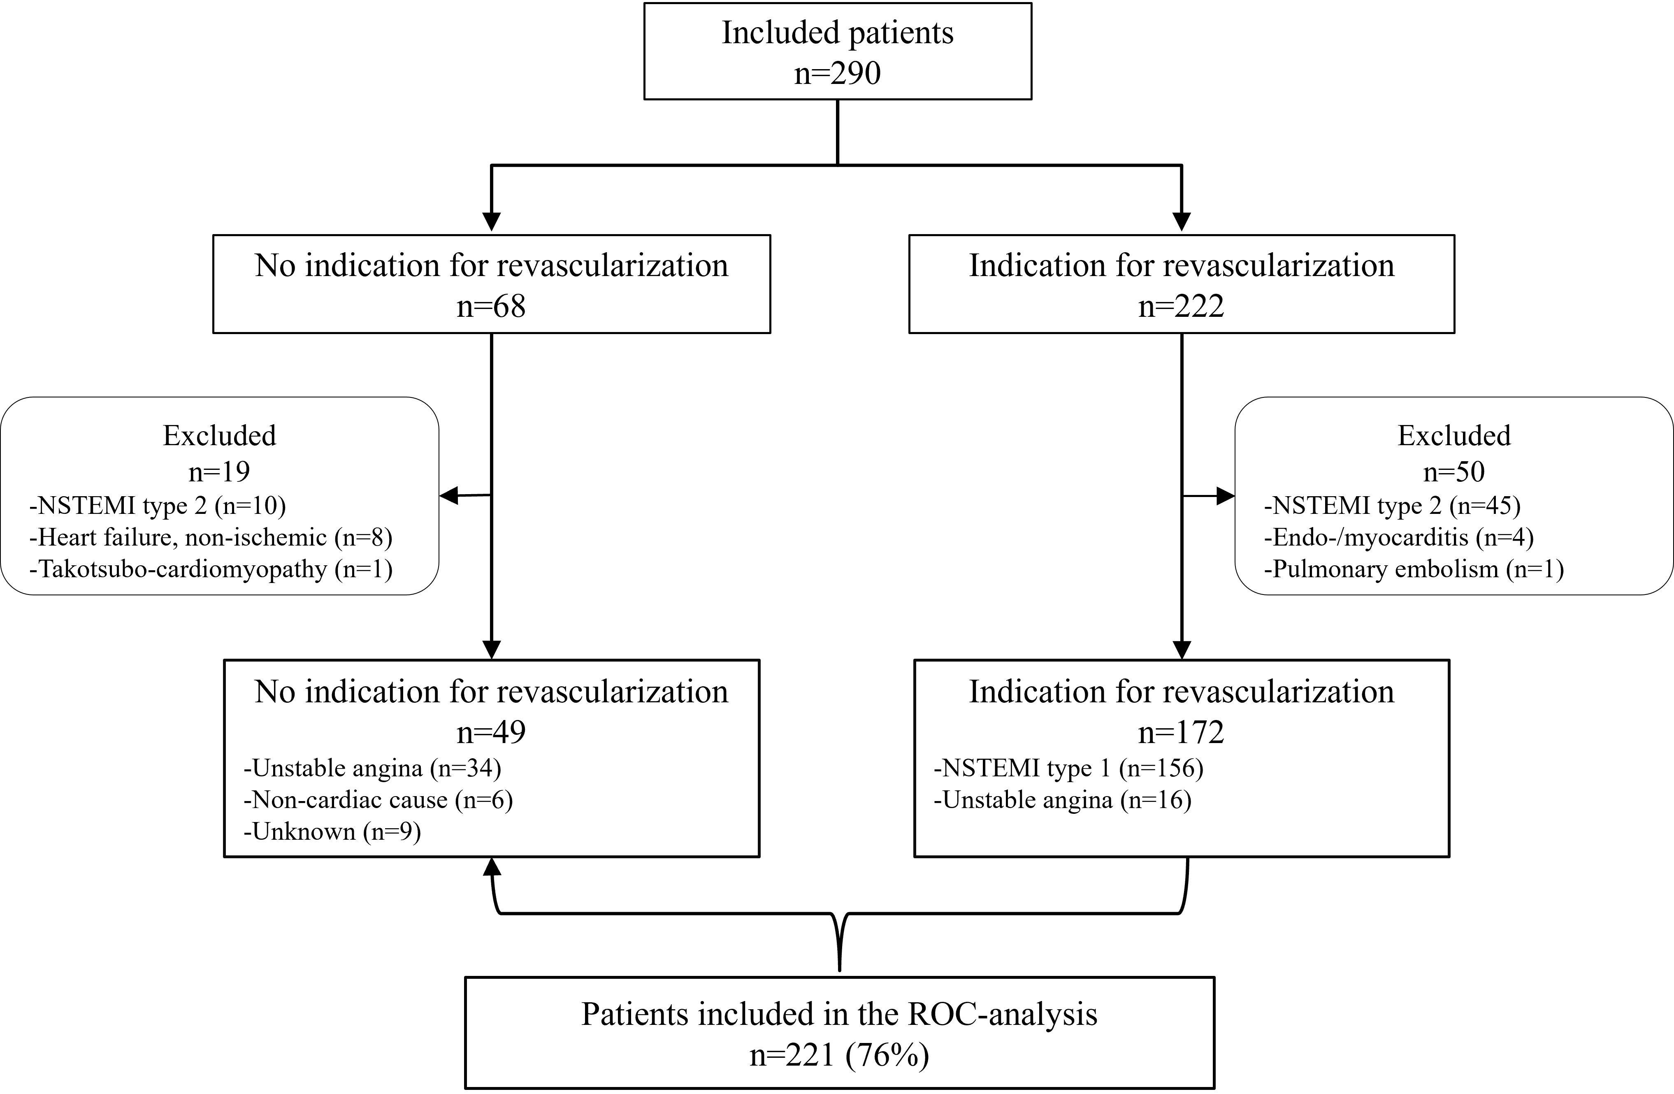
Severe CKD defined as eGFR <30 mL/min/1.73m². CKD: chronic kidney disease; eGFR: estimated glomerular filtration rate according to the CKD-EPI creatinine equation; NSTEMI: non-ST-elevation acute myocardial infarction; ROC: receiver operating characteristic curve.

Figure S2. Correlation between hs-cTnT and creatinine levels.

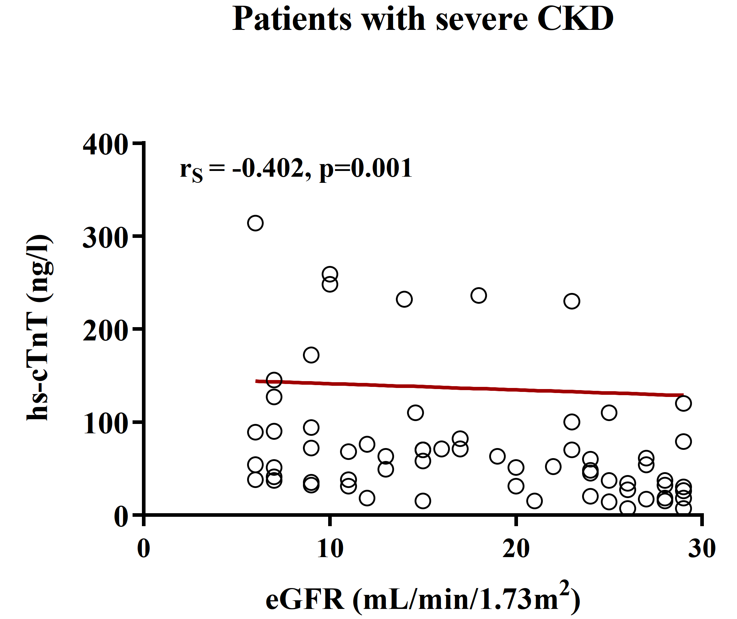
Depicted is the correlation between levels of hs-cTnT and creatinine in the non-revascularization subgroup of the cohort with severe CKD. Severe CKD defined as eGFR <30 mL/min/1.73m². RS is the Spearman correlation coefficient. CKD: chronic kidney disease; eGFR: estimated glomerular filtration rate according to the CKD-EPI creatinine equation.

Figure S3. Kaplan Meier estimates of adverse events at one year.
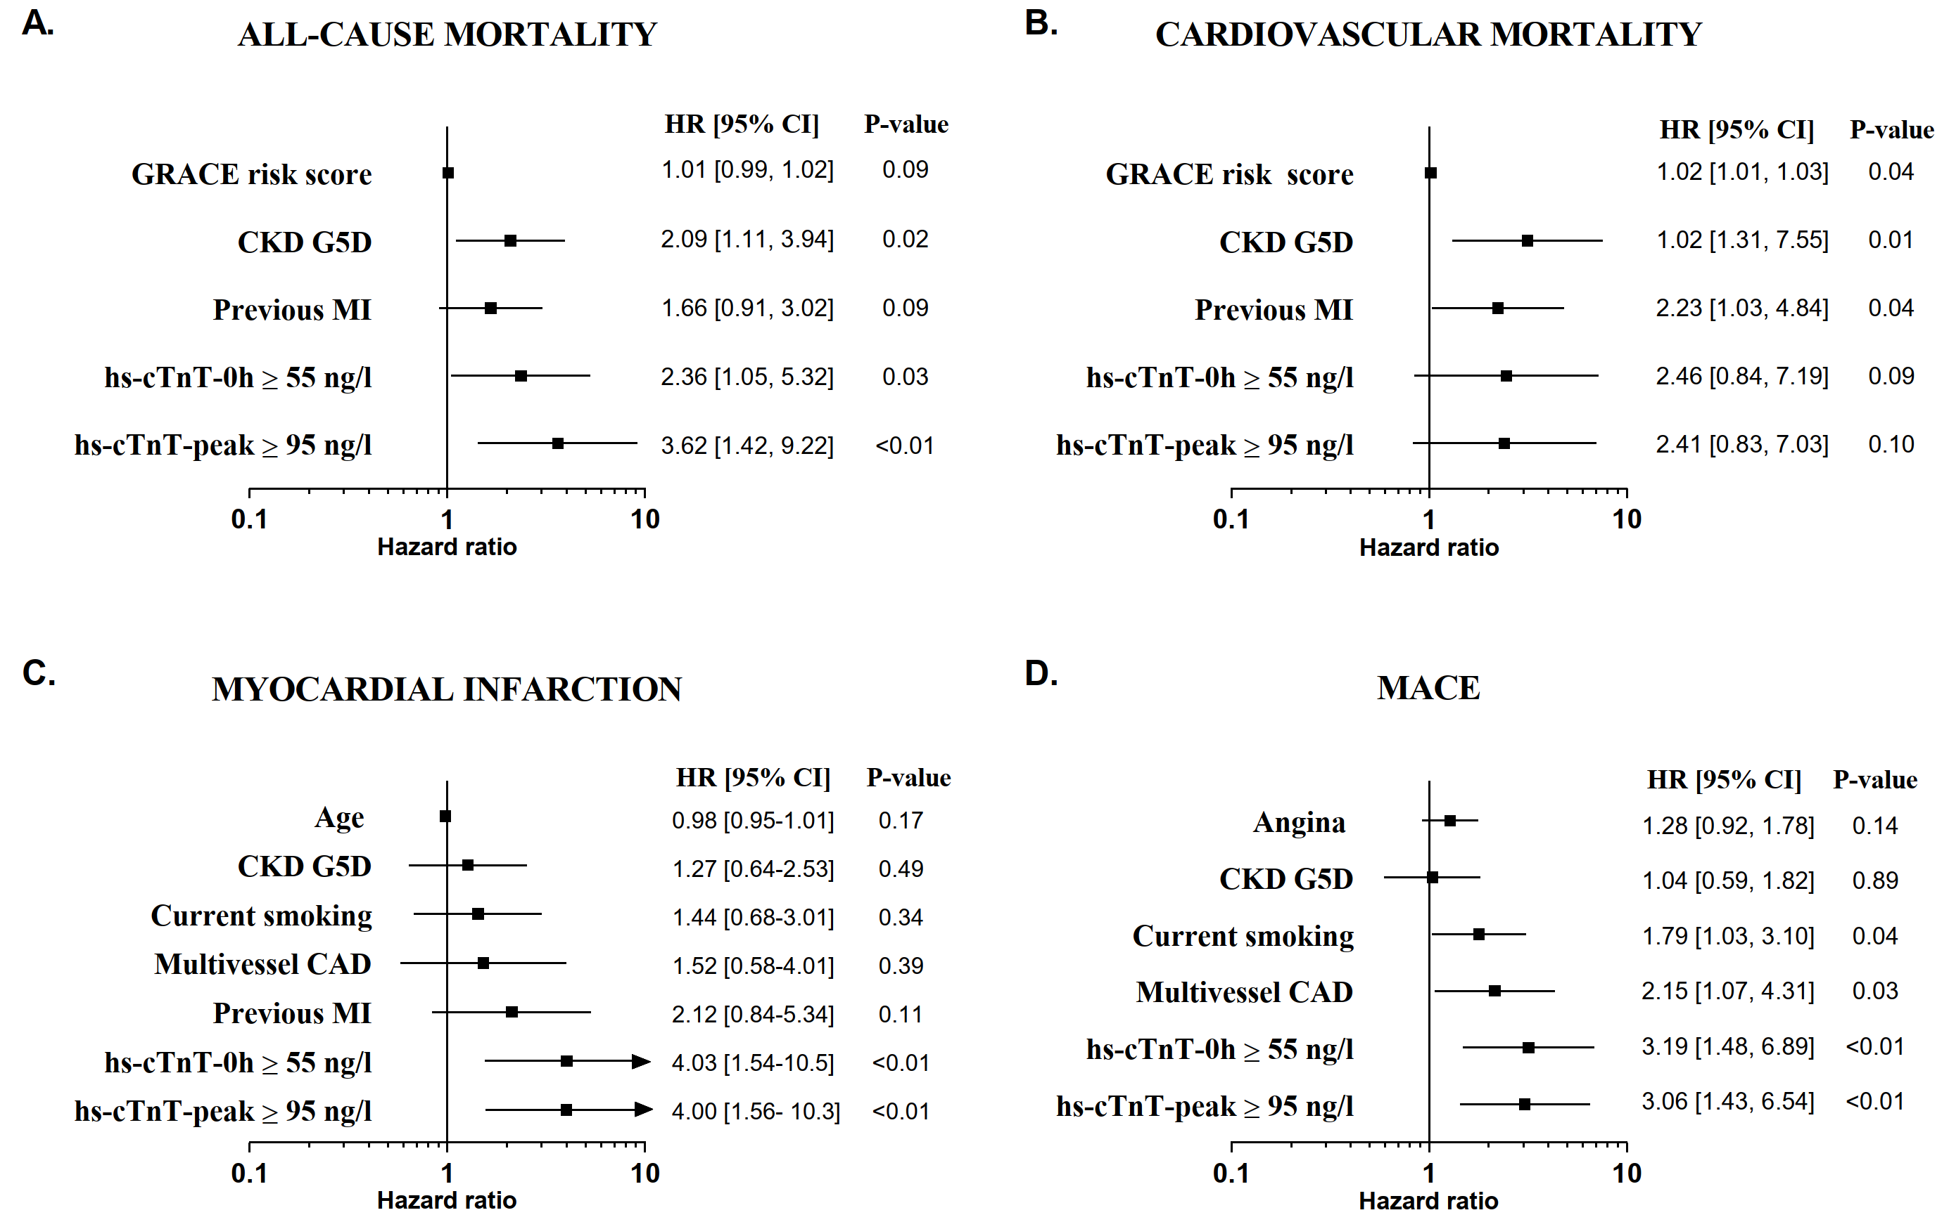
Depicted are the Kaplan Meier estimates of adverse events in patients with severe CKD (eGFR <30 mL/min/1.73m²) at one year, according to ROC optimized hs-cTnT cutoffs at presentation and peak of all-cause mortality (A and C) and MACE (B and D). Cumulative incidence (%) of events is from Kaplan Meier, crude hazard ratios (HR) and 95% CIs are from Cox regressions. CKD: chronic kidney disease; eGFR: estimated glomerular filtration rate according to the CKD-EPI creatinine equation; hs-cTnT: high sensitivity cardiac troponin T; MACE: composite of cardiovascular death, myocardial infarction or unplanned revascularization for ischemia; ROC: receiver-operating characteristic curve.

Figure S4. Independent predictors of adverse events at one year
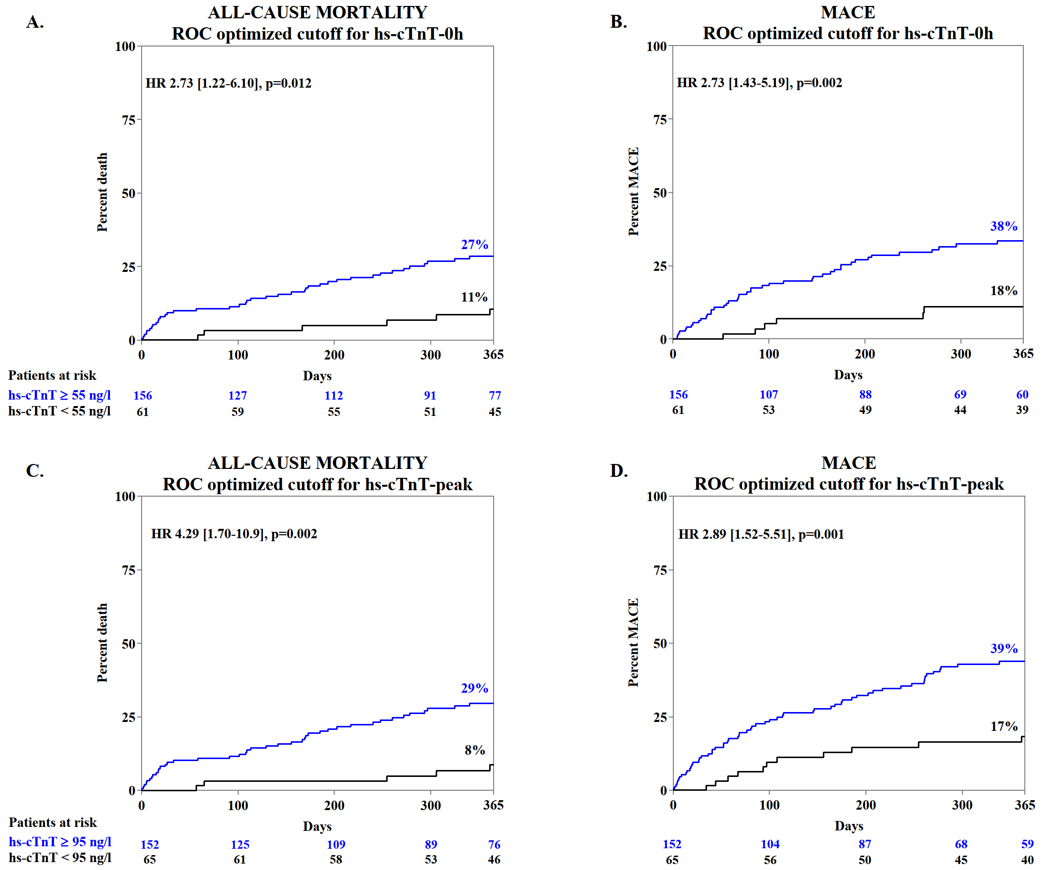
Depicted are the independent predictors of adverse events in patients with severe CKD (eGFR <30 mL/min/1.73m²) at one year: A) all-cause mortality, B) cardiovascular mortality, C) myocardial infarction and D) MACE. The symbols indicate the point estimate (hazard ratios [HR]) and the lines the 95% Confidence Intervals [95% CI] from multivariate logistic regression. The arrow indicates a CI-value beyond the shown axis limit. CAD: coronary artery disease; CKD: chronic kidney disease; eGFR: estimated glomerular filtration rate according to the CKD-EPI creatinine equation; CKD G5D: chronic kidney disease G5 treated by dialysis; GRACE: Global Registry of Acute Coronary Events; MI: myocardial infarction; MACE: composite of cardiovascular death, MI or unplanned revascularization for ischemia; ROC: receiver-operating characteristic curve.

